PHIL 201

Answers for Chapter 5 Exercises

***Exercises 5A***

**1.** Subject term: *senior citizen*

Predicate term: *people eligible for subsidized drug prescriptions*

This is an example of an **A**-proposition.

**2.** Subject term: *public schools*

Predicate term: *schools* *meeting national standards for excellence*

This is an example of an **O**-proposition.

**3.** Subject term: *family incomes*

Predicate term: *incomes below the poverty line*

This is an example of an **I**-proposition.

**4.** Subject term: *national health-care plans*

Predicate term: *ideas worth implementing*

This is an example of an **E**-proposition.

**5.** Subject term: *malicious murderers*

Predicate term: *evil people*

This is an example of an **A**-proposition.

**6.** Subject term: *X-rated movies*

Predicate term: *intellectually stimulating* *events*

This is an example of an **A**-proposition.

**7.** Subject term: *video games*

Predicate term: *violent* *activities*

This is an example of an **O**-proposition.

**8.** Subject term: *petty bureaucrats*

Predicate term: *tyrannical* *people*

This is an example of an **I**-proposition.

**9.** Subject term: *lottery winners*

Predicate term: *lucky* *people*

This is an example of an **E**-proposition.

**10.** Subject term: *diet fads*

Predicate term: *healthy* *lifestyles*

This is an example of an **O**-proposition.

**11.** Subject term: *sporting events*  
Predicate term: *television shows worth watching*

This is an example of an **A**-proposition.

**12.** Subject term: *philosophy books*

Predicate term: *important contributions to literature*

This is an example of an **I**-proposition.

**13.** Subject term: *amendments to the U.S. Constitution*   
Predicate term: *unconstitutional* *acts*

This is an example of an **E**-proposition.

**14.** Subject term: *gamblers*

Predicate term: *superstitious people*

This is an example of an **A**-proposition.

**15.** Subject term: *psychics*  
Predicate term: *frauds*

This is an example of an **I**-proposition.

***Exercises 5B***

**I.**

**1.** Universal affirmative; subject term distributed; predicate term undistributed.

**2.** Particular negative; subject term undistributed; predicate term distributed.

**3.** Universal negative; subject term distributed; predicate term distributed.

**4.** Particular affirmative; subject term undistributed; predicate term undistributed.

**5.** Universal negative; subject term distributed; predicate term distributed.

**6.** Universal negative; subject term distributed; predicate term distributed.

**7.** Particular affirmative; subject term undistributed; predicate term undistributed.

**8.** Particular negative; subject term undistributed; predicate term distributed.

**9.** Universal affirmative; subject term distributed; predicate term undistributed.

**10.** Universal negative; subject term distributed; predicate term distributed.

**11.** Universal affirmative; subject term distributed; predicate term undistributed.

**12.** Particular negative; subject term undistributed; predicate term distributed.

**13.** Universal negative; subject term distributed; predicate term distributed.

**14.** Particular affirmative; subject term undistributed; predicate term undistributed.

**15.** Universal negative; subject term distributed; predicate term distributed.

**II.**

**1.** No board games are colorful diversions.

**2.** Some detectives are not logical thinkers.

**3.** All shopping malls are convenience stores.

**4.** Some swimming pools are adequately chlorinated places.

**5.** All high-definition TV shows are shows for children.

**6.** No birdcages are sanitary areas.

**7.**  Some house plants are not illegal substances.

**8.** Some singers are highly-trained professionals

**9.** No karaoke bars are noisy rooms.

**10.** Some race car drivers are not ambidextrous people.

**III.**

**1.** No firecrackers are safe products.

**2.** Some scuba divers are not claustrophobic people.

**3.** Some hamsters are cuddly animals.

**4.** All plastic trash bags are things that break easily.

**5.** Some wood-burning stoves are warmth givers.

**6.** All knickknacks are antique items.

**7.** Some tsunamis are not surfing paradises.

**8.** No fantasy magazines are carefully written material.

**9.** Some tuna fish sandwiches are high-protein meals.

**10.** Some pick-up trucks are not electric vehicles.

**IV. Change both the *quality* and the *quantity* of the following categorical propositions.**

**1.** Some caregivers are not altruistic people.

**2.** No airplane seats are uncomfortable spaces.

**3.** Some skydivers are people afraid of heights.

**4.** All European castles are heated domiciles.

**5.** Some dancers are not physically gifted athletes.

**6.** Some refrigerators are self-cleaning machines.

**7.** No drive-in theaters are places going out of business.

**8.** All fruit trees are plants capable of surviving a frost.

**9.** Some movie special effects are not scenes generated by a computer.

**10.** Some painful experiences are things soon forgotten.

***Exercises 5D***

**1.** Let S = *snowmen*, and P = *permanent lawn fixtures*. Some S are P.

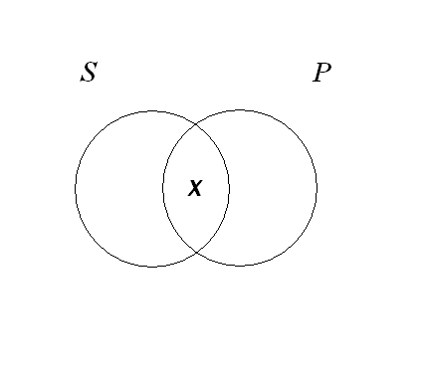

**2.** Let S = *leeches*, and P = *lawyers.* No S are P.

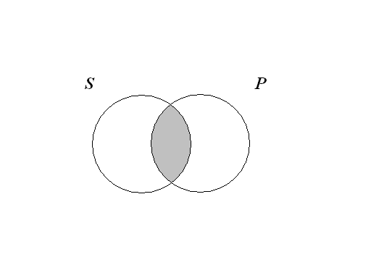

**3.** Let S = *television newscasters*, and P = *good actors.* Some S are P.



**4.** Let S = *donuts*, and P = *fat-free snacks.* All S are P.

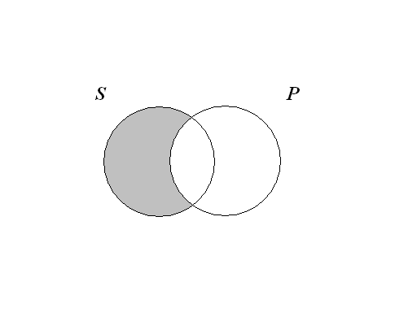

**5.** Let S = *psychics*, and P = *frauds.* All S are P.



**6.** Let S = *children*, and P = *offspring following in their parents’ footsteps.* Some S are not P.

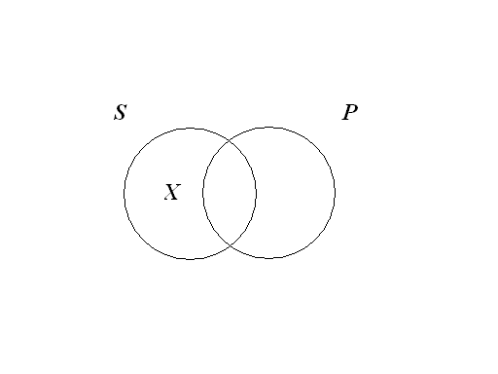

**7.** Let S = *volcanoes*, and P = *currently active geologic structures.* No S are P.



**8.** Let S = *wrestling shows*, and P = *scripted events.* Some S are P.

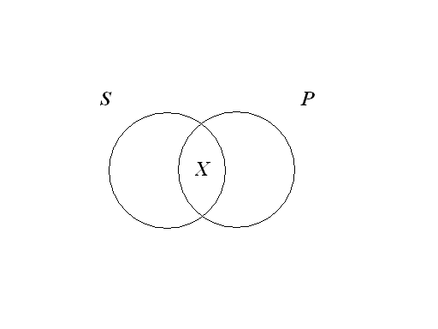

**9.** Let S = *teachers*, and P = *miserable wretches.* All S are P.



**10.** Let S = *poems*, and P = *beautifully written works of literature.* Some S are P.



**11.** Let S = *viruses*, and P = *lethal organisms.* Some S are not P.



**12.** Let S = *Nobel laureates*, and P = *Olympic champions.* No S are P.



**13.** Let S = *sea creatures*, and P = *bivalves.* All S are P.



**14.** Let S = *rock stars*, and P = *good parents.* Some S are P.



**15.** Let S = *condiments*, and P = *free items.* All S are P.



**16.** Let S = *exotic vegetables*, and P = *edible products.* Some S are not P.



**17.** Let S = *scientific researchers*, and P = *people with impeccable credentials.* Some S are P.



**18.** Let S = *television commercials*, and P = *events worthy of our attention*. No S are P.



**19.** Let S = *finely tuned instruments*, and P = *noise emitters.* All S are P.



**20.** Let S = *floppy disks*, P = *defective products.* Some S are P.



**21.** Let S = *French pastries*, and P = *baked items.* All S are P.



**22.** Let S = *cows*, and P = *flatulent animals.* Some S are not P.



**23.** Let S = *Nobel Prize winners*, and P = *illiterate people.* No S are P.



**24.** Let S = *swimmers*, and P = *healthy athletes.* Some S are P.



**25.** Let S = *dogs*, and P = *faithful pets.* All S are P.



**26.** Let S = *spiders*, P = *nocturnal creatures.* No S are P.



**27.** Let S = *race car drivers*, and P = *fearless competitors.* Some S are P.



**28.** Let S = *college textbooks*, and P = *works of art.* Some S are P.



**29.** Let S = *teachers*, and P = *inspired orators.* All S are P.



**30.** Let S = *games of chance*, and P = *sucker bets.* Some S are P.



**31.** Let S = *sandwiches*, and P = *meatless foods.* Some S are P.



**32.** Let S = *bats*, and P = *vegetarians.* No S are P.



**33.** Let S = *designer jeans*, and P = *genetically engineered objects.* All S are P.



**34.** Let S = *greedy politicians*, and P = *people likely to go to prison.* No S are P.



**35.** Let S = *fruitcakes*, and P = *regifted presents.* Some S are not P.



**36.** Let S = *embezzlers*, and P = *social deviants.* All S are P.



**37.** Let S = *traffic accidents*, and P = *speeding incidents.* Some S are P.



**38.** Let S = *public holidays*, and P = *days when banks close.* All S are P.



**39.** Let S = *music videos*, and P = *tragedies.* Some S are not P.



**40.** Let S = *fajitas*, and P = *mouth-watering morsels.*  Some S are P.



**41.** Let S = *ice cream toppings*, and P = *diet-friendly products.* No S are P.



**42.** Let S = *yogurt products*, and P = *healthy foods.* All S are P.



**43.** Let S = *vegetables*, and P = *vitamin-deficient produce.* No S are P.



**44.** Let S = *barbeque wings*, and P = *undercooked meat.* Some S are P.



**45.** Let S = *French fries*, and P = *grease-laden spuds.* All S are P.



***Exercises 5E***

**1.** A. *Converse*: Some sucker bets are games of chance. *Valid*

B. *Obverse*: Some games of chance are not non-sucker bets. *Valid*

C.  *Contrapositive*: Some non-sucker bets are non-games of chance. *Invalid*

**2.** A. *Converse*: Some meaty things are not sandwiches. *Invalid*

B. *Obverse*: Some sandwiches are non-meaty things. *Valid*

C. *Contrapositive*: Some non-meaty things are not non-sandwiches. *Valid*

**3.** A. *Converse*: No vegetarians are bats. *Valid*

B. *Obverse*: All bats are non-vegetarians. *Valid*

C. *Contrapositive*: No non-vegetarians are non-bats. *Invalid*

**4.** A. *Converse*: All genetically engineered objects are designer jeans. *Invalid*

B. *Obverse*: No designer jeans are non-genetically engineered objects. *Valid*

C. *Contrapositive*: All non-genetically engineered objects are non-designer jeans. *Valid*

**5.** A. *Converse*: No people likely to go to prison are greedy politicians. *Valid*

B. *Obverse*: All greedy politicians are non-people likely to go to prison. *Valid*

C. *Contrapositive*: No non-people likely to go to prison are non-greedy politicians. *Invalid*

**6.** A. *Converse*: Some re-gifted presents are not fruitcakes. *Invalid*

B. *Obverse*: Some fruitcakes are non-re-gifted presents. *Valid*

C. *Contrapositive*: Some non-re-gifted presents are not non-fruitcakes. *Valid*

**7.** A. *Converse*: All social deviants are embezzlers. *Invalid*

B. *Obverse*: No embezzlers are non-social deviants. *Valid*

C. *Contrapositive*: All non-social deviants are non-embezzlers. *Valid*

**8.** A. *Converse*: Some speeding incidents are traffic accidents. *Valid*

B. *Obverse*: Some traffic accidents are not non-speeding incidents. *Valid*

C. *Contrapositive*: Some non-speeding incidents are non-traffic accidents. *Invalid*.

**9.** A. *Converse*: All days when banks close are public holidays. *Invalid*

B. *Obverse*: No public holidays are non-days when banks close. *Valid*

C. *Contrapositive*: All non-days when banks close are non-public holidays. *Valid*

**10.** A. *Converse*: Some tragedies are not music videos. *Invalid*

B. *Obverse*: Some music videos are non-tragedies. *Valid*

C. *Contrapositive*: Some non-tragedies are not non-music videos. *Valid*

**11.** A. *Converse*: Some juicy items are T-bone steaks. *Valid*

B. *Obverse*: Some T-bone steaks are not non-juicy items. *Valid*

C. *Contrapositive*: Some non-juicy items are non-T-bone steaks. *Invalid*

**12.** A. *Converse*: Some mouth-watering morsels are fajitas. *Valid*

B. *Obverse*: Some fajitas are not non-mouth-watering morsels. *Valid*

C. *Contrapositive*: Some non-mouth-watering morsels are non-fajitas. *Invalid*

**13.** A. *Converse*: No diet-busters are ice cream toppings. *Valid*

B. *Obverse*: All ice cream toppings are non-diet-busters. *Valid*

C. *Contrapositive*: No non-diet-busters are non-ice cream toppings. *Invalid*

**14.** A. *Converse*: All healthy foods are yogurt products. *Invalid*

B. Obverse: No yogurt products are non-healthy foods. *Valid*

C. *Contrapositive*: All non-healthy foods are non-yogurt products. *Valid*

**15.** A. *Converse*: No vitamin-deficient foods are vegetables. *Valid*

B. *Obverse*: All vegetables are non-vitamin-deficient foods. *Valid*

C. *Contrapositive*: No non-vitamin-deficient foods are non-vegetables. *Invalid*

**16.** A. *Converse*: Some spicy meals are barbecue wings. *Valid*

B. *Obverse*: Some barbecue wings are not non-spicy meals. *Valid*

C. *Contrapositive*: Some non-spicy meals are non-barbecue wings. *Invalid*

**17.** A. *Converse*: All grease-laden products are French fries. *Invalid*

B. *Obverse*: No French fries are non-grease-laden products. *Valid*

C. *Contrapositive*: All non-grease-laden products are non-French fries. *Valid*

**18.** A. *Converse*: Some sugar-free products are cheesecakes. *Valid*

B. *Obverse*: Some cheesecakes are not non-sugar-free products. *Valid*

C. *Contrapositive*: Some non-sugar-free products are non-cheesecakes. *Invalid*

**19.** A. *Converse*: All foods best eaten when ripe are bananas. *Invalid*

B. *Obverse*: No bananas are non-foods best eaten when ripe. *Valid*

C. *Contrapositive*: All non-foods best eaten when ripe are non-bananas. *Valid*

**20.** A. *Converse*: Some delicious snacks are tofu products. *Valid*

B. *Obverse*: Some tofu products are not non-delicious snacks. *Valid*

C. *Contrapositive*: Some non-delicious snacks are non-tofu products. *Invalid*

**21.** A. *Converse:* Some great works of art are tattoos. *Valid*

B. *Obverse*: Some tattoos are not non-great works of art. *Valid*

C. *Contrapositive*: Some non-great works of art are non-tattoos. *Invalid*

**22.** A. *Converse*: Some warm garments are not modern clothes. *Invalid*

B. *Obverse*: Some modern clothes are non-warm garments. *Valid*

C. *Contrapositive*: Some non-warm garments are not non-modern clothes. *Valid*

**23.** A. *Converse*: No easy to clean objects are swimming pools. *Valid*

B. *Obverse*: All swimming pools are non-easy to clean objects. *Valid*

C. *Contrapositive*: No non-easy to clean objects are non-swimming pools. *Invalid*

**24.** A. *Converse*: All artificially sweetened products are movie theater drinks. *Invalid*

B. *Obverse*: No movie theater drinks are non-artificially sweetened products. *Valid*

C. *Contrapositive*: All non-artificially sweetened products are non-movie theater drinks. *Valid*

**25.** A. *Converse*: No acts left unrewarded are good deeds. *Valid*

B. *Obverse*: All good deeds are non-acts left unrewarded. *Valid*

C. *Contrapositive*: No non-acts left unrewarded are non-good deeds. *Invalid*

***Exercises 5F.1***

**I.**

**1.** (b) is correct. Since “No football players are opera singers” is an **E-**proposition its contradictory must be an **I-**proposition, which is answer (b). The correct answer cannot be (a) because it is an **A-**proposition, which is the *contrary* of an **E-**proposition. Also, (c) is not correct because it is an **O-**proposition, which is the subaltern of an **E-**proposition.

**2.** Yes. **A-**propositions and **E-**propositions are *contraries*.

**3.** Yes. **I-**propositions and **O-**propositions are *subcontraries*.

**4.** False. One must be true and the other false.

**5.** True.

**II.**

**1**. a. True. The first is an **I-**proposition, and if it is false, its contradictory **E-**proposition is true.

**2.** a. True. The first is an **I-**proposition, and if it is false, its contradictory **E**-proposition is true.

**3.** b. False. Since these fall under *subalternation,* if the particular (in this case an **I-**proposition) is false, then the corresponding universal (in this case an **A**-proposition) is false, too.

**4.** c. Undetermined. Since these fall under *subalternation,* if the particular (in this case an **I**-proposition) is true, then the corresponding universal (in this case an **A**-proposition) could be either true or false.

**5.** a. True. Since these fall under *subalternation,* if the universal (in this case an **E**-proposition) is true, then the corresponding particular (in this case an **O-**proposition) is true, too.

**6.** c. Undetermined. Since these fall under *subalternation,* if the universal (in this case an **E**-proposition) is false, then the corresponding particular (in this case an **O**-proposition) could be either true or false.

**III.**

**1.** Some sports cars are not gas-guzzling machines.

Since the first sentence is an **A**-proposition, its contradictory is an **O**-proposition.

**2.** No diamond rings are expensive items.

Only **A**-propositions and **E-**propositions are contraries.

**3.** There is no relationship of opposition between these propositions. Both are **I-**propositions. They have the same subject term, but different predicate terms.

**4.** The second proposition is the contradictory of the first; so, it is false, if the first is true.

**5.** Undetermined. No immediate inference can be made about the subaltern of a false **A-**proposition.

**IV.**

**1.** b. False. Since they are *contraries,* they cannot both be true at the same time.

**2.** a. True. Since these fall under *subalternation,* if the universal is true, then the corresponding particular is true.

**3.** b. False. Since they are *contradictories*, if one is true, then the other is false.

**4.** c. Undetermined. Since they are *contraries,* they can both be false at the same time.

**5.** c. Undetermined. Since these fall under *subalternation,* if the universal is false, then the corresponding particular could be either true or false.

**6.** a. True. Since they are *contradictories*, if one is false, then the other is true.

**7.** b. False. Since they are *contraries,* they cannot both be true at the same time.

**8.** b. False. Since they are *contradictories*, if one is true, then the other is false.

**9.** a. True. Since these fall under *subalternation,* if the universal is true, then the corresponding particular is true.

**10.** c. Undetermined. Since they are *contraries,* they can both be false at the same time.

**11.** a. True. Since they are *contradictories*, if one is false, then the other is true.

**12.** c. Undetermined. Since these fall under *subalternation,* if the universal is false, then the corresponding particular could be either true or false.

**13.** c. Undetermined. Since these fall under *subalternation,* if the particular is true, then the corresponding universal could be either true or false.

**14.** b. False. Since they are *contradictories*, if one is true, then the other is false.

**15.** c. Undetermined. Since they are *subcontraries*, they can both be true at the same time.

**16.** b. False. Since these fall under *subalternation,* if the particular is false, then the corresponding universal is false.

**17.** a. True. Since they are *contradictories*, if one is false, then the other is true.

**18.** a. True. Since they are *subcontraries,* they cannot both be false at the same time.

**19.** b. False. Since they are *contradictories*, if one is true, then the other is false.

**20.** c. Undetermined. Since these fall under *subalternation,* if the particular is true, then the corresponding universal could be either true or false.

**21.** c. Undetermined. Since they are *subcontraries,* they can both be true at the same time.

**22.** a. True. Since they are *contradictories*, if one is false, then the other is true.

**23.** b. False. Since these fall under *subalternation,* if the particular is false, then the corresponding universal is false.

**24.** a. True. Since they are *subcontraries,* they cannot both be false at the same time.

***Exercises 5F.2***

**1.** We start by drawing a Venn diagram of the premise.

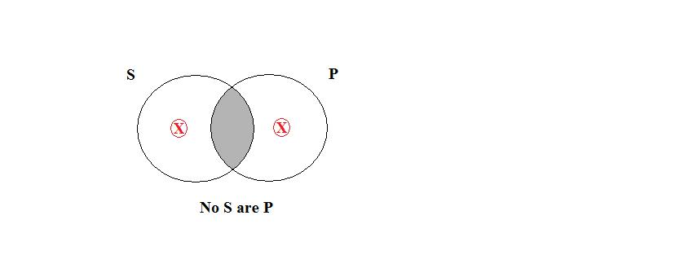

Next, we check to see if the conclusion is necessarily true. Since the conclusion is an **O-**proposition, in order for it to be true there has to be an X in the unshaded area of S. As we can see, the assumption of existence symbol (the circled X) is in the area. Now we need to see if the circled X represents something that actually exists. Since the S stands for *fashion models*, and they surely exist, the assumption of existence symbol does represent something that actually exists. Therefore, the argument is valid under the traditional interpretation.

**2.**

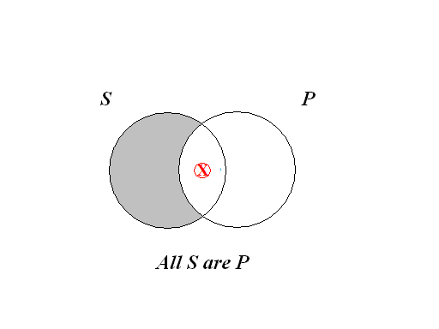

Under the *traditional interpretation*, in order for the conclusion to be true (an **I**-proposition) there would have to be an X in the area where *S* and *P* overlap. As we can see, the assumption of existence symbol (the circled X) is in the area. Now we need to see if the circled X represents something that actually exists. Since the *S* stands for *cruise ships*, and they exist, the assumption of existence symbol does represent something that actually exists. Therefore, the argument is valid under the traditional interpretation.

**3.**



Under the *traditional interpretation*, in order for the conclusion to be true (an **A-**proposition) the area of *S* outside of *P* would have to be shaded. Since this is not the case, this is an invalid argument.

**4.**

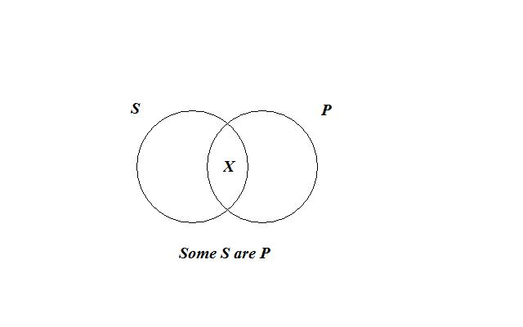

In order for the conclusion to be true (an **E-**proposition) the area of where *S* and *P* overlap would have to be shaded. Since this is not the case, this is an invalid argument.

**5.**



Under the *traditional interpretation*, in order for the conclusion to be true (an **I-**proposition) an X needs to be in the area where *S* and *P* overlap. Since this is not the case, this is an invalid argument.

**6.**



Under the *traditional interpretation*, in order for the conclusion to be true (an **O-**proposition) an X needs to be in the area of *S* outside of *P*. Since this is not the case, this is an invalid argument.

**7.**



In order for the conclusion to be true (an **A-**proposition) the area of *S* outside *P* would have to be shaded. Since this is not the case, this is an invalid argument.

**8.**



In order for the conclusion to be true (an **O-**proposition) there needs to be an X in the area of *S* outside *P*. Since this is not the case, this is an invalid argument.

**9.**

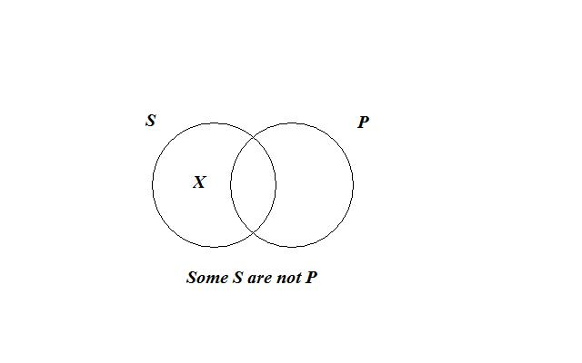

In order for the conclusion to be true (an **I-**proposition) there needs to be an X in the area where *S* and *P* overlap. Since this is not the case, this is an invalid argument.

**10.**



Under the *traditional interpretation*, in order for the conclusion to be true (an **I-**proposition) there would have to be an X in the area where *S* and *P* overlap. As we can see, the assumption of existence symbol (the circled X) is in the area. Now we need to see if the circled X represents something that actually exists. Since the *S* stands for *credit card billing statements*, and they exist, the assumption of existence symbol does represent something that actually exists. Therefore, the argument is valid under the traditional interpretation.

**11.**



In order for the conclusion to be true (an **I-**proposition) there needs to be an X in the area where *S* and *P* overlap. Since this is not the case, this is an invalid argument.

**12.**



Under the *traditional interpretation*, in order for the conclusion to be true (an **I-**proposition) there would have to be an X in the area where *S* and *P* overlap. As we can see, the assumption of existence symbol (the circled X) is in the area. Now we need to see if the circled X represents something that actually exists. Since the *S* stands for *dogs*, and they exist, the assumption of existence symbol does represent something that actually exists. Therefore, the argument is valid.

**13.**



Under the *traditional interpretation*, in order for the conclusion to be true (an **E-**proposition) the area where *S* and *P* overlap needs to be shaded. Since this is not the case, this is an invalid argument.

**14.**



Under the *traditional interpretation*, in order for the conclusion to be true (an **I-**proposition) there needs to be an X in the area where *S* and *P* overlap. Since this is not the case, this is an invalid argument.

**15.**



Under the *traditional interpretation*, in order for the conclusion to be true (an **O-**proposition) an X needs to be in the area of *S* outside of *P*. Since this is not the case, this is an invalid argument.

**16.**



In order for the conclusion to be true (an **A-**proposition) the area of *S* outside *P* would have to be shaded. Since this is not the case, this is an invalid argument.

**17.**



Under the *traditional interpretation*, in order for the conclusion to be true (an **I-**proposition) there would have to be an X in the area where *S* and *P* overlap. As we can see, the assumption of existence symbol (the circled X) is in the area. Now we need to see if the circled X represents something that actually exists. Since the *S* stands for *abominable snowmen*, and they do not exist, the assumption of existence symbol does not represent something that actually exists. Therefore, the argument is invalid under the traditional interpretation.

**18.**



In order for the conclusion to be true (an **A-**proposition) the area of *S* outside *P* needs to be shaded. Since this is not the case, this is an invalid argument.

**19.**



Under the *traditional interpretation*, in order for the conclusion to be true (an **I-**proposition) there would have to be an X in the area where *S* and *P* overlap. As we can see, the assumption of existence symbol (the circled X) is in the area. Now we need to see if the circled X represents something that actually exists. Since the *S* stands for *bathing suits*, and they do exist, the assumption of existence symbol does represent something that actually exists. Therefore, the argument is valid.

**20.**



In order for the conclusion to be true (an **I-**proposition) there needs to be an X in the area where *S* and *P* overlap. Since this is not the case, this is an invalid argument.

***Exercises 5G***

**1.** A. *Converse*: Some sucker bets are games of chance. *Valid*

B. *Obverse*: Some games of chance are not non-sucker bets. *Valid*

C.  *Contrapositive*: Some non-sucker bets are non-games of chance. *Invalid*

**2.** A. *Converse*: Some meaty things are not sandwiches. *Invalid*

B. *Obverse*: Some sandwiches are non-meaty things. *Valid*

C. *Contrapositive*: Some non-meaty things are not non-sandwiches. *Valid*

**3.** A. *Converse*: No vegetarians are bats. *Valid*

B. *Obverse*: All bats are non-vegetarians. *Valid*

C. *Contrapositive*: Some non-vegetarians are not non-bats. *Valid by limitation*

**4.** A. *Converse*: Some genetically engineered objects are designer jeans. *Valid by limitation*

B. *Obverse*: No designer jeans are non-genetically engineered objects. *Valid*

C. *Contrapositive*: All non-genetically engineered objects are non-designer jeans. *Valid*

**5.** A. *Converse*: No people likely to go to prison are greedy politicians. *Valid*

B. *Obverse*: All greedy politicians are non-people likely to go to prison. *Valid*

C. *Contrapositive*: Some non-people likely to go to prison are not non-greedy politicians. *Valid by limitation*

**6.** A. *Converse*: Some regifted presents are not fruitcakes. *Invalid*

B. *Obverse*: Some fruitcakes are non-regifted presents. *Valid*

C. *Contrapositive*: Some non-regifted presents are not non-fruitcakes. *Valid*

**7.** A. *Converse*: Some social deviants are embezzlers. *Valid by limitation*

B. *Obverse*: No embezzlers are non-social deviants. *Valid*

C. *Contrapositive*: All non-social deviants are non-embezzlers. *Valid*

**8.** A. *Converse*: Some speeding incidents are traffic accidents. *Valid*

B. *Obverse*: Some traffic accidents are not non-speeding incidents. *Valid*

C. *Contrapositive*: Some non-speeding incidents are non-traffic accidents. *Invalid*.

**9.** A. *Converse*: Some days when banks close are public holidays. *Valid by limitation*

B. *Obverse*: No public holidays are non-days when banks close. *Valid*

C. *Contrapositive*: All non-days when banks close are non-public holidays. *Valid*

**10.** A. *Converse*: Some tragedies are not music videos. *Invalid*

B. *Obverse*: Some music videos are non-tragedies. *Valid*

C. *Contrapositive*: Some non-tragedies are not non-music videos. *Valid*

**11.** A. *Converse*: Some juicy items are T-bone steaks. *Valid*

B. *Obverse*: Some T-bone steaks are not non-juicy items. *Valid*

C. *Contrapositive*: Some non-juicy items are non-T-bone steaks. *Invalid*

**12.** A. *Converse*: Some mouth-watering morsels are fajitas. *Valid*

B. *Obverse*: Some fajitas are not non-mouth-watering morsels. *Valid*

C. *Contrapositive*: Some non-mouth-watering morsels are non-fajitas. *Invalid*

**13.** A. *Converse*: No diet-busters are ice cream toppings. *Valid*

B. *Obverse*: All ice cream toppings are non-diet-busters. *Valid*

C. *Contrapositive*: Some non-diet-busters are not non-ice cream toppings. *Valid by limitation*

**14.** A. *Converse*: Some healthy foods are yogurt products. *Valid by limitation*

B. *Obverse*: No yogurt products are non-healthy foods. *Valid*

C. *Contrapositive*: All non-healthy foods are non-yogurt products. *Valid*

**15.** A. *Converse*: No vitamin-deficient foods are vegetables. *Valid*

B. *Obverse*: All vegetables are non-vitamin-deficient foods. *Valid*

C. *Contrapositive*: Some non-vitamin-deficient foods are not non-vegetables. *Valid by limitation*

**16.** A. *Converse*: Some spicy meals are barbeque wings. *Valid*

B. *Obverse*: Some barbeque wings are not non-spicy meals. *Valid*

C. *Contrapositive*: Some non-spicy meals are non-barbeque wings. *Invalid*

**17.** A. *Converse*: Some grease-laden products are French fries. *Valid by limitation*

B. *Obverse*: No French fries are non-grease-laden products. *Valid*

C. *Contrapositive*: All non-grease-laden products are non-French fries. *Valid*

**18.** A. *Converse*: Some sugar-free products are cheesecakes. *Valid*

B. *Obverse*: Some cheesecakes are not non-sugar-free products. *Valid*

C. *Contrapositive*: Some non-sugar-free products are non-cheesecakes. *Invalid*

**19.** A. *Converse*: Some foods best eaten when ripe are bananas. *Valid by limitation*

B. *Obverse*: No bananas are non-foods best eaten when ripe. *Valid*

C. *Contrapositive*: All non-foods best eaten when ripe are non-bananas. *Valid*

**20.** A. *Converse*: Some delicious snacks are tofu products. *Valid*

B. *Obverse*: Some tofu products are not non-delicious snacks. *Valid*

C. *Contrapositive*: Some non-delicious snacks are non-tofu products. *Invalid*

**21.** A. *Converse:* Some great works of art are tattoos. *Valid*

B. *Obverse*: Some tattoos are not non-great works of art. *Valid*

C. *Contrapositive*: Some non-great works of art are non-tattoos. *Invalid*

**22.** A. *Converse*: Some warm garments are not modern clothes. *Invalid*

B. *Obverse*: Some modern clothes are non-warm garments. *Valid*

C. *Contrapositive*: Some non-warm garments are not non-modern clothes. *Valid*

**23.** A. *Converse*: No easy to clean objects are swimming pools. *Valid*

B. *Obverse*: All swimming pools are non-easy to clean objects. *Valid*

C. *Contrapositive*: Some non-easy to clean objects are not non-swimming pools. *Valid* *by limitation*

**24.** A. *Converse*: Some artificially sweetened products are movie theater drinks. *Valid* *by limitation*

B. *Obverse*: No movie theater drinks are non-artificially sweetened products. *Valid*

C. *Contrapositive*: All non-artificially sweetened products are non-movie theater drinks. *Valid*

**25.** A. *Converse*: No acts left unrewarded are good deeds. *Valid*

B. *Obverse*: All good deeds are non-acts left unrewarded. *Valid*

C. *Contrapositive*: Some non-acts left unrewarded are not non-good deeds. *Valid by limitation*