***Exercises 6B***

**I.**

**1.** *major term*: vegetarians; *minor term*: bears; *middle term*: animals; *mood*: **EAE;** *figure*: **1**

**2.** *major term*: parents; *minor term*: politicians; *middle term*: college students; *mood*: **IOO;** *figure*: **2**

**3.** *major term*: quiet vehicles; *minor term*: fast machines; *middle term*: jet airplanes; *mood*: **EAE;**

*figure*: **3**

**4.** *major term*: cholesterol-free foods; *minor term*: beef products; *middle term*: hot dogs; *mood*: **EIO;**

*figure*: **1**

**5.** *major term*: independent creatures; *minor term*: lovable pets; *middle term*: cats; *mood*: **OOO;**

*figure*: **3**

**6.** *major term*: pastries; *minor term*: nutritious products; *middle term*: sweet treats; *mood*: **AEE**;

*figure*: **4**

**7.** *major term*: novels; *minor term*: fantasies; *middle term*: comic books; *mood*: **OOO**; *figure*: **3**

**8.** *major term*: luxury resorts; *minor term*: five-star hotels; *middle term*: secluded areas; *mood*:

**AAA**; *figure*: **2**

**9.** *major term*: surgical tools; *minor term*: blunt instruments; *middle term*: hammers; *mood*: **EIO**;

*figure*: **1**

**10.** *major term*: surfboards; *minor term*: tires; *middle term*: paper products; *mood*: **EEE**;

*figure*: **2**

**11.** *major term*: games; *minor term*: crossword puzzles; *middle term*: challenging diversions;

*mood*: **IAI**; *figure*: **2**

**12.** *major term*: commuter schools; *minor term*: urban schools; *middle term*: colleges;

*mood*: **IOO**; *figure*: **3**

**13.** *major term*: brain food; *minor term*: sporting events; *middle term*: math poblems;

*mood*: **AEE**; *figure*: **1**

**14.** *major term*: abstract works of art; *minor term*: valuable objects; *middle term*: paintings;

*mood*: **III**; *figure*: **3**

**15.** *major term*: space aliens; *minor term*: living organisms; *middle term*: creatures; *mood*: **IAI**;

*figure*: **3**

**II.**

**1.** **AII-3**

**2.** **EOO-1**

**3.** **AAA-2**

**4.** **III-2**

**5.** **OOO-3**

**6.** **EEE-4**

**7.** **AIA-2**

**8.** **IOO-4**

**9.** **AEO-1**

**10.** **EII-1**

***Exercises 6C***

**I.**

**1.** All Mare P.

Some M are S.

Some S are P.

***Answer:*** Valid

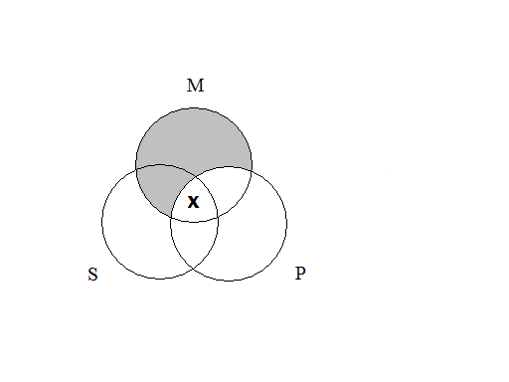

**2.** No M are P.

Some S are not M.

Some S are not P.

***Answer:*** Invalid

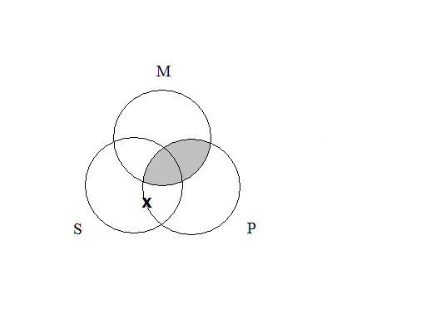

**3.** All P are M.

All S are M.

All S are P.

***Answer:*** Invalid

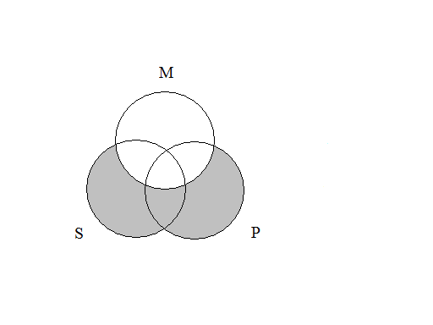

**4.** Some P are M.

Some S are M.

Some S are P.

***Answer:*** Invalid

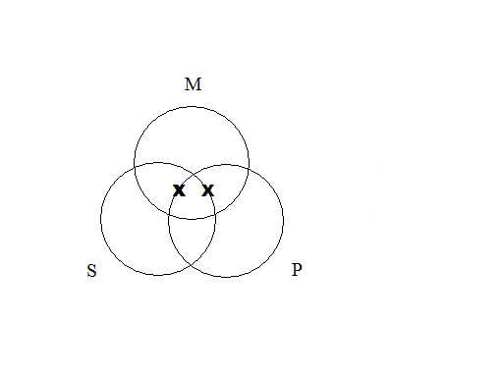

**5.** Some M are not P.

Some M are not S.

Some S are not P.

***Answer:*** Invalid

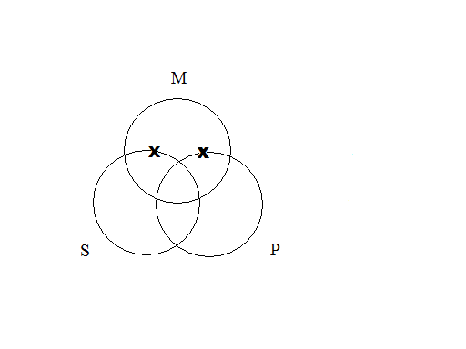

**6.** No P are M.

No M are S.

No S are P.

***Answer:*** Invalid

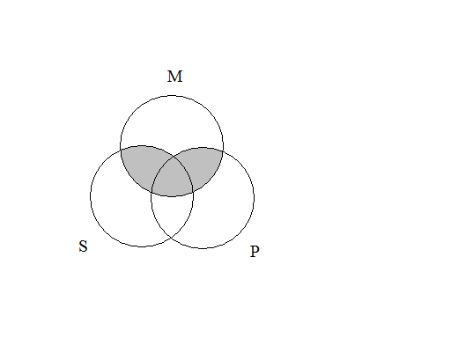

**7.** All P are M.

Some S are M.

All S are P.

***Answer:*** Invalid

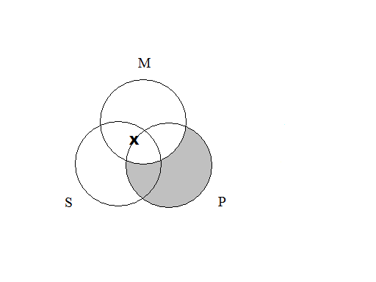

**8.** Some P are M.

Some M are not S.

Some S are not P.

***Answer:*** Invalid

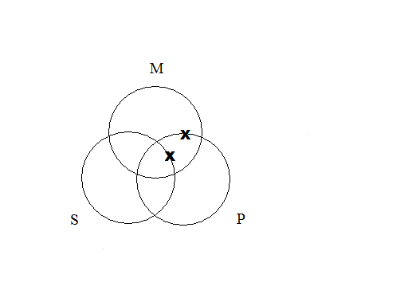

**9.** All M are P.

No S are M.

Some S are not P.

***Answer:*** Invalid

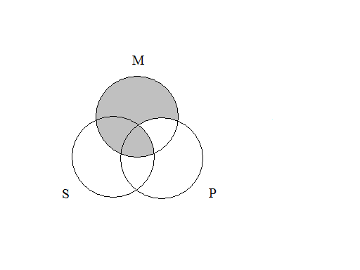

**10.** No M are P.

Some S are M.

Some S are P.

***Answer:*** Invalid

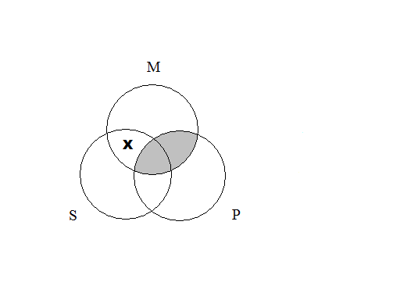

**11.** All M are P.

No S are M.

No S are P.

***Answer:*** Invalid



**12.** No P are M.

Some S are M.

Some S are not P.

***Answer:*** Valid



**13.** All M are P.

All S are M.

All S are P.

***Answer:*** Valid

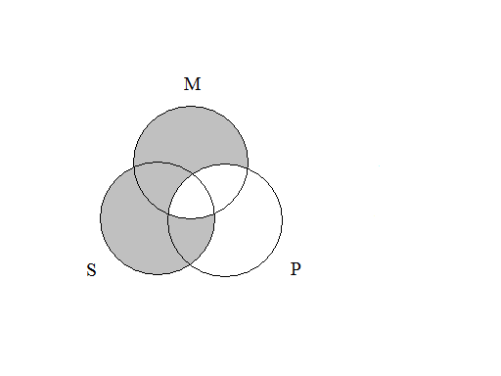

**14.** All M are P.

Some S are not M.

Some S are not P.

***Answer:*** Invalid

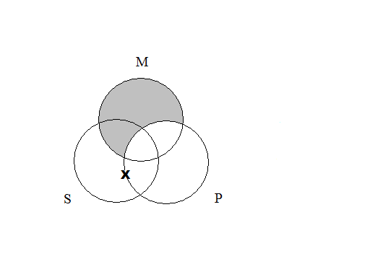

**15.** Some M are P.

All M are S.

Some S are P.

***Answer***: Valid

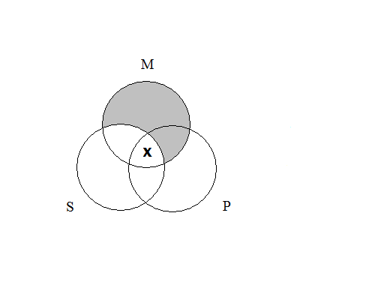

**16.** Some M are not P.

No S are M.

Some S are not P.

***Answer***: Invalid

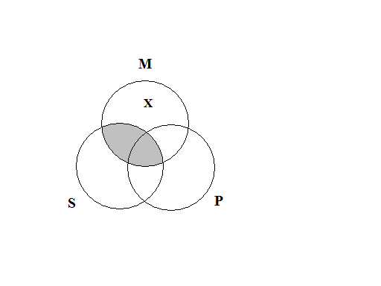

**17.**  All P are M.

No S are M.

All S are P.

***Answer***: Invalid

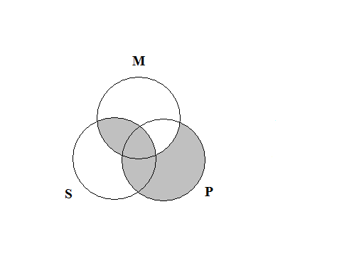

**18.** Some P are M.

Some S are not M.

Some S are P.

***Answer***: Invalid

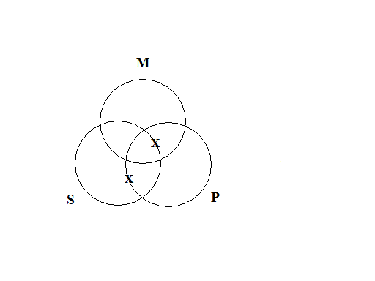

**19.** Some M are not P.

All M are S.

Some S are not P.

***Answer***: Valid

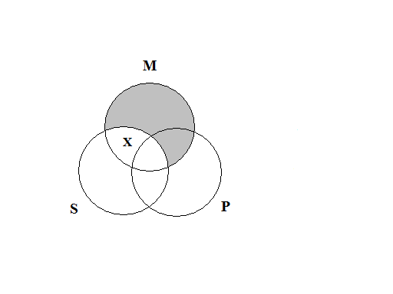

**20.** No P are M.

Some M are S.

No S are P.

***Answer***: Invalid

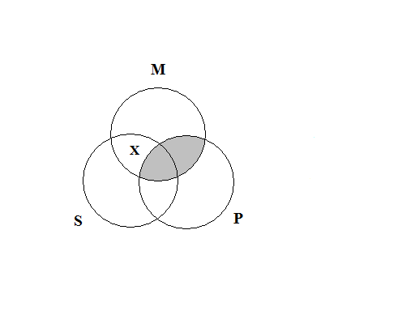

**21.** All P are M.

Some S are not M.

No S are P.

***Answer***: Invalid

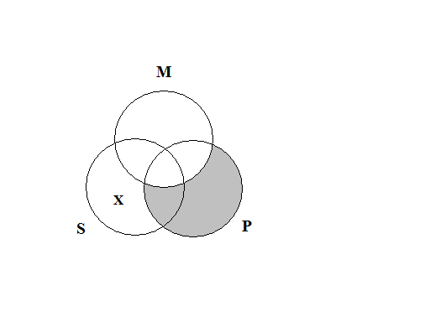

**22.** Some P are M.

Some M are S.

Some S are P.

***Answer***: Invalid

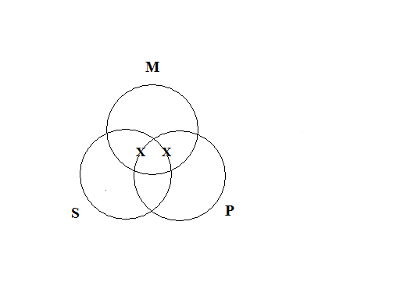

**23.** No M are P.

No S are M.

Some S are not P.

***Answer***: Invalid

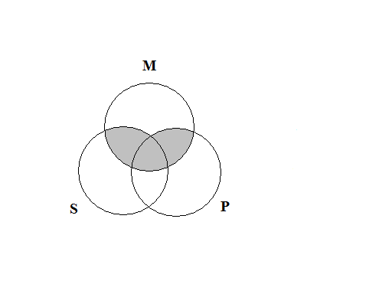

**24.** All M are P.

Some S are M.

Some S are P.

***Answer***: Valid

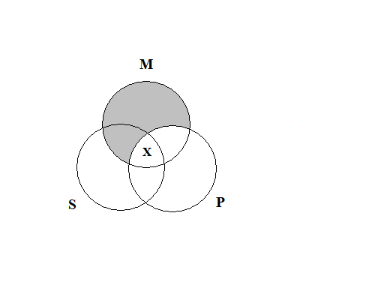

**25.** All M are P.

No S are M.

Some S are P.

***Answer***: Invalid

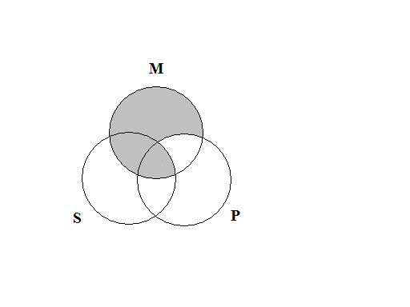

**26.**  All P are M.

Some S are M.

Some S are not P.

***Answer***: Invalid

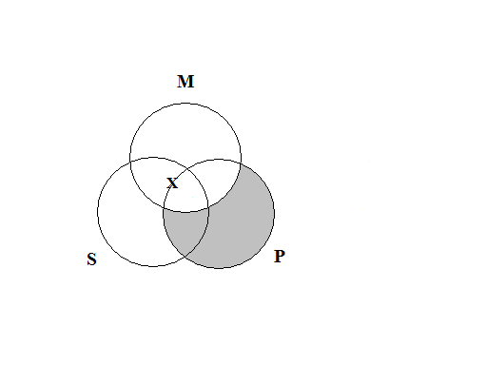

**27.**  All M are P.

Some S are not M.

No S are P.

***Answer***: Invalid

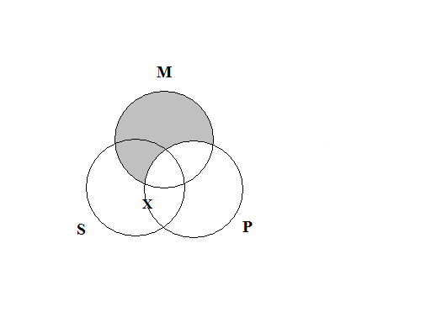

**28.** Some M are P.

Some S are not M.

Some S are not P.

***Answer***: Invalid

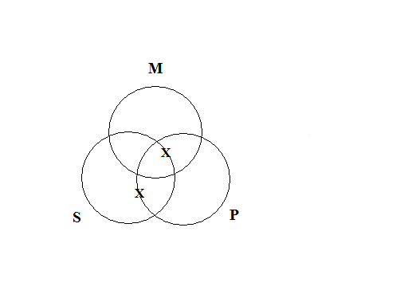

**29.**  No M are P.

All S are M.

All S are P.

***Answer***: Invalid

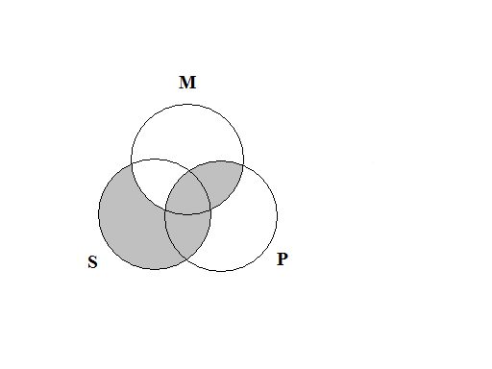

**30.** Some M are P.

Some S are not M.

Some S are P.

***Answer***: Invalid



**II.**

**1.** All fast-food items are overpriced objects. No overpriced objects are nutritious products. Therefore, no nutritious products are fast-food items.

***Answer:***Valid.

All F are O.

No O are N.

No N are F.

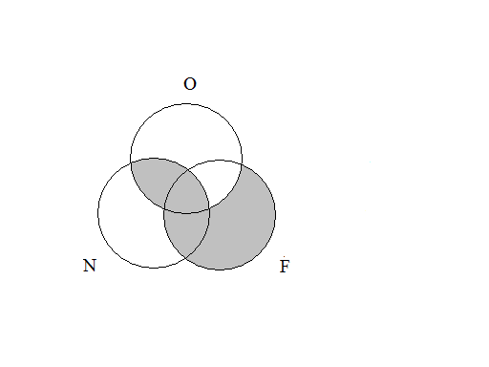

**2.** Some vegetables are not tasty foods. Therefore some tasty foods are not green foods, because some vegetables are not green foods.

***Answer:*** Invalid.

Some V are not G.

Some V are not T.

Some T are not G.

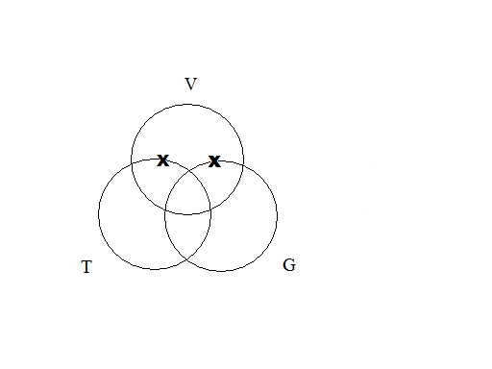

**3.** All mechanical objects are noisy objects. All airplanes are noisy objects. Thus, all airplanes are mechanical objects.

***Answer:*** Invalid.

All M are N.

All A are N.

All A are M.

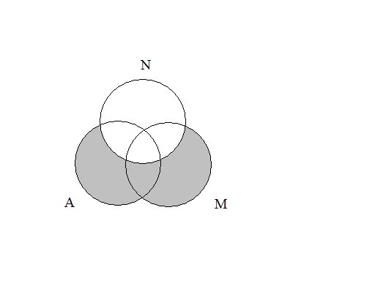

**4.** Some pens are not useful tools. This is because some pens are leaky writing implements, and no leaky writing implements are useful tools.

***Answer:***Valid.

No L are U.

Some P are L.

Some P are not U.

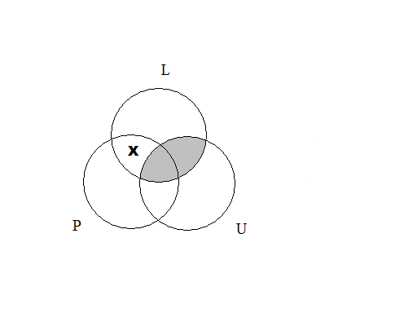

**5.** No septic tanks are swimming pools. No sewers are swimming pools. Therefore, no septic tanks are sewers.

***Answer:*** Invalid.

No W are P.

No S are P.

No S are W.

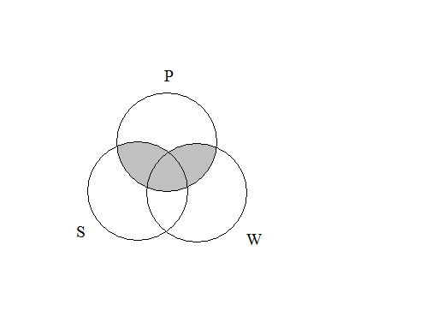

**6.** All voice messages are distracting pieces of information. Some games people play are distracting pieces of information. So, some voice messages are games people play.

***Answer:*** Invalid.

Some G are D.

All V are D.

Some V are G.

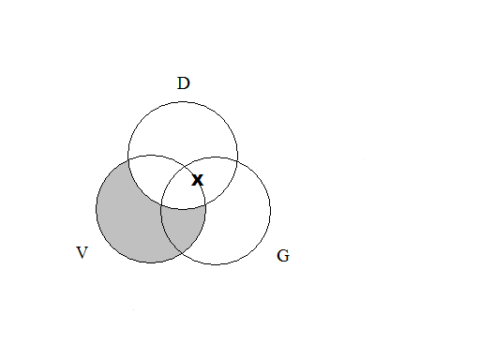

**7.** Some universities are not expensive places to attend. Some universities are conveniently located complexes. Thus, some expensive places to attend are not conveniently located complexes.

***Answer:*** Invalid.*.*

Some U are C.

Some U are not E.

Some E are not C.

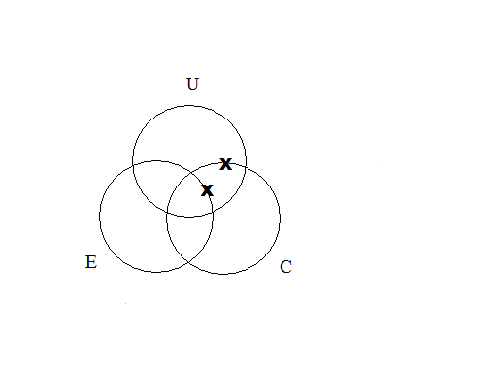

**8.** No sports fanatics are rational creatures. Therefore, no sports fanatics are benevolent people, since all rational creatures are benevolent people.

***Answer:*** Invalid.

All R are B.

No S are R.

No S are B.

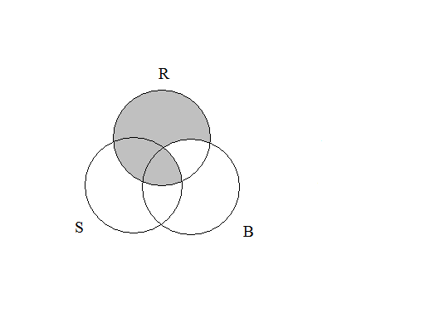

**9.** Some buildings are poorly constructed domiciles. Some buildings are architectural nightmares. So, some architectural nightmares are poorly constructed domiciles.

***Answer:*** Invalid.

Some B are P.

Some B are A.

Some A are P.

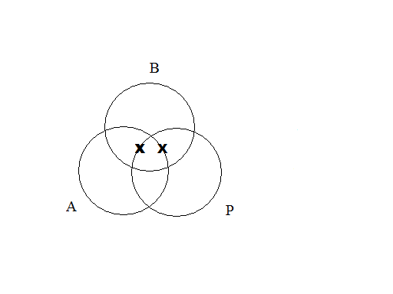

**10.** All sea creatures are intelligent animals. Some sea creatures are predators. So, some intelligent animals are predators.

***Answer:*** Valid.*.*

Some S are P.

All S are I.

Some I are P.

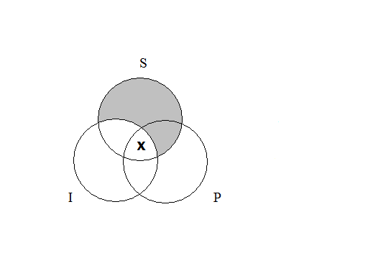

**III.**

**1.** **AAA-1**

***Answer:***Valid

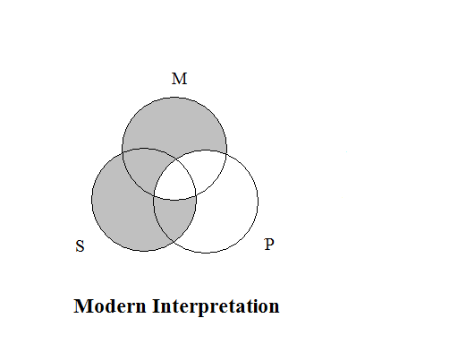

**2.** **AII-1**

***Answer:*** Valid

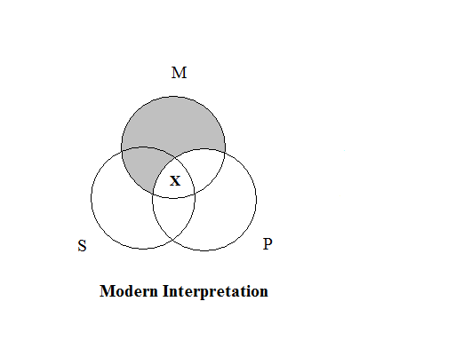

**3.** **EAE-1**

***Answer:*** Valid

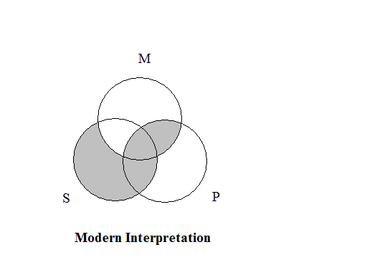

**4.** **EIO-1**

***Answer:*** Valid

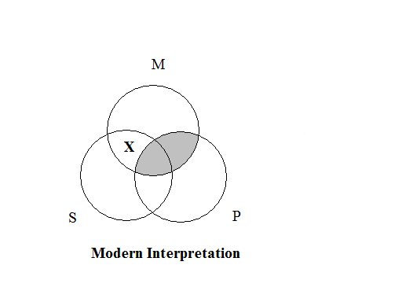

**5.** **AEE-2**

***Answer:*** Valid

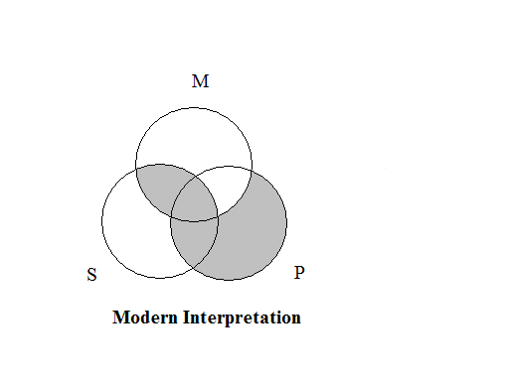

**6.** **AOO-2**

***Answer:*** Valid**.**

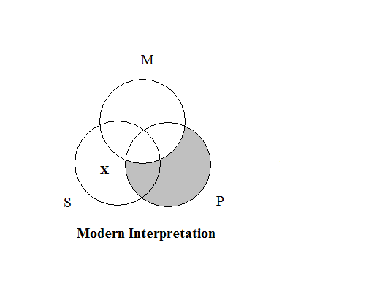

**7.** **EAE-2**

***Answer:*** Valid



**8.** **EIO-2**

***Answer:*** Valid



**9.** **AII-3**

***Answer:*** Valid



**10.** **EIO-3**

***Answer:*** Valid



**11.** **IAI-3**

***Answer:***Valid

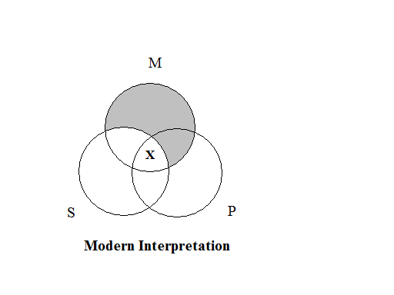

**12.** **OAO-3**

***Answer:*** Valid.

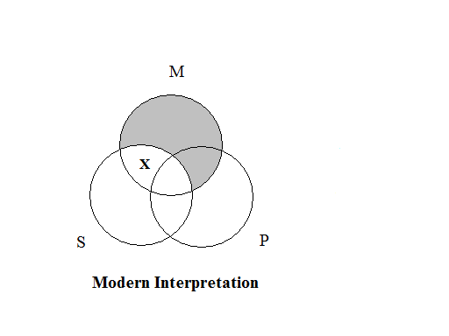

**13.** **AEE-4**

***Answer:*** Valid



**14.** **EIO-4**

***Answer:*** Valid



**15.** **IAI-4**

***Answer:*** Valid.



**IV.**

**1.** **AAI-1**

***Answer:*** Invalid under the modern interpretation.



**2.** **EAO-1**

***Answer:*** Invalid under the modern interpretation.



**3.** **AEO-2**

***Answer:*** Invalid under the modern interpretation.



**4.** **EAO-2**

***Answer:*** Invalid under the modern interpretation.



**5.** **AAI-3**

***Answer:*** Invalid under the modern interpretation.

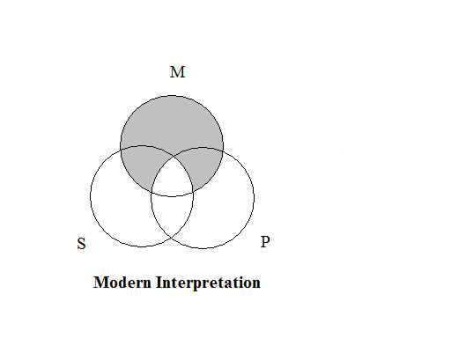

**6.**  **EAO-3**

***Answer:*** Invalid under the modern interpretation.

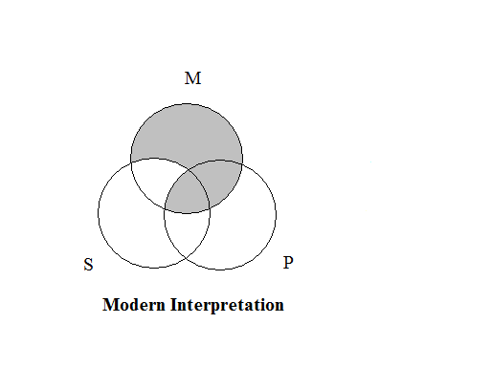

**7.**  **AAI-4**

***Answer:*** Invalid under the modern interpretation.

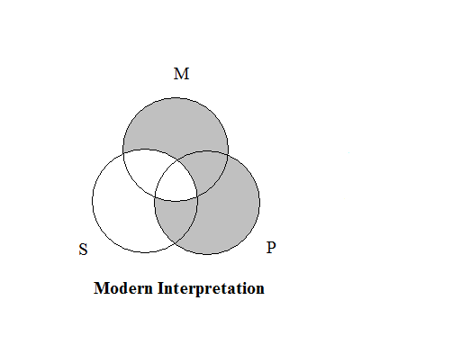

**8.**  **AEO-4**

***Answer:*** Invalid under the modern interpretation.



**9.** **EAO-4**

***Answer:*** Invalid under the modern interpretation.



***Exercises 6D***

**I.**

**1.** **AAA-1**

***Answer:*** All six rules are met.

Rule 1: The middle term is distributed in the first premise.

Rule 2: The major term is not distributed in the conclusion.

Rule 3: **AAA-1** does not have two negative premises.

Rule 4: **AAA-1** does not have a negative premise.

Rule 5: **AAA-1** does not have a negative conclusion.

Rule 6: **AAA-1** does not have universal premises and a particular conclusion.

**2.**  **AII-1**

***Answer:*** All six rules are met.

Rule 1: The middle term is distributed in the first premise.

Rule 2: The major term is not distributed in the conclusion.

Rule 3: It does not have two negative premises.

Rule 4: Itdoes not have a negative premise.

Rule 5: Itdoes not have a negative conclusion.

Rule 6: Itdoes not have universal premises and a particular conclusion.

**3.** **EAE-1**

***Answer:*** All six rules are met.

Rule 1: The middle term is distributed in the first premise.

Rule 2: The major term is distributed in the conclusion and the major premise.

Rule 3: It does not have two negative premises.

Rule 4: It has a negative premise and a negative conclusion.

Rule 5: It has a negative conclusion and a negative premise.

Rule 6: Itdoes not have universal premises and a particular conclusion.

**4.** **EIO-1**

***Answer:*** All six rules are met.

Rule 1: The middle term is distributed in the second premise.

Rule 2: The major term is distributed in the conclusion and in the major premise.

Rule 3: It does not have two negative premises.

Rule 4: Itdoes have a negative premise and a negative conclusion.

Rule 5: It does have a negative conclusion and a negative premise.

Rule 6: Itdoes not have universal premises and a particular conclusion.

**5.** **AEE-2**

***Answer:*** All six rules are met.

Rule 1: The middle term is distributed in the second premise.

Rule 2: The major term is distributed in the conclusion and in the major premise.

Rule 3: It does not have two negative premises.

Rule 4: It has a negative premise and a negative conclusion.

Rule 5: It has a negative conclusion and a negative premise.

Rule 6: It does not have universal premises and a particular conclusion.

**6.** **AOO-2**

***Answer:*** All six rules are met.

Rule 1: The middle term is distributed in the second premise.

Rule 2: The major term is distributed in the conclusion and in the major premise.

Rule 3: It does not have two negative premises.

Rule 4: It has a negative premise and a negative conclusion.

Rule 5: Ithas a negative conclusion and a negative premise.

Rule 6: Itdoes not have universal premises and a particular conclusion.

**7.** **EAE-2**

***Answer:*** All six rules are met.

Rule 1: The middle term is distributed in the first premise.

Rule 2: The major term is distributed in the conclusion and in the major premise.

Rule 3: It does not have two negative premises.

Rule 4: Ithas a negative premise and a negative conclusion.

Rule 5: Ithas a negative conclusion and a negative premise.

Rule 6: It does not have universal premises and a particular conclusion.

**8.** **EIO-2**

***Answer:*** All six rules are met.

Rule 1: The middle term is distributed in the first premise.

Rule 2: The major term is distributed in the conclusion and in the major premise.

Rule 3: It does not have two negative premises.

Rule 4: Ithas a negative premise and a negative conclusion.

Rule 5: Ithas a negative conclusion and a negative premise.

Rule 6: It does not have universal premises and a particular conclusion.

**9.** **AII-3**

***Answer:*** All six rules are met.

Rule 1: The middle term is distributed in the first premise.

Rule 2: The major term is not distributed in the conclusion.

Rule 3: It does not have two negative premises.

Rule 4: Itdoes not have a negative premise.

Rule 5: Itdoes not have a negative conclusion.

Rule 6: Itdoes not have universal premises and a particular conclusion.

**10.** **EIO-3**

***Answer:*** All six rules are met.

Rule 1: The middle term is distributed in the first premise.

Rule 2: The major term is distributed in the conclusion and in the major premise.

Rule 3: It does not have two negative premises.

Rule 4: It has a negative premise and a negative conclusion.

Rule 5: It has a negative conclusion and a negative premise.

Rule 6: It does not have universal premises and a particular conclusion.

**11.** **IAI-3**

***Answer:*** All six rules are met.

Rule 1: The middle term is distributed in the second premise.

Rule 2: The major term is not distributed in the conclusion.

Rule 3: It does not have two negative premises.

Rule 4: Itdoes not have a negative premise.

Rule 5: Itdoes not have a negative conclusion.

Rule 6: Itdoes not have universal premises and a particular conclusion.

**12.** **OAO-3**

***Answer:*** All six rules are met.

Rule 1: The middle term is distributed in the second premise.

Rule 2: The major term is distributed in the conclusion and in the major premise.

Rule 3: It does not have two negative premises.

Rule 4: It has a negative premise and a negative conclusion.

Rule 5: It has a negative conclusion and a negative premise.

Rule 6: Itdoes not have universal premises and a particular conclusion.

**13.** **AEE-4**

***Answer:*** All six rules are met.

Rule 1: The middle term is distributed in the second premise.

Rule 2: The major term is distributed in the conclusion and in the major premise.

Rule 3: It does not have two negative premises.

Rule 4: It has a negative premise and a negative conclusion.

Rule 5: It has a negative conclusion and a negative premise.

Rule 6: Itdoes not have universal premises and a particular conclusion.

**14.** **EIO-4**

***Answer:*** All six rules are met.

Rule 1: The middle term is distributed in the first premise.

Rule 2: The major term is distributed in the conclusion and in the major premise.

Rule 3: It does not have two negative premises.

Rule 4: It has a negative premise and a negative conclusion.

Rule 5: It has a negative conclusion and a negative premise.

Rule 6: It does not have universal premises and a particular conclusion.

**15. IAI-4**

***Answer:*** All six rules are met.

Rule 1: The middle term is distributed in the second premise.

Rule 2: The major term is not distributed in the conclusion.

Rule 3: It does not have two negative premises.

Rule 4: Itdoes not have a negative premise.

Rule 5: Itdoes not have a negative conclusion.

Rule 6: Itdoes not have universal premises and a particular conclusion.

**II.**

**1.** All cultures that venerate senior citizens are systems built on a strong tradition of philosophical inquiry. Some recently developed cultures are not systems built on a strong tradition of philosophical inquiry. Therefore, some recently developed cultures are not cultures that venerate senior citizens.

***Answer:***

All C are S.

Some R are not S.

Some R are not C.

**AOO-2.** Valid under the modern interpretation. No rules are broken.

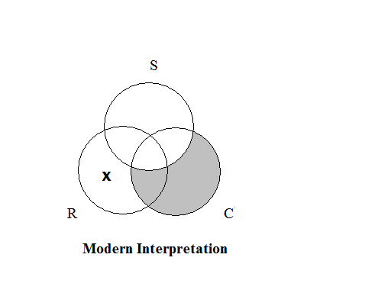

**2.** Some planets with oxygen are planets capable of sustaining life. Some planets outside our solar system are planets with oxygen. So, some planets outside our solar system are planets capable of sustaining life.

***Answer:***

Some O are L.

Some S are O.

Some S are L.

**III-1. Invalid. Rule 1 is broken: The middle term is not distributed in at least one premise.**

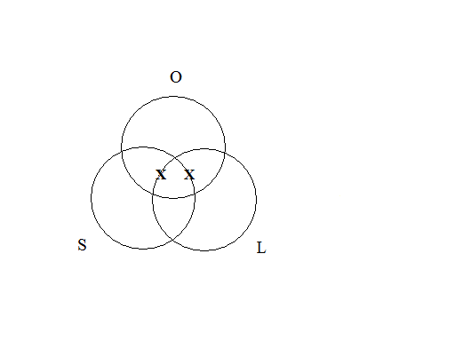

**3.** All great works of literature are creative illuminations of the human predicament. Thus, no pulp fiction novels are great works of literature, because no pulp fiction novels are creative illuminations of the human predicament.

***Answer:***

All G are C.

No P are C.

No P are G.

**AEE-2. Valid. No rules are broken.**

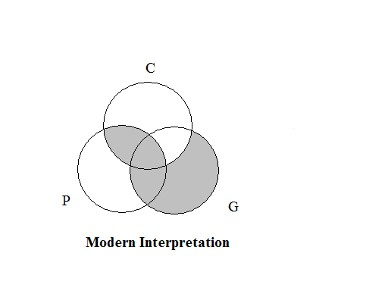

**4.** All natural disasters are scientifically explainable phenomena. Some human maladies are scientifically explainable phenomena. Thus, some human maladies are natural disasters.

***Answer:***

All N are S.

Some H are S.

Some H are N.

**AII-2. Invalid. Rule 1 is broken: The middle term is not distributed in at least one premise.**

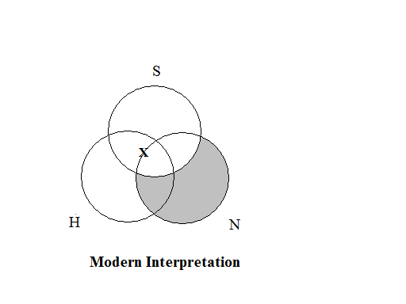

**5.** Some furry creatures are lovable pets. Some eccentric people are lovable pets. So, some eccentric people are furry creatures.

***Answer:***

Some F are L.

Some E are L.

Some E are F.

**III-2. Invalid.**

**Rule 1 is broken: The middle term is not distributed in at least one premise.**

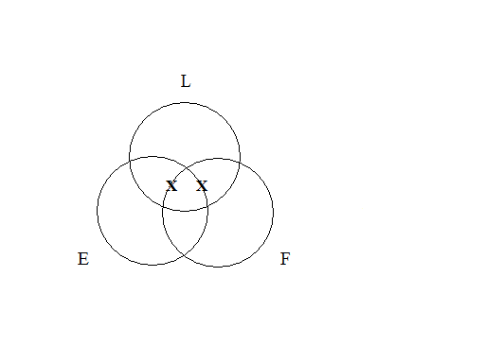

***Exercises 6E***

**I.**

**1.** No M are P.

Some S are not M.

Some S are not P.

***Answer:*** Invalid

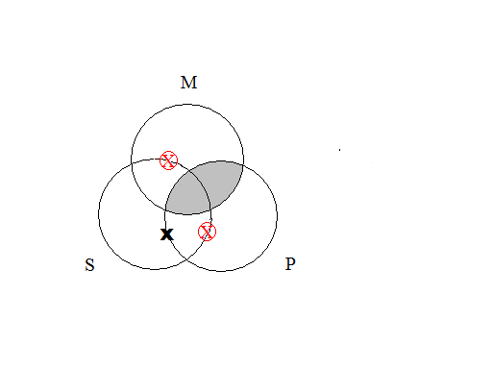

**2.** All M are P.

Some M are S.

Some S are P.

***Answer:*** Valid

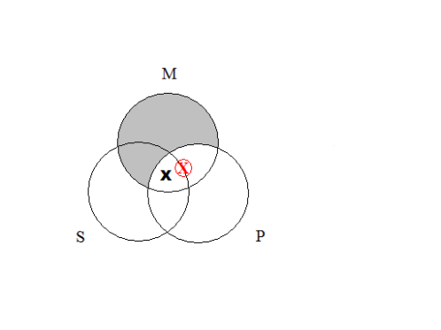

**3.** All P are M.

All S are M.

Some S are P.

***Answer:*** Invalid

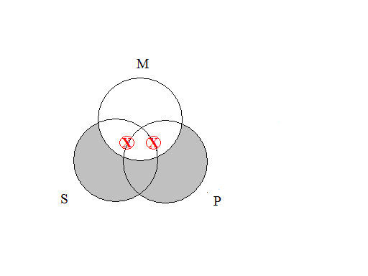

**4.** Some P are M.

All S are M.

Some S are P.

***Answer:*** Invalid

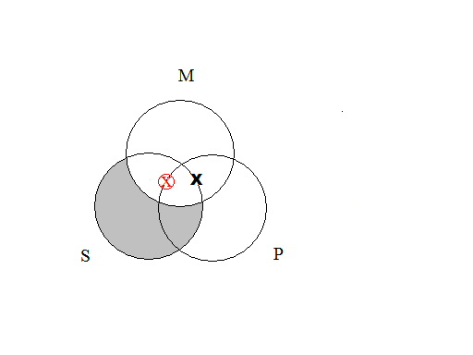

**5.** Some M are not P.

No M are S.

Some S are not P.

***Answer:*** Invalid

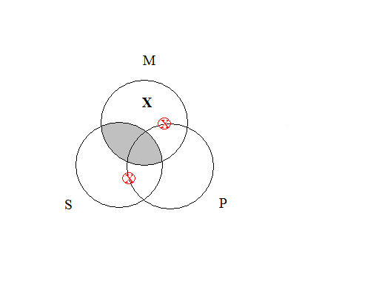

**6.** No P are M.

No M are S.

Some S are not P.

***Answer:*** Invalid

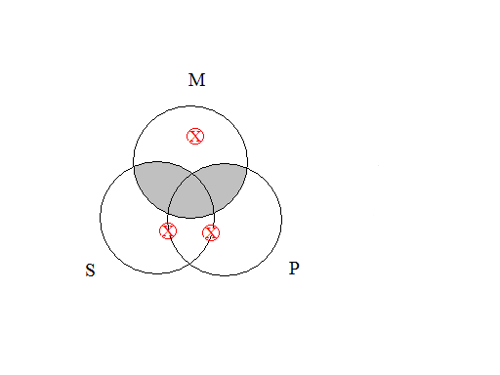

**7.** All P are M.

Some S are M.

Some S are P.

***Answer:*** Invalid

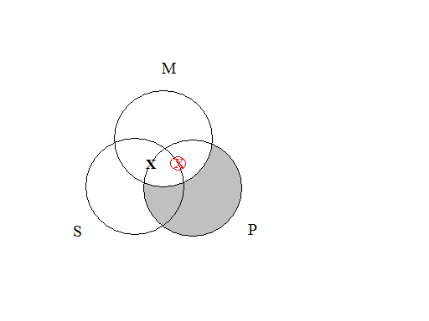

**8.** All P are M.

Some M are not S.

Some S are not P.

***Answer:*** Invalid

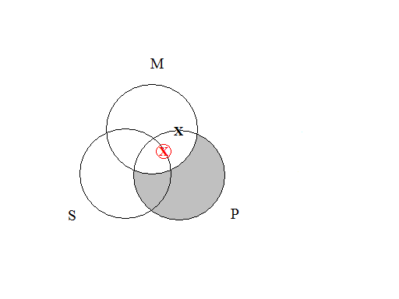

**9.** All M are P.

No S are M.

Some S are not P.

***Answer:*** Invalid

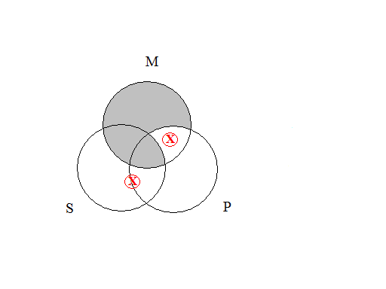

**10.** No M are P.

Some S are M.

Some S are P.

***Answer:*** Invalid

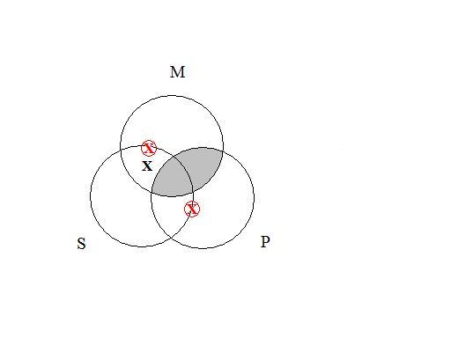

**11.** All M are P.

No S are M.

Some S are not P.

***Answer:*** Invalid

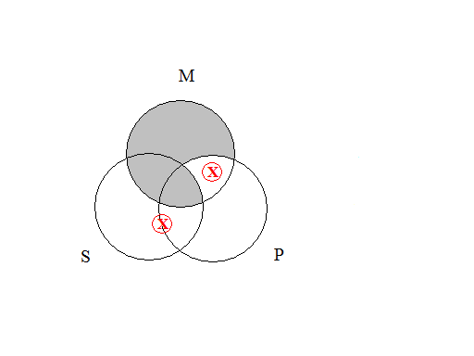

**12.** No P are M.

Some S are M.

Some S are not P.

***Answer:*** Valid

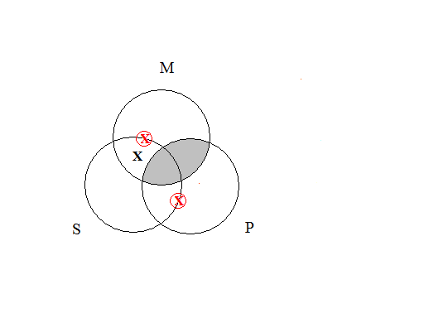

**13.** All M are P.

All S are M.

Some S are not P.

***Answer:*** Invalid

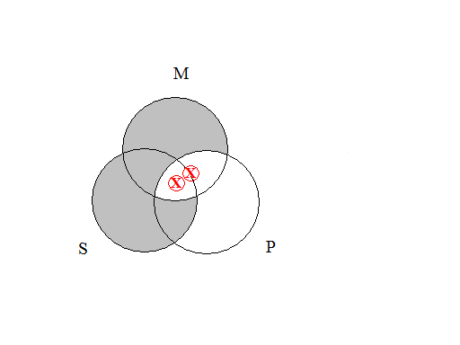

**14.** All M are P.

Some S are not M.

Some S are not P.

***Answer:*** Invalid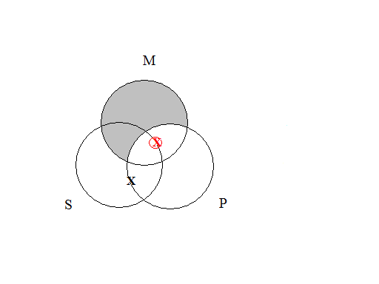

**II.**

**1.** All fast-food items are overpriced objects. No overpriced objects are nutritious products. Therefore, some nutritious products are not fast-food items.

***Answer: Valid***

All F are O.

No O are N.

Some N are not F.

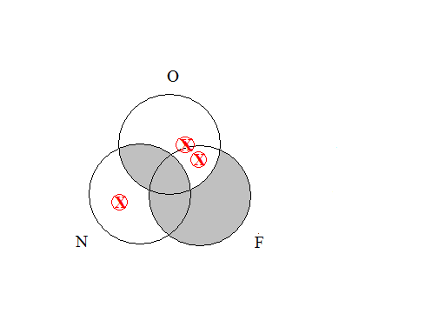

**2.** Some vegetables are not tasty foods. So some tasty foods are not green foods, because no vegetables are green foods.

***Answer:***Invalid.

No V are G.

Some V are not T.

Some T are not G.

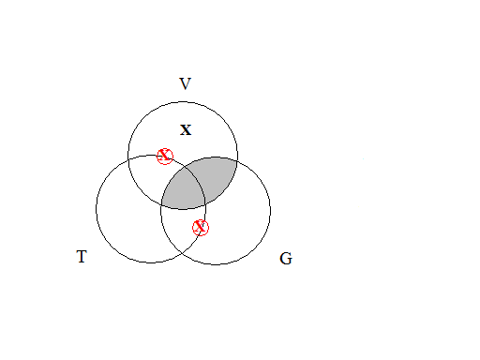

**3.** All mechanical objects are noisy objects. All airplanes are noisy objects. Thus, some airplanes are mechanical objects.

***Answer:***Invalid.

All M are N.

All A are N.

Some A are M.

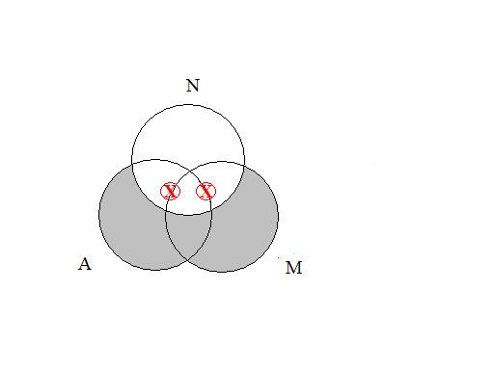

**4.** Some pens are not useful tools. This is because some pens are leaky writing implements, and no leaky writing implements are useful tools.

***Answer:***Valid.

No L are U.

Some P are L.

Some P are not U.

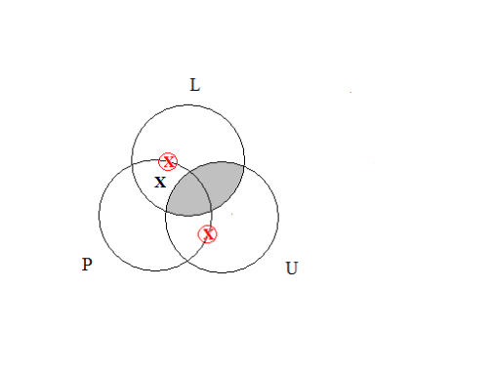

**5.** No septic tanks are swimming pools. No sewers are swimming pools. Therefore, some septic tanks are not sewers.

***Answer:***Invalid.

No W are P.

No S are P.

Some S are not W.

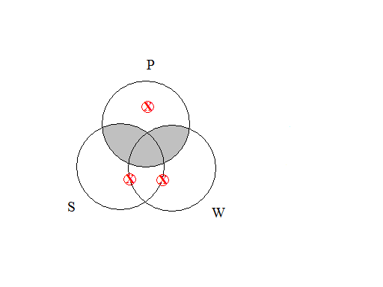

**6.** All voice messages are distracting pieces of information. Some games people play are distracting pieces of information. So, some voice messages are games people play.

***Answer:***Invalid.

Some G are D.

All V are D.

Some V are G.

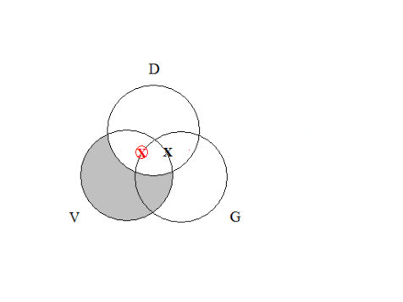

**7.** Some universities are not expensive places to attend. No universities are conveniently located complexes. Thus, some expensive places to attend are not conveniently located complexes.

***Answer:***Invalid.

No U are C.

Some U are not E.

Some E are not C.

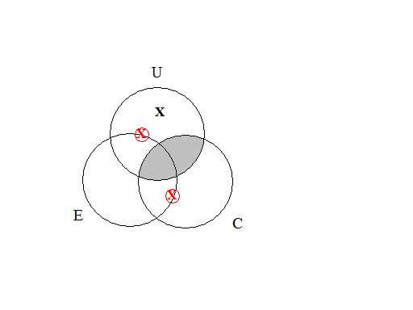

**8.** Some sports fanatics are rational creatures. Therefore, some sports fanatics are benevolent people, since all rational creatures are benevolent people.

***Answer:***Valid.

All R are B.

Some S are R.

Some S are B.

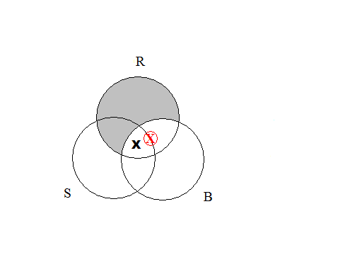

**9.** Some buildings are poorly constructed domiciles. No buildings are architectural nightmares. So, some architectural nightmares are poorly constructed domiciles.

***Answer:*** Invalid.

Some B are P.

No B are A.

Some A are P.

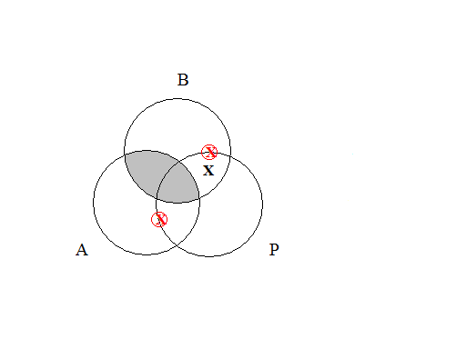

**10.** All sea creatures are intelligent animals. Some sea creatures are predators. So, some intelligent animals are predators.

***Answer:***Valid.

Some S are P.

All S are I.

Some I are P.

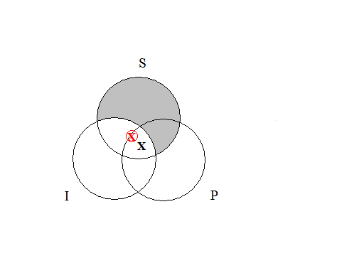

**III.**

**1.** **AAA-1**

***Answer:***Valid

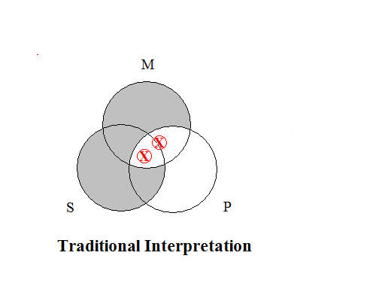

**2.** **AII-1**

***Answer:*** Valid

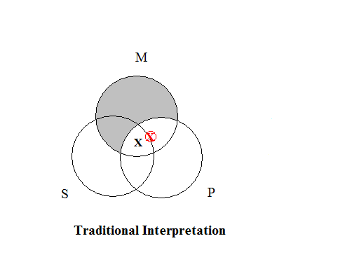

**3.** **EAE-1**

***Answer:*** Valid

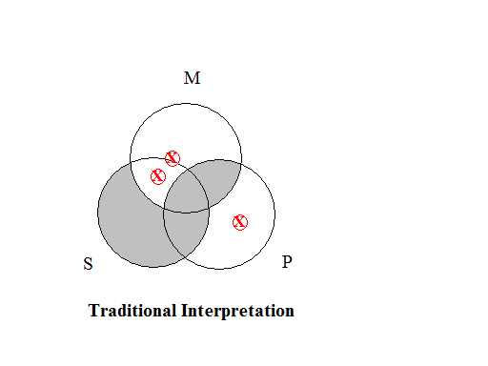

**4.** **EIO-1**

***Answer:*** Valid

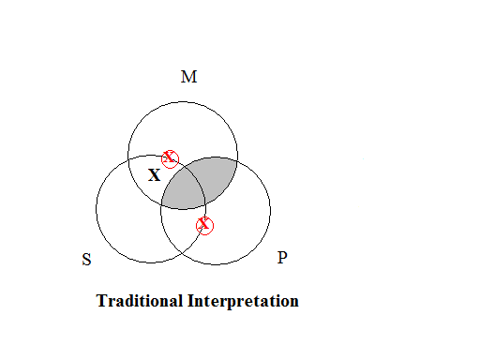

**5.** **AEE-2**

***Answer:*** Valid

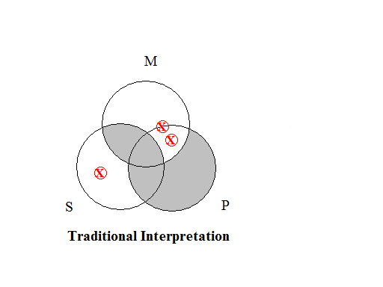

**6.** **AOO-2**

***Answer:*** Valid

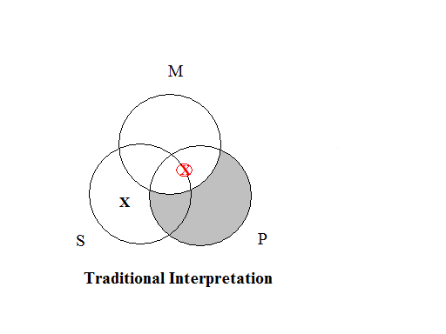

**7.** **EAE-2**

***Answer:*** Valid



**8.** **EIO-2**

***Answer:*** Valid



**9.** **AII-3**

***Answer:*** Valid



**10.** **EIO-3**

***Answer:*** Valid



**11.** **IAI-3**

***Answer:***Valid

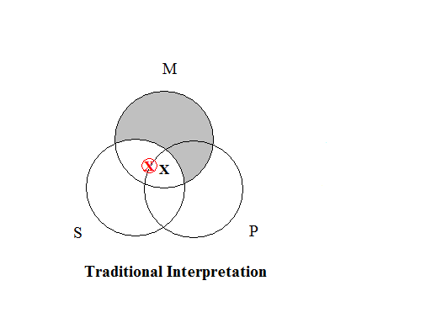

**12.** **OAO-3**

***Answer:*** Valid

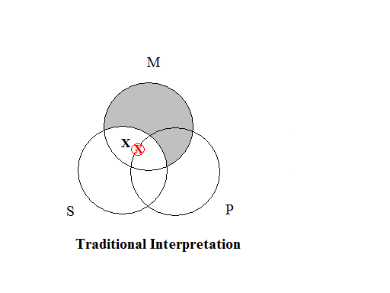

**13.** **AEE-4**

***Answer:*** Valid

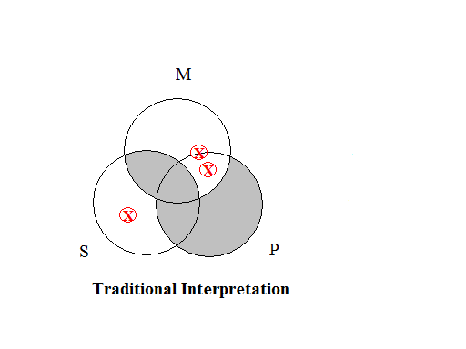

**14.** **EIO-4**

***Answer:*** Valid



**15.** **IAI-4**

***Answer:*** Valid



**IV.**

**1.** **AAI-1**

***Answer:*** Provisionally valid under the traditional interpretation.



**2.** **EAO-1**

***Answer:*** Provisionally valid under the traditional interpretation.



**3.** **AEO-2**

***Answer:*** Provisionally valid under the traditional interpretation.



**4.** **EAO-2**

***Answer:*** Provisionally valid under the traditional interpretation.



**5.** **AAI-3**

***Answer:*** Provisionally valid under the traditional interpretation.

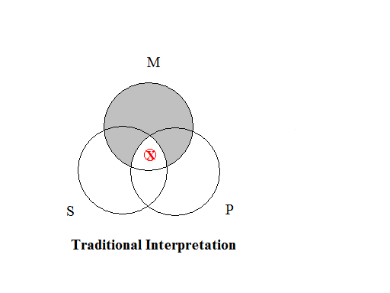

**6.**  **EAO-3**

***Answer:*** Provisionally valid under the traditional interpretation.

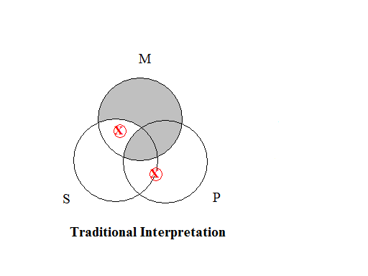

**7.**  **AAI-4**

***Answer:*** Provisionally valid under the traditional interpretation.

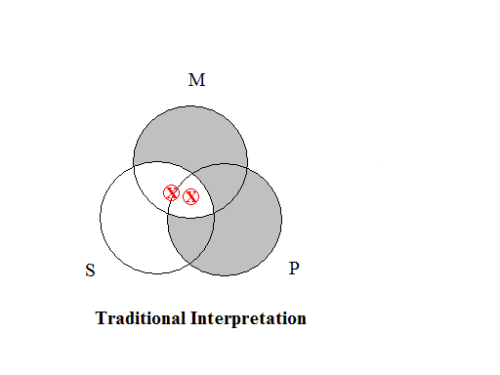

**8.**  **AEO-4**

***Answer:*** Provisionally valid under the traditional interpretation.



**9.** **EAO-4**

***Answer:*** Provisionally valid under the traditional interpretation.

