1. Implement the Logistic Regression with new data set which is not used in class

1a. Show the graph in TensorBoard

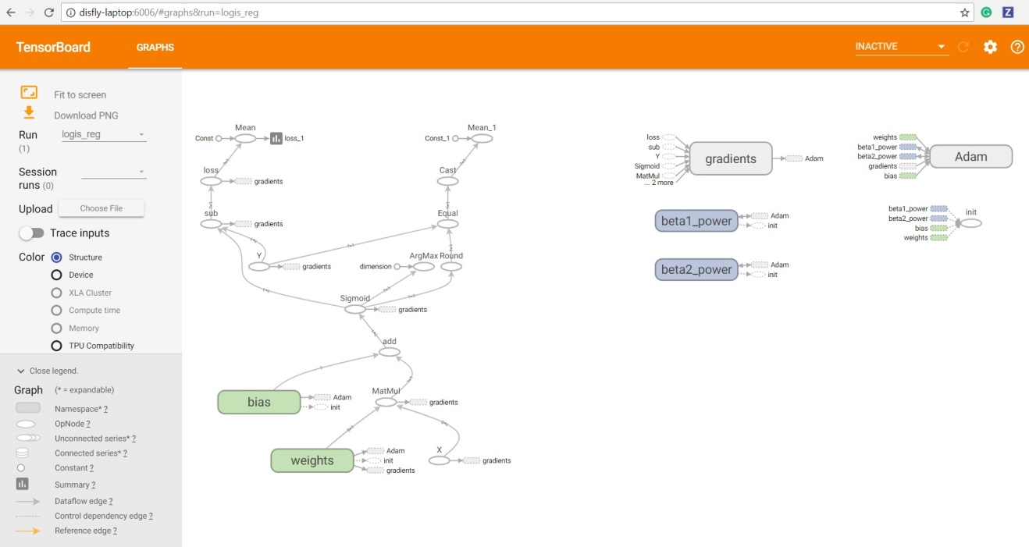

Accuracy = 0.98050976

1b. Change the hyperparameter and compare the result

**Using different optimizers to check the loss change with respect to Epoch(50)**

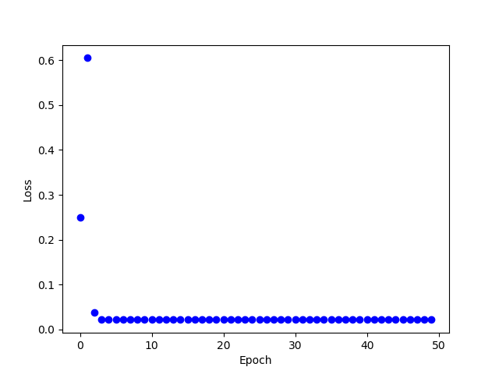 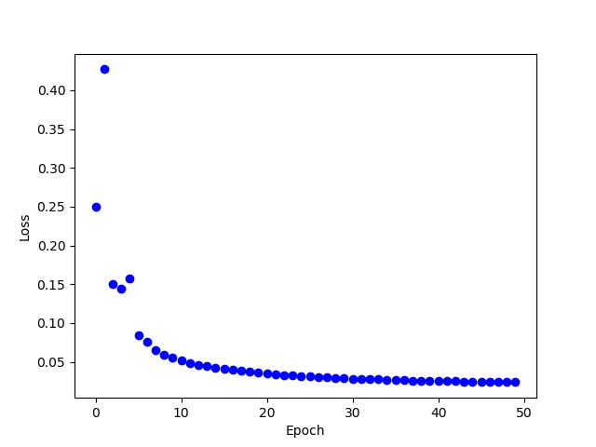

‘

GradientDescentOptimizer RMSPropOptimizer

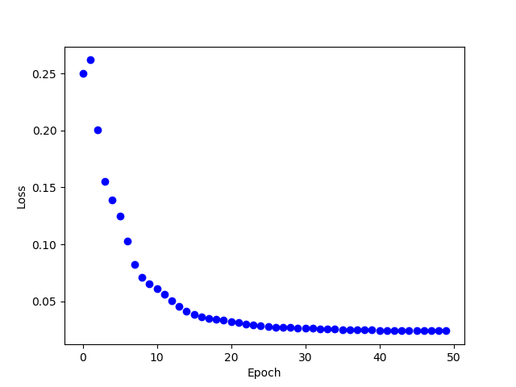 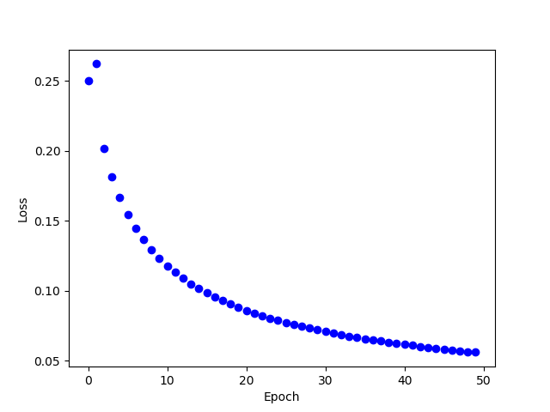

AdamOptimizer AdagradOptimizer

Analysis: RMSPropOptimizer reduce the loss at fast speed

**Using different learning rates (0.0001, 0.0005, 0.001, 0.005) to check the loss change with respect to Epoch(50).**

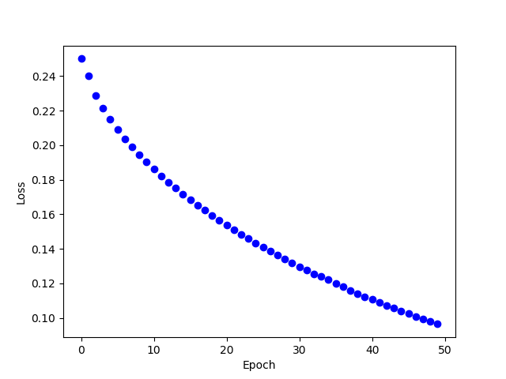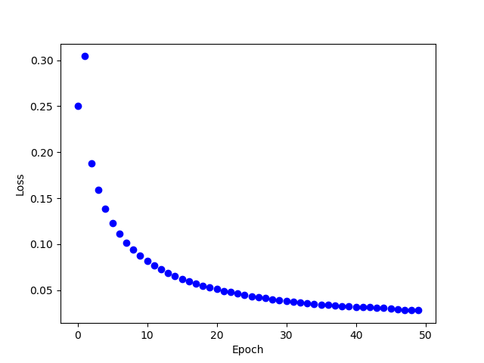

Learning Rate=0.0001 Learning Rate=0.0005

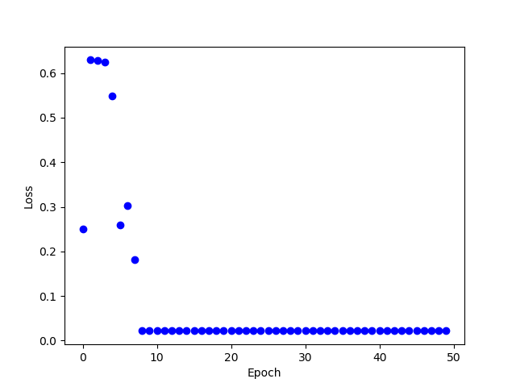

Learning Rate=0.001 Learning Rate=0.005

Analysis: Learning rate from 0.0005-0.001 for reducing the loss.