Datacenter Network Simulator — User Guide
This guide walks through running a simulation end to end: load a topology, bind device IPs, start each protocol simulator (SNMP, gNMI, BACnet, Redfish), then use the trap, metric-tick, console, graph-layer, and live-metrics features.
The workflow is sequential — bind IPs before starting any simulator, and generate datasets before starting SNMP/gNMI. Top-bar badges (Devices, SNMP, gNMI, BACnet, Redfish) show each subsystem's state (idle / ready / running).

Step 1 — Load a Topology
Open File ▸ Open Topology and pick a topology JSON (e.g. dual_dc_enterprise.json or demo_single_dc.json). New / Save / Close / Export as JSON live in the same menu.
When nothing is loaded the canvas shows *No topology loaded*; the device list and graph populate once a file opens.
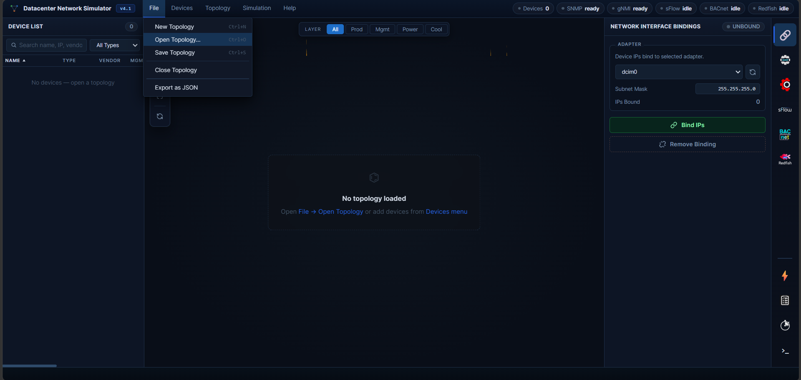
File ▸ Open Topology — empty canvas before a topology is loaded

Step 2 — Bind IPs
Open the Network Interface Bindings panel (right side). Pick the network adapter (Windows: *Microsoft KM-TEST Loopback*; Linux: dcim0), confirm the subnet mask, then click Bind IPs. The simulator assigns one virtual IP per device onto the adapter. Remove Binding tears them down.
Binding must succeed before any protocol simulator can serve traffic — each simulated device listens on its own bound IP.
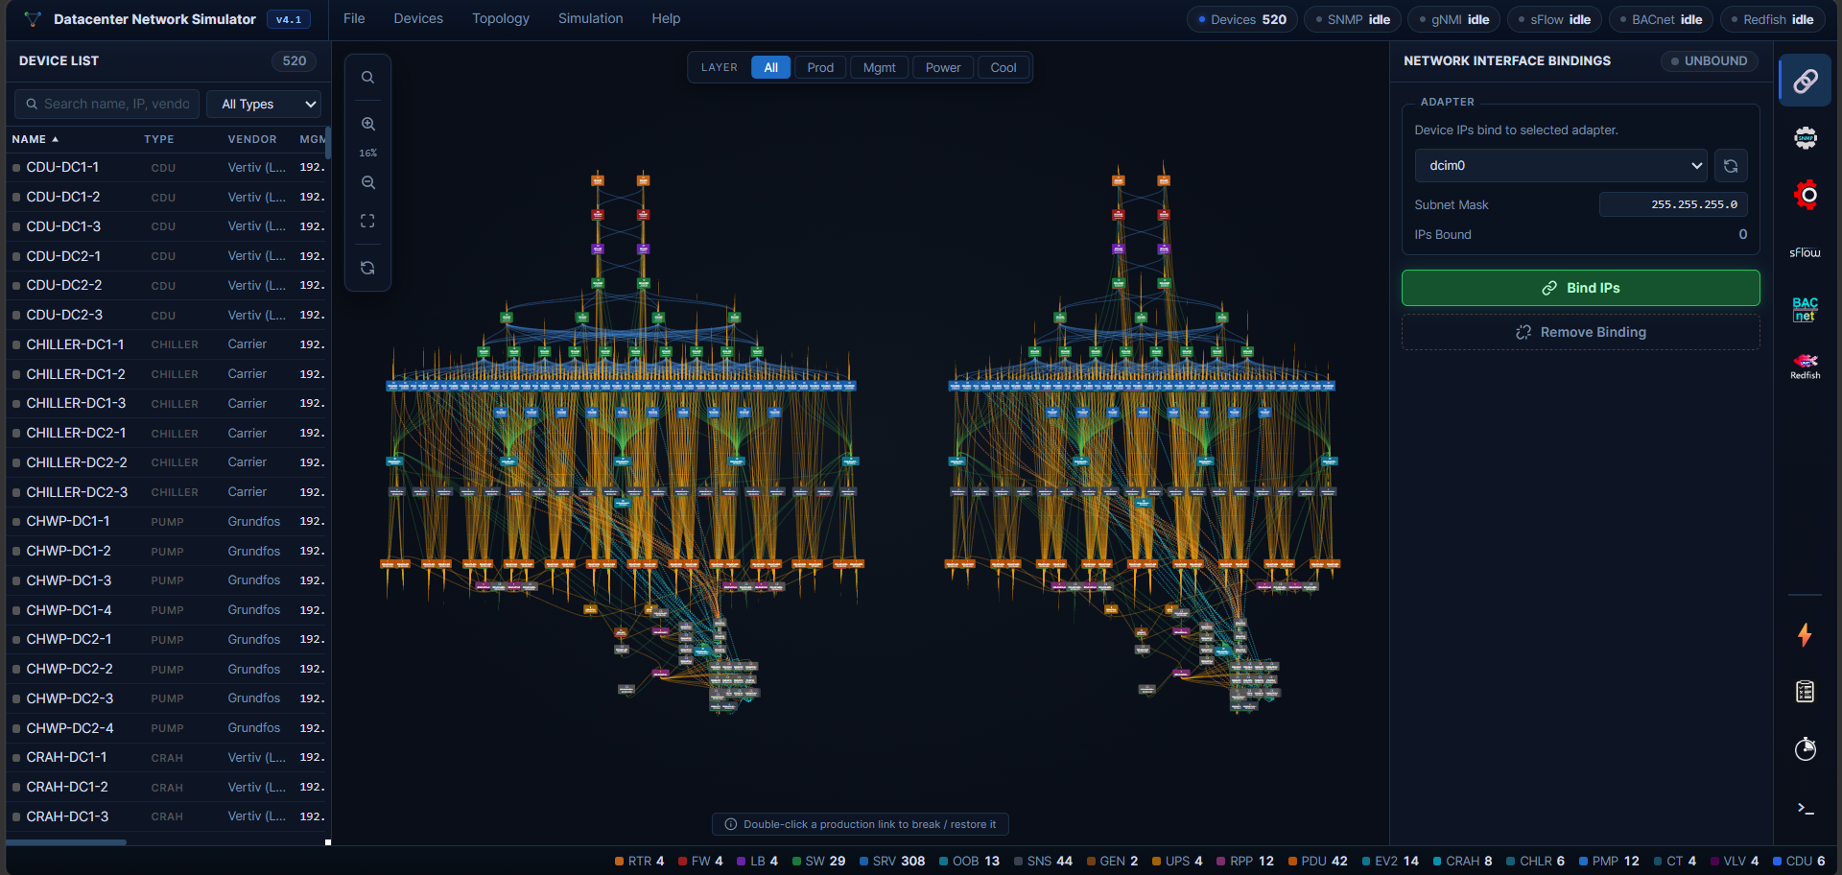
Network Interface Bindings — select adapter and click Bind IPs

Step 3 — Start the SNMP Simulator
Open the SNMP Simulator panel. It lists how many devices of each type will be simulated and the Port Configuration (SNMP port 161, management/SET port 1161).
3.1 — Generate datasets. Click Generate Datasets to build the per-device SNMP data (.snmprec) from the topology.
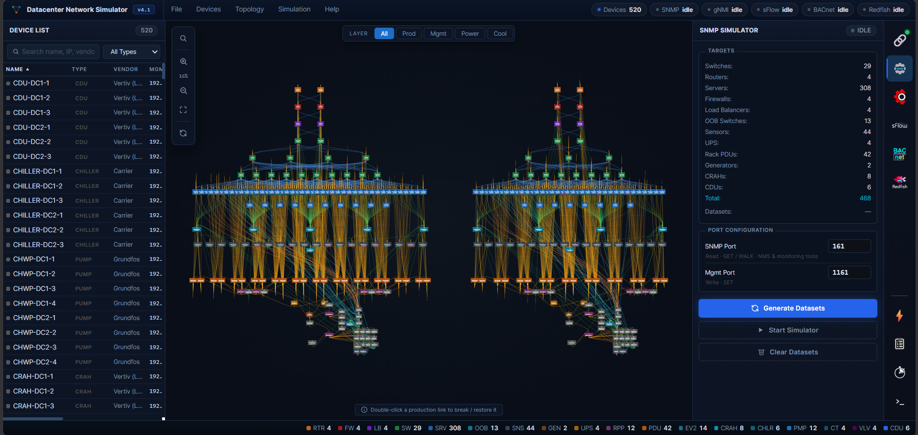
SNMP Simulator — Generate Datasets builds per-device SNMP data
3.2 — Start the simulator. Once datasets are READY, click Start Simulator. Use Regenerate Datasets to rebuild after topology changes, or Close Datasets to discard them.
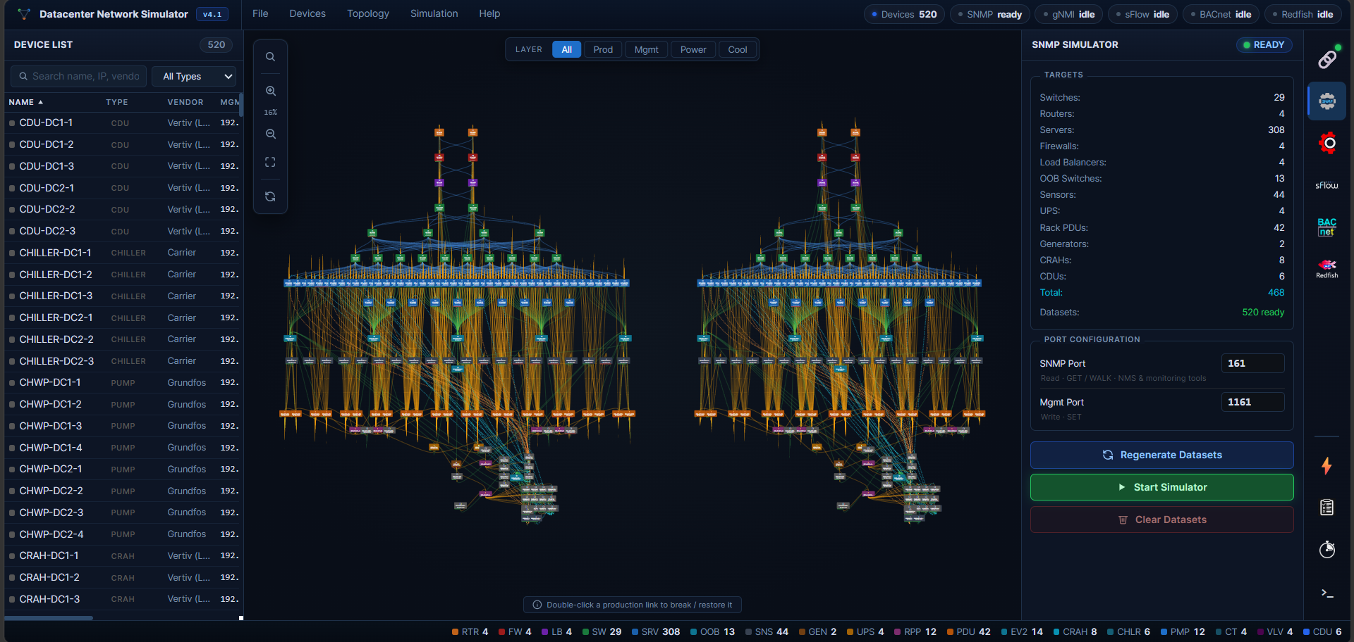
SNMP Simulator — READY; click Start Simulator

Step 4 — Start the gNMI Simulator
Open the gNMI Simulator panel (gNMI port 57400). Generate datasets, then Start Simulator. gNMI is the streaming-telemetry interface for the network devices. Optionally Enable Proxy on the configured proxy port to aggregate device gNMI endpoints behind a single port.
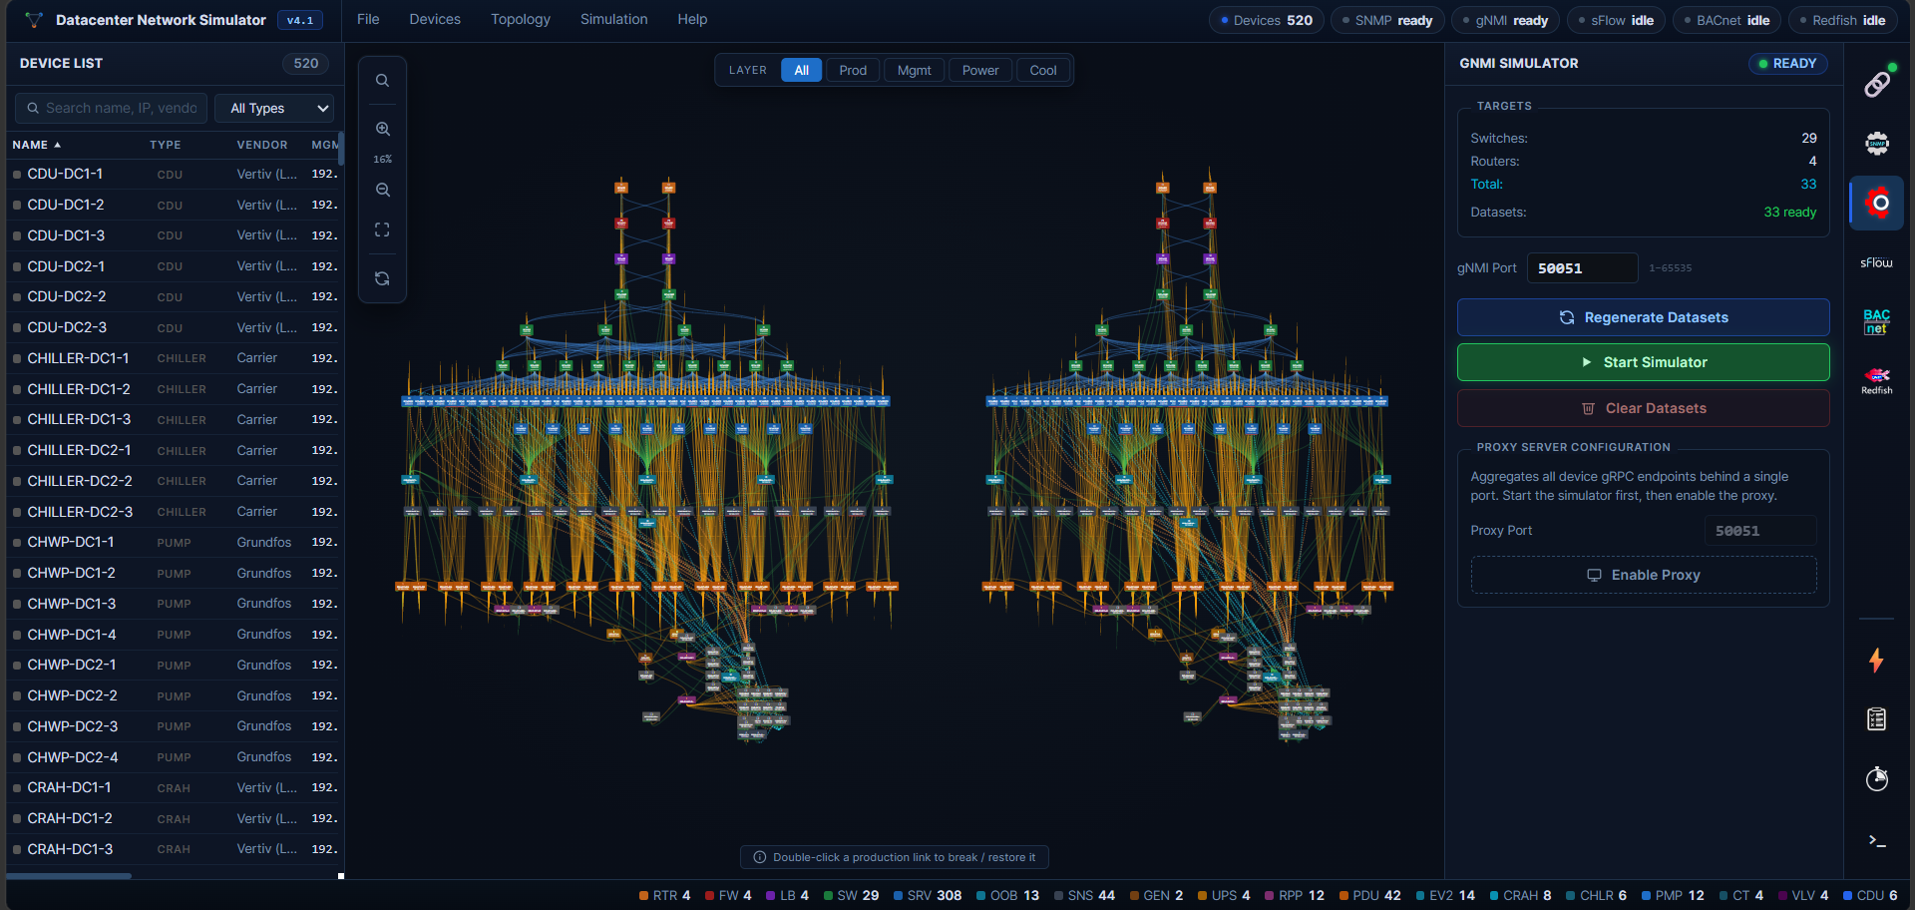
gNMI Simulator — Generate Datasets then Start Simulator; optional proxy

Step 5 — Start the BACnet Simulator
Open the BACnet Simulator panel — this models the mechanical / facility devices (chillers, CRAHs, CDUs, pumps, cooling towers, valves, plant sensors) over BACnet/IP on UDP port 47808 (BAC0). Set the Base Instance and Name Template, review the target device counts, then click Start BACnet.
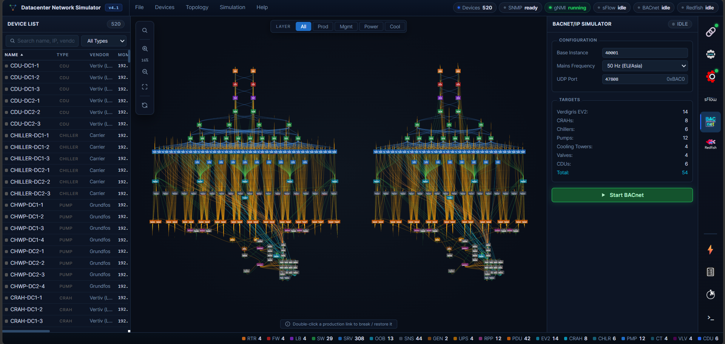
BACnet Simulator — facility devices over BACnet/IP (UDP 47808)

Step 6 — Start the Redfish Simulator
Open the Redfish Simulator panel — the modern server-management interface (DMTF Redfish over HTTPS, port 8443). Set the Username / Password, then click Start Redfish. Each simulated server exposes a Redfish service root for out-of-band (BMC) management.
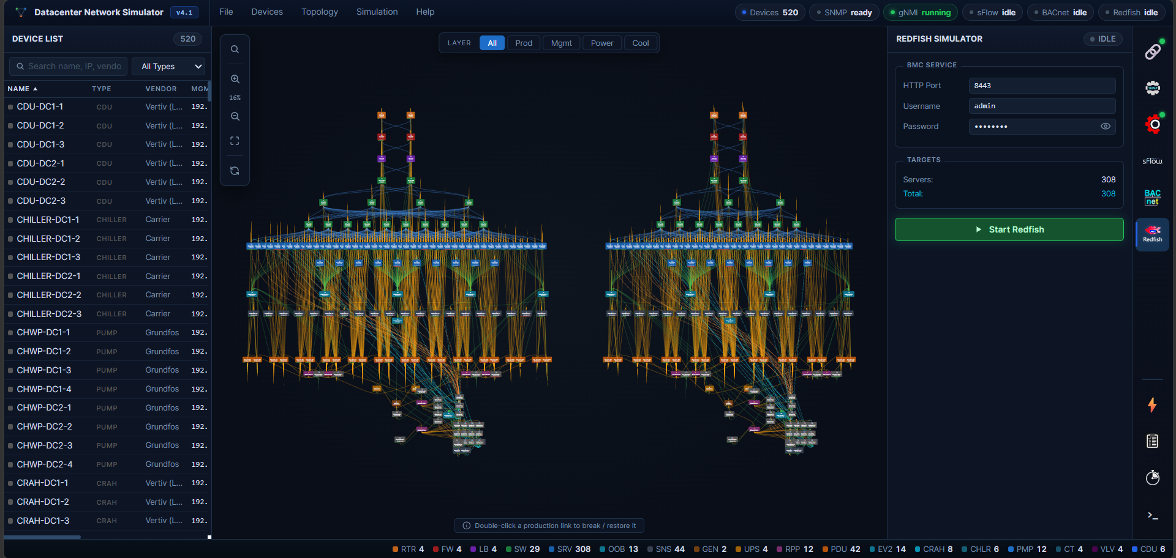
Redfish Simulator — server BMC management over HTTPS (port 8443)

Enable Trap Simulation (optional)
Open the SNMP Traps panel. Set the Trap Receiver (destination IP:port) and click Set Receiver, then toggle Trap Simulation on. The simulator emits SNMP traps to the receiver; the panel logs each trap it sends.
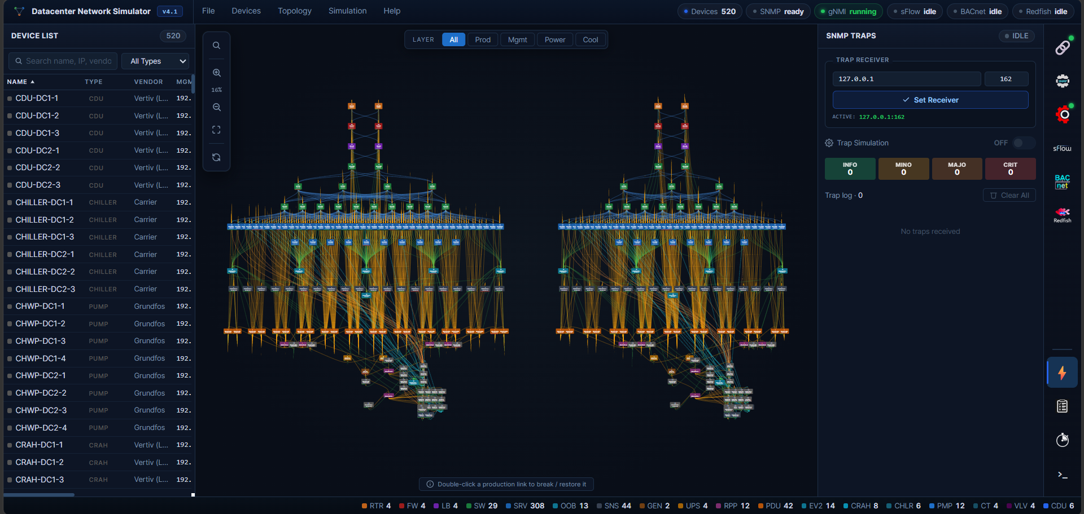
SNMP Traps — set receiver and toggle trap simulation

Enable / Disable Trap Rules
Open the Traps Rule Engine. Rules are grouped (Interface/Link, CPU, Memory, Power/UPS, …); each has a checkbox to enable/disable it and a threshold. Use the per-rule toggles to control which conditions generate traps, and Reset Counts to clear the per-rule fire counters.
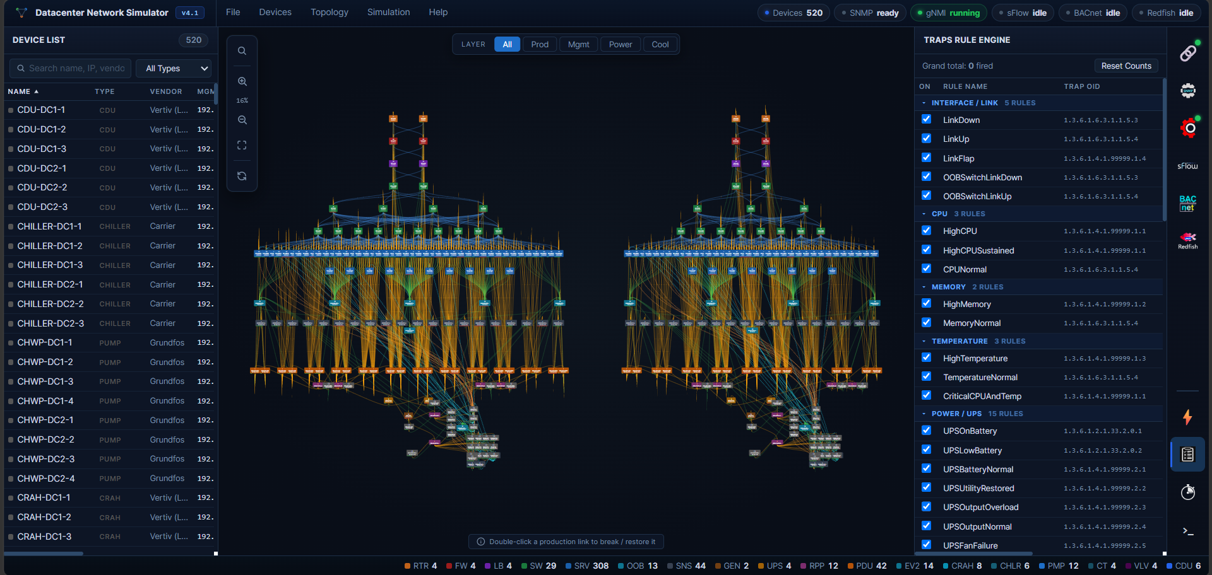
Traps Rule Engine — enable/disable individual rules and thresholds

Metric Tick — Interval, Per-Metric Toggles, Limits
The Metric Tick panel drives how simulated metrics evolve over time.
Metrics tab — set the Tick Interval (seconds), toggle the engine Enabled, and enable/disable individual metrics per device class (CPU usage, memory, temperatures, interface counters; sensor temp/humidity; UPS load/battery, …). Click Apply.
!Metric Tick (Metrics) — tick interval and per-metric enable toggles.png)
Limits tab — bound each metric to a min/max range per device type so simulated values stay realistic. Click Apply to commit.
!Metric Tick (Limits) — clamp each metric to a min/max range.png)

Monitor the Console
The Console panel streams runtime logs, tabbed by subsystem (Boot/Simulator, gNMI, BACnet, Redfish). Use Auto-Scroll to follow live output and Clear to reset. This is the first place to look when a simulator fails to start or a dataset build errors.
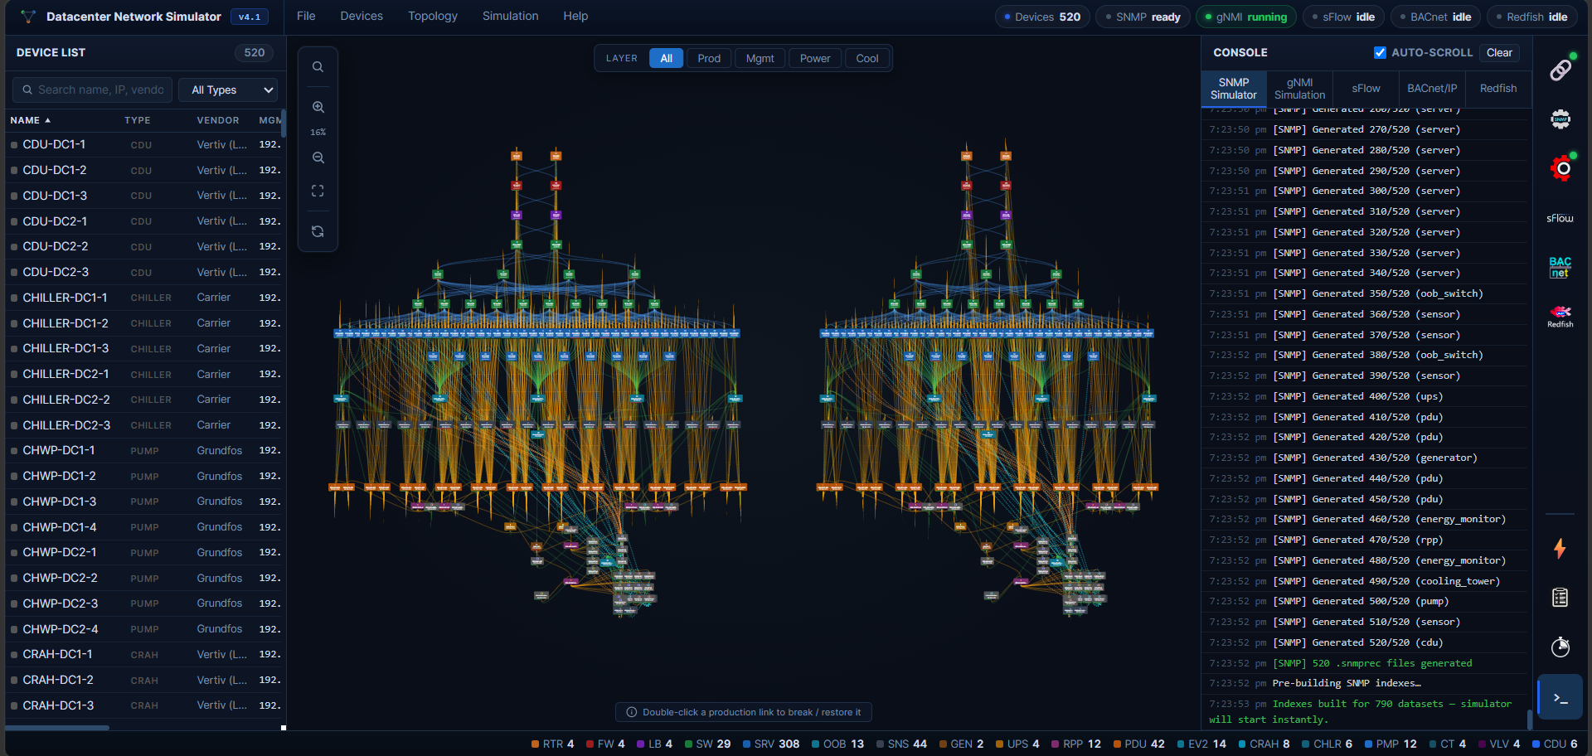
Console — tabbed live logs per subsystem

Switch Between Graph Layers
The layer toggle in the top bar filters the topology view by relationship type: All, Prod (production network), Mgmt (OOB management), Power (generator → UPS → RPP → PDU), and Cool (chilled-water + condenser loop). Switching layers isolates one plane of the datacenter at a time.
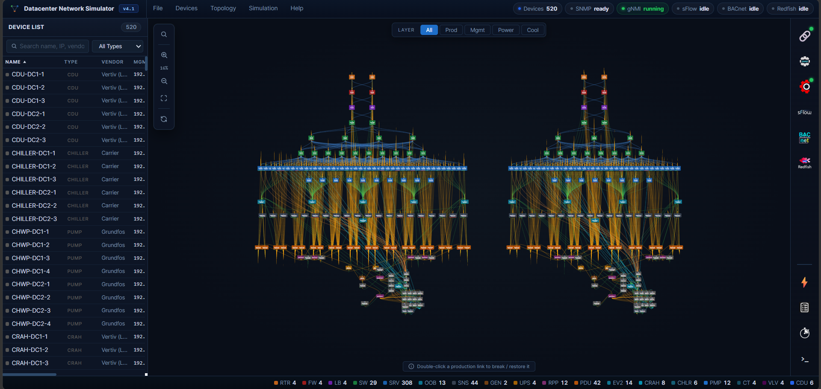
Graph Layers — All view showing every relationship plane
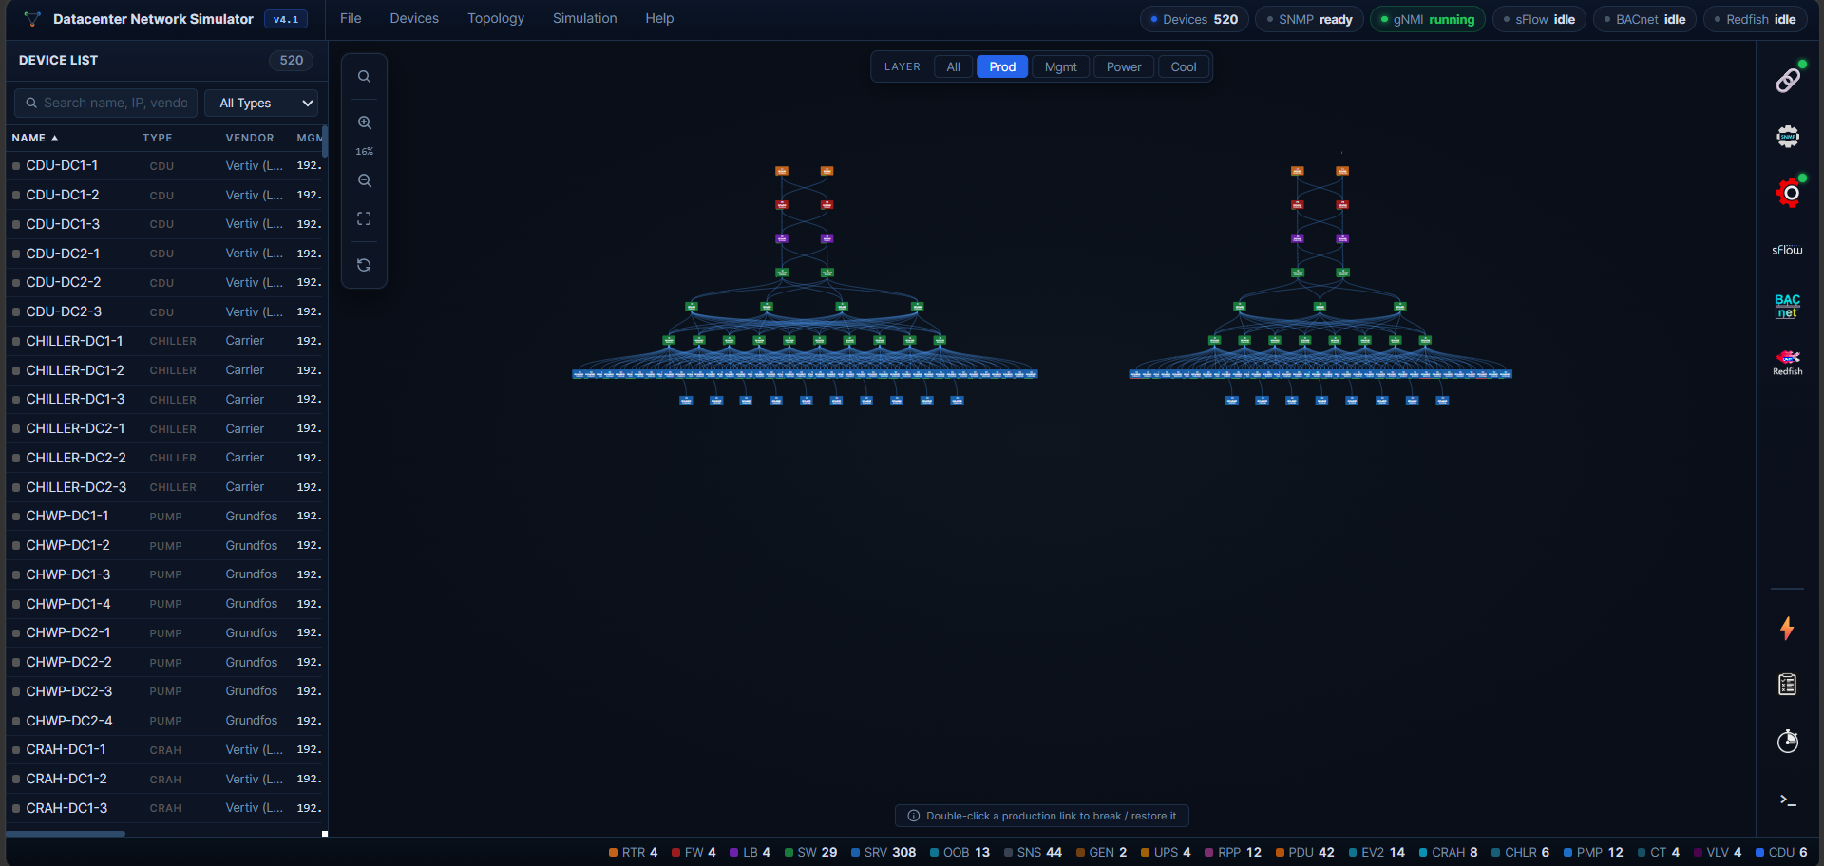
Graph Layers — Production network only
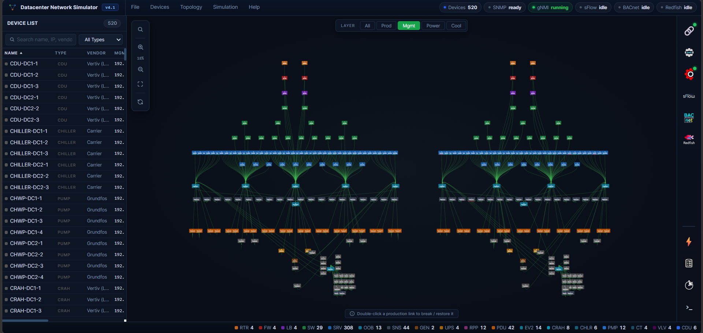
Graph Layers — Management (OOB) plane
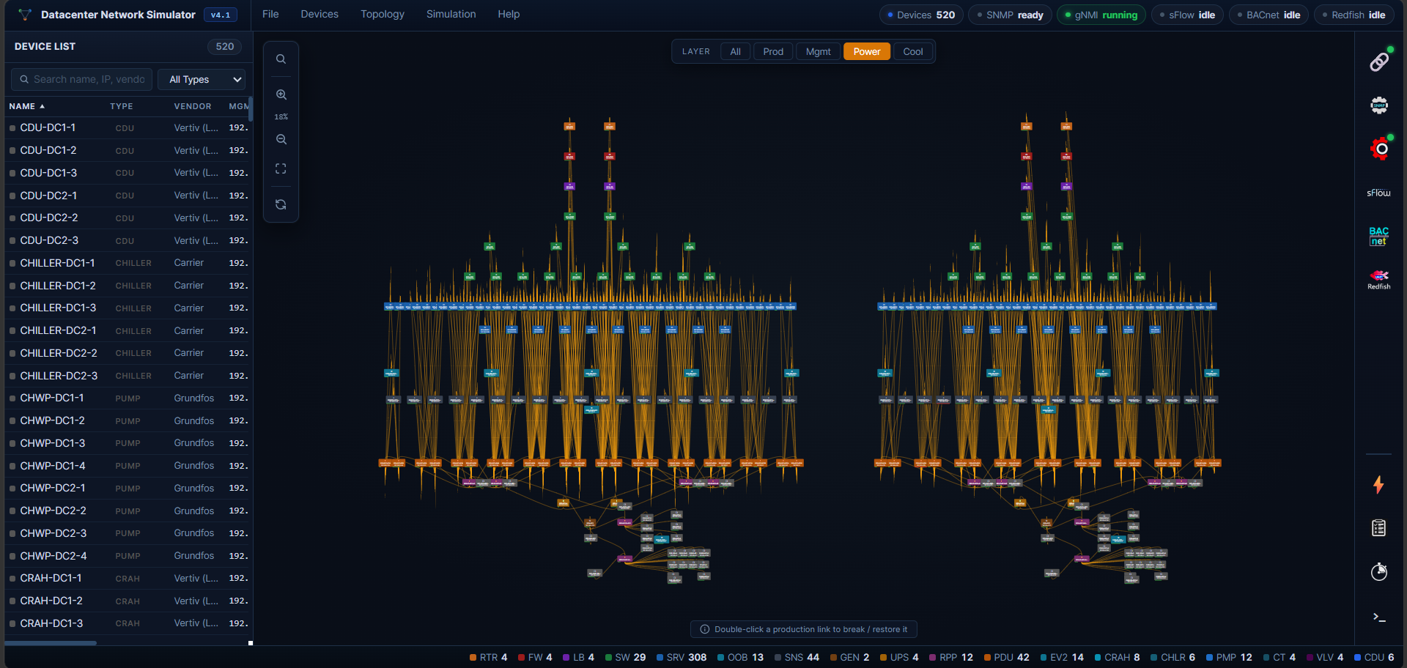
Graph Layers — Power chain
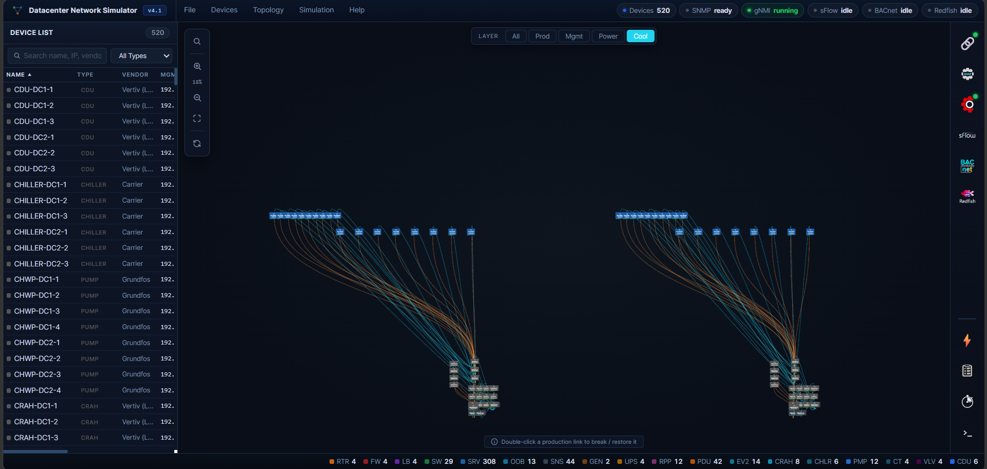
Graph Layers — Cooling loop

Monitor Live Metrics
The Live Metrics page shows a real-time table of every device's current metric values, with inline bars and per-device-type filter chips (Network, Server, UPS, PDU, Energy, CDU, Pump, Cooling tower, CRAH, Chiller, Sensor, Valve). Values update each metric tick.
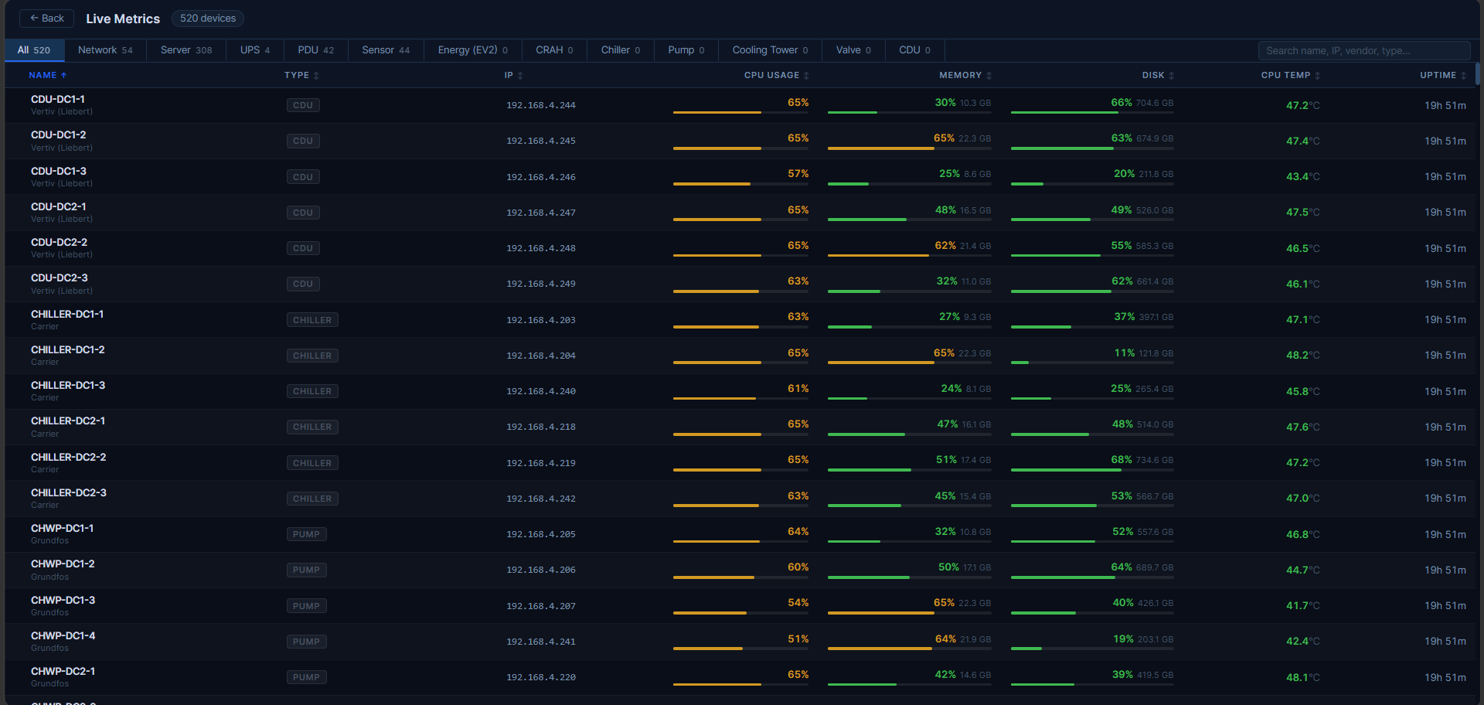
Live Metrics — all devices with live value bars
Filter to a single device class to focus on its metrics:
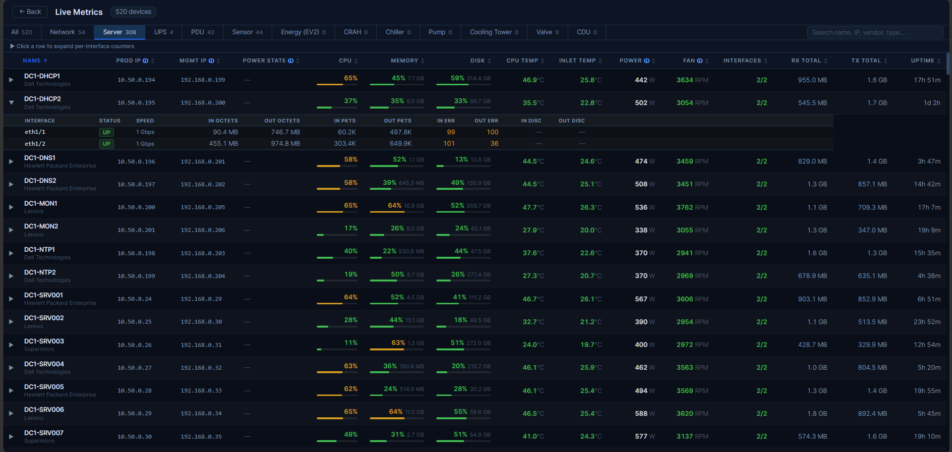
Live Metrics — Server view
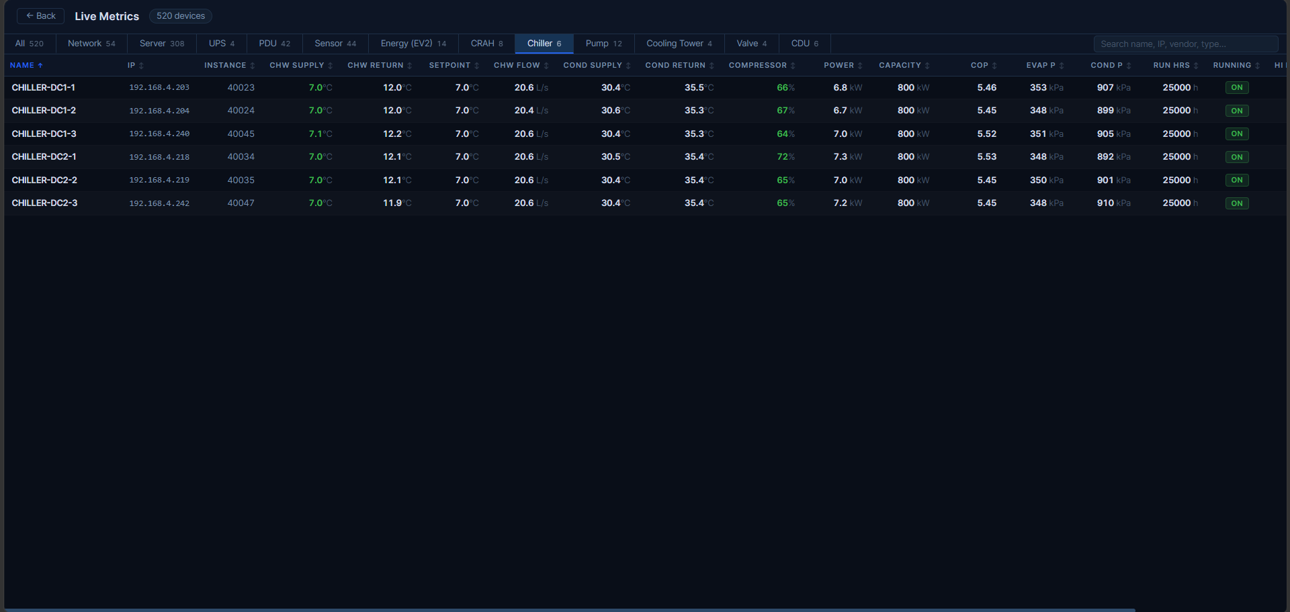
Live Metrics — Chiller view

Send Traps Manually
Right-click any node on the graph to open its context menu (Edit Device, Remove Device, Locate on Graph, Show Info, Send Trap). Hover Send Trap to pick a trap type — Cold Start, Warm Start, Authentication Failure, CPU High Usage, Temperature Alert, Link Flap — to emit that trap for the selected device on demand.
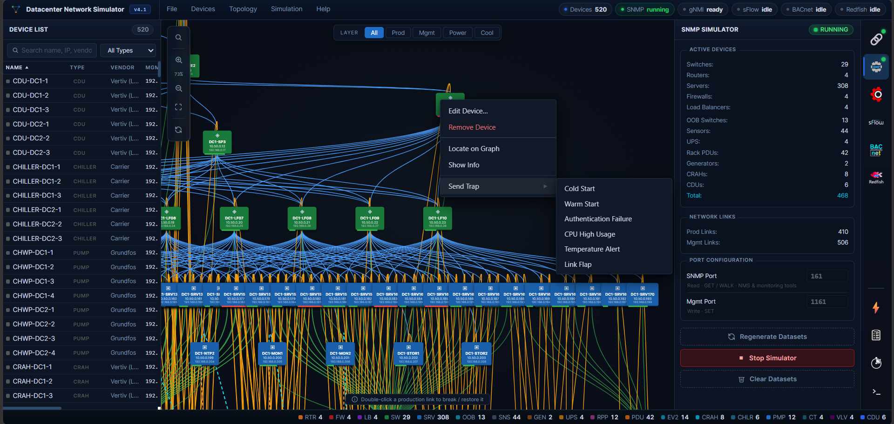
Send Trap — right-click a node ▸ Send Trap ▸ choose trap type

