Supplementary Materials

Hang Zhou, Yang Yang and Hong-Bin Shen, Hum-mPLoc 3.0: Prediction enhancement of human protein subcellular localization through modeling the hidden correlations of gene ontology and functional domain features.

1 Equations

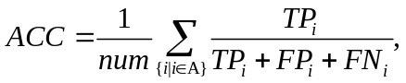 (S1)
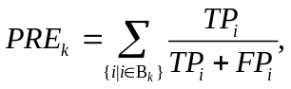 (S2)
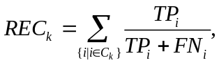 (S3)
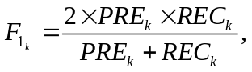 (S4)
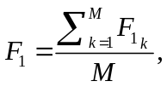 (S5)
where num denotes the total number of test proteins, TP_{i} , FP_{i} and FN_{i} denote the number of true positives, false positives and false negatives predictions, respectively. A denotes the test data set, B_{k} denotes the subset of test set whose proteins are predicted in the kth subcellular location, C_{k} denotes the subset of test set whose proteins truly locate to the kth subcellular location, and M denotes the number of subcellular locations.
ACC is an average of individual accuracies of all the test samples, where the individual accuracy is the ratio of the number of correctly predicted labels to the sum of correctly and falsely predicted labels. For example, a protein has three locations: cytoplasm, nucleus and mitochondrion. Suppose the predictor successfully predicts cytoplasm and nucleus, but misses the location of mitochondrion, then the TP, FP and FN are 2, 0, and 1, respectively. Thus the individual accuracy is 0.67 (2/3). If the predictor predicts cytoplasm, nucleus and lysosome, the TP, FP and FN become 2, 1, and 1, respectively. Then the individual accuracy is 0.5 (2/4). The overall accuracy index considers each protein with equal weight, while F₁-score treats each class (location) with equal weight. Since F₁ is a measurement considering precision and recall comprehensively, in general, F₁-score is more suitable for imbalanced data set.

2 Tables

The Höglund data set (Table S3) has the same similarity cutoff and clustering strategy as BaCelLo, but it covers more subcellular locations. Both of them include only mono-locational proteins, while DBMLoc data set (Table S4) contains a large proportion of multi-locational proteins.

Table S1. The new data sets of human proteins ª
Locations | # proteins in HumB | # proteins in HumT
Centrosome | 93 | 22
Cytoplasm | 1039 | 159
Cytoskeleton | 232 | 41
Endoplasmic reticulum | 207 | 41
Endosome | 65 | 15
Extracellular | 336 | 13
Golgi apparatus | 146 | 20
Lysosome | 81 | 8
Mitochondrion | 359 | 60
Nucleus | 1034 | 105
Peroxisome | 36 | 2
Plasma membrane | 601 | 55
Total # protein | 3129 | 379
Total # label | 4229 | 541
ªHumB is the training set. HumT is the test set.

Table S2. Animal proteins in BaCelLo data set
Locations | Training set | Test set | Test set (group)∗
Cytoplasm | 439 | 104 | 85
Mitochondrion | 188 | 60 | 48
Nucleus | 1166 | 273 | 224
Secreted | 804 | 139 | 75
Total # protein | 2597 | 576 | 432
* Sequence similarity between the training and test sets is below 30%, but there is no screening for redundant sequences in test set. Therefore, to reduce bias, the BaCelLo’s test set was clustered into 432 groups by merging proteins with the same locations as well as high sequence similarity (> 30%). In the prediction phase, each group is treated as a single protein by averaging the prediction accuracy for proteins within the group.

Table S3. Animal proteins in Höglund data set
Locations | Training set | Test set | Test set (group)∗
Cytoplasm | 935 | 0 | 0
Endoplasmic | 118 | 26 | 25
Extracellular | 772 | 106 | 78
Golgi | 110 | 14 | 14
Lysosome | 103 | 5 | 4
Mitochondrion | 271 | 0 | 0
Nucleus | 312 | 0 | 0
Peroxisome | 70 | 3 | 3
Membrane | 1215 | 44 | 34
Total # protein | 3906 | 198 | 158
∗ The same as in Table S2.

Table S4. DBMLoc data set

Locations | # proteins
Cytoplasm | 2374
Mitochondrion | 360
Nucleus | 2115
Membrane | 586
Extracellular | 562
Endoplasmic | 115
Total # protein | 3056
Total # label | 6112

Table S5. Distribution of predicted subcellular localization for whole human proteome
Locations | # Number
Centrosome | 170
Cytoplasm | 7152
Cytoskeleton | 947
Endoplasmic reticulum | 830
Endosome | 332
Extracellular | 1859
Golgi apparatus | 700
Lysosome | 215
Mitochondrion | 1679
Nucleus | 6057
Peroxisome | 103
Plasma membrane | 4050
Total # protein | 20197
Total # label | 24094

Table S6. Accuracies for the 25 proteins that cannot be represented by GO
Locations | Pre | Rec | F₁
Cytoplasm (7) | 0.667 | 0.571 | 0.615
Endoplasmic reticulum (2) | 0 | 0 | 0
Extracellular (4) | 1 | 0.750 | 0.857
Golgi apparatus (2) | 0 | 0 | 0
Mitochondrion (4) | 0.500 | 0.500 | 0.500
Nucleus (7) | 0.600 | 0.857 | 0.706
Plasma membrane (3) | 1 | 0.667 | 0.800

Table S7. Co-occurrence times for each pair of compartments
 | CE | CYP | CYS | EN | ER | EX | GA | LY | MI | NU | PE | PM
CE | 170 | 167 | 159 | 0 | 0 | 0 | 0 | 0 | 0 | 4 | 0 | 0
CYP | 167 | 7152 | 869 | 60 | 28 | 33 | 52 | 9 | 59 | 1718 | 10 | 192
CYS | 159 | 869 | 947 | 1 | 1 | 0 | 9 | 0 | 0 | 45 | 0 | 26
EN | 0 | 60 | 1 | 332 | 71 | 5 | 115 | 40 | 1 | 2 | 0 | 78
ER | 0 | 28 | 1 | 71 | 830 | 8 | 115 | 2 | 4 | 0 | 0 | 41
EX | 0 | 33 | 0 | 5 | 8 | 1859 | 41 | 20 | 3 | 3 | 0 | 194
GA | 0 | 52 | 9 | 115 | 115 | 41 | 700 | 9 | 0 | 1 | 0 | 68
LY | 0 | 9 | 0 | 40 | 2 | 20 | 9 | 215 | 1 | 0 | 0 | 22
MI | 0 | 59 | 0 | 1 | 4 | 3 | 0 | 1 | 1679 | 12 | 6 | 11
NU | 4 | 1718 | 45 | 2 | 0 | 3 | 1 | 0 | 12 | 6057 | 0 | 40
PE | 0 | 10 | 0 | 0 | 0 | 0 | 0 | 0 | 6 | 0 | 103 | 0
PM | 0 | 192 | 26 | 78 | 41 | 194 | 68 | 22 | 11 | 40 | 0 | 4050
CE: Centrosome ; CYP: Cytoplasm ; CYS : Cytoskeleton; EN: Endosome; ER: Endoplasmic reticulum; EX: Extracellular; GA: Golgi apparatus; LY: Lysosome; MI: Mitochondrion; NU: Nucleus; PE: Peroxisome; PM: Plasma membrane.

3 Figures

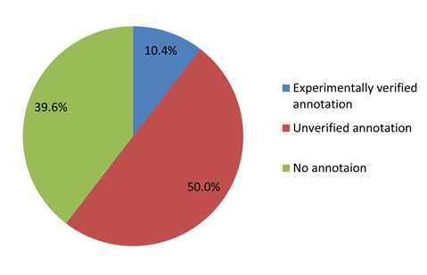
Fig. S1. Distribution of subcellular localization annotations of all proteins in SWISSPROT

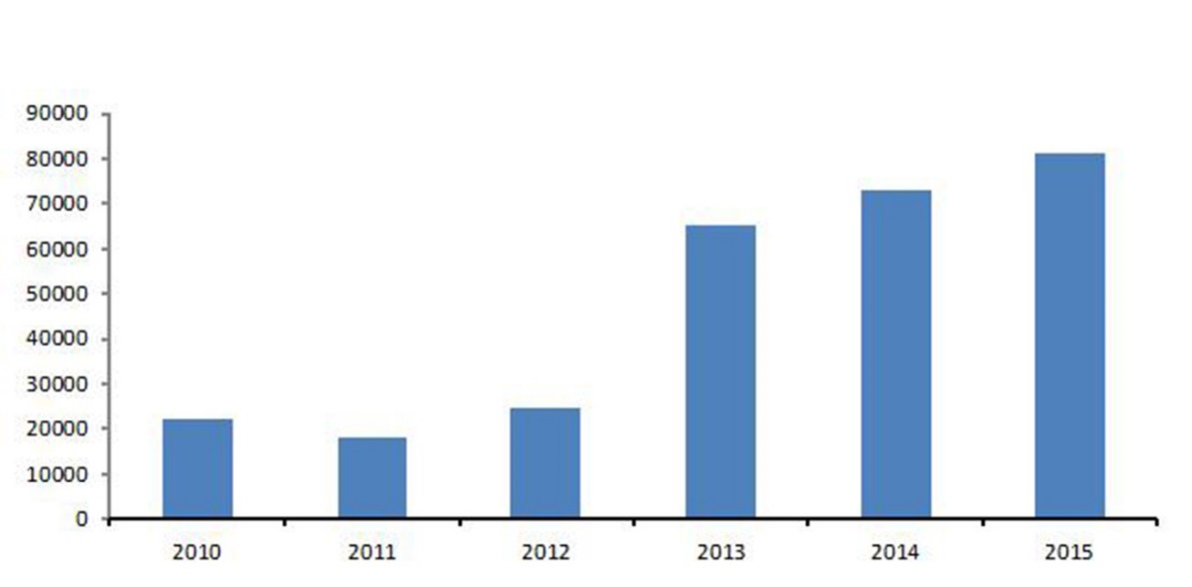
Fig. S2. Amounts of calls per year of Hum-mPLoc 2.0 from 2010 to 2015

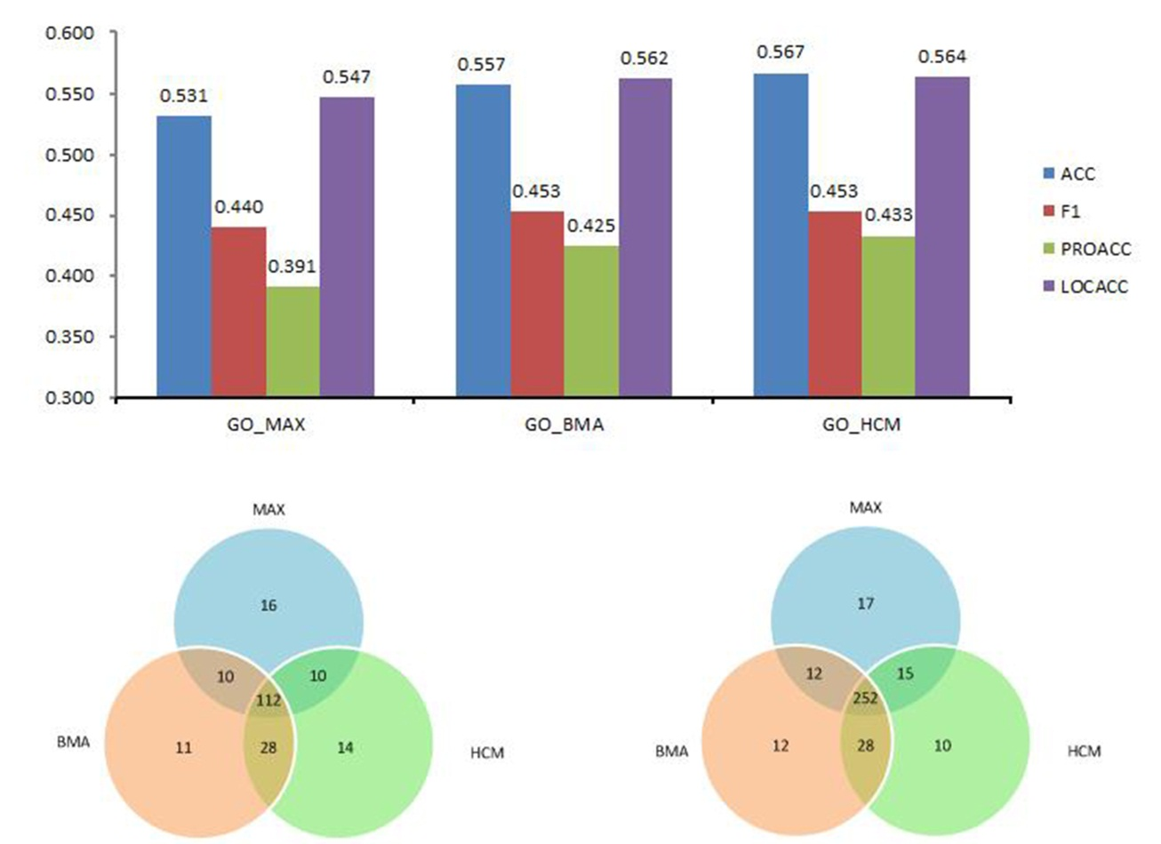

In the bar chart, PROACC is the ratio of correctly predicted proteins, and LOCACC is the ratio of correctly predicted locations (labels). The left Venn diagram shows the number of proteins whose locations are predicted all correctly (corresponding to PROACC), and the right one shows the number of locations predicted correctly (corresponding to LOCACC).

Fig. S3. Comparison of methods for computing protein similarity based on GO correlation

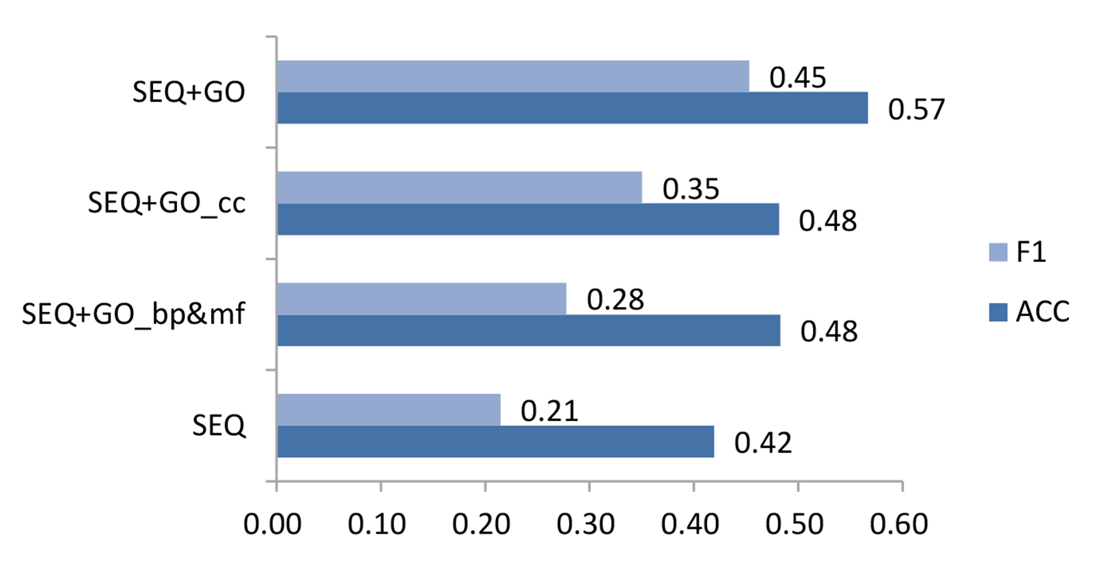
SEQ: Use solely sequence-based features.
SEQ+GO_bp&mf: Use both sequence features and GO but without CC terms.
SEQ+GO_cc: the method using sequence features and typical CC terms without BP or MF. (Typical CC terms include: GO0005813 for centrosome, GO0005737 for cytoplasm, GO0005856 for cytoskeleton, GO0005768 for endosome, GO0005783 for endoplasmic reticulum, GO0005615 for extracellular space, GO0005794 for Golgi apparatus, GO0005764 for lysosome, GO0005739 for mitochondrion, GO0005634 for nucleus, GO0005777 for peroxisome, and GO0005886 for plasma membrane.)
The CC terms are extracted from homologues proteins and directly used to assign subcellular locations for the query protein. If no CC term for these 12 locations are available, then sequence-based features are used.
SEQ+GO: Use all MF, BP and CC terms.

Fig. S4. Comparison of GO-based feature extraction with and without CC terms

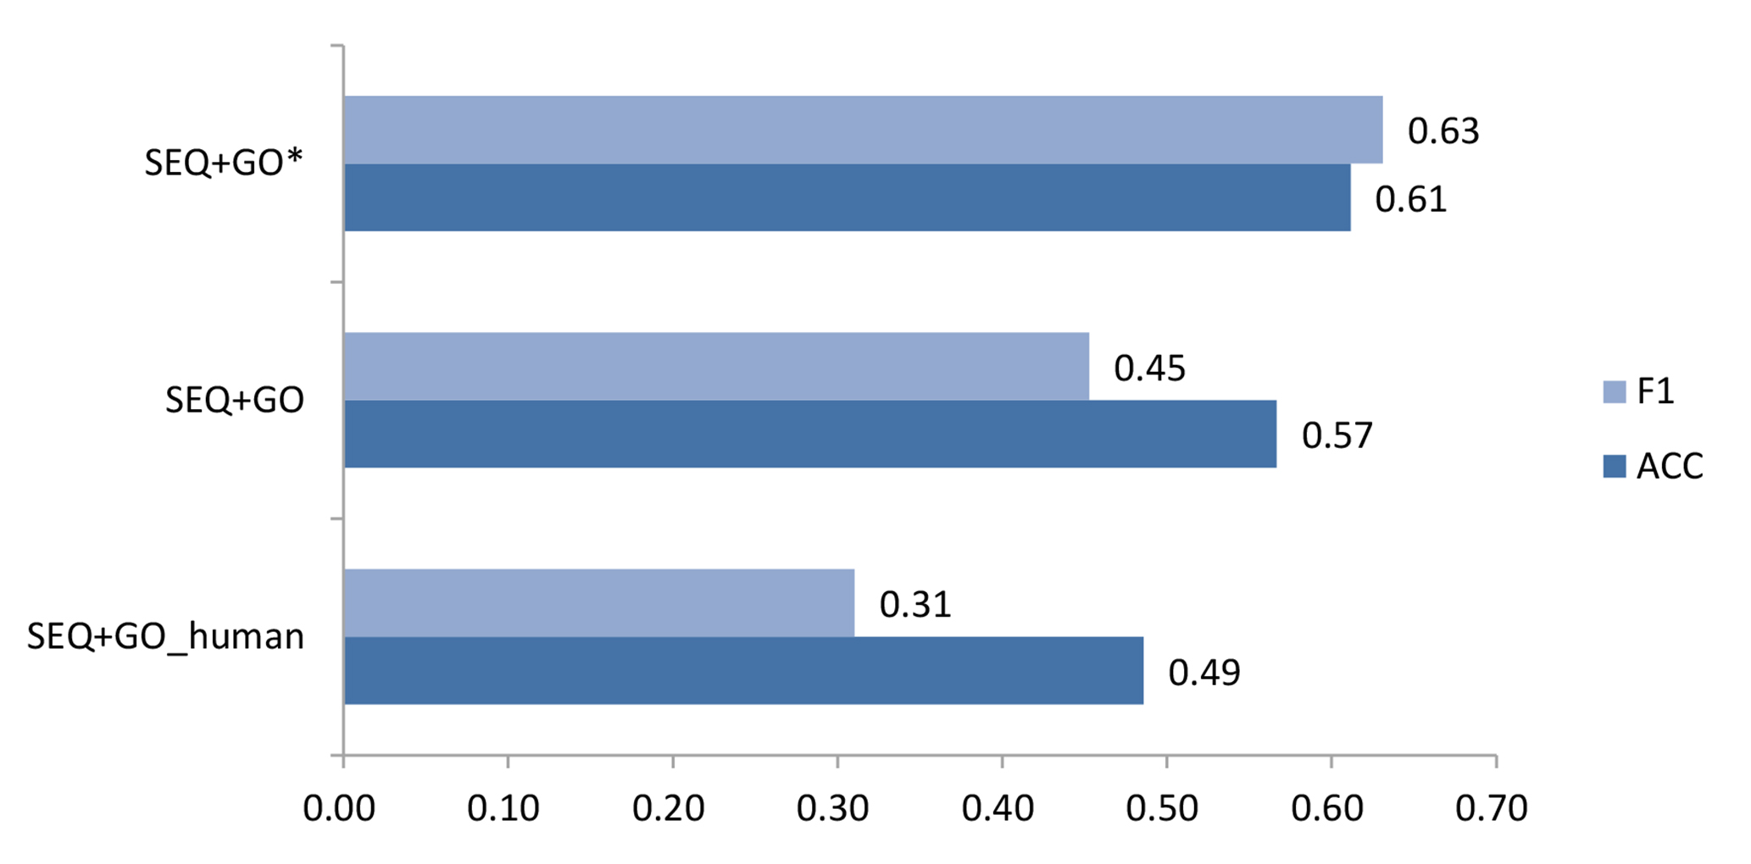
SEQ+GO_human: the method that we only select human proteins as representative proteins.
SEQ+GO: represent the method that we select all proteins as representative proteins.
SEQ+GO*: represent the method that we not only choose GO terms which have experimental evidence but also GO terms inferred by computational analysis.

Fig. S5. Comparison of methods with different sources of GO terms.

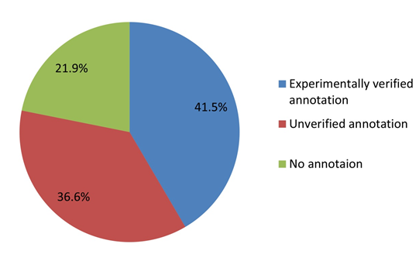
Fig. S6. Distribution of subcellular localization annotations of human proteins in SWISS-PROT database.

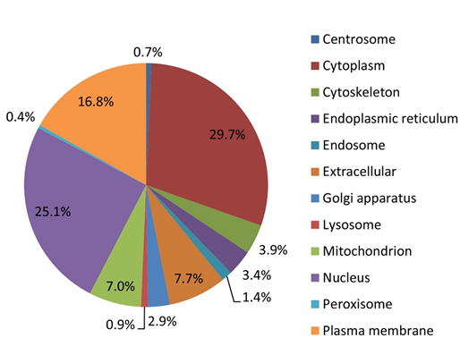
- Whole human proteome (20197 proteins)

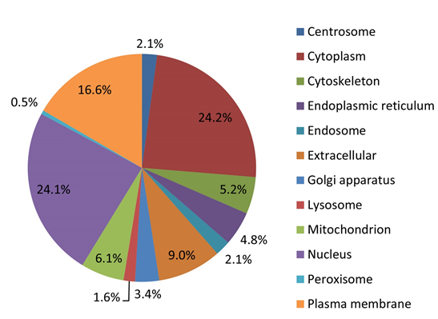
- The human proteins with veriﬁed localization (8389 proteins)

Fig.S7. Distributions of number of proteins in the 12 subcellular localizations, (a): According to the predicted results for 20197 proteins; (b) According to the experimentally verified annotations of 8389 proteins.
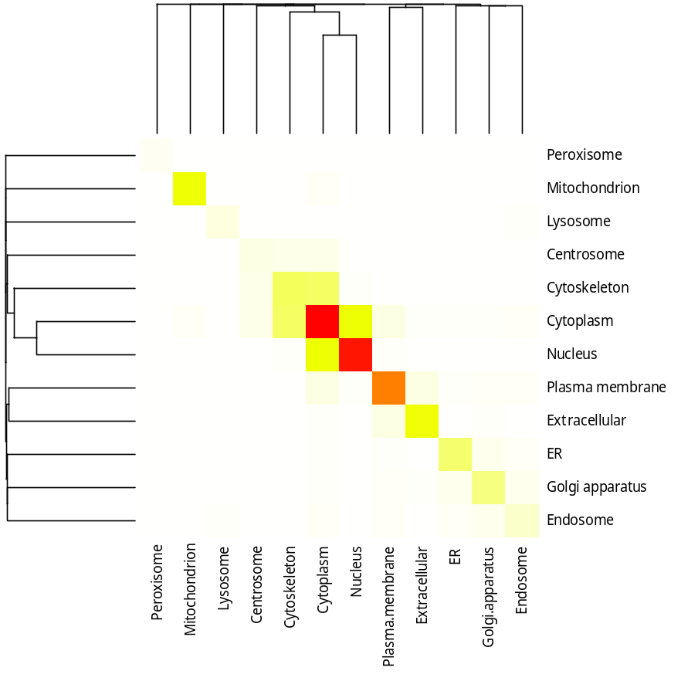
(a) Heatmap
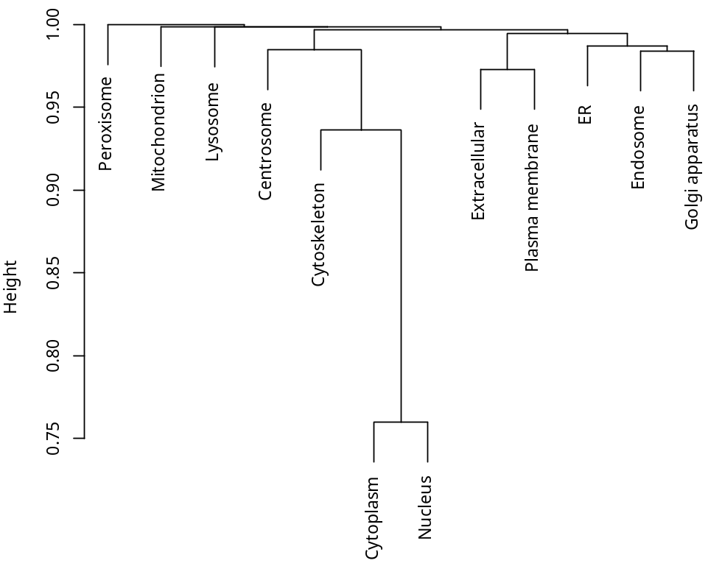
(b) Cluster dendrogram
Fig.S8. Hierarchical clustering on the co-occurrence matrix for compartment pairs.

