Code Smells

Code Smell 1: Dead Code/Speculative Generality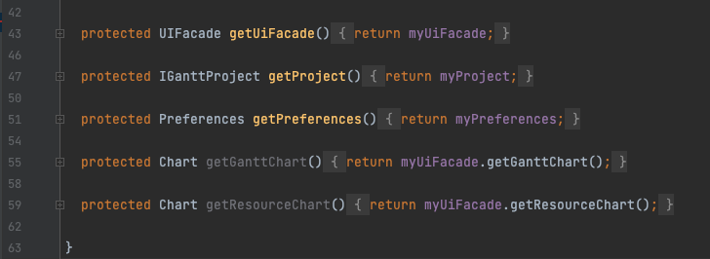

Location: 

Line 55 and 59;

Synopsis: Dead Code is found when we have obsolete code that is never called throughout the entire project, which is similar to Speculative generality, but here the code is made with future intentions, even tho it is not being used at the moment.

Rationale: This class has methods that are never called in the entire code, which makes this obsolete, even if it is with future intentions, if is not something requested from the client then it is only a waste of time .

Refactor proposal: I would delete this piece of code since it is not being used and only makes the code more extensive.

Code Smell 2: Data Class

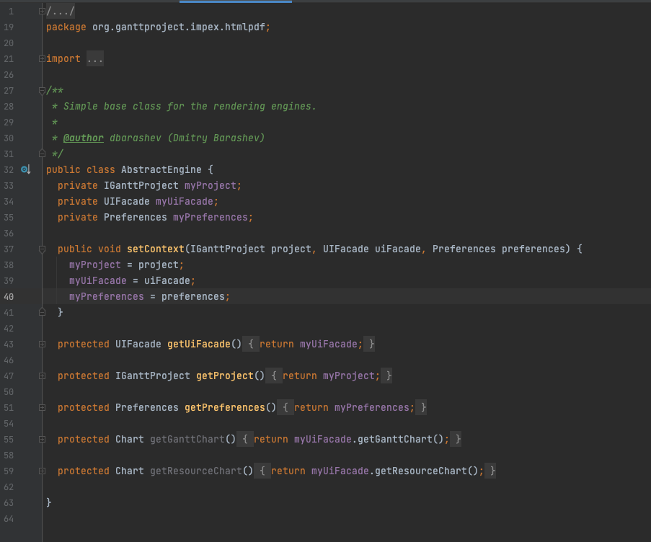

Location:



Synopsis: A Data Class is a class in which we only have getter and setter methods, and so it has no real functionality, which may indicate it may not be a good abstraction, or a necessary class.

Rationale: As we can observe the entire class as nothing but get methods.

Refactor: I would suggest trying to understand if there is something other than getters that would make sense to be placed in this class or, on the other hand, trying to see if the classes that use this gets can place this behaviours in their own class.

Code Smell 3: Long Method

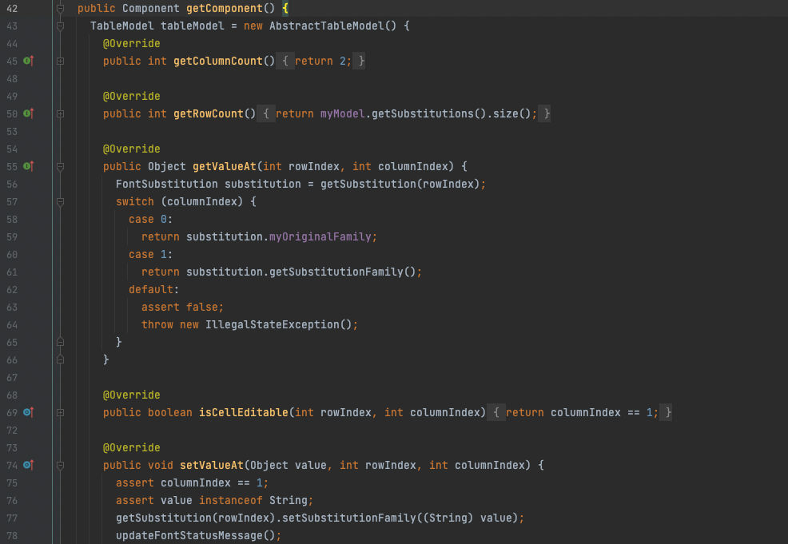

Location: 

From line 42 to 134;

Synopsis: A Long Method, as its name suggests, is a method which is too long, and so, it may suggest that the method is too complex and does too much stuff that it probably didn't need.

Rationale: As we can see in the previous image the code is really extensive, and it continues for sixty more lines. Also it does various operations that probably could be divided throughout the code.

Refactor: As I said before this method deals with a lot of operations, and so I would try to divide them and try to put them in more adequate spots, rather than being all in the same method.