Design Pattern 1: Adapter Pattern

Location: 

Rationale: This class receives a ics file and converts it into a format our Calendar Class can read so I believe this is an Adaptor Design pattern.

Design Pattern 2: Factory Method Pattern

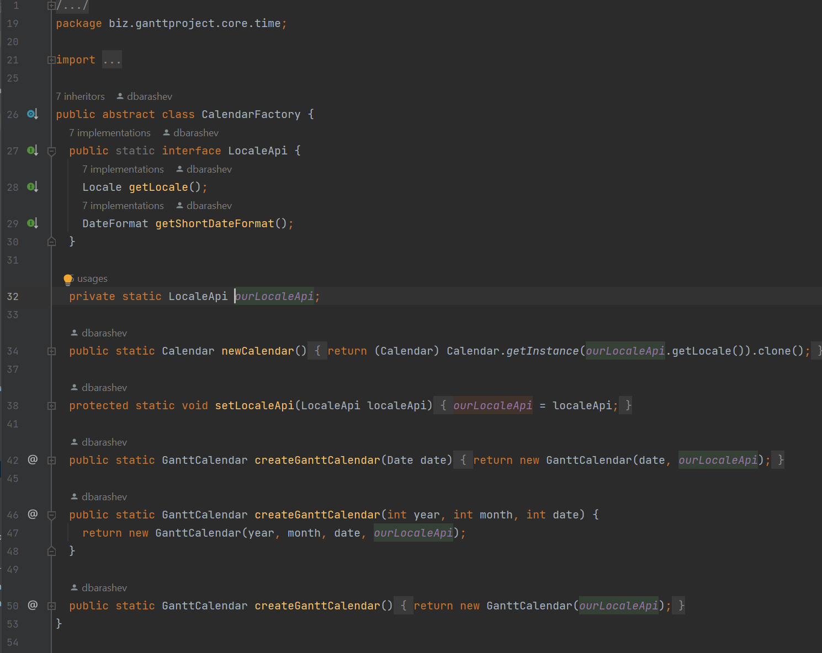

Location: 

Rationale: This class’s purpose is to hide the creation of instances of Calendars behind an abstract class “CalendarFactory”. Therefore, I believe this is a Factory Method design Pattern.

Design Pattern 3: Decorator Pattern

This is the Interface

This is the Decorator Class

Location: 



Rationale: There are 73 implementations of the Interface GPOption, each one using a different subclass of the GPAbstractOption (which implements the GPOption Interface) and most of these subclasses override certain methods, adding their own touch to it, So I believe that GPAbstractOption is the Decorator class, and we are in the presence of a Decorator Design Pattern.