**Design Pattern 1: Memento Pattern**

This is the interface:

Location:



Rationale: This class allows to return an object to one of its previous states. In this case, our class extends an interface that has methods ( *canUndo()* and *undo()* ) that allow the object to check if it has saved a previous state and if that is the case, it can return to them.

**Design Pattern 2: Factory Method Pattern**

Location: 

Rationale: This class’s purpose is to hide the creation of instances of a given type

**Design Pattern 3: Facade Pattern**

This is the class that implements the interface:

Location:

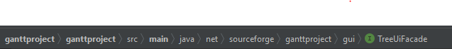

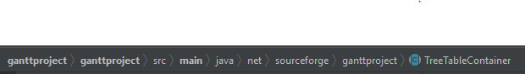

Rationale: A façade is a wrapper class that encapsulates a subsystem in order to hide the subsystem complexity. The intent is to hide complexity behind an interface. In this case, we hide the complexity in the TreeUiFacade.