Scenario1 7 hosts and one switch:

1. One client without loss

1. Three clients without loss

1. Three clients without loss

1. One client with loss

1. Two clients with loss

1. Three clients with loss

Scenario2 7 hosts and 7 switches

1. 1 client without delay

1. 2 clients without delay

1. 3 clients without delay

4. 1 client with loss = 5

1. 2 clients with loss = 5

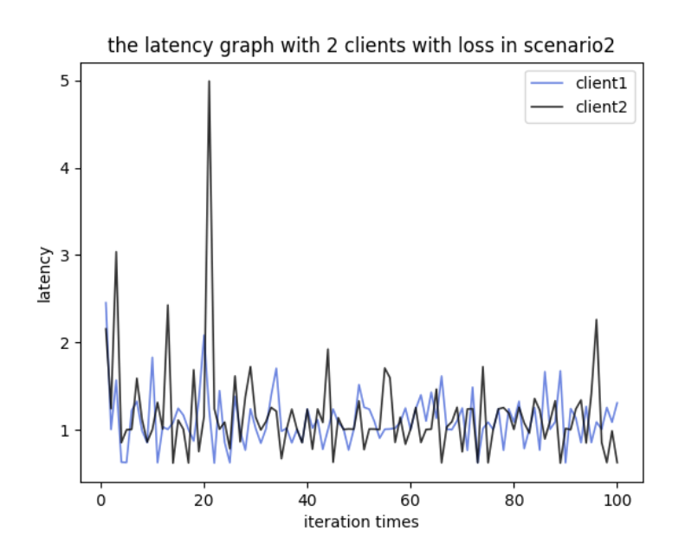

6. 3 clients with loss = 5

Scenario3 27 hosts and 13 switches:

1. 1 client without delay

1. 2 clients without delay

1. 3 clients without delay

1. 1 client with loss = 5

1. 2 clients with loss = 5

1. 3 clients with loss = 5

