ONTARIO SENIOR INCOME &
GAINS BENEFITS
Statistical Analysis in R
Portfolio Project Report
Data: Ontario GAINS benefit-rate schedule, age 75+
Period: April 1 - June 30, 2024
Rows analyzed: 1,067
Methods: Data Cleaning • EDA • Welch t-test • Bootstrap • Regression • 10-fold Cross-Validation

Executive Summary
This project evaluates how private income relates to Ontario GAINS support and total monthly income across a published benefit-rate schedule for seniors aged 75 and older. The work began as an academic R assignment and was rebuilt into a reproducible, portfolio-ready statistical analysis with corrected group definitions, a leakage-free validation design, and documented limitations.

Key Findings
- The corrected $7,500 comparison found mean minimum total monthly income of $1,979.91 below the threshold and $2,278.02 at/above the threshold, a difference of approximately $298.11.
- Welch's t-test produced t = -43.31, df = 732.43, p ≈ 3.66 × 10^-204, with a 95% confidence interval for the lower-minus-higher mean difference of [-$311.62, -$284.59].
- A simple regression of GAINS on minimum annual private income estimated a slope of -0.0008357 with R² = 0.1499. The relationship is statistically strong but only modestly predictive.
- The original cross-validation result was artificially perfect because total monthly income was predicted using variables that directly reconstruct the target. The revised model produced a cross-validated R² of about 0.146, RMSE of 12.09, and MAE of 6.86.

Headline Metrics
Metric | Verified Result | Interpretation
Dataset size | 1,067 rows | Published rate-table rows, not individual recipients
Corrected mean difference | -$298.11 | Lower-threshold rows have lower minimum total monthly income
Regression R² | 0.1499 | Private income alone explains about 15% of GAINS variation
Revised CV R² | ≈ 0.146 | Out-of-fold performance is similar to in-sample explanatory strength
Leakage audit | Confirmed | Original target could be reconstructed from predictor components

1. Data & Analytical Context
The CSV contains 1,067 rows and 10 numeric fields describing annual and monthly private-income bands, GAINS/RRAG, Old Age Security (OAS), Guaranteed Income Supplement (GIS), combined OAS/GIS, and minimum/maximum total monthly income. The schedule covers the April 1-June 30, 2024 period.
Critical data limitation: these rows are entries in a benefit-rate schedule rather than observations on 1,067 independently sampled seniors. Inferential procedures are included to demonstrate statistical methods and compare schedule segments; their p-values and bootstrap intervals should not be interpreted as population-sampling uncertainty in the usual survey sense.

Selected Descriptive Statistics
Variable | Mean | SD | Range
Minimum annual private income | $10,054.48 | $6,064.52 | $0 - $21,600
GAINS / RRAG | $3.27 | $13.09 | $0 - $83
GIS / SRG | $532.91 | $307.75 | $0.43 - $1,065.47
Minimum total monthly income | $2,158.72 | $197.04 | $1,933.14 - $2,585.10
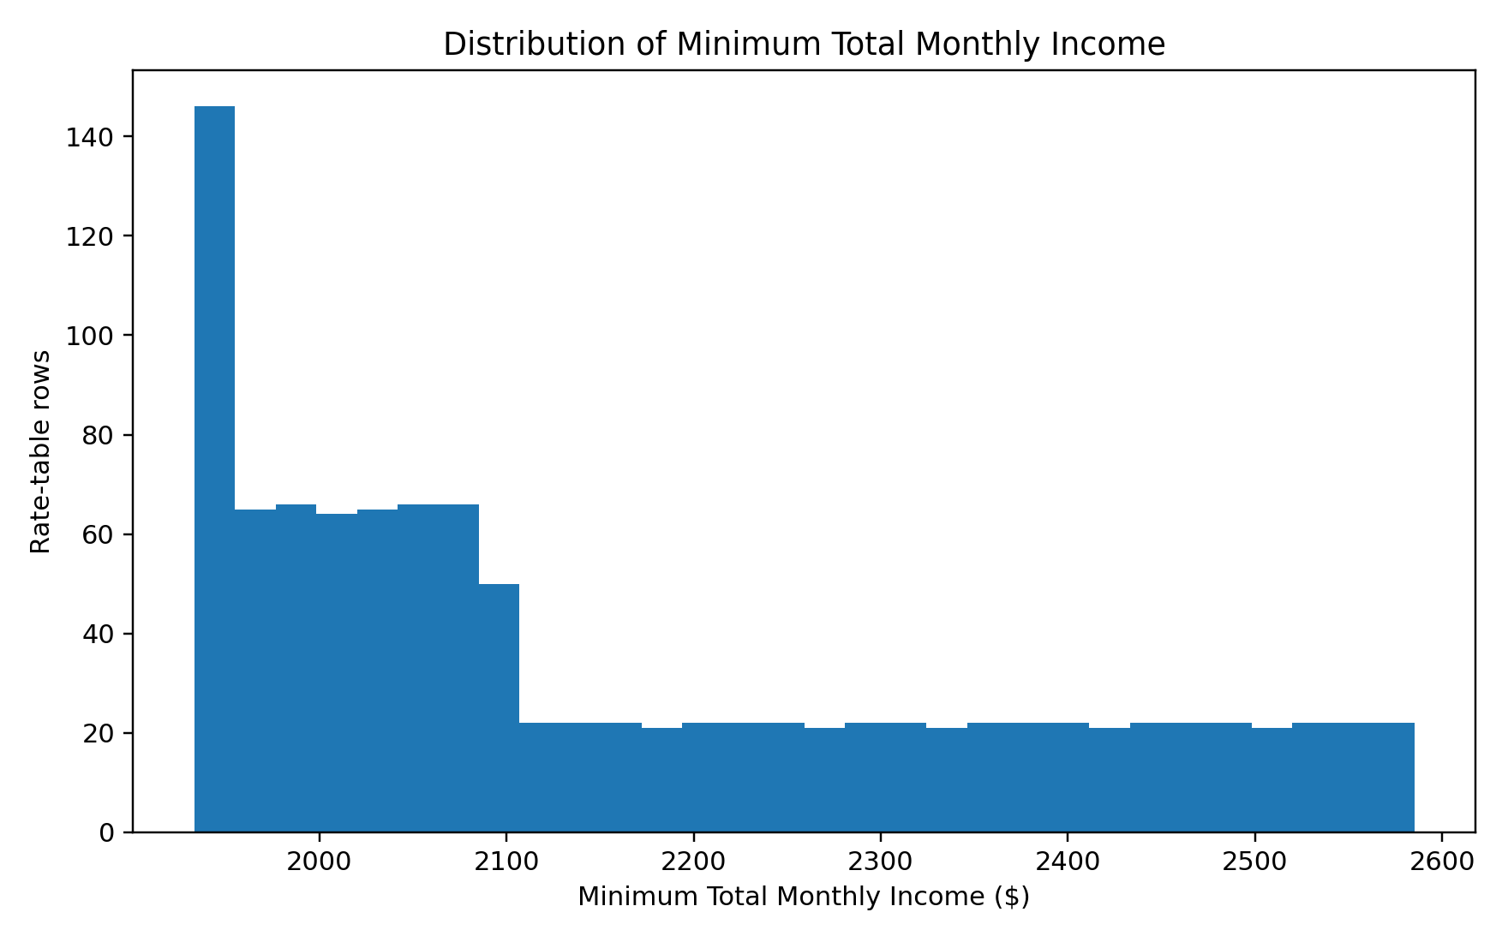
Figure 1. Distribution of minimum total monthly income across benefit-rate rows.

2. Hypothesis Test: $7,500 Private-Income Threshold
The original assignment intended to compare mean minimum total monthly income below and above a $7,500 private-income threshold, but its code used minimum variables for the lower group and maximum variables for the higher group. The revised analysis uses minimum annual private income to define both groups and minimum total monthly income as the outcome for both groups.

Hypotheses
- H0: the mean minimum total monthly income is equal for rows below $7,500 and rows at/above $7,500 in minimum annual private income.
- H1: the two group means are different.
Income Group | n | Mean | SD
Below $7,500 | 427 | $1,979.91 | $37.60
$7,500 or above | 640 | $2,278.02 | $167.95
Verified Welch result: t = -43.31, df = 732.43, p ≈ 3.66 × 10^-204. The estimated lower-minus-higher difference is -$298.11, with a 95% interval from -$311.62 to -$284.59.
Across this rate schedule, rows at or above the $7,500 threshold have substantially higher minimum total monthly income. The test statistic is very large partly because the schedule is highly structured and contains many closely spaced deterministic income bands; this reinforces the limitation that these are not independent recipient observations.
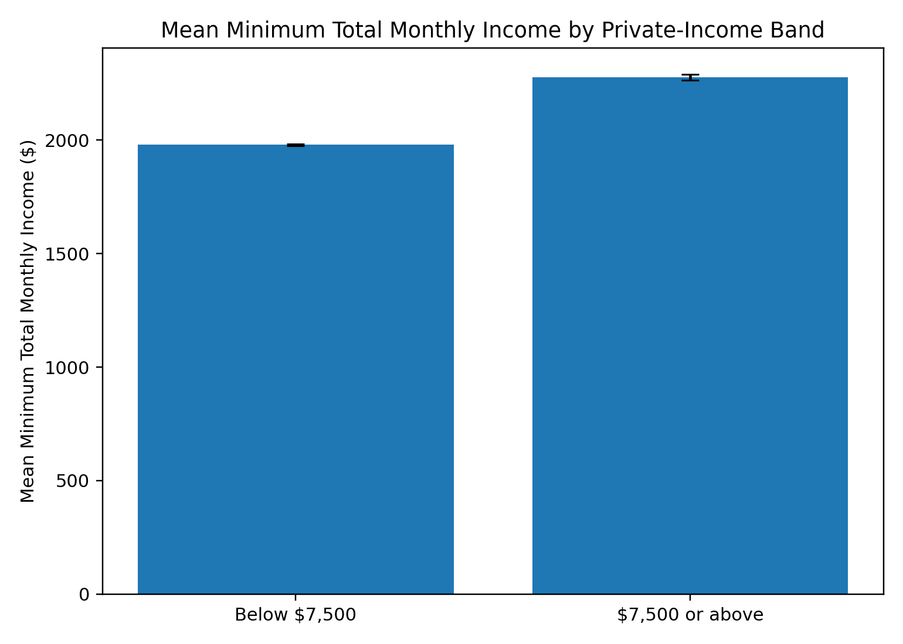
Figure 2. Mean minimum total monthly income by private-income threshold group; error bars show approximate 95% standard-error intervals.

3. Bootstrap Resampling
A non-parametric bootstrap with 5,000 resamples was used to examine the stability of the mean minimum total monthly income across schedule rows. The observed mean is $2,158.72. An independent verification produced a percentile interval of approximately $2,147.19 to $2,170.40.
Because the dataset is a complete rate schedule rather than a random sample, this is best interpreted as a resampling-sensitivity exercise, not a conventional population confidence interval.
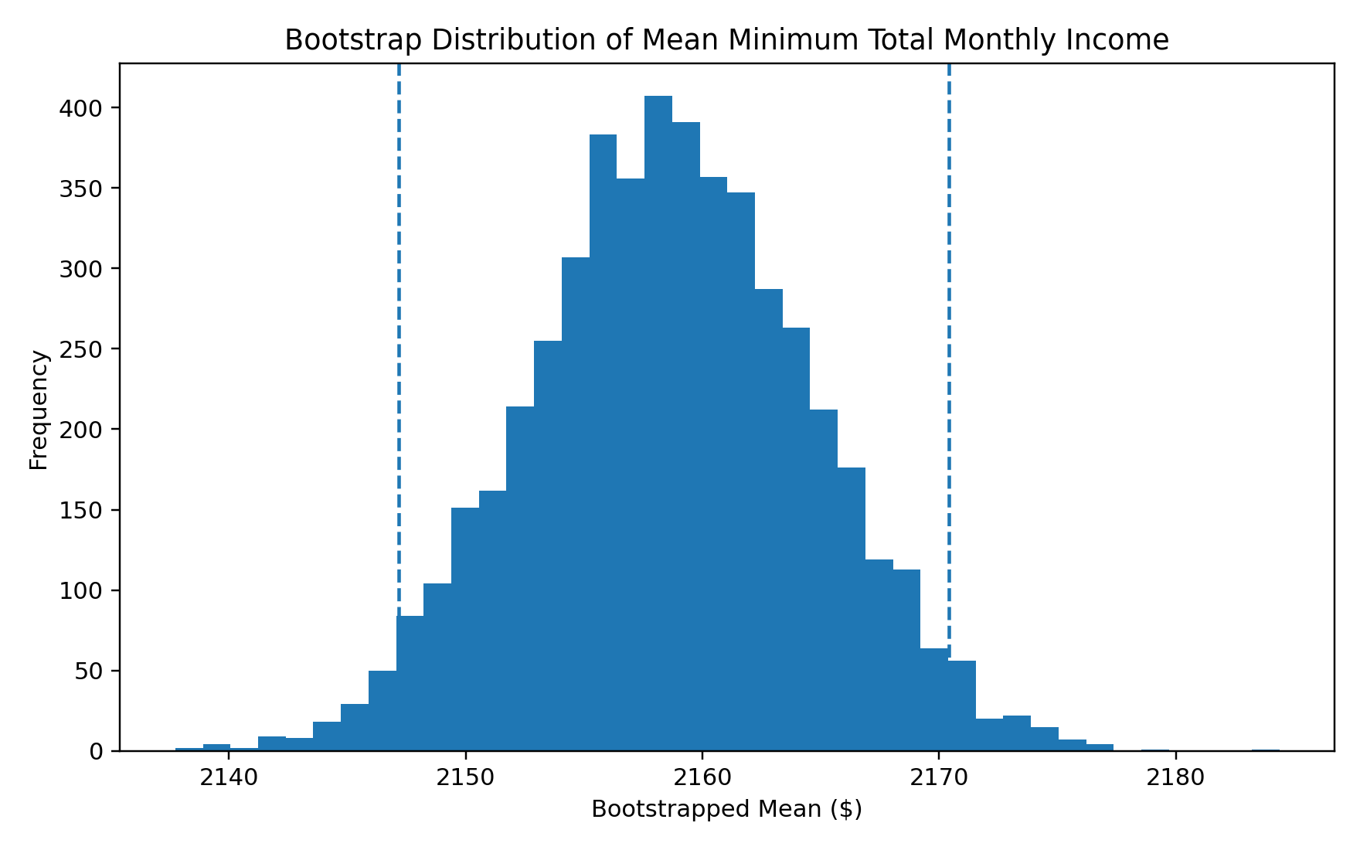
Figure 3. Bootstrap distribution of the mean minimum total monthly income.

4. Regression Analysis: Private Income vs. GAINS
A simple ordinary least squares model was fit with GAINS as the response and minimum annual private income as the predictor:
GAINS = 11.6693 - 0.0008357 × Annual Private Income (minimum)
Term / Metric | Estimate | Statistical Result | Meaning
Intercept | 11.6693 | p < 0.001 | Predicted GAINS when minimum annual private income is $0
Private-income slope | -0.0008357 | p ≈ 1.76 × 10^-39 | GAINS decreases as private income rises
R² | 0.1499 | — | About 15% of GAINS variation is explained by this one predictor
The negative coefficient confirms an inverse relationship, but the modest R² shows that statistical significance does not imply strong predictive performance. In this schedule, GAINS is zero across many higher-income bands and varies only in a subset of rows, so a single straight-line model is intentionally simple.
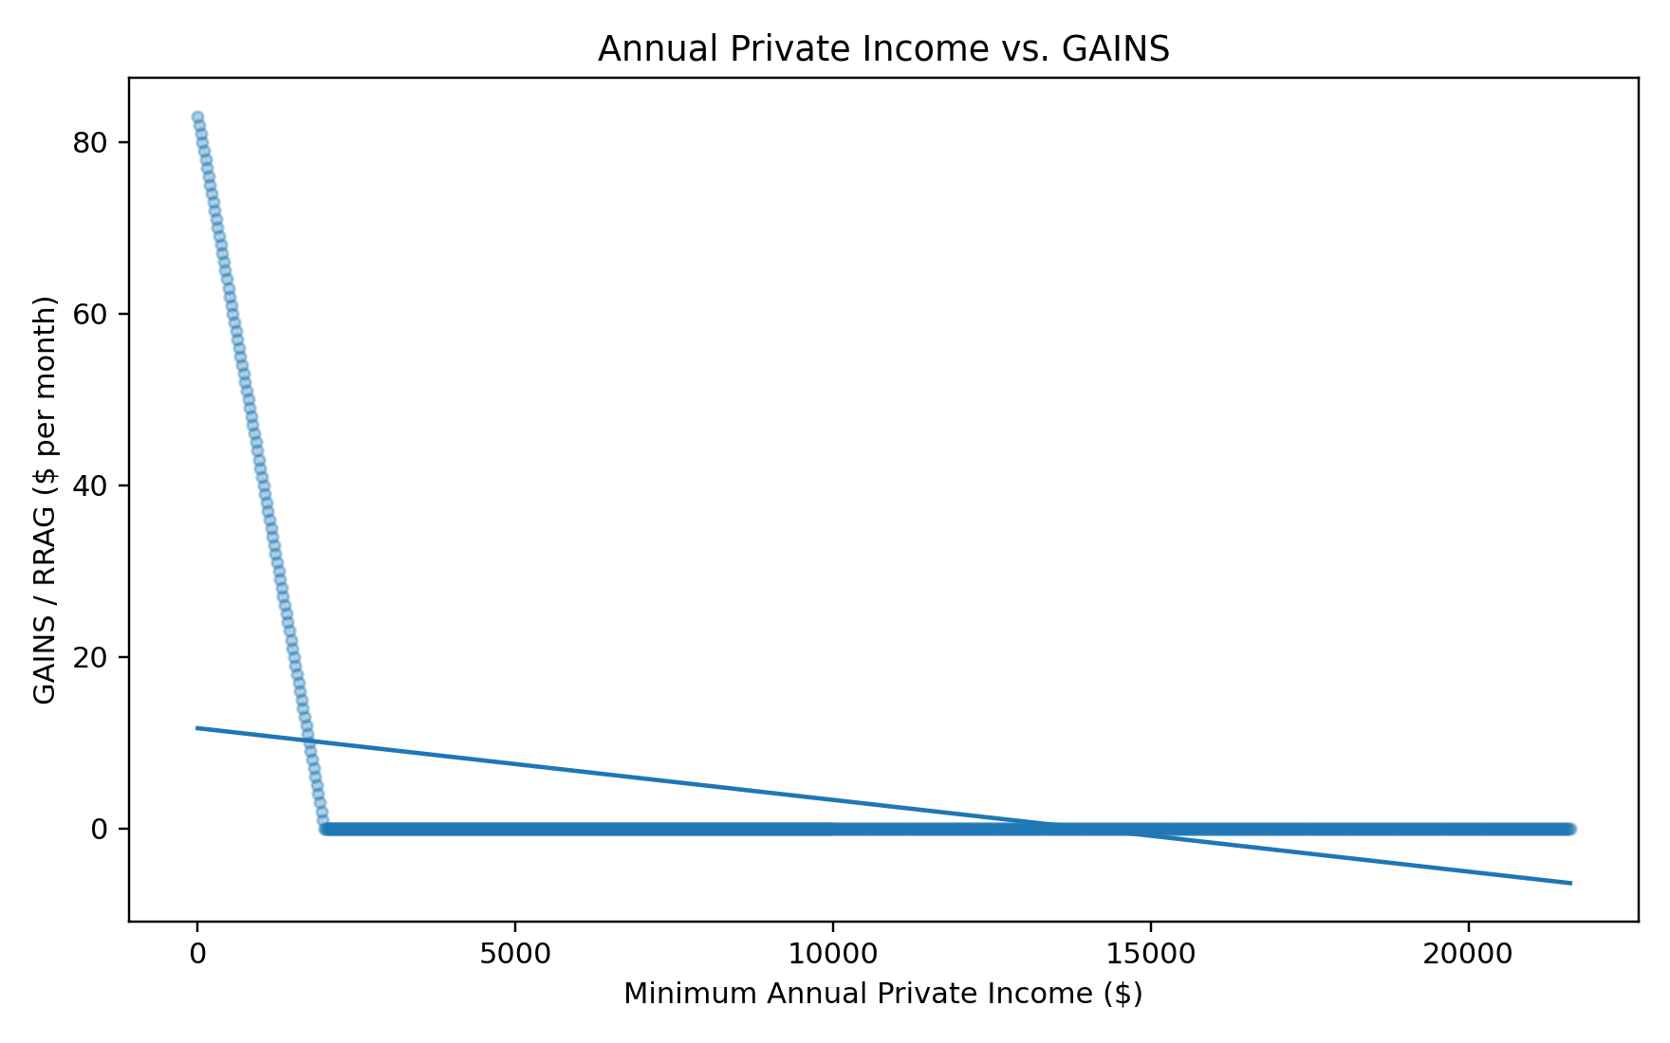
Figure 4. Minimum annual private income and GAINS with fitted linear trend.

5. Model Validation & Target Leakage
The original assignment used all available columns to predict minimum total monthly income and obtained R² = 1 with essentially zero error. That result is not evidence of an exceptionally strong model. The target can be reconstructed exactly from variables included among the predictors:
Minimum Total Monthly Income = OAS/GIS Total + GAINS + Minimum Monthly Private Income
Including those components makes the prediction task mathematically circular. This is target leakage: information that directly determines the outcome is supplied to the model as input.

Revised 10-Fold Cross-Validation
Metric | Verified Value | Interpretation
RMSE | 12.09 | Typical prediction error in GAINS dollars
MAE | 6.86 | Average absolute GAINS error
R² | 0.146 | Out-of-fold explanatory performance
The revised cross-validation predicts GAINS using only minimum annual private income. The resulting out-of-fold R² is close to the in-sample R², which is a much more credible performance profile than the original perfect score.
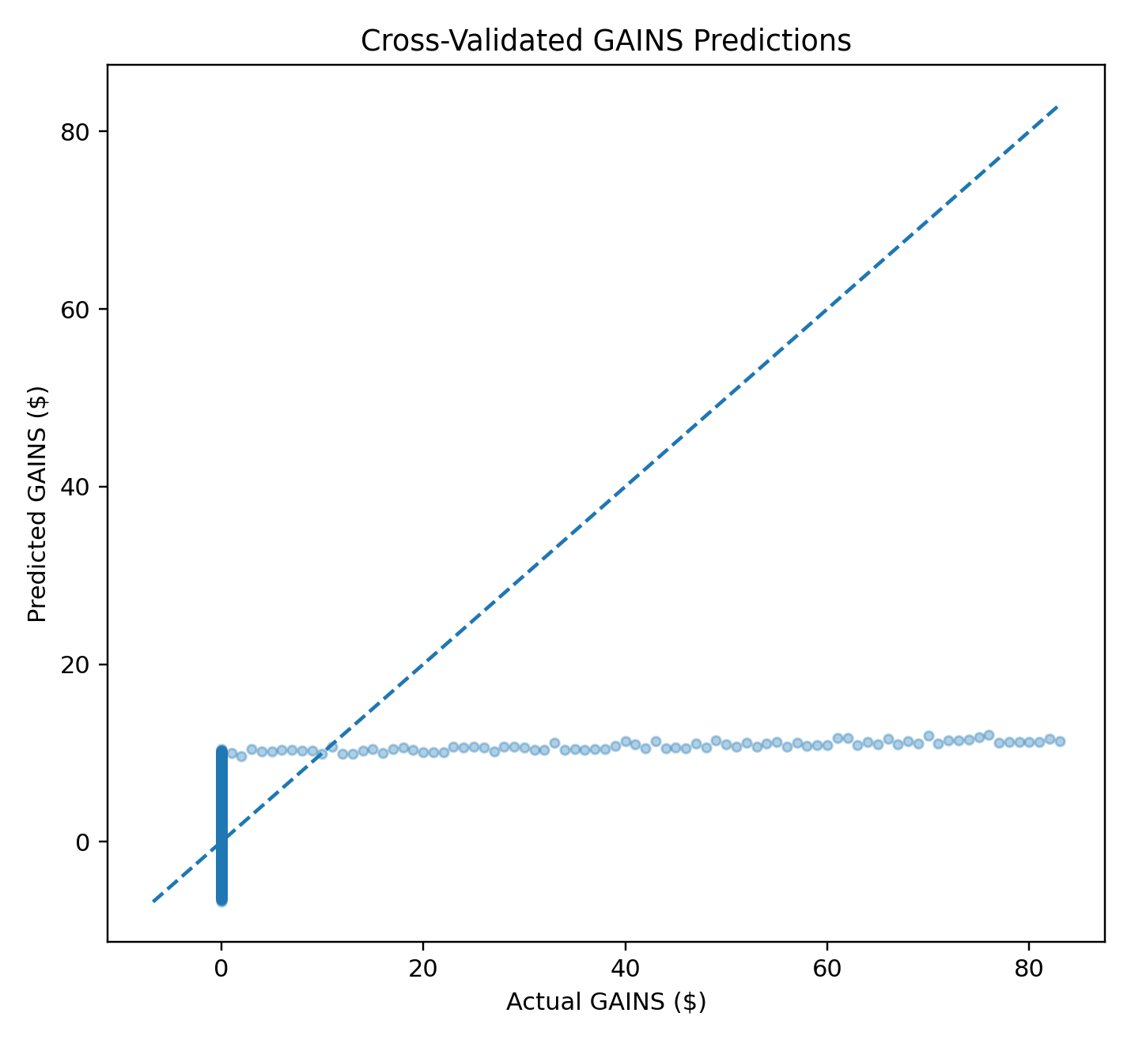
Figure 5. Actual versus out-of-fold predicted GAINS under the revised validation design.

6. Professional Interpretation
- Private income is strongly tied to the structure of public-income support across the rate schedule, but GAINS alone is not well represented by a single linear relationship over the full income range.
- The $7,500 threshold comparison shows a large difference in minimum total monthly income across schedule segments, but it should not be generalized as a causal or population-level effect on individual seniors.
- The project demonstrates why model auditing matters: a perfect validation score can be a warning sign when the target is directly constructed from predictors.
- A stronger future analysis would use recipient-level administrative or survey data with demographic and beneficiary-category variables, then evaluate multivariable models under a true out-of-sample design.

7. Reproducibility
The project is organized as a modular R workflow. Open the .Rproj file in RStudio and run:
source("R/07_run_all.R")
The scripts import and clean the CSV, generate descriptive visualizations, run the corrected hypothesis test, perform bootstrap resampling, fit the regression, and run leakage-free 10-fold cross-validation. Verified result tables are also stored in the results/ directory.

8. Portfolio Value
This project demonstrates more than the ability to run statistical functions in R. It shows an end-to-end analytical process: understanding a public-sector dataset, cleaning numeric fields, selecting statistical methods, interpreting effect size versus significance, validating models, identifying leakage, documenting limitations, and producing reproducible outputs for technical and non-technical audiences.

Appendix: Project Files
- README.md - project overview and verified findings
- analysis_report.Rmd - reproducible narrative report
- R/01_data_cleaning.R through R/06_model_validation.R - modular analysis scripts
- R/07_run_all.R - master execution script
- results/verified_results.csv - independently verified headline metrics
- figures/ - portfolio-ready analytical charts

