485 19200,N,8,1

TCP端口 **8000** UDP端口 **8101**

开启监控

7e 43 55 2d 42 48 38 30 34 34 37 30 36 30 30 31 36 ff ff ff ff 1a 13 3f ae 01 0b 00 00 00 00 00 a5 7e

   7E 1A 13 3F AE 43 55 2D 42 48 38 30 34 34 37 30 36 30 30 31 36 FF FF FF FF 21 01 00 00 00 00 00 BB 7E

开门

**7e** 43 55 2d 42 48 38 30 34 34 37 30 36 30 30 31 36 ff ff ff ff 1b 24 ff a0 03 03 00 00 00 00 04 00 00 01 00 68 7e

     7E 1B 24 FF A0 43 55 2D 42 48 38 30 34 34 37 30 36 30 30 31 36 FF FF FF FF 21 01 00 00 00 00 00 7F 02 7E7E FF FF FF FF 43 55 2D 42 48 38 30 34 34 37 30 36 30 30 31 36 FF FF FF FF 19 04 00 00 00 00 08 03 18 03 05 21 20 22 01 27 7E

**除标志码和检验码，命令中所有字节都总加合**

 ---

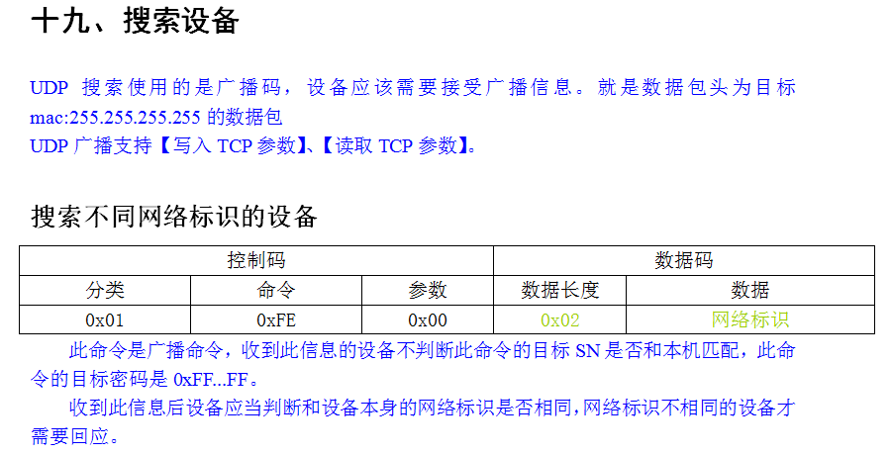

UDP端口  **8101**

UDP搜索时，使用UDP广播搜索设备。

设备只接收：【搜索不同网络标识设备】、【设置设备网络标识】、【读TCP参数】、【写TCP参数】

在UDP模式时不判断接收到的命令中的目标SN，而且返回的命令中需要把源SN更改为设备的SN，通讯密码就是固定的0xFFFFFFFF。

此命令是广播命令，收到此信息的设备不判断此命令的目标SN是否和本机匹配，此命令的目标密码是0xFF...FF。

收到此信息后设备应当判断和设备本身的网络标识是否相同，网络标识不相同的设备才需要回应。

搜索流程参看：【附录V 自动搜索设备】

网络标识：设备内存中的一个数字，每次开机时都会初始化为0xFFFF，软件在每次搜索时都会即时生成一组网络标识。

Send 36 字节    01 fe

7e 30 30 30 30 30 30 30 30 30 30 30 30 30 30 30 30 ff ff ff ff 1e d9 31 c4 01 fe 00 00 00 00 02 2e f0 07 7e

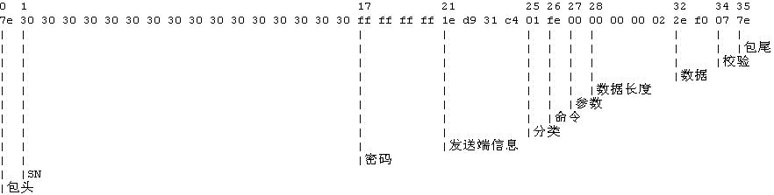

回复 171字节  绿色通讯密码 红色为数据内容长度

7E 1E D9 31 C4 43 55 2D 42 48 38 30 34 34 37 30 36 30 30 31 36 11 22 33 FF 31 FE 00 00 00 00 89 00 18 06 11 97 FC C0 A8 01 1D FF FF FF 00 C0 A8 01 01 00 00 00 00 00 00 00 00 02 1F 40 1F A5 00 00 00 00 00 00 00 00 00 00 00 00 00 00 00 00 00 00 00 00 00 00 00 00 00 00 00 00 00 00 00 00 00 00 00 00 00 00 00 00 00 00 00 00 00 00 00 00 00 00 00 00 00 00 00 00 00 00 00 00 00 00 00 00 00 00 00 00 00 00 00 00 00 00 00 00 00 00 00 00 00 00 00 00 00 00 00 00 00 00 00 00 00 00 00 00 00 00 00 00 00 00 00 00 00 00 60 7E

数据内容  (网络参数)

00 18 06 11 97 FC C0 A8 01 1D FF FF FF 00 C0 A8 01 01 00 00 00 00 00 00 00 00 02 1F 40 1F A5 00 00 00 00 00 00 00 00 00 00 00 00 00 00 00 00 00 00 00 00 00 00 00 00 00 00 00 00 00 00 00 00 00 00 00 00 00 00 00 00 00 00 00 00 00 00 00 00 00 00 00 00 00 00 00 00 00 00 00 00 00 00 00 00 00 00 00 00 00 00 00 00 00 00 00 00 00 00 00 00 00 00 00 00 00 00 00 00 00 00 00 00 00 00 00 00 00 00 00 00 00 00 00 00 00 00 60 7E

从1算起 22开始的4个字节为密码

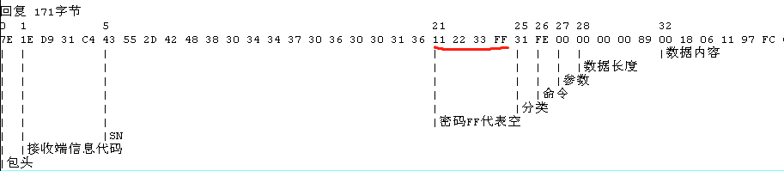

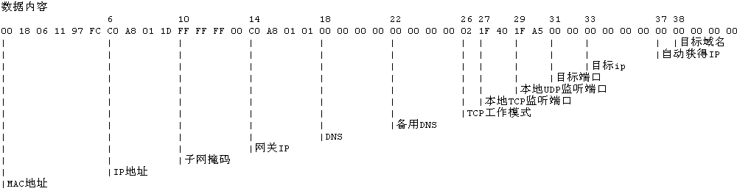

------------------------------------------------

查询机器Tcp参数   01 06

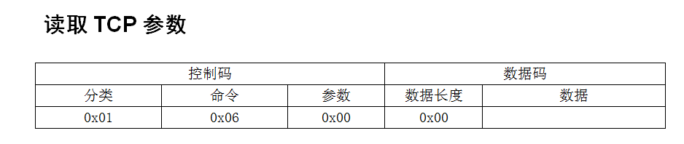

                                                                                         通讯密码     信息代码 分类命令参数各1字节

                                                                                                                                            数据长度

7e 43 55 2d 42 48 38 30 34 34 37 30 36 30 30 31 33 12 34 56 78 00 00 00 01 **01 06** 00 00 00 00 00 9c 7e

7e 00 00 00 01 43 55 2d 42 48 38 30 34 34 37 30 36 30 30 31 33 12 34 56 78 31 06 00 00 00 00 89 00 18 06 11 97 f9 c0 a8 01 19 ff ff ff 00 c0 a8 01 01 00 00 00 00 00 00 00 00 01 1f 40 1f a5 00 00 00 00 00 00 00 00 00 00 00 00 00 00 00 00 00 00 00 00 00 00 00 00 00 00 00 00 00 00 00 00 00 00 00 00 00 00 00 00 00 00 00 00 00 00 00 00 00 00 00 00 00 00 00 00 00 00 00 00 00 00 00 00 00 00 00 00 00 00 00 00 00 00 00 00 00 00 00 00 00 00 00 00 00 00 00 00 00 00 00 00 00 00 00 00 00 00 00 00 00 00 00 00 00 00 21 7e

检验码：除标志码和检验码，命令中所有字节都想加然后取尾子节。

读Tcp参数

7E 43 55 2D 42 48 38 30 34 34 37 30 36 30 30 31 36 FF FF FF FF FF FF FF FF 01 06 00 00 00 00 00 82 7E

回复

7E FF FF FF FF 43 55 2D 42 48 38 30 34 34 37 30 36 30 30 31 36 FF FF FF FF 31 06 00 00 00 00 89 00 18 06 11 97 FC C0 A8 01 21 FF FF FF 00 C0 A8 01 01 00 00 00 00 00 00 00 00 02 1F 40 1F A5 00 00 00 00 00 00 00 00 00 00 00 00 00 00 00 00 00 00 00 00 00 00 00 00 00 00 00 00 00 00 00 00 00 00 00 00 00 00 00 00 00 00 00 00 00 00 00 00 00 00 00 00 00 00 00 00 00 00 00 00 00 00 00 00 00 00 00 00 00 00 00 00 00 00 00 00 00 00 00 00 00 00 00 00 00 00 00 00 00 00 00 00 00 00 00 00 00 00 00 00 00 00 00 00 00 00 13 7E

7E FF FF FF FF 43 55 2D 42 48 38 30 34 34 37 30 36 30 30 31 36 FF FF FF FF 31 06 00 00 00 00 89 00 18 06 11 97 FC C0 A8 01 21 FF FF FF 00 C0 A8 01 01 00 00 00 00 00 00 00 00 02 1F 40 1F A5 00 00 00 00 00 00 00 00 00 00 00 00 00 00 00 00 00 00 00 00 00 00 00 00 00 00 00 00 00 00 00 00 00 00 00 00 00 00 00 00 00 00 00 00 00 00 00 00 00 00 00 00 00 00 00 00 00 00 00 00 00 00 00 00 00 00 00 00 00 00 00 00 00 00 00 00 00 00 00 00 00 00 00 00 00 00 00 00 00 00 00 00 00 00 00 00 00 00 00 00 00 00 00 00 00 00 13 7E

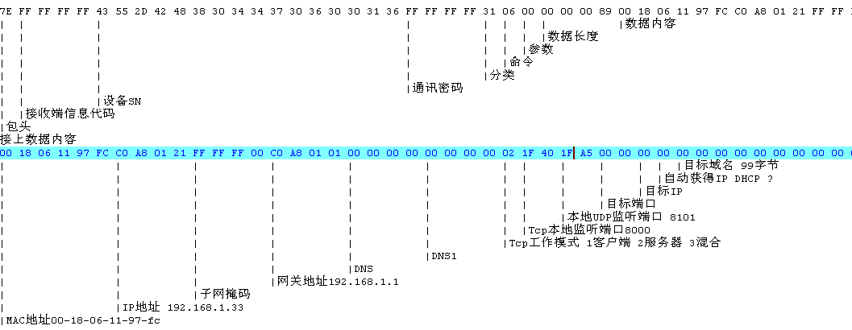

**客户端模式实际是 混合模式  也支持其他Client连接控制板,目前只支持IP方式,不支持域名方式**

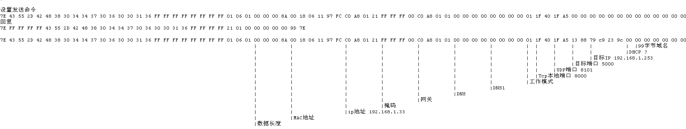

-----------关于客户端设置----------

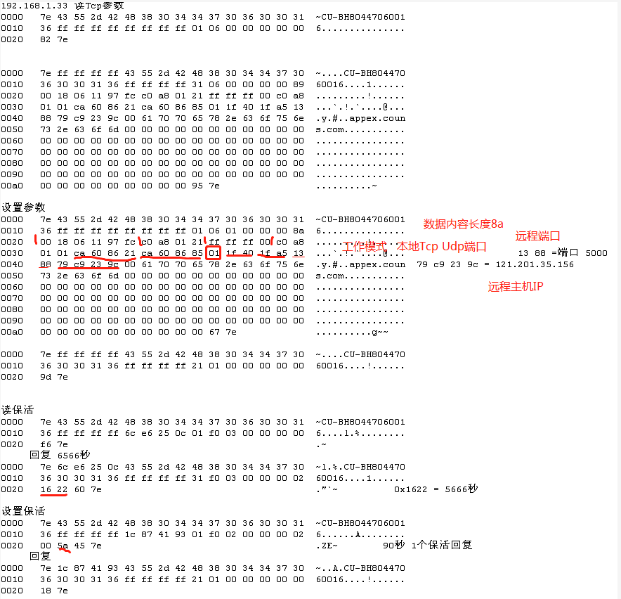

----- 设置通讯密码为 12345678原密码为空 长度38字节

7e 43 55 2d 42 48 38 30 34 34 37 30 36 30 30 31 36 ff ff ff ff 20 4c aa 8c 01 03 00 00 00 00 04 12 34 56 78 3d 7e

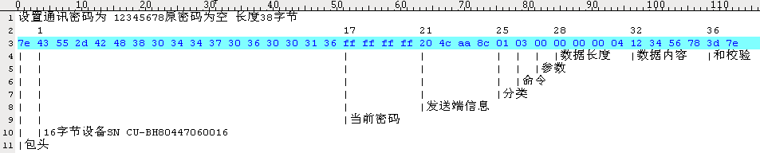

----- 授权过程 1.读取授权卡信息  2.授权  3.授权完成后为何发指令清除所有节假日

7e 43 55 2d 42 48 38 30 34 34 37 30 36 30 30 31 36 12 34 56 78 18 85 f6 74 07 01 00 00 00 00 00 a6 7e

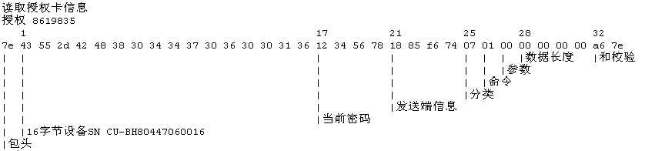

设备回复

7e 18 85 f6 74 43 55 2d 42 48 38 30 34 34 37 30 36 30 30 31 36 12 34 56 78 37 01 00 00 00 00 10 00 01 d4 c0 00 00 00 00 00 00 8c a0 00 00 00 03 aa 7e

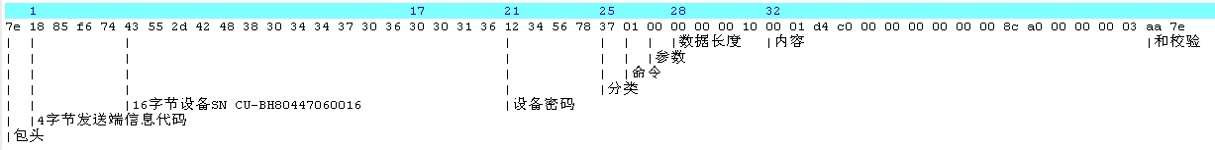

内容解释

信息内容：

|  |  |
| --- | --- |
| 第一部分(8b) | 第二部分(8b) |
| 排序卡区域容量信息 | 非排序卡区域容量信息 |

容量信息：

|  |  |
| --- | --- |
| 第一部分(4b) | 第二部分(4b) |
| 授权卡容量 | 已存数量 |

 授权卡号 8619835 0x00 83 87 3b 指令长度71

内容解释 4字节本次授权卡数量 + 0x21(卡信息长度33)*授权卡数量

7e 43 55 2d 42 48 38 30 34 34 37 30 36 30 30 31 36 12 34 56 78 19 c5 40 7d 07 04 00 00 00 00 25 00 00 00 01 00 00 83 87 3b ff ff ff ff 30 06 30 23 59 01 01 01 01 ff ff f0 00 00 00 00 00 00 00 00 00 00 00 00 78 7e

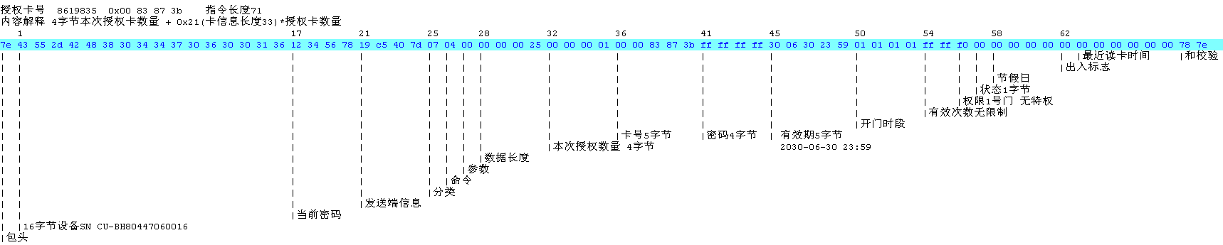

回复 ok

7e 19 c5 40 7d 43 55 2d 42 48 38 30 34 34 37 30 36 30 30 31 36 12 34 56 78 21 01 00 00 00 00 00 54 7e

