
MINISTRY OF EDUCATION, CULTURE AND RESEARCH
OF THE REPUBLIC OF MOLDOVA
Technical University of Moldova
Faculty of Computers, Informatics and Microelectronics
Department of Software Engineering and Automation

Cimendur Rustem
FAF-243

Process and Pipe Report
Laboratory work nr.7
of Operating Systems

Chisinau - 2026

Linux Processes Redirection and Pipes

Purpose of the work
I compiled and ran small C programs to examine how Linux creates a process, replaces its program, redirects standard output and connects commands through pipes. The experiments showed how a parent collects a child exit status and why every unused pipe descriptor must be closed. Both the two-stage and optional three-stage programs produced the same counts as their shell equivalents.

Environment and preparation
I worked in Ubuntu Linux inside VirtualBox, using Bash as vboxuser on host rustem. The terminal recorded kernel 7.0.0-38-generic and GCC 15.2.0 from the Ubuntu 15.2.0-16ubuntu1 package. The execution screenshots were taken on 24 October 2026; the guest displayed UTC.
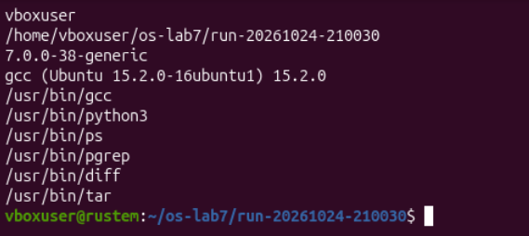
Figure 1.1. Linux account kernel compiler and required command paths
The working directory was /home/vboxuser/os-lab7/run-20261024-210030. The environment check found GCC, Python 3, ps, pgrep, diff and tar under /usr/bin. I kept the main terminal open for the experiments and used a second terminal to inspect the blocked pipeline.
The original run.c, redirect.c and pipeline.c followed the assignment. Separate files held the date, missing-command and deliberately broken-pipeline variants. zombie.c was derived from the original ls version, while pipeline3.c implemented the optional extension.

Part 1 Creating and replacing a process
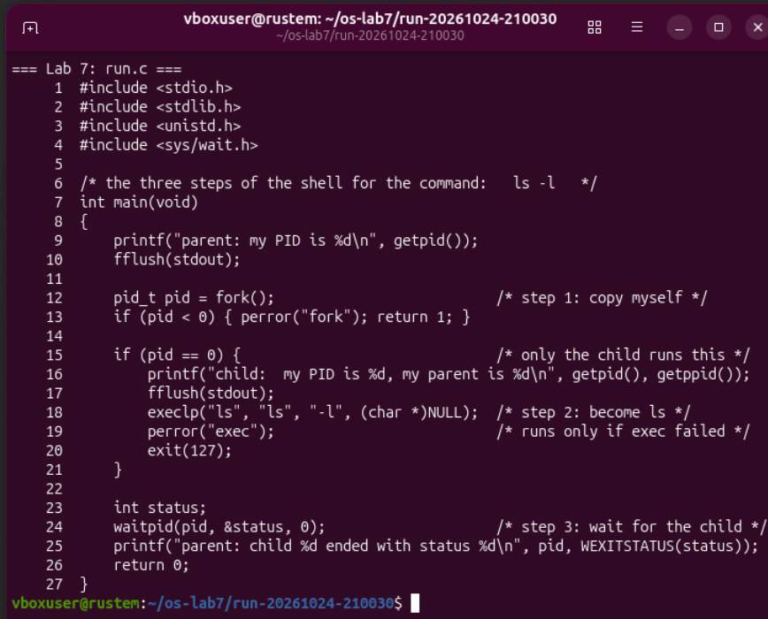
Figure 1.2. The original run program uses fork execlp and waitpid

How the program works
The parent prints its PID and flushes stdout before calling fork(). A negative return indicates failure, zero selects the child branch, and a positive return gives the child PID to the parent. The child prints its own PID and parent PID, then calls execlp("ls", "ls", "-l", (char *)NULL).
A successful exec replaces the child program while keeping its process identity. The parent calls waitpid(pid, &status, 0) and prints the collected exit status after the child finishes. Flushing the initial message before fork prevents that buffered text from being inherited and printed again by the child.

Running ls and changing the child to date
gcc -Wall -Wextra -o run run.c && ./run
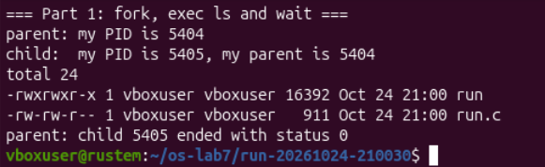
Figure 1.3. Parent 5404 waits for child 5405 which finishes with status zero
The original run showed parent PID 5404 and child PID 5405. The child identified 5404 as its parent, produced the directory listing, and ended with status 0. The parent printed its final message after the listing.
execlp("date", "date", (char *)NULL);
gcc -Wall -Wextra -o run_date run_date.c && ./run_date
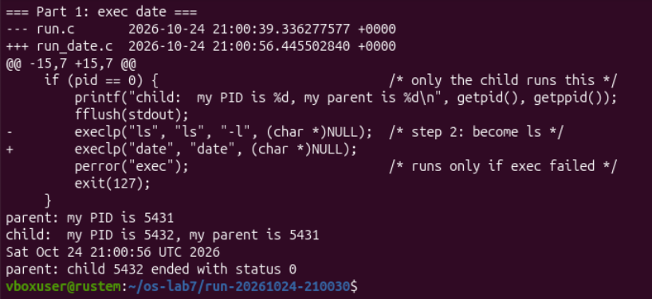
Figure 1.4. Changing one exec line runs date and still returns child status zero
The diff showed one changed source line in run_date.c. This run used parent PID 5431 and child PID 5432. The child printed Sat Oct 24 21:00:56 UTC 2026, and the parent collected status 0. The process-creation and waiting logic remained the same.

Exec failure and the collected exit status
execlp("nosuchprog", "nosuchprog", (char *)NULL);
gcc -Wall -Wextra -o run_bad run_bad.c && ./run_bad
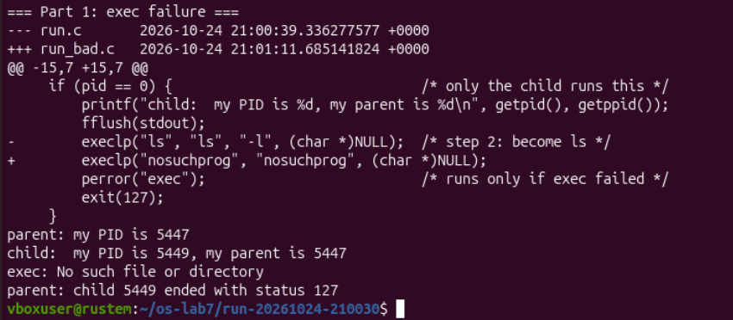
Figure 1.5. The missing command produces an exec error and child status 127

Observe 1 Why perror runs only after a failed exec
A successful execlp replaces the child process image and never returns to the next statement in this C program. With nosuchprog, the call failed and returned, so perror("exec") printed exec: No such file or directory. The child then executed the explicit exit(127). [2]

Observe 2 Which PID the child reports as its parent
The child prints the value returned by getppid(), which identifies the process that forked it. In the original run, child 5405 printed 5404, matching the parent message. The date and failure variants likewise showed 5431 and 5447 as their respective parent PIDs.

Observe 3 Statuses seen for ls and the missing command
The parent collected status 0 for ls and status 127 for nosuchprog. In the failure run, parent 5447 collected 127 from child 5449. This value came from the child error branch, rather than from an automatically assigned exec return status. The supplied parent still returns 0 from main after printing the child result.

Part 2 Creating a zombie deliberately
I copied the original ls program into zombie.c and inserted sleep(20) immediately before the parent calls waitpid. The child therefore finishes while its parent is sleeping.
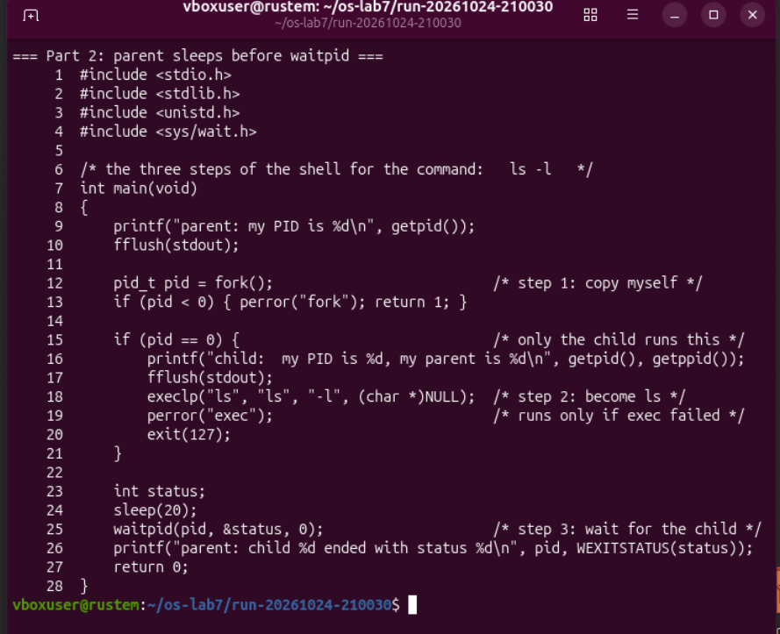
Figure 2.1. The zombie version delays the parent before waitpid at line 25
gcc -Wall -Wextra -o zombie zombie.c
./zombie > /dev/null &
sleep 2
ps -o pid,ppid,stat,cmd
Redirecting stdout to /dev/null kept the child listing out of the terminal. Running the program in the background allowed the shell to inspect the process table during the pause. I recorded the parent and child PIDs so the same child could be checked after the parent resumed.

Observing the zombie and collecting its status
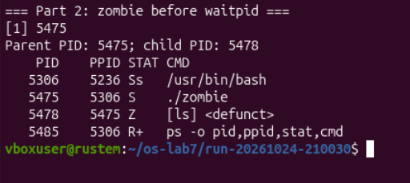
Figure 2.2. Parent 5475 is sleeping while child 5478 is a defunct ls process

Observe 1 Meaning of the STAT letter
The ls child, PID 5478 with parent PID 5475, had STAT Z and appeared as [ls] <defunct>. Z means zombie: the child has terminated, but its parent has not yet collected its termination status. The parent itself had STAT S because it was sleeping. [3]
sleep 20
wait "$LAB7_ZOMBIE_PID"
ps -o pid,ppid,stat,cmd
ps -p "$LAB7_CHILD_PID" -o pid,ppid,stat,cmd
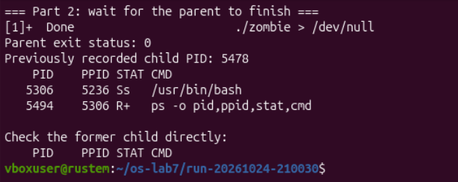
Figure 2.3. The parent finishes with status zero and child 5478 is no longer listed

Observe 2 Which line makes the zombie disappear
After the pause, the defunct child line was gone. The call waitpid(pid, &status, 0) at line 25 of zombie.c collected the child status and reaped it. The shell wait command separately waited for the background parent to finish; it was the waitpid inside that parent that reaped ls.

Part 3 Redirecting standard output
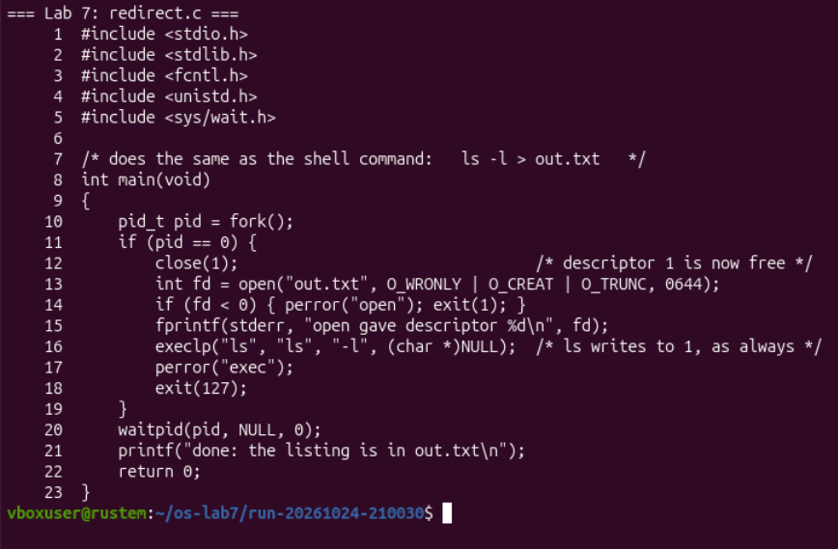
Figure 3.1. The redirection program closes stdout opens out.txt and then executes ls

Descriptor setup in the child
The child closes descriptor 1, then opens out.txt with O_WRONLY | O_CREAT | O_TRUNC. These flags request writing, create the file if necessary, and discard previous contents. The requested creation mode is 0644, subject to the process umask. The open call returns a descriptor which remains available when exec starts ls. [4]
The diagnostic uses fprintf(stderr, ...), so it follows descriptor 2. The parent has its own descriptor table and continues to print its done message to its original stdout after waiting for the child.
gcc -Wall -Wextra -o redirect redirect.c && ./redirect
head -3 out.txt
ls -l out.txt

Redirection output and separate diagnostics
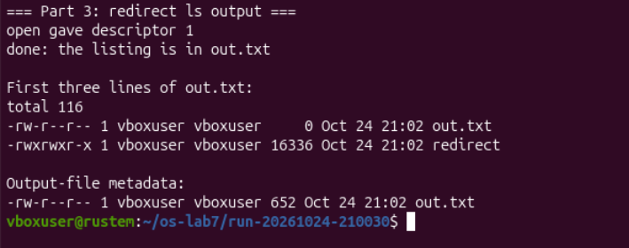
Figure 3.2. Open returns descriptor one and the completed out.txt contains 652 bytes
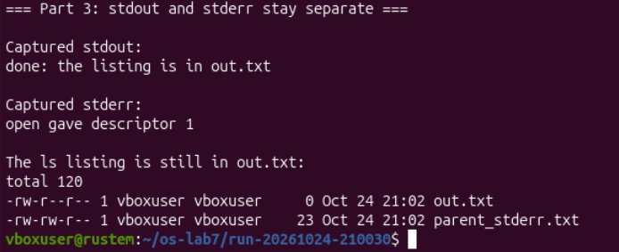
Figure 3.3. The parent message and descriptor diagnostic are captured separately

Observe 1 Why open returns descriptor one
The program printed open gave descriptor 1. Descriptor 1 had just been closed, while descriptors 0 and 2 remained open. Open selects the lowest unused descriptor, so the new file occupied slot 1. [4]

Observe 2 Why the unchanged ls writes to the file
Ls writes its listing to standard output, descriptor 1. The child had connected that descriptor to out.txt before exec, and ls inherited the connection. The screenshot showed the listing in the file, while the descriptor diagnostic stayed on stderr and the parent message stayed on its own stdout.

Observe 3 Which descriptor redirects errors
To redirect standard error in the same way as 2> err.txt, close descriptor 2 before opening err.txt. Assuming descriptors 0 and 1 remain open, the open call then reuses slot 2. The existing stdout connection can continue to display the normal listing.

Part 4 Connecting two child processes
The pipeline program creates one pipe, forks an ls child and a wc child, then closes both pipe descriptors in the parent and waits for both children.
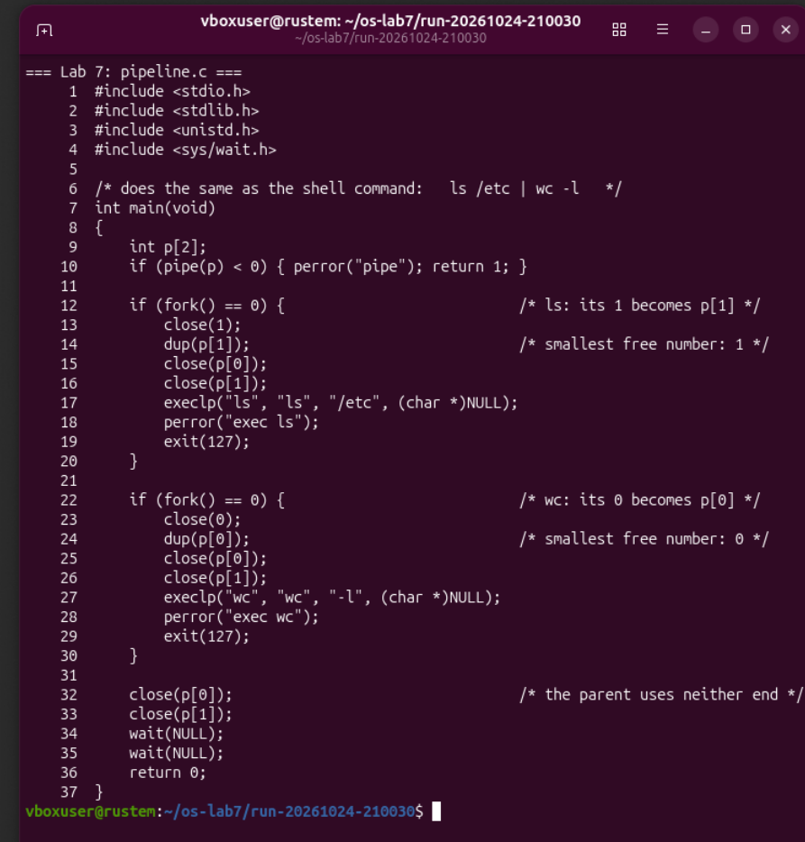
Figure 4.1. The two-stage pipeline connects ls stdout to wc stdin
In the ls child, closing descriptor 1 lets dup(p[1]) reuse it. In the wc child, closing descriptor 0 lets dup(p[0]) reuse it. Each child closes both original pipe descriptors after duplication. The retained standard descriptor continues to refer to the pipe. [5]

Comparing the pipeline and introducing a fault
gcc -Wall -Wextra -o pipeline pipeline.c
./pipeline
ls /etc | wc -l
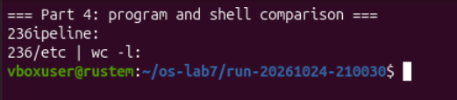
Figure 4.2. The program and shell pipeline each produce the count 236

Observe 1 Whether the two counts agree
Yes. Both ./pipeline and ls /etc | wc -l printed 236. The working version was run again after the interruption in Figure 4.6 and again matched the shell with status 0. These are newline counts from ls output under a pipe; the value depends on the directory contents.

Leaving the parent write end open
I created pipeline_broken.c by commenting out only the parent close of p[1]. Both child branches retained their original cleanup. The diff identified the single changed line at the end of main.
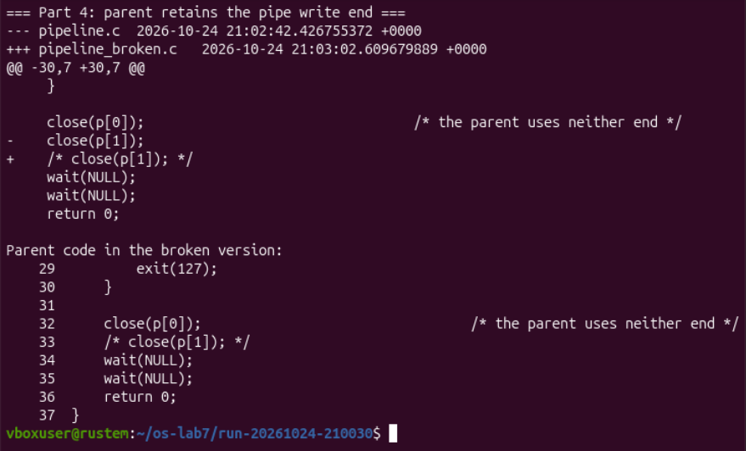
Figure 4.3. The broken variant omits only the parent close of the pipe write end

Inspecting the blocked pipeline
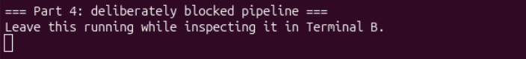
Figure 4.4. The broken program remains in the foreground without printing a count
While the program remained blocked in the main terminal, I used a second terminal to inspect its process tree and open descriptors. The process listing and /proc links identified the remaining reader and writer of the same pipe.
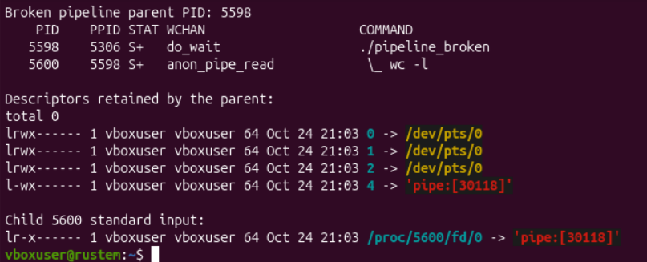
Figure 4.5. Parent 5598 retains pipe 30118 while wc 5600 waits to read it
Process | Observed state | Relevant descriptor
Parent 5598 | S+ with do_wait | fd 4 writes to pipe:[30118]
wc child 5600 | S+ with anon_pipe_read | fd 0 reads from pipe:[30118]

Observe 2 Which child never finishes
The wc child remained blocked. The inspection showed PID 5600 running wc -l in anon_pipe_read, while its parent, PID 5598, waited in do_wait. The ls child had already finished and was absent from the displayed process tree.

Observe 3 What wc is waiting for
Wc is waiting for EOF, which cannot arrive while the parent still holds an open descriptor for the pipe write end. [6]

Stopping the fault and restoring normal completion
I pressed Ctrl+C in the main terminal to stop the deliberately blocked foreground pipeline. I then ran the unmodified working program and compared it with the shell again.
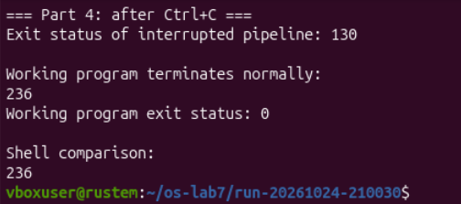
Figure 4.6. Ctrl+C yields status 130 and the working pipeline returns zero with count 236

Descriptor connections in the working program
Process | Standard input | Standard output | Original pipe ends
ls child | Inherited terminal | Pipe write end | Both closed
wc child | Pipe read end | Inherited terminal | Both closed
Parent | Inherited terminal | Inherited terminal | Both closed

The broken program was interrupted with shell status 130. The working program then printed 236 and returned status 0; the shell comparison also printed 236. This rerun confirmed normal termination when the parent closes its unused write descriptor.
After ls finishes writing and exits, the working program has no remaining pipe writers. Wc can consume the buffered data, observe EOF and print the final line count. The parent can then complete its waits. An empty pipe alone does not mean EOF while a write descriptor is still open. [6]

Part 5 Optional three-stage pipeline
I implemented ls /usr/bin | grep x | wc -l using two pipes and three children. The first pipe carries the listing to grep; the second carries matching lines from grep to wc.
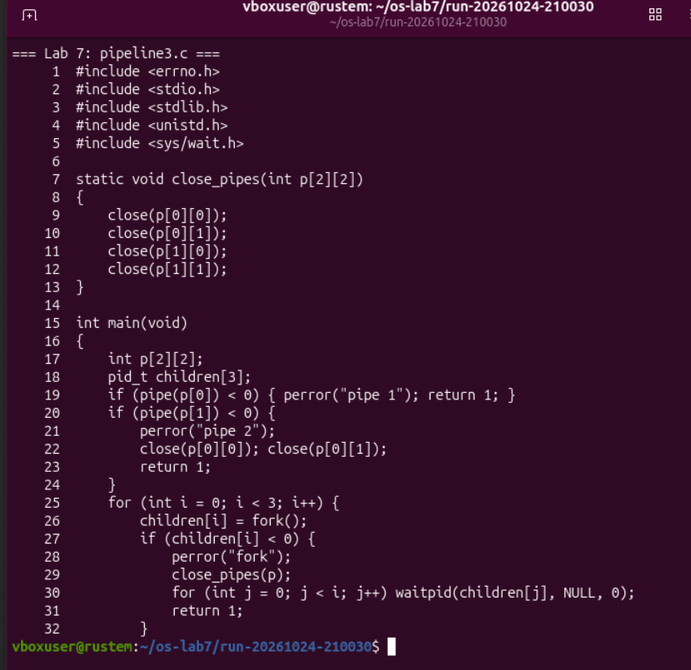
Figure 5.1. The optional source creates two pipes and forks three children

Creating the channels and children
The close_pipes helper closes all four original pipe descriptors. Main creates both pipes before the fork loop, so each child inherits the ends it needs. The loop index selects the command. If pipe creation or a fork fails, the parent closes its descriptors and waits for children already created.

Connecting and cleaning up the three stages
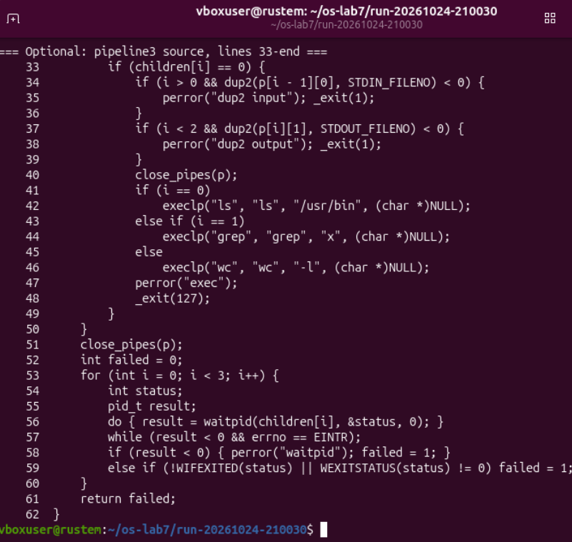
Figure 5.2. The children duplicate their required ends and all processes close the originals
For a child after the first stage, dup2(p[i - 1][0], STDIN_FILENO) connects its input to the preceding pipe. For a child before the last stage, dup2(p[i][1], STDOUT_FILENO) connects its output to the next pipe. Dup2 selects the destination descriptor explicitly. [5]
Each child calls close_pipes before its exec. The parent also closes all four ends and waits for each recorded PID, retrying waitpid if a signal interrupted it. The program checks whether every child exited normally with status 0; a failed exec reports an error and exits with 127.

Optional results and conclusions
gcc -Wall -Wextra -o pipeline3 pipeline3.c
./pipeline3
ls /usr/bin | grep x | wc -l
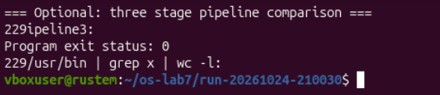
Figure 5.3. Both three-stage pipelines print 229 and the program exits with status zero
The optional C program and the shell pipeline each printed 229. The program returned status 0. This matched the required data flow through two pipes, with three children and all unused original descriptors closed.

Conclusions
The experiments connected shell behavior with process and descriptor operations. Fork created the child; exec replaced its program; waitpid collected its exit status and removed a zombie after the deliberate pause. Closing stdout and opening a file made the unchanged ls program write its listing into out.txt.
The pipeline fault showed why cleanup affects completion: the parent retained a write descriptor, leaving wc waiting for EOF. Closing unused ends allowed both working pipelines to finish and match the shell counts of 236 and 229.

References
1. Operating Systems, FCIM / FAF, Technical University of Moldova. Lab 7, Three Small Programs: Processes, Redirection, a Pipe. Track A, 2026-2027. Supplied assignment. Experimental outputs are recorded in Figures 1.1 to 5.3.
2. Linux manual pages exec program replacement
3. Linux manual pages wait and waitpid
4. Linux manual pages open and descriptor allocation
5. Linux manual pages dup and dup2
6. Linux manual pages pipes and EOF

