
MINISTRY OF EDUCATION, CULTURE AND RESEARCH
OF THE REPUBLIC OF MOLDOVA
Technical University of Moldova
Faculty of Computers, Informatics and Microelectronics
Department of Software Engineering and Automation

Cimendur Rustem
FAF-243

xv6 Processes and Pipes
Laboratory work nr.8
of Operating Systems

Chisinau - 2026

The Same Calls Inside xv6

Purpose of the work
I built and ran xv6 programs to repeat the process operations studied on Linux in Lab 7. The run program created a child, replaced its program with echo or ls, and collected its exit status. I then used two pipes for a byte exchange between a parent and child and completed the optional process pipeline that prints primes from 2 to 35.

Environment and preparation
I worked as vboxuser on host rustem in Ubuntu Linux inside VirtualBox. The screenshots record 24 October 2026 in UTC. The xv6 source tree was /home/vboxuser/xv6-riscv, revision 06aad25. The environment check reported Linux 7.0.0-38-generic, RISC-V GCC 15.2.0 and QEMU 10.2.1.
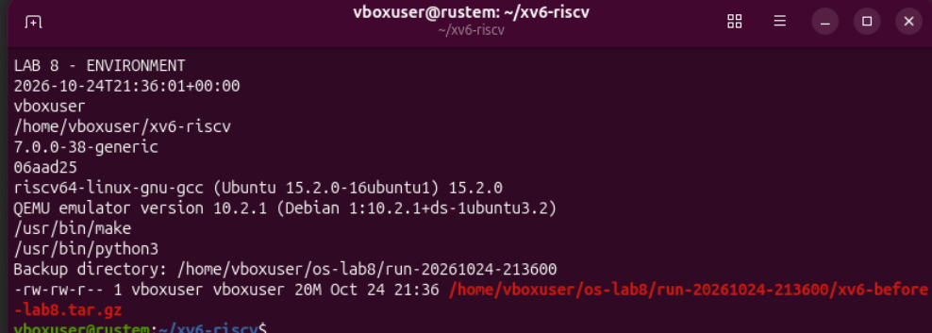
Figure 1.1. Linux environment xv6 revision tool versions and backup archive
Before editing, I saved a 20 MB backup under /home/vboxuser/os-lab8/run-20261024-213600. The existing tree already contained the programs from earlier xv6 laboratories.
cd ~/xv6-riscv
make qemu
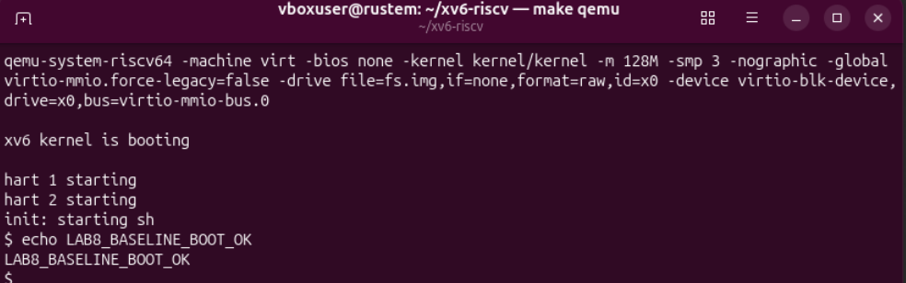
Figure 1.2. The existing xv6 tree boots and prints the baseline confirmation
The kernel started its harts, init launched sh, and echo LAB8_BASELINE_BOOT_OK printed the requested marker. I left QEMU with Ctrl+A followed by X before editing Linux-side source files.

Part 1 Creating and replacing a process
I created user/run.c with the assignment implementation. The two xv6 headers provide the types and user interface required by this program; no Linux glibc headers are used.
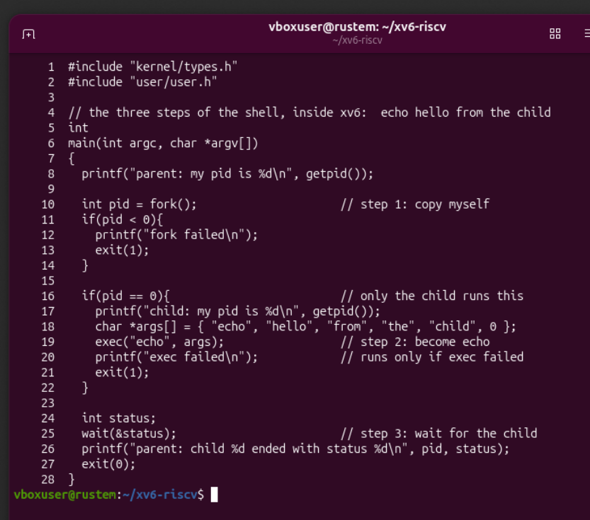
Figure 1.3. The original run source calls fork exec and wait

Process lifecycle in the source
The parent prints its PID before fork(). A negative return selects the failure branch, zero selects the child branch, and the positive return in the parent identifies the child. The child prints its own PID and calls exec("echo", args) with a zero-terminated argument array.
On success, exec replaces the child program while keeping its PID. The exec failed diagnostic is reached only if exec returns with a failure. The parent calls wait(&status) and prints the status collected after the child terminates.

Registering and running the echo version
I added the run executable to the Makefile UPROGS list. The entry starts with a tab and ends with a continuation backslash. The displayed ^I represents the tab, while $ marks the end of the displayed line.
make kernel/kernel fs.img
make qemu
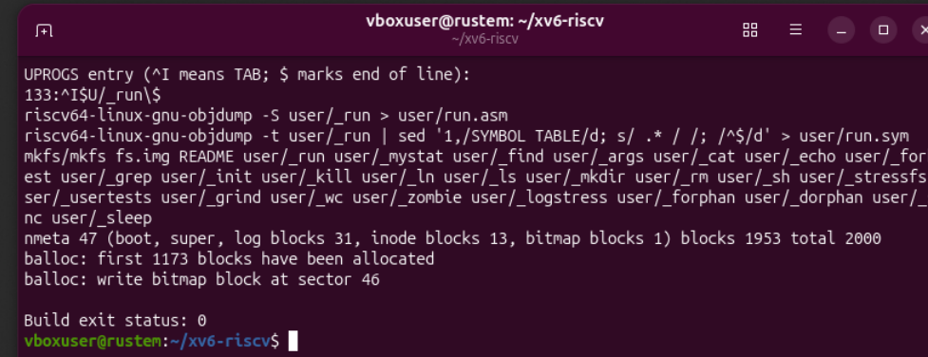
Figure 1.4. The run entry is registered and the build exits with status zero
The image builder included user/_run alongside the existing programs. Its output reported 2,000 filesystem blocks, with 47 metadata blocks and 1,953 blocks in the data region. The build exit status was 0.
run
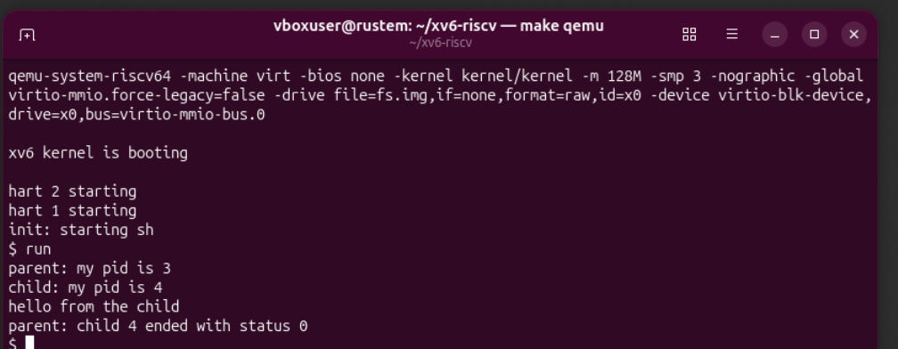
Figure 1.5. Parent three collects status zero after child four runs echo
The parent reported PID 3 and the child reported PID 4. The line hello from the child appeared before the parent collected child 4 with status 0. The returned shell prompt showed that the experiment completed.

Replacing the child with ls
I changed the argument array to { "ls", 0 } and the executable path to "ls", then rebuilt and booted xv6. The fork and wait logic remained unchanged.
char *args[] = { "ls", 0 };
exec("ls", args);
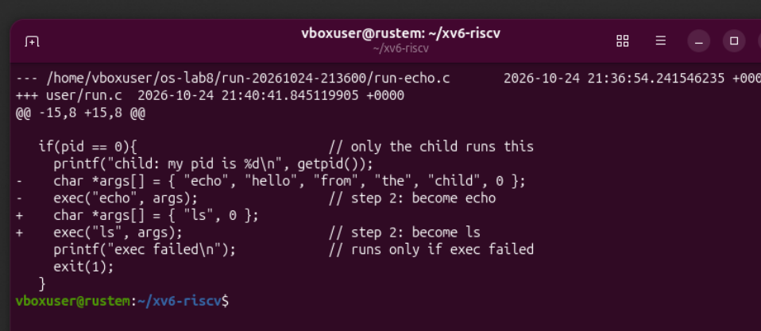
Figure 1.6. The diff changes the argument array and executable from echo to ls
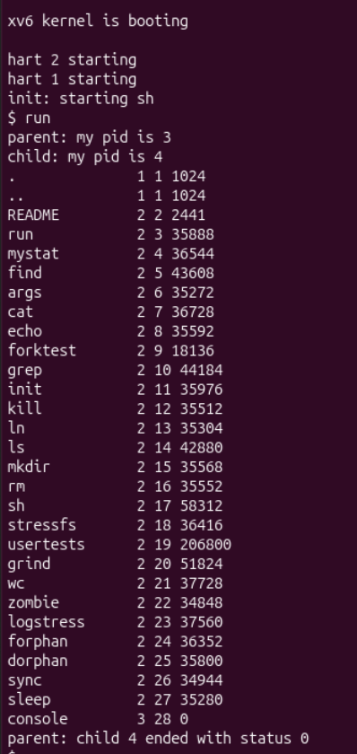
Figure 1.7. Child four produces the xv6 directory listing and finishes with status zero
The listing included run, mystat, find, args and sleep. Parent PID 3 collected child PID 4 with status 0. The output therefore changed with the executed program while the surrounding lifecycle stayed the same.

A failed exec and the collected exit status
For the failure experiment, I changed only the executable pathname to nosuchprog. The argument array still began with ls; exec failed while trying to open the nonexistent pathname, before any replacement program could run.
exec("nosuchprog", args);
make qemu
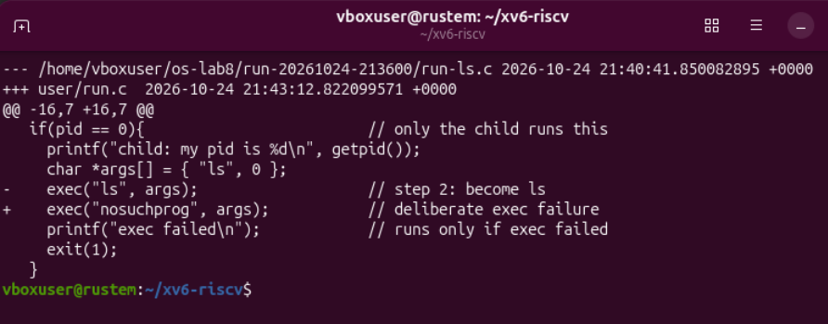
Figure 1.8. Only the exec pathname changes to the deliberately missing program
run
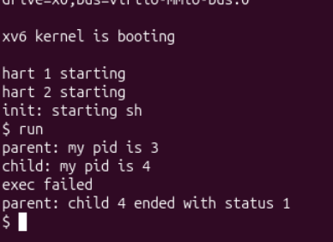
Figure 1.9. The failed exec reaches the diagnostic and the child exits with status one
Parent PID 3 created child PID 4. The child printed exec failed, executed the explicit exit(1) at line 21, and the parent reported status 1. The child did not become ls or another program in this test.

Why the error message is reachable
A successful exec does not return to the old run code because that program image has been replaced. A failed exec returns to the caller, leaving the old program in place. That is why the following diagnostic and exit statement execute only in the failure case.

Restoring run and answering the Part 1 observations
cp "$LAB8_SAVE/run-echo.c" user/run.c
cmp "$LAB8_SAVE/run-echo.c" user/run.c
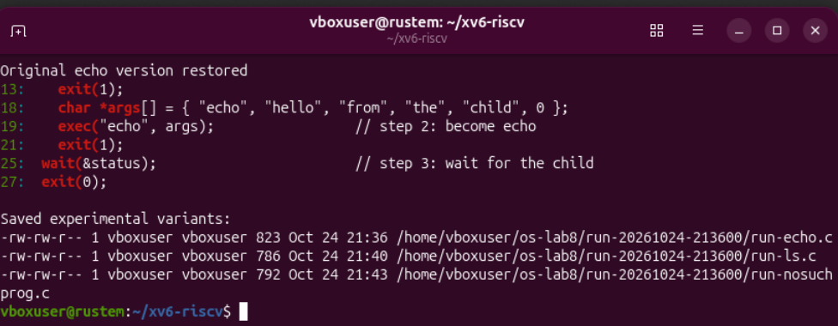
Figure 1.10. The final run source is restored to echo and all three variants are retained
The comparison confirmed that the original echo source was restored. Separate copies retained the echo, ls and nosuchprog variants for the experimental record. The later runtime check in Figure 2.4 also confirmed the restored behavior.

Observe 1 Calls in xv6 and Linux
The xv6 program uses fork(), exec() and wait(). The Linux Lab 7 program used fork(), execlp() and waitpid(). Both create a child, replace its program and collect its termination status. Their interfaces differ: xv6 exec takes an argument array, Linux execlp takes a variadic argument list and searches PATH, and waitpid can select a particular child PID. The xv6 wait used here collects a child without a PID-selection argument.

Observe 2 Who prints the child greeting
The echo program prints hello from the child. The run program supplies those words in its argument array, but its own code prints only the parent and child diagnostics. After a successful exec, the child executes echo in place of run.

Observe 3 Why the failure status differs from Linux
The xv6 failure branch explicitly calls exit(1), so the parent receives status 1. In Lab 7, the Linux failure branch explicitly called exit(127), and the parent collected 127. These values were chosen in the application code; a failed exec does not itself terminate the caller with either value.

Part 2 Exchanging a byte through two pipes
I completed user/pingpong.c using p2c for parent-to-child traffic and c2p for the reply. The byte was initialized to x. The implementation checks pipe creation, fork, and the one-byte reads and writes, and closes each used end after its transfer.
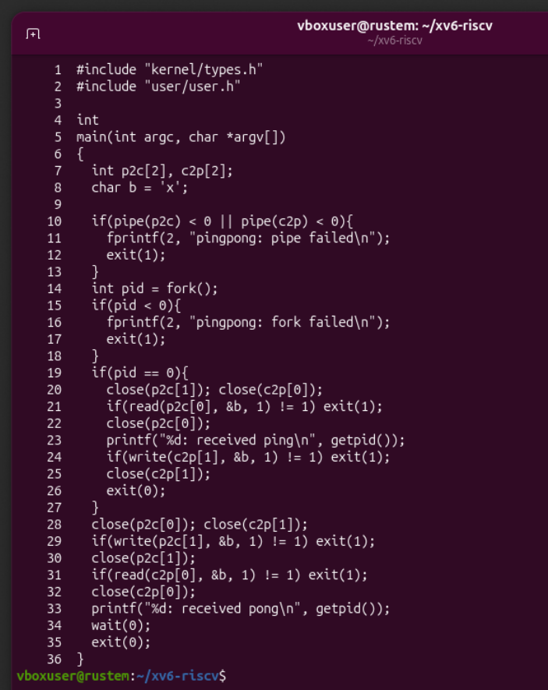
Figure 2.1. The complete pingpong source connects the parent and child with two pipes
In the child, the unused p2c write end and c2p read end are closed first. In the parent, the complementary ends are closed. The child prints ping after receiving the byte, writes that byte back, and exits. The parent reads the reply, prints pong and collects its child with wait(0).

Building pingpong and observing the first exchange
make kernel/kernel fs.img
make qemu
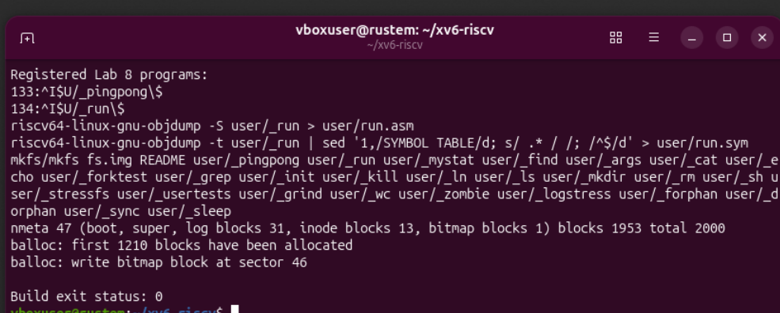
Figure 2.2. Both run and pingpong are registered and the rebuilt image succeeds
The Makefile showed pingpong at line 133 and run at line 134, each with the required tab and continuation backslash. The image build included both executables and reported exit status 0.
pingpong
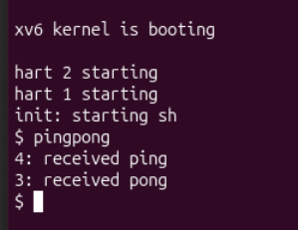
Figure 2.3. Child four receives ping before parent three receives pong
The first exchange printed 4: received ping followed by 3: received pong. The prompt returned after both messages. The printed PIDs identify child 4 as the receiver of the first byte and parent 3 as the receiver of the reply.

Observe 1 Why two pipes are used
Each pipe provides a byte stream with a read end and a write end. The first pipe carries the parent message to the child; the second carries the child reply to the parent. Separate streams ensure that each process reads the message intended for it. Using one shared stream for both directions would allow a process to consume its own message and would not reliably route the reply.

Repeated exchanges and the blocking read
pingpong
pingpong
pingpong
run
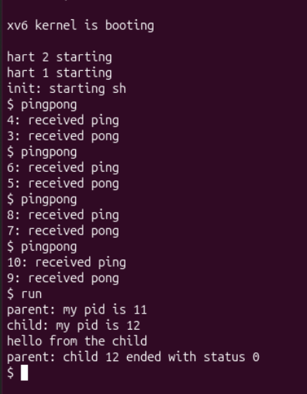
Figure 2.4. Repeated exchanges finish and the restored run program executes echo
The screenshot contains four exchanges, including the preceding run. The child and parent PID pairs were 4 and 3, 6 and 5, 8 and 7, and 10 and 9. Ping appeared before pong in every exchange. The subsequent run used parent PID 11 and child PID 12, printed the echo greeting, and reported child status 0.

Observe 2 Which call waits for the reply
The parent blocks in read(c2p[0], &b, 1) while the reply pipe is empty and a write end remains open. The child prints ping before writing the reply byte, so the parent can print pong only after that write makes the read complete. The later wait(0) collects the child termination; the read provides the synchronization for the byte exchange.
The pipe ends are closed as soon as their role is complete. This keeps descriptor ownership clear and permits EOF when all write references to a stream have been closed. The program does not use a timed delay to establish the ping-before-pong order.

Part 3 Optional prime filtering pipeline
I implemented the optional user/primes.c program. The initial process writes integers 2 through 35 to a pipe. Each filter process reads its first integer as a prime, prints it, and passes only numbers not divisible by that prime to the next stage.
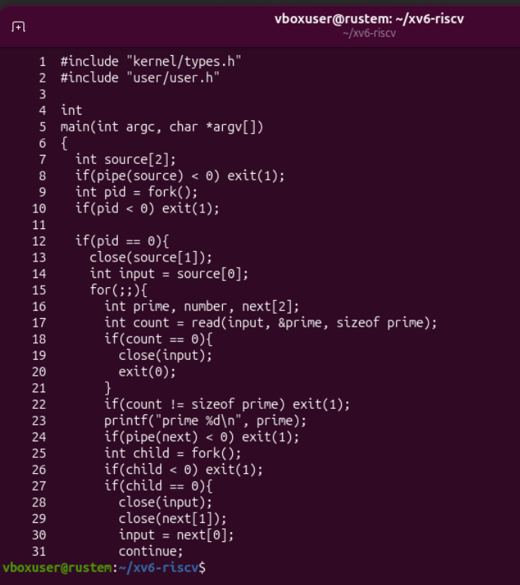
Figure 3.1. The first half creates the input stream and the next filter process

Creating each stage
After reading and printing its prime, a stage creates another pipe and forks. The new child closes the previous input, retains the new read end and continues the loop as the next filter. The current stage closes the new read end and becomes the producer for that child. An input EOF closes the descriptor and ends the final stage.

Forwarding candidates and closing the pipeline
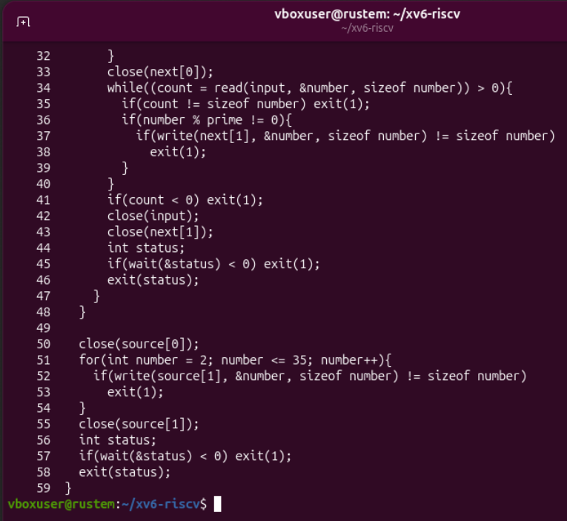
Figure 3.2. The second half filters numbers closes descriptors and waits for descendants
The filtering loop sends a candidate only when number % prime != 0. Every read and write transfers sizeof(int) bytes, with checks for incomplete operations. After its input reaches EOF, the stage closes that input and the next pipe write end, waits for its child, and propagates the collected status.
The original producer closes the source read end, writes all integers from 2 through 35, closes the write end and waits. Closing the write end is essential: it lets the filter chain consume the remaining data and observe EOF instead of waiting indefinitely. Each child discards the preceding input descriptor before taking over its new stream.

Building primes and checking its output
make kernel/kernel fs.img
make qemu
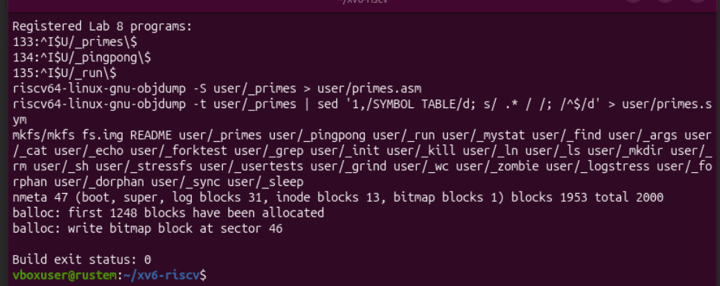
Figure 3.3. Primes pingpong and run are registered and the image build succeeds
The Makefile showed primes at line 133, pingpong at 134 and run at 135. The image builder included all three programs and reported build exit status 0. At this stage the initial filesystem allocation reached block 1248, while total image capacity remained 2,000 blocks.
primes
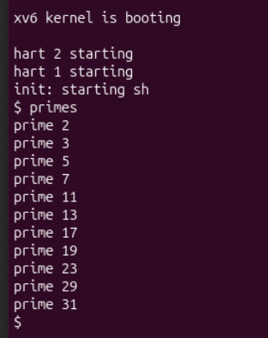
Figure 3.4. The process chain prints all eleven primes between two and thirty five
The output was 2, 3, 5, 7, 11, 13, 17, 19, 23, 29, 31, each preceded by prime on its own line. There were no composite values or duplicate primes. The xv6 shell prompt returned after the chain finished.

Part 4 Recording the required answers
I saved the answers to the assignment Observe questions in notes.md. The file records the comparison with Linux, the program responsible for the greeting, the explicit failure statuses, the two pipe directions and the blocking read that waits for the reply.
cat notes.md
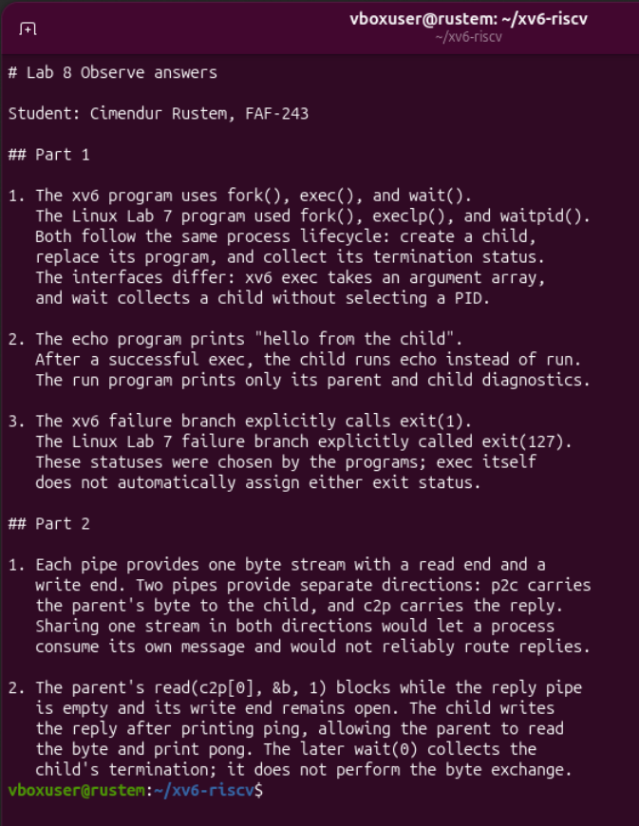
Figure 4.1. The notes file contains all three Part 1 answers and both Part 2 answers

Conclusions
I repeated the Linux process lifecycle inside the xv6 kernel that I built. Fork created the child, exec replaced its program, and wait collected its exit status. The echo and ls experiments ended with status 0; the deliberately missing executable reached the error branch and ended with the explicit status 1. Restoring the original source returned run to its required echo behavior.
The pingpong experiment demonstrated bidirectional communication using two independent pipe streams. Every recorded child printed ping before its parent printed pong. The ordering followed from the parent blocking on the reply read and the child writing only after its ping message, without requiring a timed delay.
The optional prime pipeline extended the same process and pipe mechanisms to a chain of filters. It printed all eleven primes from 2 through 35 and returned to the shell. Closing unused descriptors and completed write ends let the stages receive EOF and terminate. The final program registrations and notes file accompany the experimental results documented in Figures 1.1 through 4.1.

References
1. Operating Systems, FCIM / FAF, Technical University of Moldova. Lab 8, The Same Calls, Inside Your Own OS. Track B, 2026-2027. Supplied assignment.
2. Cimendur Rustem. Laboratory work 7, Linux Processes Redirection and Pipes. The Linux source and report establish the fork, execlp and waitpid comparison and the explicit exit status 127.
3. MIT PDOS. xv6 RISC-V source revision 06aad25. User system call declarations in user/user.h and program registration and image construction in Makefile.
https://github.com/mit-pdos/xv6-riscv/tree/06aad25

