
MINISTRY OF EDUCATION, CULTURE AND RESEARCH
OF THE REPUBLIC OF MOLDOVA
Technical University of Moldova
Faculty of Computers, Informatics and Microelectronics
Department of Software Engineering and Automation

Cimendur Rustem
FAF-243

xv6 File System Report
Laboratory work nr.6
of Operating Systems

Chisinau - 2026

Inside the xv6 File System

Purpose of the work
I examined the xv6 filesystem through its directory listings and source code, then implemented two user programs. mystat displayed inode metadata for named paths, and find recursively searched directory entries by name. I used the results to explain hard links, inode reclamation, fixed-size directory entries and the limits of the on-disk block-addressing scheme.

Environment and preparation
I worked as vboxuser on the Linux host rustem, using the source tree /home/vboxuser/xv6-riscv at revision 06aad25. The environment check found Make, the RISC-V GCC cross compiler, QEMU and Python 3. I saved a backup before rebuilding the guest filesystem image.
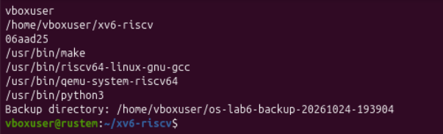
Figure 1.1. Linux account, xv6 revision, required tools and backup directory
Item | Recorded value
Student | Cimendur Rustem, FAF-243
Source revision | 06aad25
Working tree | /home/vboxuser/xv6-riscv
Backup directory | /home/vboxuser/os-lab6-backup-20261024-193904
Execution environment | RISC-V xv6 in QEMU; Linux Bash for source editing and builds

The report groups the experiments by assignment part. Figure numbering restarts in each part. The two programs were compiled into the image before the runtime tests, and fresh images separated the link, limits and recursive-search experiments.

Part 1 Read what xv6 shows
cat kernel/stat.h
grep -nE "ROOTINO|DIRSIZ" kernel/fs.h
sed -n '/^struct dirent/,/^};/p' kernel/fs.h
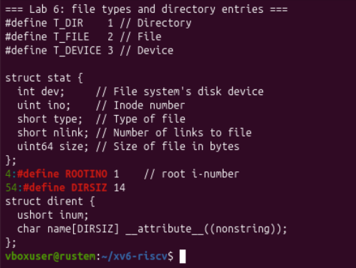
Figure 1.2. File type constants, stat fields, root inode and directory-entry layout

Observe 1 Meanings of the three type numbers
Value | Constant | Meaning
1 | T_DIR | Directory
2 | T_FILE | Regular file
3 | T_DEVICE | Device

The definitions came from kernel/stat.h. Each ls row contained a name followed by type, inode number and size in bytes. These type values described the object, while the inode number identified which object the directory entry referred to.
The same header declared struct stat with device, inode number, type, hard-link count and byte size. The mystat program used this public metadata interface in Part 2.

Root directory and fixed size entries
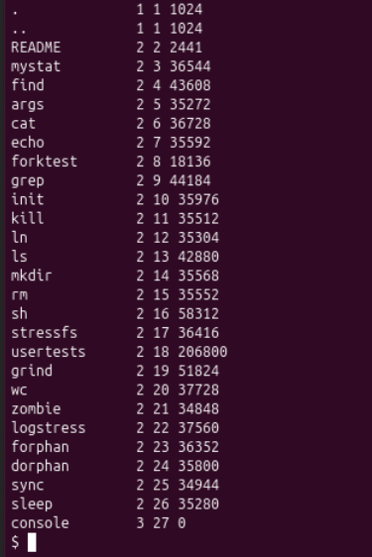
Figure 1.3. Root listing with inode one and the newly built mystat and find executables

Observe 2 Why dot and dot-dot have the same inode at root
The root listing showed both . and .. as type 1, inode 1, size 1024 bytes. ROOTINO was also defined as 1 in kernel/fs.h. The dot entry refers to the current directory; at the root, dot-dot refers back to the root itself because there is no directory above it in the xv6 namespace.

Observe 3 The size of one directory entry
An empty directory of 32 bytes contains two 16-byte entries: . and ... Each struct dirent contains a 2-byte ushort inum and a 14-byte name array (DIRSIZ = 14), giving 16 bytes per entry. The newly created long-name directory in Figure 3.3 also had a size of 32 bytes, providing a runtime example of this empty-directory size.

Part 2 Write mystat
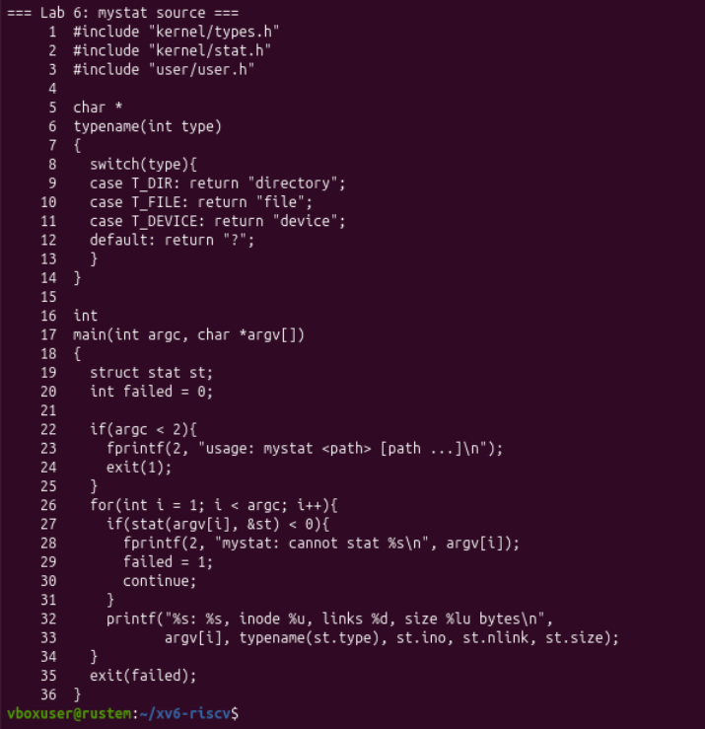
Figure 2.1. Complete mystat implementation with type names and per-path error handling

How the program works
The typename function maps T_DIR, T_FILE and T_DEVICE to readable strings. The main loop calls stat(argv[i], &st) for every supplied path. For a successful call, it prints the path, type, inode number, link count and byte size. The format uses %u for the unsigned inode number and %lu for the 64-bit size on this RISC-V target.
With no path arguments, the program prints usage to file descriptor 2 and exits with status 1. A failed stat also writes its diagnostic to descriptor 2, sets failed, and continues to later arguments. The final exit(failed) preserves failure information without abandoning the remaining paths.

Registering and building the programs
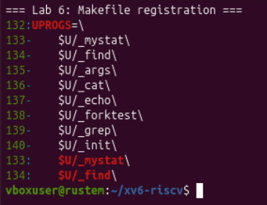
Figure 2.2. UPROGS includes mystat at line 133 and find at line 134
I added user/mystat.c and user/find.c, then registered $U/_mystat and $U/_find in UPROGS. The screenshot showed the new entries immediately before the existing args and cat entries. Each Makefile continuation line retained its leading tab and trailing backslash.
make clean
make kernel/kernel fs.img
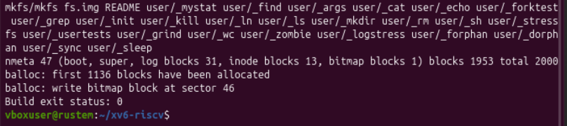
Figure 2.3. Filesystem creation reports the disk layout and build exit status zero
The build succeeded with exit status 0. The mkfs command included both new programs, and the resulting image booted into the xv6 shell. The runtime root listing in Figure 1.3 showed mystat as inode 3 with 36,544 bytes and find as inode 4 with 43,608 bytes.

Metadata output and error handling
mystat README . console
mystat missing README console
mystat
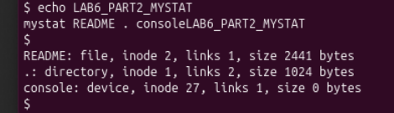
Figure 2.4. mystat reports a regular file, the current directory and a device
Path | Type | Inode | Links | Size in bytes
README | file | 2 | 1 | 2441
. | directory | 1 | 2 | 1024
console | device | 27 | 1 | 0

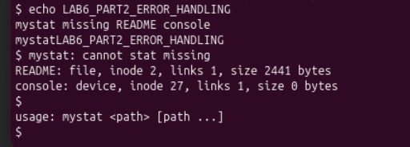
Figure 2.5. A missing path produces an error while subsequent paths are processed
The invalid path printed mystat: cannot stat missing, but the same invocation continued to report README and console. Calling mystat without arguments printed its usage message. These outputs confirmed both continuation after a path error and argument validation.

Watching hard links at work
ln README r2
mystat README r2
rm README
mystat README r2
cat r2 | wc
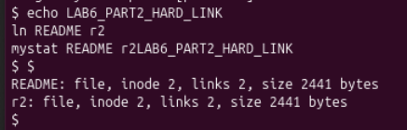
Figure 2.6. README and r2 share inode two with two hard links
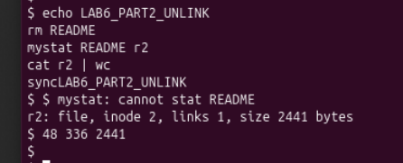
Figure 2.7. After removing README the remaining name still reads the same file

Observe 1 What changed after ln and rm
Stage | Names available | Inode | Link count | File size
Before linking | README | 2 | 1 | 2441 bytes
After ln | README, r2 | 2 for both | 2 | 2441 bytes
After rm README | r2 | 2 | 1 | 2441 bytes

Creating the link added a directory name and increased nlink; it did not copy the contents into a different inode. Removing README made that pathname fail, but r2 retained inode 2, the same size and the original data. The final pipeline reported 48 lines, 336 words and 2441 bytes.

Unlinking a name in the kernel
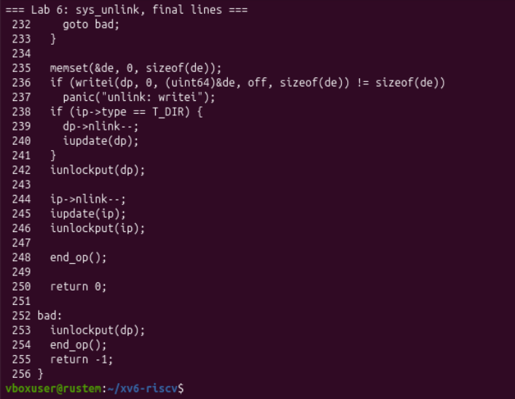
Figure 2.8. sys_unlink clears a directory entry and decrements the inode link count

Observe 2 Where the link count is decremented
In kernel/sysfile.c, the file inode link count was decremented by ip->nlink-- at line 244. The next lines called iupdate(ip) and iunlockput(ip). Earlier lines zeroed the directory entry and wrote it back to the parent directory. The separate dp->nlink-- at line 239 applied when removing a directory; it adjusted the parent directory link count.
The decrement alone did not imply that the contents were immediately freed. In the README experiment, the count remained 1 after removal because r2 still named the inode. Reclamation also depends on the final in-memory reference, which the iput implementation checks in Figure 2.9.

When the inode and blocks are reclaimed
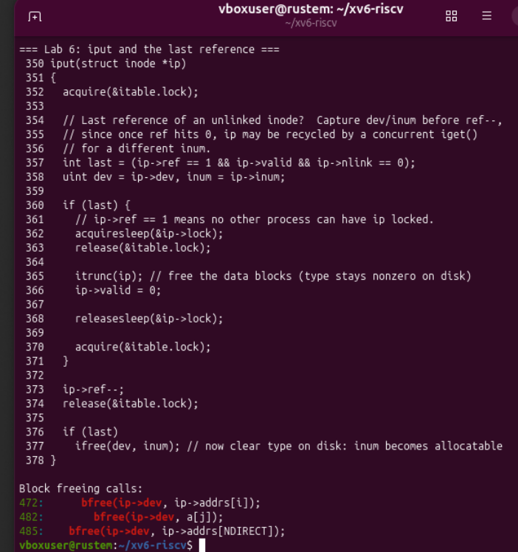
Figure 2.9. iput checks the last reference and itrunc releases the data blocks
At line 357 in kernel/fs.c, iput computed the following condition:
ip->ref == 1 && ip->valid && ip->nlink == 0
This identifies a valid unlinked inode whose final in-memory reference is being released. When the condition holds, line 365 calls itrunc(ip) to release its contents. Line 377 calls ifree(dev, inum) to make the on-disk inode allocatable again.
The displayed bfree calls in itrunc were at lines 472, 482 and 485. They release direct data blocks, data blocks reached through the indirect block, and the indirect block itself. An open descriptor can keep an unlinked inode referenced; the data can be reclaimed when no hard links remain and the final reference is dropped.

The on disk inode structure
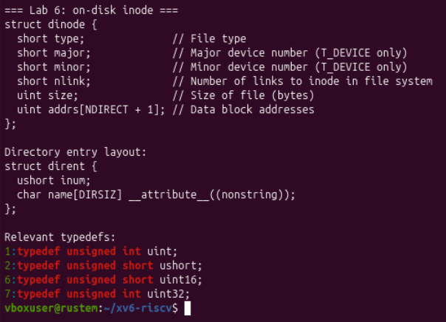
Figure 2.10. dinode stores file metadata and block addresses while dirent stores names

Observe 3 Fields present in an xv6 inode
Field | Meaning
short type | Directory, regular-file or device type
short major | Major device number, meaningful for a device inode
short minor | Minor device number, meaningful for a device inode
short nlink | Number of hard links to the inode
uint size | File size in bytes
uint addrs[NDIRECT + 1] | Twelve direct block addresses and one indirect-block address

The structure contained no Unix owner ID, group ID or permission-mode field, and the unmodified type definitions contained no symbolic-link type. The filename belonged to struct dirent, rather than to struct dinode. This separation allowed README and r2 to be different names for the same on-disk object.

Part 3 Measure the limits
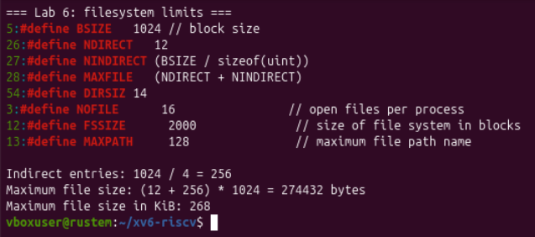
Figure 3.1. Local filesystem constants and the maximum-file-size calculation

Observe 2 Largest file supported by the block addresses
The source defined BSIZE = 1024, NDIRECT = 12, and NINDIRECT = BSIZE / sizeof(uint). A block number is a 4-byte unsigned integer on this target. One indirect block therefore holds 256 block numbers.
Indirect entries = 1024 / 4 = 256
Maximum data blocks = 12 + 256 = 268
Maximum file size = 268 * 1024 = 274432 bytes
274432 / 1024 = 268 KiB
The maximum file payload was therefore 274,432 bytes, or 268 KiB. The indirect block itself stores block addresses; its storage does not add another block of file payload. This calculation describes the per-inode addressing limit, while the availability of free disk blocks can impose an additional practical constraint.
Constant | Observed value | Role
DIRSIZ | 14 | Maximum stored component-name length
NOFILE | 16 | Open descriptors per process
MAXPATH | 128 | Kernel pathname-buffer limit
FSSIZE | 2000 | Filesystem image size in blocks

Disk layout reported by mkfs
make clean
make kernel/kernel fs.img
grep nmeta "$LAB6_SAVE/build-limits.log"
make qemu
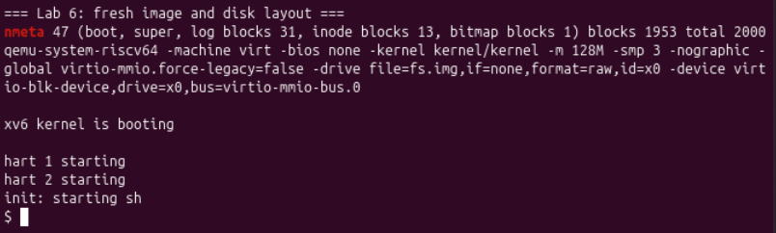
Figure 3.2. A rebuilt image reports 47 metadata blocks and 1953 data-region blocks

Observe 3 Total log inode and data blocks
The build printed nmeta 47, log blocks 31, inode blocks 13, bitmap blocks 1, data blocks 1953, and total blocks 2000. Using the layout order declared in kernel/fs.h, these counts give the following block ranges.
Region | Block range | Count
Boot block | 0 | 1
Superblock | 1 | 1
Log | 2 to 32 | 31
Inode table | 33 to 45 | 13
Free-block bitmap | 46 | 1
Data region | 47 to 1999 | 1953

Metadata = 1 + 1 + 31 + 13 + 1 = 47 blocks
Total = 47 + 1953 = 2000 blocks
Image capacity = 2000 * 1024 = 2048000 bytes
The 1953 blocks describe the data region, including blocks already used for the initial directories and program files. They are not a count of free blocks. The initial build in Figure 2.3 separately reported that the first 1136 blocks had been allocated.

The directory name length limit
mkdir averyveryverylongname
ls
mystat averyveryveryl
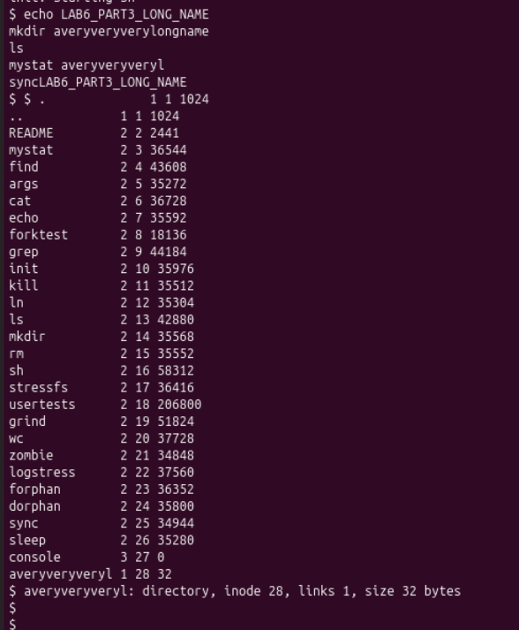
Figure 3.3. The long directory name is stored as fourteen characters and has size 32

Observe 1 What happened to the long name
The listing displayed averyveryveryl, the first 14 characters of averyveryverylongname. DIRSIZ = 14 explains this truncation. mystat averyveryveryl reported a directory at inode 28, link count 1 and size 32 bytes. This newly created directory also demonstrated the two-entry empty-directory size explained in Part 1.

Part 4 Write find
I implemented a recursive name search in user/find.c, using user/ls.c as the model for reading directory entries. The program also accepted the optional -n argument, which printed each matching path together with its inode number.
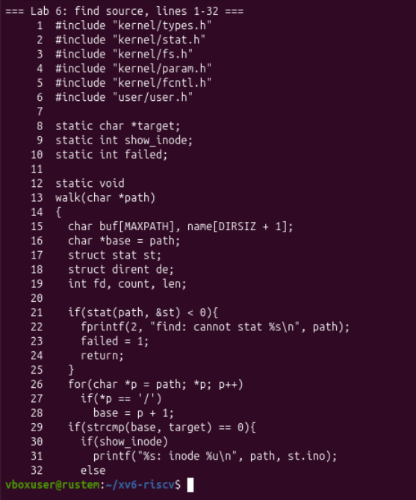
Figure 4.1. find reads metadata and compares the final path component with the target

Matching a path
The program calls stat before examining a path. It locates the final component by scanning for slashes, then uses strcmp to compare that component with the target. A match prints the path, or the path and inode when show_inode is enabled. Regular files and devices return after this check; only directories are traversed.

Reading entries and descending into directories
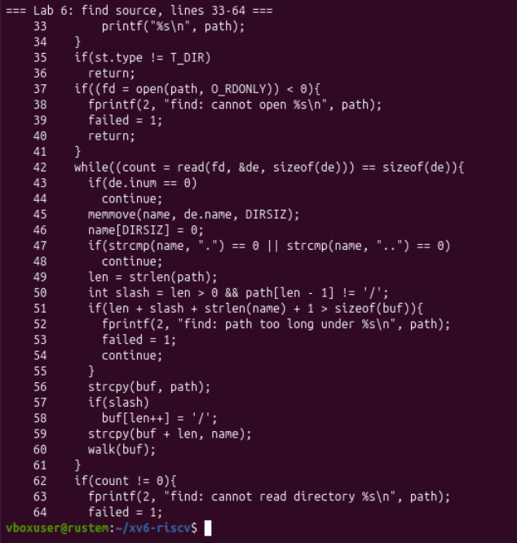
Figure 4.2. find skips unused entries dot and dot-dot and builds bounded child paths
For a directory, walk opens the path read-only and reads one struct dirent at a time. An entry with inum == 0 is a free slot and is skipped. The program copies all DIRSIZ bytes into a buffer with one additional byte, explicitly terminates the name, and skips both . and ... This avoids following the directory self and parent entries into an endless traversal.
For each remaining entry, it checks that the parent path, optional slash, name and terminating NUL fit within MAXPATH. It then constructs the child path and calls walk recursively. The slash check also avoids introducing a doubled slash after a root pathname.
Directories remain open while their descendants are explored. With NOFILE = 16, sufficiently deep recursion can reach the descriptor limit; failed metadata lookups or directory opens produce diagnostics. The supplied shallow test tree completed successfully. Closing each directory after its read loop prevents descriptors from accumulating across completed subtrees.

Cleanup argument validation and exit status
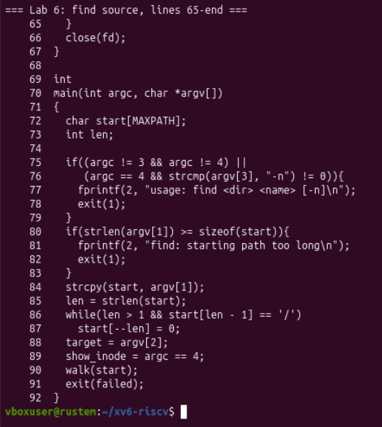
Figure 4.3. find closes each opened directory and validates its optional argument
find <dir> <name>
find <dir> <name> -n
After the directory loop, the program checks for a read error or incomplete entry and calls close(fd). The main function accepts exactly two required arguments and an optional final -n; other combinations print usage and exit with status 1. An overlong starting path is rejected before copying it into the fixed-size buffer.
The main function also removes trailing slashes while preserving a single root slash. The target and display mode are then assigned, and the walk begins. The global failed flag records errors encountered during traversal and is passed to exit at the end.

Constructing the recursive search test tree
I recreated the filesystem image before the search tests, then made two small files named r2 in different directories and a hard link from the root r2 name to cat.
mkdir a
mkdir a/b
echo x > a/b/r2
echo y > a/r2
ln cat r2
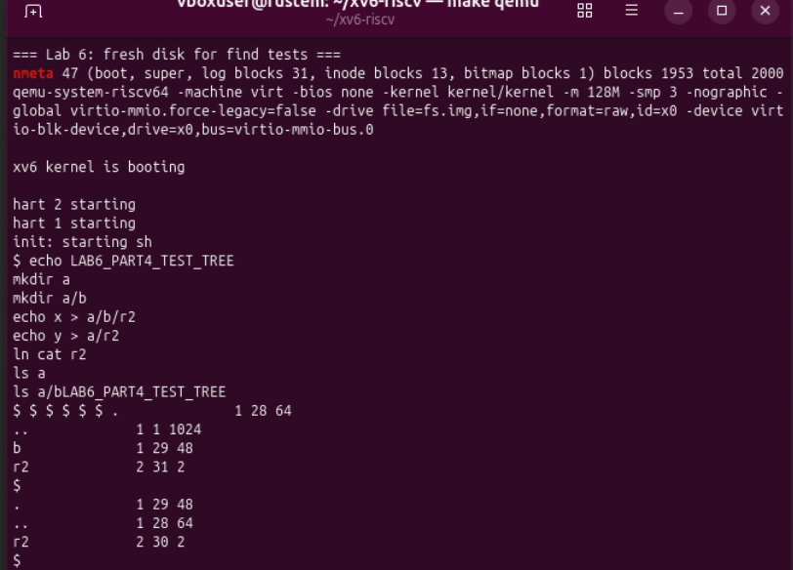
Figure 4.4. Fresh boot and directory listings for the required find test tree
.
|-- a
| |-- b
| | `-- r2 content x plus newline
| `-- r2 content y plus newline
`-- r2 hard link to cat
The listing showed a as inode 28 with 64 bytes and a/b as inode 29 with 48 bytes. These sizes corresponded to four and three directory entries respectively. The two regular r2 files had size 2 bytes, including the newline written by echo.

Required results and optional inode display
find . r2
find a b
find . r2 | wc
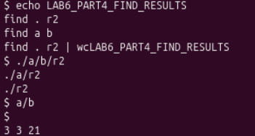
Figure 4.5. The searches find three r2 paths and the directory a/b
The first query returned ./a/b/r2, ./a/r2 and ./r2. The second returned a/b. The pipeline counted 3 lines, 3 words and 21 bytes, matching the three printed pathnames and their newline characters.
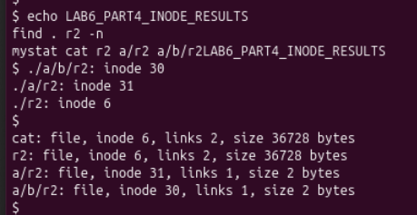
Figure 4.6. The optional inode output identifies which r2 is the hard link to cat
Path | Inode | Links | Size in bytes
cat | 6 | 2 | 36728
r2 | 6 | 2 | 36728
a/r2 | 31 | 1 | 2
a/b/r2 | 30 | 1 | 2

Only the root-level r2 was the same file as cat: both named inode 6 and had two links. The nested paths named separate inodes 31 and 30. Matching the same final filename did not mean that the files shared their contents or inode.

Error handling and additional search checks
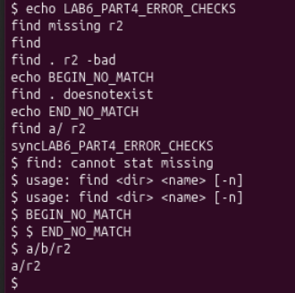
Figure 4.7. Missing-path usage no-match and trailing-slash checks complete
Invocation | Observed result
find missing r2 | Printed cannot stat missing
find | Printed usage
find . r2 -bad | Printed usage for the unsupported option
find . doesnotexist | Printed no paths between the BEGIN and END markers
find a/ r2 | Printed a/b/r2 and a/r2

The no-match case completed without inventing a result or reporting a missing starting directory. The trailing-slash query confirmed that the normalized starting path still found both nested files. These checks complemented the required successful searches and the separate inode comparison.

Conclusions
I connected the xv6 directory listing format with the definitions in the filesystem headers. The root directory used inode 1, and fixed 16-byte directory entries explained the 32-byte size of an empty directory. The filename limit of 14 bytes was visible in the truncated directory name.
The mystat program exposed the metadata needed to distinguish a pathname from its inode. README and r2 shared inode 2 after linking; removing README reduced the link count while r2 retained the contents. Reading sys_unlink and iput showed how removal of a directory entry, link-count updates and release of the final reference lead to inode and block reclamation.
The filesystem constants allowed a maximum payload of 274,432 bytes per file through twelve direct blocks and 256 indirect data blocks. The actual image contained 2,000 blocks, with 47 metadata blocks and a 1,953-block data region. These are separate limits: per-file addressing capacity and whole-image capacity.
The recursive find program located all three required r2 paths and the directory a/b. Skipping dot and dot-dot, bounding path construction and closing directories were essential to the traversal. The optional inode display showed that only the root r2 was a hard link to cat; the same filename in the two nested directories identified different files.

References
The experimental evidence is recorded in Figures 1.1 to 4.7. The inspected xv6 source revision was 06aad25.
1. Operating Systems, FCIM / FAF, Technical University of Moldova. Lab 6, Inside the xv6 File System, Track B, 2026-2027. Supplied assignment.
2. xv6 source: on-disk filesystem structures
3. xv6 source: link and unlink system calls
4. xv6 source: inode references and block reclamation
5. xv6 source: directory reading in ls

