
MINISTRY OF EDUCATION, CULTURE AND RESEARCH
OF THE REPUBLIC OF MOLDOVA
Technical University of Moldova
Faculty of Computers, Informatics and Microelectronics
Department of Software Engineering and Automation

The File System with Your Own Hands
Laboratory work 5
of Operating Systems

Done by: st. gr. FAF-243, Cimendur Rustem
Checked by: Reițman Patricia, asist. univ.

Chișinău 2026

The File System with Your Own Hands

Purpose of the work
I examined the Linux filesystem through its directory tree, file types, inode metadata, links, permissions and storage devices. I compared the commands with their actual outputs and used two additional experiments to test content identification and the lifetime of an open file. The results showed that a filename, an inode, allocated data blocks and an open file descriptor are distinct parts of file access.

Environment and preparation
I worked in Bash as the normal user vboxuser, with UID and GID 1000, on the VirtualBox guest rustem. I created a fresh directory under ~/os-lab5 and kept the experiments there. I did not run the permission tests as root.
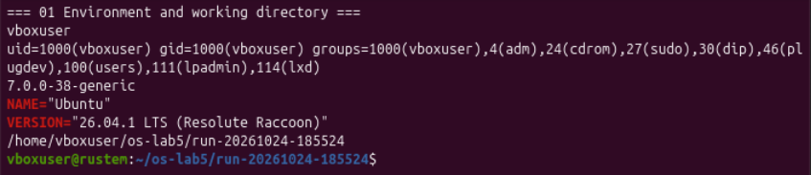
Figure 1.1 – Normal user, Ubuntu release, kernel and experiment directory
Item | Observed value
Linux distribution | Ubuntu 26.04.1 LTS (Resolute Raccoon)
Kernel | 7.0.0-38-generic
User and host | vboxuser@rustem
Working directory | /home/vboxuser/os-lab5/run-20261024-185524
Experiment date | 24 October 2026

The following sections answer all Observe questions in Parts 1 to 4. Figures 1.1 to 5.4 preserve the terminal evidence, including the expected failures when a target was missing or a permission check denied access.

Part 1 The tree and the file types
ls /
ls -ld /etc /etc/passwd /bin /dev/null /tmp
file /usr/bin/ls /etc/passwd /bin
readlink /bin
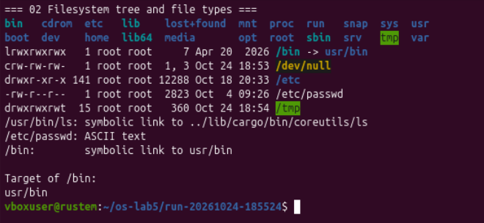
Figure 1.2 – Root entries, file types and the target of the bin link

Observe 1 File types from the first character
Path | First character | Type
/etc | d | Directory
/etc/passwd | - | Regular file
/bin | l | Symbolic link
/dev/null | c | Character device
/tmp | d | Directory

Observe 2 What bin represents
/bin was a symbolic link to usr/bin, which resolves to /usr/bin. The separate file command reported /etc/passwd as ASCII text. On this system, /usr/bin/ls was itself a symbolic link to ../lib/cargo/bin/coreutils/ls; I therefore did not classify that pathname as a regular executable from its name alone.

Devices and directory sizes
ls -l /dev | head
ls -l /dev/null
find /dev -maxdepth 2 -type b -exec ls -l {} + | head -n 6
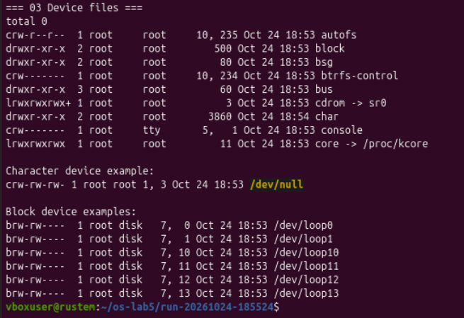
Figure 1.3 – Character and block device examples in dev

Observe 3 One character and one block device
/dev/null was a character device, marked c, with major/minor numbers 1 and 3. /dev/loop0 was a block device, marked b, with numbers 7 and 0. The loop devices provide block-device access to backing files; later listings associated them with mounted Snap images.
du -sh /var/log 2>/dev/null
du -sh /usr 2>/dev/null
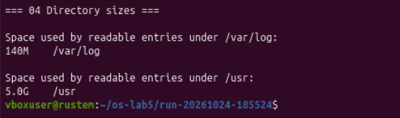
Figure 1.4 – Readable directory totals for var log and usr

Observe 4 Which directory was larger
du -sh reported 140M for /var/log and 5.0G for /usr. Using these rounded binary-unit values, /usr was roughly 37 times larger, or about 4.9 GiB larger. The commands ran without root privileges and suppressed error messages, so inaccessible entries could be absent from the totals.

Part 2 Inodes and links
echo hello > notes.txt
stat notes.txt
ls -li notes.txt
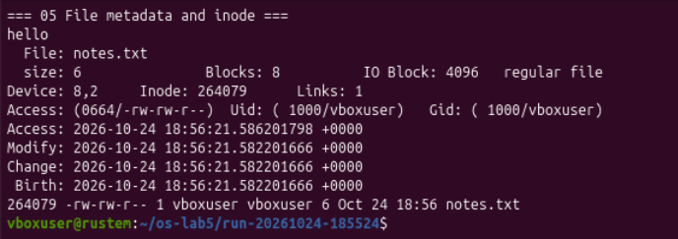
Figure 2.1 – Initial inode metadata and the single name notes txt

Observe 1 Inode number and number of names
stat showed inode 264079 and Links: 1 for notes.txt. The inode number identifies the filesystem object within this filesystem; the link count gives its number of hard-linked directory entries. The file contained six bytes: the five letters in hello and the newline written by echo.
ln notes.txt hard.txt
ls -li notes.txt hard.txt
rm notes.txt
cat hard.txt; ls -li hard.txt
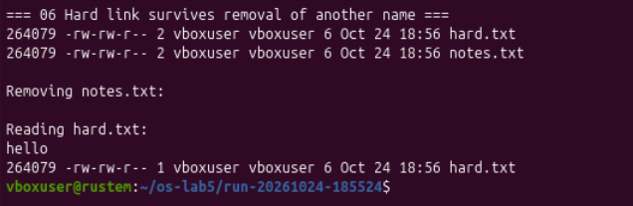
Figure 2.2 – Two names for one inode and the surviving hard link

Observe 2 Why hard txt remained readable
Before removal, both names had inode 264079 and link count 2. After rm notes.txt, hard.txt still printed hello and its link count was 1. rm removed the directory entry named notes.txt; it did not erase the inode while another hard link still referred to it.

Symbolic links and missing targets
ln -s hard.txt soft.txt
ls -li hard.txt soft.txt
cat soft.txt
stat -c "name=%n inode=%i links=%h size=%s bytes" soft.txt
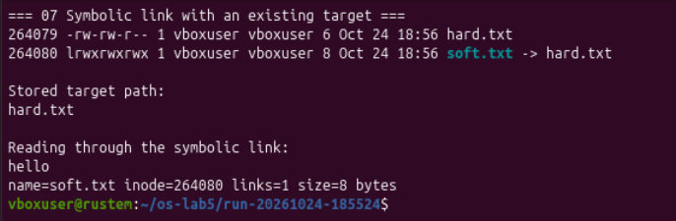
Figure 2.3 – The symbolic link has its own inode and an eight byte target path
The target retained inode 264079, while soft.txt had inode 264080. Reading soft.txt followed the stored relative pathname hard.txt and returned hello.
rm hard.txt
cat soft.txt
ls -l soft.txt
readlink soft.txt
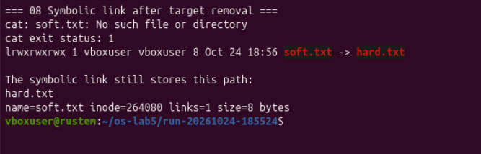
Figure 2.4 – The link remains after its target name has been removed

Observe 3 Why cat failed and why the link was eight bytes
After I removed hard.txt, cat soft.txt reported No such file or directory and returned status 1. The symbolic link still existed, but its stored target pathname could no longer be resolved. Its size was exactly 8 bytes because hard.txt contains eight ASCII characters, including the dot; the link stores that pathname without an added newline or terminating NUL byte.

Directory links and allocated space
mkdir d; ls -ld d
mkdir d/x d/y; ls -ld d d/x d/y
ls -lai d
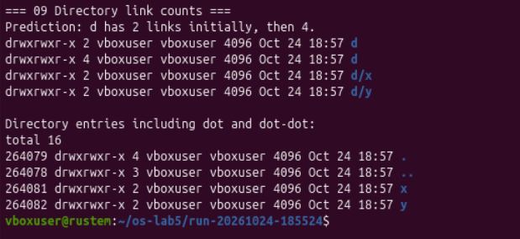
Figure 2.5 – The directory link count increases from two to four

Observe 4 Where directory links come from
The prediction matched: d initially had 2 links and then 4. Initially, its parent contained the entry named d, and d/. referred to the same inode. Creating x and y added d/x/.. and d/y/.., each pointing back to d. The entry d/.. points to the parent directory and does not add a link to d itself.
echo x > one.txt; ls -l one.txt; du -h one.txt
truncate -s 1G big.img; ls -lh big.img; du -h big.img
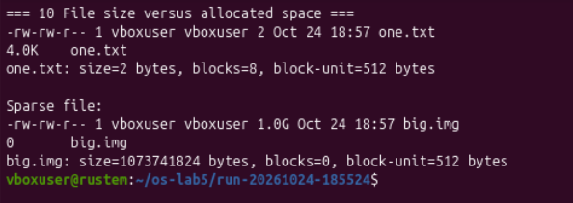
Figure 2.6 – A two byte file uses a block while a sparse GiB file has no data blocks

Observe 5 Why size and space differed
one.txt had a logical size of 2 bytes but used 8 units of 512 bytes, or 4096 bytes (4.0K), for data allocation. big.img had a logical size of 1,073,741,824 bytes (1 GiB) and zero allocated data blocks. truncate extended the file with a sparse hole; reads from the hole return zeros without requiring data blocks for that range. Zero reported allocation does not mean the file requires no filesystem metadata.

Part 3 Permissions
echo secret > s.txt
chmod 600 s.txt; cat s.txt
chmod 000 s.txt; cat s.txt
chmod u+r s.txt; cat s.txt
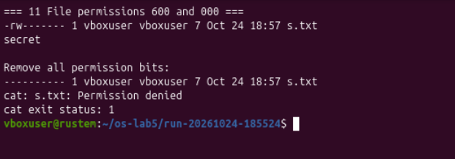
Figure 3.1 – Mode 600 allows reading and mode 000 denies it to the owner

Observe 2 Why ownership did not allow reading
With mode 600, s.txt printed secret. After chmod 000, the same user still owned the file, but cat returned Permission denied with status 1. Ownership selects the owner permission bits; it does not automatically grant read access. As the owner, I could change the mode, so chmod u+r restored owner read permission and the next read succeeded.
umask; umask -S
touch new.txt; mkdir newdir
ls -ld new.txt newdir
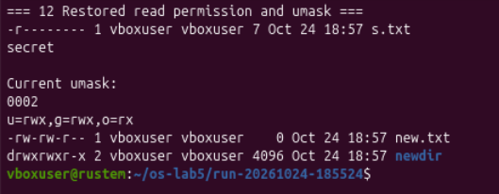
Figure 3.2 – Owner read permission is restored and the current umask is 0002

Observe 3 How umask determined creation permissions
The mask was 0002, removing the write bit for other users. A regular file created with requested mode 0666 therefore received 0666 & ~0002 = 0664 (rw-rw-r--). A directory created with requested mode 0777 received 0777 & ~0002 = 0775 (rwxrwxr-x). These values matched new.txt and newdir. Regular files did not gain execute bits because those bits were not requested at creation.

Common permission modes
chmod 600 private.txt
chmod 644 public.txt
chmod 755 shared_dir
chmod 700 private_dir
ls -ld private.txt public.txt shared_dir private_dir
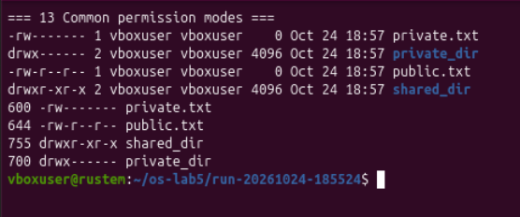
Figure 3.3 – Four explicit modes and their symbolic permission strings

Observe 1 Modes as rwx strings and practical uses
Mode | Permission bits | Example use
600 | rw------- | A private file readable and writable only by its owner.
644 | rw-r--r-- | A document others may read while only the owner may modify it.
755 | rwxr-xr-x | A directory everyone may list and traverse, while only its owner may change entries.
700 | rwx------ | A private directory accessible only to its owner.

Each octal digit represents read (4), write (2) and execute/search (1) for owner, group and others respectively. The extra first character in ls -l indicates the file type: for example, d identifies a directory and is not part of the nine permission bits.
For a regular executable file, execute permission permits execution. For a directory, the same bit is search permission: it permits resolving names inside that directory. The next experiment isolates directory read and search permission.

Directory read and search permissions
mkdir box; echo hi > box/f; chmod 644 box/f
chmod u=r,go= box; ls box; cat box/f
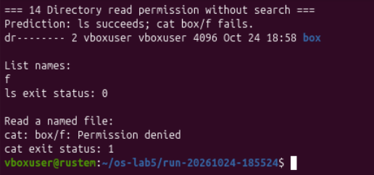
Figure 3.4 – Read permission lists the name but does not allow resolving the file path
chmod u=x,go= box; ls box; cat box/f
chmod 755 box
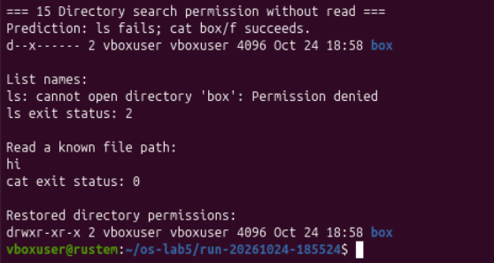
Figure 3.5 – Search permission allows a known file path but denies listing names

Observe 4 What r and x mean on a directory
Both predictions matched. With owner read permission only (0400), ls box displayed f and returned 0, while cat box/f failed with status 1 because search permission was missing. With search permission only (0100), ls box failed with status 2, but cat box/f printed hi and returned 0: the name was already known, the directory allowed traversal, and f allowed reading. I then restored the directory mode to 0755.

Special bits and protected account data
ls -l /usr/bin/passwd; ls -ld /tmp
stat -c "%a %A %U:%G %n" /usr/bin/passwd /tmp
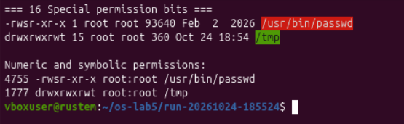
Figure 3.6 – Setuid on passwd and the sticky bit on tmp

Observe 5 The meanings of s and t
/usr/bin/passwd belonged to root and had mode 4755 (-rwsr-xr-x). The s in the owner execute position combines execute permission with the set-user-ID bit. On this system, executing the program gives it effective root identity so it can perform the controlled update of protected password data after its own checks, rather than granting users direct write access to that data.
/tmp had mode 1777 (drwxrwxrwt). The final t is the sticky bit with execute/search permission. Although the directory allows all users to create entries, the sticky bit restricts removal or renaming of another user's entries; the file owner, directory owner or a suitably privileged process may perform those operations.
cat /etc/shadow
ls -l /etc/shadow
stat -c "%a %A %U:%G %n" /etc/shadow
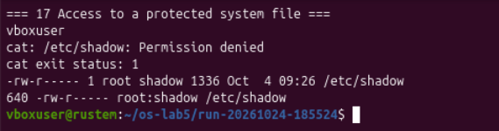
Figure 3.7 – A normal user cannot read the root and shadow owned password file
The direct read returned Permission denied and status 1. /etc/shadow belonged to root:shadow, had mode 0640 (-rw-r-----) and a size of 1336 bytes. My account was neither its owner nor a member of the shadow group, so it had no read permission. Being in the sudo group did not give this ordinary cat process elevated permissions.

Part 4 Disks and the kernel as files
I used lsblk to connect device names with partitions, filesystem types and mount points. The listing also distinguished the virtual disk from Snap loop devices and the VirtualBox optical image.
lsblk
lsblk -o NAME,TYPE,SIZE,FSTYPE,MOUNTPOINTS
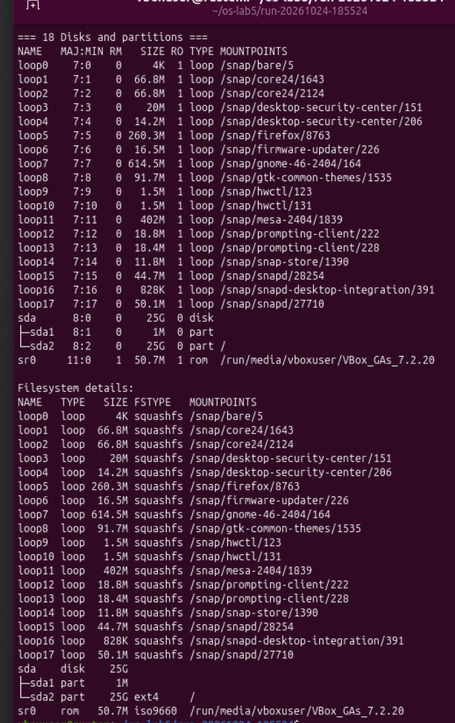
Figure 4.1 – Block devices and filesystem details for the virtual machine

Root filesystem layout and usage

Observe 1 Diagram of the virtual disk
sda 25G virtual disk
|-- sda1 1M partition, no mount point shown
`-- sda2 25G ext4, mounted at /
The displayed sizes were rounded. /dev/sda2 supplied the root filesystem. The loop devices contained squashfs images mounted under /snap; they were not additional physical disks. sr0 exposed an ISO 9660 image mounted under /run/media/vboxuser/VBox_GAs_7.2.20.
df -h
df -h /
mount | grep " / "
findmnt -n -o SOURCE,FSTYPE,TARGET /
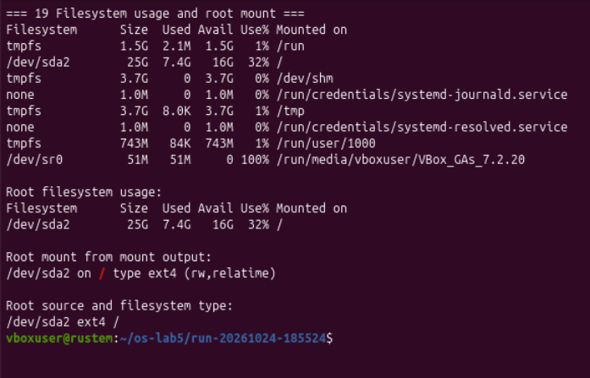
Figure 4.2 – Root capacity, usage and the ext4 mount source

Observe 2 How full the root filesystem was
df -h / reported a 25G filesystem with 7.4G used, 16G available and 32% usage. Both mount and findmnt identified /dev/sda2, filesystem type ext4, mounted at /. The mount options shown were rw,relatime; rw permits read and write operations.

CPU and RAM reported by proc
grep -c processor /proc/cpuinfo
head -3 /proc/meminfo
awk '/^MemTotal:/ {printf "%.2f GiB\n", $2 / 1048576}' /proc/meminfo
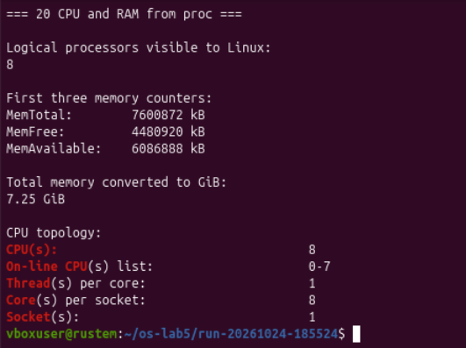
Figure 4.3 – Eight virtual CPUs and approximately 7.25 GiB of total memory

Observe 3 CPU cores and memory
Measurement | Observed value
Logical processor entries | 8
Topology exposed to the guest | 1 socket, 8 cores per socket, 1 thread per core
MemTotal | 7,600,872 kB, approximately 7.25 GiB
MemFree | 4,480,920 kB
MemAvailable | 6,086,888 kB

The processor count from /proc/cpuinfo measures logical processors. The additional lscpu output showed an eight-core virtual topology with one thread per core, so both counts were eight in this guest. These values describe the VM resources exposed by VirtualBox, not necessarily the physical host's complete CPU or RAM configuration.
The memory counters labelled kB use 1024-byte units here. Dividing MemTotal by 1,048,576 gives approximately 7.25 GiB. Available memory is larger than completely free memory because it includes an estimate of memory the kernel can reclaim for applications.

Process information through proc
head -5 /proc/self/status
ls -l /proc/self/fd
printf "Bash PID: %s\n" "$$"
head -5 "/proc/$$/status"
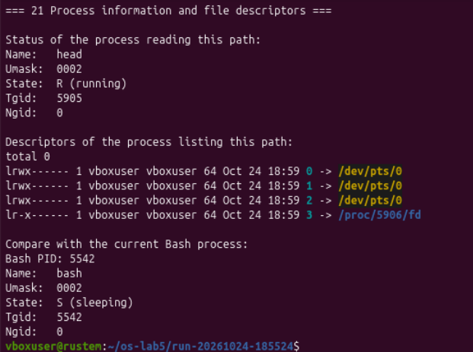
Figure 4.4 – Self refers to each inspecting process while the explicit PID identifies Bash

Observe 4 Which program appeared in self status
The first command showed Name: head, state R (running), and thread-group ID 5905. /proc/self refers to the process accessing that path, so the status described head, which opened and read the file. It did not describe the parent shell simply because I typed the command there.
The comparison used Bash PID 5542 explicitly and reported Name: bash, state S (sleeping), and thread-group ID 5542. Bash was waiting while its child command ran. The separate descriptor listing belonged to ls process 5906: descriptors 0, 1 and 2 pointed to /dev/pts/0, while descriptor 3 pointed to /proc/5906/fd, the directory opened for the listing.
Descriptor | Meaning in the ls snapshot
0 | Standard input connected to the terminal
1 | Standard output connected to the terminal
2 | Standard error connected to the terminal
3 | The descriptor directory opened by ls itself

Part 5 Optional experiments

Magic numbers and file identification
gzip -c /etc/passwd > notes.txt
file notes.txt
xxd -l 16 notes.txt
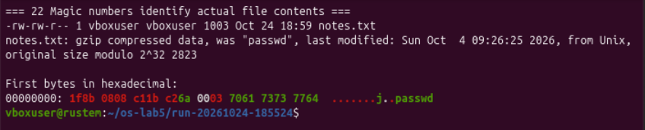
Figure 5.1 – The txt filename contains gzip data with the signature 1f 8b
Although the filename ended in .txt, file identified gzip compressed data. The first bytes were 1f 8b 08: 1f 8b is the gzip identification signature and 08 identifies DEFLATE compression. The compressed file was 1003 bytes; its header information recorded the original name passwd, and file reported an original size modulo 2^32 of 2823 bytes. The contents and header identified the format rather than the filename suffix.

Preparing a file that remains open
dd if=/dev/zero of=bigfile bs=1M count=8 status=none
exec 3< bigfile
ls -l "/proc/$$/fd/3"
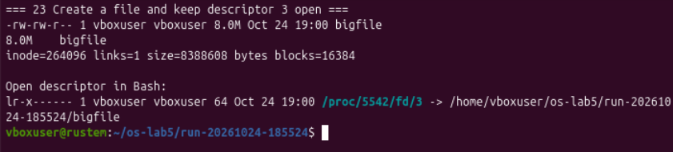
Figure 5.2 – An eight MiB file is held open by descriptor three in Bash
The file had inode 264096, one hard link, a logical size of 8,388,608 bytes (8 MiB), and 16,384 allocated 512-byte units. Unlike the sparse file, this file had actual allocated data blocks. exec 3< bigfile opened it in the current Bash process, and /proc/5542/fd/3 pointed to its pathname.

Deleting a file while it remains open
rm bigfile
ls -l "/proc/$$/fd"
stat -Lc "inode=%i links=%h size=%s bytes blocks=%b" "/proc/$$/fd/3"
dd bs=1 count=16 status=none <&3 | od -An -tx1
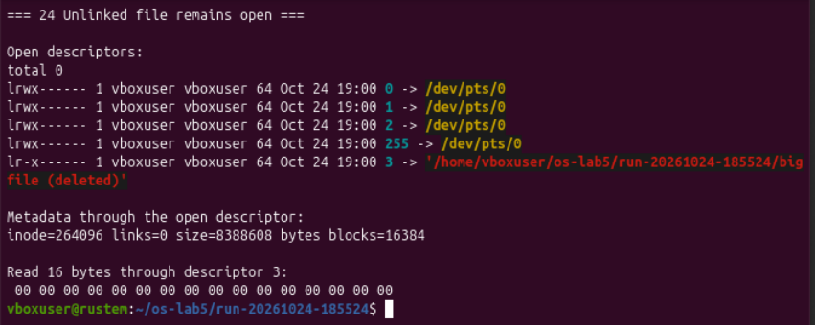
Figure 5.3 – The deleted file keeps its inode and data through the open descriptor
After rm, descriptor 3 still pointed to the old pathname with (deleted) appended. The inode remained 264096, the link count became 0, and the size and allocated block count were unchanged. Reading through descriptor 3 still returned sixteen zero bytes. Removing the final directory entry therefore did not destroy the file while it remained open.
exec 3<&-
ls -l "/proc/$$/fd/3"
ls -l "/proc/$$/fd"
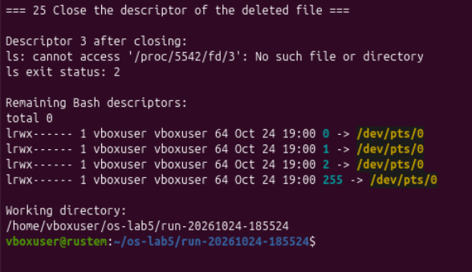
Figure 5.4 – Closing descriptor three removes the final open reference from Bash
After I closed descriptor 3, its /proc entry was absent and ls returned status 2. For an unlinked file, the filesystem can reclaim the inode and data blocks once the last open reference is released. The space is not freed merely when the final filename is removed.

Conclusions
I identified directories, regular files, symbolic links and device nodes from their metadata. The /bin link and the device listings showed how the filesystem tree provides names for both stored data and access to system resources. The directory measurements also showed that /usr occupied much more space than /var/log in this VM.
The link experiments distinguished directory names from the underlying inode. Hard-linked names shared one inode, whereas the symbolic link had its own inode and stored a target pathname. Directory link counts rose from two to four after two subdirectories were added. The small-file and sparse-file tests showed that logical size and allocated data space can differ substantially.
The permission experiments confirmed that a normal file owner remains subject to the selected permission bits. Umask 0002 explained the initial modes 0664 and 0775. Directory read permission allowed listing names, while search permission allowed resolving known names. The setuid and sticky bits explained the controlled privilege of passwd and the shared use of /tmp.
The storage and /proc commands connected the root mount to the ext4 partition /dev/sda2, recorded 32% root filesystem usage, and showed eight virtual CPUs with approximately 7.25 GiB RAM. /proc/self described the process reading it. Finally, gzip magic bytes identified a file independently of its suffix, and an unlinked file stayed readable until its open descriptor was closed.

References
The experimental evidence consists of Figures 1.1 to 5.4, captured during the lab on 24 October 2026. The assignment and technical references are listed below.
1. Operating Systems, FCIM / FAF, Technical University of Moldova. Lab 5, The File System with Your Own Hands, Track A, 2026-2027. Supplied assignment.
2. GNU Coreutils manual: ln and hard versus symbolic links
3. Linux kernel documentation: The proc Filesystem
4. RFC 1952: GZIP file format specification, section 2.3.1

