
MINISTRY OF EDUCATION, CULTURE AND RESEARCH
OF THE REPUBLIC OF MOLDOVA
Technical University of Moldova
Faculty of Computers, Informatics and Microelectronics
Department of Software Engineering and Automation

Cimendur Rustem
FAF-243
Report
Laboratory work n.1
of Operating Systems

Chisinau - 2026

Contents
Laboratory work 1 covers resource management in Linux. The experiments observe files, permissions, processes, memory and storage on a running system.
Laboratory 1 Linux resource management 3
System identification 3
Part 1 File hierarchy 4
Home directory and file operations 5
Permissions and observations 6
Part 2 Processes 7
Background jobs and process state 8
Part 3 Memory 9
Part 4 Storage 10
Devices and laboratory conclusions 11
Bonus System calls 12

Laboratory 1 Linux resource management
Track A Observing a running operating system
I used a Linux virtual machine to examine how the operating system manages files, processes, memory and storage. Command output made these resources visible and allowed me to compare file permissions, process states and memory counters.

System identification
Command | Purpose
cd ~/os-lab1 | Enter the directory used for the experiments.
whoami | Display the current Linux account.
uname -a | Identify the kernel build and processor architecture.
uptime | Show the time since boot, user count and load averages.

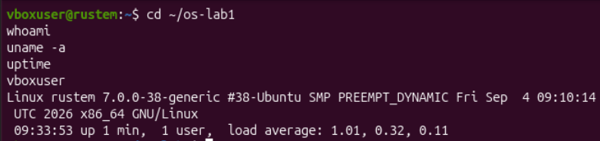
Figure 1. Linux account, kernel version and uptime
The account was vboxuser and the hostname was rustem (my name). The machine ran Linux 7.0.0-38-generic, with an Ubuntu kernel build, on x86_64. This identifies the environment as a 64-bit x86 Linux system.
At the first measurement, the system had been running for one minute and had one logged-in user. The load averages were 1.01, 0.32 and 0.11 for the last 1, 5 and 15 minutes. These values describe runnable tasks and tasks in uninterruptible sleep; they are not CPU usage percentages.
I kept the file experiments under /home/vboxuser/os-lab1 and used the demo subdirectory for creating and removing sample files.

Part 1 File hierarchy
Command | Purpose
pwd | Print the absolute path of the current directory.
ls -la / | List the root directory, including hidden entries and metadata.
ls -la ~ | Inspect the home directory and the ownership of its entries.
cd /etc; ls | head | Inspect the first ten names in the configuration directory.

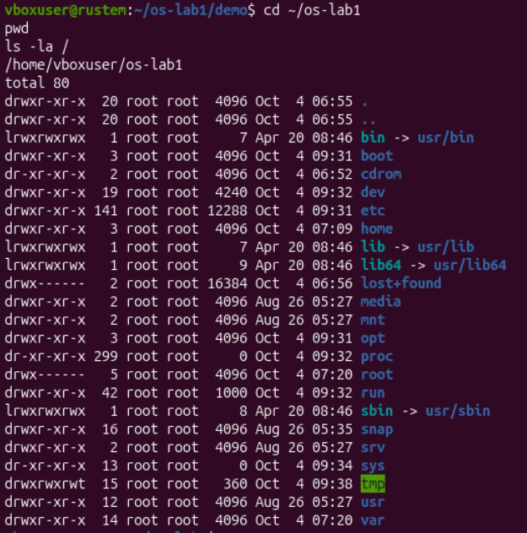
Figure 2. Working directory and entries directly under the filesystem root
The working directory was /home/vboxuser/os-lab1. The root listing included /etc, /home, /dev, /proc, /usr and /var. The entries /bin and /sbin were symbolic links to usr/bin and usr/sbin; /lib and /lib64 also pointed into /usr.
/etc stores system configuration, while /home contains ordinary users' home directories. /dev provides device nodes and /proc exposes information supplied by the running kernel.

Home directory and file operations
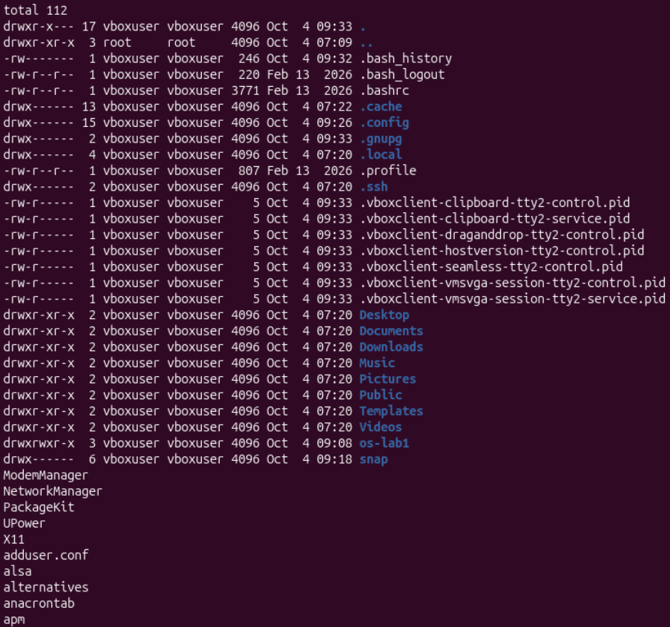
Figure 3. Home-directory ownership and a sample of entries in /etc
Most home-directory entries belonged to vboxuser:vboxuser. The listing included Desktop, Documents, Downloads and os-lab1, as well as hidden configuration files. The /etc sample included NetworkManager, X11 and adduser.conf.
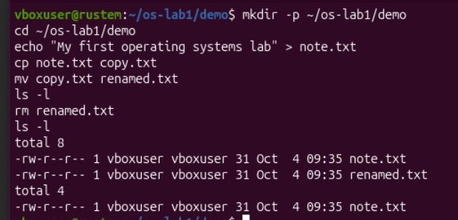
Figure 4. Creating a sample file, copying it, renaming the copy and deleting it
In ~/os-lab1/demo, I wrote a line into note.txt, copied it to copy.txt, renamed the copy to renamed.txt and removed that copy. The first listing contained two 31-byte files; the final listing contained only note.txt. The original file therefore remained available after the copy was deleted.

Permissions and observations
Command | Purpose
ls -l note.txt | Display the file type, permissions, owner, group and size.
chmod 600 note.txt | Allow only the owner to read and write the file.
chmod 644 note.txt | Restore read access for the group and other users.

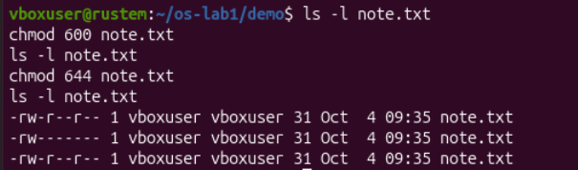
Figure 5. Permissions before the changes and after chmod 600 and chmod 644
The mode was initially -rw-r--r--. After chmod 600 it became -rw-------; after chmod 644 it returned to -rw-r--r--. The owner and group remained vboxuser:vboxuser, and the file size stayed at 31 bytes.

Observations
1. Who owns the files, and which group is assigned?
Both sample files were owned by vboxuser and assigned to the vboxuser group. In this directory, newly created files used the account and group under which the shell commands ran. The permission changes did not change ownership.
2. What do the ten characters after chmod 600 mean?
In -rw-------, the first character identifies a regular file. The next three characters, rw-, give the owner read and write permission. The following two groups of three dashes give the group and other users no permissions. No execute permission is set.
3. What do two directories directly under / contain?
/etc contains system-wide configuration files and directories. /home contains home directories for ordinary accounts, including /home/vboxuser in this experiment.

Part 2 Processes
Command | Purpose
ps aux | head | Show a sample of processes from all users.
ps aux | wc -l | Count output lines, including the heading.
ps -p 1 -o pid,comm | Identify the process with PID 1.
top | Observe changing process, CPU and memory statistics; q exits.

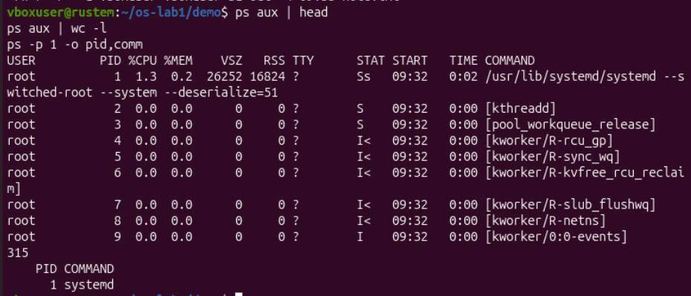
Figure 6. Process listing, line count and identification of PID 1
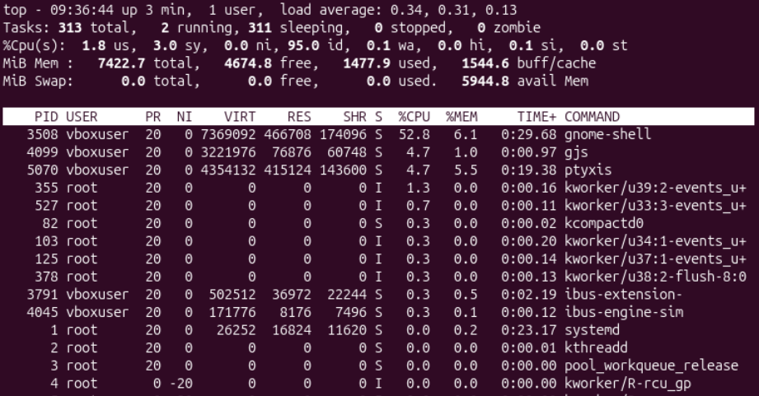
Figure 7. The top snapshot with 313 tasks and 95 percent idle CPU time
1. What is process number 1?
PID 1 was systemd, running as root. It acts as the system's init process and starts and supervises services after the kernel boots.
2. Approximately how many processes were present?
top reported 313 tasks: 2 running and 311 sleeping, with no stopped or zombie tasks. The ps pipeline returned 315 lines, which includes its header and may include temporary command processes. The measurements were taken at different moments, so their counts need not match exactly.

Background jobs and process state
Command | Purpose
sleep 300 & | Start a waiting process in the background.
PID=$!; echo "$PID" | Store and display the most recent background process ID.
jobs | List jobs managed by the current shell.
ps -ef | grep '[s]leep' | Locate sleep without matching the grep command itself.
ls /proc/$PID/ | Inspect the kernel-provided entries for this process.
head -20 /proc/$PID/status | Read its state, identifiers and selected counters.

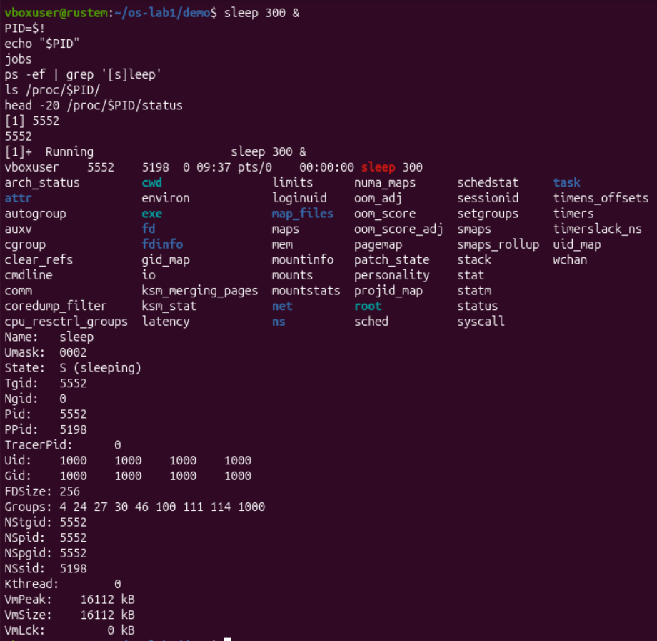
Figure 8. Background sleep process 5552 and its /proc status
3. What state was reported for the waiting process?
The status file reported State: S (sleeping) for PID 5552. Its parent PID was 5198 and its user and group IDs were 1000. While it waited for the timer, it did not need to execute continuously on the CPU.
The shell labelled the job Running because it was still active and had not been stopped. This job-control label can coexist with the kernel process state S. Later, kill "$PID" sent SIGTERM and the shell reported Terminated, as shown in the memory experiment.

Part 3 Memory
Command | Purpose
free -h | Display RAM and swap statistics in readable units.
head -6 /proc/meminfo | Read memory counters exposed by the kernel.
grep -E 'VmSize|VmRSS' /proc/$PID/status | Compare virtual memory size with resident memory.
kill "$PID"; jobs | Terminate the background process and inspect its job status.

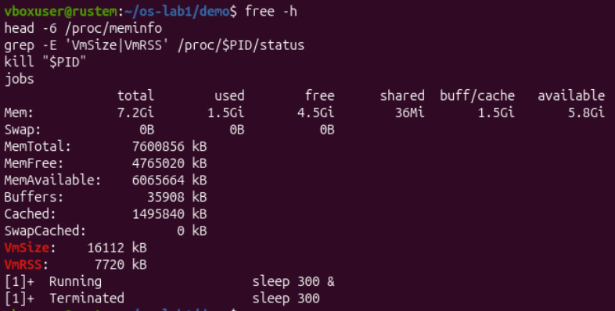
Figure 9. System memory, sleep memory counters and confirmed termination

Observations
1. How much memory was installed, free and available?
free -h showed 7.2 GiB total RAM, 1.5 GiB used, 4.5 GiB free and 5.8 GiB available. The kernel reported MemTotal as 7,600,856 kB. Free memory is unused memory, whereas available memory estimates what can be given to applications, including reclaimable cache. The buff/cache column was approximately 1.5 GiB.
2. What is swap, and how much was configured?
Swap is storage used to hold memory pages outside RAM, usually on disk. It can help the system handle memory pressure, although accessing disk is slower than accessing RAM. In this virtual machine, the total, used and free swap values were all 0 B, so no swap was configured.
3. How much resident memory did sleep use?
VmRSS was 7,720 kB, approximately 7.54 MiB. VmSize was 16,112 kB, approximately 15.73 MiB. The virtual address space was therefore larger than the amount resident in RAM. A small program still requires its executable, runtime mappings and other process memory; these counters alone do not show how much of that memory is shared.

Part 4 Storage
Command | Purpose
df -h | Show capacity, usage and mount points of filesystems.
lsblk | Show block devices and partitions as a tree.
du -sh ~/os-lab1 | Measure space used by the experiment directory.

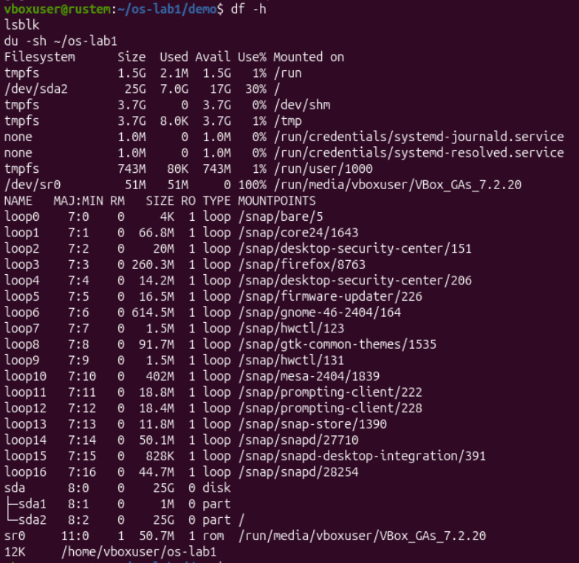
Figure 10. Filesystem usage, disk partitions, optical media and loop devices
The virtual disk sda had a size of 25G. Its second partition, /dev/sda2, was mounted at /. df reported 7.0G used, 17G available and 30% usage for this filesystem. The os-lab1 directory occupied 12K.
The output also showed numerous loop devices associated with mounted Snap images. The sr0 device represented optical media mounted under /run/media/vboxuser/VBox_GAs_7.2.20. The 1M sda1 partition had no mount point shown in this listing.

Devices and laboratory conclusions
Command | Purpose
ls -l /dev | head | Inspect device nodes, links and their file types.
mount | head | Inspect mount points, filesystem types and options.

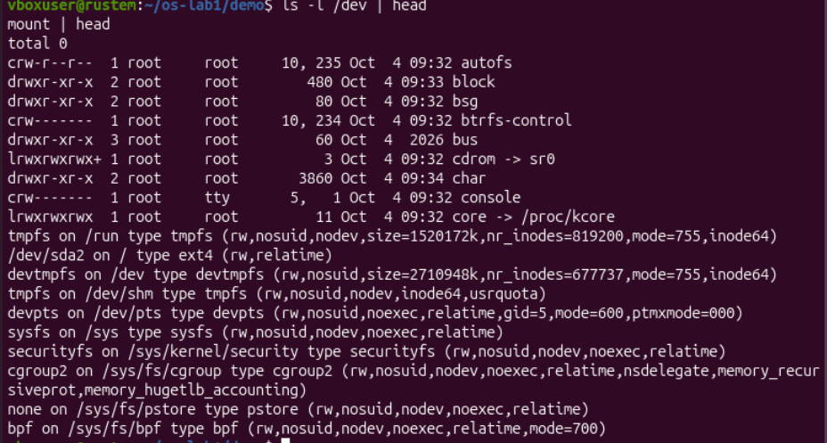
Figure 11. Device entries and mounted filesystems

Observations
1. Where is the root filesystem mounted?
The root filesystem / was mounted from /dev/sda2. The mount output identified its type as ext4 and its options as rw,relatime. The rw option allows read and write operations.
2. What does one entry in /dev represent?
/dev/console is a character device for console input and output; its listing begins with c. /dev/cdrom is a symbolic link to sr0, the optical device also visible in lsblk. Device nodes let programs access devices through file descriptors.
3. What does everything is a file mean?
Unix-like systems provide file names and file-descriptor operations for many resources, including ordinary files, devices and kernel information, while the behaviour of each resource still depends on its type.

Laboratory 1 conclusion
The experiments showed four aspects of resource management in one system. Ownership and permission bits controlled access to files; process tools revealed systemd and the states of active jobs; memory counters distinguished free, available, virtual and resident memory; and storage tools connected mount points to device partitions. Most tasks were sleeping, and the machine had substantial available RAM without configured swap.

Bonus System calls
I ran strace -c ls in the experiment directory. The command printed demo and then a summary of the system calls made while ls executed.
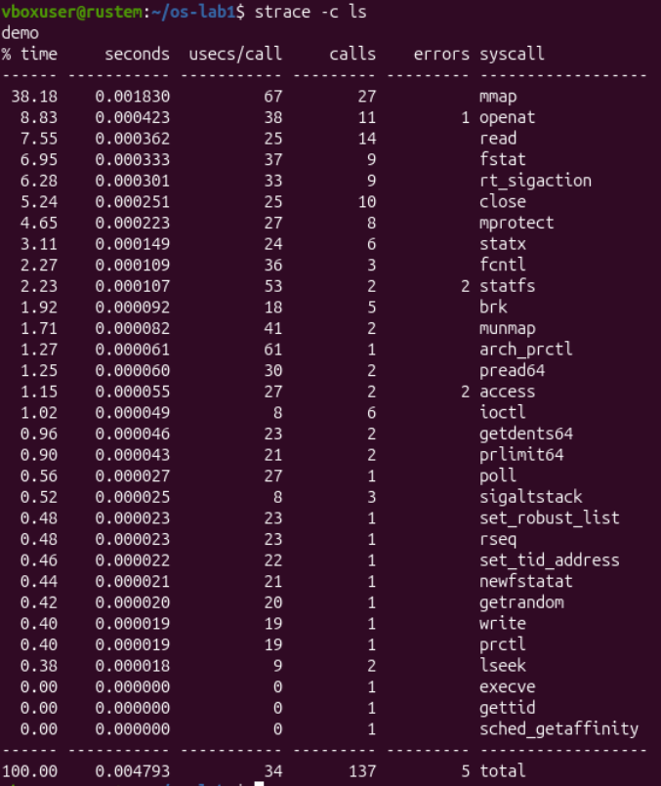
Figure 12. Summary of the system calls made by ls
System call or metric | Observed result
Total | 137 calls, 5 reported errors and 0.004793 seconds of measured syscall time.
mmap | 27 calls; 38.18% of the measured syscall time.
openat and read | 11 and 14 calls respectively, for opening and reading resources.
getdents64 | 2 calls used to obtain directory entries.
write | 1 call used to write output.

The summary includes program startup and runtime activity as well as directory access. It shows why even a short command requires several kernel services. Five calls were reported as errors, but the aggregate view does not identify their paths or error codes. The syscall time is not the complete wall-clock execution time of ls.

