
MINISTRY OF EDUCATION, CULTURE AND RESEARCH
OF THE REPUBLIC OF MOLDOVA
Technical University of Moldova
Faculty of Computers, Informatics and Microelectronics
Department of Software Engineering and Automation

Cimendur Rustem
FAF-243
Report
Laboratory work n.2
of Operating Systems

Chisinau - 2026

Contents
Laboratory work 2 covers the build, source structure and extension of xv6. The experiments connect shell commands with their implementation and add a small user program.
Laboratory 2 Building and extending xv6 3
Part 1 Toolchain and boot 3
Part 2 Shell commands 4
Shell observations and source exploration 5
Part 3 Reading cat 6
System call interface 7
Source observations and the sleep program 8
Part 4 Testing sleep and conclusions 9

Laboratory 2 Building and extending xv6
Track B Working with a small RISC-V operating system
I built and booted xv6, used its shell, inspected the user/kernel boundary in the source and added a small program. This connected familiar Unix commands with operating-system code that I could rebuild.

Part 1 Toolchain and boot
Command | Purpose
cd ~/xv6-riscv; ls | Inspect the source tree in /home/vboxuser/xv6-riscv.
git rev-parse --short HEAD | Identify the source revision: 06aad25.
riscv64-linux-gnu-gcc --version | Check the RISC-V cross compiler: GCC 15.2.0.
qemu-system-riscv64 --version | Check the emulator: QEMU 10.2.1.
make qemu | Build xv6 and its disk image, then launch the emulator.

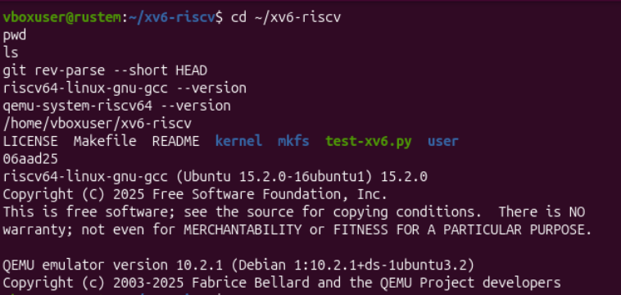
Figure 1. The xv6 source directory, revision and installed tool versions
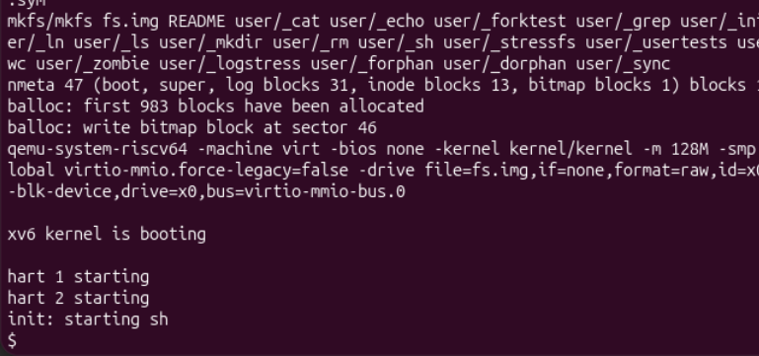
Figure 2. Disk-image creation and successful xv6 boot
The tree contained kernel, user, mkfs, Makefile and README. The build created fs.img and launched a RISC-V machine with 128 MiB of memory. The boot log showed hart 1 and hart 2 starting, then init: starting sh and the $ prompt, confirming that the kernel and shell had started.

Part 2 Shell commands
Inside xv6, I listed the available files, read README, printed a message and connected two commands with a pipe. The shell accepted familiar Unix command names despite running in a much smaller environment.
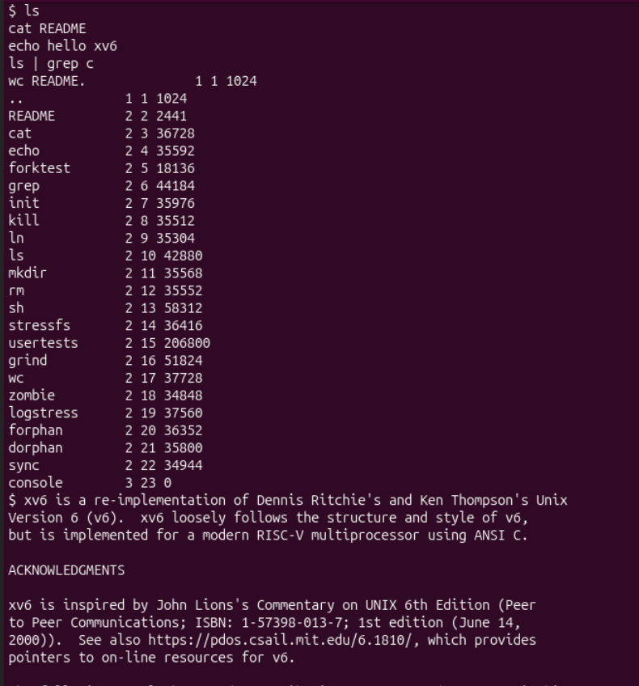
Figure 3. The xv6 directory listing and the beginning of README
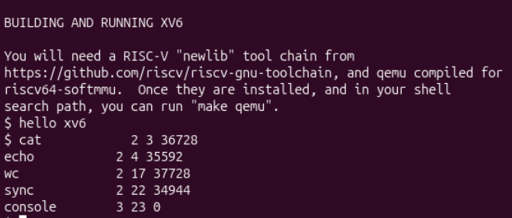
Figure 4. The printed message and the filtered output of ls through grep
ls | grep c retained names containing c, including cat, echo, wc, sync and console. The separate wc README test returned 48 lines, 336 words and 2,441 bytes; its output appears with the final program tests in Figure 9.

Shell observations and source exploration
1. Which programs are supplied with xv6?
The directory listing included ls, cat and grep, as well as echo, wc, sh, mkdir, rm and several test programs. The last listing column showed file size; the other columns included file type and inode number.
2. Which operating-system features support a pipe?
The kernel must support separate processes and a communication channel between them. For ls | grep c, the shell creates the processes, connects the output of ls to a pipe and connects the input of grep to its read end. File descriptors allow the programs to use ordinary read and write operations with that channel.
3. How does the xv6 shell compare with the Linux shell?
Both start programs and support pipes and redirection, but the xv6 shell provides a small command interpreter without the interactive conveniences and extensive language features of Bash.

Beginning the source inspection
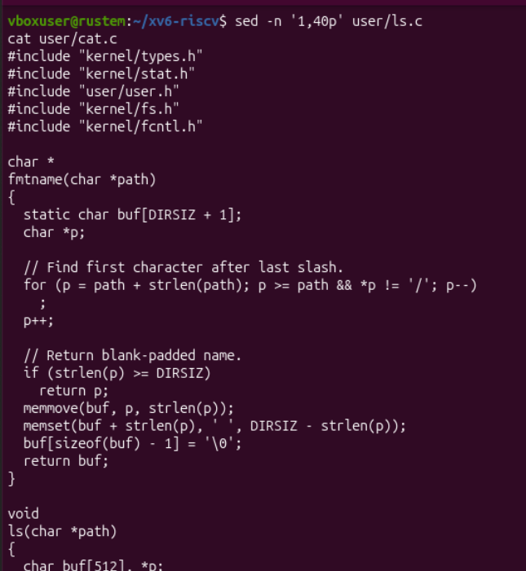
Figure 5. The beginning of user/ls.c and its filename-formatting function
The fmtname function extracts the final component of a path and pads the displayed name. This is formatting performed by a user program, while access to filesystem data requires services from the kernel.

Part 3 Reading cat
cat user/cat.c displayed the implementation below. Its central loop reads into a 512-byte buffer and writes the bytes to standard output.
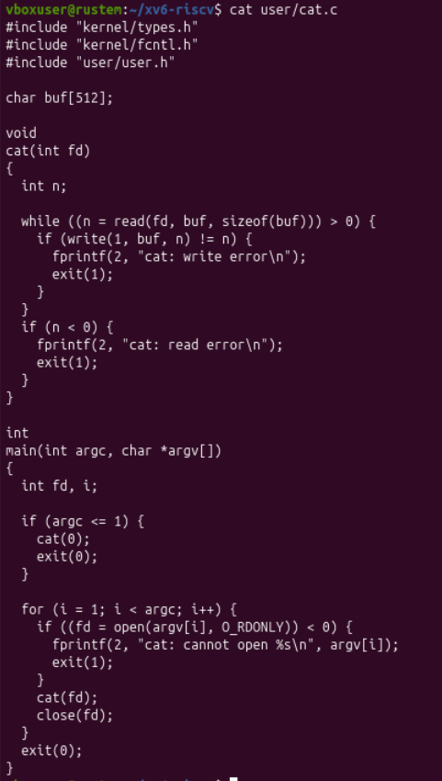
Figure 6. The complete user/cat.c implementation

System call interface
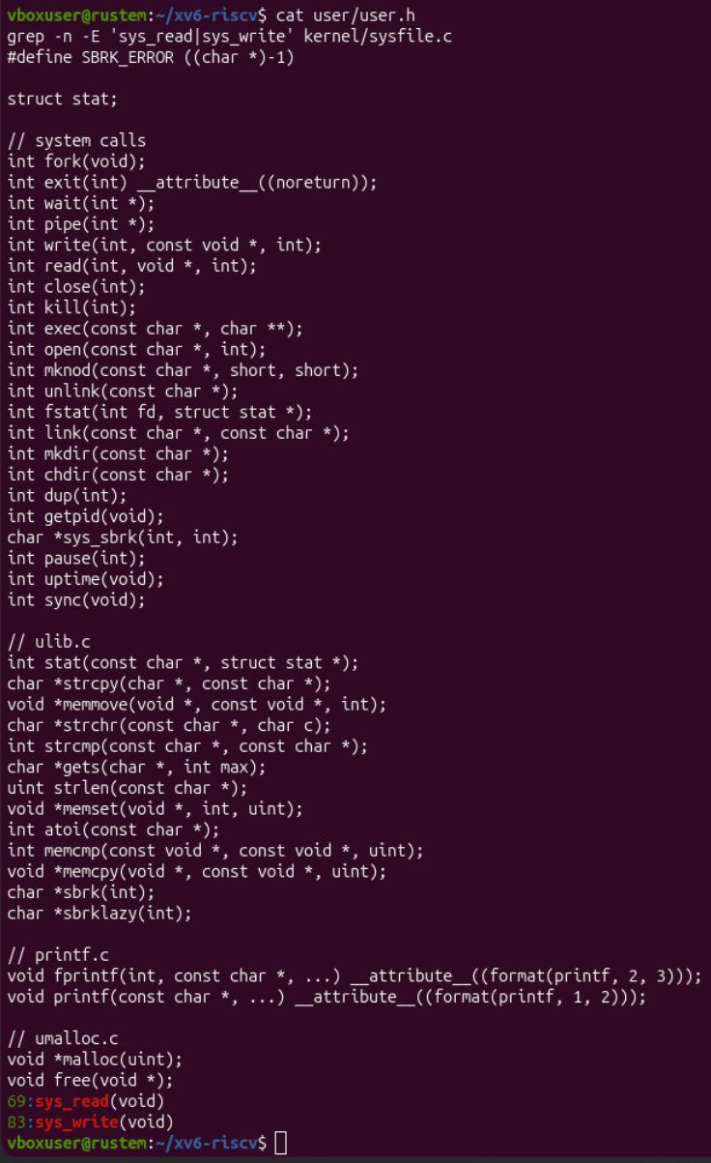
Figure 7. Declarations in user/user.h and the locations of sys_read and sys_write

Source observations and the sleep program
1. Which system calls does cat use?
open obtains a descriptor for each named input file; read fills the buffer; write sends bytes to descriptor 1, standard output; close releases an input descriptor; and exit terminates the program. Without file arguments, cat reads descriptor 0, standard input. fprintf formats error messages in user space and ultimately uses write.
2. Where is sys_read implemented?
In revision 06aad25, the grep result located sys_read in kernel/sysfile.c at line 69, and sys_write at line 83. These functions are the kernel-side handlers corresponding to the user-facing calls.
3. How do kernel and user code differ?
kernel contains privileged operating-system code, whereas user contains applications that request kernel services through system calls.

Part 4 Adding sleep
I created user/sleep.c and added $U/_sleep to the UPROGS list in Makefile. The entry is shown at line 153. The header in this source revision declares pause(int), so the program uses pause rather than a sleep call.
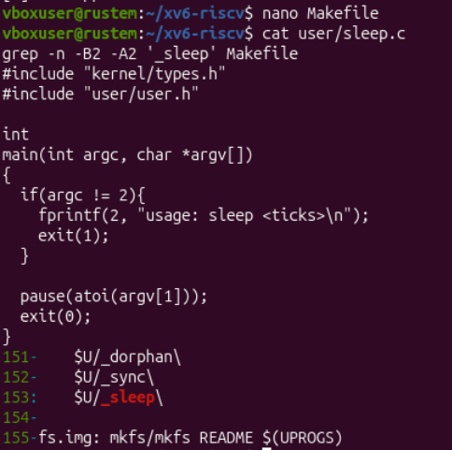
Figure 8. The new sleep source and its entry in the Makefile
The program expects one argument. If argc is not 2, it writes usage: sleep <ticks> to descriptor 2 and exits with status 1. Otherwise, atoi converts the argument and pause asks the kernel to wait for that number of timer ticks. The program then exits with status 0.

Testing sleep and conclusions
After rebuilding with make qemu, I tested the new program inside xv6. The listing contained sleep with file type 2, inode 23 and size 35,280 bytes.
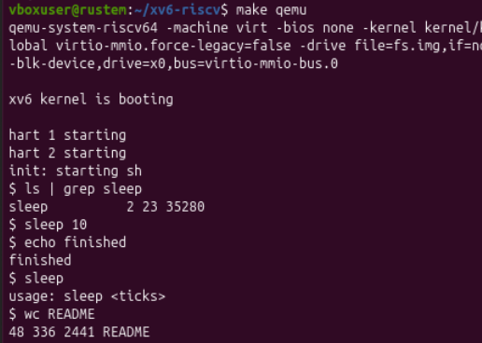
Figure 9. Successful boot, sleep tests and the README word count
Test | Result
ls | grep sleep | The sleep executable was present in the xv6 filesystem.
sleep 10 | Control returned to the shell after the wait request.
echo finished | Printed finished after the preceding command completed.
sleep | Printed usage: sleep <ticks> because the argument was missing.
wc README | Reported 48 lines, 336 words and 2441 bytes.

The argument denotes timer ticks, not seconds. The screenshots confirm successful execution and the missing-argument message, but do not measure the elapsed waiting time. The program checks argument count; it does not validate whether the supplied text is a non-negative integer.

Laboratory 2 conclusion
I compiled xv6 for RISC-V, booted it in QEMU and used its shell to run programs and a pipe. Reading cat and the system-call declarations showed how user programs request read and write operations from the kernel. Adding sleep connected source creation, the Makefile program list, filesystem-image construction and a successful run of a new application.

