
MINISTRY OF EDUCATION, CULTURE AND RESEARCH
OF THE REPUBLIC OF MOLDOVA
Technical University of Moldova
Faculty of Computers, Informatics and Microelectronics
Department of Software Engineering and Automation

Cimendur Rustem
FAF-243
Report
Laboratory work nr.4
of Operating Systems

Chisinau – 2026

Purpose of the work
I compared Bash with the xv6 shell to identify the operations that a shell performed before a program started. I updated a delay program, tested shell syntax, inspected the arguments received by two C programs, and related the observed behaviour to the xv6 shell source. The experiments showed that Bash expanded filenames and variables and interpreted quotes, while xv6 passed these characters literally.
Test | Result
Linux environment | vboxuser on rustem; Linux 7.0.0-38-generic.
Shell and toolchain | Bash 5.3.9(1)-release; GCC, Make, QEMU and riscv64-linux-gnu-gcc were found.
xv6 working tree | /home/vboxuser/xv6-riscv.
Preparation check | The setup script was not found. I verified the environment by building and booting xv6 directly.

Part 1 Updating sleep for the current xv6
I checked the delay system call declared in user/user.h. The output showed int pause(int); at line 25. I therefore used pause() in the user program named sleep; the executable name remained unchanged.
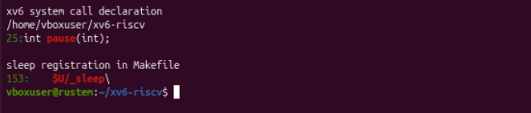
Figure 1.1 – Checking the pause declaration and the sleep registration
Command | Purpose
grep -n "pause\|sleep" user/user.h | Identify the delay system call available in this tree.
grep -nF '$U/_sleep' Makefile | Check that the sleep program was included in UPROGS.
make qemu | Build the modified programs and start xv6 in QEMU.

The updated program
I wrote user/sleep.c with an argument-count check. For a valid invocation, the program converted the tick argument with atoi, called pause, and exited. Without an argument, it printed a usage diagnostic to file descriptor 2.
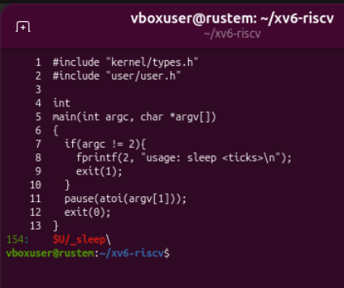
Figure 1.2 – The pause based sleep program and its UPROGS entry
I confirmed the _sleep entry in the Makefile; it appeared at line 154 after I added _args. The build log showed compilation and linking of both programs, creation of the file-system image, and the xv6 boot messages.

Execution and validation
I ran sleep 20 and sleep in xv6. An initial pasted-input sequence produced an execution error. I repeated sleep 20 individually, and the command returned to the shell without a diagnostic. The argument-free invocation printed usage: sleep <ticks>. I did not measure elapsed wall-clock time.
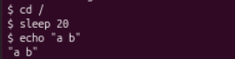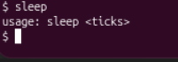
Figure 1.3 – The silent sleep run and the missing argument diagnostic
Test | Result
Build and boot | The programs compiled, and xv6 started its shell.
sleep 20 | The clean run returned without output or an execution error.
sleep | The program printed usage: sleep <ticks>.

Part 2 Comparing Bash with the xv6 shell
I ran the comparison commands in a fresh Linux directory containing README and then at the xv6 prompt. I kept the shell commands distinct from the programs they launched. In particular, a failure to find a program after changing directories was different from a failure of the program itself.

Comparison of the observed results
Command | Bash | xv6 | Explanation
echo hello > f ; cat < f | hello | hello | Both shells connected files to standard input and output.
ls | grep READ | README | A README row with file metadata | Both shells connected two programs through a pipe.
(echo a; echo b) | wc | 2 2 4 | 2 2 4 | Both passed two lines, two words and four bytes.
echo one ; echo two | one, then two | one, then two | A semicolon selected sequential execution.
echo bg & | bg; job 1, PID 6445; Done | bg, near the next prompt | Both accepted background execution; Bash displayed job information.
ls * | README f | ls: cannot open * | Bash expanded the pattern; xv6 passed a literal asterisk.
echo $HOME | /home/vboxuser | $HOME | Only Bash substituted the variable value.
echo "a b" | a b | "a b" | Bash removed syntactic quotes; xv6 preserved them.
mkdir d ; cd d ; ls .. | Changed into d; listed README, d and f | exec cd failed; listed the parent of the current root directory | xv6 did not recognise cd as a builtin inside this command list.
Up arrow, Tab, Ctrl+R | Tab and Ctrl+R worked; Up did not recall the command in this test | Tab did not complete; Ctrl+R opened no search; key-test text remained literal | The Bash key results differed by feature. No comparable line editor was demonstrated in xv6.
The quote test was significant even though echo displayed the two words together in both shells. The argument-printing program in Part 3 showed that xv6 had actually split the quoted text into separate arguments.

Command output in the two shells
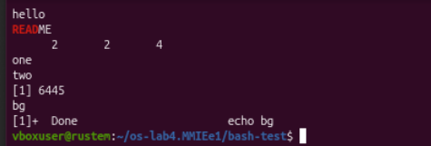
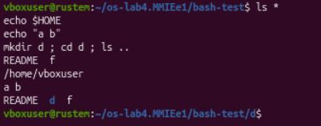
Figure 2.1 – Redirection pipelines expansion and directory changes in Bash
I observed hello, the matching README name, the counters 2 2 4, the sequence one and two, and the background output bg. Bash also expanded * to the existing names and $HOME to /home/vboxuser. The compound directory command left Bash in bash-test/d.
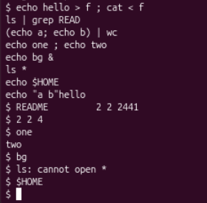
Figure 2.2 – The xv6 command comparisons and the literal quote result
The xv6 shell successfully handled redirection, pipes, grouping, sequencing and background syntax. It passed * literally to ls, which reported an open error. It also printed $HOME literally. In the clean quote rerun, I observed the quote characters in "a b".

Directory changes and program lookup
I first ran the exact compound line from the assignment. The directory was created, but the nested cd was treated as an executable and failed. I then entered cd d as a separate line. That form changed the parent shell directory successfully.
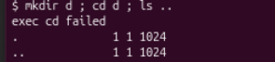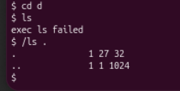
Figure 2.3 – The nested cd failure and absolute program lookup inside d
Inside d, the command ls failed with exec ls failed, but /ls . succeeded. The successful listing showed . as inode 27 and .. as inode 1. This confirmed that I had entered the new directory and that the executable still existed in the root directory.
Test | Result
cd inside a semicolon list | exec cd failed.
Standalone cd d followed by ls | Directory change succeeded; the relative executable name failed.
/ls . from inside d | The root executable ran and listed the current directory.

Observe 1 Features shared by the two shells
I demonstrated input and output redirection, pipes, parenthesised grouping, sequential command lists, and background execution in both shells. Both also supported a standalone directory change. Bash additionally expanded filename patterns and variables, interpreted quotes, and provided the demonstrated Tab completion and reverse history search. The Up-arrow test failed in my Bash terminal, so I did not count that particular key test as successful.

Observe 2 Why ls failed after cd d
The xv6 shell passed the command name directly to exec. It did not search a PATH variable for executable directories. After I entered d, the relative path ls referred to a file in that directory, where no such executable existed. I solved the problem by using the absolute path /ls .. The root-directory executable was independent of the shell current directory.

History completion and the keyboard tests
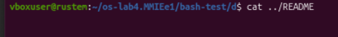
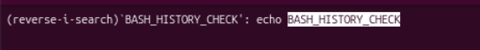
Figure 2.4 – Bash filename completion and reverse history search
I used Tab to complete cat ../REA to cat ../README. I also used Ctrl+R to find echo BASH_HISTORY_CHECK; the terminal displayed the reverse-search interface and highlighted the matching text. In the separate Up-arrow test, the previous command was not restored. I did not establish the terminal or key-binding cause of that failure.
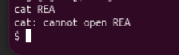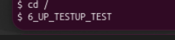
Figure 2.5 – The xv6 completion failure and literal keyboard test input
In xv6, Tab did not complete REA, and cat reported that it could not open that name. The keyboard-test line also contained literal input instead of a recalled command. When I pressed Ctrl+R, no history-search interface appeared. These observations agreed with the simple line-input behaviour of the xv6 shell.
Command | My prediction | Real output | Explanation
Up arrow in Bash | Recall the last command | No command was restored | Did not match. The cause was not established.
Tab in Bash | Complete ../README | The name was completed | Matched. Filename completion worked.
Ctrl+R in Bash | Show a matching history entry | The search found the earlier echo command | Matched. Reverse history search worked.
Ctrl+R in xv6 | No history-search interface | No search appeared | Matched. The key did not start a search.

Observe 3 The feature I would prioritise
I would miss filename completion most in daily work because it reduced typing and helped me select existing paths. I considered executable lookup through a fixed list of directories the easiest useful addition among the tested missing features: the shell could try the current name and then a root-directory path before reporting failure. This limited search would be simpler than a general PATH implementation with environment variables. Quote handling and globbing would require additional token or expansion processing.

Part 3 Inspecting the arguments received by programs
I wrote an xv6 program that printed argc and every element of argv. I wrote the Linux version with <stdio.h> and return 0 in place of the xv6 headers and exit(0). This kept the argument-printing logic equivalent while matching each environment.
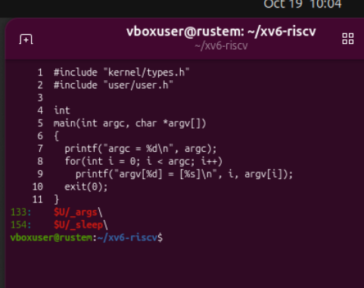
Figure 3.1 – The xv6 argument printer and the registered user programs
Command | Purpose
gcc -o args args_linux.c | Build the Linux argument printer.
args one two three | Inspect whitespace separation in xv6; use ./args in Bash.
args *.c "x y" | Compare filename expansion and double-quote handling.
args $HOME  args 'single quoted' | Compare variable substitution and single-quote handling in separate runs.
I ran the Linux tests in a directory containing exactly three C filenames: a.c, args_linux.c and b.c. The two extra files were empty pattern-matching fixtures. I compiled only args_linux.c. In all reported counts, argc included the executable name at argv[0].

Predictions and actual argument counts
Command | My prediction | Real output | Explanation
args one two three | Bash 4; xv6 4 | Bash 4; xv6 4 | Matched. Each shell separated three words.
args *.c "x y" | Bash 5; xv6 4 | Bash 5; xv6 4 | Matched. Bash expanded three filenames and kept x y together.
args $HOME | Bash 2; xv6 2 | Bash 2; xv6 2 | Matched counts; only Bash expanded the value.
args 'single quoted' | Bash 2; xv6 3 | Bash 2; xv6 3 | Matched. Only Bash treated the quotes as grouping syntax.

Observed argument output
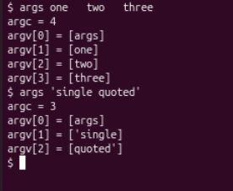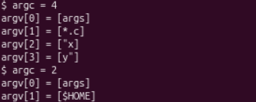
Figure 3.2 – All four xv6 argument tests from the confirmed runs
The first and last tests were confirmed in the individual reruns. The middle two outputs showed a literal *.c, two quote-containing word fragments, and a literal $HOME. The initial execution error visible in the earlier pasted sequence was not used as the result of a successful argument test.
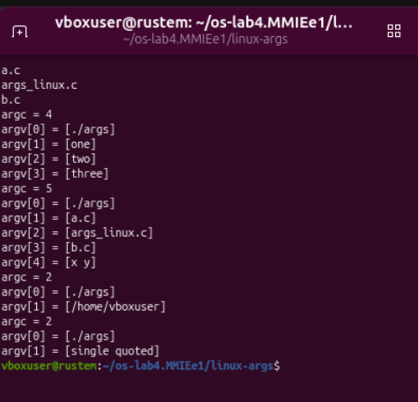
Figure 3.3 – The Bash argument printer after expansion and quote removal
The Bash output listed the three expanded C filenames separately, preserved x y as one argument, substituted /home/vboxuser, and passed single quoted as one argument without quote characters.

Observe 1 The full wildcard and quote outputs
For ./args *.c "x y" in Bash, I obtained the following output:
argc = 5
argv[0] = [./args]
argv[1] = [a.c]
argv[2] = [args_linux.c]
argv[3] = [b.c]
argv[4] = [x y]
For args *.c "x y" in xv6, I obtained:
argc = 4
argv[0] = [args]
argv[1] = [*.c]
argv[2] = ["x]
argv[3] = [y"]
Bash passed four user arguments plus the program name, giving argc = 5. xv6 passed three user arguments plus the program name, giving argc = 4. The larger Bash count came from the three matching filenames, even though Bash combined the quoted text into one argument.

Observe 2 Who expanded the pattern and removed the quotes
The shell performed these transformations before it started the program. The two programs only printed the argument array they received. Bash replaced *.c with matching filenames and removed the quote syntax while preserving the enclosed space. xv6 performed neither transformation in these tests. The kernel received the argument strings from the shell through the process-execution interface; it did not apply shell filename or quote rules.

Observe 3 What happened to the extra spaces
In one two three, both shells treated runs of unquoted whitespace as separators. I received the three arguments one, two and three, with no empty arguments for the additional spaces. Bash could preserve a space inside a quoted argument, as x y demonstrated. xv6 also split at the space between "x and y" because it did not give quotes a grouping role.
Test | Result
Argument-count predictions | All four pairs matched the confirmed output.
Bash variable value | argv[1] contained /home/vboxuser.
xv6 variable text | argv[1] contained the literal $HOME.
Single-quoted text | One user argument in Bash; two quote-containing user arguments in xv6.

Part 4 Relating shell behaviour to the source
I inspected user/sh.c in my xv6 tree. The line count was 499. I located the command-type definitions, the execution cases and the parent-shell directory handling. I then searched for dollar and asterisk characters to distinguish shell syntax from ordinary C source text.
Command | Purpose
wc -l user/sh.c | Measure the size of the local shell source.
grep -n "#define" user/sh.c | Locate command-type constants.
grep -n "case " user/sh.c | Locate command execution and parser branches.
grep -n "cd" user/sh.c | head | Locate the directory-change special case.
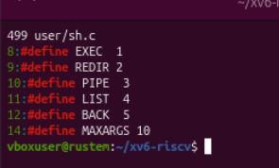
Figure 4.1 – The five command kinds defined in the 499 line shell
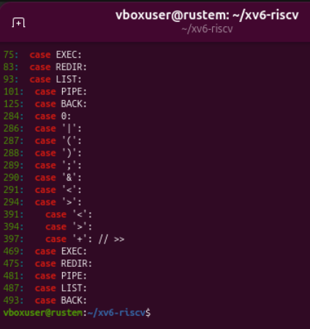
Figure 4.2 – Execution parser and termination cases in the xv6 shell

Observe 1 The five command representations
Kind | Syntax | Meaning
EXEC = 1 | An ordinary command word | Execute a program. No special operator was required.
REDIR = 2 | <, > and >> | Redirect input or output around another command.
PIPE = 3 | | | Connect the left output to the right input.
LIST = 4 | ; | Run command lists in sequence.
BACK = 5 | & | Run a command in the background.
The parentheses in the grouping test combined a parsed command block; they did not introduce a sixth command-type constant. I found the main execution cases at lines 75, 83, 93, 101 and 125. Later case entries belonged to token handling, redirection parsing and string termination rather than additional command kinds.
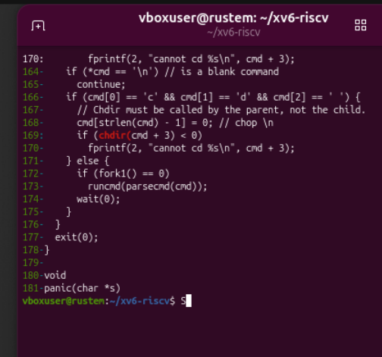
Figure 4.3 – The parent shell handles cd before it forks a child

Observe 2 Where cd was handled and why
I found the cd prefix check in main at line 166, before the branch that called fork1. The parent called chdir(cmd + 3) at line 169. A current directory belonged to a process, so changing only a child directory would not change the shell used by later commands. Handling cd in the parent made the change persist. The prefix-only check also explained why a standalone cd d worked while the nested cd in the semicolon list was executed as a missing program.

Observe 3 Searching for expansion code
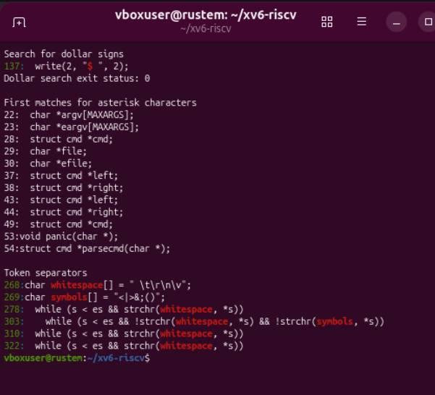
Figure 4.4 – The dollar prompt pointer asterisks and token separators
My dollar-sign search matched write(2, "$ ", 2); at line 137 and returned status 0. This string printed the prompt; it did not substitute variables. The displayed asterisks belonged to C pointers, not filename-expansion logic.
I found the whitespace array at line 268 and the operator symbols <|>&;() at line 269. The displayed token logic separated words and operators. The absence of expansion and quote interpretation explained the literal patterns, dollar text and quote-containing arguments from the earlier tests.

Conclusions
I updated sleep to use pause, built and booted xv6, and confirmed the normal invocation and missing-argument diagnostic. This connected the program source and Makefile registration to execution inside xv6.
I demonstrated redirection, pipes, grouping, sequential lists and background execution in both shells. The directory test showed why persistent cd belonged in the parent shell and why executable lookup mattered. Bash completion and reverse search worked, while its Up-arrow test did not.
The argument printers showed that Bash expanded patterns and variables and interpreted quotes before execution. xv6 passed those characters literally. Both shells discarded extra unquoted separator spaces. I related these results to the five command representations and token handling in user/sh.c.

