
MINISTRY OF EDUCATION, CULTURE AND RESEARCH
OF THE REPUBLIC OF MOLDOVA
Technical University of Moldova
Faculty of Computers, Informatics and Microelectronics
Department of Software Engineering and Automation

Cimendur Rustem
FAF-243
Report
Laboratory work nr.3
of Operating Systems

Chisinau – 2026

Shell pipes and text filters

Purpose of the work
I used Bash in a Linux virtual machine to examine command lookup, shell expansion, redirection, pipelines and job control. I then analysed a generated access log and wrote a script that reported request failures. The experiments showed how the shell prepared command arguments and connected small programs through files and pipes.

Part 1 Shell navigation and help

Environment and data preparation
Item | Observed value
Account and host | vboxuser on rustem
Shell and system | Bash 5.3.9(1)-release; Linux 7.0.0-38-generic; x86_64
Working directory | /home/vboxuser/os-lab3
Dataset | access.log: 500 generated request records

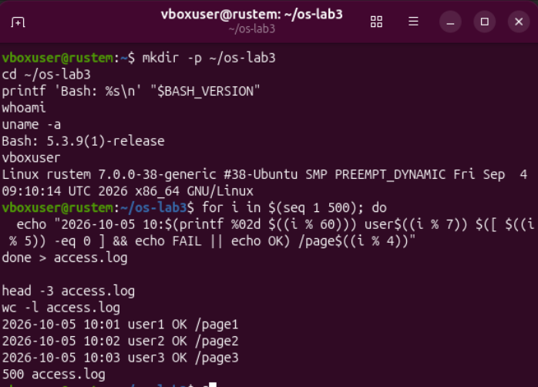
Figure 1.1 – Linux environment and generation of the 500 record access log
I generated the dataset with the loop supplied in the assignment. The first records contained the date, time, user, result and page fields. I checked the file with wc -l access.log, which returned 500 access.log. The date 2026-10-05 belonged to the synthetic dataset.

Completion and command lookup
I used Tab to complete directory names. The prefix ls /usr/sh became ls /usr/share/, and Bash offered to display 253 possible completions. The prefix cd /et became cd /etc/. This reduced the amount of manual typing and helped identify valid paths.
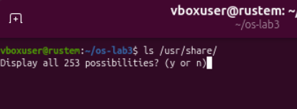
Figure 1.2 – Tab completion of the share directory and its possible entries
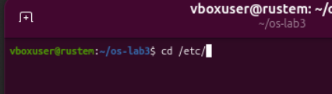
Figure 1.3 – Tab completion of the etc directory
Command | Purpose
pwd; whoami; uname -r | Display the working directory, account and kernel release.
type cd; type ls; type echo | Identify builtins, aliases and external commands.
which ls | Locate the executable selected through PATH.
echo "$PATH" | tr ':' '\n' | Display one PATH entry per line.

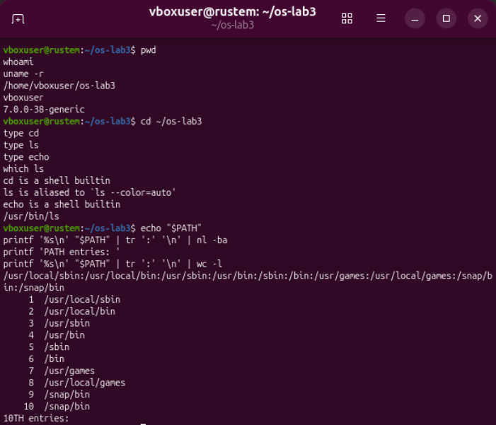
Figure 1.4 – Command types and the location of the ls executable
I observed that cd and echo were shell builtins. In the interactive shell, ls was an alias for ls --color=auto; its executable was /usr/bin/ls. The alias added a display option to an external program.
Why did cd need to be a shell builtin?
A working directory belongs to a process. The builtin changed the directory of the current shell, so later commands used the new location. A separate external process could change only its own directory and could not directly change the parent shell.

Search path exit status and help
Figure 1.5 – The ten entries in the shell search path
I counted 10 PATH entries. The directory /snap/bin appeared twice, so there were nine distinct directory strings. The directory /usr/bin, which contained ls, was the fourth entry. Bash searched PATH directories in order when resolving a command name without a slash, after considering shell features such as aliases and builtins.

Figure 1.6 – Exit status of an unavailable command
I ran nosuchprog and immediately printed $?. The shell reported that the command was not found and returned status 127. Reading the status immediately preserved the result of the failed command.
Command | Purpose
man ls | Read the manual; use /sort to search, n for the next match and q to exit.
ls --help | head | Show the beginning of the command usage information.
man -k "list directory" | Search manual descriptions for directory-listing commands.
help cd | Read Bash documentation for its cd builtin.

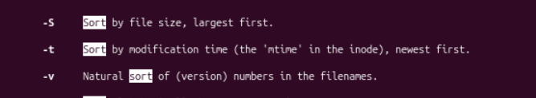
Figure 1.7 – The manual option for sorting by modification time
I found that ls -t sorted entries by modification time, with the newest first. The manual distinguished this from -S, which sorted by size, and -v, which used a natural order for version numbers.

Help results and command history
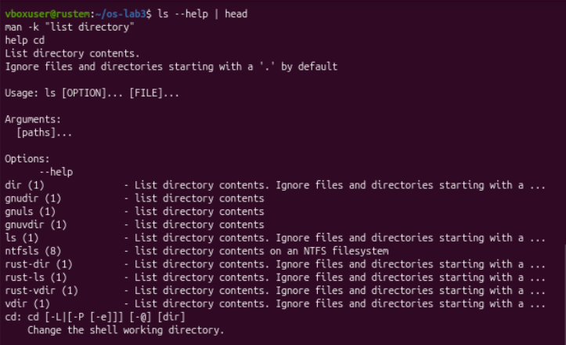
Figure 1.8 – Command usage manual search results and builtin help
I used the short help output to inspect the syntax of ls, and man -k returned related commands such as dir, ls and vdir. The builtin help described cd, its default use of HOME and its directory-handling options. These tools provided documentation directly in the terminal.

History search and repeated commands
Bash provided reverse history search through Ctrl+R. Typing part of a previous command selected a matching history entry; Enter ran the selected line. This mechanism could repeat an earlier command without retyping it.
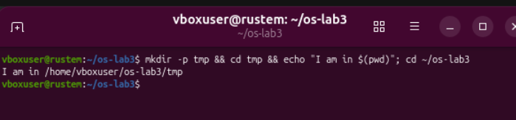
Figure 1.9 – A repeated directory command and its printed working directory
The repeated command created or reused tmp, changed into it and printed /home/vboxuser/os-lab3/tmp. The final cd returned the shell to the laboratory directory. The pwd, whoami and uname -r outputs also identified the current directory, user and kernel used in these experiments.

Part 2 Shell expansion and quoting
I created six files in ~/os-lab3/play and inspected the Bash options that affected unmatched filename patterns. Both nullglob and failglob were off. I compared the predictions prepared before execution with the actual outputs.
Command | Purpose
mkdir -p ~/os-lab3/play; cd ~/os-lab3/play | Create and enter the test directory.
touch a.c b.c file1.txt file2.txt notes.txt "alfa beta.txt" | Create files for pattern and quoting experiments.
shopt nullglob failglob | Check how Bash handles patterns without matches.

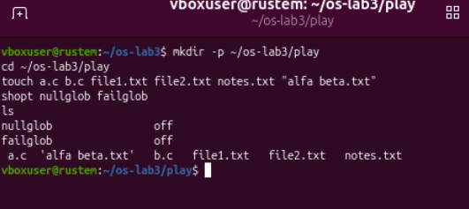
Figure 2.1 – Files created for shell expansion experiments
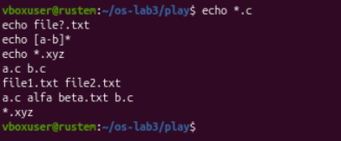
Figure 2.2 – Expansion of filename patterns and an unmatched pattern
I observed that Bash replaced matching patterns with filenames before it invoked echo. The command itself did not search the directory. Because no file matched *.xyz and both relevant options were off, Bash passed that pattern unchanged.

Predictions and observed output
Command | My prediction | Real output | Explanation
echo *.c | a.c b.c | a.c b.c | Matched. Bash expanded the .c pattern.
echo file?.txt | file1.txt file2.txt | file1.txt file2.txt | Matched. ? selected one character.
echo [a-b]* | a.c alfa beta.txt b.c | a.c alfa beta.txt b.c | Matched. Names began with a or b.
echo *.xyz | Literal *.xyz | Literal *.xyz | Matched. There were no matching files.
ls alfa beta.txt | Errors for two missing paths | Errors for alfa and beta.txt | Matched. The space split two arguments.
ls "alfa beta.txt" | The single file was listed | 'alfa beta.txt' | Matched. Quoting kept one argument.
echo '$HOME' "$HOME" \$HOME | Literal, expanded path, literal | $HOME /home/vboxuser $HOME | Matched. Only the double-quoted variable expanded.
echo {1..5}; echo $((7 * 6)) | 1 2 3 4 5, then 42 | 1 2 3 4 5, then 42 | Matched. Brace and arithmetic expansion occurred.
echo "today is $(date +%A), I am $(whoami)" | A weekday and the current account | today is Sunday, I am vboxuser | Matched. Command outputs replaced the substitutions.
touch log{1..3}.txt && ls log* | Three numbered log files | log1.txt log2.txt log3.txt | Matched. Bash generated three names and then expanded log*.

All ten experiments agreed with the prepared predictions. For the weekday and home directory, the prediction described values obtained from the environment rather than assuming that every system would use the same values.

Spaces quotes and other expansions
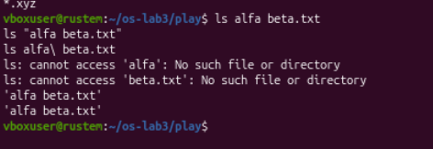
Figure 2.3 – An unquoted space caused errors while quoting and escaping succeeded
Why did ls alfa beta.txt fail and how could I fix it?
The shell passed two arguments, alfa and beta.txt, neither of which existed. I fixed the command in two ways: ls "alfa beta.txt" and ls alfa\ beta.txt. Both forms passed one filename. The quotes printed by ls made the embedded space clear; they were display formatting and were not part of the stored name.
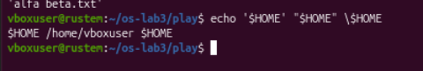
Figure 2.4 – Single quotes double quotes and an escaped dollar sign
What was the difference between single and double quotes?
Single quotes preserved $HOME literally. Double quotes allowed its value to expand to /home/vboxuser while keeping the result in one argument. A backslash before the dollar sign also prevented variable expansion. Double quotes still allowed command substitution, as the date and account experiment showed.
Command | Purpose
echo {1..5}; echo $((7 * 6)) | Generate a sequence and evaluate an integer expression.
echo "today is $(date +%A), I am $(whoami)" | Insert command outputs into a sentence.
touch log{1..3}.txt && ls log* | Create three files and list the matching names.

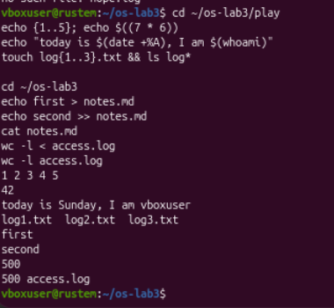
Figure 2.5 – Sequence arithmetic command substitution and generated log filenames
I obtained the sequence 1 to 5, the result 42, the weekday Sunday and the account vboxuser. The final listing contained log1.txt, log2.txt and log3.txt.

Part 3 Redirection chaining and jobs
Command | Purpose
ls /etc /nope > out.txt 2> err.txt | Write standard output and standard error to separate files.
wc -l out.txt; cat err.txt | Count the saved output lines and read the error.
ls /etc /nope > all.txt 2>&1 | Send both streams to the same file.
ls /etc /nope 2>&1 > all.txt | Copy the current stdout destination to stderr before redirecting stdout.

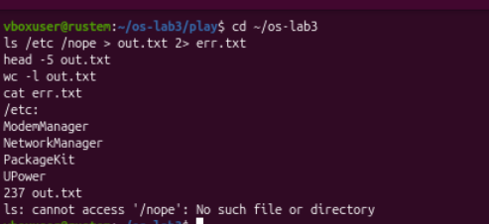
Figure 3.1 – Directory output and the missing path error in separate files
I found the directory listing in out.txt and the missing-path diagnostic in err.txt. The saved standard output contained 237 lines, including the /etc: heading. This was a count of output lines rather than a direct count of directory entries.
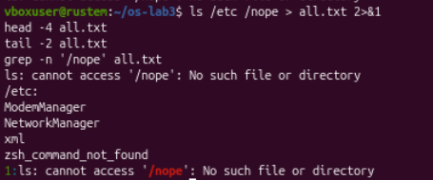
Figure 3.2 – Both output streams were captured after redirecting stdout first
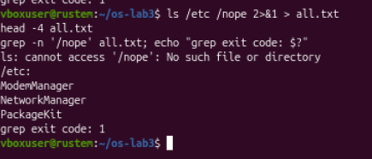
Figure 3.3 – The error stayed in the terminal when stderr was redirected first

Redirection order and file input
Why did the order of redirections change the result?
Bash processed redirections from left to right. In > all.txt 2>&1, stdout first referred to the file, and stderr then copied that destination. In 2>&1 > all.txt, stderr first copied stdout's terminal destination; moving stdout to the file afterwards did not move stderr. I confirmed this with grep: the first file contained the error on line 1, while the second search found no match and returned status 1.
Command | Purpose
echo first > notes.md | Create or overwrite the notes file.
echo second >> notes.md | Append a second line without discarding the first.
cat notes.md | Inspect the two saved lines.
wc -l < access.log | Read the log through standard input.
wc -l access.log | Open the named file and include its name in the result.

Figure 3.4 – Two saved lines and the two forms of line counting
I observed first followed by second, which confirmed the difference between overwriting and appending. Both counting commands returned 500. The redirection form printed only the number because wc read standard input; the filename form also printed access.log because the filename was an explicit argument.

Chaining commands
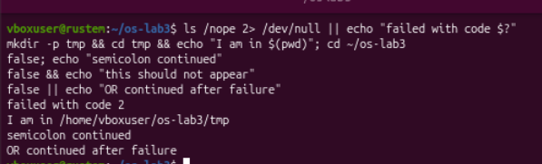
Figure 3.5 – Conditional and unconditional execution with shell operators
The semicolon ran the next command regardless of the previous exit status. The && operator ran the next command only after success, and || ran it only after failure. In my tests, false; echo printed its message, false && echo did not, and false || echo printed the recovery message. The missing-path command returned status 2 and activated its || branch.

Background execution and termination
Command | Purpose
sleep 100 & | Start a process in the background and immediately return control to the shell.
LAB3_SLEEP_PID=$! | Save the PID of the most recent background process.
jobs -l | Display jobs and their process IDs.
kill "$LAB3_SLEEP_PID" | Send SIGTERM to the process started for this experiment.
wait "$LAB3_SLEEP_PID"; echo "wait exit code: $?" | Wait for termination and inspect its exit status.

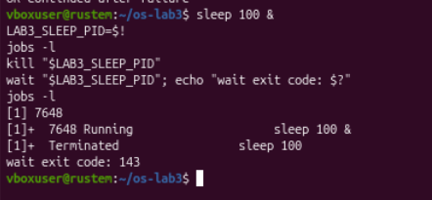
Figure 3.6 – Background sleep process 7648 and its termination
I started sleep 100 as job 1 with PID 7648. The first job listing showed it as Running. I sent the default termination signal with kill, and the shell reported Terminated. The wait command returned 143, which Bash represented as 128 plus signal 15, SIGTERM. The final job listing was empty.
Saving $! let me address the process created by this experiment directly. This avoided relying on a job number that could refer to a different job in a shell with other background tasks.

Part 4 Analysing the access log
I saved one command line for each question in oneliners.sh. I used pipelines to select fields, group equal values and count records. The filters matched the result field as FAIL , including its surrounding spaces, to avoid accidental substring matches.

Q1 Number of failed requests
Command | Purpose
printf 'Q1 - Failed requests: '; grep -c ' FAIL ' access.log | Count records with a FAIL result.

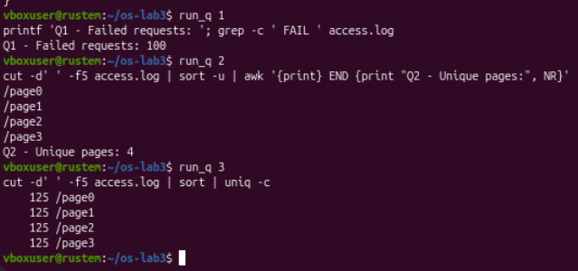
Figure 4.1 – Number of failed requests
I counted 100 failed requests out of 500, a failure rate of 20 percent.

Q2 Distinct requested pages
Command | Purpose
cut -d' ' -f5 access.log | sort -u | awk '{print} END {print "Q2 - Unique pages:", NR}' | Extract the page field, remove duplicates and count the distinct names.

Figure 4.2 – The four distinct requested pages
I found four pages: /page0, /page1, /page2 and /page3.

Q3 Requests for each page
Command | Purpose
cut -d' ' -f5 access.log | sort | uniq -c | Group equal page names and count each group.

Figure 4.3 – Equal request counts for all four pages
Each page received 125 requests. Their sum was 500, equal to the total number of log records.

Users and recent failures

Q4 Users with the highest failure count
Command | Purpose
grep ' FAIL ' access.log | cut -d' ' -f3 | sort | uniq -c | sort -rn | awk 'NR == 1 {maximum = $1} $1 == maximum {print $2 ": " $1 " failures"}' | Count failures per user and retain every user tied for the maximum.

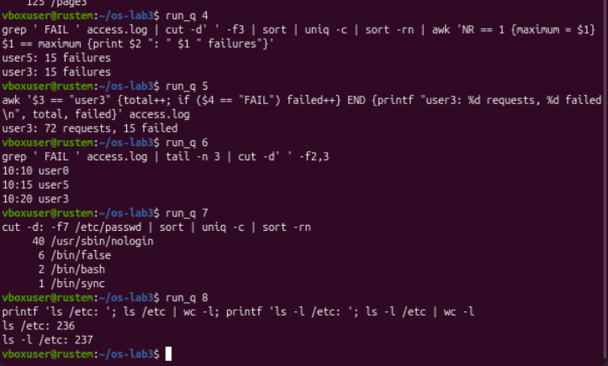
Figure 4.4 – Both users tied for the highest failure count
I found a tie: user3 and user5 each had 15 failed requests. Returning only the first sorted row would have omitted one valid answer.

Q5 Requests made by user3
Command | Purpose
awk '$3 == "user3" {total++; if ($4 == "FAIL") failed++} END {printf "user3: %d requests, %d failed\n", total, failed}' access.log | Select user3 and count all requests and failures separately.

Figure 4.5 – Total requests and failures for user3
I counted 72 requests from user3, including 15 failures. The remaining 57 requests were successful.

Q6 The last three failed requests
Command | Purpose
grep ' FAIL ' access.log | tail -n 3 | cut -d' ' -f2,3 | Select the last three failure records in file order and print time and user.

Figure 4.6 – Times and users of the final three failed requests
The final three failure records were 10:10 user0, 10:15 user5 and 10:20 user3. I used file order rather than sorting by the displayed time, because the generated minute values repeated throughout the log.

Account shells and listing formats

Q7 Shells assigned to accounts
Command | Purpose
cut -d: -f7 /etc/passwd | sort | uniq -c | sort -rn | Extract the seventh colon-separated field and count each shell path.

Figure 4.7 – Account counts grouped by their configured shell
Shell | Number of accounts
/usr/sbin/nologin | 40
/bin/false | 6
/bin/bash | 2
/bin/sync | 1

I counted 49 account records in these four groups. Most accounts used programs that did not provide a normal interactive shell. These were configured account fields, not a count of users currently logged in.

Q8 Why the line counts differed
Before running the comparison, I expected the long listing to contain one additional line because of its total header.
Command | Purpose
printf 'ls /etc: '; ls /etc | wc -l; printf 'ls -l /etc: '; ls -l /etc | wc -l | Compare the line counts of ordinary and long listings.

Figure 4.8 – The long listing contained one extra line
I observed 236 lines for the ordinary listing and 237 for the long listing. When piped, the ordinary listing printed one entry per line. The long listing contained the same visible entries plus its initial total line, which explained the difference of one.

Complete execution and consistency checks
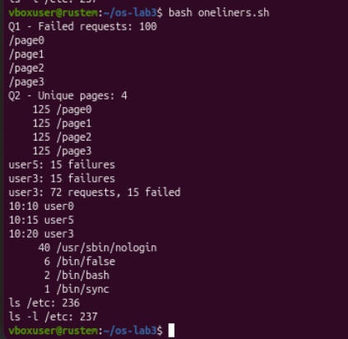
Figure 4.9 – Complete run of all eight commands in oneliners.sh
I ran bash oneliners.sh from ~/os-lab3. The full execution reproduced the individual results, including both users tied for the highest number of failures.
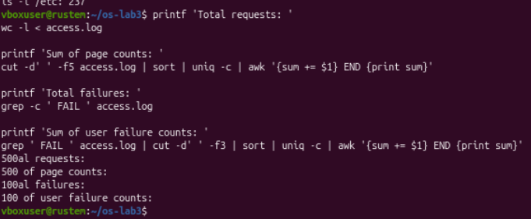
Figure 4.10 – Independent totals used to check the pipelines
Test | Result
Log line count | 500 records
Sum of page counts | 125 + 125 + 125 + 125 = 500; matched the log
Total FAIL records | 100
Sum of user failure counts | 14 + 14 + 14 + 15 + 14 + 15 + 14 = 100; matched the failure total

Part 5 Building the report script
I turned the log queries into report.sh. The script accepted the log path as its first argument, checked that the file existed, counted all requests and failures, and used a loop to report failures for user0 through user6. I quoted the filename variable so that a path containing spaces would remain one argument.
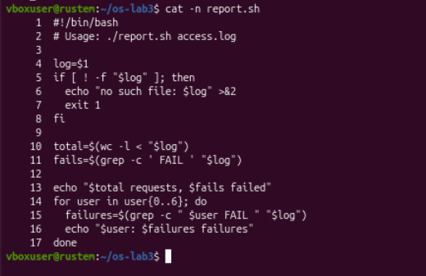
Figure 5.1 – Completed script with input validation and a per-user loop
Command | Purpose
log=$1 | Read the first command-line argument.
[ ! -f "$log" ] | Check whether the supplied path is not a regular file.
wc -l < "$log" | Count all request records without printing a filename.
grep -c ' FAIL ' "$log" | Count failures in the result field.
for user in user{0..6}; do ...; done | Generate the seven usernames and count failures for each.

What did the first line do?
The shebang #!/bin/bash selected Bash as the interpreter when the executable script was launched directly. This matched the Bash-specific brace expansion used in the loop. The shebang did not itself grant execute permission.

Script execution and error handling
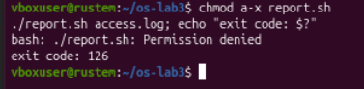
Figure 5.2 – Direct execution failed without execute permission
I removed execute permission with chmod a-x report.sh. Direct execution then failed with Permission denied and exit status 126. I restored execute permission with chmod +x report.sh before running the script again.
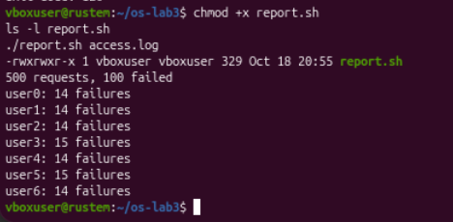
Figure 5.3 – Successful report for all 500 requests
The successful run printed 500 requests, 100 failed. It reported 14 failures each for user0, user1, user2, user4 and user6, and 15 each for user3 and user5. These counts matched the pipelines in Part 4.
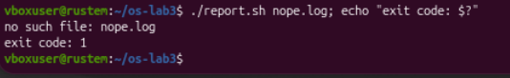
Figure 5.4 – A missing input file produced an error and exit status one
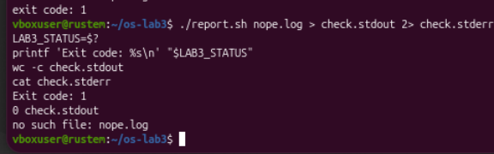
Figure 5.5 – The diagnostic was written to stderr while stdout remained empty

Script observations and conclusions
Why did I use ./report.sh rather than report.sh?
The prefix ./ referred to a file in the current directory. A bare command name was resolved through PATH, whose entries did not include the current directory in this environment. Using ./report.sh therefore selected the intended local script explicitly.
Why did the error use stderr and exit 1?
The script sent its diagnostic to standard error with >&2, keeping it separate from normal report output. The nonzero status exit 1 allowed the calling shell or another program to detect failure. I verified this by capturing the streams separately: stdout contained zero bytes, stderr contained no such file: nope.log, and the captured status was 1.
Test | Result
Direct launch without execute permission | Permission denied; status 126
Run with access.log | 500 requests, 100 failed; all seven user counts printed
Run with nope.log | Diagnostic printed; status 1
Capture output for the missing file | stdout: 0 bytes; stderr: missing-file diagnostic
Compare script and pipeline totals | All observed request and failure counts agreed

Conclusions
I observed that Bash expanded patterns, variables and command substitutions before it ran a command. Quoting controlled how the resulting text became arguments. The filename with a space showed why preserving argument boundaries mattered, and the unmatched pattern showed how shell options affected expansion.
I separated standard output from standard error, compared two redirection orders and used exit statuses to control command chains. The background-job experiment connected the PID returned by $! with explicit process termination and the status reported by wait.
I analysed 500 log records with pipelines and found 100 failures, four equally requested pages and two users tied at 15 failures. I checked the totals independently and reproduced them in report.sh. The permission and missing-file tests showed that a usable script needed predictable error handling as well as correct counts.

Laboratory files
The completed command collection was oneliners.sh, and the executable report program was report.sh. Both were designed to run with the generated access.log in the laboratory directory.

