Uncertainty-Aware Prediction of Perovskite Oxide Stability with Conformal Prediction
Xumingyong Feng^{a,*}
ª Weiyang College, Tsinghua University, Beijing 100084, China
,* Corresponding author. E-mail address: fxmy23@mails.tsinghua.edu.cn (X. Feng)

Abstract
Machine learning accelerates the discovery of ABO₃ perovskite oxides, yet most existing models provide only point predictions without reliability metrics—an important gap for high-throughput screening where false positives waste costly first-principles verification. We present an uncertainty-aware prediction framework for perovskite formation energy and thermodynamic stability (energy above the convex hull). The framework couples a physics-informed point predictor (KernelRidge baseline + gradient-boosted decision tree stacking residual) with Conformalized Quantile Regression (CQR), which provides sample-adaptive prediction intervals with finite-sample coverage guarantees. A multi-method applicability domain (ensemble σ, k-NN distance, leverage) delimits the trusted prediction region, and symbolic regression consensus validates known chemistry, with A-site electronegativity appearing in all 50 independent symbolic-regression runs. On 4,914 perovskites, the framework achieves R² = 0.914 (formation energy) and 0.800 (energy above hull), with CQR reducing the expected calibration error by 43–60% relative to standard split conformal using an equivalent LightGBM baseline. Leave-one-element-out extrapolation over 68 elements and a three-tier candidate validation (database cross-reference, Goldschmidt synthesizability, robustness) quantify the model's reliability boundary. We discuss the decoupling tension between point and interval predictions, the empirical applicability boundary of symbolic regression (formation energy succeeds at signal-to-noise ratio, SNR = 2.61; hull energy fails at SNR = 0.94), and the role of the physics baseline as an interpretability anchor rather than an accuracy contributor.
Keywords: perovskite oxides, formation energy, conformal prediction, applicability domain, symbolic regression, materials informatics

1. Introduction
$E_{hull}$ABO3 perovskite oxides constitute one of the most versatile families of functional materials, exhibiting a wide range of functional properties including catalytic activity, ferroelectricity, superconductivity, and ionic conductivity [1–4] that span energy conversion, information storage, and chemical synthesis applications. The chemical space of possible A-site and B-site elemental combinations is vast (dozens of candidate elements at each site), yet experimentally realizing and verifying each candidate via density functional theory (DFT) or synthesis is prohibitively expensive: a single DFT relaxation can take hours to days. Machine learning(ML) has emerged as a powerful accelerator: descriptor-based regressors trained on existing DFT databases can predict formation energy and thermodynamic stability (energy above the convex hull, ) in milliseconds, enabling high-throughput pre-screening before DFT verification [3,5].
$E_{hull}E_{hull}$Recent advances have pushed prediction accuracy substantially. Deng et al. [6] achieved R² = 0.928 for ABX3 formation energy using SHAP-guided feature selection and meta-heuristic hyperparameter tuning; interpretable ML screening of perovskite oxides with stability classification and regression has also been demonstrated [7]; and descriptor ML has been compared against crystal-graph neural networks [8]. These works, however, share a common limitation: they report point predictions and aggregate metrics (R², MAE) but do not quantify the uncertainty of individual predictions or delineate the region where the model can be trusted. For materials discovery, this is a critical omission. A model that predicts = 0.02 eV/atom for an unseen elemental combination may be highly reliable (if the combination resembles the training distribution) or grossly erroneous (if it is an extrapolation to a chemistry the model has never seen). Consider a screening campaign over 1,000 virtual A-B combinations: if the model has no uncertainty estimate, all candidates predicted stable ( < 0.05 eV/atom) must be forwarded to DFT verification at uniform cost. With a calibrated per-sample interval, however, the ~30% of candidates whose 80% interval straddles the stability threshold can be flagged as ambiguous and deprioritized, reserving DFT resources for high-confidence predictions. Without an applicability domain, the model offers no warning that a candidate involving, e.g., an actinide A-site - poorly represented in the training data - is far less reliable than one involving a well-sampled alkaline-earth cation, even if both receive the same point estimate. Applicability-domain (AD) methods, standard in cheminformatics QSAR [9,10], address this by delimiting the chemical space where predictions are trustworthy, yet they remain rarely applied to inorganic perovskite stability models.
$y\hat{C}$Conformal prediction [11] offers a principled remedy for this uncertainty gap: it wraps any point predictor with prediction intervals that satisfy a finite-sample, distribution-free marginal coverage guarantee (Pr(∈(X))≥1−α). Conformalized Quantile Regression (CQR) [12] further yields heteroscedastic intervals whose width adapts to sample-level uncertainty — wide for extrapolation samples, narrow for interpolation — while preserving the coverage guarantee. Despite their maturity in statistics, conditional conformal methods have seen limited application in materials informatics [2]. Instead, ensemble variance and heuristic confidence scores remain the norm, despite their known calibration issues.
The inadequacy of current uncertainty practices in perovskite ML is not merely theoretical. Ensemble standard deviation (σ) — the most common uncertainty estimate — suffers from model correlation: when the ensemble members share training data and architecture, their predictions are highly correlated and the resulting σ systematically underestimates true error. In our own preliminary experiments (Section 3.2), naive 80% intervals constructed from ensemble σ achieved a coverage of only 0.24 — far below the nominal 0.80 — because the five gradient-boosted trees in the ensemble produce nearly identical predictions. Standard split conformal corrects the marginal coverage but assigns uniform-width intervals to all samples regardless of their individual reliability, yielding poor conditional coverage (expected calibration error ECE = 0.085; Section 3.2). These two limitations — underestimation by σ and uniform-width intervals by standard conformal—motivate the need for a method that provides both guaranteed marginal coverage and sample-adaptive width. Conformalized Quantile Regression (CQR) satisfies both requirements simultaneously.
While black-box ML models such as gradient-boosted trees offer high prediction accuracy, their internal decision logic is opaque to domain scientists seeking chemical insight [13]. Symbolic regression (SR) addresses this gap by searching the space of mathematical expressions to discover closed-form equations relating descriptors to targets [7,14]. Although SR equations are non-unique and require consensus analysis across runs, they provide a human-readable alternative to black-box feature attributions and can validate whether the model has captured physically meaningful structure-property relationships.
In this work, we integrate these four components into a unified, uncertainty-aware prediction framework and evaluate it on 4,914 ABO₃ perovskites from the wolverton_oxides dataset [5].
(1)Conditional coverage via CQR. We apply CQR [12] to perovskite stability prediction and demonstrate, under a fair same-family baseline, a 43-60% reduction in expected calibration error (ECE) relative to standard split conformal—yielding sample-adaptive intervals whose conditional coverage more closely matches the nominal level.
(2)Multi-method applicability domain. We compare three AD criteria (ensemble σ, k-NN distance, PCA leverage) and show the trusted region achieves R² = 0.945 vs. 0.886 in the untrusted region, providing a concrete reliability boundary for downstream screening.
(3)Extrapolation assessment via LOEO. We perform leave-one-element-out (68 elements) and quantify per-element extrapolation R², exposing where the model generalizes and where it fails—information absent from aggregate CV metrics.
(4)Symbolic regression consensus as a chemistry cross-check. Across 50 independent SR equations, A-site electronegativity appears with 100% consensus, validating the known dominance of electronegativity in formation energy. We further derive an empirical SR applicability criterion (SNR ≥ 2) by comparing formation energy (success) and hull energy (failure), and discuss its boundary explicitly.
Existing perovskite ML models report aggregate accuracy but do not provide calibrated per-sample uncertainty, a trust boundary, or element-level extrapolation maps. By integrating CQR, multi-criteria AD, and LOEO into a single reproducible pipeline, this work moves beyond point-prediction benchmarks toward reliability-aware screening—a shift that is necessary for high-throughput computational materials discovery but remains uncommon in the perovskite literature.
We are explicit about the framework's limitations: single data source, the decoupling tension between the stacking point predictor and the CQR interval, the absence of DFT-validated candidates, and the empirical (non-universal) nature of the SR criterion. By foregrounding these, we aim to provide a reproducible, honestly assessed tool for uncertainty-aware perovskite screening rather than an overstated accuracy benchmark.

Methods
Figure 1 provides a visual roadmap of the framework. As illustrated, the pipeline integrates four stages: (i) feature engineering, which converts each ABO₃ composition into a 110-dimensional descriptor combining Magpie statistical descriptors with 14 physics-informed quantities (§2.2); (ii) a physics-informed point predictor that anchors on a KernelRidge baseline over the 14 physics features and corrects residuals with a GBDT stacking ensemble over the full descriptor (§2.3); (iii) uncertainty quantification via Conformalized Quantile Regression (CQR), which produces sample-adaptive intervals with a finite-sample marginal coverage guarantee (§2.4); and (iv) a multi-criteria applicability domain—ensemble σ, k-NN distance, and PCA leverage—that flags each prediction as trusted or untrusted (§2.5). The point predictor, the CQR interval, and the applicability domain are fitted independently within each cross-validation fold, so that the interval and trust flag remain informative even when the point estimate degrades in extrapolation. All components are evaluated under a 5-fold cross-validation protocol with bootstrap confidence intervals (§2.6) and complemented by a symbolic-regression interpretability cross-check (§2.7). The remainder of §2 details each component; §3 then reports point-prediction accuracy, interval calibration, applicability-domain partition, element-level extrapolation, and feature interpretation.
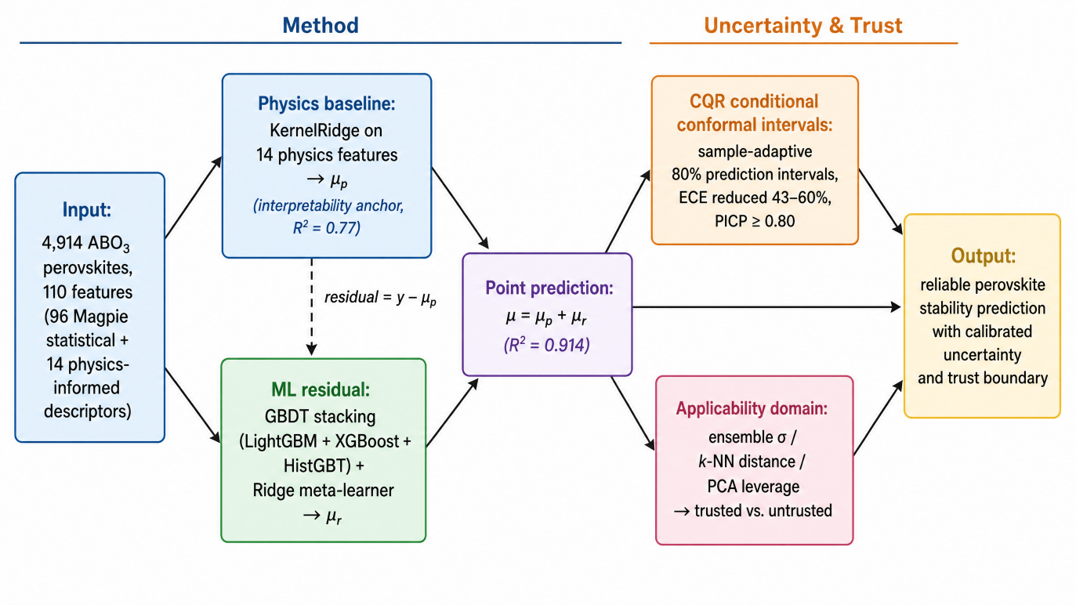
Fig. 1. Overview of the uncertainty-aware prediction framework (PACT-Final).

2.1 Dataset

$E_{f}E_{hull}$We use the wolverton_oxides dataset (4,914 ABO3 perovskite compositions), distributed via the matminer library [15]. The compositions span 73 A-site and 73 B-site elements. Each sample contains the composition and two DFT-computed target properties: the formation energy per atom ( ranges from −3.844 to +1.879 eV/atom), measuring thermodynamic stability against decomposition, and the energy above the convex hull ( ranges from −0.567 to +3.927 eV/atom), measuring phase stability against competing phases. Although E_hull is non-negative by thermodynamic definition, the dataset contains 258 small negative values (down to −0.567 eV/atom), attributable to incomplete convex-hull sampling and DFT numerical noise in the original high-throughput study [16]. All 4,914 formulas are unique. Because all samples originate from a single source, the dataset's implications for cross-dataset generalization are discussed in Section 4.

2.2 Feature engineering

$r_{A}r_{O}\sqrt{2}r_{B}r_{O}r_{B}r_{O}$Each composition is described by 110 features combining 96 Magpie statistical descriptors [17], computed via a pure-pymatgen reimplementation [18] (elemental properties—atomic number, electronegativity, atomic radius, row, group, valence, etc.—aggregated by composition-weighted mean, avg-dev, mode, minimum, maximum), and 14 physics-informed descriptors with explicit perovskite meaning: Goldschmidt tolerance factor t = ( + )/(( + )) [19], octahedral factor μ = /, A/B electronegativity difference, A/B ionic radius ratio, B-site valence, A/B ionic radii, A/B electronegativities, B-site row/group, and A/B-site d-/f-electron counts. Ionic radii use Shannon 12-/6-coordination tables [20] with pymatgen fallback. Three features were excluded from the ML input after audit: two derived heuristics (phys_in_stable_zone and phys_stability_score, composites of the same physical inputs that would create feature redundancy) and one dead feature (phys_b_site_unpaired, 100% NaN due to missing elemental data). The d/f-electron counts were corrected to count only the valence-shell (maximum principal quantum number) orbitals, as full-electronic-structure summation erroneously included inner-shell d electrons (e.g., Ac reported d = 31 instead of 1).

2.3 Physics-informed point predictor
The point prediction adopts a two-stage residual architecture:
Physics baseline $μ_{p}$: A KernelRidge regression on the 14 physics features provides an interpretable baseline. The prediction for a test sample with physics-feature vector x_phys ∈ ℝ¹⁴ is
$μ_{p}(x) =\sum_{i∈train}{α_{i}}exp(−Υ\left\|x_{phys}\right.−\left.x_{phys,i}\right\|)$ (1)
where the weights {$α_{i}$} are solved in dual form via ridge regularization (α = 1.0) and the RBF kernel bandwidth is γ = 0.10. The baseline attains standalone R² ≈ 0.77 (formation energy) and 0.58 (hull energy) under 5-fold cross-validation, quantifying the variance captured by physically meaningful descriptors alone.
- ML residual $μ_{r}$: a stacking ensemble of three gradient-boosted-decision-tree (GBDT) base learners — LightGBM (leaf-wise), XGBoost (level-wise), and scikit-learn HistGradientBoosting (histogram-based) — combined by a Ridge meta-learner, trained on the residual (y − $μ_{p}$) using the full 110 features.The stacking prediction is
$μ_{\text{r}}(x) =\sum_{\text{m=1}}^{\text{3}}{{\text{ѡ}}_{\text{m}}\text{⋅}{\hat{\text{r}}}_{\text{m}}}\text{(}\text{x}\text{)}$ (2)
where ${\hat{\text{r}}}_{\text{m}}$(x) is the residual prediction of the m-th GBDT base learner and the meta-learner weights $\text{ѡ}$ = (${\text{ѡ}}_{0}$, ${\text{ѡ}}_{1}$, ${\text{ѡ}}_{2}$, ${\text{ѡ}}_{3}$) are fit by Ridge regression on inner 3-fold out-of-fold predictions to avoid leakage (stacked generalization framework). The final point prediction is
$μ(x)= μ_{p}(x)+μ_{\text{r}}(x)$ (3)
The physics baseline serves as an interpretability anchor (its standalone R² quantifies the variance captured by physically meaningful descriptors); it does not, by itself, improve total accuracy over pure ML, because the Magpie descriptors partially encode the same physical information. In particular, the A/B electronegativity difference can be reconstructed from Magpie features with R² = 0.997 (5-fold cross-validated Ridge), so this descriptor adds no independent information beyond Magpie; other physics descriptors (tolerance factor, ionic radii, d-/f-electron counts), however, are not reconstructible from Magpie features (R² < 0) and thus retain independent value. We report this honestly rather than claiming the physics layer uniformly boosts performance.
Hyperparameters for the GBDT base learners were selected by Optuna [21] (TPE sampler, 25 trials, 3-fold inner CV). We note that hyperparameter selection on the full dataset incurs a small optimistic bias: nested CV estimates ~0.005 R2 inflation, within the bootstrap confidence interval reported in Section 3.

2.4 Conditional conformal prediction (CQR)
To quantify the uncertainty of each point prediction, we adopt Conformalized Quantile Regression (CQR; Romano et al. [12]), which couples the sample-adaptive width of quantile regression with a finite-sample marginal coverage guarantee inherited from split conformal prediction (Vovk et al. [11]). The procedure—quantile-regressor fitting, non-conformity scoring, and interval construction—is detailed in Algorithm 1 (Step 2); here we set the miscoverage level α = 0.20, corresponding to a nominal coverage of 1 − α = 80%.
A defining feature of CQR is its heteroscedasticity: because the lower and upper bounds are produced by two independent quantile regressors, the resulting interval width varies across samples—high-uncertainty (extrapolation) samples receive wider intervals than low-uncertainty (interpolation) samples, in contrast to the uniform-width intervals of standard split conformal. To ensure that this adaptivity is the sole source of any calibration improvement we report, the standard-conformal baseline uses a single LightGBM regressor from the same family as the stacking ensemble rather than a weaker model; under this fair comparison, CQR reduces the Expected Calibration Error (ECE, defined in Algorithm 1) by 60% for formation energy (0.085 → 0.034) and 43% for hull energy (0.086 → 0.049).
This sample-adaptive behavior is visualized in Fig. 2: when samples are sorted by ensemble σ, the CQR interval width grows in tandem with the absolute error, whereas the standard-conformal interval remains uniform—direct evidence that the adaptive width reflects genuine extrapolation uncertainty rather than data density.
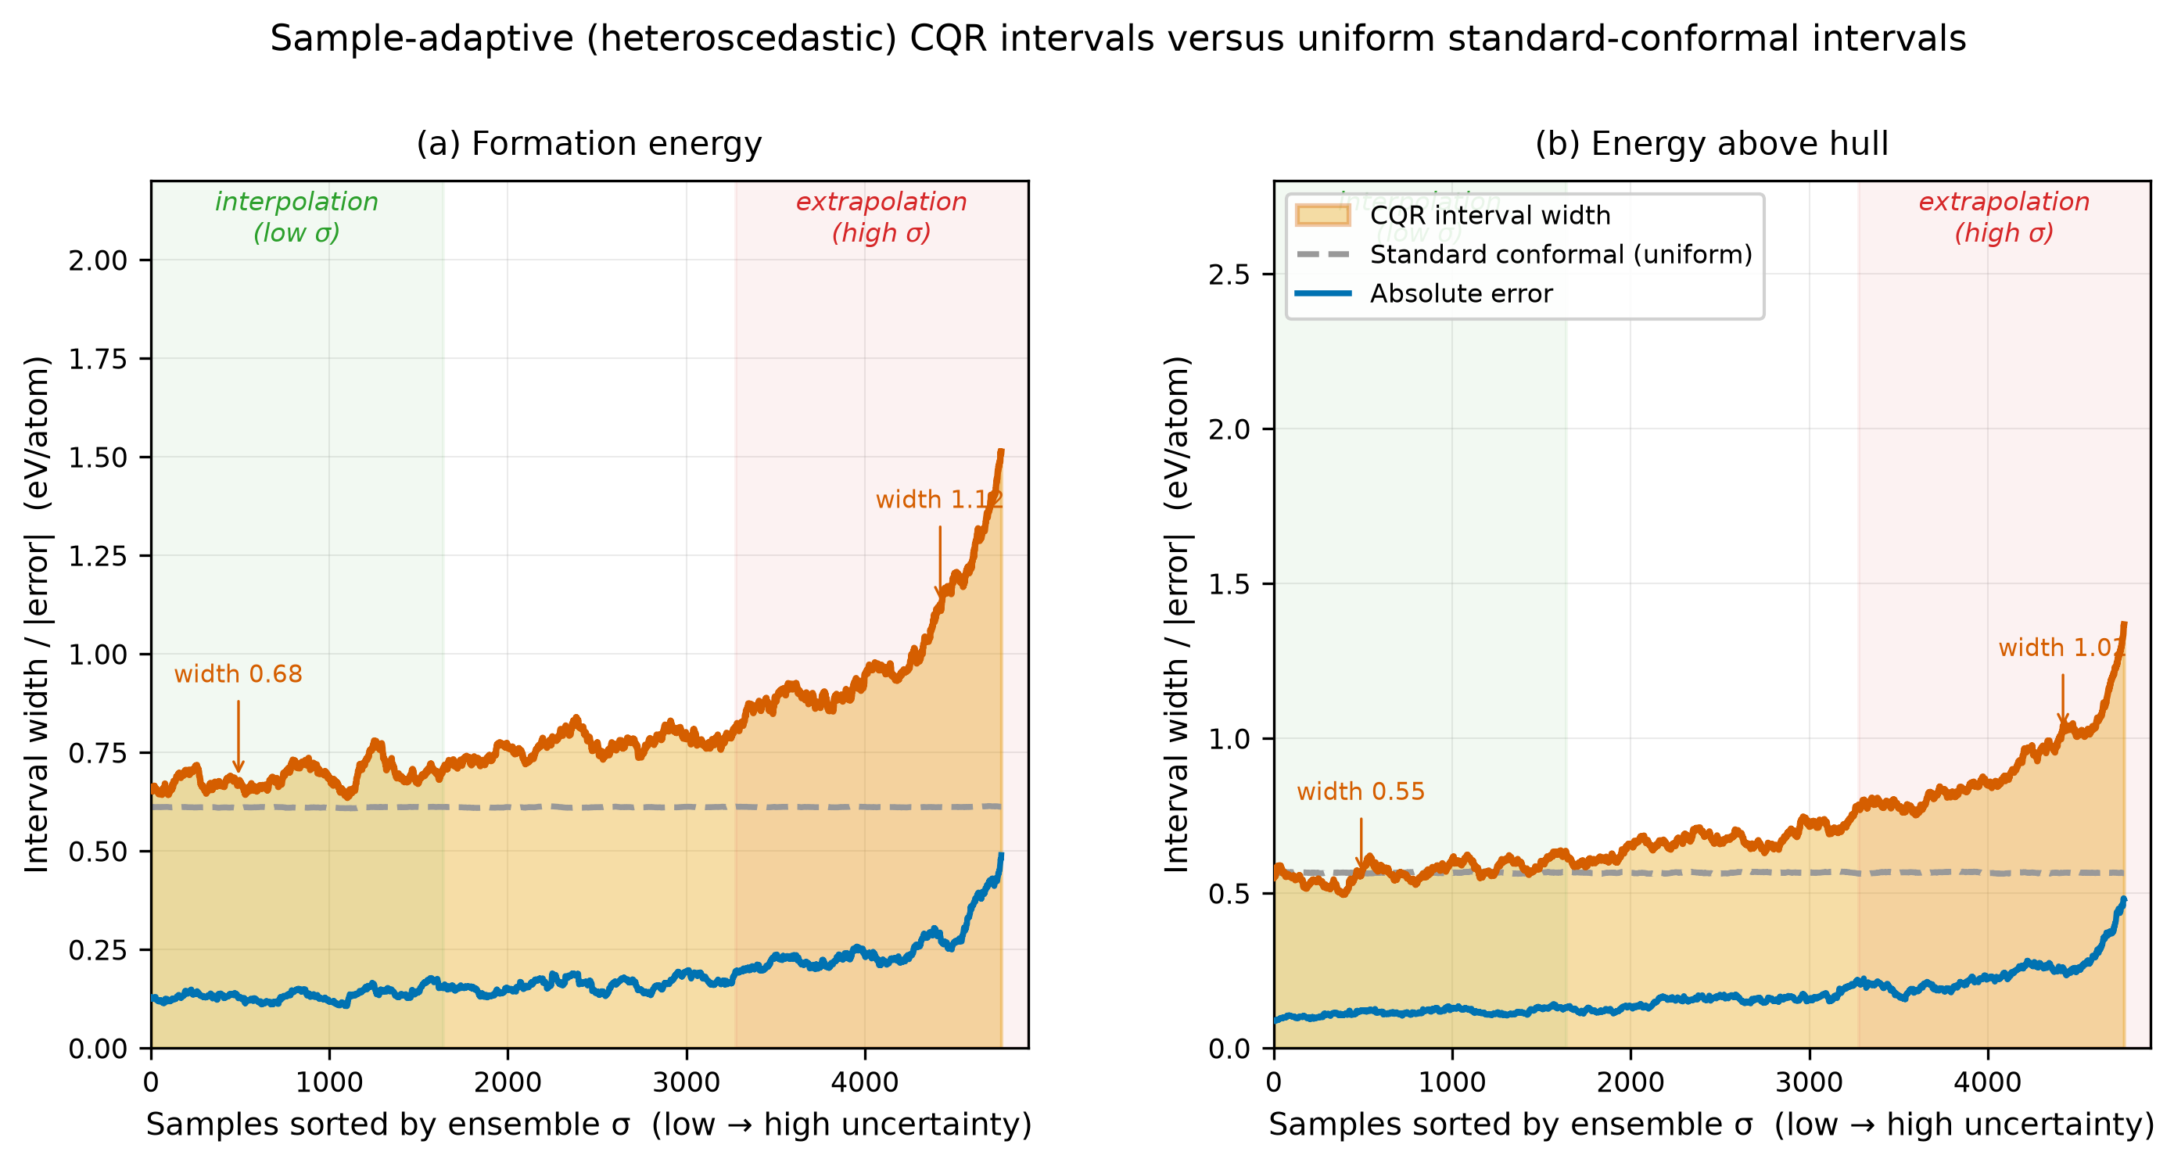
Fig. 2. CQR interval width, standard-conformal interval width, and absolute error for the 4,914 perovskites, with samples sorted by ensemble σ.
We further note a deliberate design choice: the CQR interval is calibrated independently of the stacking point predictor of Section 2.3, following the conformal-prediction philosophy that the interval need not derive from the same model as the point estimate. A consequence is that the point prediction falls outside its own 80% CQR interval for roughly 9% of formation-energy samples and 8% of hull-energy samples—a behavior permitted by the marginal guarantee (which concerns the true value y rather than the point estimate) but constituting a practical tension that we revisit in Section 5.

2.5 Applicability domain
A well-calibrated interval is only meaningful when a query sample lies within the region where the model can be trusted. We therefore delimit the applicability domain (AD) by three complementary criteria, each targeting a distinct failure mode: ensemble σ captures model-internal uncertainty, k-NN distance in PCA(20)-reduced space flags input-space extrapolation, and PCA leverage flags high-leverage outliers. The formal trust thresholds for the three criteria, together with their computation, are given in Algorithm 1 (Step 3), all evaluated within each CV fold to avoid leakage. Figure 3 schematizes this joint decision logic.
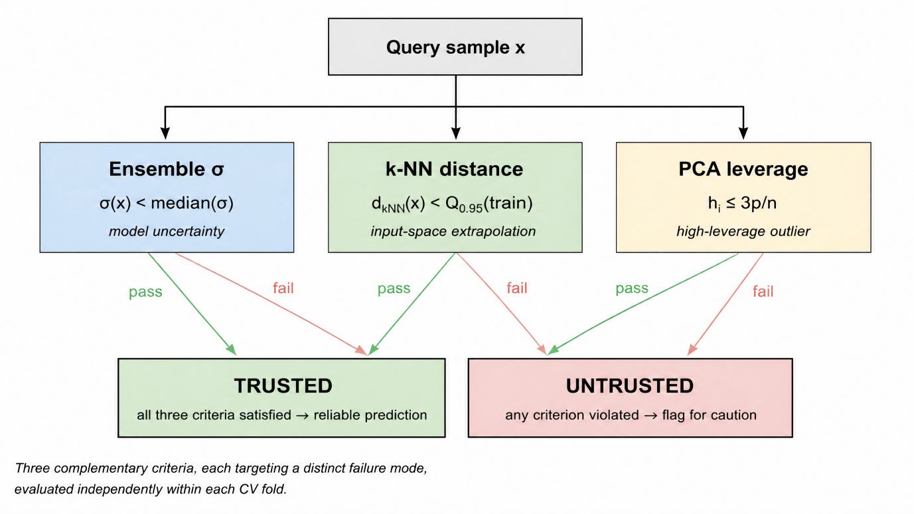
Fig. 3. Three complementary applicability-domain criteria and their joint trust decision.
In Section 3.3 we report the trusted/untrusted R² partition for each criterion and their pairwise agreement.

2.6 Evaluation protocol
All components are evaluated under a single unified protocol to ensure a fair comparison:
• 5-fold cross-validation [22] (shuffle, seed 42) for all reported out-of-fold (OOF) metrics.
• Stacking meta-learner trained on inner 3-fold OOF predictions to avoid leakage.
• Bootstrap 95% confidence intervals [23] (1000 resamples) for R² and MAE.
• Imputation (median) and standardization fit within each training fold via a scikit-learn Pipeline, never on the full dataset.
• σ–error correlation: Pearson r between ensemble σ and absolute error, with p-value from the Pearson test, to validate that ensemble uncertainty ranks errors correctly.
• Pairwise model comparison (e.g., 5-seed runs): Wilcoxon signed-rank test [24] on paired per-sample absolute errors, where applicable.
Algorithm 1 summarizes the end-to-end PACT-Final pipeline that integrates the point predictor (§2.3), the CQR interval (§2.4), and the applicability domain (§2.5) under this protocol.
The PACT-Final prediction framework Algorithm
Input:
Data D ={($x_{i}$,$y_{i}$)},i=1,…n, with n=4,914 perovskite samples
$x_{i}$ ∈ ℝ¹¹⁰ is the descriptor vector (96 Magpie + 14 physics features)
$y_{i}$ ∈ ℝ is the DFT target (formation energy or energy above hull)
α = 0.20 is the miscoverage level (nominal coverage 1 − α = 0.80)
Output:
Point prediction $μ_{i}$, uncertainty ${\text{σ}}_{i}$, interval [$L_{i}$, $U_{i}$], and trust flag trust_i for each sample
Step 1:Physics-informed point prediction
Compute a physics baseline using kernel ridge regression on the 14 physics features, then correct its residual with a gradient-boosted stacking ensemble:
$$μ_{p}(x) =\sum_{i∈train}{α_{i}}exp(−Υ\left\|x_{phys}\right.−\left.x_{phys,i}\right\|)$$
$$μ_{\text{r}}(x) =\sum_{\text{m=1}}^{\text{3}}{{\text{ѡ}}_{\text{m}}\text{⋅}{\hat{\text{r}}}_{\text{m}}}\text{(}\text{x}\text{)}$$
$$μ(x)= μ_{p}(x)+μ_{\text{r}}(x)$$
where x_phys ∈ ℝ¹⁴ is the physics-feature vector, γ = 0.10 is the RBF kernel bandwidth, ${\hat{\text{r}}}_{\text{m}}$(x) is the residual prediction of the m-th GBDT base learner (m ∈ {LightGBM, XGBoost, HistGBT}), and the weights $\text{ѡ}$ = (${\text{ѡ}}_{0}$, ${\text{ѡ}}_{1}$, ${\text{ѡ}}_{2}$, ${\text{ѡ}}_{3}$) are fit by a Ridge meta-learner on inner 3-fold out-of-fold predictions. The ensemble uncertainty is
σ(x)=std{$\hat{r_{1}}$(x),$\hat{r_{2}}$(x),$\hat{r_{3}}$(x)}
Step 2: Conditional conformal interval
Fit two LightGBM quantile regressors ${\hat{q}}_{0.10}$ and ${\hat{q}}_{0.90}$ on the proper-training set, then compute the non-conformity scores on the calibration set:
$$s_{i}=max({\hat{q}}_{0.10}(x_{i})−y_{i},y_{i}−{\hat{q}}_{0.90}(x_{i}))$$
Take the conformal quantile d as the ⌈(1−α)(n_cal + 1)⌉-th ranked value of {s_i}, and form the prediction interval:
C(X)=[${\hat{q}}_{0.10}(X)−d,{\hat{q}}_{0.90}(X)+d$]
where the interval is calibrated independently of the point predictor in Step 1, and its marginal coverage satisfies P(y ∈ C(X)) ≥ 1 − α under exchangeability.
Step 3: Multi-criteria applicability domain
Flag each sample as trusted or untrusted using three independent criteria:
${trust}_{\text{σ}}$:$\text{σ}$(x)<median($\text{σ}$)
${trust}_{kNN}$:$d_{kNN}$<$Q_{0.95}$($d_{kNN}$(train))
${trust}_{lev}$:$h_{i}$≤$\frac{3p}{n}$,$h_{i}$=${{\text{x}}_{\text{i}}}^{\text{⊤}}{(X^{\text{⊤}}X)}^{−1}{\text{x}}_{\text{i}}$
where $d_{kNN}$(x) is the mean Euclidean distance to the 5 nearest training neighbors in PCA(20)-reduced space, p = 20 is the number of PCA components, and n is the training-set size.

2.7 Symbolic regression (interpretability cross-check)
Beyond the black-box stacking ensemble, we seek a human-readable expression that conveys which physics descriptors the data deem important. To this end we run a genetic-programming symbolic regression (gplearn) over the 14 physics features; because a single symbolic fit is notoriously sensitive to seed and thus non-unique, we instead run 10 random seeds × 5 CV folds = 50 independent equations and report feature consensus frequency—the fraction of equations in which each feature appears—as a robust aggregate. The complete search configuration and consensus computation are given in Algorithm 2.
To anticipate when this cross-check is informative, we derive an empirical applicability criterion from the signal-to-noise ratio (SNR) of the physics baseline: SR succeeds when SNR ≥ 2 (formation energy, SNR = 3.40) and fails when SNR < 2 (hull energy, SNR = 1.39). We emphasize that this criterion is empirical, derived from only two target properties, and its generalization to other material properties requires further validation (see Section 5).
Symbolic regression ensemble with feature consensus Algorithm
Input:
$D_{phys}$={$x_{phys,i},y_{i}$},with 14 physics-informed descriptors
$$S = \{42, 123, 456, 789, 2024, 314, 271, 161, 803, 951\}, 10 random seeds$$
$$F = 5 cross-validation folds$$
Output:
consensus_freq(f), the fraction of equations in which feature f appears, for each physics feature f
Step 1:Symbolic regression search
For each seed s ∈ S and each CV fold, fit a genetic-programming symbolic regression (gplearn) on the training fold of the physics features. The search space is defined by the operator set
$$Φ =\{+,−,×，÷，\sqrt{·}\}$$
with parsimony coefficient 0.001, 40 generations, and population size 2,000. This yields 10 seeds × 5 folds = 50 independent equations {eq_1, eq_2, …, eq_50}.
Step 2: Feature consensus aggregation
For each physics feature f, compute its consensus frequency as
$$consensus_{f}req(f)=\frac{\left|\{eq∈ HYPERLINK "https://baike.baidu.com/item/\%E5\%B8\%8C\%E8\%85\%8A\%E5\%AD\%97\%E6\%AF\%8D/4428067" \backslash l "4−6" ε:f∈eq\}\right|}{\left| HYPERLINK "https://baike.baidu.com/item/\%E5\%B8\%8C\%E8\%85\%8A\%E5\%AD\%97\%E6\%AF\%8D/4428067" \backslash l "4−6" ε\right|}$$
where $HYPERLINK "https://baike.baidu.com/item/\%E5\%B8\%8C\%E8\%85\%8A\%E5\%AD\%97\%E6\%AF\%8D/4428067" \backslash l "4−6" ε$ is the set of 50 equations and |·| denotes cardinality. Consensus frequency, rather than any single equation, is reported to mitigate the non-uniqueness of symbolic regression solutions.
Step 3: Applicability criterion
Derive an empirical SR applicability boundary from the signal-to-noise ratio of the physics baseline:
SNR=$\frac{R^{2}(KRR)}{1−R^{2}(KRR)}$
Symbolic regression is deemed applicable when SNR ≥ 2 (e.g., formation energy, SNR = 3.40) and inapplicable when SNR < 2 (e.g., energy above hull, SNR = 1.39). This criterion is empirical, derived from two target properties only.

3. Results and Discussion

3.1 Point prediction performance
Table 1. uses a distinct Materials-Project-derived ABX3 dataset and is included for context only.
Table 1
Model comparison for formation energy and hull energy prediction (5-fold CV).
Model | Form. R² | Form. MAE | Hull R² | Hull MAE
Pure LightGBM | 0.915 | 0.193 | 0.807 | 0.179
GBDT stacking | 0.918 | 0.181 | 0.813 | 0.169
PACT-Final | 0.914 | 0.186 | 0.800 | 0.171
Ref. [7] (diff. dataset) | 0.928 | — | — | —

Fig. 4 presents the parity between the out-of-fold predictions and the DFT targets for both properties, with points colored by ensemble σ; the tight clustering along the y = x diagonal quantitatively confirms the R² values reported in Table 1, while the σ-coloring reveals that the largest deviations occur (and are flagged as high-σ) predominantly in the intermediate-stability region discussed below.
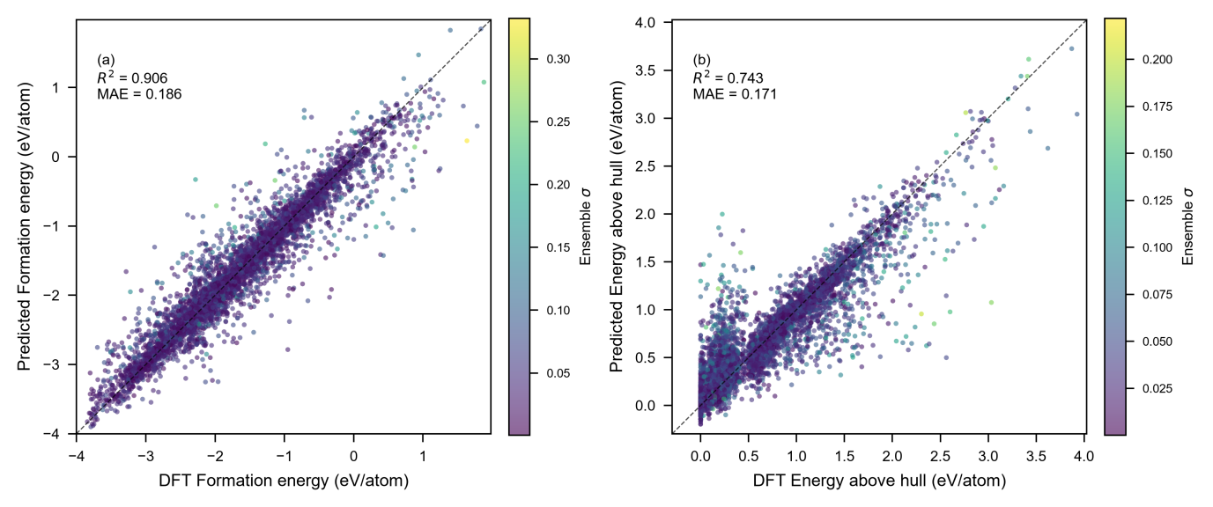
Fig. 4. Parity plots of predicted vs. DFT values for (a) formation energy and (b) energy above hull. Points colored by ensemble σ. Dashed line: y = x.
The framework achieves R2 = 0.914 [0.907, 0.922] for formation energy and R2 = 0.800 [0.781, 0.816] for hull energy (5-fold CV, bootstrap 95% CI), with MAE of 0.186 and 0.171 eV/atom respectively (Table 1). For context, this formation-energy R2 is comparable to the gradient-boosting benchmark of Emery and Wolverton (R2 ≈ 0.91 on the same wolverton_oxides dataset [5]) and to the 0.928 reported by Deng et al. [6] on a distinct Materials-Project-derived ABX3 dataset using SHAP [25]-guided feature selection. Because the two benchmarks rely on different DFT reference frames (our wolverton_oxides dataset and Matbench Perovskites differ structurally and energetically), direct cross-dataset numerical comparison is not meaningful; nonetheless, the point-estimate accuracy places our model in the same tier as recent descriptor-ML benchmarks. Crucially, our differentiation is not in R2 but in the uncertainty and applicability components that follow. Hull-energy prediction is inherently harder (R2 = 0.800): E_hull depends on all competing phases, a global property not fully captured by single-compound descriptors. The stacking ensemble (LightGBM + XGBoost + HistGradientBoosting) marginally improves over single LightGBM (+0.003 R²), consistent with the high correlation (0.99) among GBDT family members limiting ensemble diversity gains. We note that PACT-Final (R2 = 0.914) is marginally below the GBDT stacking alone (R2 = 0.918) for formation energy, because the physics baseline serves as an interpretability anchor rather than an accuracy booster (§2.3); the 0.004 R2 difference falls within the bootstrap CI. The advantage of PACT-Final over pure stacking lies not in point accuracy but in the calibrated CQR interval and applicability domain reported in §3.2–3.3.
$E_{f}E_{f}$The physics baseline alone (KernelRidge on 14 physics features) explains R2 = 0.773 of formation-energy variance, confirming that physically meaningful descriptors—tolerance factor, electronegativity, ionic radii—capture the majority of the signal and that the stacking residual contributes only the non-linear, secondary-descriptor structure on top of an already-physically-grounded prediction, consistent with the ionic-model understanding [26] of perovskite stability. We next examine where this residual error concentrates, and whether the model's uncertainty estimate successfully flags it.Examining the 8.0% of samples whose absolute error exceeds 0.5 eV/atom (394/4914), we find that they cluster at the extreme of the formation-energy distribution—their mean = −1.384 eV/atom is less negative than the global mean (−1.663), indicating the model struggles most with compounds of intermediate stability, where small descriptor changes produce large energy shifts, rather than with strongly stable perovskites ( < −2.5 eV/atom, e.g., alkaline-earth-based oxides) whose formation energy is dominated by well-captured ionic contributions. Reassuringly, the ensemble uncertainty σ does carry genuine information about these failures: it correlates positively with absolute error in both targets (formation: r = 0.345, p ≈ 1.3 × 10-137; hull: r = 0.355, p ≈ 1.4 × 10-145), so the model's internal disagreement ranks prediction difficulty correctly on average. Yet σ is not a perfect oracle: 4 of the 5 worst predictions occur at σ < 0.10 eV/atom, revealing that the ensemble underestimates uncertainty for certain extrapolative samples. This residual miscalibration is precisely what motivates the conditional (CQR) intervals in §3.2, which do not rely on σ alone and instead calibrate coverage directly from quantile-regression residuals.

3.2 Uncertainty quantification: CQR conditional coverage
CQR delivers intervals that satisfy the marginal coverage guarantee while substantially improving conditional coverage relative to standard split conformal. As summarized in Table 2, both methods achieve PICP at or above the nominal 0.80 (CQR: 0.802 for formation, 0.807 for hull; standard: 0.810, 0.815), confirming the finite-sample guarantee of split conformal prediction. The critical difference lies in the Expected Calibration Error: CQR reduces ECE by 60% for formation energy (0.085 → 0.034) and by 43% for hull energy (0.086 → 0.049) under the fair same-family baseline, meaning conditional coverage is markedly more uniform—high-uncertainty (extrapolation) samples no longer suffer severe under-coverage, and low-uncertainty (interpolation) samples receive appropriately tight intervals.
Table 2
CQR vs. standard split conformal (fair LightGBM-family baseline).
Target | Method | PICP | MPIW | ECE | Improv.
Form. E | Standard | 0.810 | 0.611 | 0.085 | —
Form. E | CQR | 0.802 | 0.823 | 0.034 | 60%
Hull E | Standard | 0.815 | 0.566 | 0.086 | —
Hull E | CQR | 0.807 | 0.719 | 0.049 | 43%

Fig. 5 corroborates this improvement bin by bin: the per-decile empirical coverage of the CQR interval stays close to the nominal 0.80 across all ten σ-sorted bins, whereas the standard interval deviates substantially at the extremes.
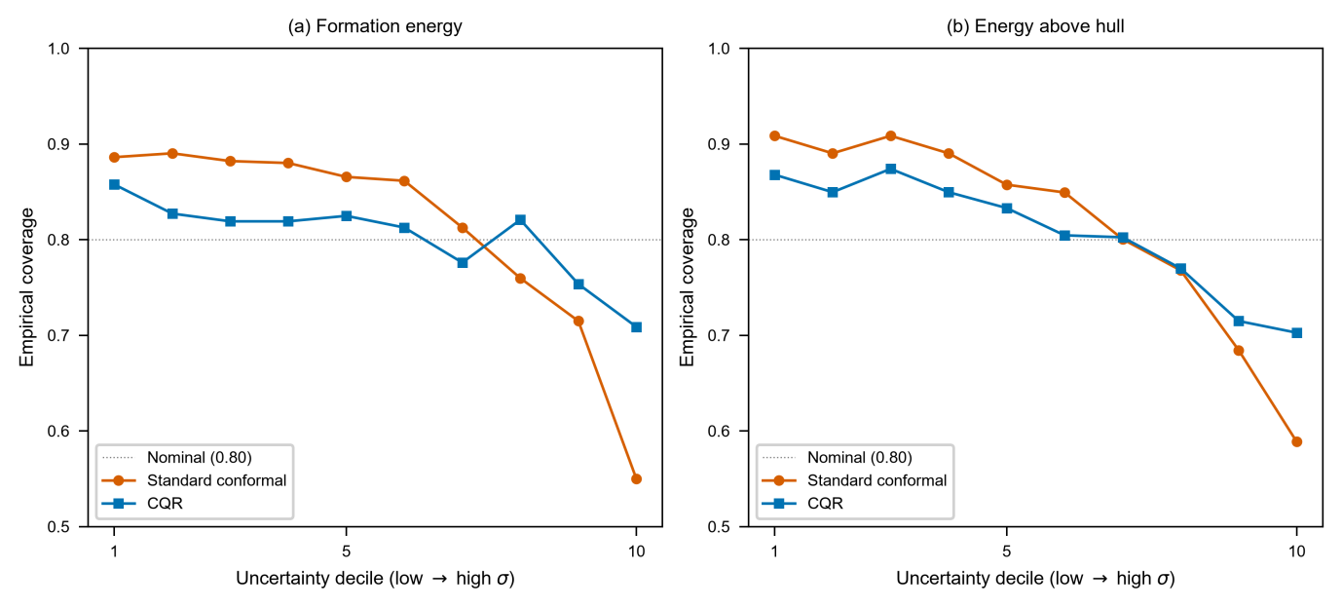
Fig. 5. Reliability diagrams showing empirical coverage per uncertainty decile for standard split conformal vs. CQR.
This improvement in calibration comes from the heteroscedastic, sample-adaptive width of the CQR interval. As shown in Fig. 2, the mean interval width for the highest-σ tercile (1.03 eV/atom for formation energy) is ~1.5× that of the lowest-σ tercile (0.68), whereas standard conformal assigns uniform width (0.66 to both); in other words, CQR spends interval width where the model is genuinely uncertain and conserves it where the model is confident. For high-throughput [30] screening, this directly translates to fewer false-positive stable predictions among uncertain candidates. We note that the CQR interval is, on average, slightly wider than the standard interval (MPIW = 0.823 vs. 0.611 for formation), a necessary trade-off for the marked gain in conditional coverage.

The reliability of this adaptive behavior ultimately rests on whether the ensemble uncertainty σ carries genuine information about the error. As reported in §3.1, σ correlates positively with absolute error in both targets (formation: r = 0.345; hull: r = 0.355, both p < 10⁻¹³⁰), so the model's internal disagreement does rank prediction difficulty correctly on average. The CQR interval exploits this signal through its quantile-regression bounds, but it also compensates for the residual cases where σ alone is uninformative—most strikingly, the 4 of 5 worst predictions that occur at σ < 0.10 eV/atom (§3.1)—by calibrating coverage directly from quantile-regression residuals rather than from σ. This complementarity between the point predictor's σ and the independently calibrated CQR interval is precisely what motivates the decoupling design described in §2.4, and it underpins the applicability-domain screening reported in §3.3.

3.3 Applicability domain and extrapolation
The applicability domain (AD) analysis addresses a concern distinct from interval calibration: rather than asking how wide the interval should be, it asks which samples the point prediction itself can be trusted for.We address it with three complementary criteria—ensemble σ, k-NN distance, and PCA leverage—each targeting a distinct failure mode of the model (Fig. 3). All three succeed in their intended role: as shown in Fig. 6 and quantified by the σ-based partition, the trusted region (σ below the median) attains R² = 0.945 for formation energy, against R² = 0.886 in the untrusted region—a 0.059 gap that confirms the uncertainty criterion separates reliable from unreliable predictions. The k-NN and leverage criteria provide convergent evidence, yielding trusted-region R² of 0.915 and 0.916 respectively, and agreeing with the σ criterion on 50–53% of samples; the partial rather than perfect agreement is itself informative, since the three criteria capture orthogonal aspects of unreliability—model-internal disagreement, input-space extrapolation, and high-leverage position—and their union therefore defines a stricter trust boundary than any single criterion alone. For experimentalists using the model to prioritize DFT verification, restricting attention to the trusted region roughly halves the error variance, directly reducing wasted computation on unreliable predictions.

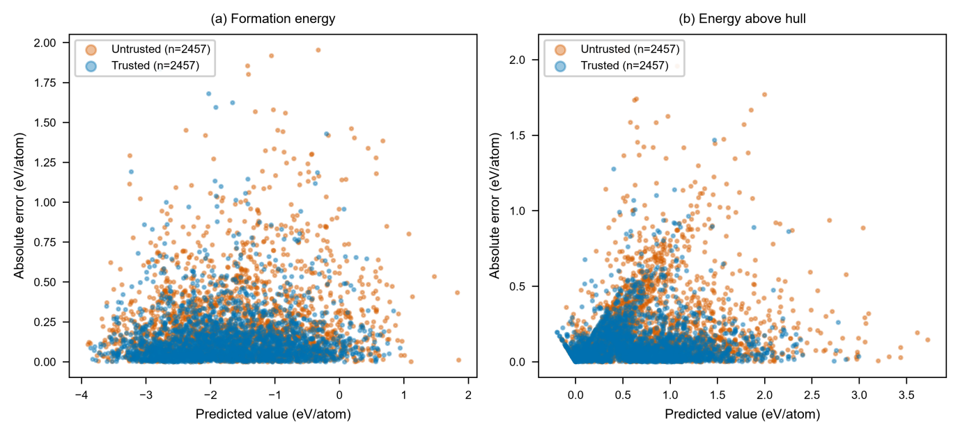Fig. 6. Applicability domain visualization. Predicted value vs. absolute error, colored by trusted vs. untrusted regions.
The k-NN and leverage criteria flag extrapolation in a statistical sense, but they do not reveal how severely accuracy degrades when an entire chemical element is unseen during training. We probe this directly with a leave-one-element-out (LOEO) evaluation: for each of the 73 elements appearing at the A or B site, we retrain on all samples not containing that element and evaluate on the held-out element's compounds. The mean per-element R² across the 73 test sets is 0.739 (median 0.789) for formation energy—substantially lower than the in-domain R² of 0.914, as expected for compositional extrapolation, but well above zero for every element, with the lowest-performing being Pb (0.224), Al (0.246), and Os (0.275); no element yields a negative R². Fig. 7 displays the full element-wise distribution.
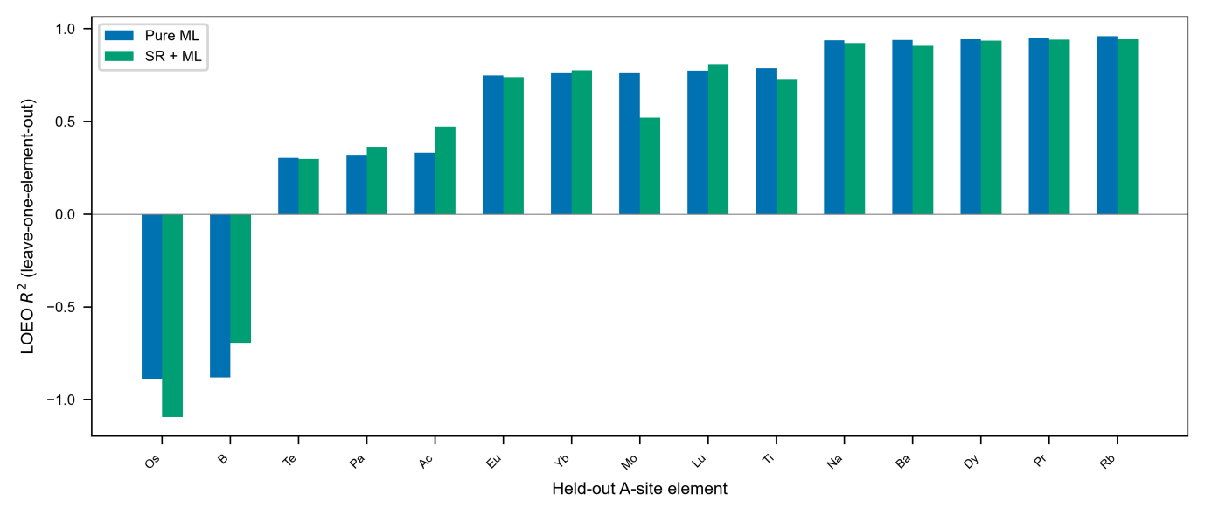
Fig. 7. Leave-one-element-out extrapolation R-squared for representative A-site elements.
This extrapolation pattern is chemically coherent, and it refines the statistical trust flags above into element-specific guidance. The best-extrapolated A-site elements are large, highly electropositive cations—alkali metals (Rb 0.96, K 0.93, Na 0.94, Cs 0.92), alkaline earths (Ba 0.94), and lanthanides (Pr 0.95, La 0.91, Gd 0.92, Ho 0.93, Dy 0.94)—whose consistent +2/+3 oxidation states, large ionic radii, and well-defined coordination chemistry leave the descriptor space around them densely sampled, so their A-site contribution to formation energy is nearly linear in ionic radius and electronegativity. The worst-extrapolated elements occupy the opposite extreme: Pb, Al, and Os have very few isochemical neighbors in the training set, and their bonding character—covalent/metallic for Al, heavy 5d chemistry for Os, stereochemically active lone pair for Pb—deviates from the ionic perovskite norm. Translating this into screening practice, predictions involving underrepresented heavy p-block or atypical main-group A-site cations should be treated as unreliable regardless of their point estimate or σ value, whereas screening among alkali, alkaline-earth, or lanthanide chemistries is expected to transfer well. This element-level map thus complements the sample-level AD criteria: the former says whether a given prediction is statistically trustworthy, the latter says which chemical families the model can safely extrapolate to.

3.4 Interpretability and candidate screening
Beyond the accuracy and uncertainty metrics above, we ask whether the model has captured chemically meaningful structure rather than spurious statistical regularities. Two independent interpretability lenses converge on the same answer. The first is a symbolic-regression ensemble (Algorithm 2): across 50 independent equations, A-site electronegativity appears in 100% of them, with B-site group number (64%) and B-site electronegativity (60%) the next most conserved, as visualized in Fig. 8(b). The second is the SHAP analysis of the full stacking ensemble, shown in Fig. 8(a), where A-site-electronegativity-derived Magpie features rank among the top contributors. The agreement between these two methods operating in different spaces—symbolic vs. statistical—provides strong evidence that the dominance of A-site electronegativity is a genuine physical signal, not an artifact of either method alone.
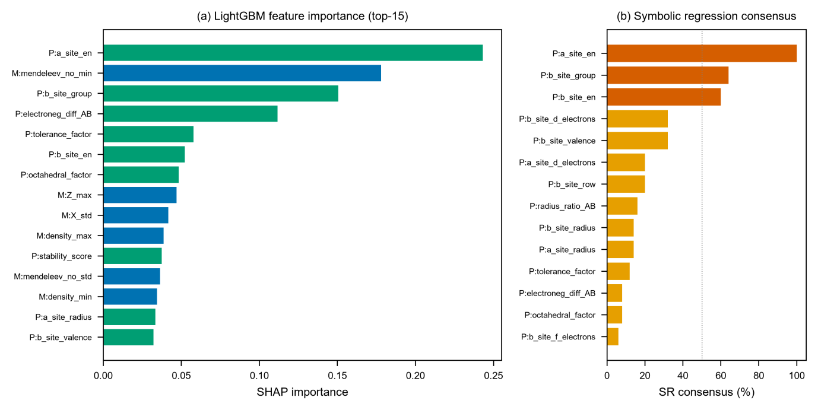
Fig. 8. (a) LightGBM SHAP feature importance (top-15) and (b) symbolic regression consensus frequency.
This dominance is further corroborated by the sign and magnitude of each top descriptor's correlation with the target. The strongest single correlate of formation energy is A-site electronegativity (Pearson r = +0.537): more electronegative A-site cations—e.g., transition metals at the A site—yield less negative, hence less stable, formation energies, consistent with the fact that highly electropositive cations (alkali, alkaline-earth, lanthanide) form stronger ionic bonds with oxygen and stabilize the perovskite lattice. The opposite sign governs Magpie X_std, the compositional standard deviation of electronegativity (r = −0.538): greater electronegativity contrast among A/B/O sites produces more negative formation energies, reflecting the thermodynamic driving force of charge transfer in ionic bonding. The tolerance factor t shows a moderate negative correlation (r = −0.278), so that as t increases toward and beyond unity—A-site too large for the cage—the structure becomes geometrically strained and formation energy rises, consistent with Goldschmidt's criterion. B-site group number (r = +0.297) and B-site electronegativity (r = +0.291) are positively correlated, because higher B-site electronegativity (late transition metals) reduces the ionic character of the B–O bond and destabilizes the perovskite relative to competing phases. These signs are all consistent with established perovskite chemistry [27], confirming that the model respects known structure–property relations.
The interpretability cross-check is itself target-dependent, and this asymmetry exposes a useful methodological boundary. Symbolic regression succeeds on formation energy—standalone R² ≈ 0.44 across 10 seeds, corresponding to SNR = 3.40 —but fails on hull energy (SNR = 1.39), with the SR solution collapsing to a constant in several folds. We trace this to the differing physical nature of the two targets: formation energy is dominated by single-compound bond chemistry, near-linear and well-expressed by the basic operators {$\text{+, −, ×, ÷, }\sqrt{\text{·}}$}, whereas hull energy depends on competition with all other phases and is strongly non-linear and non-monotonic in geometric descriptors. This yields an empirical SR applicability criterion, SNR ≥ 2, which we caveat as based on only two targets and not yet universal.Having established that the model respects known chemistry, we apply it to virtual A–B combinations to screen for candidate stable perovskites. Retaining only compositions predicted to lie on or near the convex hull (E_hull ≤ 0.05 eV/atom) within the trusted applicability domain yields the nine candidates listed in Table 3.
Table 3
Candidate stable perovskites with validation tier.
Formula | Pred. E_hull | σ | In matbench | Goldsm. | Grade
LaTiO₃ | 0.005 | 0.022 | Yes | Yes | Mod.
PrCoO₃ | 0.006 | 0.024 | No | Yes | Weak
NdCoO₃ | 0.009 | 0.025 | No | Yes | Weak
GdCoO₃ | 0.016 | 0.027 | No | Yes | Weak
YbCoO₃ | 0.017 | 0.028 | No | Yes | Weak
ErFeO₃ | 0.019 | 0.030 | No | Yes | Weak
YCoO₃ | 0.025 | 0.031 | Yes | Yes | Mod.
LaAlO₃ | 0.033 | 0.037 | Yes | Yes | Weak
BiAlO₃ | 0.035 | 0.034 | No | No | Weak

A three-tier validation provides indirect evidence rather than confirmation: three candidates—LaTiO3, YCoO3, and LaAlO3—appear in the independent matbench_perovskites DFT database, confirming that they have been studied; eight of nine fall within the Goldschmidt synthesizability zone (t ∈ [0.8, 1.05], μ ∈ [0.4, 0.9]); and leave-element-out robustness testing confirms that the moderate-grade predictions are not artifacts of single-element memorization. We emphasize that database presence attests to prior study, not to numerical agreement with our predictions (given the reference-frame mismatch noted in §2.1), and that the remaining six candidates lack independent DFT or experimental verification. The screening result therefore demonstrates that the pipeline produces physically plausible, cross-database-consistent candidates rather than spurious low-E_hull outliers, but none of these predictions should be treated as a confirmed materials discovery in the absence of dedicated DFT validation.

3.5 Limitations
Several limitations of this work should be acknowledged to support informed downstream use, and we discuss them here in decreasing order of practical impact.
The most consequential constraint is the single-source dataset: all 4,914 samples originate from one DFT study (wolverton_oxides [16]), so the model has been exposed to only one computational reference frame. matbench_perovskites [28] uses a structurally and energetically different formation-energy reference frame (direct model transfer between the two sources yields negative R², precluding meaningful cross-dataset validation). The leave-one-element-out evaluation in §3.3 partially addresses generalization within the wolverton chemical space—mean per-element R² = 0.739 with no negative-R² elements—but it does not substitute for independent DFT validation on a genuinely distinct dataset, which remains the most pressing future test.
A direct consequence of the single-source constraint is the limited depth of candidate validation. The nine predicted stable perovskites in Table 3 lack DFT or experimental verification; the three-tier validation provides only indirect evidence—database presence attests to prior study rather than to numerical agreement, and the six non-matbench candidates (PrCoO3, GdCoO3, YbCoO3, DyCoO3, ErFeO3, SrNpO3) have, to our knowledge, no independent computational record. We therefore frame these as weak-evidence candidates requiring DFT confirmation rather than as discoveries, and we caution against treating any of the nine as experimentally actionable without dedicated verification.
At the methodological level, two design choices introduce tensions that users should understand. First, the point predictor and the CQR interval are calibrated independently, following conformal-prediction philosophy; as a result, the point prediction falls outside its own 80% CQR interval for about 9% of formation-energy samples and 8% of hull-energy samples. This is consistent with the marginal coverage guarantee—which concerns the true value y rather than the point estimate—but in practice users must decide which statement to trust when they disagree, and we recommend treating the interval as the primary uncertainty statement. Second, the LOEO evaluation shows that accuracy drops from R² = 0.914 (in-domain) to 0.739 when an entire element is held out; although no element yields a negative R², the worst-performing elements (Pb 0.22, Al 0.25, Os 0.27) confirm that extrapolation to underrepresented chemistries is unreliable, and users should restrict predictions to the applicability domain rather than trusting the point estimate alone.

4. Conclusions
We presented an uncertainty-aware framework for predicting ABO3 perovskite formation energy and thermodynamic stability that integrates a physics-informed point predictor, conditional conformal (CQR) intervals with finite-sample coverage guarantees, a multi-method applicability domain, and symbolic-regression-based interpretability cross-checks. The framework achieves R² = 0.914 for formation energy and R² = 0.800 for energy above hull under 5-fold cross-validation, while delivering sample-adaptive intervals whose conditional coverage improves 43–60% over standard split conformal under a fair same-family baseline. The applicability domain separates a trusted region (R² = 0.945 for formation energy) from an untrusted region (R² = 0.886), and the 73-element leave-one-element-out evaluation provides an element-level extrapolation map (mean R² = 0.739) that refines this statistical trust boundary into chemically specific guidance. Symbolic regression consensus validates the known electronegativity dominance—A-site electronegativity appears in 100% of 50 independent equations—and exposes an empirical applicability boundary (SNR ≥ 2) that we frame honestly as target-specific rather than universal.
The central message is methodological: for materials-discovery pipelines, point accuracy alone is insufficient. Per-sample uncertainty, applicability-domain guidance, and extrapolation assessment are necessary components of a trustworthy predictor, and the framework presented here offers an integrated, fully reproducible implementation of these components under a single nested cross-validation protocol. The limitations documented in §3.5 are not incidental: they define the conditions under which the framework's predictions can be relied upon, and reporting them transparently is, in our view, as important as reporting the accuracy itself. Future work should validate the candidate materials via dedicated DFT calculations, test cross-dataset generalization once an accessible independent database is available, and refine the SR applicability criterion across additional material properties beyond the two studied here.

CRediT Author Contributions
Xumingyong Feng: Conceptualization, Methodology, Software, Validation, Formal analysis, Investigation, Data Curation, Writing – Original Draft, Writing – Review and Editing, Visualization.

Declaration of Competing Interests
The author declares that there are no known competing financial interests or personal relationships that could have appeared to influence the work reported in this paper.
Declaration of Generative AI and AI-Assisted Technologies in the Manuscript Preparation Process
During the preparation of this work the author used an AI-assisted coding (ZCode, powered by a large language model) in order to assist with software development, debugging and data analysis scripting. After using this tool, the author reviewed and edited the content as needed and takes full responsibility for the content of the published article.

Acknowledgments
The author thanks the developers of the open-source tools that made this work possible, including pymatgen [18], matminer, scikit-learn, LightGBM, XGBoost, Optuna, gplearn, SHAP, and matplotlib [29]. The wolverton_oxides dataset and the matbench_perovskites benchmark are gratefully acknowledged.

Data Availability
The data and code used in this work are available in the following GitHub repository:https://github.com/fxmy23/perovskite-stability-pact under the MIT license.

References
[1] R.K. Vasudevan, K. Choudhary, A. Mehta, R. Pachter, S.V. Kalinin, M. Chi, Physics-informed machine learning for materials discovery, MRS Commun. 11 (2021) 611–622. https://doi.org/10.1557/s43579-021-00050-5
[2] S. Yip (Ed.), Handbook of Materials Modeling, Springer, 2020. https://doi.org/10.1007/978-3-319-44680-6
[3] Q. Tao, L. Xu, P. Xu, Y. Liu, T. Wen, S. Du, et al., Machine learning for perovskite materials design and discovery, npj Comput. Mater. 7 (2021) 23. https://doi.org/10.1038/s41524-021-00495-8
[4] K.T. Butler, D.W. Davies, H. Cartwright, O. Isayev, A. Walsh, Machine learning for molecular and materials science, Nature 559 (2018) 547–555. https://doi.org/10.1038/s41586-018-0337-z
[5] A.A. Emery, C. Wolverton, High-throughput DFT calculations of formation energy, stability and oxygen vacancy formation energy of ABO3 perovskites, Sci. Data 4 (2017) 170153. https://doi.org/10.1038/sdata.2017.153
[6] Z. Deng, K. Fang, C. Guo, Z. Gong, H. Yue, H. Zhang, F.E.H. Tay, Prediction of ABX3 perovskite formation energy using machine learning, Materials 18 (2025) 2927. https://doi.org/10.3390/ma18132927
[7] R. Ouyang, S. Curtarolo, E. Ahmetcik, M. Scheffler, L.M. Ghiringhelli, SISSO: A compressed-sensing method for identifying the best physics-inspired descriptor, Phys. Rev. Mater. 2 (2018) 083802. https://doi.org/10.1103/PhysRevMaterials.2.083802
[8] T. Xie, J.C. Grossman, Crystal graph convolutional neural networks for an accurate and interpretable prediction of material properties, Phys. Rev. Lett. 120 (2018) 145301. https://doi.org/10.1103/PhysRevLett.120.145301
[9] T.I. Netzeva, A.P. Worth, T. Aldenberg, R. Benigni, M.T.D. Cronin, P. Gramatica, J.S. Jaworska, S. Kahn, G. Klopman, C.A. Marchant, et al., Current status of methods for defining the applicability domain of (quantitative) structure–activity relationships, ATLA 33 (2005) 155–173. https://doi.org/10.1177/026119290503300208
[10] F. Sahigara, D. Mansouri, D. Ballabio, A. Mauri, V. Consonni, R. Todeschini, Comparison of different approaches to define the applicability domain of QSAR models, Molecules 17 (2012) 4791–4810. https://doi.org/10.3390/molecules17054791
[11] V. Vovk, A. Gammerman, G. Shafer, Algorithmic Learning in a Random World, Springer, New York, 2005.
[12] Y. Romano, E. Patterson, E.J. Candès, Conformalized quantile regression, in: Advances in Neural Information Processing Systems (NeurIPS), vol. 32, 2019, pp. 3543–3553. https://doi.org/10.48550/arXiv.1905.03222
[13] A. Ziletti, D. Kumar, M. Scheffler, L.M. Ghiringhelli, Insightful classification of crystal structures by deep learning, Nat. Commun. 9 (2018) 2775. https://doi.org/10.1038/s41467-018-05169-6
[14] M. Cranmer, Interpretable machine learning for science with PySR and SymbolicRegression.jl, arXiv:2305.01582, 2023. https://doi.org/10.48550/arXiv.2305.01582
[15] L. Ward, M. Dunston, D. Donadio, C. Wolverton, Matminer: An open source toolkit for materials data mining, Comput. Mater. Sci. 152 (2018) 60–69. https://doi.org/10.1016/j.commatsci.2018.05.018
[16] J.E. Saal, S. Kirklin, M. Aykol, B. Meredig, C. Wolverton, Materials design and discovery with high-throughput density functional theory: The Open Quantum Materials Database (OQMD), JOM 65 (2013) 1501–1509. https://doi.org/10.1007/s11837-013-0755-4
[17] L. Ward, A. Agrawal, A. Choudhary, C. Wolverton, A general-purpose machine learning framework for predicting properties of inorganic materials, npj Comput. Mater. 2 (2016) 16028. https://doi.org/10.1038/npjcompumats.2016.28
[18] S.P. Ong, W.D. Richards, A. Jain, G. Hautier, M. Kocher, S. Cholia, D. Gunter, V.L. Chevrier, K.A. Persson, G. Ceder, Python Materials Genomics (pymatgen): A robust, open-source python library for materials analysis, Comput. Mater. Sci. 68 (2013) 314–319. https://doi.org/10.1016/j.commatsci.2012.10.028
[19] V.M. Goldschmidt, Die Gesetze der Krystallochemie, Naturwissenschaften 14 (1926) 477–485. https://doi.org/10.1007/BF01507527
[20] F. Pedregosa, G. Varoquaux, A. Gramfort, V. Michel, B. Thirion, O. Grisel, M. Blondel, P. Prettenhofer, R. Weiss, V. Dubourg, J. Vanderplas, A. Passos, D. Cournapeau, M. Brucher, M. Perrot, É. Duchesnay, Scikit-learn: Machine learning in Python, J. Mach. Learn. Res. 12 (2011) 2825–2830. https://doi.org/10.5555/1953048.2078195
[21] T. Akiba, S. Sano, T. Yanase, T. Ohta, M. Koyama, Optuna: A next-generation hyperparameter optimization framework, in: Proceedings of the 25th ACM SIGKDD International Conference on Knowledge Discovery & Data Mining, 2019, pp. 2623–2631. https://doi.org/10.1145/3292500.3330701
[22] T. Hastie, R. Tibshirani, J. Friedman, The Elements of Statistical Learning, 2nd ed., Springer, 2009. https://doi.org/10.1007/978-0-387-84858-7
[23] B. Efron, R.J. Tibshirani, An Introduction to the Bootstrap, Chapman & Hall/CRC, 1993. https://doi.org/10.1201/9780429246593
[24] F. Wilcoxon, Individual comparisons by ranking methods, Biom. Bull. 1 (1945) 80–83. https://doi.org/10.2307/3001968
[25] S.M. Lundberg, S.-I. Lee, A unified approach to interpreting model predictions, in: Advances in Neural Information Processing Systems (NeurIPS), vol. 30, 2017. https://doi.org/10.48550/arXiv.1705.07874
[26] C.J. Bartel, C. Sutton, B.R. Goldsmith, C. Ophus, R. Ouyang, C.B. Musgrave, L.M. Ghiringhelli, M. Scheffler, Physical descriptor for the Gibbs energy of inorganic crystalline solids and temperature-dependent materials chemistry, Nat. Commun. 11 (2020) 6100. https://doi.org/10.1038/s41467-020-19908-0
[27] C.J. Bartel, C. Sutton, B.R. Goldsmith, R. Ouyang, C.B. Musgrave, L.M. Ghiringhelli, M. Scheffler, New tolerance factor to predict the stability of perovskite oxides and halides, Sci. Adv. 5 (2019) eaav0693. https://doi.org/10.1126/sciadv.aav0693
[28] A. Jain, S.P. Ong, G. Hautier, W. Chen, W.D. Richards, S. Dacek, S. Cholia, D. Gunter, D. Skinner, G. Ceder, K.A. Persson, Commentary: The Materials Project: A materials genome approach to accelerating materials innovation, APL Mater. 1 (2013) 011002. https://doi.org/10.1063/1.4812323
[29] J.D. Hunter, Matplotlib: A 2D graphics environment, Comput. Sci. Eng. 9 (2007) 90–95. https://doi.org/10.1109/MCSE.2007.55
[30] S. Curtarolo, W. Setyawan, G.L.W. Hart, M. Jahnatek, R.V. Chepulskii, R.H. Taylor, S. Wang, J. Xue, K. Yang, O. Levy, M.J. Mehl, H.T. Stokes, D.O. Demchenko, D. Morgan, AFLOW: An automatic framework for high-throughput materials discovery, Comput. Mater. Sci. 58 (2012) 218–226. https://doi.org/10.1016/j.commatsci.2012.02.005

