­­

**Carte de visite**

**Spécifications Fonctionnelles**

**Sommaire**

Page

Objectifs 3

Contexte technique 3

# Objectifs

L’objectif est d’afficher, quand le terminal est orienté à l’horizontal, une carte de visite à partir d’un flux d’informations au format json.

# Contexte technique

Le développement est réalisé en Objective-C/Swift avec Xcode et est compatible iOS8 et version supérieure.

## Exemple de carte de visite.

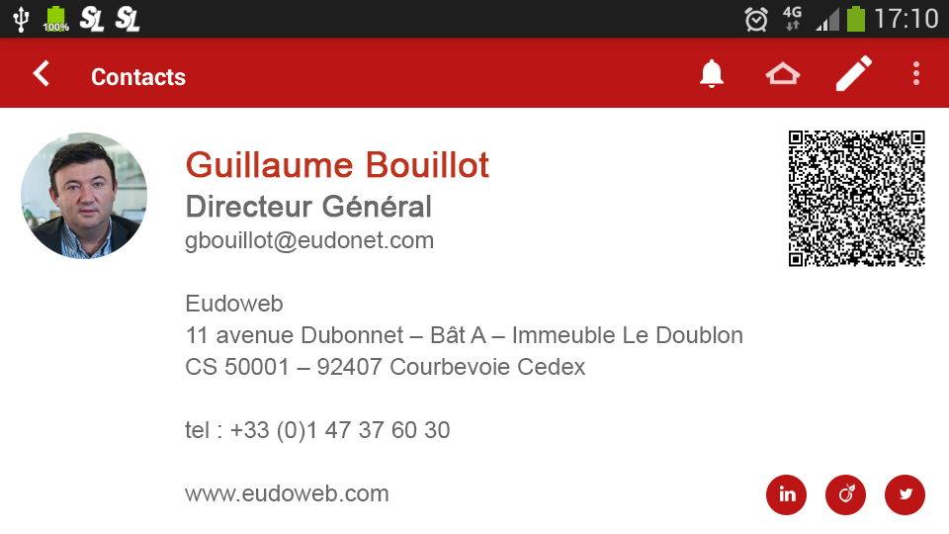

## Exemple de flux Json source de données de la carte de visite à afficher.

### Source de données :

|  |
| --- |
| curl -X POST --header 'Content-Type: application/json' --header 'Accept: application/json' --header 'x-auth: ' -d '{  "ShowMetadata": false,  "RowsPerPage": 1,  "NumPage": 0,  "ListCols": [  207,201,202,402,407,409,410,403,405,408  ],  "WhereCustom": {  "WhereCustoms": [  {}  ],  "Criteria": {  "Operator": 9,  "Field": "201",  "Value": "MAGINOT"  },  "InterOperator": 0  },  "OrderBy": [  {  "DescId": 0,  "Order": 0  }  ]  }  ' 'http://ww2.eudonet.com/EudoAPI/Search/200' |

### Flux réponse

|  |
| --- |
| {  "ResultInfos": {  "ApiMessage": "",  "ErrorMessage": "",  "ErrorNumber": 0,  "Success": true  },  "ResultData": {  "Rows": [  {  "DelAllowed": true,  "Fields": [  {  "DbValue": "Monsieur",  "DescId": 207,  "UpdateAllowed": true,  "Value": "Monsieur",  "ViewAllowed": true  },  {  "DbValue": "MAGINOT",  "DescId": 201,  "UpdateAllowed": true,  "Value": "MAGINOT Raphaël",  "ViewAllowed": true  },  {  "DbValue": "Raphaël",  "DescId": 202,  "UpdateAllowed": true,  "Value": "Raphaël",  "ViewAllowed": true  },  {  "DbValue": "11 avenue Dubonnet",  "DescId": 402,  "FileId": 97140,  "UpdateAllowed": true,  "Value": "11 avenue Dubonnet",  "ViewAllowed": true  },  {  "DbValue": "Etage 1",  "DescId": 407,  "FileId": 97140,  "UpdateAllowed": true,  "Value": "Etage 1",  "ViewAllowed": true  },  {  "DbValue": "92400",  "DescId": 409,  "FileId": 97140,  "UpdateAllowed": true,  "Value": "92400",  "ViewAllowed": true  },  {  "DbValue": "COURBEVOIE",  "DescId": 410,  "FileId": 97140,  "UpdateAllowed": true,  "Value": "COURBEVOIE",  "ViewAllowed": true  },  {  "DbValue": "FRANCE",  "DescId": 403,  "FileId": 97140,  "UpdateAllowed": true,  "Value": "FRANCE",  "ViewAllowed": true  },  {  "DbValue": "01 47 37 60 30",  "DescId": 405,  "FileId": 97140,  "UpdateAllowed": true,  "Value": "01 47 37 60 30",  "ViewAllowed": true  },  {  "DbValue": "06 78 53 82 33",  "DescId": 408,  "FileId": 97140,  "UpdateAllowed": true,  "Value": "06 78 53 82 33",  "ViewAllowed": true  }  ],  "FileId": 93036,  "Tab": 200,  "UpdateAllowed": true  }  ]  },  "ResultMetaData": {  "NumPage": 0,  "RowsByPage": 0,  "Tables": [],  "TotalPages": 0,  "TotalRows": 0  }  } |