OOP Teamwork Documentation

Team "J.R.R. Tolkien"
Велико Величков | veliko
Петър Радев | fxpqfxpq
Нина Аначкова | nivcanfly
Ивайло Цветков | ivailoven
Петър Ников | petar_nikov
Иван Александров | vancuver

The game “The Crystal Ball Game” is a console role-playing game, in which the player has to develop his Hero until he reaches the necessary experience to obtain an item, known as “The Crystal Ball of Knowledge”. The Hero is placed on a ASCII-art map through which he can navigate in search of quests (in the form of riddles) or battles with enemy creatures to gain the necessary experience. He has the attributes of Damage, Strength, Magery and Resistance to Spells points, and he can also acquire bonus points in any of these attributes trough the acquisition of special items. When the player picks a Hero, he is allowed to choose his name and race (among the six races - Human, Elf, Balrog, Orc, Dwarf, Hobbit). The Hero Enemies are generated to be random creatures from any of the other races.

Class Diagram

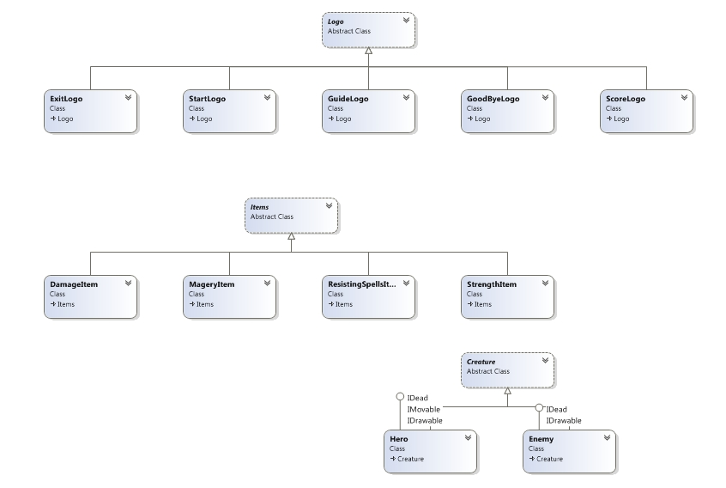
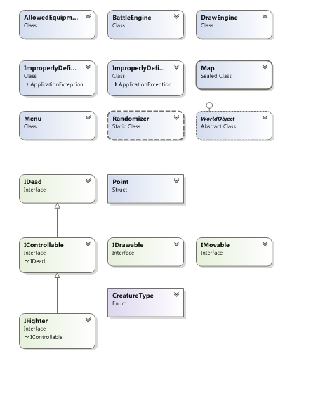
GitHub repository URL: https://github.com/fxpqfxpq/TeamJRRTolkien/

