WSL (Windows-only):

Run a PowerShell terminal as Administrator. Enter the following commands:
dism.exe /online /enable-feature /featurename:Microsoft-Windows-Subsystem-Linux /all /norestart
dism.exe /online /enable-feature /featurename:VirtualMachinePlatform /all /norestart

Reboot. Then re-open a PowerShell a terminal as Administrator. Run the following commands:
wsl --set-default-version 2
wsl --install Ubuntu-24.04

VSCODE:
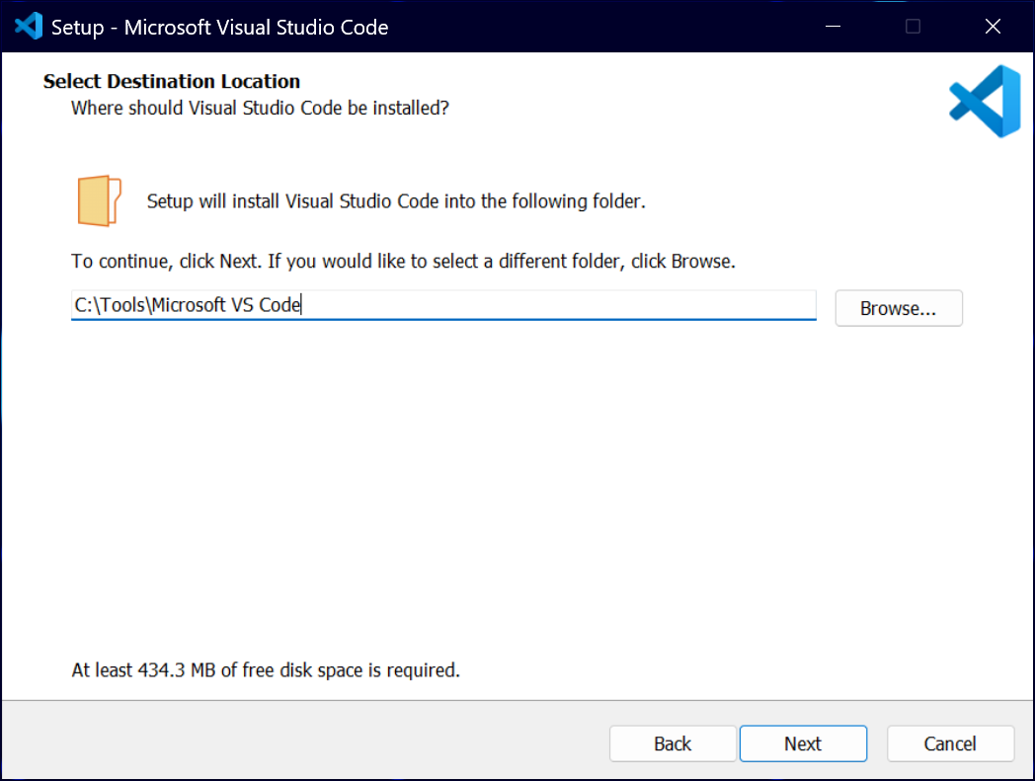

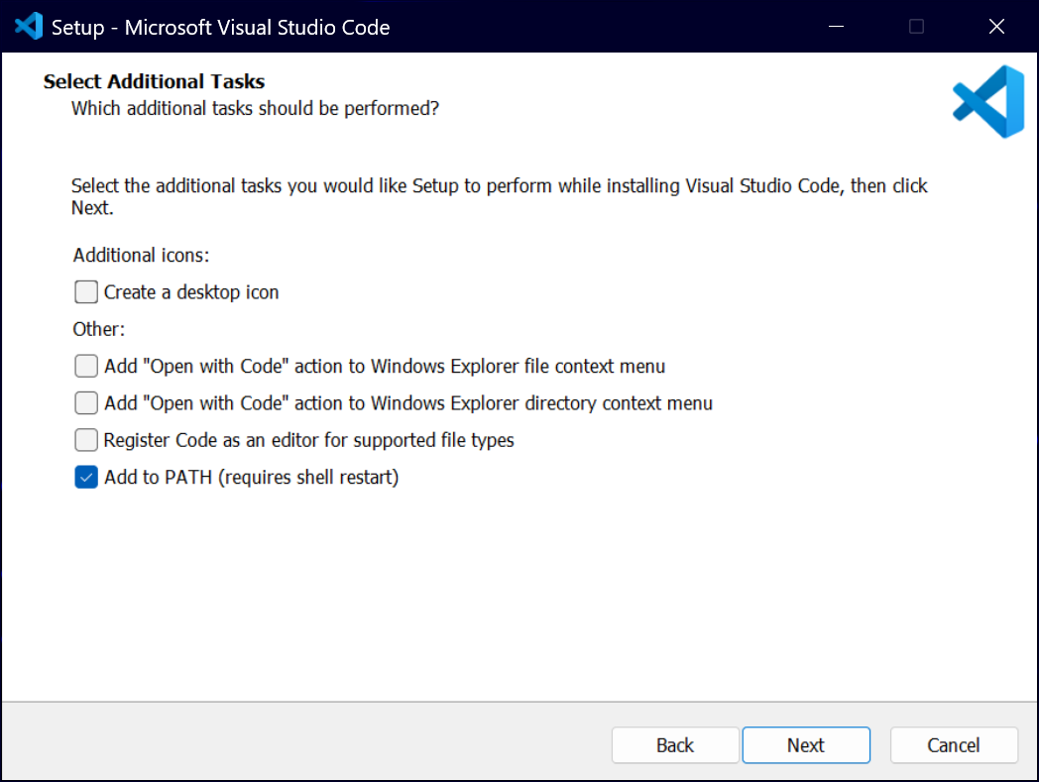

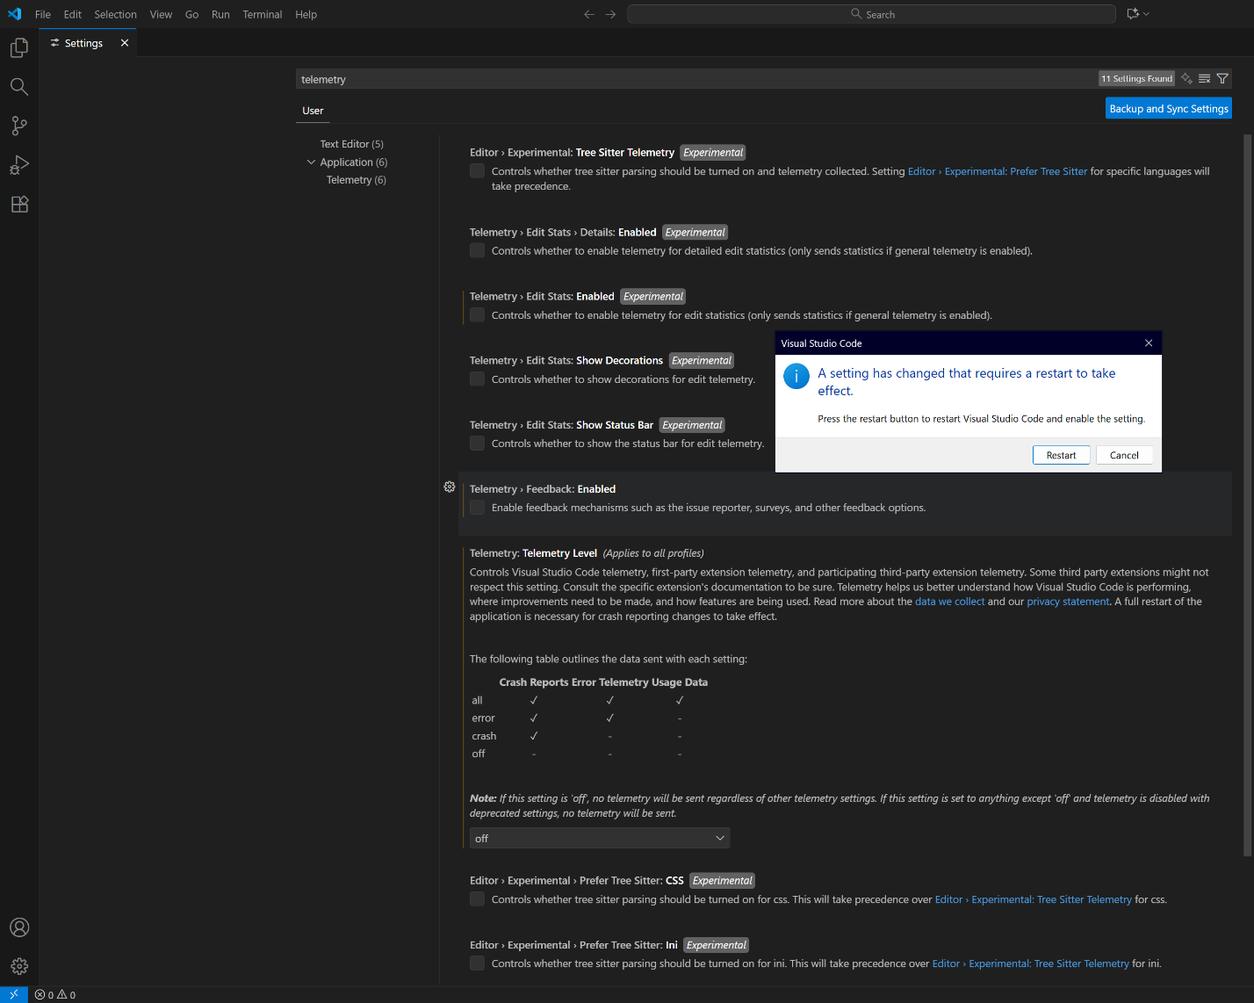

Windows-only:

Apt-update && apt-upgrade && apt-dist-upgrade

Apt-update && apt-upgrade && apt-dist-upgrade
Apt-install -y build-essentials tree
F. Introduction to the Bash Shell

- Follow the tutorials (1 through 8) located here: https://info-ee.surrey.ac.uk/Teaching/Unix/

In tutorial 2, replace this command cp /vol/examples/tutorial/science.txt . with wget http://www.ee.surrey.ac.uk/Teaching/Unix/science.txt.

In tutorial 8, replace this command source .cshrc with source ~/.bashrc. Also replace this command set path = ($path ~/units174/bin) with set PATH = ($PATH ~/units174/bin)

Whenever the program nedit is used, use instead vi.

- Using the command line, copy the resulting parent folder (unixstuff) to the Desktop.

- Switch to the resulting folder. And execute the tree command. The output must be placed in a file named ../tree.txt.

- Use the history command and output its result in a file named ../history.txt

- (R) Compress the resulting folder and the last created files in a .tar file. Copy the contents of the tree.txt file in the report.

- (Optional) If any instruction was not clear or you want to find out more about the bash shell, then check out the following link: http://linuxcommand.org/lc3_learning_the_shell.php

#include <stdio.h>
#include <inttypes.h>
#include <stdlib.h>

int main(int argc, char* argv[])
{
uint32_t* A = NULL;
uint32_t* B = NULL;
uint32_t* C = NULL;

uint32_t N = 0;
uint32_t i = 0;
uint32_t j = 0;

if (argc < 2)
{
printf("ERROR: Incorrect number of arguments!\n");
return -1;
}
else
{
N = atoi(argv[1]);
}

A = (uint32_t*)malloc(N*N*sizeof(uint32_t));
B = (uint32_t*)malloc(N*N*sizeof(uint32_t));
C = (uint32_t*)malloc(N*N*sizeof(uint32_t));

for (i = 0; i < N*N; i++)
{

if (i/N == i%N)
{
A[i] = 1;
}
else
{
A[1] = 0;
}

B[i] = i;
//printf("A[%d] = %d\tB[%d] = %d\n", i, A[i], i, B[i]);
}

for(i = 0; i < N*N; i++)
{
for(j = 0; j < N; j++)
{
C[i] += A[i/N*N + j]*B[j*N + i%N];
}
printf("C[%d] = %d\n", i, C[i]);
}

free(A);
free(B);
free(C);

return 0;
}

Modify the previous program to do a dot-product.

PROCESSES
#include <stdio.h>
#include <inttypes.h>
#include <stdlib.h>

#include <unistd.h>
#include <sys/mman.h>
#include <sys/wait.h>

int main(int argc, char* argv[])
{
uint32_t* A = NULL;
uint32_t* B = NULL;
uint32_t* C = NULL;

uint32_t N = 0;
uint32_t i = 0;
uint32_t j = 0;
pid_t pid = 0;

if (argc < 2)
{
printf("ERROR: Incorrect number of arguments!\n");
return -1;
}
else
{
N = atoi(argv[1]);
}

A = mmap(NULL, N*N*sizeof(uint32_t), PROT_READ | PROT_WRITE, MAP_SHARED | MAP_ANONYMOUS, -1, 0);
B = mmap(NULL, N*N*sizeof(uint32_t), PROT_READ | PROT_WRITE, MAP_SHARED | MAP_ANONYMOUS, -1, 0);
C = mmap(NULL, N*N*sizeof(uint32_t), PROT_READ | PROT_WRITE, MAP_SHARED | MAP_ANONYMOUS, -1, 0);

for (i = 0; i < N*N; i++)
{
if (i/N == i%N)
{
A[i] = 1;
}
else
{
A[1] = 0;
}

B[i] = i;
//printf("A[%d] = %d\tB[%d] = %d\n", i, A[i], i, B[i]);
}

for(i = 0; i < N*N; i++)
{
pid = fork();
if (pid < 0)
{
printf("ERROR: Process not created!");
return -1;
}
else if (pid == 0)
{

for(j = 0; j < N; j++)
{
C[i] += A[i/N*N + j]*B[j*N + i%N];
}
printf("C[%d] = %d\n", i, C[i]);
return 0;
}

}

while(wait(NULL)!=-1);

munmap(A, N*N*sizeof(uint32_t));
munmap(B, N*N*sizeof(uint32_t));
munmap(C, N*N*sizeof(uint32_t));

return 0;
}

THREADS
#include <stdio.h>
#include <inttypes.h>
#include <stdlib.h>

#include <pthread.h>

uint32_t* A = NULL;
uint32_t* B = NULL;
uint32_t* C = NULL;

uint32_t N = 0;

typedef struct
{
uint32_t i;
} thread_data;

void* dotp(void* params)
{
uint32_t i = ((thread_data*)params)->i;
uint32_t j = 0;

//pthread_detach(pthread_self());

for(j = 0; j < N; j++)
{
C[i] += A[i/N*N + j]*B[j*N + i%N];
}

//printf("C[%d] = %d\n", i, C[i]);

pthread_exit(NULL);
}

int main(int argc, char* argv[])
{
uint32_t i = 0;

pthread_t* threads = NULL;
thread_data* params = NULL;

if (argc < 2)
{
printf("ERROR: Incorrect number of arguments!\n");
return -1;
}
else
{
N = atoi(argv[1]);
}

A = (uint32_t*)malloc(N*N*sizeof(uint32_t));
B = (uint32_t*)malloc(N*N*sizeof(uint32_t));
C = (uint32_t*)malloc(N*N*sizeof(uint32_t));
threads = (pthread_t*)malloc(N*N*sizeof(pthread_t));
params = (thread_data*)malloc(N*N*sizeof(thread_data));

for (i = 0; i < N*N; i++)
{
if (i/N == i%N)
{
A[i] = 1;
}
else
{
A[1] = 0;
}

B[i] = i;
}

for(i = 0; i < N*N; i++)
{
params[i].i = i;
pthread_create(&threads[i], NULL, dotp, (void*) &params[i]);
}

for(i = 0; i < N*N; i++)
{
pthread_join(threads[i], NULL);
printf("C[%d] = %d\n", i, C[i]);
}

free(A);
free(B);
free(C);
free(threads);
free(params);

pthread_exit(NULL);
}

cd ${HOME} && mkdir -p stm32mp257f-openstlinux && cd stm32mp257f-openstlinux
mv ../FLASH-stm32mp2-openstlinux-6.6-yocto-scarthgap-mpu-v26.02.18.tar.gz .
sudo apt-get update && sudo apt-get install -y gawk wget git git-lfs diffstat unzip texinfo gcc-multilib chrpath socat cpio python3 python3-pip python3-pexpect xz-utils debianutils iputils-ping python3-git python3-jinja2 libsdl1.2-dev pylint xterm bsdmainutils libusb-1.0-0 bison flex libssl-dev libgmp-dev libmpc-dev lz4 zstd libegl1-mesa-dev build-essential libncurses-dev libyaml-dev coreutils bsdmainutils sed curl bc lrzsz corkscrew cvs subversion mercurial nfs-common nfs-kernel-server libarchive-zip-perl dos2unix texi2html libxml2-utils gdisk
tar -xaf FLASH-stm32mp2-openstlinux-6.6-yocto-scarthgap-mpu-v26.02.18.tar.gz
cd stm32mp2-openstlinux-6.6-yocto-scarthgap-mpu-v26.02.18/images/stm32mp2/
./scripts/create_sdcard_from_flashlayout.sh flashlayout_st-image-weston/optee/FlashLayout_sdcard_stm32mp257f-dk-optee.tsv
sudo dd if=FlashLayout_sdcard_stm32mp257f-dk-optee.raw of=/dev/sdX bs=8M conv=fdatasync status=progress
cd ${HOME}/stm32mp257f-openstlinux/
mv ../SDK-x86_64-stm32mp2-openstlinux-6.6-yocto-scarthgap-mpu-v26.02.18.tar.gz .
tar -xaf SDK-x86_64-stm32mp2-openstlinux-6.6-yocto-scarthgap-mpu-v26.02.18.tar.gz
cd stm32mp2-openstlinux-6.6-yocto-scarthgap-mpu-v26.02.18/sdk/
chmod +x st-image-weston-openstlinux-weston-stm32mp2.rootfs-x86_64-toolchain-5.0.15-openstlinux-6.6-yocto-scarthgap-mpu-v26.02.18.sh
./st-image-weston-openstlinux-weston-stm32mp2.rootfs-x86_64-toolchain-5.0.15-openstlinux-6.6-yocto-scarthgap-mpu-v26.02.18.sh
nano ~/.bashrc
# Anexar lo siguiente al final: source /opt/st/stm32mp2/5.0.15-openstlinux-6.6-yocto-scarthgap-mpu-v26.02.18/environment-setup-cortexa35-ostl-linux
source ~/.bashrc
# Close current terminal and open a new one

cd ${HOME} && mkdir -p stm32mp257f-dev && cd stm32mp257f-dev
# Create a program that prints "Hello World!"
${CC} -o hello.x hello.c
scp hello.x root@192.168.7.1:~

# Connect another USB-C cable to the board
# Open another terminal and run
ssh root@192.168.7.1
./hello.x

