Swagger Introduction

In this lab we’ll use the Swagger editor to create a simple Restful web API. We follow the “API first” approach by specifying the API design independently of platform, coding technology etc.

The following is the design for managing a dog day care business “clients”

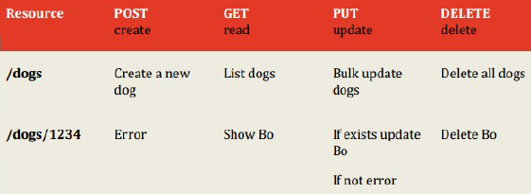

Figure : Dog Day Care API

We will use Swagger to implement some of the methods shown above.

# Install The Swagger editor and Node.js

If you have not done so already, install node.js by following instructions [here](https://nodejs.org/en/download/).

The Swagger editor is a browser based tools that you can use to edit YAML document. Go to <http://swagger.io/> and in the tools section select the [swagger editor](http://swagger.io/swagger-editor/). There are several options for running Swagger. You can use the live demo if you wish at <http://editor.swagger.io/#/> . Otherwise, to run it locally follow the relevant instructions. On completion, you should see the following:

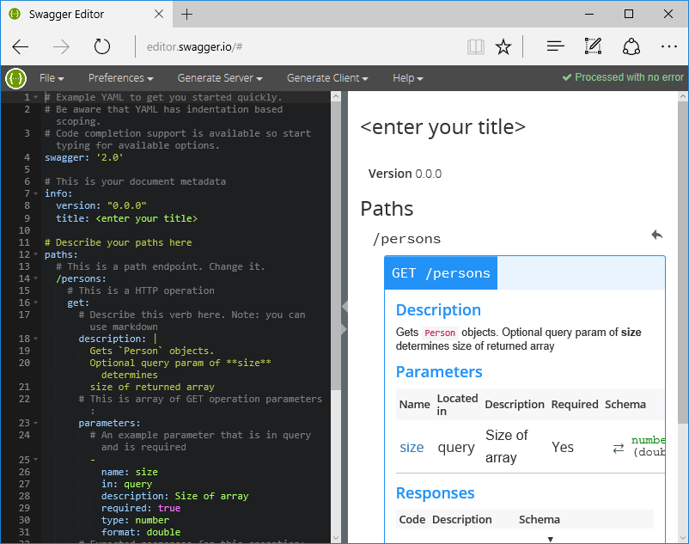

Figure : Swagger Editor

# Create YAML Specification

Open the Swagger editor and select File->New. Replace the YAML in the left-hand pane with the following YAML at this link:

<https://drive.google.com/file/d/0BxtnCYpIWp3DUVJNMXNlN3BzNjA/view?usp=sharing>

You should see the following:

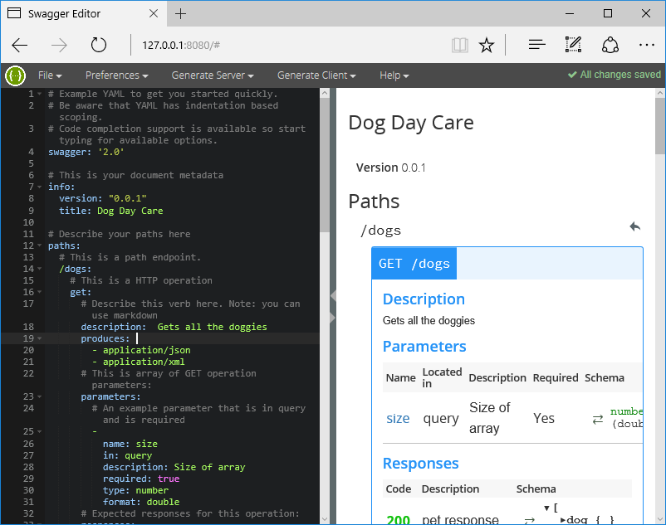

Figure : Swagger Editor with starter YAML

Examine the spec and compare it to the initial high level design. Examine the following:

* One thing to notice is the definitions section at the bottom of the document. You can see how YAML allows you to specify schemas for your data models that can then be referenced in the HTTP verb descriptions.
* The HTTP verb descriptions include the possible resource representations that the service can produce.

# Generate the service

The editor allows you to generate a skeleton implementation of the service in various programming languages.

* In the editor, select Generate Server->node.js. This will generate a zip archivecontaining a runnable node.js implementation of the service.
* Extract the archive and open the README.md file. Follow the instructions to run the service on your local machine.
* Check it works by entering the following in your browser: <http://localhost:8080/docs>. You should see the following (make sure to click on default)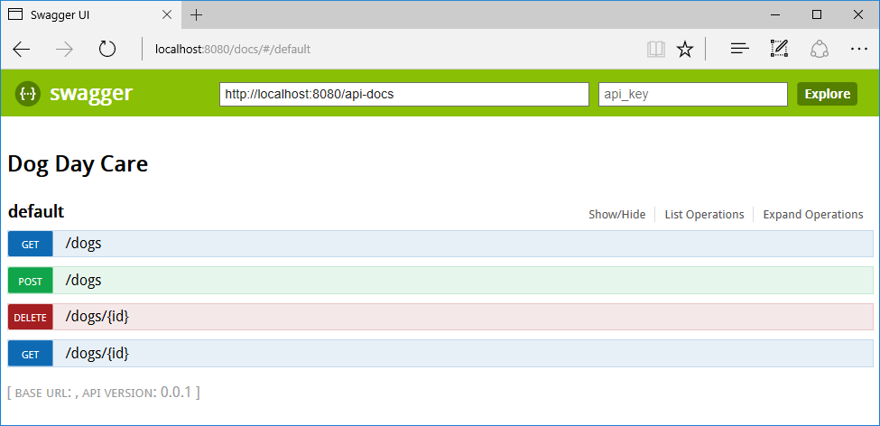

Figure : Swagger UI

You can check the function by clicking on the desired method and following the instructions. This UI also serves to document the service.