人
- Human GSE138852 Pubmed_ID31768052 内嗅皮层 N=6 抽核
Here we applied single-nucleus RNA sequencing to entorhinal cortex samples from control and Alzheimer’s disease brains (n= 6 per group), yielding a total of 13,214 high-quality nuclei.

- Human syn18485175 Pubmed_ID31042697
Here, we profiled and analysed 80,660 single-nucleus transcriptomes from prefrontal cortex of 48 individuals with varying degrees of AD pathology.

- Human syn21125841 Pubmed_ID 31932797 人和鼠都有
Human and mouse single-nucleus transcriptomics reveal TREM2-dependent and TREM2-independent cellular responses in Alzheimer's disease. Nat Med. 2020 Jan;26(1):131-142.
β and microglial activation across cell types in mice, we performed snRNA-seq on 7-month-old 5XFAD, Trem2-deficient 5XFAD (Trem2–/– 5XFAD), wild-type (WT) and Trem2–/– mice (3 mice per genotype)
We performed snRNA-seq of postmortem samples
of dorsolateral prefrontal cortexes from 11 people with AD with
the TREM2-CV, 10 bearing TREM2-R62H and 11 controls, all
obtained from the Rush AD center (Supplementary Table 2). We
analyzed a total of 66,311 individual nuclei with a median of 1,312 genes per nucleus, which were visualized in 2 dimensions by t-SNE
- 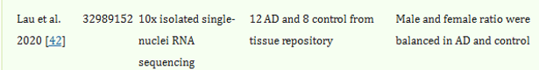
GEO (accession no. GSE157827) 文章中没有OPC
21 prefrontal cortex tissue samples from patients with AD (n = 12) and NC subjects (n = 9) at the single-cell level by single-nucleus RNA sequencing (snRNA-seq)
We sampled 169,496 nuclei: 90,713 and 78,783 nuclei from AD and NC brain samples, respectively.
(Gene Expression Omnibus [GEO] accession no. GSE33000), who performed bulk transcriptome microarray analysis of prefrontal cortical tissues in a large cohort (AD: n = 310; NC: n = 157)
We also used the same pipeline to process the microarray dataset of AD temporal cortical samples from Webster et al. (GEO accession no. GSE15222)

- 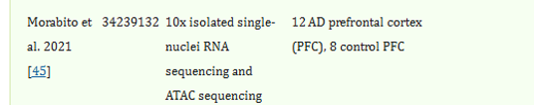
GSE174367
We performed both snATAC-seq (10x Genomics; n = 12 late-stage AD; n = 8 control) and snRNA-seq (10x Genomics v3; n = 11 late-stage AD; n = 7 control) on nuclei isolated from the prefrontal cortex (PFC) using postmortem human tissue from individuals with late-stage AD and age-matched cognitively healthy controls (74–90+ years old; Fig. 1a).

小鼠：
- GSE140510 snRNA-seq on 7-month-old 5XFAD, Trem2-deficient 5XFAD (Trem2–/– 5XFAD), wild-type (WT) and Trem2–/– mice (3 mice per genotype)

- Mouse GSE143758 Pubmed_ID 32341542

54,769 single-nucleus RNA profiles from hippocampi of 7-month-old male mice, four WT and four 5xFAD (AD)
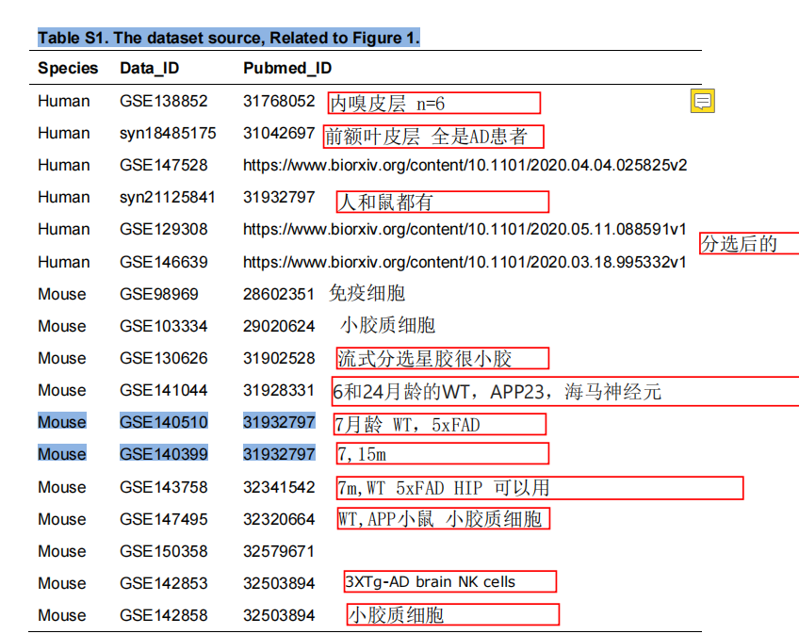

- 6-month 5xFAD cortex samples（GSM5903396 (GSE196873)

4. GSE196871 6M WT,5XFAD
1. RNA-seq of stranded mRNA of 6-month old of wild-type, N40K-Tg, 5XFAD, dTg (N40K-Tg and 5xFAD) mice generated by crossing N40K-Tg and 5xFAD mice.
2. RNA-seq of stranded mRNA of 12-month old of wild-type and Tau P301S mice.

