# 

|  |  |
| --- | --- |
| **ELECTRONIC ASSIGNMENT COVERSHEET** |  |

**Kaplan Singapore**

|  |  |
| --- | --- |
| Student Number | 35342323 |
| Surname | Yang |
| Given name | Fengfan |
| Email | Ffclass2023@gmail.com |
|  |  |
| Unit Code |  |
| Unit name | ICT206 Intelligent Systems |
| Enrolment mode |  |
| Date | 29/03/2024 |
| Assignment number | 2 |
| Assignment name | Project Report |
| Tutor | Loo Poh Kok |

|  |
| --- |
| **Student’s Declaration:**   * Except where indicated, the work I am submitting in this assignment is my own work and has not been submitted for assessment in another unit. * This submission complies with Murdoch University's academic integrity commitments. I am aware that information about plagiarism and associated penalties can be found at http://www.murdoch.edu.au/teach/plagiarism/. If I have any doubts or queries about this, I am further aware that I can contact my Unit Coordinator prior to submitting the assignment. * I acknowledge that the assessor of this assignment may, for the purpose of assessing this assignment:  -reproduce this assignment and provide a copy to another academic staff member; and/or   -submit a copy of this assignment to a plagiarism-checking service. This web-based service may -   -retain a copy of this work for the sole purpose of subsequent plagiarism checking, but has a   legal agreement with the University that it will not share or reproduce it in any form.   * I have retained a copy of this assignment. |
| I am aware that I am making this declaration by submitting this document electronically and by using my Murdoch ID and password it is deemed equivalent to executing this declaration with my written signature.  Signed Yang Fengfan    (Write your name in the space above) | |

Expert System for Detecting Fraudulent Deals on Online Marketplaces with a Focus on Resellers of Secondhand Concert Tickets 3

Introduction 3

Background 3

AI Method and Tools 4

Rules, Conditions and Actions 4

User Guide 6

Discussion of Results and Evaluation 7

References 8

Appendices 9

Appendix A: reseller.kb 9

Appendix B: reseller.kbt 11

Expert System for Detecting Fraudulent Deals on Online Marketplaces with a Focus on Resellers of Secondhand Concert Tickets

# Introduction

Ecommerce fraud has become a significant concern, reflecting broader trends in online criminal activity. "Social Media Scams Lead to Record Losses in 2021," [1] reports that Instagram was the top platform for fraudulent ads (36%), followed by Facebook (28%), WhatsApp (9%), and Telegram (7%). The median individual loss due to investment-related fraud on social media was $1,800 in 2021. Scams originating on social media platforms have led to $2.7 billion in reported losses since 2021, making social media the most significant source of reported fraud losses compared to other contact methods. The most frequently reported type of fraud loss in the first half of 2023 on social media was from consumers trying to buy products advertised on these platforms. A staggering 44% of all social media fraud loss reports were related to undelivered goods, with clothing and electronics being the most common items that consumers reported not receiving. [3] Within ecommerce spaces, including the popular local secondhand market Carousell, there has been a surge in concert ticket reselling scams because of the highly popular Taylor Swift Eras Tour. [2]

This project aims to create a rule-based expert system for detecting fraudulent sales listings on any platform, with a focus on ticket reselling scams on online marketplaces such as Carousell. Analysing various characteristics of the listing, seller behavior, and other information, the proposed system aims to alert users to potentially fraudulent post, help them distinguish between legitimate and fraudulent ads, by identifying common scam tactics such as demanding usual modes of payment and too-good-to-be-true offers.

# Background

Various studies have been done on using expert systems to detect antisocial behaviour on social media including fraudulent commercial usage. *Deep learning for misinformation detection on online social networks: a survey and new perspectives.* [4] explores misinformation detection (MID) in social networks, including false information, fake news, rumors, spam, and disinformation. It emphasizes the use of deep learning (DL) techniques to automatically process data and create patterns for better results. DL proves effective and scalable for MID, but challenges remain for real-world implementation.

*Ads and Fraud: A Comprehensive Survey of Fraud in Online Advertising* [5] focuses on how bad actors exfiltrate money from the ad ecosystem by conducting various types of fraudulent actions. It examines the techniques used for user tracking and profiling, then defines the different types of ad fraud and the methods used to prevent and detect it.

Bolster [6] has developed an SaaS with automation and machine learning capabilities to address social media fraud, including fake ads, counterfeit products, trademark infringements, impersonations, phishing campaigns, and content abuses. The SaaS offers real-time monitoring and intuitive dashboards aid in tracking threats.

So far, there is no expert system targeting the problem of ticket resale scams, perhaps because it is a relatively niche phenomenon.

# AI Method and Tools

Implementing an expert system for identifying potentially fraudulent concert ticket reseller advertisements on online marketplace platforms like Carousell involves a structured approach to inputting data, analyzing it against a set of predefined rules, and then determining an outcome based on this analysis. To start, each ticket reselling advertisement/sales listing needs to be evaluated based on specific criteria, such as the seller's account age, seller history, the asking price compared to the market rate, the preferred method of transaction to close the deal, and whether the seller is verified. This input data forms the foundation upon which the expert system operates.

I chose the ‘e2gRuleEngine’ by eXpertise2Go, a backward chaining expert system, to create the Expert System for Detecting Fraudulent Deals on Online Marketplaces. It is a rule and prompt system with the heuristics stored in in a knowledge base, which is a type of database that the inference engine searches for rules that fit the conditions entered. Prompts are used to specify the status or value of variables that will be utilised as rule conditions. When the set of conditions for a rule is met, the rule is executed, and a recommendation is supplied.

Once the data is input, the expert system processes it by applying a series of rules designed to identify signs of potential fraud. These rules assess factors like the recency of the account creation date coupled with high ticket prices, preference for non-standard payment methods, and the absence of seller verification to gauge the risk level of fraud associated with each advertisement. The outcomes of this process are a classification of the fraud risk as high, moderate, or low, and a recommendation for follow-up action. This classification aids users in making informed decisions about the trustworthiness of ticket resellers so they may avoid getting scammed.

## Rules, Conditions and Actions

This table organizes all the rules in the final expert system based on various conditions related to the seller's profile and the ticket sale specifics, offering clear advice and an assessment of the fraud risk associated with each set of conditions. Each row represents a rule that is applied based on matching conditions, helping users make informed decisions about the trustworthiness of ticket resellers on platforms like Carousell.

The system also makes recommendations on the type of follow-up action a buyer made do, such as requesting to meet up in person with sellers posing a moderate risk of fraud, or flagging and reporting obvious scam posts.

The full knowledge database written in the syntax of e2gRuleEngine is in **Appendix A**.

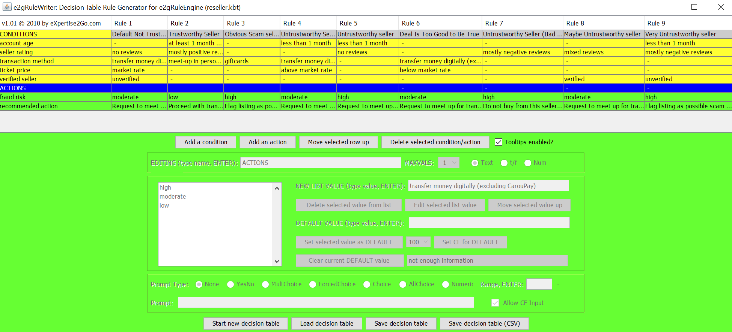

|  |  |  |  |  |  |  |  |  |  |
| --- | --- | --- | --- | --- | --- | --- | --- | --- | --- |
| CONDITIONS | Rule 1 | Rule 2 | Rule 3 | Rule 4 | Rule 5 | Rule 6 | Rule 7 | Rule 8 | Rule 9 |
|  | Default Untrustworthy Seller | Trustworthy Seller | Obvious Scam Seller | Untrustworthy Seller (New, High-Value Risk) | Untrustworthy Seller | Deal Is Too Good to Be True | Untrustworthy Seller  (Bad Ratings) | Maybe Untrustworthy seller | Very Untrustworthy Seller |
| **Account Age** | - | > 1 month | - | < 1 month | < 1 month | - | - | - | < 1 month |
| **Seller Rating** | No reviews from buyers | Mostly positive reviews | - | - | No reviews from buyers | - | Mostly negative reviews | Mixed reviews | Mostly negative reviews |
| **Transaction Method** | Transfer funds digitally | Meet up in person | Giftcard | Transfer funds digitally | - | Transfer funds digitally | - | - | - |
| **Verified Seller** | Unverified | Verified | - | - | - | - | - | Verified | Unverified |
| **Ticket Price** | Market rate | - | - | Higher than market rate | - | Lower than market rate | - | - | - |
| **ACTIONS** |  |  |  |  |  |  |  |  |  |
| Fraud Risk | Moderate | Low | High | Moderate | High | High | High | Moderate | High |
| **Advice** | Request to meet up for transaction | Proceed with transaction | Flag listing as possible scam | Request to meet up for transaction | Request to meet up for transaction | Request to meet up for transaction | Do not buy from this seller | Request to meet up for transaction | Flag listing as possible scam |

# User Guide

To run on a PC:

The Expert System for Detecting Fraudulent Deals on Online Marketplaces runs as a Java Applet. To run the expert system, open e2gRuleEngine.jar then locate the ‘reseller.kb’ file in the project folder and copypaste its file address into the blank field.

Wait for the page to load then click the 'Find Out' button to begin. You will be brought to the expert system's startup screen. Read the question at the top of the screen, select the most suitable choice then clickt he ‘Submit’ button to proceed to the next question.

The ‘Why Ask?’ button shows the rule being assessed and the status of each condition for that rule.

The ‘Go Back’ button allows you to change your answers to previous questions if necessary.

The ‘Restart’ button restarts the expert system.

## Demo

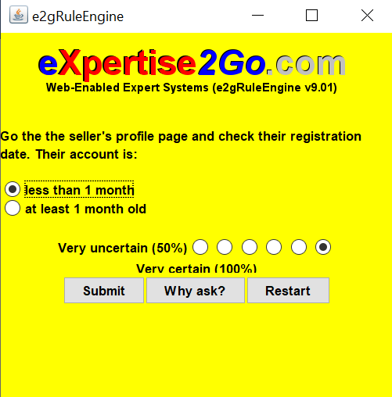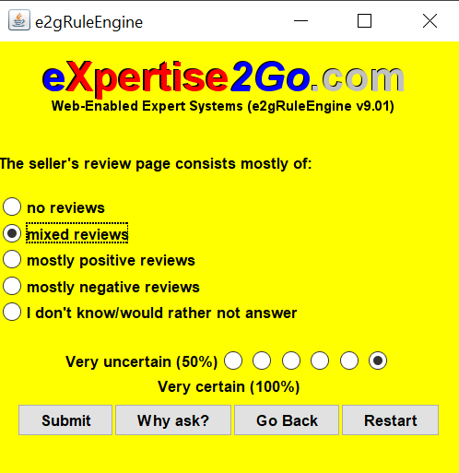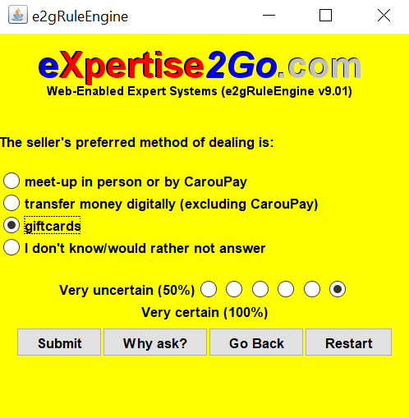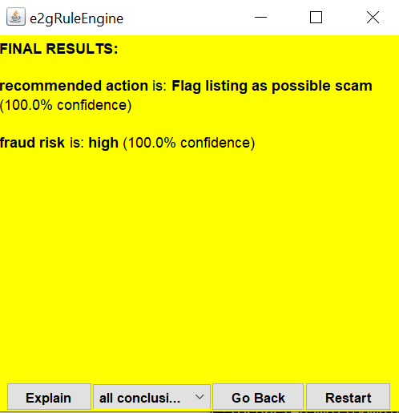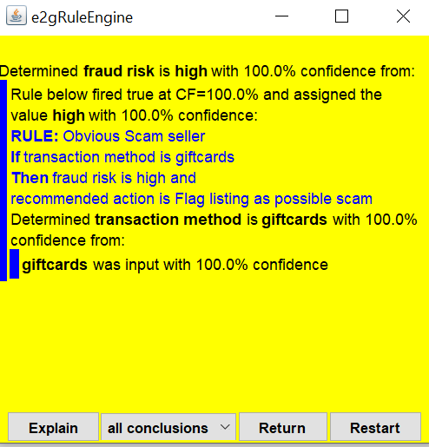

# Discussion of Results and Evaluation

The expert system can detect suspicious listings successfully as far as I can tell, but more testing is needed. We would need to assess the tangible impact of the system on reducing fraudulent transactions. Metrics might include the amount of reduction in reported scams and level of user compliance with the system’s recommendations.

To keep the rules up to date, we would need to gather regular feedback from users who interact with the system and have experienced suspicious ecommerce activity to better understand indicators of scams, and work closely with domain experts to refine rules and ensure they accurately reflect real-world knowledge and scenarios. The system has good scalability and can be easily updated to include new rules and conditions.

# References

[1] Federal Trade Commission, "Social Media Scams Lead to Record Losses in 2021," [Online]. Available: https://www.ftc.gov/news-events/news/press-releases/2022/02/social-media-scams-lead-record-losses-2021. [Accessed February 6, 2024].

[2] Lim, R. (2023, August 21). S$571,000 lost to e-commerce concert ticket scams since January; most cases involved Taylor Swift shows. Channel News Asia. https://www.channelnewsasia.com/singapore/taylor-swift-concert-ticket-scams-571000-45-investigated-telegram-carousell-4177346

[3] Federal Trade Commission, "FTC Data Shows $770 Million Lost to Social Media Scams in 2021," [Online]. Available: https://www.ftc.gov/news-events/news/press-releases/2023/01/ftc-data-shows-770-million-lost-social-media-scams-2021. [Accessed February 6, 2024].

[4] Islam, M. R., Liu, S., Wang, X., & Xu, G. (2020). Deep learning for misinformation detection on online social networks: a survey and new perspectives. *Social Network Analysis and Mining*, 10(82) [Online]. Available: <https://link.springer.com/article/10.1007/s13278-020-00696-x>

[5] Sadeghpour, S., & Vlajic, N. (2021). Ads and Fraud: A Comprehensive Survey of Fraud in Online Advertising. *Journal of Cybersecurity and Privacy*, 1(4), 804-832. Online]. Available: <https://www.mdpi.com/2624-800X/1/4/39>

[6] “How to Detect and Stop Social Media Fraud.” *Security Boulevard*. December 7, 2021. [Online]. Available: https://securityboulevard.com/2021/12/how-to-detect-and-stop-social-media-fraud/

# Appendices

## Appendix A: reseller.kb

REM Generated by v1.01 of e2gRuleWriter 03/30/2024 04:55 from: reseller.kbt

RULE [Default Not Trustworthy Seller]

If [seller rating] = "no reviews" and

[transaction method] = "transfer money digitally (excluding CarouPay)" and

[ticket price] = "market rate" and

[verified seller] = "unverified"

Then [fraud risk] = "moderate" and

[recommended action] = "Request to meet up for transaction"

RULE [Trustworthy Seller]

If [account age] = "at least 1 month old" and

[seller rating] = "mostly positive reviews" and

[transaction method] = "meet-up in person or by CarouPay"

Then [fraud risk] = "low" and

[recommended action] = "Proceed with transaction"

RULE [Obvious Scam seller]

If [transaction method] = "giftcards"

Then [fraud risk] = "high" and

[recommended action] = "Flag listing as possible scam"

RULE [Untrustworthy Seller (New, High-Value Risk)]

If [account age] = "less than 1 month" and

[transaction method] = "transfer money digitally (excluding CarouPay)" and

[ticket price] = "above market rate"

Then [fraud risk] = "moderate" and

[recommended action] = "Request to meet up for transaction"

RULE [Untrustworthy seller]

If [account age] = "less than 1 month" and

[seller rating] = "no reviews"

Then [fraud risk] = "high" and

[recommended action] = "Request to meet up for transaction"

RULE [Deal Is Too Good to Be True]

If [transaction method] = "transfer money digitally (excluding CarouPay)" and

[ticket price] = "below market rate"

Then [fraud risk] = "moderate" and

[recommended action] = "Request to meet up for transaction"

RULE [Untrustworthy Seller (Bad Rating)]

If [seller rating] = "mostly negative reviews"

Then [fraud risk] = "high" and

[recommended action] = "Do not buy from this seller"

RULE [Maybe Untrustworthy seller]

If [seller rating] = "mixed reviews" and

[verified seller] = "verified"

Then [fraud risk] = "moderate" and

[recommended action] = "Request to meet up for transaction"

RULE [Very Untrustworthy seller]

If [account age] = "less than 1 month" and

[seller rating] = "mostly negative reviews" and

[verified seller] = "unverified"

Then [fraud risk] = "high" and

[recommended action] = "Flag listing as possible scam"

PROMPT [account age] ForcedChoice

"Go the the seller's profile page and check their registration date. Their account is:"

"less than 1 month"

"at least 1 month old"

PROMPT [seller rating] MultChoice CF

"The seller's review page consists mostly of:"

"no reviews"

"mixed reviews"

"mostly positive reviews"

"mostly negative reviews"

PROMPT [transaction method] MultChoice CF

"The seller's preferred method of dealing is:"

"meet-up in person or by CarouPay"

"transfer money digitally (excluding CarouPay)"

"giftcards"

PROMPT [ticket price] MultChoice CF

"The seller is offering the item at:"

"market rate"

"above market rate"

"below market rate"

PROMPT [verified seller] ForcedChoice

"The seller is:"

"verified"

"unverified"

DEFAULT [account age] = "unknown"

DEFAULT [seller rating] = "no reviews"

DEFAULT [transaction method] = "other"

DEFAULT [fraud risk] = "not enough information"

DEFAULT [recommended action] = "not enough information"

GOAL [fraud risk]

GOAL [recommended action]

MINCF 80

## Appendix B: reseller.kbt

v1.01

N

N

N

N

N

N

N

N

Y

N

4

00005

00002

00009

0100

0100

0100

0100

0111

0148

0144

0144

0157

0

0

0.0

0.0

Y

N

00

01

Rule 1

Rule 2

Rule 3

Rule 4

Rule 5

Rule 6

Rule 7

Rule 8

Rule 9

000

CONDITIONS

0

0

0.0

0.0

Y

N

00

01

Default Not Trustworthy Seller

Trustworthy Seller

Obvious Scam seller

Untrustworthy Seller (New, High-Value Risk)

Untrustworthy seller

Deal Is Too Good to Be True

Untrustworthy Seller (Bad Rating)

Maybe Untrustworthy seller

Very Untrustworthy seller

000

account age

3

0

0.0

0.0

Y

N

Go the the seller's profile page and check their registration date. Their account is:

unknown

00

01

-

at least 1 month old

-

less than 1 month

less than 1 month

-

-

-

less than 1 month

002

less than 1 month

at least 1 month old

seller rating

2

0

0.0

0.0

Y

N

The seller's review page consists mostly of:

no reviews

00

01

no reviews

mostly positive reviews

-

-

no reviews

-

mostly negative reviews

mixed reviews

mostly negative reviews

004

no reviews

mixed reviews

mostly positive reviews

mostly negative reviews

transaction method

2

0

0.0

0.0

Y

N

The seller's preferred method of dealing is:

other

00

01

transfer money digitally (excluding CarouPay)

meet-up in person or by CarouPay

giftcards

transfer money digitally (excluding CarouPay)

-

transfer money digitally (excluding CarouPay)

-

-

-

003

meet-up in person or by CarouPay

transfer money digitally (excluding CarouPay)

giftcards

ticket price

2

0

0.0

0.0

Y

N

The seller is offering the item at:

00

01

market rate

-

-

above market rate

-

below market rate

-

-

-

003

market rate

above market rate

below market rate

verified seller

3

0

0.0

0.0

Y

N

The seller is:

unverified

00

01

unverified

-

-

-

-

-

-

verified

unverified

002

verified

unverified

ACTIONS

0

0

0.0

0.0

Y

N

00

01

-

-

-

-

000

fraud risk

0

0

0.0

0.0

Y

N

not enough information

00

01

moderate

low

high

moderate

high

moderate

high

moderate

high

003

high

moderate

low

recommended action

0

0

0.0

0.0

Y

N

not enough information

00

01

Request to meet up for transaction

Proceed with transaction

Flag listing as possible scam

Request to meet up for transaction

Request to meet up for transaction

Request to meet up for transaction

Do not buy from this seller

Request to meet up for transaction

Flag listing as possible scam

004

Do not buy from this seller

Flag listing as possible scam

Request to meet up for transaction

Proceed with transaction