Individual Log-scaled Concentration of REGN2810 in Serum vs Actual Sampling Day Following Subcutaneous or Intravenous Dose(s) of REGN2810 (tmp)

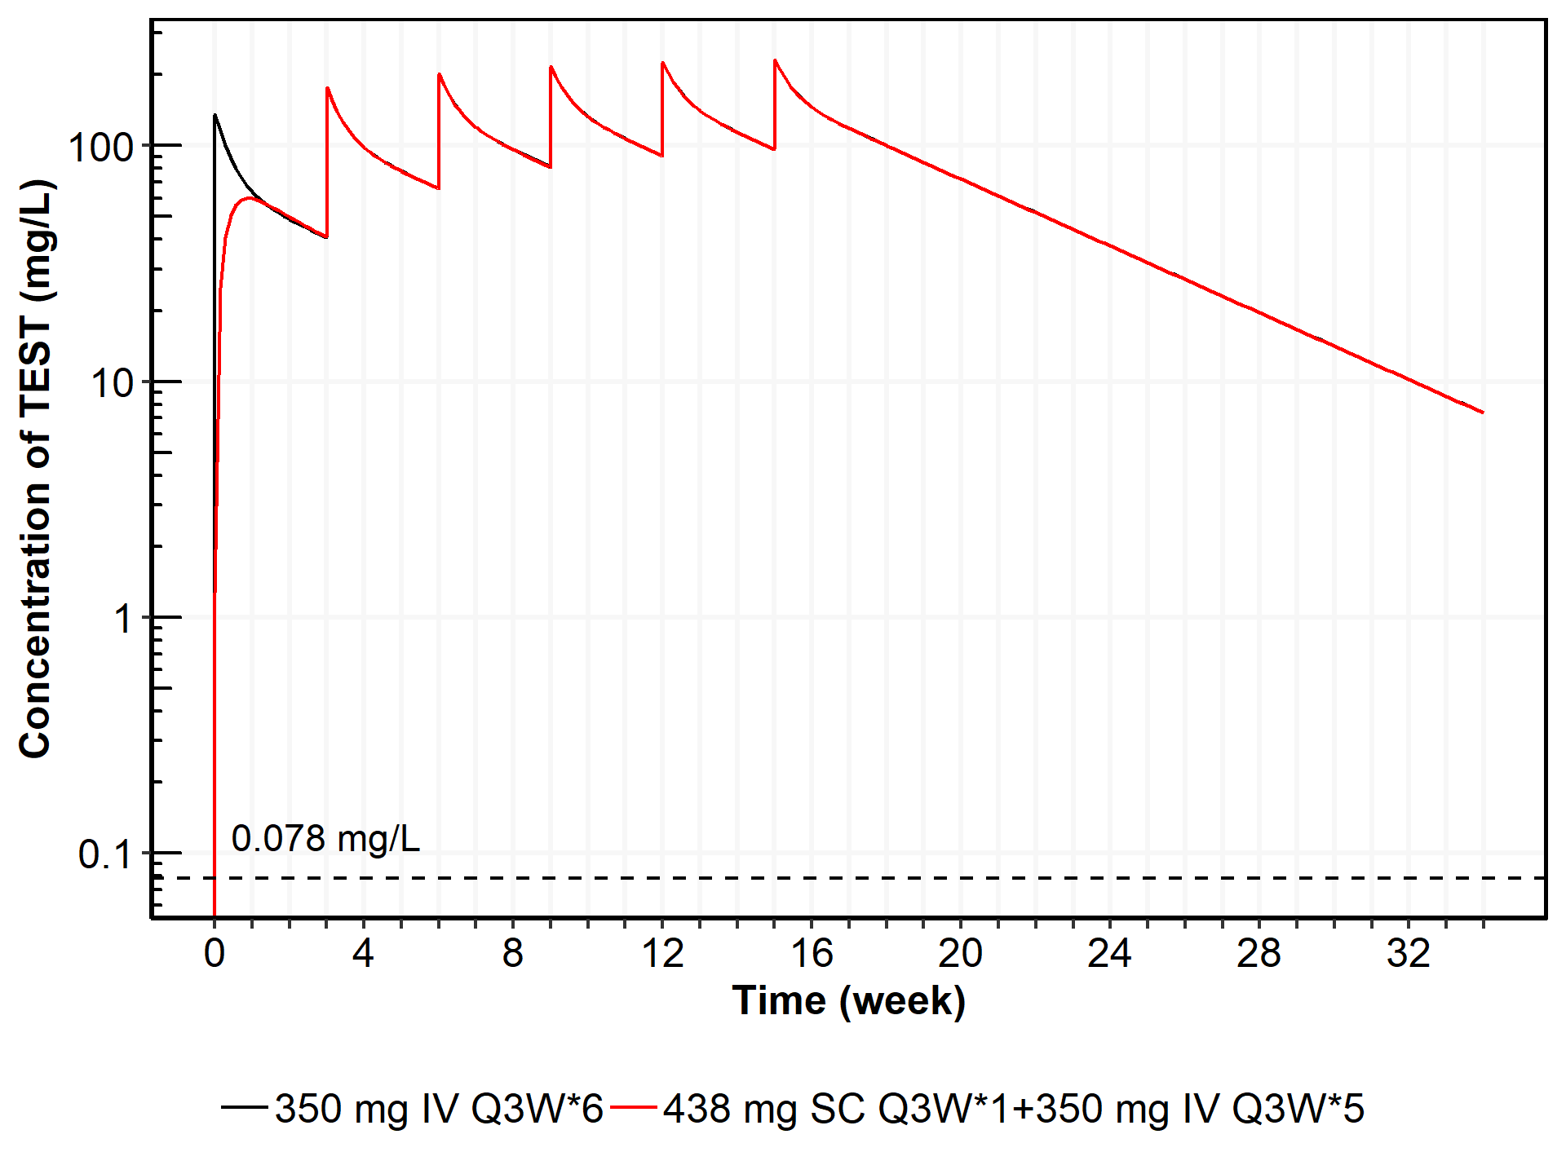

Individual Log-scaled Concentration of REGN2810 in Serum vs Actual Sampling Day Following Subcutaneous or Intravenous Dose(s) of REGN2810 (tmp)

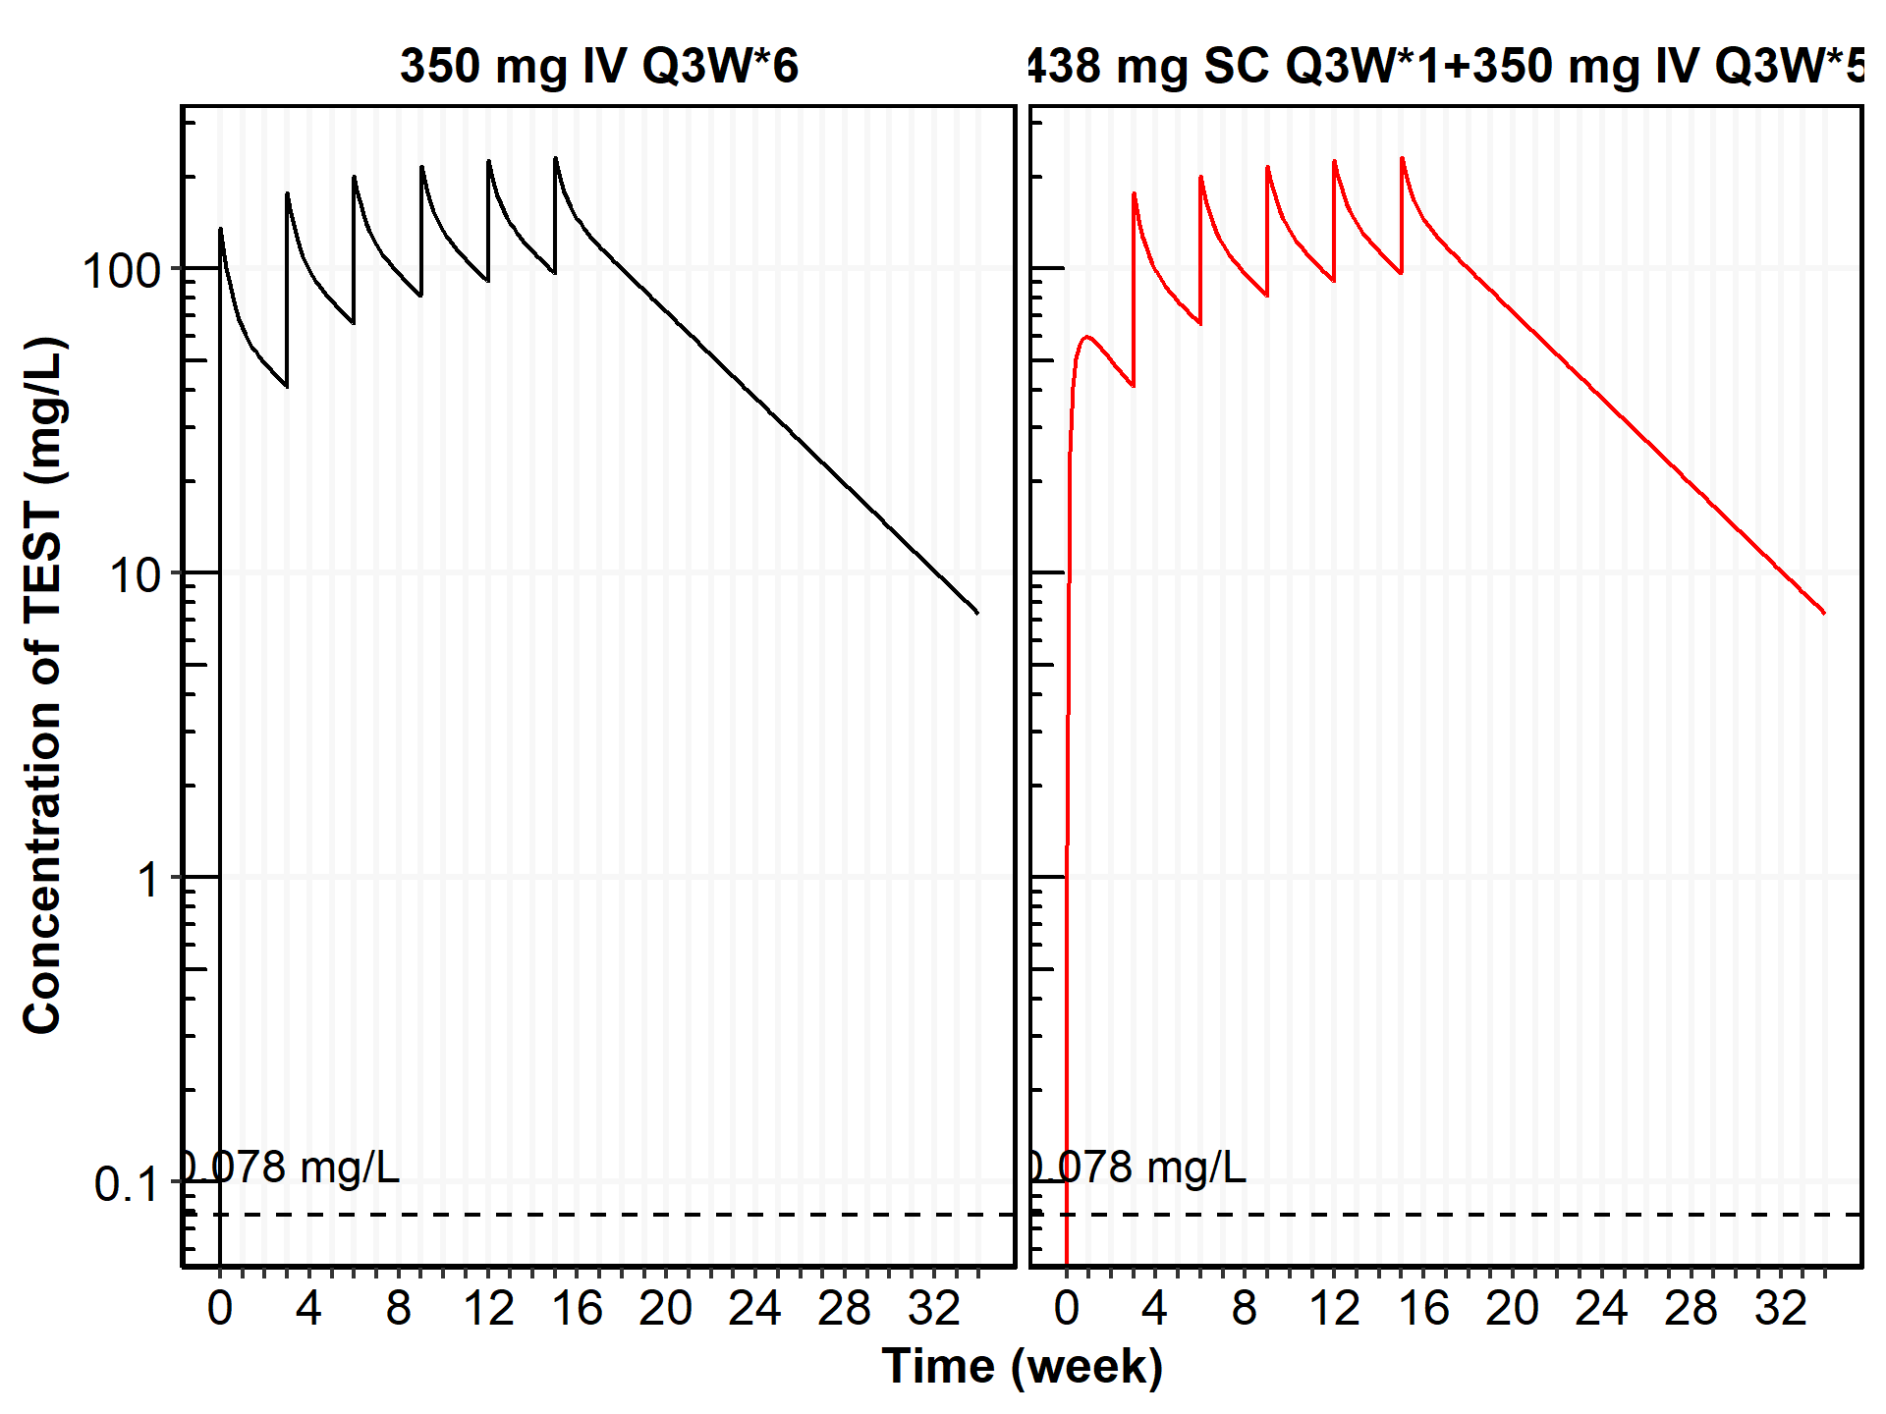

Predeicted Time-profile With 95% Confidence Interval

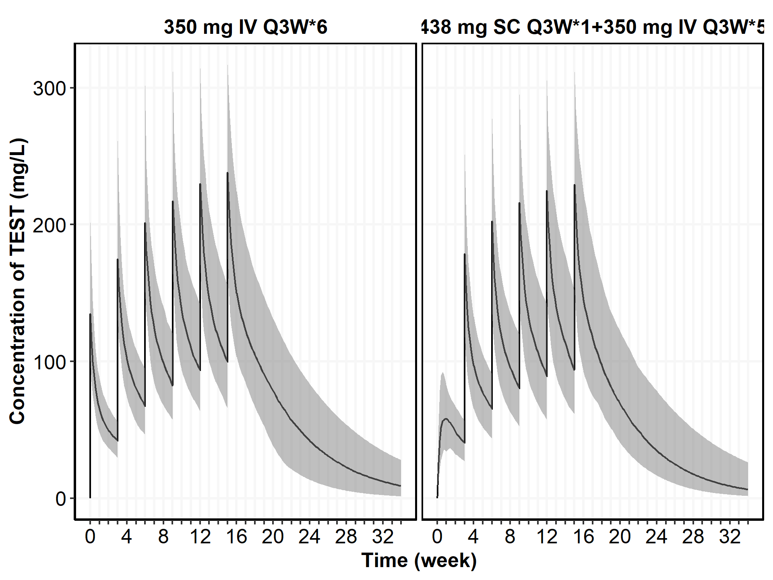

No title yet

| ARMA | N | AUCtau | CMAX | CMIN |
| --- | --- | --- | --- | --- |
| 350 mg IV Q3W*6 | 1 | 2920 (± NaN) | 232 (± NaN) | 100 (± NaN) |
| 438 mg SC Q3W*1+350 mg IV Q3W*5 | 1 | 2920 (± NaN) | 232 (± NaN) | 100 (± NaN) |