CURRICULUM VITAE

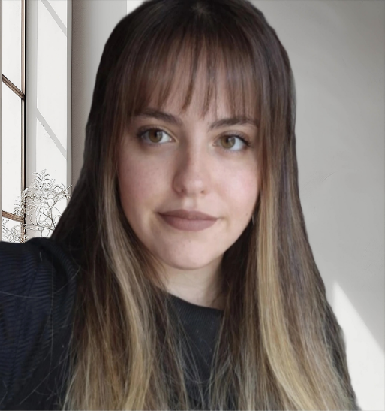
PERSONAL INFORMATION:
Name: Fatma Yaren Surname: Birben Date of Birth: •••••••••• Birth Place: ••••••••• •••••• Mobile: •••••••••••••••
E-mail Address: yarenbirben11@gmail.com
LinkedIn Profile: http://www.linkedin.com/in/fatmayarenbirben
Driving License: B
Marital Status: ••••••

EDUCATION:
(2013) - (2019): Ozyegin University, International Relations (BA) - [4 years] + Prep School (1 year), Main Language: %100 English, with %50 Scholarship.
(2009) - (2013): Cengelkoy High School - 6 certificates of appreciation.
(2002) – (2009): Rasathane Primary & Secondary School - 8 certificates of appreciation + 1 honor certificate.

EXPERIENCES:

(July 2026 - Present): AI Marketing Intern at FlyRank.ai.
- (Mar 2025 - Present): Search Quality & AI Evaluation Specialist, Data Annotator, Search Engine Optimiser.
- Key Projects at Yandex: Search Engine Evaluation Search & Page Quality Rating
AI Response & LLM Evaluation (Perplexity, ChatGPT, Yandex AI)
Data Labeling & Annotation
Relevance Judging (Image, Music, and Video Relevance)
Side-by-Side Evaluation Tasks
Web Ranking
SinSig 2.0 & SinSig Global
1
Side-by-Side Translate Evaluation [TR-ENG, ENG-TR]

- (Jan 2024 - Jan 2025): English Tutor: I provided private English lessons to some high school and university prep students. While I was studying for KPSS (an exam for being a civil servant in Turkey) very intensely, I was also working at the same time.

- (Nov 2022 - Dec 2023): Logistics Operations Specialist at TSI Logistics Istanbul:
I worked as an operational specialist at TSI Logistics Istanbul full-time for a year. I managed communication with European customers via phone and e-mail. I negotiated pricing offers and coordinated logistics operations. I also prepared and processed logistics documentation, including CMRs. I contributed to international shipping projects and customer relations.

- (Mar 2021 - Sep 2022): Export Sales Consultant:
I worked as an export sales consultant at Mendoza Jewelry and Leather Store, which is located in Fatih, İstanbul. I provided assistance in exporting products from Turkey to Italy, Russia, and Germany. Also, I had the opportunity to develop my professional English communication and international sales skills.
- (2019): Interviewer:
I conducted an interview with Süheyla Demir, a Turkish journalist, newsreader, and the foreign news manager of Haber Global, for my graduation project. I asked her many questions about global political issues related to Russia, Syria, and Turkey.

- (2017 - 2019): English Tutor:
While I was studying at the university, I taught English to some high school students.

LANGUAGES: ENGLISH: Reading, writing, speaking, listening all fluently. ITALIAN: Reading, writing, listening, speaking all at B2 level. KOREAN: Reading, writing, listening, speaking all in begining.
TURKISH: Native Language.

COMPUTER SKILLS:
Microsoft Word: Advanced PowerPoint: Advanced
Siber Software Program: Intermediate Microsoft Outlook: Advanced
2

ATTENDING COURSES, EXAMS AND CONFERENCES:
2024 - KPSS Score:78/100 2023 - KPSS Score: 68/100
(KPSS: It is an exam for being a civil servant in the Turkish government.)
2016: Landmark Worldwide Conference ISTANBUL:
I attended this conference for 3 days in Taksim/ ••••••••• in the field of personal development. The conference aimed to gain new and fruitful perspectives on life. (Info:https://www.landmarkworldwide.com/https://landmarkworldwideturkey.com/)
(2019 - 2021): Italian Language School:
I took Italian lessons at the university as a second foreign language because it is mandatory to graduate. After I graduated from Ozyegin University, I wanted to improve my Italian further. Therefore, I enrolled in ‘Italian Language Center School’ in Kadıköy, İstanbul.

PROFILE AND INTERESTS:

I am a proactive, detail-oriented, innovative, curious, self-motivated, and hardworking individual. I am interested in international politics, AI marketing, LLM evaluation, data labeling and data analysis, AI response and search engine evaluation, and SEO. My hobbies are: learning foreign languages, travelling abroad (I have been to 9 countries in Europe so far), swimming, listening to music, watching films and TV series, reading books and researching new topics. I am an animal and nature lover. I enjoy helping others and solving complex problems.

REFERENCES:

- Faik Gür: Doctor Lecturer at Ozyegin University. Address: •••••••• •••••••••••••• •••••• •••••••• Ozyegin University. •••••• •••••• ••••••••••••, Turkey. Phone Number: +••••••••••••

- Deniz Şenol Sert: Associate Professor at Ozyegin University. Address: •••••••• •••••••••••••• •••••• •••••••• Ozyegin University. •••••• •••••• ••••••••••••, Turkey. Phone Number: +••••••••••••

- İzzet Uğur Günel, Foreign Trade Director at Mendoza Jewelry & Leather Store. Address: •••••••••• •••••••••••••• •••••••••• •••••••• ••••••••• •••••• ••••••••• Turkey.
Phone Number: •••••••••••••
3

