Engineering Project Detailed Research Plan
Please complete the information/questions begun/seen below in red ink. Save this document to your computer, and add a printed hardcopy to your application.
Date: Jan 07, 2023
Student Name: Fnu Yash, Aniket Gupta
Project Title: PyLPR: Using darknet and yolov4 to build a custom license plate recognition tool.

Parts of the generic engineering project are listed below with descriptions to the students in the boxes. Students may provide a detailed research plan by describing their specific project in response to each box below.
Engineering Goal: PROBLEM BEING ADDRESSED: All engineering projects solve a problem or fill a need. This goal should be a simple statement that describes the product being designed, the customer it is for and the problem or need it satisfies. Example” “The goal is to design a solar powered lawn mower for inexpensive automated lawn care for homeowners”
My Project Goal is:
- The goal is to design a custom license plate recognition tool using Python to implement further security features in parking-lot cameras.
Design Criteria: Design criteria define the product’s required performance . Examples: “ It will have a minimum speed of 10 KPH”, The output will be within 15% of the mean of the experimental data”. “It must withstand 15 repetitions of a 10N impact” The International System of units (SI) required.
My Project Design Criteria are the following:
- The application must correctly identify license plates with an accuracy of at least 90 percent.

Constraints: Constraints are factors that limit the engineer’s flexibility such as size, cost, and time limitations. Examples: “It must fit in a box no larger than 10x20x50 cm” “The maximum cost is $50” “The software must run in real time on a Raspberry Pi”
My Project Constraints are the following:
- The application must run as intended on a web/cloud server which is accessible to all machines such as chromebooks or tablets.

Provide your chosen design. For hardware, provide a sketch. For software, provide a flowchart. Indicate the components you will develop, and the libraries you are using.
My Project Design is shown below: insert photos, diagrams, or illustrations below.
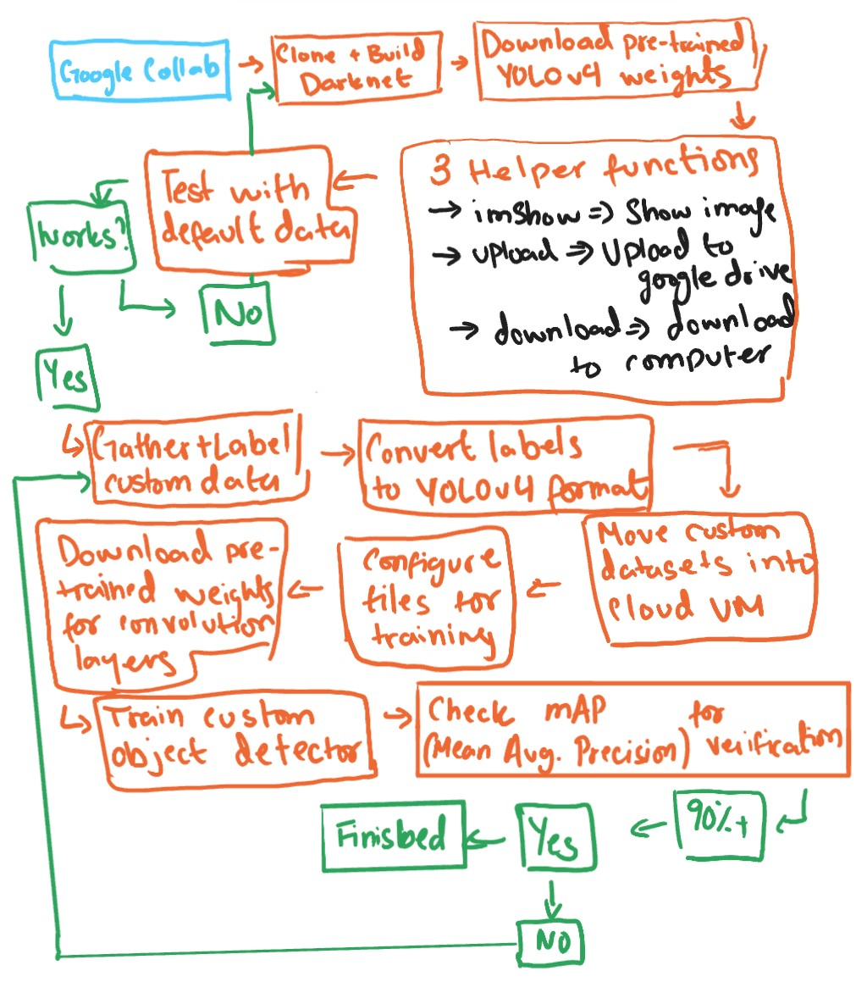

Test and evaluate your prototypes against the design criteria listed above to show how well the product meets the need/goal. Provide a test plan describing how you will test the design criteria and constraints you listed above., How will you analyze the data? If the product requires human testing please fill out and append https://science-fair.org/wp/wp-content/uploads/2015/10/Research-Plan-Human-Participants.docx
I test and analyze my prototypes using the following methods:
- We will provide the custom trained algorithm using images of license plates found on dataset websites such as “Kaggle” and retrain the algorithm with Google’s Open Images v7 datasets.

Bibliography: List at least five (5) major references (e.g. science journal articles, books, internet sites & dates of review) from your literature review. If you plan to use vertebrate animals, one of these references must be an animal care reference.
- https://www.police.uk/advice/advice-and-information/rs/road-safety/automatic-number-plate-recognition-anpr/
- https://viso.ai/computer-vision/automatic-number-plate-recognition-anpr/
- https://www.npcc.police.uk/FreedomofInformation/ANPR.aspx
- https://www.met.police.uk/advice/advice-and-information/rs/road-safety/automatic-number-plate-recognition-anpr/
- https://en.wikipedia.org/wiki/Automatic_number-plate_recognition

