Monopoly Deal Card Game
Final Software Engineering Project Report
Group 9
Prepared for the Software Engineering course submission and project interview
GitHub Repository: https://github.com/fyb123654-creator/md2

Technology stack: Java 25, JavaFX 25, Maven, JUnit 5, TCP socket networking

Executive Summary
Monopoly Deal is a digital card game implementation developed in Java and JavaFX. The project supports offline play for 2 to 5 players and online multiplayer through a host-client TCP architecture. Beyond implementing the core game rules, the team designed a structured software system that separates user interface concerns, game logic, domain entities, networking responsibilities, and rule calculation logic.
The assignment required the team to demonstrate strong requirements engineering, clean object-oriented design, appropriate use of interfaces, meaningful design pattern usage, correct functionality, teamwork evidence, and testing. The current codebase provides concrete evidence for these goals: a layered package structure, reusable card hierarchy, a central GameManager facade, event-based state updates, DTO-based network synchronisation, and 28 unit tests across 6 test classes.
This final report therefore has two purposes. First, it explains how the implemented system satisfies the course assessment criteria. Second, it reflects on the project as a software engineering effort by mapping course topics such as requirements engineering, system modelling, design patterns, testing, refactoring, software evolution, and process management to the final implementation.

Project Overview
The product is a playable digital version of Monopoly Deal. It reproduces the main game mechanics of the physical card game, including collecting property sets, depositing money, using action cards, charging rent, applying buildings such as houses and hotels, switching wild-card colours, and winning by completing three full property sets.
- Offline multiplayer for 2 to 5 players.
- Online room flow with host creation, client join, ready state, and synchronised game start.
- Turn timer with automatic timeout handling and hand-size enforcement.
- Game event log and in-game chat to improve transparency in online matches.
- Custom player names, avatar selection, themed visuals, and optional background music.
- Unit tests for game logic, action-card behaviour, DTO serialization, player assets, and rent rules.
From a software engineering perspective, the project is more than a simple GUI game. It is a mid-sized interactive system that combines desktop UI programming, object-oriented modelling, state management, networking, persistence-like DTO transfer, and quality assurance through testing.

Assignment Requirement Mapping
The official project brief evaluates the work using requirement and modelling quality, clean design, correct functionality, teamwork, and testing. Table 1 maps those expectations to concrete artefacts in the repository and in this report.
Assessment Area | Expectation in the Brief | Evidence in This Project
Requirements and modelling | Elicit functional / non-functional requirements and show system understanding | Sections on user requirements, system requirements, use-case view, architecture view, and class relationships
Clean design | Small focused classes, interfaces, suitable data structures, inheritance, patterns | Package separation, GameInteractor interface, GameEventListener, GameManager facade, card hierarchy, EnumMap / List usage
Functionality | Correct game rules and preferably GUI support | JavaFX UI, local and online play, timer, chat, event log, action-card support, deck/discard management
Teamwork | Meaningful Git usage and visible contribution | GitHub repository, 37 commits, multi-author commit history, contribution summary table
Testing | Meaningful tests for important methods | 28 test cases across GameManagerTest, ActionCardTest, PlayerManagementTest, DTO tests, rent rules tests, and card-manager tests
This mapping is important because the report is not just a description of features. It is an argument that the delivered software is aligned with the criteria used to evaluate the project.

Requirements Engineering

User Requirements
Following the spirit of the requirements engineering lectures, the system can be understood through user-centred expectations rather than implementation details alone. The main users are players participating in either an offline or online match, and the system should let them complete a full game without ambiguity about the current state of play.
- A player should be able to start a local game quickly and select the number of participants.
- A host should be able to create an online room and remote players should be able to join and signal readiness.
- A player should always know whose turn it is, how many cards may still be played, and what action just happened.
- A player should be able to inspect cards, bank assets, property sets, and discard / draw piles through the interface.
- A player should be able to use key action cards such as Sly Deal, Deal Breaker, Debt Collector, It’s My Birthday, Just Say No, and Double the Rent.
- The system should handle timing constraints, invalid actions, and end-of-turn rules fairly.

System Requirements
Translating those user needs into system requirements leads to several functional and non-functional expectations.

Functional Requirements
- Maintain correct deck creation, drawing, discard, reshuffle, and card ownership changes.
- Support turn-based play, turn progression, winner detection, and elimination handling.
- Represent players, bank assets, property zones, buildings, rent values, and action resolution.
- Synchronise online game state between host and clients.
- Provide GUI feedback for logs, chat, timer, and action hints.

Non-Functional Requirements
- Maintainability: the code should be split into understandable packages and classes.
- Usability: the interface should clearly present hand cards, table state, and current player information.
- Reliability: invalid actions should be blocked and the server should reject impossible room states.
- Extensibility: new cards, effects, or UI assets should be addable with limited disruption.
- Testability: important game rules should be verifiable without the graphical environment.
The repository structure and test design show that the team moved from abstract course concepts to concrete system requirements. For example, the introduction of the GameInteractor abstraction allows rule-heavy action cards to be tested without launching JavaFX, which directly improves testability.

System Modelling and Architecture
The original assignment encouraged the use of use-case, sequence, and class diagrams. This report therefore includes several visual aids so that readers can understand the main structure and flow of the system more quickly.
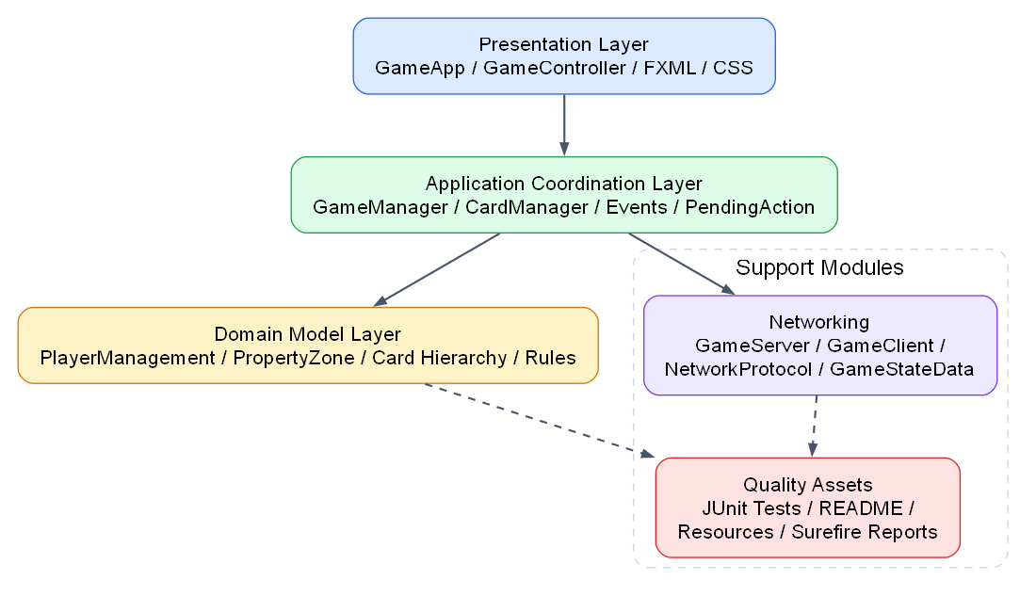
Figure 1. Layered architecture of the Monopoly Deal system.

Simplified Use-Case View
Player -> Start Local Game
Player -> Join Room / Ready Up
Host -> Host Online Room
Player -> Play Cards and Manage Assets
Player -> View Event Log / Chat
System -> Synchronise Game State
Team -> Run Tests and Validate Rules
The use-case view highlights that the system serves both local and networked play. This dual-mode requirement strongly influenced the architecture because the code had to separate presentation logic from reusable game rules. Otherwise, online support would have required duplicating too much behaviour.

Layered Architecture View
Presentation Layer: GameApp, GameController, FXML, theme.css
|
Application / Coordination Layer: GameManager, CardManager, pending actions, event flow
|
Domain Model Layer: PlayerManagement, PropertyZone, card hierarchy, rent rules
|
Networking + Quality Support: GameServer, GameClient, DTOs, tests, README, assets
The layered view is consistent with good software engineering practice taught in the system modelling and process lectures: responsibilities are partitioned so that change is localized. User interface classes do not directly own the rules of the card game; instead they delegate to the domain and coordination layers.
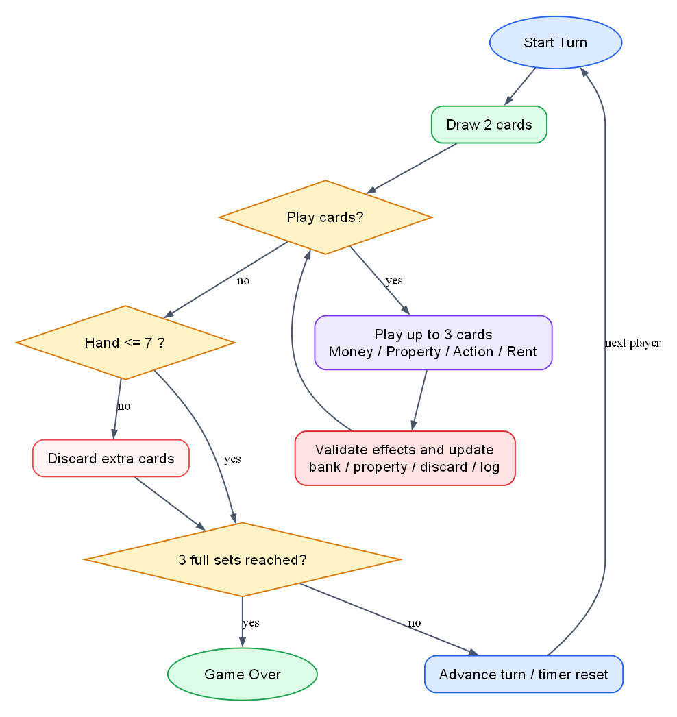
Figure 2. Main gameplay turn flow from draw phase to win check.

Core Class Relationship View
GameApp -> GameController -> GameManager -> CardManager
|-> PlayerManagement -> PropertyZone
GameServer <-> GameClient <-> GameStateData DTO
GameEventListener observes GameManager events
The class relationship view shows why GameManager acts as the central backbone of the project. It coordinates player state, deck state, pending actions, and event publication, while CardManager, PlayerManagement, PropertyZone, and GameStateData each handle more focused concerns. This decomposition is one of the strongest clean-design features of the codebase.

Object-Oriented Design and Clean Architecture
The codebase reflects an object-oriented design style that aligns with the OOP and clean-design content covered in the course. The source tree contains dedicated packages for application bootstrap (`app`), card hierarchies (`cards`), core engine logic (`core`), domain models (`model`), network behaviour (`network`), rule calculation logic (`rules`), and JavaFX controllers / components (`ui`). This package structure reduces conceptual coupling and makes the project easier to navigate.
Module | Primary Responsibility | Why It Matters
app | Entry points, settings, scene loading, avatar visuals | Keeps startup and shell concerns out of core game logic
cards | Action, money, property, rent, and base card abstractions | Encapsulates rule-specific behaviour and supports reuse
core | Turn flow, deck coordination, events, pending actions | Acts as the heart of game execution
model | Player state, property zones, colours, data invariants | Stores domain concepts cleanly
network | Server, client, protocol, DTO serialization | Enables online play without polluting local game logic
rules | Rent calculation policies | Separates specialized calculations from UI and orchestration
ui | Controllers and components for interaction and rendering | Delivers user-facing behaviour while delegating rules
Several clean-code signals are visible in the implementation. First, immutable or read-only views are frequently returned through unmodifiable collection wrappers, which reduces accidental state corruption. Second, domain constraints are enforced through exceptions and validation methods. Third, classes tend to represent a coherent concept, such as card management, player assets, network state transfer, or UI control.
At the same time, the project also shows realistic growth pains that are worth acknowledging in a final report. `GameController` has become a relatively large class because it coordinates many JavaFX responsibilities. This is understandable in a feature-rich GUI game, but it also provides a good example of a future refactoring target: the controller could later be split into smaller presenters for chat, timer management, pile rendering, and drag-and-drop interaction.

Design Patterns Used in the Project
The project brief explicitly asked for substantial design-pattern usage, mentioning Singleton, Facade, Observer, and MVC while requiring at least five pattern types overall. The current implementation satisfies that expectation and in practice uses more than five reusable design ideas.
Pattern | Repository Evidence | Software Engineering Benefit
Singleton | AppSettings exposes a single shared instance | Centralises global player preferences such as name, avatar, and setup values
Facade | GameManager provides a unified entry point for gameplay actions | Reduces coupling because UI and networking code can call one coordinating object
Observer | GameEventListener with GameManager.fireEvent() | Supports event-driven updates without hardwiring listeners to the engine
MVC | Model/core packages + FXML views + UI controllers | Separates domain state, presentation, and control logic
Strategy | Different action-card classes implement specialised effect behaviour | Allows each card type to encapsulate its own gameplay logic
Factory Method | CardManager.createDefaultCardManager() | Creates a valid shuffled standard deck in one place
DTO | GameStateData / PlayerData / CardData for online transfer | Provides a stable serialized state for networking
These patterns are not added for decoration. They solve real problems encountered in the project. Singleton avoids duplicated UI settings, the facade hides coordination complexity, the observer pattern decouples listeners from core logic, MVC keeps the UI manageable, Strategy localises card behaviour, and DTOs make network serialization explicit rather than ad hoc.

Pattern Evidence Excerpts
The following short excerpts illustrate two of the clearest pattern implementations.
public final class AppSettings {
private static final AppSettings INSTANCE = new AppSettings();
private AppSettings() {}
public static AppSettings getInstance() { return INSTANCE; }
}
The code above is a direct Singleton implementation. It guarantees one settings object and provides a globally accessible access point.
public interface GameEventListener {
void onGameEvent(GameEvent event);
}

private void fireEvent(GameEventType type, String message) {
GameEvent event = new GameEvent(type, message);
for (GameEventListener listener : new ArrayList<>(eventListeners)) {
listener.onGameEvent(event);
}
}
This excerpt shows the Observer pattern. The core engine broadcasts events without depending on any single concrete listener implementation, which is a practical way to support logging and UI refresh flows.

Implementation Highlights

Game Logic
GameManager defines important gameplay constants such as player limits, initial hand size, draw count, maximum plays per turn, and payment values for action cards. This improves readability because core rules are explicitly named rather than scattered as magic numbers across the codebase.
- 2 to 5 supported players.
- 5 initial cards and 2 cards drawn at the start of a turn.
- At most 3 plays per turn.
- Event log capped to a finite size for UI clarity.
- Winner detection tied to the completion of three full property sets.

Deck and Card Modelling
CardManager creates the complete 106-card deck, shuffles it, supports drawing, and reshuffles the discard pile when the draw pile is empty. The card hierarchy distinguishes action, money, property, and rent cards while also modelling wild-property behaviour and building cards. This is a strong use of inheritance and polymorphism because the class structure follows meaningful rule differences.

Online Multiplayer
The network package adds significant depth to the project. `GameServer` manages room capacity, ready states, client assignment, and broadcast logic. `GameClient` sends player actions and receives synchronised state updates. `GameStateData` acts as a serializable DTO snapshot of the current game, which prevents the UI from depending directly on server-side domain objects.
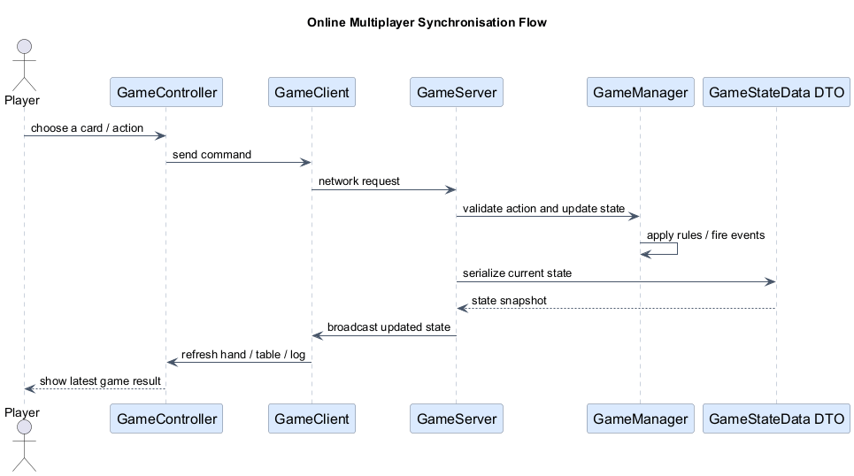
Figure 3. Online state synchronisation sequence between player action, client request, server validation, and UI refresh.

User Experience
The JavaFX application offers a themed menu, avatar selection, visual panels, card previews, logs, chat, and turn-timer cues. From a report perspective, these GUI features matter because the brief explicitly encouraged a graphical interface, and the team went beyond a minimal GUI by adding quality-of-life features that make the game understandable and visually engaging.

Testing and Quality Assurance
Testing is one of the strongest evidence sections for this project. The repository README and test sources indicate 28 test cases across 6 test classes. The tests are not superficial getter/setter checks; they focus on behavioural rules and interaction-heavy gameplay logic.
Test Class | Cases | Main Verification Focus
GameManagerTest | 7 | Round start, bank deposit, property placement, turn advance, draw rules, winner detection, elimination
ActionCardTest | 8 | Sly Deal, Deal Breaker, Debt Collector, Pass Go, It’s My Birthday, Just Say No interactions
PlayerManagementTest | 5 | Asset valuation, asset transfer, set completion, rent with buildings
GameStateDataTest | 4 | Serialization and DTO reconstruction integrity
PropertyRentRulesTest | 3 | Rent values across colour sets and buildings
CardManagerTest | 1 | Discard-pile reshuffle back into draw pile
The testing approach shows good alignment with the lecture on software testing. Important domain logic is tested at the unit level, including rule-heavy methods and state transitions. The tests also use mocking concepts effectively. For example, `ActionCardTest` constructs a mock `GameInteractor` so that action-card flows can be tested without a live GUI, which is a strong design-for-testability decision.
private GameInteractor mockInteractor;

@BeforeEach
void setUpInteractor() {
mockInteractor = new GameInteractor() {
@Override
public PlayerManagement choiceTargetPlayer(PlayerManagement currentPlayer, List<PlayerManagement> players) {
...
}
};
}
This test design is meaningful because it isolates card behaviour from JavaFX concerns. In software engineering terms, that improves observability, repeatability, and the cost of regression testing.
The generated Surefire XML files in the repository also indicate zero recorded failures and zero recorded errors for the available test reports, which is consistent with a stable tested baseline for submission.

Refactoring, Evolution, and Maintainability
The refactoring and software evolution lectures emphasise that software quality is not static. A system gains value when it can be changed safely, extended without architectural collapse, and repaired without introducing widespread side effects. The Monopoly Deal project already reflects this mindset in several ways.
- The package structure isolates responsibilities, which lowers the cost of future changes.
- DTO-based network transfer creates a seam between the domain model and online synchronisation.
- The card hierarchy allows new card types or special effects to be introduced with limited disruption.
- Read-only collection views reduce accidental mutation bugs and support safer evolution.
- Unit tests provide a safety net for rule-level refactoring.
Repository history also shows evidence of iterative improvement. Recent commits include UI and BGM improvements, updates to the README test coverage section, and bug fixes related to multi-property behaviour. This indicates that the team treated the codebase as an evolving product rather than a one-shot prototype.
A balanced final report should also identify remaining improvement opportunities. The current project could be evolved further by extracting smaller UI presenters from `GameController`, adding stronger integration tests for online scenarios, and formalising additional UML artefacts such as a detailed sequence diagram for a networked turn. These are realistic next steps rather than signs of failure; they are exactly the sort of evolution path that well-structured software should enable.

Process Management and Teamwork
The software development process lecture highlights planning, iteration, traceability, and team coordination. In this project, GitHub was used as the shared repository, the implementation evolved iteratively, and different members focused on different parts of the system such as networking, core engine design, UI logic, testing, and project materials.
- A shared GitHub repository was used throughout development.
- The team iterated on UI polishing, gameplay fixes, online logic, and test expansion.
- The work was divided according to individual strengths and responsibilities.

Member Contributions
The workload was distributed according to each member's strengths.
Name | GitHubName | UCDID | Role | Key Contributions
Zhao Entai | ZhAoEttt | 24107671 | Network & Code Quality | Use case diagram; card image display; online multiplayer architecture (client/server, game state sync, chat, Just Say No protocol); code quality improvements (magic number elimination, DRY refactoring, structured logging, defensive copying); test suite expansion; long method refactoring
Fan Yibo | YiboFan | 24107688 | Core Engine | Founded the project and built the entire initial codebase (6,000+ lines), including the complete card class hierarchy (action, property, rent, money, wild cards), core GameManager engine (turn control, victory conditions, card effects), deck management, player model, networking infrastructure (GameServer, GameClient, protocol), and UI controllers. Also designed the class diagram and performed comprehensive debugging of game mechanics.
Qi Xuefei | XuefeiQi24107718 | 24107718 | UI & Online Logic | Implemented online logic for action cards (trade, steal, debt, birthday) and property cards (placement, sets, buildings); fixed online freezes, missing popups/buttons, turn errors, Just Say No deadlock; integrated renaming, chat, and avatar features, card zoom, physical piles; refactored package structure; wrote unit tests for core classes.
Deng Kaile | Dengkaile-666 | 24107760 | Materials and UML | Organised and summarised the UML diagrams produced by the team.
Wang Yongqi | Q1jiu | 24107681 | Testing & Documentation | Action card unit tests — 8 JUnit 5 cases covering SlyDeal, DealBreaker, DebtCollector, PassGo, It'sMyBirthday with mock interactor; README documentation

Critical Reflection
Overall, the project is a good example of applying software engineering concepts to a concrete interactive product. The system is not just functionally complete; it also shows an understanding of structure, abstraction, testing, and change management. In particular, the separation between UI, game engine, domain model, and networking is the clearest sign that the team moved beyond a monolithic student prototype.
The strongest parts of the project are the breadth of implemented functionality, the pattern-aware architecture, and the meaningful unit tests. The strongest improvement opportunity is architectural refinement on the UI side, where the main controller has grown as new features were added. This is a normal outcome of iterative development and an excellent example of why refactoring remains necessary even in successful projects.
If this project were continued after the course, the most valuable next enhancements would be: more formal UML deliverables, replay logging or persistence, AI opponents for single-player testing, integration tests for host-client flows, and deeper analytics around player actions and game outcomes.

Conclusion
The Monopoly Deal Card Game project satisfies the spirit of the assignment by combining requirement-driven thinking, clean design, correct gameplay functionality, teamwork evidence, and meaningful tests. The final implementation demonstrates that the team can move from course concepts to a working multi-module software system.
More importantly, the project shows that software engineering is not only about making a program work. It is about making the program understandable, testable, extensible, and defensible in front of evaluators. Through its architecture, patterns, tests, repository history, and GUI quality, this project provides strong evidence of that broader engineering mindset.

Appendix A: Selected Code Evidence

Facade and Core Rule Coordination
public class GameManager {
public static final int MIN_PLAYER_COUNT = 2;
public static final int MAX_PLAYER_COUNT = 5;
public static final int INITIAL_HAND_CARD_COUNT = 5;
public static final int TURN_DRAW_CARD_COUNT = 2;
public static final int MAX_PLAY_COUNT_PER_TURN = 3;
...
}
These named constants improve readability and centralise core gameplay rules. The same class also coordinates event publication, pending actions, player turn state, and winner detection, which is why it is best understood as a facade over the gameplay subsystem.

Interface-Driven Interaction
public interface GameInteractor {
PlayerManagement choiceTargetPlayer(PlayerManagement currentPlayer, List<PlayerManagement> players);
Card choiceStealablePropertyCard(PlayerManagement targetPlayer);
boolean confirmJustSayNo(PlayerManagement responder, PlayerManagement opponent, String actionToCancel);
List<Card> showSelectableAssets(PlayerManagement targetPlayer, int requiredAmount);
}
The interface above is a strong clean-design decision because it separates decision prompts from the core rules. It also makes unit tests possible without launching the graphical interface.

Network State Transfer
public static GameStateData fromGameManager(GameManager gameManager) {
GameStateData data = new GameStateData();
data.currentPlayerIndex = gameManager.getCurrentPlayerIndex();
data.playedCardsThisTurn = gameManager.getPlayedCardsThisTurn();
data.players.add(PlayerData.fromPlayerManagement(player));
data.eventLog = new ArrayList<>(gameManager.getEventLog());
...
}
This DTO conversion is essential for online play because it gives the network layer a serializable representation of the game rather than exposing internal engine objects directly.

Appendix B: Submission Notes
- The document is written in an expanded final-report style so that it can serve as a stronger Phase 2 submission and as interview preparation material.
- If the team has an official member list with student IDs, it can be inserted on the cover page before submission.
- If the instructor specifically requires original UML screenshots from Papyrus or another modelling tool, the simplified diagrams in this report can be replaced later with the official diagrams while keeping the rest of the text unchanged.
- The Git contribution table should be verified against any offline work not visible in commit history.

