##### **Impacts of Covid-19 on Economic Vitality Assessed by Electricity Production: Evidence from Shanxi, China**

##### **Siming Yan**

Agricultural and Applied Economics Department

University of Wisconsin Madison

***Abstract* -**

***Index Terms*** -

1. Introduction

The COVID-19 pandemic has caused over 1 million death worldwide (WHO, 2020), many researchers have established reliable virus spreading models (Chinazzi et al., 2020) and estimated economic changes around the world (Baldwin et al., 2020).

In the previous literature, McKibbin Warwick has found the worst scenario of any certain pandemic influenza can cause over 142.2 million people killed and a GDP loss of $US 4.4 trillion (6.7%) worldwide (Warwick & Alexandra, 2006). To deal with pandemic influenza, lockdown is considered to be one of the most efficient way (Atalan, 2020). But how long the lockdown should last is yet another topic which has been debated for years. In a recent literature, an estimation of countries GDP growth in 2020 under 1.5 months of lockdown has an average of -2.5% (median = -2.8%) (Fernandes, 2020). The estimated average GDP growth in 2020 is -6.2% (median = -6.3%) when the lockdown last for 3 months. For the single case of China, which has the world’s largest GDP growth rate (IMF, 2020), the estimated GDP growth rate changes are +1.6% [from 0.2% to 2.9%] for 1.5 months countrywide lockdown and -1.9% [from -4.2% to 0.3%] for 3 months countrywide lockdown (Fernandes, 2020).

China has lockdown many major cities approximately three months from January to April, according to National Bureau of Statistics of China and International Monetary Fund, the first quarter growth rate is +1.2% (IMF, 2020), growth rate over the same period last year (2019) is -6.8% (NBS, 2020), which is deviant from the estimation in the previous literature.

As GDP growth rate can be influenced by many factors not only limited to economic vitality, electricity production and consumption is yet another reliable index to quantify real-time economic behaviors (Hirsh & Koomey, 2015; Quoctrung & Justin, 2020). Electricity has two critical characteristics to make it a quantifier to economic vitality: first, it is a real-time indicator of economic activities, imagine any of industrial production behaviors, electricity is always needed; Second, it is approximately used-by-all once it is produced, it is hard to store large amounts of electricity, the only method is to store in batteries.

This study focusses on quantifying the impacts of COVID-19 on economic vitality in the case study of electricity production in Shanxi province, China. Shanxi is a Midwest province among 34 provinces and special areas in China, with GDP 1,702.67 billion RMB in 2019, which ranks 21st in China (CEIC, 2020). Shanxi is a leading producer of coal in China and has more coal companies than any other province. For most power plants in China, coal is the major raw material of production, this makes Shanxi the largest coal storage province in China as well. During the pandemic, as coal storage is sufficient, we can assume the production behavior of electricity is only influenced by economic behaviors and government policies.

During the pandemic, Shanxi has not published any official stay home orders. However, due to the severity of the virus, citizens formed up self-constraining behavior spontaneously. A timeline from China Central Television can be used as citizens and industries behavior indicator:

1. 2020/01/15 First level emergency response, China Nationwide.
2. 2020/01/23 Wuhan city lockdown.

In this research, spring festival of China is another potential factor can influence the analysis of pandemic impacts on economic vitality. During the major festival, Chinese industries and activities related to productions may shut down or maintain a lowest operation standard for 7 to 10 days.

Besides general electricity behavior, this study will also investigate the pandemic impacts on different types of power plants. There are four major types, includes: fossil-fuel, hydro, wind and photovoltaic, each of them requires different level of human operation, which can potentially be influenced by stay home order and lockdown policy.

Also, the research will explore the pandemic influence levels on different power plant ownership. There are five major cooperation in China, and all of them are owned by Chinese government. For this five cooperation, the total capacity of fossil-fuel power plants account for 52.31% of Chinese total fossil-fuel power plant capacity, respectively, hydro plants account for 34.19%, wind plants account for 58.5%, photovoltaic plants account for 13.74% (Lingyun Group, 2018). The market share of the five major cooperation accounts for 46.67% of total electricity production in 2018 (Xi, 2019). A previous study has shown the power plants of state-owned companies show lower unified (operational and environmental) efficiency than other companies (Zhang et al., 2014). While facing with pandemic, this study assumes the five major cooperation will be more sensitive to government orders and production behaviors are more flexible compares to those owned by private.

1. Data Descriptions

The data in this research includes 485 power plants from 93 parent companies, collected monthly from December 2016 to June 2020, total observation is 12, 333. Variables includes: plants name, capacity of the plant in Capacity in 10k Kilowatt-hour (10k.kWh), monthly electricity generated in a hundred million Kilowatt-hour (GWh), plant location in county level, plant type and plant parent company. Other variables created from the data includes: dummy variable indicates whether plant is belonging to the five major cooperation, dummy variable indicates whether the plant is located in urban or else, dummy variable indicates whether the month is before or after COVID-19 outbreak and spring festival.

*Table 2.1 Data Describe*

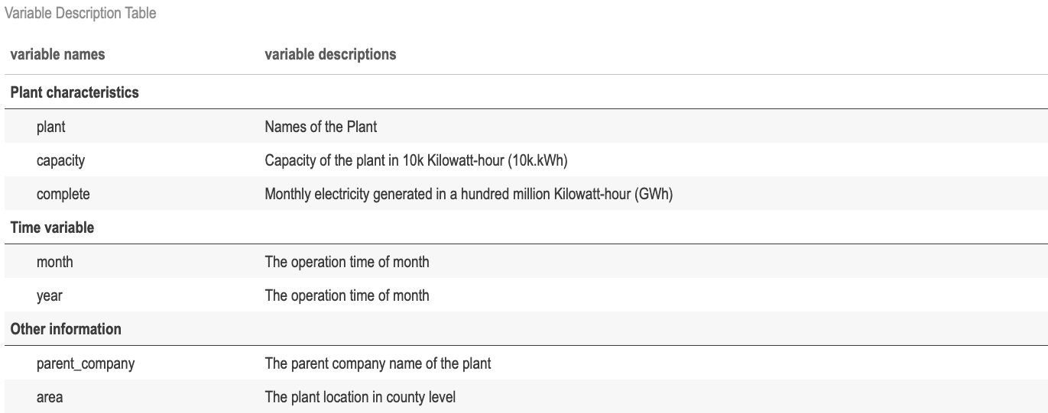

*Table 2.2 Data Describe*

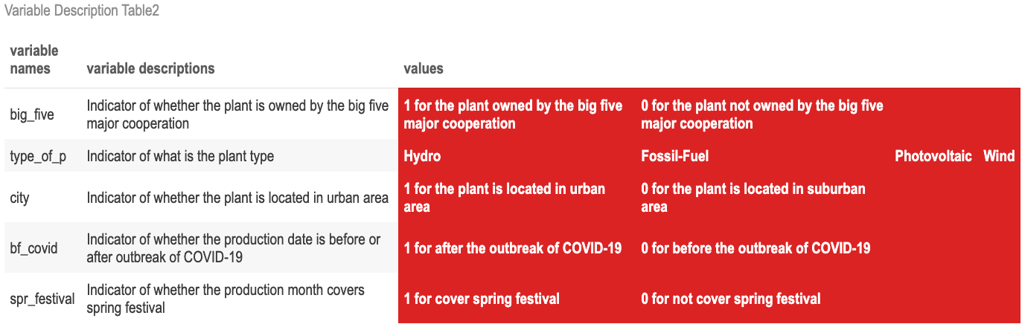

*Table 2.3 Data Describe: summarized by observations*

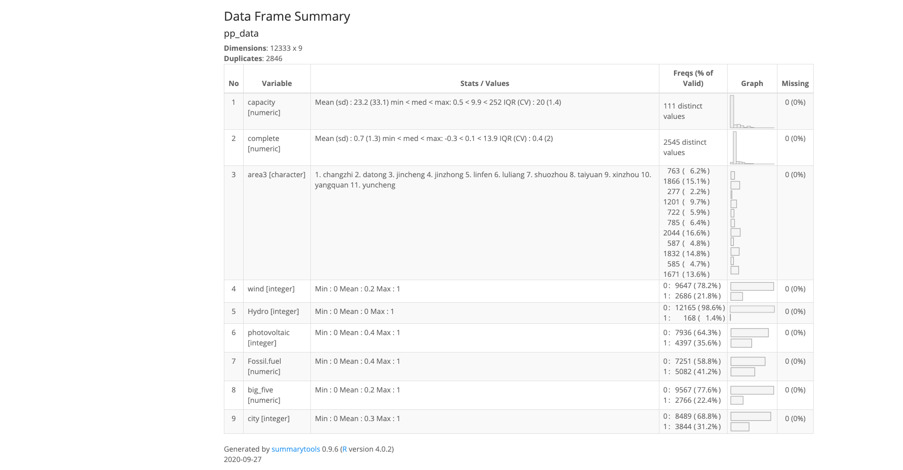

Table 2.3 shows a general description of the data. There are 11 cities in Shanxi, and 5 of them has above or nearly 1000 observations. Most plants are fossil-fuel plants, takes 41.2% of the total observations. 31.2% of the observations are located in urban area.

In Table 2.4 below, plants are summarized by different types. Fossil-Fuel plant again has the highest number. Shanxi only have four Hydro plants since its lacks of access to water, but its capacity and electricity generated per month is far larger than photovoltaic and wind plants.

*Table 2.4 Data Describe: Plants level summary over types of plants*

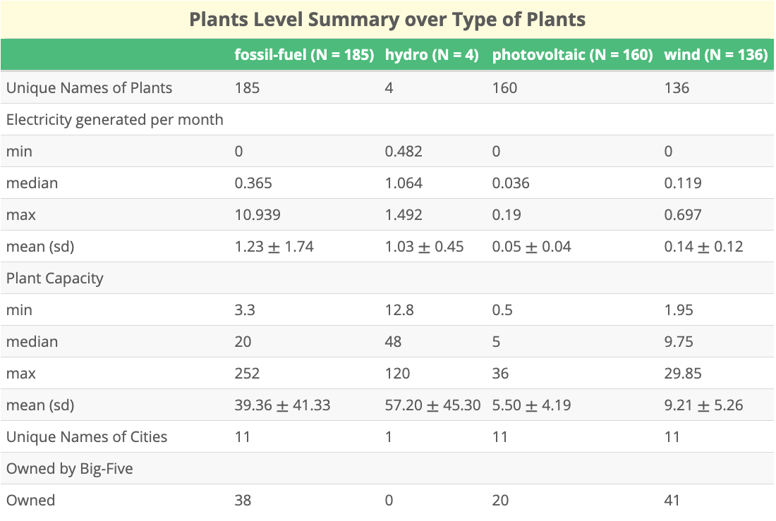

In the Table 2.5, plants are summarized by different location type, if located in urban area, takes value of 1. The plants located in urban area shows a higher mean and median electricity generated amount, and capacity of plants located in urban area is also little bit higher than those are not.

*Table 2.5 Data Describe: Plants level summary over types of cities*

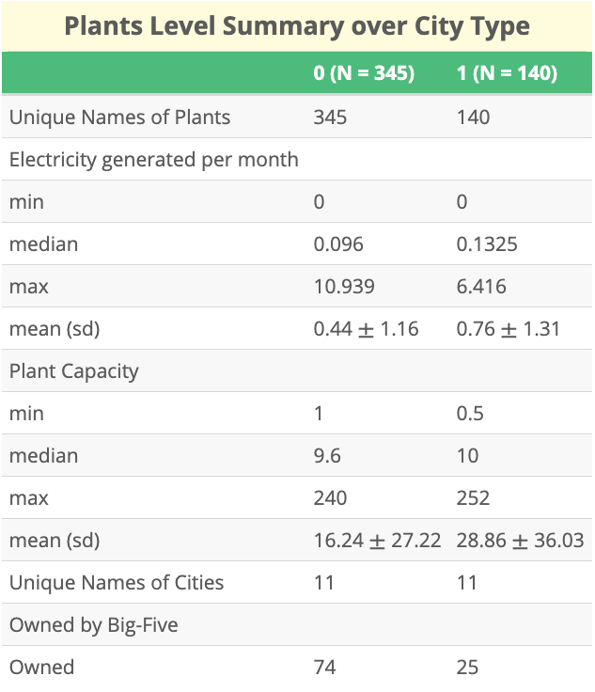

Table 2.7 shows the correlation of variables. Plants located in urban area has positive relationship to monthly electricity generated and capacity. For fossil-fuel plants and hydro plants, they have positive correlation with capacity and electricity generated, which indicates that fossil-fuel and hydro powerplant have relatively larger capacity and therefore generate more electricity.

*Table 2.6 Data Describe: Correlation table of some of the variables.*

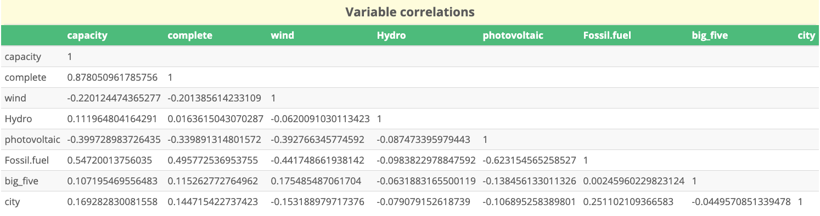

*Figure 2.7 Average capacity comparation of big-five and non-big-five owned plants*

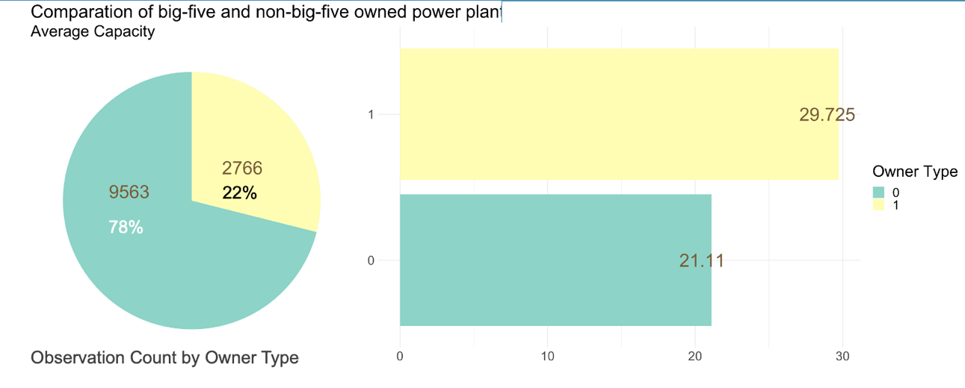

In figure 2.7 and 2.8, observations are compared by owner type. The power plants owned by big-five cooperation has smaller number of observations, but larger average capacities and average electricity generated per month.

*Figure 2.8 Average electricity generated comparation of big-five and non-big-five owned plants*

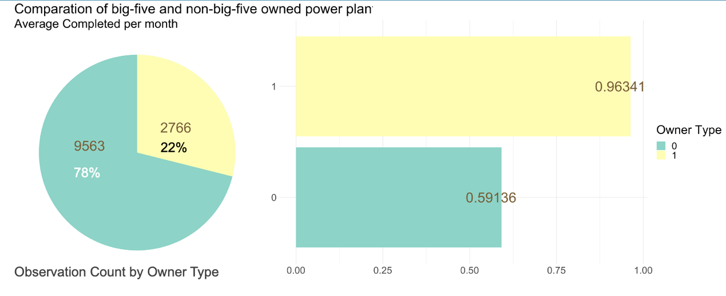

In the following figure 2.9 and figure 2.10, a comparation between big-five cooperation owned plants and non-big-five cooperation owned plants over different types of plant are shown. The difference of capacity and electricity generation are mainly caused by fossil-fuel plants. Hydro plants have large capacity, but has limited number of 4,

|  |  |
| --- | --- |
| *Figure 2.9 Average capacity comparation on types of plants and ownership of plants* | *Figure 2.10 Average electricity generated comparation on types of plants and ownership of plants* |
|  |  |
|  |  |

The total electricity generated monthly graph from January 2017 to June 2020 is shown in figure 2.12. Shanxi has heating days from November 1st to April 1st, the spring festival always happens in February. July and August are two months of cooling days, so the electricity production is respectively higher in heating and cooling months. In general, the total generation of electricity is increasing from year to year, but the year of 2020 is abnormal compare to other years, which we can assume it is caused by the outbreak of COVID-19.

*Figure 2.11 Total electricity generated by month*

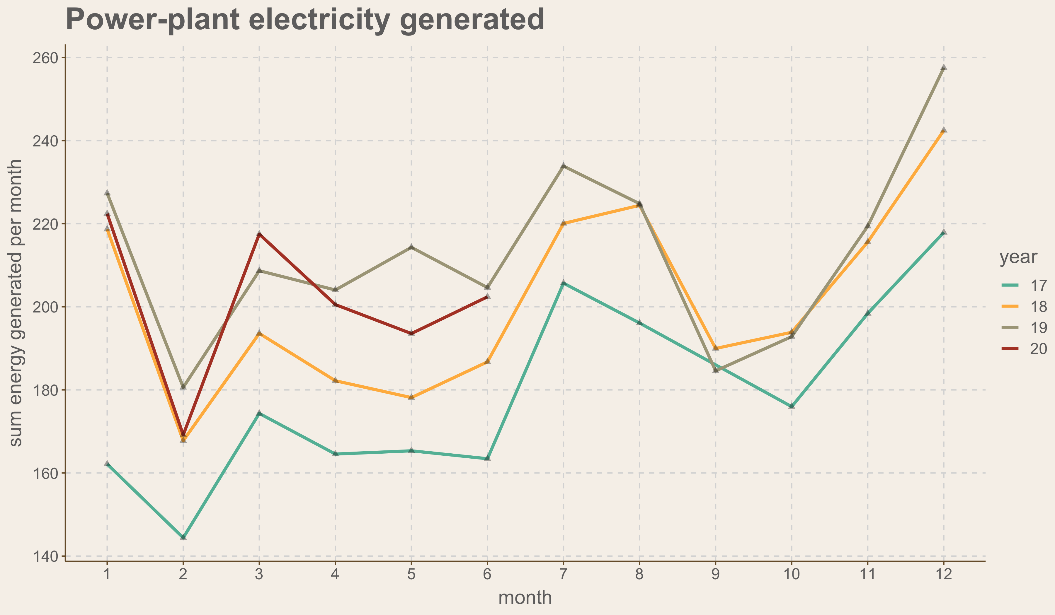

In figure 2.12, the capacity share of big five cooperation of each type of plant is compared between China mainland and Shanxi province. The only similar part is photovoltaic; hence this research is only limited to Shanxi province, but the method can also apply to nationwide.

*Figure 2.12 Big-five owned plant Capacity percentage* *Comparation of China mainland vs Shanxi*

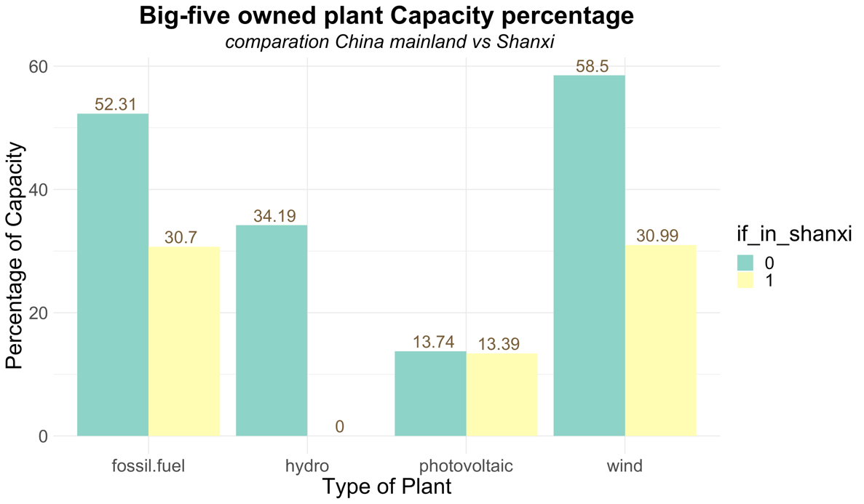

In figure 2.13, the electricity generation share of big five cooperation is compared between China mainland and Shanxi province. In China mainland, the big five cooperation owns much larger capacity (show in green) than they are in Shanxi Province (in yellow).

*Figure 2.13 Big-five owned plant Generation percentage* *Comparation of China mainland vs Shanxi*

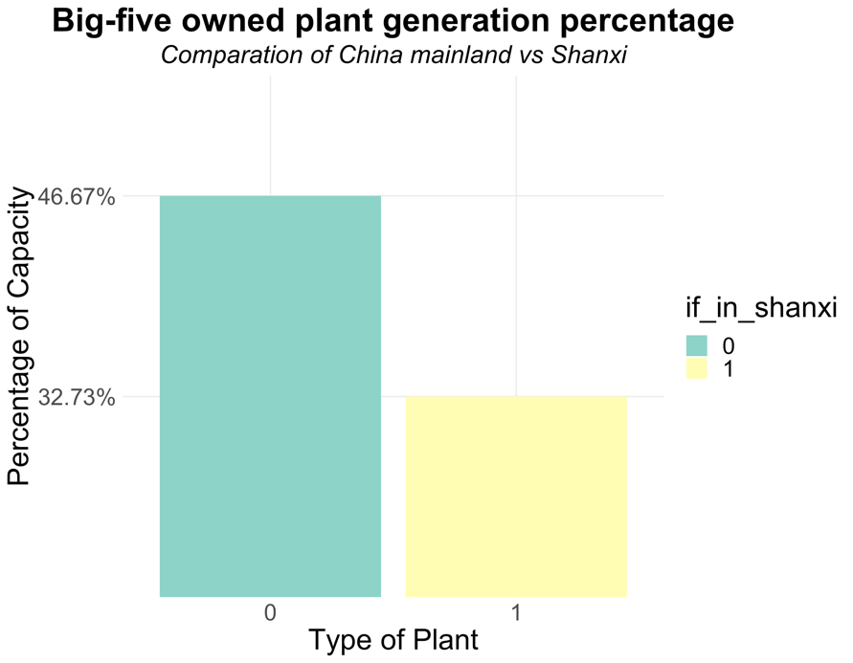

1. Methodology
   * + 1. Econometrics analysis

In order to examine how COVID-19 affects power plant production behavior, the dependent variable I chose is monthly electricity generation amount, in the following equations it is marked as *complete*. In Shanxi province, a power plant electricity generation decision is largely depended on the dispatchment order from the State Grid Corporation of China (Ho et al., n.d.), and the cost of transmission and distribution, the retail prices of electricity are set by the government. Until September, 2019, Shanxi started experimental electricity spot market trading system (Xiaofei, 2019), but it only took 10 percent of total amount of electricity generated in Shanxi province. I ignored this policy implementation in this research since its effect is hard to separate.

From all information above, we can assume a power plant electricity production decision is basically depends on its characteristics such as power plant installation capacity, type of the plant, location of the plant. In this case, power plant level fixed effect can absorb most of these characteristics. Another important factor is temperature, Shanxi has both cooling months and heating months, the total date of cooling and heating is almost fixed through years, which can be approximately absorb by the monthly fixed effects.

Due to the limitation of the information and imperfection of modeling strategy, our attempt of estimating the relationship between electricity generation and COVID-19 struck potentially suffers from some econometric challenges:

1. *Omitted variable bias:*

During the year of 2020, there are 9 new power plants included in the data set, but they only take 0.042717% of total electricity generation amount in Shanxi, the new power plant might cause decrease in other plants’ production, we can assumingly ignore this effect. From the year of 2016 to year of 2020, there are around 17 plants excluded from the data set, and they take 0.061648% of total electricity generation amount from December 2016 to January 2020. We assume the missing part of the excluded plant are covered by the existing plants, this could lead to an increase in our dependent variable *complete*, therefore it becomes an omitted variable bias. However, whenever a plant is shut down, we can assume all plants from Shanxi were affected, hence this effect can possibly be absorbed by the time fixed effects. The biggest challenge is, we are not clear about which part of the electricity generated is consumed in Shanxi and what amount of electricity are transmitted to other provinces. This might bias the estimation of the true effect of COVID-19.

1. *Measurement error of COVID-19*

COVID-19 was started in December 2019, an effective response from Shanxi government is regarded as starting at around January 23, 2020 (Li et al., 2020). If we take January as the first month of COVID-19 outbreak, the COVID-19 effect in January 2020 is considerably overestimated in this model, which can lead to the estimator of COVID-19 being biased to zero since the previous date in January might not influenced by COVID-19. On considering people’s response to policy also needs time to take effect, I set the month of February 2020 as Shanxi starting to truly running full speed to copy with COVID-19.

How long is COVID-19 lasted in Shanxi is another factor that would bias our estimators, a persuasive point of view is that it lasted to April 2020 (Li et al., 2020). However, the true time of the impact of COVID-19 disappeared is unknown.

Based on the information above, I generated the first equation to separate COVID-19 effect on power plant production:

|  |  |
| --- | --- |
|  | (1) |

On the left-hand side is the total electricity generation amount of a specific plant during a specific month of a year. On the right-hand side, captures the effect of power plant capacity, captures the impacts of COVID-19, captures year trend effect. is monthly fixed effect and is plant level fixed effect. is error term captures measurement error of COVID-19 and unknown features of plants.

The second regression model is used for separate the COVID-19 effects on different types of plants such as fossil-fuel, wind, hydro and photovoltaic:

|  |  |
| --- | --- |
|  | (2) |
|  |  |

In this equation, still captures the same effect as in equation (1). I choose fossil-fuel plants as baseline, instead captures COVID-19 effects on fossil-fuel plants’ productions. takes three values separately capture COVID-19 effects for wind, hydro and photovoltaic plants. , and still works as in equation (1).

The third regression model is used for separate the COVID-19 effects on different types and different ownership types of plants:

|  |  |
| --- | --- |
|  | (3) |

In this equation, still captures the same effect as in equation (1) and (2). takes different values when have different time, different ownership type and different type of plants. Theoretically it will have 14 different values, since hydro plants are all owned by non-big-five cooperation. , and still works as in equation (1) and (2).

* + - 1. Neural Networks Analysis

Besides econometrics analysis, in order to obtain an actual amount of decrease in electricity generation, neural networks prediction of estimation electricity generation amount when without COVID-19 struck is conducted.

Neural networks are artificial neurons connected by non-linear activation functions. During the training phase, when a random input enters the neural networks, firstly it is processed by a weight matrix (*w*) which returns a mathematical value for the relative strength of the connections from layer to layer. Then, all weighted inputs are summed to enter next level layer, in the ongoing layers, this process is repeated, until they enter the final output layer, where they can produce an output result to compare with the actual result (Law & Au, 1999). While adjusting result to approach the true result, the neural networks can adaptively discover patterns from the data. This is backpropagation algorithm of neural networks.

In this research, the input neuron includes year, month, plant name, type of plant, parent company name and capacity. All plant name, parent company names are transformed to dummy variables due to neural networks only accept numerical inputs, therefore the input layer includes 697 elements.

For hidden layer, I only used one with six nodes, since the variables actually in use are only 6. Figure 3.1 demonstrates a simplified neural network with one input layer, one hidden layer with 6 nodes and one output layer.

*Figure 3.1 neural network*

The performance measures I choose is RMSE (Zhang & Hu, 1998), which simply measures the average distance between real values and estimated values.

The data set before COVID-19 outbreak is randomly divided into training set and test set, ratio is 3:1. Training set includes 10523 observations, the desired variable *complete* has a range of 0 to 13.905, the final RMSE value is 0.73.

1. References

Automatic citation updates are disabled. To see the bibliography, click Refresh in the Zotero tab.