**Approach 1 (Single Token)**

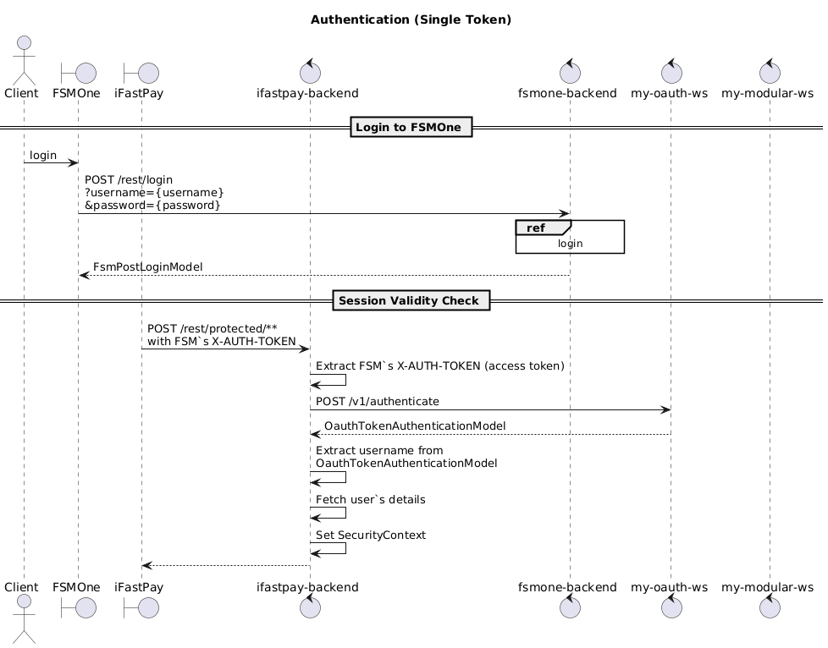

**Notes (Single Token)**:

1. Both **FSMOne** and **iFastPay** share the same access token via the X-AUTH-TOKEN header when calling **my-oauth-ws** to validate the session.
2. The same token is valid for both FSM and iFastPay endpoints.

**Approach 2 (Two tokens)**

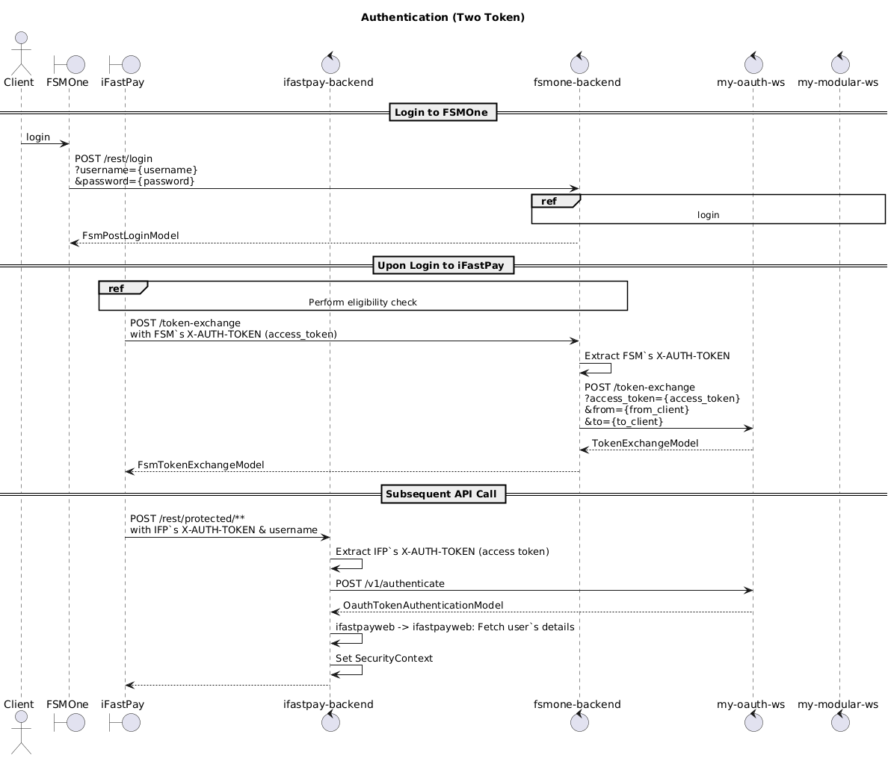

**Notes (Double Token)**:

1. From FSM, the **FSM backend** requests **my-oauth-ws** to perform a **token exchange**, obtaining a separate iFastPay access token.
2. At the end:
   1. **FSM token** can only be used for FSM endpoints.
   2. **iFastPay token** can only be used for iFastPay endpoints.
3. **Revocation**: Session revocation must apply to **all related tokens** (FSM and iFastPay).

**Comparison**

|  |  |  |
| --- | --- | --- |
| **Aspect** | **Approach 1: Single Token (FSM)** | **Approach 2: Two Tokens (FSM & iFastPay)** |
| **Development Effort** | Simple to develop — no major changes needed, minimal impact on the existing structure. | Harder to develop — requires changes in **my-oauth-ws** to support token exchange. |
| **Complexity / Errors** | Less error-prone, as fewer changes are involved. | More error-prone, since more changes are involved. |
| **Token Storage** | No change needed. | May require adjustments to token storage to support consistent revocation. |
| **Future Flexibility** | Future separation is more difficult. | Future decoupling is easier if iFastPay evolves into an independent system. |
| **Audit Trail** | Unclear — cannot determine which system is currently using the token. | Clear — audience is explicitly defined. |
| **Least Privilege** | Weaker — iFastPay inherits all access to FSMOne endpoints (and vice versa). | Stronger — least privilege by design, since each system uses a distinct token with its own scope. |