**Q.1)** [Creating account, repository on GitHub and Cloning repository in GitHub Page](http://elearning.nkc.org.in:81/moodle/mod/page/view.php?id=2178).

**a) Creating Account**

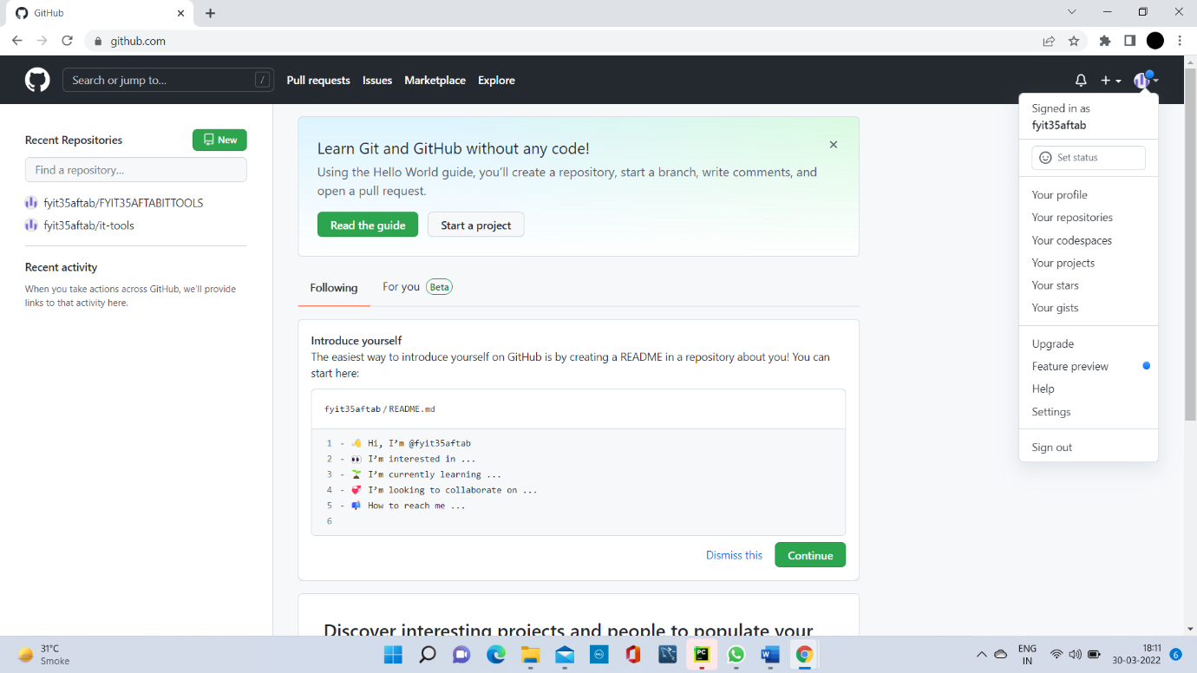

**b)** **Repository on GitHub**

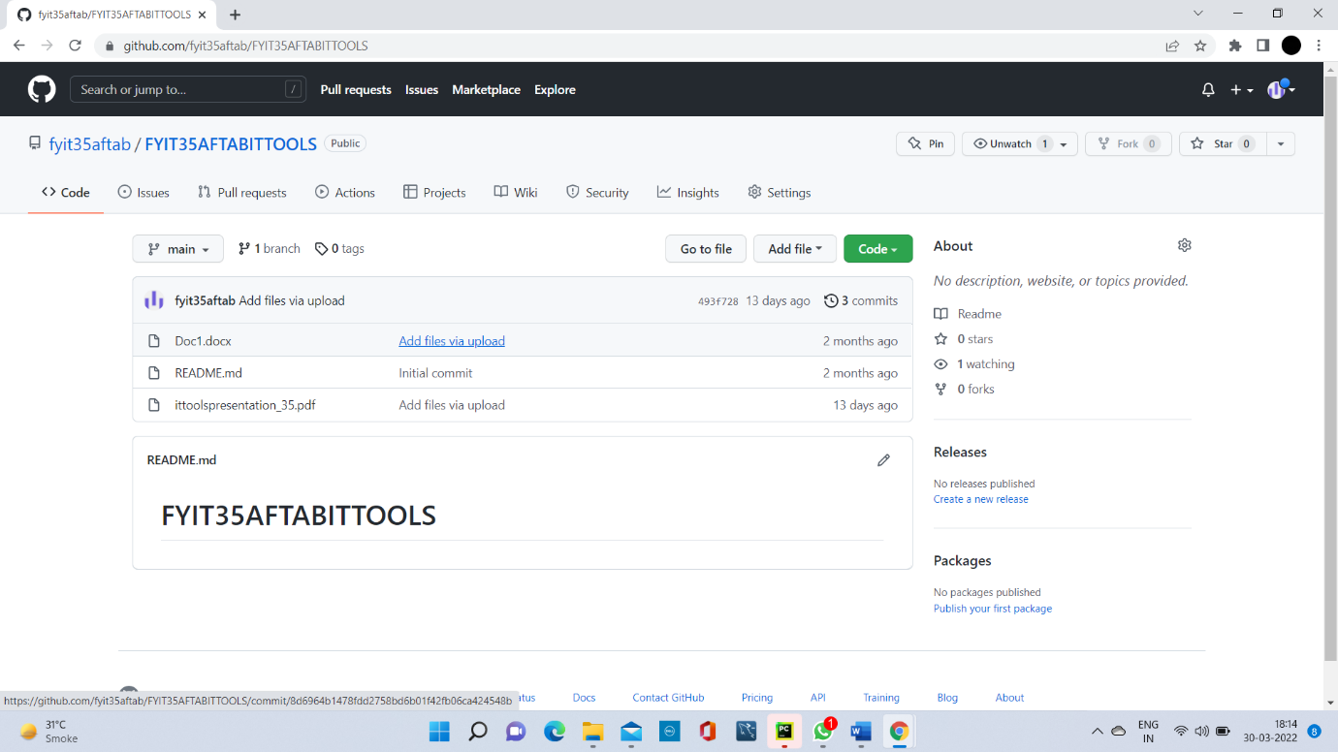

**c) Cloning Repository**

