**Q.1)** INTRODUCTION and CONTRIBUTING TO WIKIPEDIA

1. **What is Wikipedia?**
2. Wikipedia is the largest and most-read [reference work](https://en.wikipedia.org/wiki/Reference_work) in history. It is consistently one of the 15 most popular websites ranked by [Alexa](https://en.wikipedia.org/wiki/Alexa_Internet); as of 2021, Wikipedia was ranked the 13th most popular site. It is hosted by the [Wikimedia Foundation](https://en.wikipedia.org/wiki/Wikimedia_Foundation), an [American non-profit organization](https://en.wikipedia.org/wiki/501(c)(3)_organization) funded mainly through donations.

Its main figures were Bomis CEO Jimmy Wales and Larry Sanger, editor-in-chief for Nupedia and later Wikipedia.

The domains wikipedia.com (later redirecting to wikipedia.org) and wikipedia.org were registered on January 12, 2001, and January 13, 2001, respectively, and Wikipedia was launched on January 15, 2001 as a single English-language edition at www.wikipedia.com, and announced by Sanger on the Nupedia mailing list.

1. **Steps to Create Account on Wikipedia**

**Politics(Wikipedia)**

* Click **Create account** to create your new account.

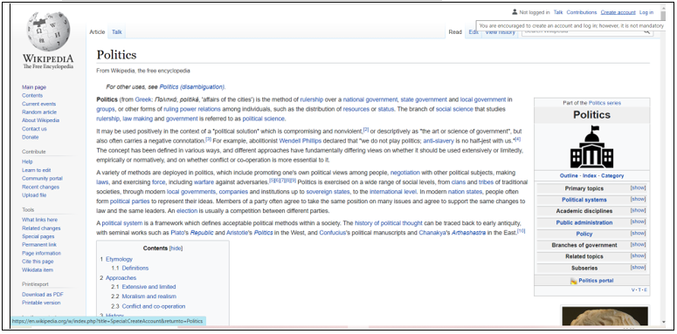

* Fill the form < Click **Create your account**

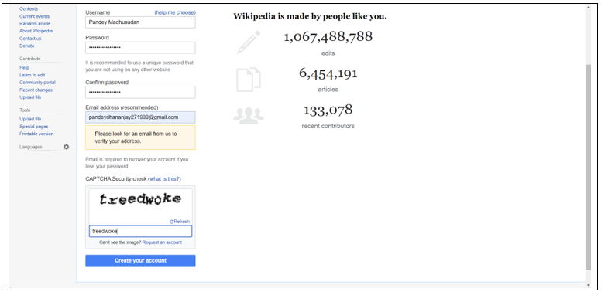

1. **Creating Page on Wikipedia**
2. **Edit your page**

* Your account created < Click **Edit Source**

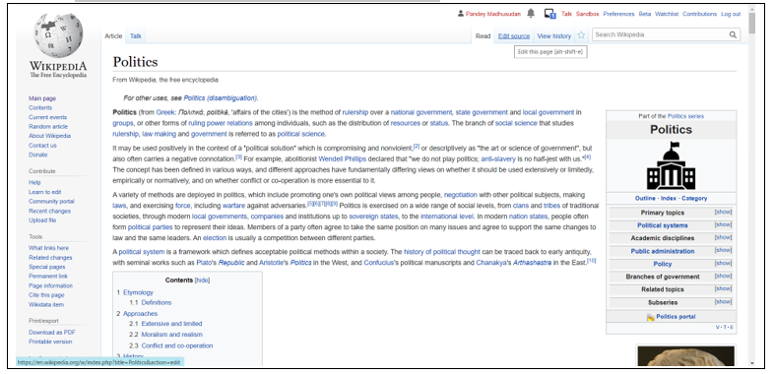

* Click **Start Editing**

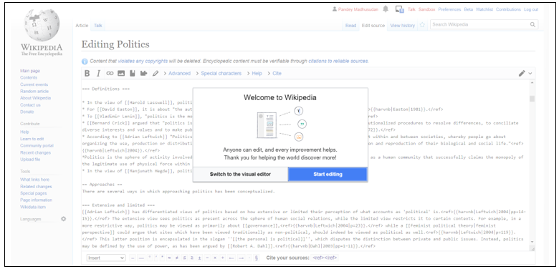

* Write **Your Changes <** Click **Publish Changes**

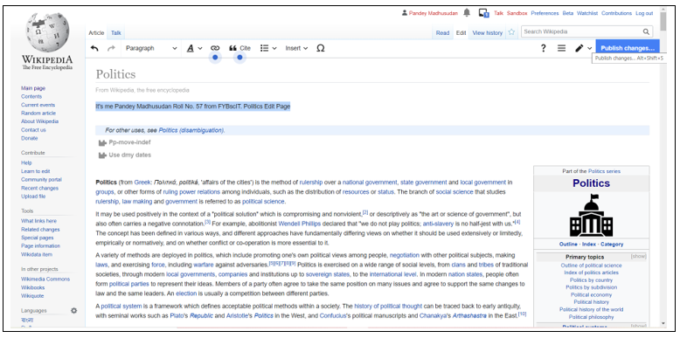

* Write **Edit Changes <** Click **Review Your Changes**

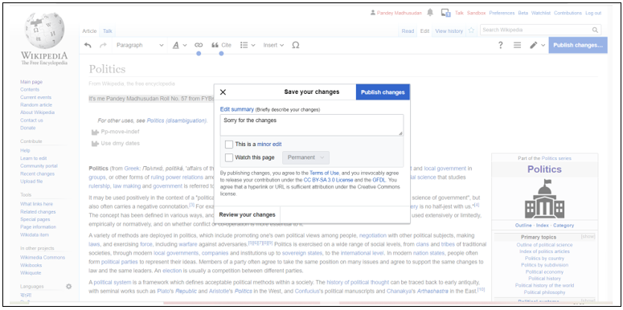

* Visit Your Changes

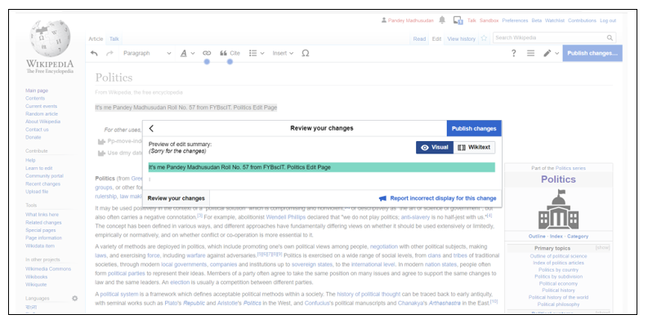

* Click **Publish Changes**

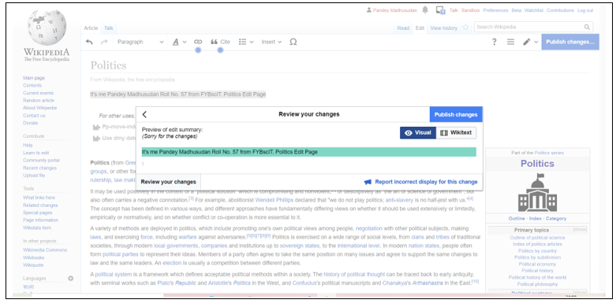

* It’s Working

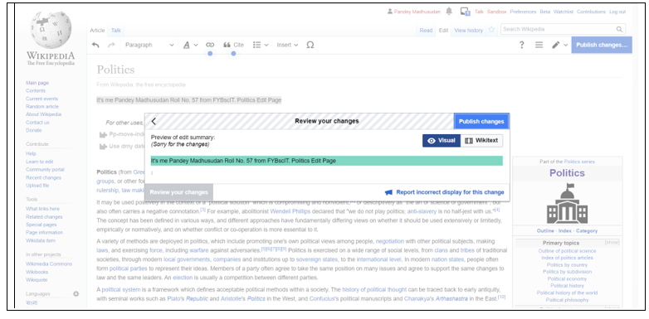

* **Changes Successfully Done**

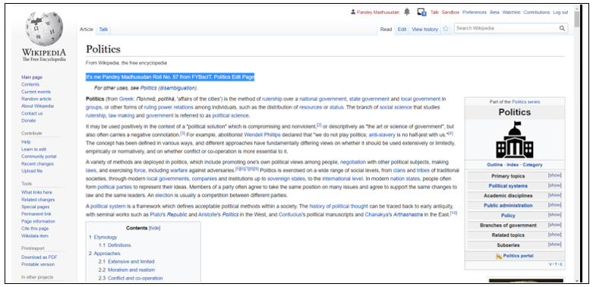

* Click **View History**

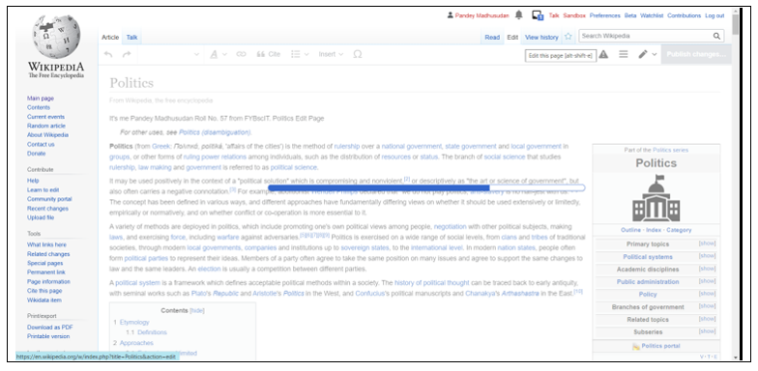

* View Changes in **History**

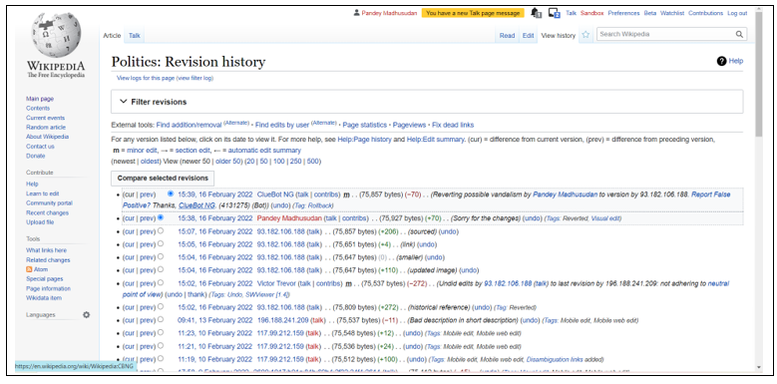

* Click **Edit** for Reedit

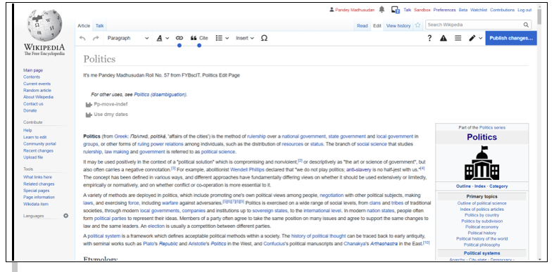

Delete Your Data < Click **Backspace**

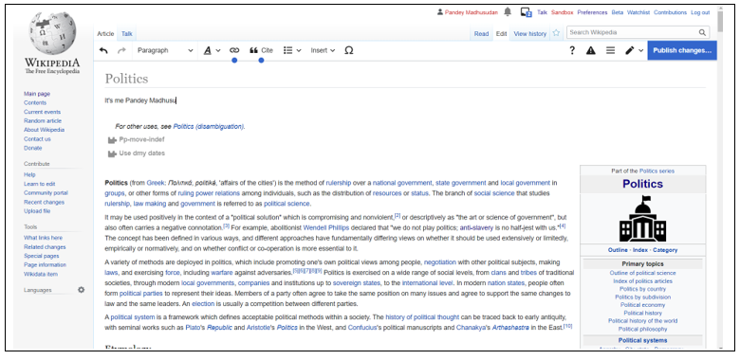

* Click **Publish changes**

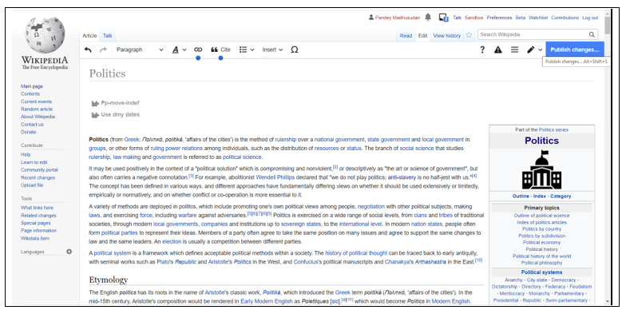

* Write **Edit Summary**

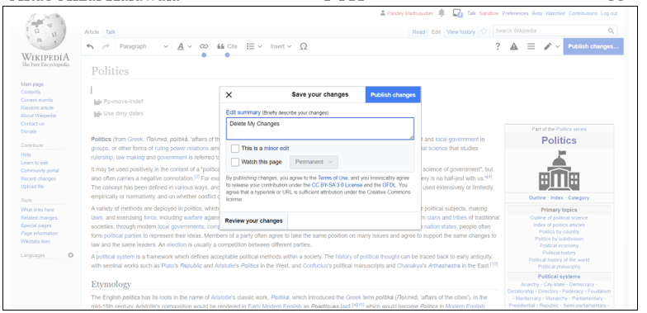

* Loading For the Changes

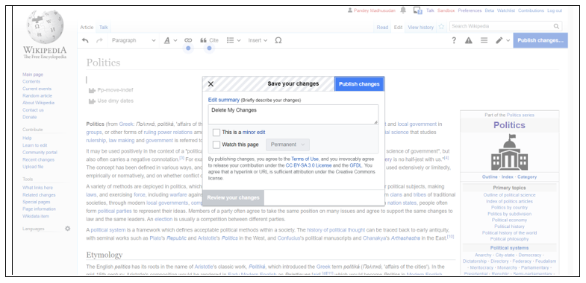

* **Delete My Content Successfully**

