Tasks:

1. **Title Change**
2. **Create new Component**
3. **Create a Class Student**
4. **Double Binding**
5. **String interpolation.**
6. **How to create method inside the class**
7. **Event Binding.**
8. **How to use ngif directory.**
9. **ng if else directory**
10. **ng for directory**
11. **ng style directory**

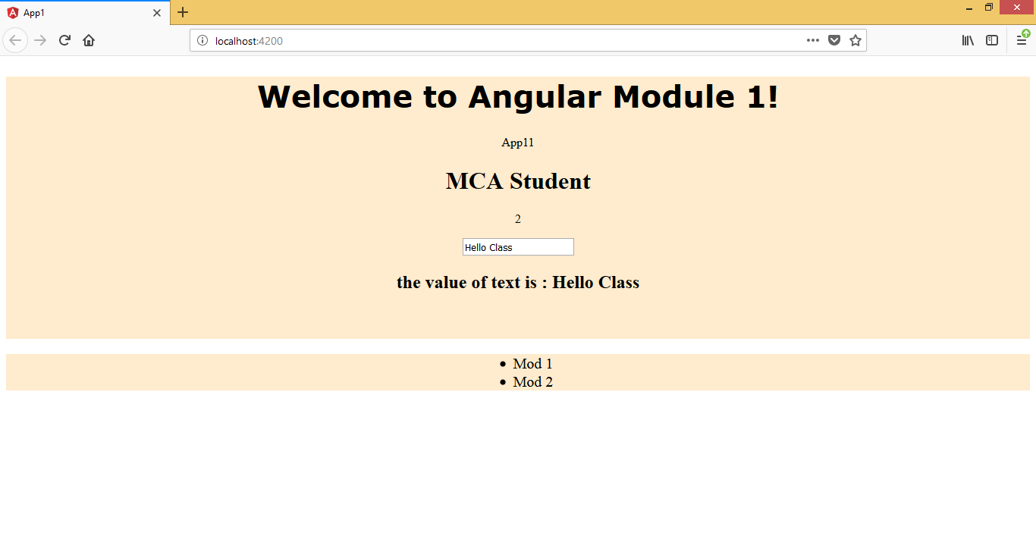

App.component.html:

<!--The content below is only a placeholder and can be replaced.-->

<div style="text-align:center">

<h1>

Welcome to {{ title }}!

</h1>

<app-app1></app-app1>

<br><br>

</div>

<div>

<ul>

<li>Mod 1</li>

<li>Mod 2</li>

</ul>

</div>

App.module.ts:

import { BrowserModule } from '@angular/platform-browser';

import { NgModule } from '@angular/core';

import {FormsModule} from '@angular/forms';

import { AppComponent } from './app.component';

import { App1Component } from './app1/app1.component';

@NgModule({

declarations: [

AppComponent,

App1Component

],

imports: [

BrowserModule, FormsModule

],

providers: [],

bootstrap: [AppComponent]

})

export class AppModule { }

app.component.css

h1{

font-family: verdana;

font-size: 40px;

}

div{

background-color: blanchedalmond;

}

ul{

font-size: 20px;

text-align: center;

}

App1.component.html

<p>

{{hero}}

</p>

<h1>{{student1.name}}</h1>

<p>{{student1.rollno}}</p>

<form name ="form1">

<input type="text" name="distext" [(ngModel)] = 'distext'>

</form>

<h2>the value of text is : {{distext}}</h2>

App1.component.ts:

import { Component, OnInit } from '@angular/core';

import {students} from './students';

import {FormsModule} from '@angular/forms';

@Component({

selector: 'app-app1',

templateUrl: './app1.component.html',

styleUrls: ['./app1.component.css']

})

export class App1Component implements OnInit {

student1:students;

distext="No";

constructor(Form:FormsModule) {

this.student1={

name:'MCA Student',

rollno:2

};

}

hero = 'App11';

ngOnInit() {

}

}

Student.ts:

export class students

{

public name:String;

public rollno:Number;

}

Task 5: **String interpolation**

1. Create a new app
2. Add a new component Server
3. Add following code

Server.component.ts:

import { Component, OnInit } from '@angular/core';

import { server } from './server';

@Component({

selector: 'app-server',

templateUrl: './server.component.html',

styleUrls: ['./server.component.css'],

providers:[server]

})

export class ServerComponent implements OnInit {

public title ='Server Component - task 5 String interpolation';

constructor(public ServerObj:server) {

}

ngOnInit() {

}

}

Server.component.html

<h2>

{{title}}

<br>

{{ServerObj.connectionStaus}}

</h2>

<button (click)="ServerObj.connect()">Connect</button>

App.component.html

<!--The content below is only a placeholder and can be replaced.-->

<div style="text-align:center">

<h1>

Welcome to {{ title }}!

</h1>

</div>

<div>

<app-server></app-server>

</div>

**Task 6 and 7 (How to create Method inside the class) and event**

1. In server.component.ts add following code
2. import { Component, OnInit } from '@angular/core';
3. import { server } from './server';
4. @Component({
5. selector: 'app-server',
6. templateUrl: './server.component.html',
7. styleUrls: ['./server.component.css'],
8. providers:[server]
9. })
10. export class ServerComponent implements OnInit {
11. public title ='Server Component - task 5 String interpolation';
12. constructor(public ServerObj:server) {
13. }
14. ngOnInit() {
15. }
16. }

Server.ts class

export class server{

public connectionStaus;

constructor(){

this.connectionStaus="Not Connected";

}

public connect()

{

this.connectionStaus="Connected - task 6 and 7: Method calling";

}

}

Server.component.html

<h2>

{{title}}

<br>

{{ServerObj.connectionStaus}}

</h2>

<button (click)="ServerObj.connect()">Connect</button>

ScreenShot:

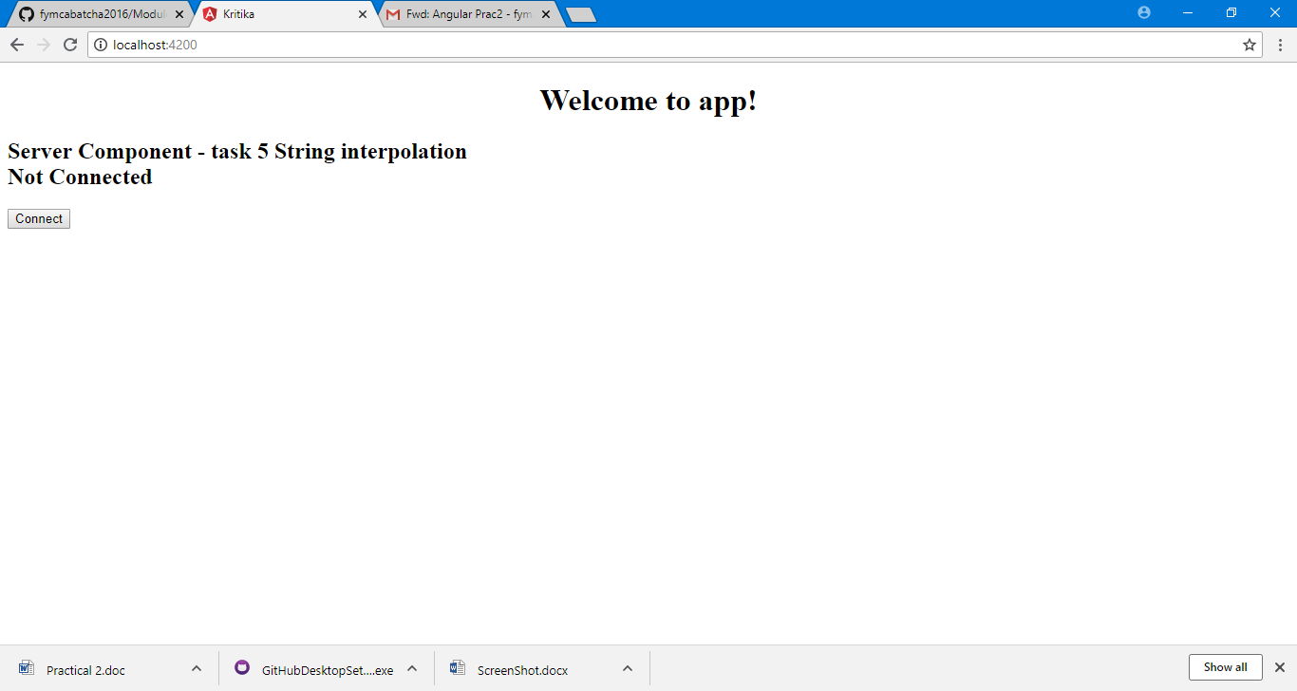

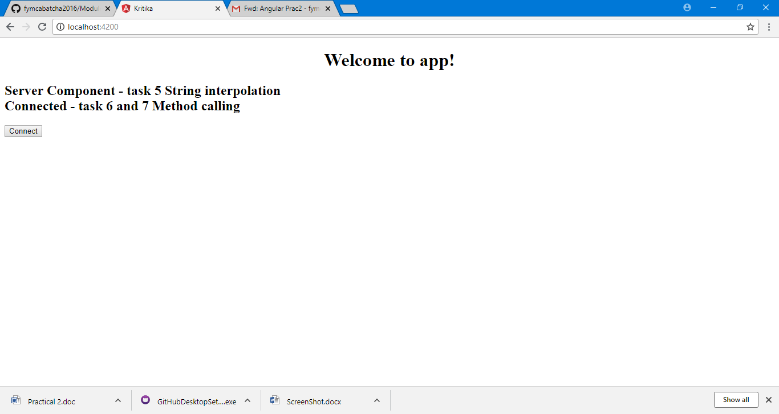

**Task 8 and 9, ngif and ngif else**

**Server.component.ts code:**

import { Component, OnInit } from '@angular/core';

import { server } from './server';

import {FormsModule} from '@angular/forms';

@Component({

selector: 'app-server',

templateUrl: './server.component.html',

styleUrls: ['./server.component.css'],

providers:[server]

})

export class ServerComponent implements OnInit {

public title ='Server Component - task 5 String interpolation';

public servername= "Server 1";

public servercreated=false;

public servercreationstatus = "No Server Created";

constructor(public ServerObj:server) {

}

public oncreateserver()

{

this.servercreated=true;

this.servercreationstatus="Server created task ngif ngifelse";

}

ngOnInit() {

}

}

**Server.component.html code:**

<h2>

{{title}}

<br>

{{ServerObj.connectionStaus}}

</h2>

<button (click)="ServerObj.connect()">Connect</button>

<br>

<br>

<p *ngIf="servercreated; else noServer">server is created and the servername is {{servername}}</p>

<ng-template #noServer>

<p>No server was created!!! else block</p>

</ng-template>

<button (click)="oncreateserver()"> server </button>>

{{servercreationstatus}}

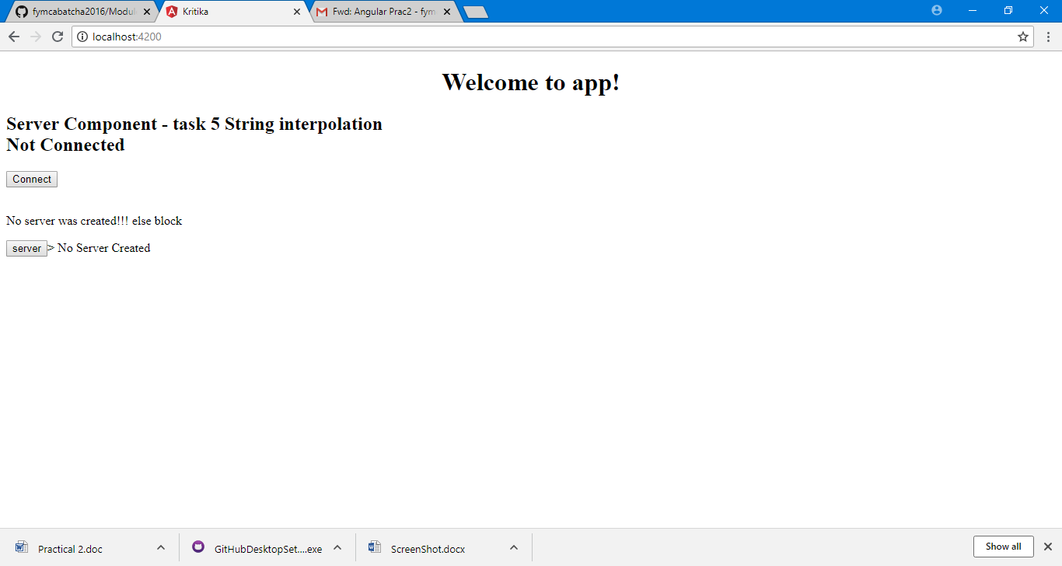

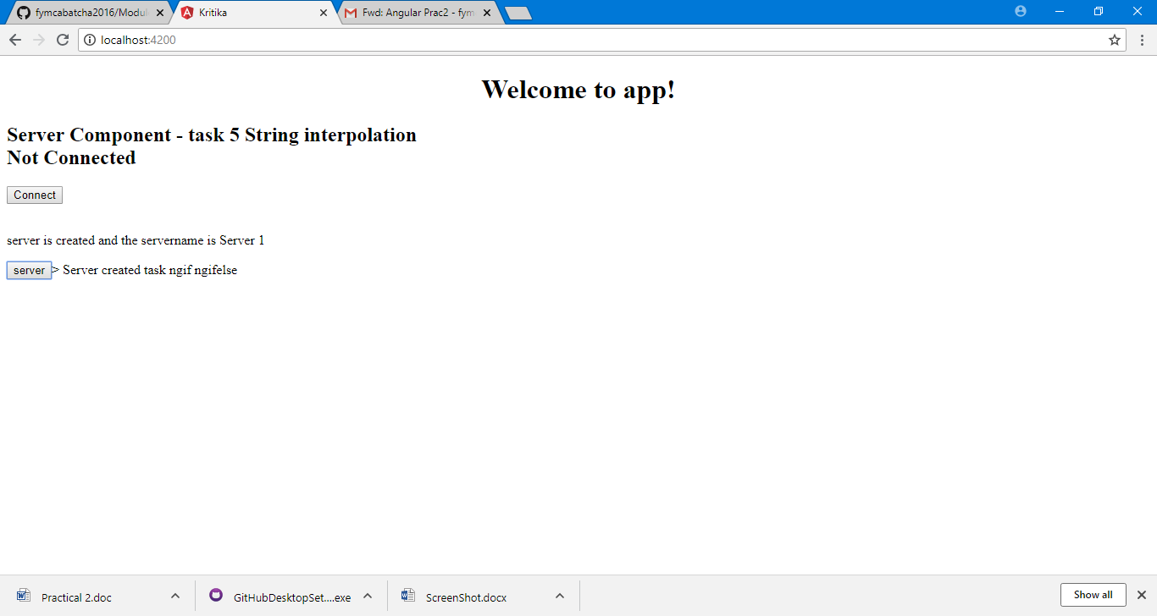

**Task 10 for:**

**server.compoent.ts code:**

export class ServerComponent implements OnInit {

public userlist=["abc","def","efh"];

public title ='Server Component - task 5 String interpolation';

public servername= "Server 1";

public servercreated=false;

public servercreationstatus = "No Server Created";

constructor(public ServerObj:server) {

}

**Server.component.html**

<ul>

<li *ngFor='let a of userlist'>

{{a}}

</li>

</ul>

**Screenshot:**

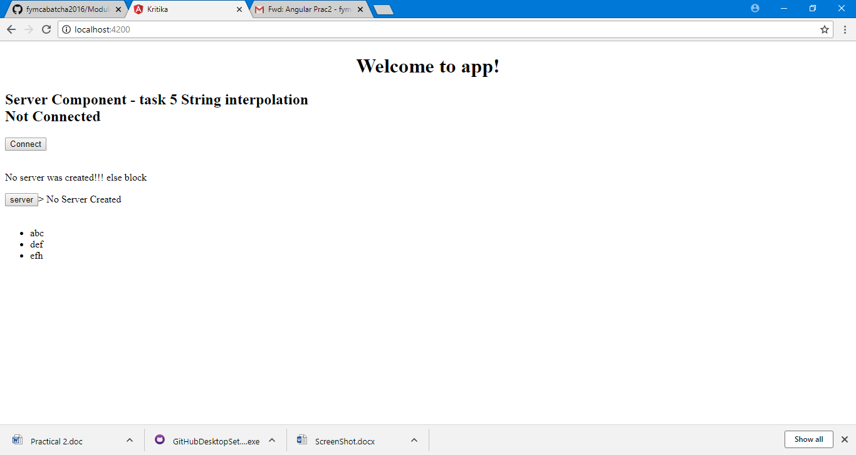

**Task 11 ng style:**

**Add Code in server.component.ts:**

export class ServerComponent implements OnInit {

public userlist=["abc","def","efh"];

public title ='Server Component - task 5 String interpolation';

public servername= "Server 1";

public servercreated=false;

public servercreationstatus = "No Server Created";

public id:number=1001;

public serverstatus1:string='offline';

constructor(public ServerObj:server) {

this.serverstatus1 = Math.random() > 0.5 ? 'online' : 'offline'

}

public getserverstatus(){

return this.serverstatus1;

}

public getcolor(){

return this.serverstatus1 === 'online' ? 'green' : 'red';

}

public oncreateserver()

{

this.servercreated=true;

this.servercreationstatus="Server created task ngif ngifelse";

}

ngOnInit() {

}

}

**Add Server.component.html**

<p [ngStyle]="{backgroundColor: getcolor()}">{{'server'}} with id {{id}} is {{getserverstatus()}}</p>

