App.js

function sayHello (name) {

console.log('Hello ' +name);

}

sayHello('Kritika');

sayHello('From first function');

Output:



Function Statement

App.js:

function func1()

{

console.log('Inside Function Statement');

}

func1();

Output:

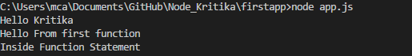

First Class Function:

App.js:

function fclass()

{

console.log('First class function calling');

}

fclass();

function logfunctionclass(fn)

{

fn();

}

logfunctionclass(fclass);

Output:

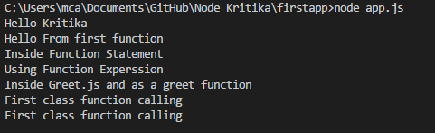

Function Expression:

App.js:

var funcexp = function() {

console.log('Using Function Experssion');

}

funcexp();

Output:

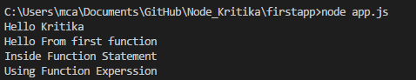

Using Module:

Create a new file name as greet.js which will be our module.

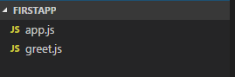

App.js:

var greet = require('./greet');

greet();

Greet.js:

var greet = function ()

{

console.log('Inside Greet.js and as a greet function');

}

module.exports = greet;

Output:

