Create database

var MongoClient = require('mongodb').MongoClient;

var url = "mongodb://localhost:27017/mydb";

MongoClient.connect(url, function(err, db) {

if (err) throw err;

console.log("Database created!");

db.close();

});



Create Collection

var MongoClient = require('mongodb').MongoClient;

var url = "mongodb://localhost:27017/";

MongoClient.connect(url, function(err, db) {

if (err) throw err;

var dbo = db.db("mydb");

dbo.createCollection("customers", function(err, res) {

if (err) throw err;

console.log("Collection created!");

db.close();

});

});



Insert Value

var MongoClient = require('mongodb').MongoClient;

var url = "mongodb://localhost:27017/";

MongoClient.connect(url, function(err, db) {

if (err) throw err;

var dbo = db.db("mydb");

var myobj = { name: "Company Inc", address: "Highway 37" };

dbo.collection("customers").insertOne(myobj, function(err, res) {

if (err) throw err;

console.log("1 document inserted");

db.close();

});

});

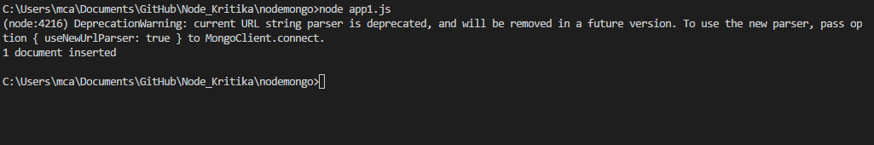

Find a value

var MongoClient = require('mongodb').MongoClient;

var url = "mongodb://localhost:27017/";

MongoClient.connect(url, function(err, db) {

if (err) throw err;

var dbo = db.db("mydb");

dbo.collection("customers").findOne({}, function(err, result) {

if (err) throw err;

console.log(result.name);

db.close();

});

});

