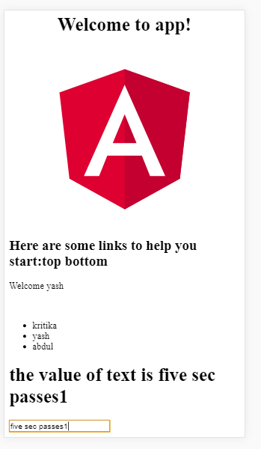

App.component.html:

<!--The content below is only a placeholder and can be replaced.-->

<div style="text-align:center">

<h1>

Welcome to {{ title }}!

</h1>

<app-app1></app-app1>

<br><br>

</div>

<div>

<ul>

<li>Mod 1</li>

<li>Mod 2</li>

</ul>

</div>

App.module.ts:

import { BrowserModule } from '@angular/platform-browser';

import { NgModule } from '@angular/core';

import {FormsModule} from '@angular/forms';

import { AppComponent } from './app.component';

import { App1Component } from './app1/app1.component';

@NgModule({

declarations: [

AppComponent,

App1Component

],

imports: [

BrowserModule, FormsModule

],

providers: [],

bootstrap: [AppComponent]

})

export class AppModule { }

app.component.css

h1{

font-family: verdana;

font-size: 40px;

}

div{

background-color: blanchedalmond;

}

ul{

font-size: 20px;

text-align: center;

}

App1.component.html

<p>

{{hero}}

</p>

<h1>{{student1.name}}</h1>

<p>{{student1.rollno}}</p>

<form name ="form1">

<input type="text" name="distext" [(ngModel)] = 'distext'>

</form>

<h2>the value of text is : {{distext}}</h2>

App1.component.ts:

import { Component, OnInit } from '@angular/core';

import {students} from './students';

import {FormsModule} from '@angular/forms';

@Component({

selector: 'app-app1',

templateUrl: './app1.component.html',

styleUrls: ['./app1.component.css']

})

export class App1Component implements OnInit {

student1:students;

distext="No";

constructor(Form:FormsModule) {

this.student1={

name:'MCA Student',

rollno:2

};

}

hero = 'App11';

ngOnInit() {

}

}

Student.ts:

export class students

{

public name:String;

public rollno:Number;

}