Randomised Trials of Digital Interventions Reporting Occupational Burnout Outcomes: A Scoping Review and Evidence Map

Abstract

Objectives: To map randomised trials of digitally delivered interventions in working populations that reported occupational burnout as an outcome.
Study design: Scoping review and evidence map, reported according to PRISMA-ScR.
Methods: We searched Europe PMC, OpenAlex, ERIC, Web of Science, Scopus and PubMed (17 September to 18 October 2026) and ClinicalTrials.gov. A first strategy that required a psychological-intervention term was followed by strategies without it, because the eligibility criteria admitted any mechanism. Reports were assessed against five ordered criteria, mostly from abstracts, and trials were charted by occupation, delivery mode, approach, comparator and burnout instrument. A human reviewer checked samples of the AI-assisted eligibility decisions and of the abstract-level coding.

Results: Of 4,991 records, 2,481 were screened and 301 reports assessed. We included 121 reports of 118 trials (27,088 participants in 109 trials reporting numbers). Most trials (64.4%) were first reported from 2023 onwards, and 73 studied healthcare workers. Web programmes (50) and smartphone apps (21) predominated; 21 trials tested non-psychological mechanisms. Waitlist controls were used in 40.8% of trials from 2023. About half of the abstracts (58) named the burnout instrument, and 31 gave a registration number. Of 15 randomised registrations completed by 2023, 4 had no located results.
Conclusions: The evidence has grown quickly but is concentrated in healthcare, increasingly waitlist-controlled and inconsistently reported in abstracts. Actively controlled trials outside healthcare, trials of work-system technologies, explicit reporting of burnout instruments and publication of completed trials are priorities.
Keywords: occupational burnout; digital health; randomised controlled trial; scoping review; evidence map; occupational health

1. Introduction
Burnout is a syndrome that results from chronic workplace stress that has not been successfully managed. It is characterised by exhaustion, mental distance from or cynicism about one's job, and reduced professional efficacy, and the World Health Organization classifies it in the International Classification of Diseases (ICD-11) as an occupational phenomenon.^{1,2} Prevalence estimates vary with the instrument and cut-off, but in health care they are high enough to threaten workforce retention and quality of care,^{3,4} and similar concerns have been raised for teachers, social-care staff and employees in other sectors.
Digital delivery through web programmes, smartphone apps, live online sessions, messaging or wearable devices promises to reach workers at scale. Evidence on interventions against burnout comes mainly from reviews restricted to physicians^{5,6} or nurses,^{7,8} to one therapeutic approach,⁹ or to broader mental-health outcomes.¹⁰ A scoping review of digital applications covered healthcare professionals only and did not restrict study design.¹¹ No review has mapped, across occupations and intervention mechanisms, where randomised trials of digital interventions reporting burnout have been done, how they were designed and reported, and whether registered trials were published.

We therefore mapped randomised trials of any digitally delivered intervention in working populations that reported burnout as an outcome. We asked: in which occupational groups and over what period have the trials been done; which delivery modes, approaches and levels of human support were tested; how were the trials designed and reported; and how many registered, completed trials have published results?

2. Methods

2.1 Design and reporting
We followed the scoping-review framework of Arksey and O'Malley, Levac et al. and the Joanna Briggs Institute,¹²⁻¹⁴ and report the review according to PRISMA-ScR,¹⁵ with a PRISMA 2020 flow diagram¹⁶ and PRISMA-S for the search.¹⁷ The protocol was not registered in advance (a retrospective protocol is supplied). Because the review maps evidence, we did not assess risk of bias or synthesise effect sizes.

2.2 Eligibility criteria
We included peer-reviewed primary reports of randomised trials (individual, cluster, factorial, crossover or stepped-wedge) in working populations (employed staff and trainees in paid employment, including workers on sick leave who remained employed; not students or patients). The intervention had to have at least one core component delivered digitally (web, app, videoconference, messaging, chatbot, virtual reality, computer or wearable device), and burnout, measured with a burnout instrument or a named burnout subscale, had to be an outcome of the randomised comparison. Interventions of any mechanism, language and date were eligible. The five criteria (report type, design, population, digital delivery, outcome) were applied in this order and the first one failed was recorded (Supplementary Table S1). Reports of one trial were linked, and the trial was the unit of analysis.

2.3 Information sources and search
The main search combined four concept blocks (burnout, digital delivery, a psychological or behavioural intervention term and randomised design) in Europe PMC, OpenAlex and ERIC (26 September 2026) and in Web of Science and Scopus (17 September 2026). Because the eligibility criteria admitted any mechanism, this strategy was too narrow. We therefore repeated the search without the intervention block (Europe PMC and OpenAlex, 28 September; Web of Science and Scopus, 29 September 2026), searched PubMed with the Medical Subject Heading "Burnout, Professional" and added further delivery terms (29 September 2026). Finally, on 18 October 2026, we ran one unified strategy (burnout AND any digital-delivery term AND randomised design) in Europe PMC and ERIC (all years) and, for records published from 1 September 2026, in OpenAlex and PubMed. Web of Science and Scopus were not searched again after 29 September 2026. ClinicalTrials.gov was searched on 28 September 2026 for completed interventional registrations with burnout as a condition and a digital term. We did not search PsycINFO, Embase or the Cochrane Central Register of Controlled Trials (no access). We checked the reference lists of five earlier reviews; none led to a further eligible trial (Supplementary Section S2). A unified Europe PMC search alone retrieved 81 of the 121 included reports (67%), so no single database was sufficient. Complete strings, dates and numbers of records are in Supplementary Appendix A and Table S2.

2.4 Selection and verification
Records were de-duplicated and screened with a rule-based classifier that could only exclude records. The first reviewer was an AI assistant (Section 2.7), which read every remaining record and proposed decisions; the corresponding author decided borderline reports. Eligibility was assessed from titles and abstracts; the full text was consulted for 31 reports in which the abstract was ambiguous or discrepant or the human reviewer disagreed. We estimated the screening error from a random sample of 45 excluded records.¹⁸ The corresponding author, as human reviewer, independently assessed a blind sample of 30 assessed reports (15 included and 15 excluded), and agreement with the first reviewer was summarised with Cohen's kappa. Decisions with reasons are in the ledger (master_registry.csv).

2.5 Data charting
Each trial was charted with one value per variable: occupational group, delivery mode, intervention approach and mechanism, comparator, human support, burnout instrument, participants (randomised, or analysed where only that was reported) and year of first report. Two heterogeneous groups ("other psychological" approaches and "employees in other sectors") were split by rules written before recoding, and all their trials were recoded with the same rules. Where the abstract did not name the instrument, we took it from the full text; four trials stayed undetermined. Two further variables were coded from abstracts only and are descriptive: five reporting indicators (named randomisation method, blinding statement, attrition numbers, registration number and analysis population), each recorded as stated or not stated in the abstract, and the direction of the burnout result as reported by the authors (six categories). They are neither quality ratings nor effect estimates, and an indicator missing from an abstract does not show that the procedure was omitted. The human reviewer coded a random 20% sample (23 of the 113 trials included at that stage) blind to the first coding. The rules that the comparison exposed (a randomisation method counts only if named; "favours the intervention" requires a benefit on the total score or on every dimension reported) were then applied to all trials.

2.6 Registry linkage and synthesis
For each registration we identified linked publications. For randomised registrations completed by the end of 2023 we classified results as reported in an included trial, reported outside the scope of the review, or not located. We summarised counts and percentages, grouped trials by year of first report (2004-2019, 2020-2022, 2023-2026) and cross-tabulated occupation against approach.

2.7 Use of artificial intelligence in the research process
A large-language-model assistant (Claude, Anthropic) was used in interactive sessions under the author's direction to write and run the search, de-duplication and triage code, to read the abstracts of records that passed the rule-based triage and propose eligibility decisions and charting codes, and to build the tables and figures from the data files. The assistant acted as first reviewer and was not independent of the author's direction. The author decided every borderline eligibility question, obtained full texts that changed decisions, completed the blind and verification samples and approved the final classification; no second human reviewer assessed every record. Each decision and its reason are recorded in the released ledger, so the process can be audited without access to the sessions.

3. Results

3.1 Selection of sources of evidence
The searches identified 4,991 records; 2,510 duplicates and non-article records were removed and 2,481 records were screened. Of 279 reports assessed from the databases, 160 were excluded (26 were not primary reports, 22 were not randomised, 41 did not study workers, 33 were not digitally delivered, 38 did not report burnout as an outcome); 119 were included, and the registry added 2 (Figure 1). In total, 121 reports of 118 trials were included. The searches added after the main search found 31 of the 118 trials (26.3%), 12 of them with non-psychological mechanisms, among them the ambient AI scribe trials. The random sample of 45 excluded records contained no eligible report (0 of 45; exact 95% confidence interval 0% to 7.9%). In the blind comparison of 30 reports the reviewers agreed on 24 (80%; kappa 0.60, 95% confidence interval 0.31 to 0.89); if the two partly digital interventions were counted as excluded, agreement was 73% (kappa 0.47).

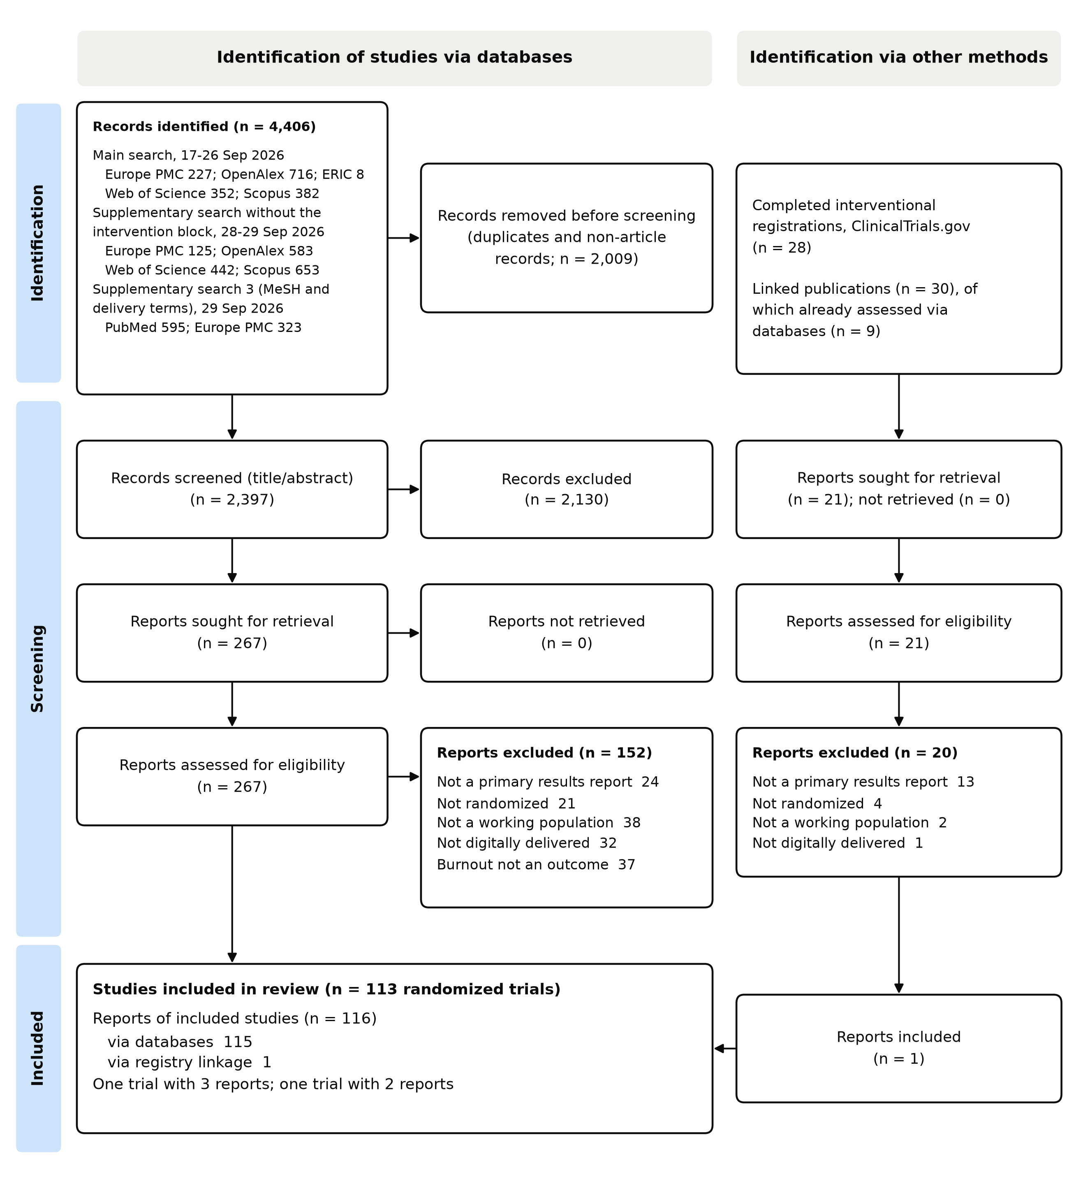
Figure 1. PRISMA 2020 flow diagram. Reports are the unit of counting up to the final box; the included reports belong to 118 trials.

3.2 Characteristics of the included trials
Table 1 summarises the 118 trials (Supplementary Appendix C). The 109 trials that reported sample size enrolled 27,088 participants (median 109, interquartile range 66-228). The number was randomised or enrolled in 73 of these trials (median 125; 19,787 participants), analysed or completed in 6, and its basis could not be identified from the abstract in 30. Healthcare workers were studied in 73 (61.9%) trials, mental-health and social-care professionals in 7, teachers in 16 and employees of other sectors in 22. Of the trials, 76 (64.4%) were first reported from 2023 onwards (Figure 2); the share studying healthcare workers rose from 23.5% before 2020 to 72.0% in 2020-2022 and 67.1% from 2023, and live online group sessions, absent before 2020, were used in 23 trials from 2023. Web programmes (50 trials) and smartphone apps (21) were the commonest delivery modes. Mindfulness was the most frequent psychological approach (24 trials), and all 6 coaching trials were in physicians (Figure 3).

Table 1. Characteristics of the included trials (n = 118)
Characteristic | Trials, n (%)
Year of first report
2004-2019 | 17 (14.4%)
2020-2022 | 25 (21.2%)
2023-2026 (to 18 October) | 76 (64.4%)
Occupational group
Other or mixed healthcare workers | 35 (29.7%)
Physicians and physician trainees | 22 (18.6%)
Nurses | 16 (13.6%)
Teachers and education staff | 16 (13.6%)
Workers selected for a health condition or risk | 9 (7.6%)
Mixed-occupation workers recruited across employers | 8 (6.8%)
Mental-health and social-care professionals | 7 (5.9%)
Employees of a named occupation, industry or enterprise | 5 (4.2%)
Main delivery mode
Web-based programme | 50 (42.4%)
Live online sessions | 25 (21.2%)
Smartphone app | 21 (17.8%)
Blended (digital and in-person) | 9 (7.6%)
Text or instant messaging | 5 (4.2%)
Wearable or motion-sensing platform | 4 (3.4%)
Ambient AI scribe | 3 (2.5%)
Chatbot | 1 (0.8%)
Intervention approach
Mindfulness or meditation | 24 (20.3%)
Non-psychological mechanism | 21 (17.8%)
Cognitive-behavioural or stress management | 13 (11.0%)
Psychoeducation or resilience training | 12 (10.2%)
Positive psychology | 9 (7.6%)
Stress recovery and coping skills | 7 (5.9%)
Acceptance and commitment | 6 (5.1%)
Coaching | 6 (5.1%)
Tailored, combined or other multicomponent psychological | 6 (5.1%)
Compassion-based | 5 (4.2%)
Emotion regulation and emotion-focused | 4 (3.4%)
Creative and experiential group formats | 4 (3.4%)
Job crafting and work-role redesign | 1 (0.8%)
Mechanism
Psychological | 97 (82.2%)
Professional training | 9 (7.6%)
Physical activity or health behaviour | 6 (5.1%)
Feedback or navigation to services | 3 (2.5%)
Workflow automation | 3 (2.5%)
Comparator
Waitlist or delayed access | 39 (33.1%)
Active or attention control | 32 (27.1%)
Usual practice or no intervention | 27 (22.9%)
Not reported | 12 (10.2%)
Head-to-head digital variants | 8 (6.8%)
Human support
Human-supported or facilitated | 50 (42.4%)
Self-guided or automated | 50 (42.4%)
Not reported | 18 (15.3%)
Burnout instrument (abstract or full text)
Maslach Burnout Inventory | 63 (53.4%)
Copenhagen Burnout Inventory | 13 (11.0%)
Oldenburg Burnout Inventory | 10 (8.5%)
Stanford Professional Fulfillment Index (burnout scale) | 7 (5.9%)
Professional Quality of Life Scale (burnout subscale) | 6 (5.1%)
Shirom-Melamed Burnout Questionnaire | 5 (4.2%)
Single-item burnout measure | 2 (1.7%)
Bergen Burnout Inventory | 2 (1.7%)
Burnout Assessment Tool | 1 (0.8%)
Turkish adaptation of a burnout scale | 1 (0.8%)
Utrecht Burnout Scale | 1 (0.8%)
Scale of Work Engagement and Burnout (burnout scale) | 1 (0.8%)
Geldard Burnout Questionnaire | 1 (0.8%)
Japanese Burnout Scale (Kubo) | 1 (0.8%)
Not determined (full text incomplete or not obtained) | 4 (3.4%)

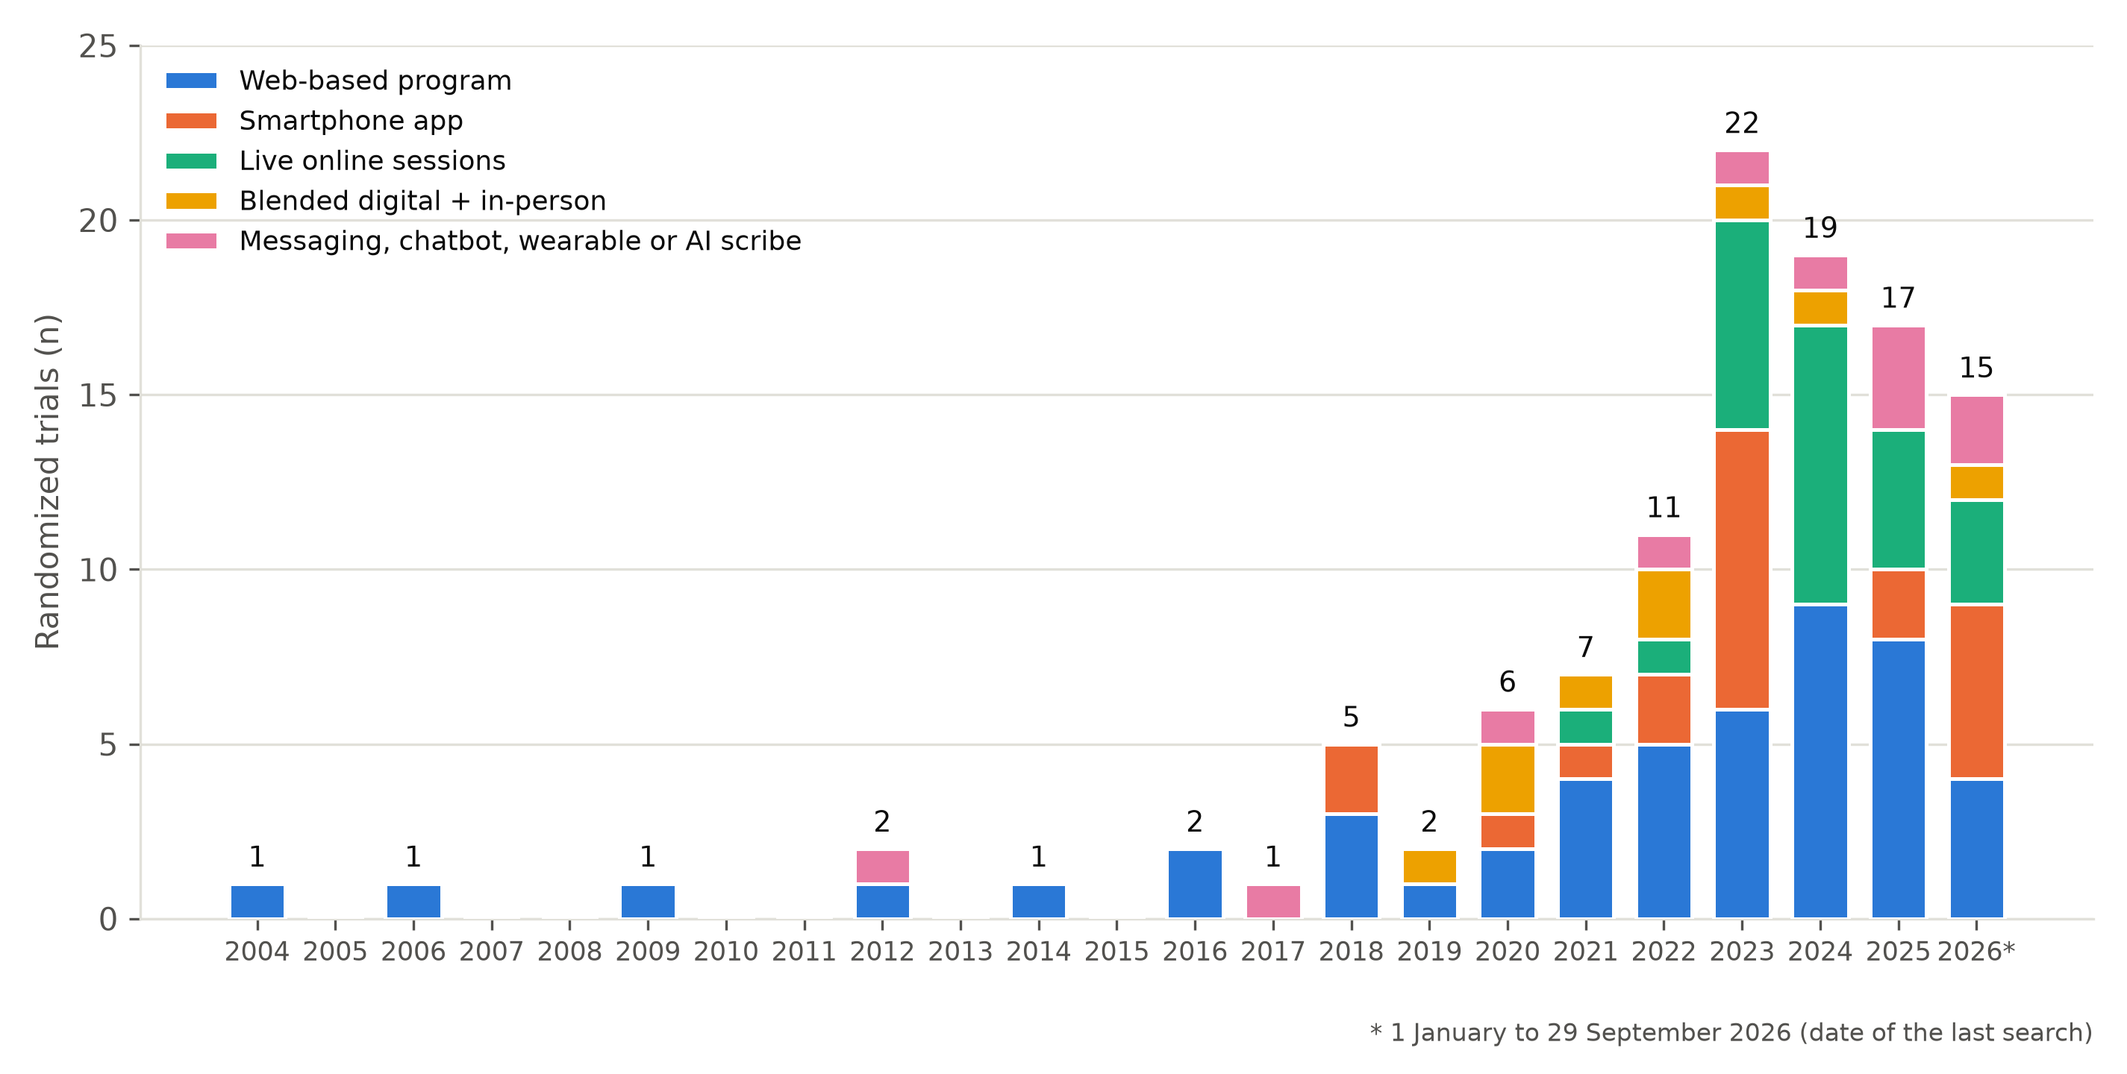
Figure 2. Included trials by year of first report and main delivery mode (n = 118). Data for 2026 cover 1 January to 18 October 2026.

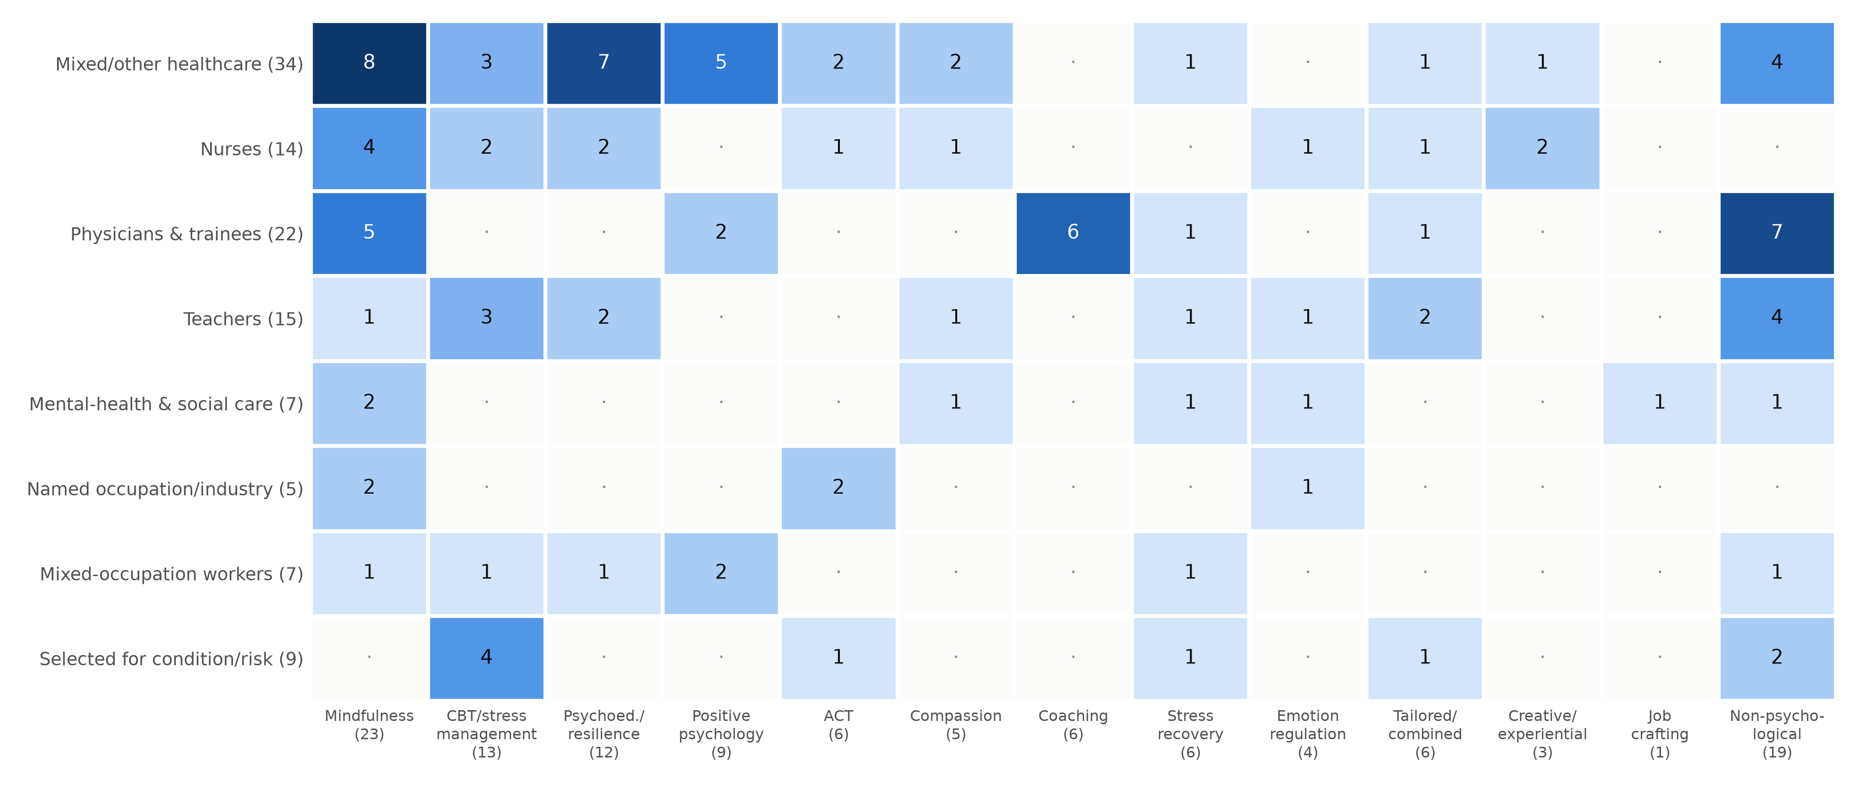
Figure 3. Evidence map: trials by occupational group and intervention approach (n = 118); totals in parentheses, dots mark empty cells.

3.3 Interventions, comparators and support
A mechanism that was not psychological was tested in 21 trials (17.8%): professional training (9), physical activity or health behaviour (6), feedback or navigation (3) and workflow automation (3, all ambient AI scribes for physicians). Of these, 12 were found only by the searches added after the main search. A waitlist or delayed-access comparator was used in 39 (33.1%) trials, an active or attention control in 32 (27.1%) and usual practice in 27 (22.9%); waitlists rose from 19.0% of trials before 2023 to 40.8% from 2023 (Table 2). Self-guided or automated interventions (50) and human-supported interventions (50) were equally common; support depended on delivery mode (24 of 25 live programmes were facilitated, 20 of 21 apps self-guided).

Table 2. Design features of the included trials by period of first report
Feature | 2004-2019 | 2020-2022 | 2023-2026 | All trials
Trials, n | 17 | 25 | 76 | 118
Median participants enrolled | 95 | 90.5 | 119 | 109
Healthcare workers, % | 23.5 | 72.0 | 67.1 | 61.9
Waitlist comparator, % | 29.4 | 12.0 | 40.8 | 33.1
Active or attention comparator, % | 35.3 | 36.0 | 22.4 | 27.1
Human-supported intervention, % | 41.2 | 32.0 | 46.1 | 42.4
Non-psychological mechanism, % | 23.5 | 16.0 | 17.1 | 17.8
Burnout instrument named in abstract, % | 23.5 | 48.0 | 55.3 | 49.2

3.4 Reporting of burnout and of trial features in abstracts
The burnout instrument was named in 58 (49.2%) abstracts; the full text identified it for 56 of the other 60, and 4 remained undetermined. The Maslach Burnout Inventory or an adaptation was used in 63 (53.4%) trials, followed by the Copenhagen (13) and Oldenburg (10) inventories. In the abstracts, a registration number was given in 31 (26.3%) trials, attrition or analysed numbers in 32 (27.1%), an analysis population in 17 (14.4%), blinding in 13 (11.0%) and a randomisation method in 7 (5.9%). The abstract reported a burnout result favouring the intervention in 50 (42.4%) trials, a mixed result (one subscale, subgroup, arm or time point) in 27 (22.9%), no difference in 20 (16.9%) and an unfavourable result in 2 (1.7%); 4 (3.4%) reported improvement in all arms and 15 (12.7%) stated no burnout result. These codes describe reporting and are not effect estimates (Supplementary Table S3). On the verification sample the reviewers' direction codes agreed for 17 of 23 trials (74%; kappa 0.62) and the indicator judgements for 110 of 115 (96%).

3.5 Registered trials
Of the 28 completed registrations, 19 were randomised and 15 of these had been completed by the end of 2023. A results report was included in this review for 9, results of 2 had been published outside its scope, and for 4 (26.7%) no results report was located (Supplementary Table S4).

4. Discussion

4.1 Principal findings
This review identified 118 randomised trials of digitally delivered interventions that reported burnout in working populations. The evidence is recent: 64.4% of the trials were first reported from 2023 onwards, and the field changed after 2020 in who was studied and how interventions were delivered. It is concentrated in healthcare (61.9%), while teachers and employees of other sectors together contribute 32.2%. Most trials test psychological programmes that ask the individual worker to change (82.2%), whereas interventions that change training, work processes or practical conditions are a small and partly hidden part of the literature: 12 of 21 were found only by the searches without an intervention block. Design and reporting leave room for improvement: waitlist controls are common and were used in 40.8% of the most recent trials, the typical trial is small, only about half of the abstracts (49.2%) name the burnout instrument, and no results could be found for 4 of 15 registered trials completed by 2023. The rise since 2020 describes published trials, not trials started, and is compatible with, but does not show, an effect of the pandemic.

4.2 Comparison with previous reviews
Earlier reviews were limited to one profession and pooled effects,⁸ covered healthcare workers regardless of delivery mode,¹⁰ or targeted stress and burnout prevention in nurses and physicians.¹¹ By restricting design to randomised trials and outcome to burnout while admitting any occupation and mechanism, this review complements them (Supplementary Table S5).

4.3 Implications for trials and reporting
Meta-analytic evidence in physicians suggests that organisation-directed interventions may be at least as effective as individual-directed ones,^{5,6} yet few digital trials target training, workflow or practical support. The ambient AI scribe trials are an example: they address documentation burden, a recognised driver of burnout, appeared in artificial-intelligence and informatics journals and do not use psychological terms, so reviews that search only for psychological interventions will miss them, as our own main search did. Waitlist designs can overestimate effects because participants told to wait may fare worse than with no intervention;¹⁹ comparisons with active controls, usual organisational support or alternative versions of a programme would show more about what the intervention adds. Burnout instruments are many, include shortened forms and rest on different concepts,²⁰ and only about half of the abstracts named them, and few gave basic trial features. Following CONSORT and its e-health extension,^{21,22} abstracts should name the instrument and the primary outcome, and completed trials should publish results; the proportion without located results here is consistent with non-publication documented elsewhere,²³ but we searched ClinicalTrials.gov only.

4.4 Strengths and limitations
Strengths are the search across six databases and a registry with repeated gap checks, a ledger that records every decision with its reason, trial-level analysis and public data. The main limitation is the search. The first strategy was narrower than the eligibility criteria; we corrected this with later searches, each of which found trials the previous one had missed, and the final unified strategy was run in only four sources, so more eligible trials probably remain, particularly in Web of Science, Scopus and the databases we did not search (PsycINFO, Embase, the Cochrane register). Second, selection and charting were done first by an AI assistant and checked by one human reviewer on samples (30 reports and 23 trials), not on every record or variable, and the kappa values from these samples are imprecise. Third, eligibility and charting relied on abstracts, so the comparator, delivery mode and sample size may be incomplete, trials that measured burnout only as a secondary outcome reported in the full text can be missed (one was found through the registry; of the 37 reports excluded on abstracts for lack of a burnout outcome, we read the open-access full text of 15 and none qualified, but 22 could not be accessed), and the reporting indicators and direction codes describe abstracts only. Fourth, the protocol was not registered in advance. Finally, each trial received one category per variable, which simplifies multicomponent interventions, and the data for 2026 are incomplete. The map describes the evidence identified by these searches and is not a complete census of trials.

5. Conclusions
Randomised evidence on digital interventions for occupational burnout has grown quickly since 2020 and now comprises 118 trials, concentrated in healthcare and in psychological programmes for individual workers. Recent trials rely more often on waitlist controls, many are small pilots, and abstracts often omit the burnout instrument and basic trial features. Future trials should include workers outside healthcare, test interventions that change training and work processes, use active or usual-practice comparators, and report the instrument and the results of every completed trial.

Declarations
Funding: This research received no specific funding.
Competing interests: The author declares no competing interests.
Ethics approval: Not required; the review used published data only.
Data availability: The ledger of all 301 assessed reports, the trial-level charting, the screening files, the abstract-coding files with the verification sample, the code and a data dictionary are in a public repository (link in the title page file, withheld here for blinded review). Abstracts retrieved from Web of Science and Scopus and full-text articles are not redistributed.

Declaration of generative AI and AI-assisted technologies in the writing process
During the preparation of this work the author used Claude (Anthropic) to draft and edit the manuscript text from the released data files, to write code that builds the tables and figures, and to improve the language. After using this tool, the author reviewed and edited the content as needed and takes full responsibility for the content of the publication. The use of the tool in the research process (searching, screening, charting) is described in Section 2.7.

References
1. World Health Organization. Burn-out an "occupational phenomenon": International Classification of Diseases. WHO. May 28, 2019. Accessed September 20, 2026. https://www.who.int/news/item/28-05-2019-burn-out-an-occupational-phenomenon-international-classification-of-diseases
2. Maslach C, Leiter MP. Understanding the burnout experience: recent research and its implications for psychiatry. World Psychiatry. 2016;15(2):103-111. doi:10.1002/wps.20311
3. Rotenstein LS, Torre M, Ramos MA, et al. Prevalence of burnout among physicians: a systematic review. JAMA. 2018;320(11):1131-1150. doi:10.1001/jama.2018.12777
4. West CP, Dyrbye LN, Shanafelt TD. Physician burnout: contributors, consequences and solutions. J Intern Med. 2018;283(6):516-529. doi:10.1111/joim.12752
5. West CP, Dyrbye LN, Erwin PJ, Shanafelt TD. Interventions to prevent and reduce physician burnout: a systematic review and meta-analysis. Lancet. 2016;388(10057):2272-2281. doi:10.1016/S0140-6736(16)31279-X
6. Panagioti M, Panagopoulou E, Bower P, et al. Controlled interventions to reduce burnout in physicians: a systematic review and meta-analysis. JAMA Intern Med. 2017;177(2):195-205. doi:10.1001/jamainternmed.2016.7674

7. Park JH, Jung SE, Ha DJ, et al. E-healthcare interventions for nurse mental health: a systematic review. Medicine (Baltimore). 2022;101(28):e29125. doi:10.1097/MD.0000000000029125
8. Yang Y, Wen J, Wan H, et al. Digital health interventions for reducing occupational burnout in nurses: a systematic review and meta-analysis. Front Public Health. 2026;14:1879258. doi:10.3389/fpubh.2026.1879258
9. Lampinen VS, Kämper E, Balla VR, Katajavuori N, Asikainen H. The effectiveness of online acceptance and commitment therapy-based interventions on depression, burnout, anxiety and stress in occupational contexts: a systematic narrative review. Internet Interv. 2026;43:100909. doi:10.1016/j.invent.2026.100909
10. Kunzler AM, Helmreich I, Chmitorz A, et al. Psychological interventions to foster resilience in healthcare professionals. Cochrane Database Syst Rev. 2020;(7):CD012527. doi:10.1002/14651858.CD012527.pub2
11. Adam D, Berschick J, Schiele JK, et al. Interventions to reduce stress and prevent burnout in healthcare professionals supported by digital applications: a scoping review. Front Public Health. 2023;11:1231266. doi:10.3389/fpubh.2023.1231266
12. Arksey H, O'Malley L. Scoping studies: towards a methodological framework. Int J Soc Res Methodol. 2005;8(1):19-32. doi:10.1080/1364557032000119616
13. Levac D, Colquhoun H, O'Brien KK. Scoping studies: advancing the methodology. Implement Sci. 2010;5:69. doi:10.1186/1748-5908-5-69
14. Peters MDJ, Godfrey C, McInerney P, et al. Chapter 11: scoping reviews. In: Aromataris E, Munn Z, eds. JBI Manual for Evidence Synthesis. JBI; 2020. doi:10.46658/JBIMES-20-12
15. Tricco AC, Lillie E, Zarin W, et al. PRISMA Extension for Scoping Reviews (PRISMA-ScR): checklist and explanation. Ann Intern Med. 2018;169(7):467-473. doi:10.7326/M18-0850
16. Page MJ, McKenzie JE, Bossuyt PM, et al. The PRISMA 2020 statement: an updated guideline for reporting systematic reviews. BMJ. 2021;372:n71. doi:10.1136/bmj.n71
17. Rethlefsen ML, Kirtley S, Waffenschmidt S, et al. PRISMA-S: an extension to the PRISMA statement for reporting literature searches in systematic reviews. Syst Rev. 2021;10(1):39. doi:10.1186/s13643-020-01542-z
18. Clopper CJ, Pearson ES. The use of confidence or fiducial limits illustrated in the case of the binomial. Biometrika. 1934;26(4):404-413. doi:10.1093/biomet/26.4.404
19. Furukawa TA, Noma H, Caldwell DM, et al. Waiting list may be a nocebo condition in psychotherapy trials: a contribution from network meta-analysis. Acta Psychiatr Scand. 2014;130(3):181-192. doi:10.1111/acps.12275
20. Schaufeli WB, De Witte H, Desart S. Burnout Assessment Tool (BAT): development, validity, and reliability. Int J Environ Res Public Health. 2020;17(24):9495. doi:10.3390/ijerph17249495
21. Schulz KF, Altman DG, Moher D; CONSORT Group. CONSORT 2010 statement: updated guidelines for reporting parallel group randomised trials. BMJ. 2010;340:c332. doi:10.1136/bmj.c332
22. Eysenbach G; CONSORT-EHEALTH Group. CONSORT-EHEALTH: improving and standardizing evaluation reports of web-based and mobile health interventions. J Med Internet Res. 2011;13(4):e126. doi:10.2196/jmir.1923
23. Chen R, Desai NR, Ross JS, et al. Publication and reporting of clinical trial results: cross sectional analysis across academic medical centers. BMJ. 2016;352:i637. doi:10.1136/bmj.i637

