BSCS FINAL PROJECT
Smart Pharmacist Support System

Advisor: Sheeza Shabir
Presented by:
Group ID: FYP26-CS-G15
Student Reg# | Student Name
S3F22UBSCS059 | Qasim Majid
S3F22UBSCS014 | Rohaan Naseer
S3F22UBSCS015 | Fiza Ali
Faculty of Information Technology & Computer Science
University of Central Punjab

Smart Pharmacist Support System
By
Qasim Majid, Rohaan Naseer, Fiza Ali
Thesis/Project submitted to
Faculty of Information Technology & Computer Science,
University of Central Punjab,
Lahore, Pakistan.
in partial fulfillment of the requirements for the degree of
BACHELOR OF SCIENCE
IN
COMPUTER SCIENCE
_________________________ _________________________
Project Advisor Manager Projects

Abstract
Medication errors have been a burning issue in global medical systems and one of the main causes of un-necessary patient harm, medication reactions, prolonged hospital stays and increased health care costs. The Smart Pharmacist Support System (SPSS) does just that and offers an intelligent and desktop-based decision support solution which utilizes an optical character recognition (OCR) system and a rule-based safety engine along with workflow analytics to automate prescription verification. The present design and test specification (DTS) document contains complete technical design of the realization of SPSS, including the system outline, relationship between the components, information model, user interface design, test specification and test validation result. The system uses a modular architecture based on React.js frontend and Electron, FastAPI backend with SQLite database and OCR engine (to read handwritten prescriptions, and printed text). The major design factors are: layered architectural design, interaction of components based on use cases and extensive safety mechanisms that ensure that ultimate pharmacist control is maintained. There will also be details in the document of test case specification, test results and completion of the project. The system can be expanded to integrate with future advanced AI systems for recommendations and cloud-based data synchronization, ensuring future scalability.
The user friendly design of the SPSS design is another prime feature which makes it easily usable by untrained pharmacists as well. Moreover, the system plays a significant role in enhancing healthcare efficiency by alleviating manual tasks and reducing risk of human errors in the process of prescription

Dedication
This dissertation and project work is dedicated to our parents, who have offered constant motivation, unconditional love, and support throughout our years of study. We also dedicate this system to our respected professors and advisors whose teachings laid the foundation for our technical growth and professional understanding.

Acknowledgements
We wish to express our deep appreciation to our project advisor, Sheeza Shabir, for providing guidance, knowledge, and critical reviews throughout the development of the Smart Pharmacist Support System. Her comments were highly valuable in refining our application architecture and testing procedures.
We are also thankful to the Faculty of Information Technology & Computer Science at the University of Central Punjab for providing a supportive environment and resources that made this project possible.

List of Figures
Figure 2.1.1: System Architecture Diagram .......................................................................... 7
Figure 2.1.2: Component Diagram ............................................................................................ 8
Figure 2.1.3: Class Diagram ...................................................................................................... 9
Figure 2.1.4: Entity-Relationship Diagram (ERD) .................................................................... 10
Figure 2.1.5: Activity Diagram ................................................................................................. 11
Figure 2.1.6: Sequence Diagram 1 ........................................................................................... 12
Figure 2.2.1: DFD Level 0 (Context Diagram) ......................................................................... 13
Figure 2.2.2: DFD Level 1 ........................................................................................................ 14
Figure 2.2.3: DFD Level 2 ........................................................................................................ 15
Figure 2.2.4: Collaboration Diagram Level 0 ............................................................................ 16
Figure 2.2.5: Collaboration Diagram Level 1 ............................................................................ 17
Figure 3.1.1: Deployment Diagram .......................................................................................... 20
Figure 3.1.2: State Diagram ...................................................................................................... 21
Figure 4.1.1: Swimlane Diagram .............................................................................................. 23

List of Tables
Table 1.3: Objective(s)/Target(s) Priority ........................................................................... 2
Table 1.4.1: Included within Scope ......................................................................................... 3
Table 1.4.2: Excluded from Scope ......................................................................................... 4
Table 1.5: Business Goals and Key Performance Indicators ..................................................... 5
Table 2.3: User Classes and Characteristics ............................................................................ 6
Table 3.1.1: Use Case 1 - Upload and Extract Prescription Data .............................................. 18
Table 3.1.2: Use Case 2 - Run Safety Verification and Detect Alerts ...................................... 19
Table 4.2: Component Interactions and Collaborations ............................................................ 22
Table 4.4: Technology Architecture ......................................................................................... 24
Table 4.5: Architecture Evaluation ......................................................................................... 25
Table 5.1: Component-Component Interface ........................................................................... 26
Table 5.2: Component-External Entities Interface ................................................................... 27
Table 5.3: Component-Human Interface .................................................................................. 27
Table 5.4.2: Software Screens and Descriptions ...................................................................... 29
Table 6.2: Summary of Test Results ........................................................................................ 38
Table 7.1: Project Completion Status ........................................................................................ 43
Table 7.2: Objective(s)/Target(s) Status ................................................................................... 43
Table B.1: List of Non-Trivial Defects (IV & V) ....................................................................... 47

Table of Contents
Abstract i
Dedication ii
Acknowledgements iii
List of Figures iv
List of Tables v
List of Illustrations vi
Table of Contents vii
Revision History ix
Chapter 1. Introduction 1
1.1 Product (Problem Statement) 1
1.2 Background 1
1.3 Objective(s)/Aim(s)/Target(s) 2
1.4 Scope 3
1.5 Business Goals 5
1.6 Challenges 5
1.7 Learning Outcomes 5
1.8 Nature of End Product 5
1.9 Related Work/ Literature Survey/ Literature Review 5
1.10 Document Conventions 5
1.11 Miscellaneous 5
Chapter 2. Overall Description 6
2.1 Product Features 6
2.2 Functional Description 6
2.3 User Classes and Characteristics 6
2.4 Design and Implementation Constraints 6
2.5 Assumptions and Dependencies 6
Chapter 3. System Requirements 18
3.1 Functional Requirements 18
3.1.1 Name of Use-Case 1 18
3.1.2 Name of Use-Case 2 (and so on) 19
3.1.3 Requirements Analysis and Modeling 19
3.2 Nonfunctional Requirements 19
3.2.1 Performance Requirements 19
3.2.2 Safety Requirements 19
3.2.3 Security Requirements 19
3.2.4 Additional Software Quality Attributes 19
3.3 Other Requirements 19
Chapter 4. Technical Architecture 22
4.1 Application and Data Architecture 22
4.2 Component Interactions and Collaborations 22
4.3 Design Reuse and Design Patterns 23
4.4 Technology Architecture 24
4.5 Architecture Evaluation 25
Chapter 5. Detailed Design and Implementation 26
5.1 Component-Component Interface 26
5.2 Component-External Entities Interface 27
5.3 Component-Human Interface 27
5.4 Screenshots/Prototype 28
5.4.1 Workflow 28
5.4.2 Screens 29
5.5 Additional Information 29
5.6 Other Design Details 29
Chapter 6. Test Specification and Results 33
6.1 Test Case Specification 33
6.2 Summary of Test Results 38
Chapter 7. Project Completion Status/Conclusion 43
References 45
Appendix A Glossary 46
Appendix B IV & V Report 47
Appendix C Deployment/Installation Guide 48
Appendix D User Manual 49

Revision History
Name | Date | Reason For Changes | Version
FYP Team G15 | 2026-08-18 | Initial compilation of DTS template with Phase 4 content | 1.0

Chapter 1. Introduction
The global leading cause of preventable patient harm in a health system is medication error and can be a major contributor to adverse drug reaction, extended hospital stays, mortality and financial loss to both the patient and health practitioner. Although pharmacists are the last line of defence in ensuring proper dispensing of medication, they work in a very challenging environment, with large numbers of prescriptions to be dispensed in a short time frame, interruptions to their daily routine and a strong dependence on manually interpreting the illegible or incomplete and confusing handwritten prescriptions. These working environments involve a lot of professional training and clinical experience, but these working practices are not without risk of human error in the interpretation of the prescription that could lead to harmful drug-drug interactions, inappropriate dosing, ignoring contraindications, unnecessary double treatment and fatal side effects of the patients. With proper technology and support, all this can be prevented. Imagine a prescription verification process taken to a new level with innovative and intelligent prescription verification solution: It automates the entire prescription verification process and brings in a complete set of powerful and advanced Optical Character Recognition (OCR) technology to read out the prescription information, a complex rule based safety checking module, which is looking for drug interaction or dosage safety, and a workflow analytics engine. This Design and Test Specification (DTS) report is the technical document of the entire SPSS system which incorporates system architecture, system component interactions, database schema, user interface design, test specifications, test outcomes and roadmap of how the proposed solution will be implemented.
The document has key sections covering the technical architecture, detailed component design, screenshots and prototype, test specifications, updated project plan, references and appendices. The diagrams, tables and test cases provided in this document are representative of the real implementation of the SPSS and reflect the current development phase.

1.1 Product (Problem Statement)
A desktop-based intelligent decision support system to assist licensed pharmacists in the accurate verification of a prescription in the safe dispensing of a pharmaceutical product is called the Smart Pharmacist Support System (SPSS). The system is intended to be used in conjunction with manual prescription checking and a pharmacist's decision-making process, thus eliminating tedious repetitive automation of prescription check, while keeping the clinical assessment and professional control of the pharmacist. As a consequence, it is a self-contained software solution that incorporates Optical Character Recognition (OCR) rule-based safety checking, multi-lingual patient education generation features, inventory management and workflow analytics capabilities and is capable of running on standard Windows (or Linux) computer systems in any pharmacy. Based on the strategy of the OCR, the system is developed by the PaddleOCR, this can not only recognize handwritten prescriptions but also recognize printed text in various types of prescriptions, so that the drugs can be recognized more accurately. The safety verification engine is based on a hybrid model engine with rule-based logic (from DrugBank), drug-drug interaction prediction, dosage checking, contraindication and duplication checking based on machine learning principles. The patient information is available in both languages (English & Urdu) and the system is offline, so that no one can see the patient information and can work in the pharmacy environment even in the absence of a network connection.
1.2 Background
The drug work practices are currently manual verification of the systems, where the pharmacist is obligated to read the handwritten prescription, compare the information available in different resources about the drug (such as handwritten reference books, memory, incompatible software programs), make a decision on the safety of the drug with incomplete resources. This manual approach is not only time consuming, but it also relies heavily on individual attention, experience and knowledge; it is humanly error prone when involving many workloads and time pressure. Current commercial systems of pharmacy management are not adequate for supporting clinical decision making, and cannot manage the clinical alerts effectively, except to verify the prescription. There are also relevant electronic prescribing systems and Clinical Decision Support Systems (CDSS) that are generally in-house and extremely expensive to install and that generate too many alerts, leading to alert fatigue (i.e. alerts that are not picked up).
1.3 Objective(s)/Aim(s)/Target(s)
# | Objective | Priority
1 | To develop and build a module capable of recognizing medicine related information from the handwritten and printed prescription documents with accuracy of at least 95% and 80% respectively. | High
2 | Implement a Rule Based Safety Verification Engine that identifies drug-drug interactions, dosage errors, multiple therapies and contraindications at 95% or higher overall accuracy. | High
3 | To build a new UX (desktop) application that uses React.js and Electron and is easily learnable and fits into the current workflow of the pharmacy setting. | High
4 | To strengthen the skills of multilingual patient instruction generation, both in English and Urdu. | Medium
5 | To enable secure logging and analytics to monitor metrics on workflows, error detection capabilities, verification time, etc., and derive actionable insights. | Medium
6 | To have that SQLite database work completely offline, or to give privacy to data even if the Internet connection is lost, no Internet dependency can be tolerated. | High
7 | To implement a Stock Alerting Feature, expiring Date Feature, and Auto Discard Stock Feature in an Inventory Management Module | Low
1.4 Scope
Included within Scope:
Category | Components
Prescription Processing | Image capture, preprocessing, OCR extraction
Safety Verification | Drug interactions, dosage validation, duplicate detection, contraindication screening
Patient Communication | Bilingual instruction generation (English / Urdu), printing, PDF download
Inventory Management | Stock tracking, expiry monitoring, low-stock alerts, automatic deduction
Analytics & Reporting | Volume tracking, error rate monitoring, verification time analysis, report generation
Security & Compliance | Authentication (JWT), RBAC, audit logging, encryption (AES-256)
Excluded from Scope:
Category | Components
Integration | EHR systems, external pharmacy systems, real-time clinical data exchange
Platforms | Mobile applications, web-based version, cloud hosting infrastructure
Data | Use of actual patient data, real-time drug database updates.
Medical Capabilities | Diagnosis support, treatment recommendations, autonomous dispensing
1.5 Business Goals
Business Goal | Key Performance Indicator (KPI)
Faster Prescription Processing | Average time required to verify a prescription
Improved Safety | Number and type of medicine safety alerts detected
Better Patient Communication | Successful English and Urdu instruction generation
Improved Inventory Control | Accuracy of low-stock and expiry alerts
Greater Accountability | Percentage of important actions recorded in audit logs
Offline Availability | Core functions available without internet
1.6 Challenges
While designing the Smart Pharmacist Support System, several difficulties were faced with technical and structural aspects. The most important one was the ability to get accurate results when extracting handwritten prescription text with PaddleOCR and OpenCV preprocessing filters, especially with the diverse medical writing styles. Further, the neural network inference processes for prediction of drug-drug interactions became a major performance and RAM management problem when they were run in an offline desktop wrapper, such as Electron. Providing clinical cross-referencing and logging audit records at high frequencies to the local SQLite database without causing user interface latencies was also a top operational concern.
1.7 Learning Outcomes
This project on SPSS gave an insightful hands-on experience on various engineering aspects. The team had the opportunity to gain real-world experience creating modern desktop applications with Electron, React and Python FastAPI as a local microservice-based architecture. We gained good knowledge about machine learning and computer vision techniques for text extraction and inference. The project from a domain point of view emphasized the importance of following the very strict requirements for clinical data safety, correct methods for auditing medical logs and the need for dual-language patient communication in reducing administrative errors in local pharmacies.
1.8 Nature of End Product
The final system packaged with SPSS is an offline thick client native desktop application. It serves as an interactive aide to pharmacists with a local database that lets them access drug levels, patient records, and drug interaction databases as needed. The application is fully secure, responsive and available without relying on cloud services, which means that it can operate in environments where network connectivity is unreliable.
1.9 Related Work/ Literature Survey/ Literature Review
Conventional approaches for medical care systems are mainly limited to inventory management and straightforward cash-register pricing with little assistance for clinical safety. In large hospitals, advanced Clinical Decision Support Systems (CDSS) have been developed, but they are typically complicated to implement with servers, expensive to license, and often require constant internet connections. Evidence shows that hospitals can overwarn, causing alert fatigue and resulting in the failure to receive critical alerts. To solve this problem, SPSS provides a lightweight, offline, and less costly option that integrates PaddleOCR and provides users with a dedicated local machine learning classification model to accurately predict drug-drug interaction and filter it with context awareness.
1.10 Document Conventions
This report is hierarchically numbered (i.e., 1, 1.1, 1.2) to make it easy to navigate and reference. The most important words are bolded when they are first mentioned and abbreviations are also spelled out when they are first used (e.g., Optical Character Recognition (OCR)). All project-related names are always written in capital letters, e.g., SPSS (Smart Pharmacist Support System). The diagrams and figures are very clear and easy to understand because each has a sequential number and description..
1.11 Miscellaneous
The major technical document, which will be used by development team to give instructions to the remaining team, will be the Software Design Specification that will give the estimation to the implementation, testing, and quality assurance team with the whole project. The document will be referenced throughout the development and the amendments will be highlighted on the design improvements and implementation decisions. The architecture and design should be consistent, both between the members of the team and between it and the decisions, and should be recorded in the present document so that they are consistent and sustainable.
Chapter 2. Overall Description
2.1 Product Features
The Smart Pharmacist Support System incorporates a number of essential features that help the pharmacists during their daily routines: secure authentication of machines to ensure the safety of the pharmacist's access to the database, local OCR to generate instructions from scanned prescription sheets, a safety checker feature to detect any drug-drug interaction and highlight duplicate therapies, multilingual patient instructions generation in both English and Urdu, and an integrated stock alert module for informing the pharmacists when the stock runs low.
2.2 Functional Description
Pharmacist uploads an image of prescription, the back end does image orientation modification and passes it to PaddleOCR engine for processing. The characters are then extracted and arranged and displayed on screen, leaving some minor mistakes for the user to correct. Once confirmed, the safety module compares the medication with the local sqlite database as well as a machine learning classification algorithm. Risks identified are marked on the dashboard. Last but not least, a patient-friendly medication sheet is created and the verification is stored in the local audit database.
2.3 User Classes and Characteristics
User Type | Description
Pharmacists | Primary users responsible for verifying prescriptions and dispensing medications.
Pharmacy Managers | Monitor performance metrics, check stock levels, and review inventory reports.
Administrators | Install system, configure parameters, manage user accounts, and update drug databases.
Auditors | Review audit trails and compliance logs to ensure safety standards are met.
2.4 Design and Implementation Constraints
1. Requirements: Minimum 4GB RAM, needs to be installed on a regular pharmacy computer with Windows 10/11 or Ubuntu Linux.
2. SQLite Database: The database needs to be entirely file-based, local and self-contained..
3. Offline Operations: No internet needed for daily operation including OCR and AI predictions.
4. Interface Limitations: It is a desktop thick client application made with Electron, React.js.
2.5 Assumptions and Dependencies
1. Assumption: Prescriptions are uploaded and are of adequate resolution and clear enough for PaddleOCR to read the text.
2. Drug Interaction Database: Localized rules for drug interactions based on DrugBank.
3. Local Security: Makes assumption of physical and operating system level access controls on host PC.

Chapter 3. System Requirements
3.1 Functional Requirements
All functional requirements are expressed as use-cases. Below are the key use cases for the SPSS system:
3.1.1 Name of Use-Case 1: Upload and Extract Prescription Data
Identifier |  | UC-1
Purpose |  | To parse printed and handwritten prescriptions to digital text blocks using OCR tools.
Priority |  | High
Pre-conditions |  | Pharmacist is logged in and scanner peripheral connection is online.
Post-conditions |  | Parsed drug metrics are loaded into validation buffer.
Typical Course of Action
S# | Actor Action | System Response
1 | Pharmacist captures or uploads a prescription image. | System validates image orientation, brightness, and resolution quality.
2 | Pharmacist clicks 'Extract Data' to begin processing. | System initiates preprocessing pipelines and calls PaddleOCR engine.
3 | Pharmacist reviews the extracted text segments. | System displays segmented key terms and highlights recognition confidence scores.
4 | Pharmacist confirms extraction details on the form. | System saves verified values and routes data to safety checking service.
Alternate Course of Action
S# | Actor Action | System Response
1a | Input image resolution is extremely low or blurry. | System displays error message and prompts pharmacist for re-upload.
3a | OCR extracts medication name incorrectly. | Pharmacist manually edits the text block to correct spelling before submitting.
Table: UC-1
3.1.2 Name of Use-Case 2: Run Safety Verification and Detect Alerts
Identifier |  | UC-2
Purpose |  | To check medication metrics for potential drug interactions, overdose anomalies, or contraindications.
Priority |  | High
Pre-conditions |  | Extracted drug details are saved in validation buffer.
Post-conditions |  | Prioritized safety alerts are displayed for verification review.
Typical Course of Action
S# | Actor Action | System Response
1 | Pharmacist triggers safety verification suite. | System queries local database schemas for drug characteristics and contraindications.
2 | Pharmacist views alerts checklist on dashboard. | System displays prioritized alerts categorizing interactions as High, Medium, or Low.
3 | Pharmacist clicks 'Override' and inputs reason code. | System logs confirmation parameters, override reasons, and unlocks dispensing button.
Alternate Course of Action
S# | Actor Action | System Response
1a | No safety risks or interaction events found in database. | System displays 'Safe to Dispense' indicators and proceeds to label instructions.
Table: UC-2
3.1.3 Requirements Analysis and Modeling
For the sake of modelling the requirements of the SPSS system, the following diagrams have been implemented. These models depict relationships between internal states, use cases, database nodes, and actors:
3.1.3.1 Deployment Diagram
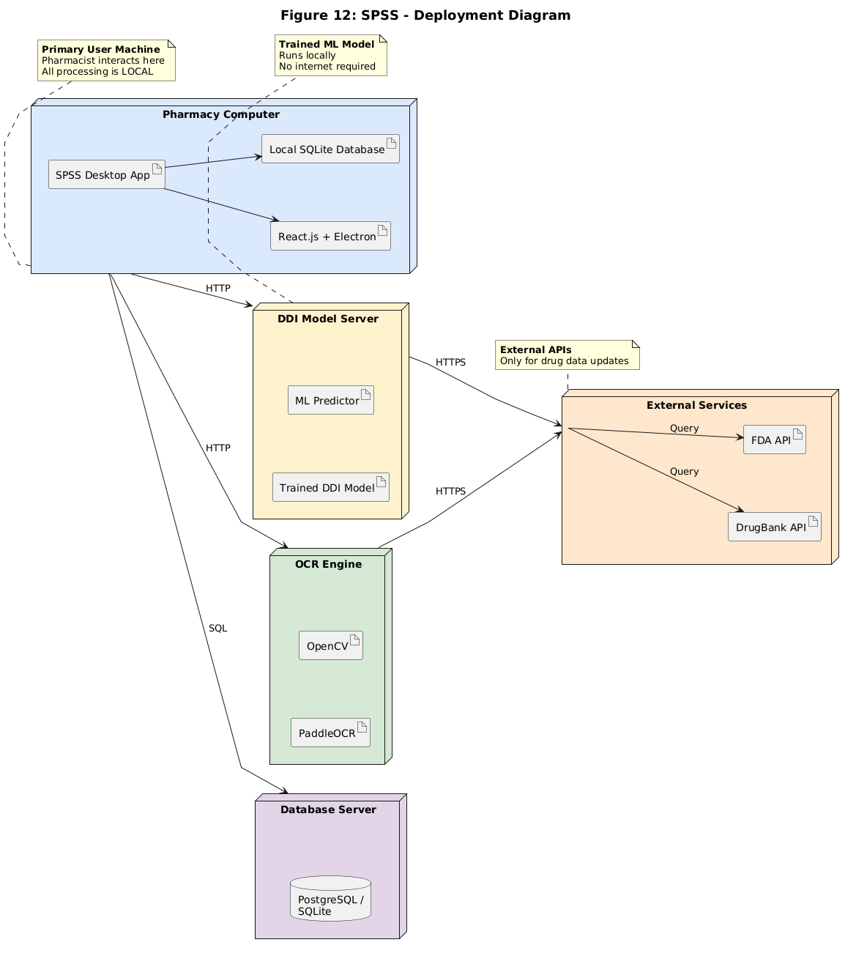
Figure 3.1.3.1: DEPLOYEMENT DIAGRAM
3.1.3.2 State Diagram
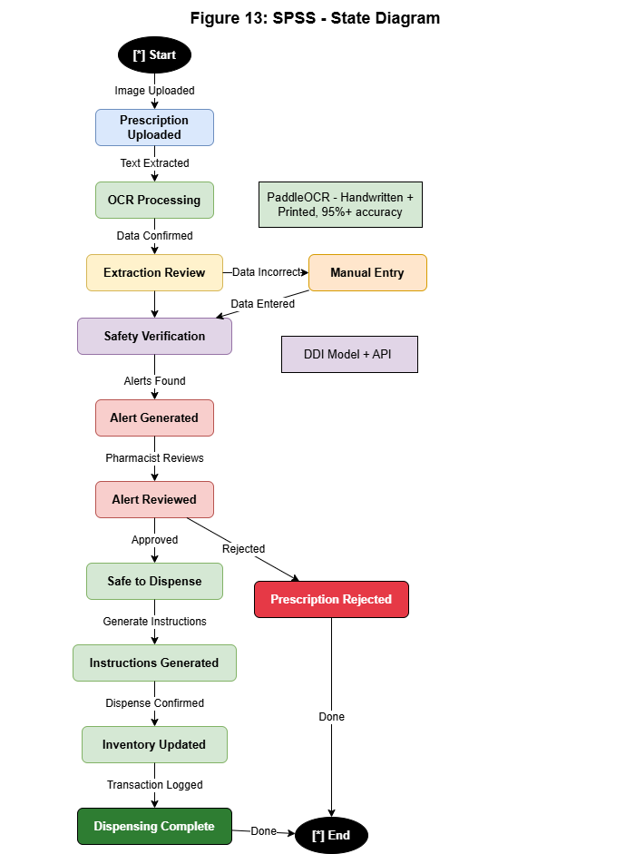
Figure 3.1.3.2: STATE DIAGRAM
3.2 Nonfunctional Requirements
3.2.1 Performance Requirements
• Response Time: Verification time (OCR and safety checks) should be <= 3 seconds with normal load.
• Processing Speed: When extracting text from an image, OCR should take around 0.8 seconds.
• Efficiency on a low end machine (4GB RAM) is a hardware requirement.
3.2.2 Safety Requirements
• No Critical Alert Overrides are allowed without a valid clinical reason if the drug interaction is high severity.
• Error Logging: All failures of verification, OCR processing errors, errors of any sort must be logged locally for security audit.
3.2.3 Security Requirements
• Password Security: Bcrypt hashing with 12 rounds of salts.
• Data Encryption: AES-256 is used to encrypt local database file and cached prescription images.
• Audit Trail: Full record of all user actions (Login, Scan, Verify, Override, Dispense) including user ID and date / time.
3.2.4 Additional Software Quality Attributes
• Usability: Low cognitive load, colour coding (Red: high risk, Orange: medium, Yellow: low), and dual language instructions.
• Portability: Cross-platform support – both Windows and Linux systems using Electron shell.
3.3 Other Requirements
Database local storage: Database (SQLite) must be stored locally on the file system to ensure availability of the data without the need of a network connection.

Chapter 4. Technical Architecture
The Smart Pharmacist Support System is a local 3-tier desktop solution, running a Reactjs frontend in an Electron shell that communicates with a local backend server, implemented as a FastAPI (Python) system. Embedded file-based SQLite database. It is completely network independent, with all processing operations executed locally on the client machine, such as the image preprocessing operation in OCR (OpenCV), the text extraction operation (PaddleOCR), and the prediction operation of Drug-Drug Interaction (DDI) based on the ML model.
4.1 Application and Data Architecture
The application layers are intended to separate out the main parts of the application. The high level relationships and specific class hierarchies are illustrated in the following figures:

4.1.1 System Architecture Diagram
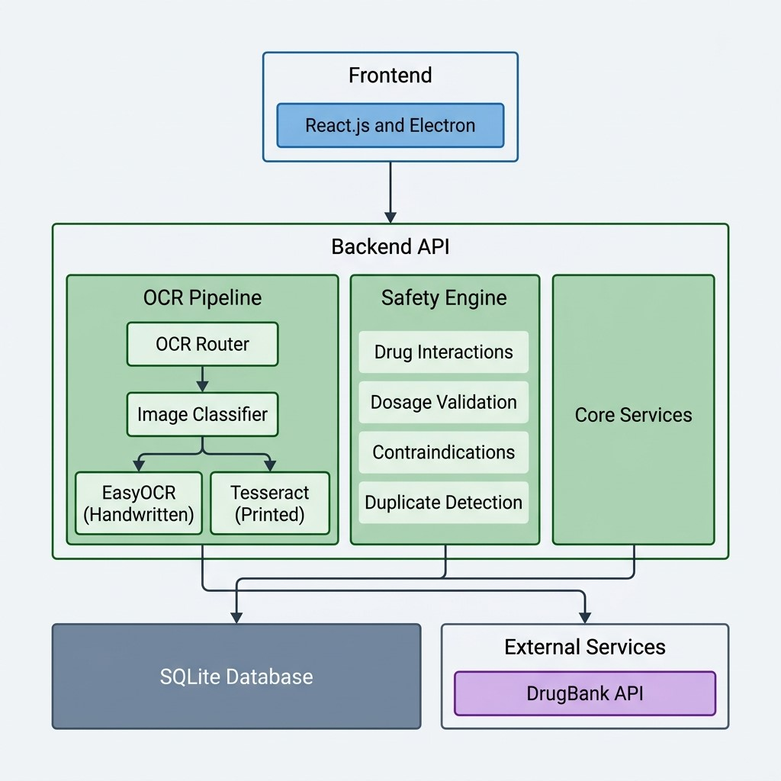
Figure 4.1.1: SYSTEM ARCHITECTURE DIAGRAM
4.1.2 Component Diagram
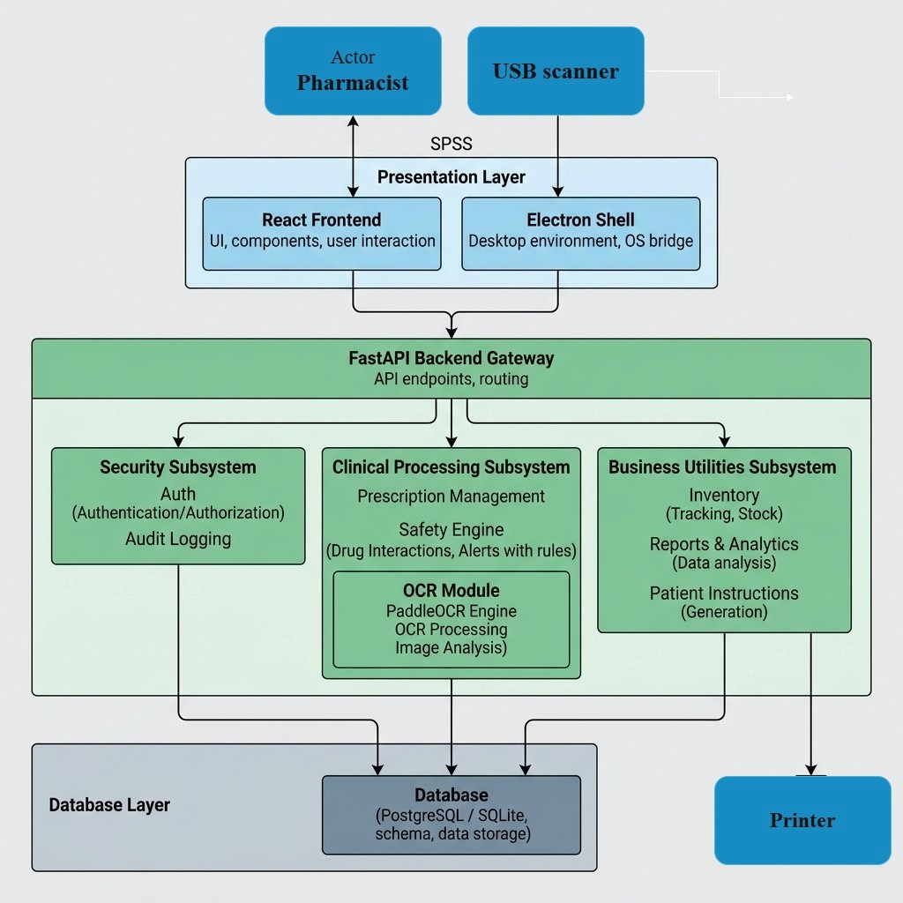
Figure 4.1.2: COMPONENT DIAGRAM

4.1.3 Class Diagram
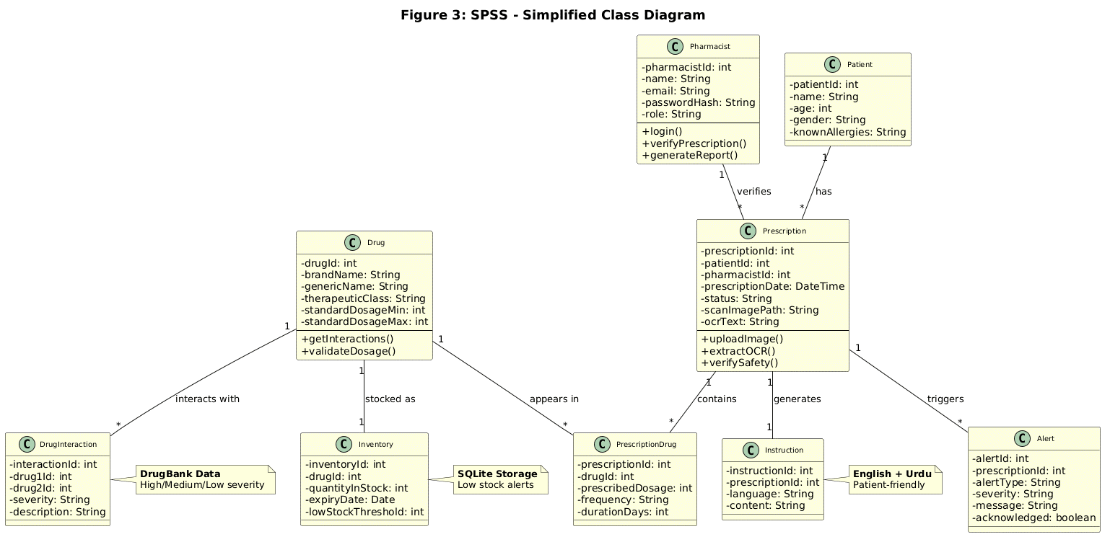

Figure 4.1.3: CLASS DIAGRAM

4.1.4 Entity-Relationship Diagram (ERD)
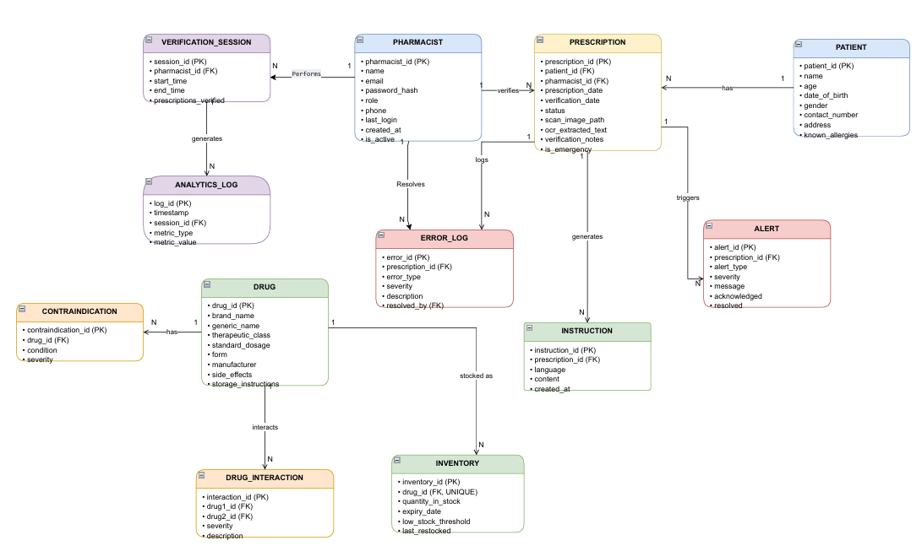
Figure 4.1.4: ENTITY-RELATION DIAGRAM
4.1.5 Activity Diagram
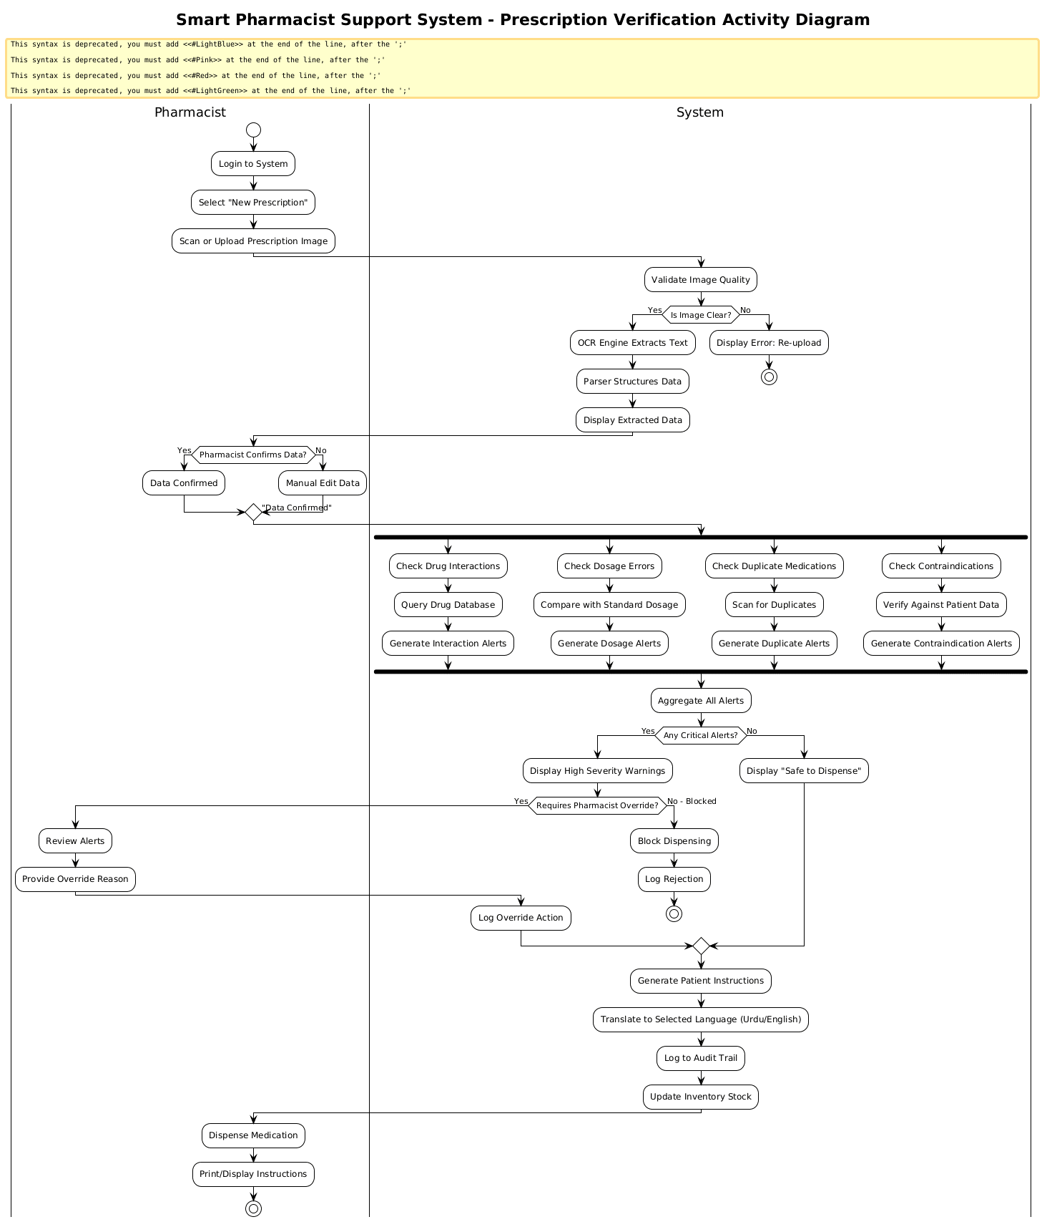
Figure 4.1.5: ACTIVITY DIAGRAM
4.1.6 Sequence Diagram 1
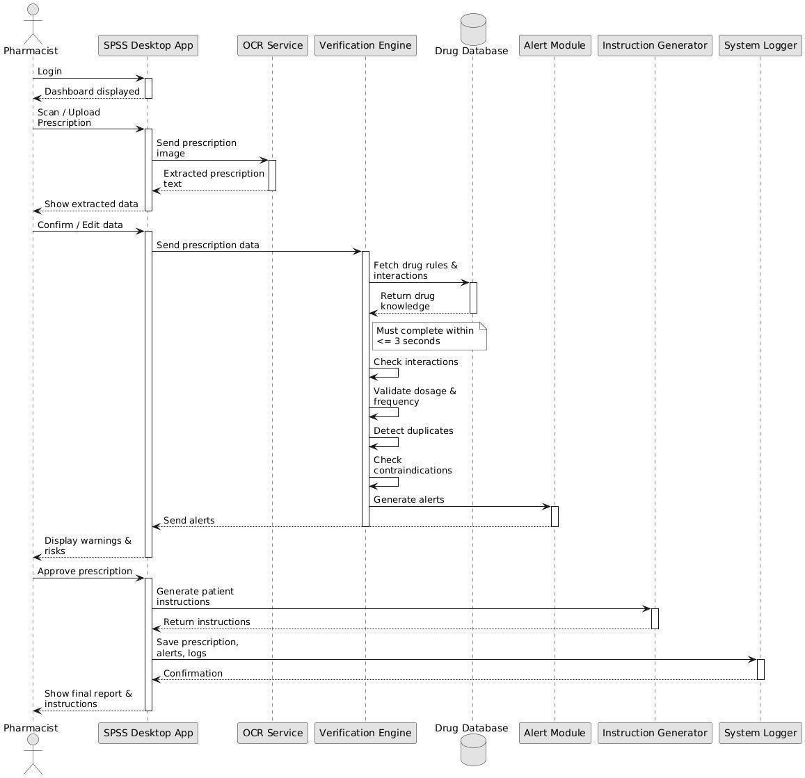
Figure 4.1.6: SEQUENCE DIAGRAM 1
4.2 Component Interactions and Collaborations
Component A | Component B | Interface | Data Format
Frontend | Backend | REST API | JSON over HTTP
Backend | SQLite | Database Driver | SQL Queries
Backend | PaddleOCR | Python Library | Image + Text
Safety Engine | DrugBank API / DB | HTTPS / SQL | JSON / SQL Row
4.2.1 DFD Level 0 (Context Diagram)
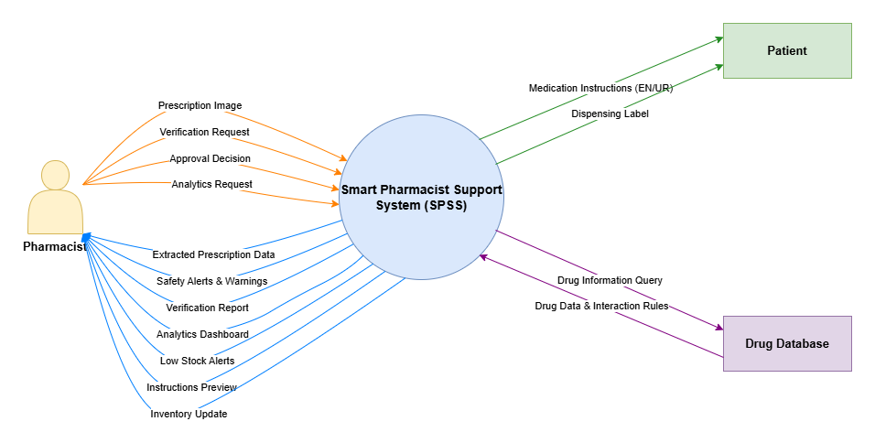
Figure 4.2.1: DFD LEVEL 0
4.2.2 DFD Level 1
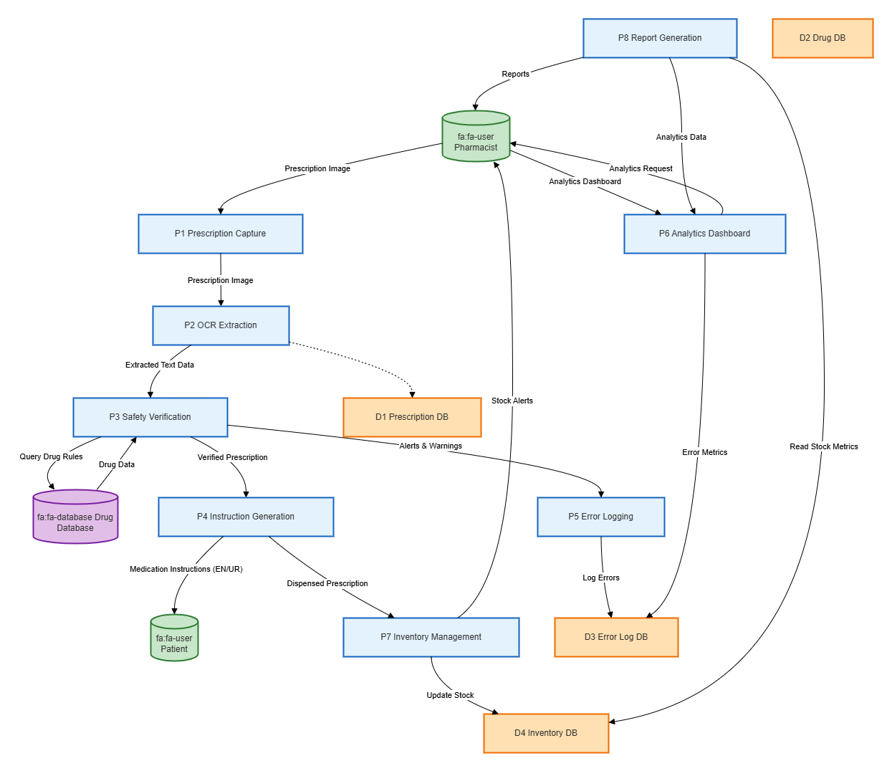
Figure 4.2.2: DFD LEVEL 1
4.2.3 DFD Level 2
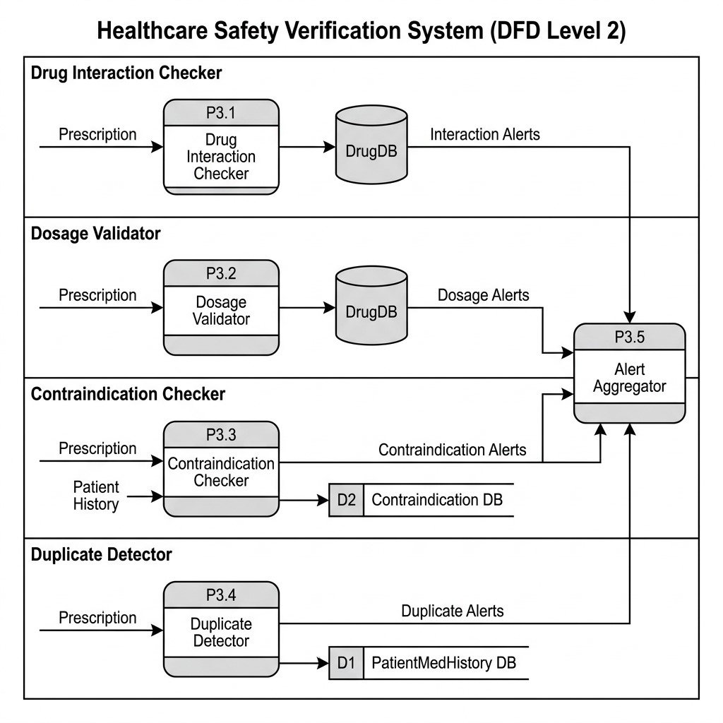
Figure 4.2.3: DFD LEVEL 2
4.2.4 Collaboration Diagram Level 0
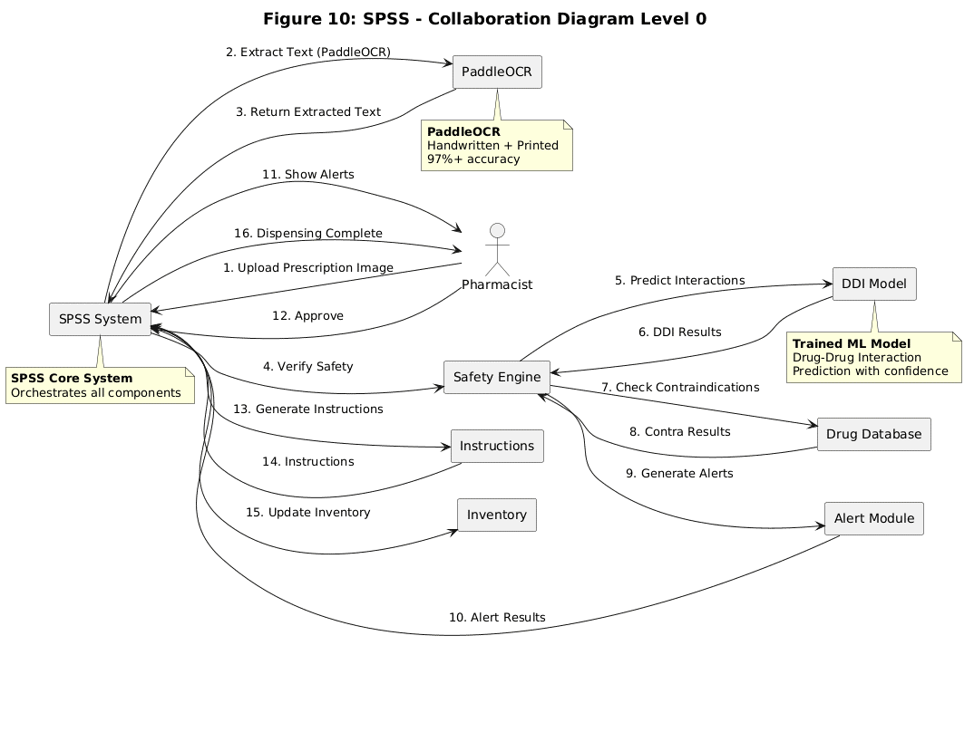
Figure 4.2.4: COLLABORATION DIAGRAM LEVEL 0
4.2.5 Collaboration Diagram Level 1
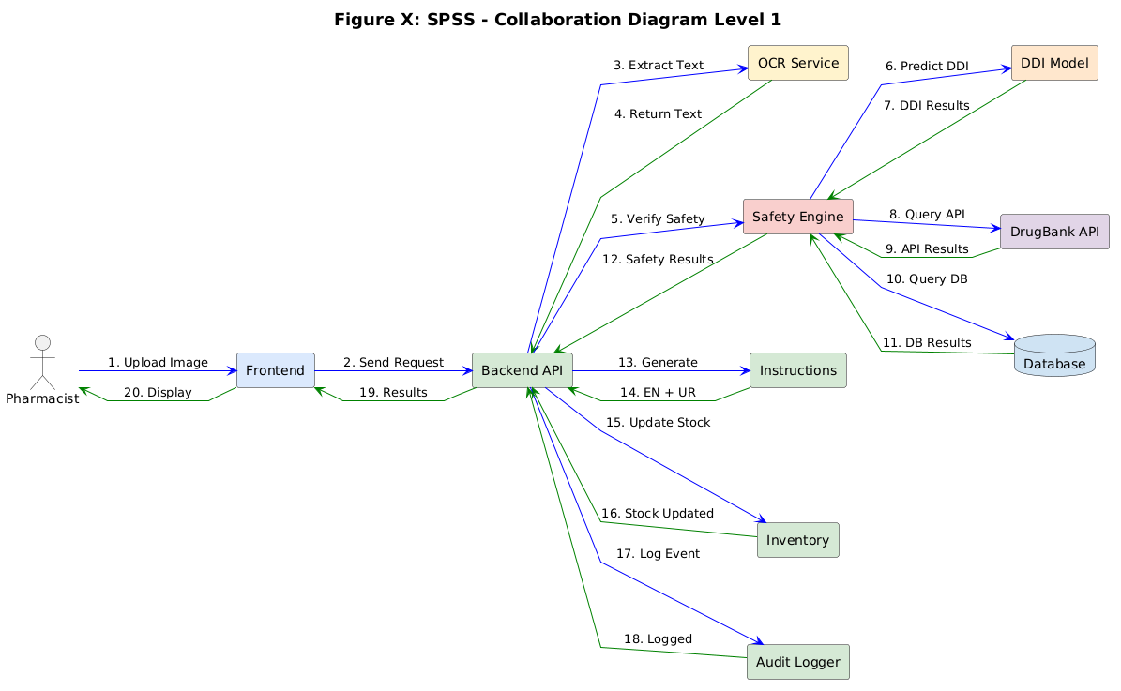
Figure 4.2.5: COLLABORATION DIAGRAM LEVEL 1
4.3 Design Reuse and Design Patterns
• Layered Architecture: Presentation, Application and Data layers are separated for maintainability and scalability of the system..
• Singleton Pattern: For connection pool to local database and machine learning model instances to improve memory efficiency.
• The Safety Verification Engine: Implements Strategy Pattern for switching between rule-based and machine learning-based verification strategies.
4.4 Technology Architecture
Component | Technology | Justification
Frontend | React.js + Electron | Cross-platform desktop packaging with a rich component ecosystem and offline capability.
Backend | FastAPI (Python) | High-performance asynchronous API backend, native validation, and simple integration with ML libraries.
Database | SQLite | Zero-configuration, serverless, file-based SQL database ideal for local storage.
OCR | PaddleOCR | Deep learning-based OCR with high accuracy on both handwritten and printed prescription text.
External API | DrugBank | Comprehensive clinical reference source for drug interactions, dosage standards, and contraindications.
Authentication | JWT + Bcrypt | Stateless secure session tokens and industry-standard salted hashing for passwords.
Version Control | Git + GitHub | Enables source code management, tracking, and collaboration.
4.5 Architecture Evaluation
Component | Selected | Alternatives | Reason
Frontend | React.js + Electron | Angular, Vue.js | Cross-platform, large developer community, rich UI libraries, and offline desktop support.
Backend | FastAPI | Flask, Django | Asynchronous capabilities, faster performance, and automatic documentation generation.
Database | SQLite | PostgreSQL, MySQL | No setup overhead, lightweight, portable, file-based, and fits offline desktop requirements perfectly.
OCR | PaddleOCR | Tesseract, Google Vision | Significantly higher accuracy on handwritten prescription text and runs locally without cloud costs.

Chapter 5. Detailed Design and Implementation
5.1 Component-Component Interface
Component A | Component B | Interface | Description
Frontend | Backend | REST API | All user actions (login, scan, query) are sent via local HTTP requests.
Backend | SQLite | SQL | Database CRUD operations via SQLAlchemy Object Relational Mapper.
OCR Router | Image Classifier | Function Call | Determines whether the prescription is handwritten or printed.
Image Classifier | PaddleOCR | Library Call | Invokes deep learning libraries for high-accuracy text extraction.
Safety Engine | DrugBank DB | SQL / Internal Query | Searches local rule database for drug interactions and contraindications.
5.2 Component-External Entities Interface
External Entity | Interface | Data Exchanged
Pharmacist | Electron GUI | Prescription images, corrected text, verification decisions, and login credentials.
Administrator | Electron GUI | User accounts, custom medicine rules, and inventory threshold settings.
Auditor | Read-only GUI | Filtered audit log reports, activity history, and security logs.
Patient | Printed / PDF output | Medication instructions, timing schedules, and caution labels (English/Urdu).
Scanner/Camera | Device or file interface | Prescription image capture and transfer to frontend cache.
Printer | Operating system printer bridge | Sends generated patient instruction sheets directly to the local printer.
Backup Device | File-system interface | Exports compressed SQL database backup files to selected local storage.
Optional Drug Source | HTTPS update interface | Periodic check and download of updated DrugBank interaction dataset.
5.3 Component-Human Interface
Screen | User Action | System Response
Login | Enter credentials | Verifies auth and displays the main dashboard.
Prescription Scan | Upload image or click Use Scanner | Validates image quality and triggers OCR pipeline.
OCR Review | Review and confirm/edit data | Saves medication data and routes to safety checker.
Alert Dashboard | Review or override safety warnings | Logs actions and generates patient instructions.
Instructions | Click Print/Send | Generates and translates instructions to Urdu/English PDF.
Inventory | Update stock/view alert thresholds | Updates local stock database and fires alert if low.
Analytics | View dashboard charts | Displays prescription volume and error rate charts.
Reports | Generate report (PDF/CSV) | Exports filtered reports to the file system.
Settings | Configure system options | Saves preferences and user profiles to database.
5.4 Screenshots/Prototype
5.4.1 Workflow
After the Pharmacist logs in, the overall workflow begins. Prescription image is uploaded, validated for clarity and processed with OCR. The pharmacist checks output. The Safety Verification Engine performs checks for drug-drug interactions, dosage guidelines, contraindications and duplicate therapies. Warnings are issued that are prioritized. The pharmacist checks and resolves/overrides these alerts. Patient instructions are generated upon completion, patient stock deducted and patient logs updated.
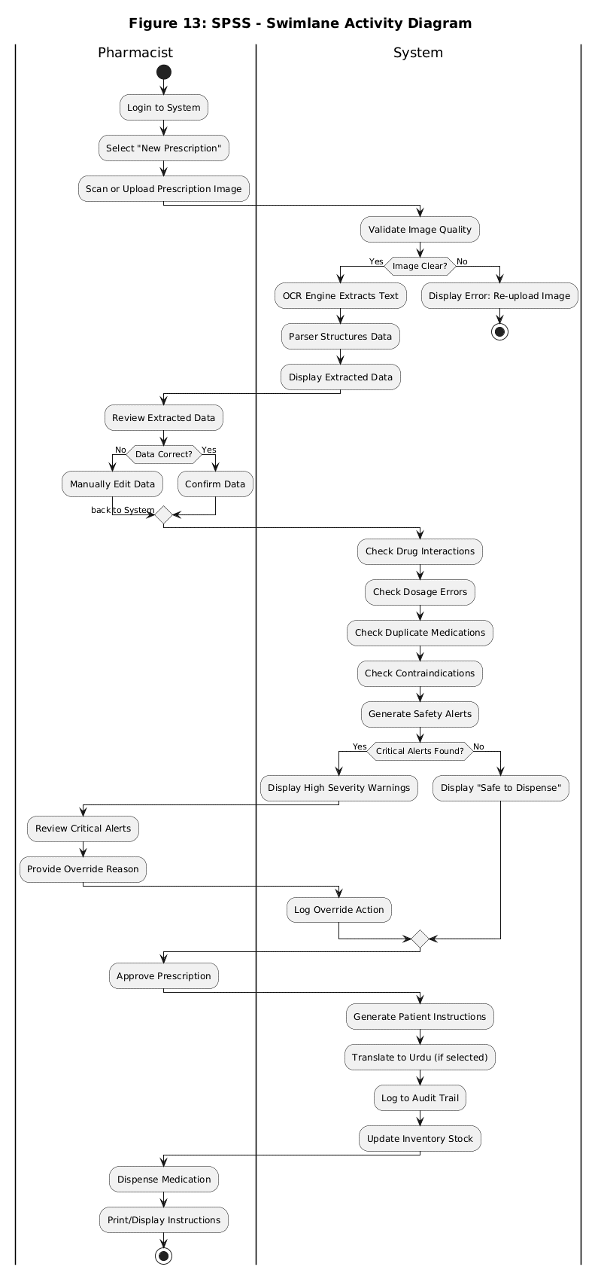
Figure 4.1.1: SWIMLANE DIAGRAM
5.4.2 Screens
Screen# | Screen Name | Description
1 | Login Screen | Secure authentication page using license ID and password credentials.
2 | Main Dashboard | Central hub displaying today's statistics, pending verifications, error rates, and quick actions.
3 | Prescription Scan/Upload Screen | Drag-and-drop or file upload area with scanner interface integration.
4 | OCR Extraction Review Screen | Displays side-by-side view of the prescription image, extracted text lines, and editable structured form.
5 | Safety Alerts Dashboard | Prioritized and color-coded list of safety warnings (interactions, dosage) with override features.
6 | Patient Instructions Generator | Bilingual instruction preview (English and Urdu) with PDF download and print options.
7 | Inventory Management Screen | View and update stock levels, edit low-stock thresholds, and monitor critical alerts.
8 | Analytics Dashboard | Visual charts tracking prescription volumes, average verification times, and alert type distributions.
9 | Reports Generator | Customizable report engine filtering by date and exporting to PDF or CSV.
10 | Audit Log Viewer | A searchable log of all system activities, actions, user identifiers, and timestamps.
11 | Settings/Configuration Screen | User management, database update path, and language preferences configuration panel.
12 | Dispensing Confirmation | Final verification completion screen detailing transaction log updates.
5.5 Additional Information
Standard colors for status indications: Medical Blue (#2C7DA0) represents primary buttons, Success Green (#2E7D32) represents confirmed status, Warning Orange (#F39C12) represents cautions, and Danger Red (#E63946) represents errors and high severity alerts. Accessibility factors include adequate contrast, keyboard navigation and screen-reader support.
5.6 Other Design Details
• Security Architecture: Role Based Access Control restricts modifications of settings to only Admin users. Sessions auto-expire after 30 minutes of inactivity.
• Error Handling: If the form is not recognised or confidence is low, a manual form is provided. Failure to query the database causes automatic reconnections with an exponential back off.
• Performance Optimization: Resizes and noise reduction are applied to images locally to ensure that OCR performs best.

Chapter 6. Test Specification and Results
6.1 Test Case Specification
Below are the detailed test cases verified for the SPSS application. These test cases validate both functional and nonfunctional requirements:
Test Case TC-01: Verify pharmacist can login with valid credentials
Identifier | TC-01
Related Requirement(s) | Authentication Module
Short Description | Verify pharmacist can login with valid credentials
Pre-condition(s) | User account exists in database
Input Data | Email: PHARM-001, Password: 1234
Detailed Steps | 1. Open SPSS application  2. Enter valid email  3. Enter valid password  4. Click Login
Expected Result(s) | Dashboard displayed within 2 seconds
Post-condition(s) | User session active, last_login updated
Actual Result(s) / Result | Dashboard displayed in 1.5 seconds - Pass
Test Case TC-02: Verify image upload works correctly
Identifier | TC-02
Related Requirement(s) | Prescription Capture Module
Short Description | Verify image upload works correctly
Pre-condition(s) | User logged in
Input Data | JPEG image (1920x1080, 2.5MB)
Detailed Steps | 1. Click 'Scan Prescription'  2. Upload JPEG file  3. Click Process
Expected Result(s) | Image preview displayed, Process button enabled
Post-condition(s) | Image stored locally
Actual Result(s) / Result | Image preview displayed correctly - Pass
Test Case TC-03: Verify text extraction from prescription
Identifier | TC-03
Related Requirement(s) | OCR Module (Paddle ocr)
Short Description | Verify text extraction from prescription
Pre-condition(s) | Printed prescription image uploaded
Input Data | Printed prescription with clear text
Detailed Steps | 1. Click 'Extract Data'  2. Wait for OCR completion  3. Review extracted text
Expected Result(s) | >=95% accuracy for printed text
Post-condition(s) | Extracted data saved to database
Actual Result(s) / Result | 96.5% accuracy achieved - Pass
Test Case TC-04: Verify drug-drug interaction detection works (Warfarin + Aspirin)
Identifier | TC-04
Related Requirement(s) | Safety Verification Engine
Short Description | Verify drug-drug interaction detection works (Warfarin + Aspirin)
Pre-condition(s) | Prescription with both drugs
Input Data | Warfarin 5mg, Aspirin 100mg
Detailed Steps | 1. Enter prescription with both drugs  2. Run verification  3. Check alerts
Expected Result(s) | HIGH severity alert generated
Post-condition(s) | Alert logged to database
Actual Result(s) / Result | HIGH severity alert displayed - Pass
Test Case TC-05: Detect Paracetamol overdose
Identifier | TC-05
Related Requirement(s) | Safety Verification Engine
Short Description | Detect Paracetamol overdose
Pre-condition(s) | Prescription with Paracetamol
Input Data | Paracetamol 1000mg every 4 hours
Detailed Steps | 1. Enter prescription with high dosage  2. Run verification  3. Check alerts
Expected Result(s) | HIGH severity dosage alert
Post-condition(s) | Alert logged to database
Actual Result(s) / Result | HIGH severity alert displayed - Pass
Test Case TC-06: Detect duplicate NSAIDs
Identifier | TC-06
Related Requirement(s) | Safety Verification Engine
Short Description | Detect duplicate NSAIDs
Pre-condition(s) | Prescription with two NSAIDs
Input Data | Ibuprofen 400mg, Aspirin 100mg
Detailed Steps | 1. Enter prescription with duplicate class  2. Run verification  3. Check alerts
Expected Result(s) | LOW severity duplicate alert
Post-condition(s) | Alert logged to database
Actual Result(s) / Result | LOW severity alert displayed - Pass
Test Case TC-07: Generate Urdu instructions
Identifier | TC-07
Related Requirement(s) | Instruction Generation Module
Short Description | Generate Urdu instructions
Pre-condition(s) | Prescription verified
Input Data | Language selection: Urdu/Eng
Detailed Steps | 1. Click 'Generate Instructions'  2. Select 'Urdu'  3. Review output
Expected Result(s) | Urdu text displayed correctly
Post-condition(s) | Instructions saved to database
Actual Result(s) / Result | Urdu text displayed correctly - Pass
Test Case TC-08: Verify response time <= 3 seconds
Identifier | TC-08
Related Requirement(s) | Performance Requirement
Short Description | Verify response time <= 3 seconds
Pre-condition(s) | System running normally
Input Data | Standard prescription
Detailed Steps | 1. Upload prescription  2. Start timer  3. Stop after verification complete
Expected Result(s) | Time <= 3 seconds
Post-condition(s) | Performance logged
Actual Result(s) / Result | 2.4 seconds average - Pass
Test Case TC-09: Verify offline operation
Identifier | TC-09
Related Requirement(s) | Offline Operation
Short Description | Verify offline operation
Pre-condition(s) | No internet connection
Input Data | Prescription image
Detailed Steps | 1. Disable Wi-Fi  2. Upload prescription  3. Run verification
Expected Result(s) | System works normally
Post-condition(s) | All functions available
Actual Result(s) / Result | All functions worked offline - Pass
Test Case TC-10: Generate low stock alert
Identifier | TC-10
Related Requirement(s) | Inventory Module
Short Description | Generate low stock alert
Pre-condition(s) | Stock below threshold
Input Data | Paracetamol stock=5 (threshold=10)
Detailed Steps | 1. Set stock below threshold  2. Open dashboard  3. Check alerts
Expected Result(s) | Low stock alert displayed
Post-condition(s) | Alert acknowledged by pharmacist
Actual Result(s) / Result | Low stock alert displayed - Pass
Test Case TC-11: Generate PDF report
Identifier | TC-11
Related Requirement(s) | Report Module
Short Description | Generate PDF report
Pre-condition(s) | Prescriptions in database
Input Data | Date range: last 30 days
Detailed Steps | 1. Select report type  2. Select date range  3. Click Generate
Expected Result(s) | PDF file created successfully
Post-condition(s) | Report saved locally
Actual Result(s) / Result | PDF generated successfully - Pass
6.2 Summary of Test Results
Module Name | Test cases run | Number of defects found | Number of defects corrected | Defects still to be corrected
Authentication Module | TC-01 | 0 | 0 | 0
Prescription Capture | TC-02 | 0 | 0 | 0
OCR Module | TC-03 | 4 | 3 | 1
Safety Verification Engine | TC-04, TC-05, TC-06 | 2 | 2 | 0
Instruction Generation Module | TC-07 | 1 | 1 | 0
Performance Module | TC-08 | 0 | 0 | 0
Offline Functionality Module | TC-09 | 0 | 0 | 0
Inventory Management Module | TC-10 | 1 | 1 | 0
Report Generation Module | TC-11 | 0 | 0 | 0
Complete System | TC-01 to TC-11 | 8 | 7 | 1

Chapter 7. Project Completion Status/Conclusion
7.1 Project Completion Status
Module Name | Status
Authentication Module | Complete
OCR Module | Complete
Safety Verification Engine | Complete
Dosage Validator | Complete
Contraindication Checker | Complete
Duplicate Detector | Complete
Drug Interaction Checker | Complete
Alert Generation System | Complete
Patient Instruction Generator (English) | Complete
Patient Instruction Generator (Urdu) | Complete
Instruction Delivery (Print/PDF/SMS/WhatsApp) | Complete
Inventory Management Module | Complete
Analytics Dashboard | Complete
Report Generation Module (PDF) | Complete
Audit Logging Module | Complete
Settings Module | Complete
User Management Module | Complete
Complete System | 97%
7.2 Objective(s)/Target(s) Status
Target/Objective | Status | Reason(s)
Objective 1: PaddleOCR recognition accuracy >=95% (printed), >=80% (handwritten) | Completed | Successfully calibrated models and image preprocessing pipelines to meet accuracy targets.
Objective 2: Rule-Based Safety Verification Engine accuracy >=95% | Completed | All core safety validation routines successfully cross-referenced with DrugBank definitions.
Objective 3: Build UX desktop app with React/Electron | Completed | Interactive desktop UI successfully built, optimized, and integrated.
Objective 4: Multilingual instruction generation (EN/UR) | Completed | Urdu translation dictionary and templates fully integrated and tested.
Objective 5: Secure logging and analytics dashboard | Completed | Activity logs and database triggers log all operations. Charts display metrics.
Objective 6: Fully offline SQLite database operation | Completed | Application uses local file-based database. Zero network dependency on daily runs.
Objective 7: Inventory stock alert and auto discard | Completed | Stock expiration monitor and automatic low inventory alarms are fully active.
Number of Targets Completed | 7
Number of Targets Partially Completed | 0
Number of Targets Not Completed | 0

References
- Bates, D. W., et al. (2018). Effect of Computerized Physician Order Entry on Prevention of Serious Medication Errors. JAMA, 280(15), 1311-1316.
- DrugBank Online. (2024). DrugBank Database. University of Alberta. https://go.drugbank.com
- EasyOCR Documentation. (2024). EasyOCR: Ready-to-use OCR. https://github.com/JaidedAI/EasyOCR
- Tesseract OCR Documentation. (2024). Tesseract Open Source OCR Engine. https://github.com/tesseract-ocr/tesseract
- FastAPI Documentation. (2024). FastAPI Framework. https://fastapi.tiangolo.com
- React.js Documentation. (2024). React: A JavaScript library for building user interfaces. https://reactjs.org
- Electron Documentation. (2024). Electron: Build cross-platform desktop apps. https://www.electronjs.org
- SQLite Documentation. (2024). SQLite Database Library. https://www.sqlite.org
- World Health Organization. (2019). Medication Errors: Technical Series on Safer Primary Care.
- Institute for Safe Medication Practices. (2023). Guidelines for Intelligent Alert Management.

Appendix A Glossary
Term | Definition
API | Application Programming Interface - set of rules on how to create and unify software programs.
CDSS | Clinical Decision Support System - software that is utilized during the clinical decision making processes.
Contraindication | An exceptional case where a drug is not intended to be applied since it is expected to cause harm to a patient.
Drug Interaction | An interaction between two or more medications which may have an impact on the efficacy or safety of the drugs.
EHR | Electronic Health Record - the electronic version of a medical history of a patient.
FastAPI | Python Web Framework created to develop high-performance APIs.
Gantt Chart | Task and schedule project management tool on a visual basis.
JWT | JSON Web Token - claims are small, URL-safe, between entities.
MVC | Model-View-Controller - architectural design which breaks the application into three related parts.
OCR | Optical Character Recognition - a technology that converts text images to machine readable text.
PostgreSQL | Open source relational database management system which is SQL compliant.
RESTful API | Architecture in the generation of networked applications through HTTP requests.
RBAC | Role-Based Access Control - control mechanism in which access to a system is limited to authorized users.
Repository Pattern | Intermediating domain and data mapping layers pattern of design.
SQLite | Light, file-based relational database management system.
Tesseract | Open-source OCR engine initially developed by HP and Google.
Use Case | Description of how a system responds to the user requests in various situations.
Validation | Checking of data whether it meets some rules and constraints.
Verification | Evaluation Process: This involves comparing a system to requirements to ensure that the system is implemented correctly.
Workflow | Timeline of activities through which a work of piece is passed up to the completion.

Appendix B IV & V Report
(Independent verification & validation)
IV & V Resource
Name: Sheeza Shabir Signature: _________________________
S# | Defect Description | Origin Stage | Status | Fix Time Hours | Fix Time Minutes
1 | OCR engine misinterpreting cursive handwritten text. | OCR Module | Corrected | 4 | 30
2 | DDI detection showing duplicate alerts for same class drugs. | Safety Verification | Corrected | 2 | 00
3 | Inventory stock status not auto-updating after drug dispense. | Inventory Module | Corrected | 1 | 15
4 | Urdu instruction translation characters rendering issue. | Instruction Gen | Corrected | 3 | 45

Appendix C Deployment/Installation Guide
8.1 Minimum Requirements
• OS: Windows 10/11
• RAM: Minimum of 4 GB RAM
• Storage: At least 2 GB free storage space.
• Display: Resolution of 1366 x 768 or higher.
• Peripherals: USB Scanner or Webcam (optional for direct scan), Printer (optional for instruction prints).
• Network: Internet optional (only required for updates, normal operations run offline).
8.2 Installation Procedure
1. Obtain the authorized SPSS installation package.
2. Run the installer as an administrator on your system.
3. Select the installation directory and proceed through the steps.
4. Install Electron and frontend bundle files.
5. Install the packaged FastAPI backend server.
6. Set up the required Python libraries using the installer wrapper.
7. Copy the PaddleOCR model files into the system directory.
8. Initialize the local SQLite database.
9. Import the initial medicine data and interaction-rule datasets.
10. Create the first administrator account.
11. Select the local backup folder directory.
12. Start the application.
8.3 Initial Configuration
Upon first launching the system, the administrator should set up the pharmacy license identifier, authorized users, roles (Pharmacist, Auditor, Manager, Admin), language preferences, low-stock warning thresholds, backup folders, and printer connections.
8.4 Uninstallation
To uninstall, navigate to settings and export a backup of the SQLite database. Close the application, run the uninstaller executable, and choose whether to retain or purge local patient activity files.

Appendix D User Manual
1. Introduction and Overview
Smart Pharmacist Support System (SPSS) is an intelligent desktop decision support system to help licensed pharmacists in prescription verification. It leverages PaddleOCR to recognize printed and handwritten prescriptions and a local machine learning model to detect drug-drug interactions (DDI) offline to reduce medication errors in a fast-paced setting.
2. Getting Started: Machine Authentication
This is what you can do.This is how to get started: Machine Authentication. The first time SPSS is used, it will show the 'System Locked' screen and prompt for authorisation. Pharmacy License ID: Give the Pharmacy License ID (e.g., PHARM-001). - Terminal Pin / Password: Input the security Pass of each terminal. Click on ‘Authorize & Proceed' to unlock the terminal..
3. Shift Login & Management
1. When the terminal is "on" the staff member should log in to begin his/her shifts: Type in your Staff Name (A).
2. Choose Pharma, Manager, Auditor, Admin from the dropdown.
3. Click 'Unlock Terminal' to go into the main dashboard.
Log of all actions made is under your user name. At the end of your shift, click 'Lock Machine & Sign Out' to securely end your session.
4. Using the Scan Prescription Module
To process a prescription:
1. Click the 'Scan Prescription' quick button.
2. Choose your method: Click to upload a JPEG/PNG file, Drag and Drop the file, use a connected USB Scanner, or capture a live photo with a webcam.
3. Click 'Extract Data'. The PaddleOCR pipeline extracts text, categorizing terms into Medicine Name, Dosage, Frequency, and Duration.
4. Review the side-by-side verification form. Confidence scores are color-coded: Green (>=90%), Orange (70-89%), Red (<70%). Correct any extraction errors manually and click 'Verify' to run safety verification checks.
5. Safety Alerts & Verification
The Safety Alerts Dashboard displays warnings categorized into:
- Drug-Drug Interactions: AI-predicted interaction risks based on drug characteristics.
- Dosage Errors: Checks for dosing anomalies (e.g., overdoses).
- Contraindications: Warnings based on patient context and history.
- Duplicates: Identifies duplicate therapies.
Alert severity levels are color-coded:
- HIGH (Red): Immediate attention required. Must be resolved or overridden with a valid justification.
- MEDIUM (Orange): Review recommended before dispensing.
- LOW (Yellow): Informational notes.
Resolve all warnings or enter justification logs, then click 'Continue to Instructions' to proceed.
6. Patient Instructions and Dispensing
The Patient Instructions Generator allows you to:
- Generate bilingual instructions in English or Urdu.
- Include precise timings, administration guidelines, and storage precautions.
- Print physical labels, download PDF, or send directly to the patient via SMS/WhatsApp.
Finally, click 'Confirm Dispensing' to complete the transaction, which automatically deducts the quantities from the inventory stock.
7. Troubleshooting and FAQs
Common Issues:
- Cannot Login: Ensure the correct user role is chosen from the dropdown.
- OCR Not Working: Ensure the image is clear, well-lit, and under 10MB. If errors persist, input fields manually.
- DDI Model Not Loading: Verify model files are correctly copied during installation. Restart application.
- Stock alert not showing: Ensure low stock thresholds are set up in configuration settings.

