BSCS FINAL PROJECT
Smart Pharmacist Support System


Advisor: Sheeza Shabir
Presented by:
Group ID: FYP26-CS-G15
Student Reg# | Student Name
S3F22UBSCS059 | Qasim Majid
S3F22UBSCS014 | Rohaan Naseer
S3F22UBSCS015 | Fiza Ali
Faculty of Information Technology & Computer Science
University of Central Punjab

Smart Pharmacist Support System
By
Qasim Majid, Rohaan Naseer, Fiza Ali
Thesis/Project submitted to
Faculty of Information Technology & Computer Science,
University of Central Punjab,
Lahore, Pakistan.
in partial fulfillment of the requirements for the degree of
BACHELOR OF SCIENCE
IN
COMPUTER SCIENCE
_________________________ _________________________
Project Advisor Manager Projects

Abstract
Medication errors have emerged as a critical challenge in modern healthcare delivery, contributing to prolonged hospital stays, patient complications, and increased economic burdens. The Smart Pharmacist Support System (SPSS) address this issue by introducing a local, desktop-based clinical decision support tool designed to streamline prescription validation. Utilizing a hybrid rule-based engine coupled with a specialized machine learning model trained on DrugBank data, the system analyzes prescription details to predict potential drug-drug interactions, flag dosage anomalies, detect duplicate therapies, and screen contraindications. The optical character recognition (OCR) interface, powered by PaddleOCR, converts scanned or uploaded handwritten and printed prescriptions into structured digital fields with high accuracy. Operating entirely offline to safeguard patient privacy, the system runs on standard hardware configurations and is packaged within an Electron desktop framework. This Design and Test Specification (DTS) outlines the system architecture, database tables, user classes, data flows, and test cases that validate the feasibility, reliability, and security of SPSS as a practical aid to working pharmacists.

Dedication
This dissertation and project work is dedicated to our parents, who have offered constant motivation, unconditional love, and support throughout our years of study. We also dedicate this system to our respected professors and advisors whose teachings laid the foundation for our technical growth and professional understanding.

Acknowledgements
We wish to express our deep appreciation to our project advisor, Sheeza Shabir, for providing guidance, knowledge, and critical reviews throughout the development of the Smart Pharmacist Support System. Her comments were highly valuable in refining our application architecture and testing procedures.
We are also thankful to the Faculty of Information Technology & Computer Science at the University of Central Punjab for providing a supportive environment and resources that made this project possible.

List of Figures
Figure 2.1.1: System Architecture Diagram .......................................................................... 7
Figure 2.1.2: Component Diagram ............................................................................................ 8
Figure 2.1.3: Class Diagram ...................................................................................................... 9
Figure 2.1.4: Entity-Relationship Diagram (ERD) .................................................................... 10
Figure 2.1.5: Activity Diagram ................................................................................................. 11
Figure 2.1.6: Sequence Diagram 1 ........................................................................................... 12
Figure 2.2.1: DFD Level 0 (Context Diagram) ......................................................................... 13
Figure 2.2.2: DFD Level 1 ........................................................................................................ 14
Figure 2.2.3: DFD Level 2 ........................................................................................................ 15
Figure 2.2.4: Collaboration Diagram Level 0 ............................................................................ 16
Figure 2.2.5: Collaboration Diagram Level 1 ............................................................................ 17
Figure 3.1.1: Deployment Diagram .......................................................................................... 20
Figure 3.1.2: State Diagram ...................................................................................................... 21
Figure 4.1.1: Swimlane Diagram .............................................................................................. 23

List of Tables
Table 1.3: Objective(s)/Target(s) Priority ........................................................................... 2
Table 1.4.1: Included within Scope ......................................................................................... 3
Table 1.4.2: Excluded from Scope ......................................................................................... 4
Table 1.5: Business Goals and Key Performance Indicators ..................................................... 5
Table 2.3: User Classes and Characteristics ............................................................................ 6
Table 3.1.1: Use Case 1 - Upload and Extract Prescription Data .............................................. 18
Table 3.1.2: Use Case 2 - Run Safety Verification and Detect Alerts ...................................... 19
Table 4.2: Component Interactions and Collaborations ............................................................ 22
Table 4.4: Technology Architecture ......................................................................................... 24
Table 4.5: Architecture Evaluation ......................................................................................... 25
Table 5.1: Component-Component Interface ........................................................................... 26
Table 5.2: Component-External Entities Interface ................................................................... 27
Table 5.3: Component-Human Interface .................................................................................. 27
Table 5.4.2: Software Screens and Descriptions ...................................................................... 29
Table 6.2: Summary of Test Results ........................................................................................ 38
Table 7.1: Project Completion Status ........................................................................................ 43
Table 7.2: Objective(s)/Target(s) Status ................................................................................... 43
Table B.1: List of Non-Trivial Defects (IV & V) ....................................................................... 47

List of Illustrations
Illustration 4.1: UI Mockup - Prescriptions Scan view ......................................................... 28
Illustration 4.2: UI Mockup - Safety Dashboard warning views ............................................ 30
Illustration 4.3: UI Mockup - Patient Instruction Panel ......................................................... 32

Table of Contents
Abstract ................................................................................................................................... i
Dedication ............................................................................................................................... ii
Acknowledgements ................................................................................................................ iii
List of Figures ........................................................................................................................ iv
List of Tables ...........................................................................................................................v
List of Illustrations ................................................................................................................ vi
Table of Contents ................................................................................................................... vii
Revision History ..................................................................................................................... ix
Chapter 1. Introduction ..........................................................................................................1
1.1 Product (Problem Statement) ........................................................................................... 1
1.2 Background ....................................................................................................................... 1
1.3 Objective(s)/Aim(s)/Target(s) ......................................................................................... 2
1.4 Scope ................................................................................................................................ 3
1.5 Business Goals ................................................................................................................. 5
1.6 Challenges ........................................................................................................................ 5
1.7 Learning Outcomes ........................................................................................................... 5
1.8 Nature of End Product ....................................................................................................... 5
1.9 Related Work/ Literature Survey/ Literature Review ....................................................... 5
1.10 Document Conventions ................................................................................................... 5
1.11 Miscellaneous ................................................................................................................. 5
Chapter 2. Overall Description ................................................................................................6
2.1 Product Features .............................................................................................................. 6
2.2 Functional Description ..................................................................................................... 6
2.3 User Classes and Characteristics ...................................................................................... 6
2.4 Design and Implementation Constraints ........................................................................... 6
2.5 Assumptions and Dependencies ........................................................................................ 6
Chapter 3. System Requirements ..........................................................................................18
3.1 Functional Requirements .................................................................................................. 18
3.2 Nonfunctional Requirements .................................................................................----------- 19
3.3 Other Requirements .................................................................................................-------- 19
Chapter 4. Technical Architecture ..........................................................................................22
4.1 Application and Data Architecture .................................................................................... 22
4.2 Component Interactions and Collaborations .................................................................--- 22
4.3 Design Reuse and Design Patterns .................................................................................. 23
4.4 Technology Architecture .................................................................................................. 24
4.5 Architecture Evaluation ................................................................................................... 25
Chapter 5. Detailed Design and Implementation .................................................................--26
5.1 Component-Component Interface .................................................................------------------ 26
5.2 Component-External Entities Interface .................................................................----------- 27
5.3 Component-Human Interface .................................................................................--------- 27
5.4 Screenshots/Prototype ..................................................................................................... 28
5.5 Additional Information .................................................................................................... 29
5.6 Other Design Details .................................................................................................------- 29
Chapter 6. Test Specification and Results .................................................................------------33
6.1 Test Case Specification .................................................................................................--- 33
6.2 Summary of Test Results .................................................................................................. 38
Chapter 7. Project Completion Status/Conclusion .................................................---------------43
References .................................................................................................................---------------45
Appendix A Glossary .................................................................................................------------46
Appendix B IV & V Report ..................................................................................................--47
Appendix C Deployment/Installation Guide .................................................................-------48
Appendix D User Manual .................................................................................................------49

Revision History
Name | Date | Reason For Changes | Version
FYP Team G15 | 2026-08-18 | Initial compilation of DTS template with Phase 4 content | 1.0

Chapter 1. Introduction
One of the biggest preventable patient harms in a health system, worldwide, is medication error, and it is a leading cause of adverse drug reactions, longer hospital stays, increased mortality, and financial loss for both the patient and the health practitioner. Despite being the final line of defense in the right dispensing of medication, pharmacists find themselves working in a very challenging environment, with huge quantities of prescriptions to fill, tight time limits to work within, interruptions to their daily routines, and a heavy reliance on manually interpreting the illegible, incomplete or confusing handwritten prescriptions. These working environments involve a lot of professional training and clinical experience, but these working practices are not without risk of human error in the interpretation of the prescription that could lead to harmful drug-drug interactions, inappropriate dosing, ignoring contraindications, unnecessary double treatment and fatal side effects of the patients. All of this can be avoided with adequate technology and support. The prescription verification process one can imagine is now being taken up to a next level by innovative and intelligent prescription verification solution, designed for the direct automation of the whole prescription verification workflow using a full range of powerful and advanced Optical Character Recognition (OCR) technology to read out the medication information from prescriptions, a complex rule based safety checking module looking for drug interactions or drug dosage error and a workflow analytics engine.
This Design and Test Specification (DTS) report is the technical document of the entire SPSS system which incorporates system architecture, system component interactions, database schema, user interface design, test specifications, test outcomes and roadmap of how the proposed solution will be implemented. The document has key sections covering the technical architecture, detailed component design, screenshots and prototype, test specifications, updated project plan, references and appendices. The diagrams, tables and test cases provided in this document are representative of the real implementation of the SPSS and reflect the current development phase.
1.1 Product (Problem Statement)
A desktop-based intelligent decision support system to assist licensed pharmacists in the accurate verification of a prescription in the safe dispensing of a pharmaceutical product is called the Smart Pharmacist Support System (SPSS). The system is intended to be used in conjunction with manual prescription checking and a pharmacist's decision-making process, thus eliminating tedious repetitive automation of prescription check, while keeping the clinical assessment and professional control of the pharmacist. In result, it is a stand-alone software application combining Optical Character Recognition (OCR) safety checks based on rules, multilingual patient education generation capabilities, inventory management and workflow analytics, running on standard Windows or Linux computer systems in any pharmacy. Based on the OCR strategy, the system is developed using PaddleOCR, which can not only recognize handwritten prescriptions but also recognize printed text in various types of prescriptions, ensuring that drugs can be recognized with higher accuracy. The safety verification engine utilizes a hybrid model engine with rule-based logic (from DrugBank), drug-drug interaction prediction, dosage checking, duplication and contraindication checks via machine learning principles. The patient information is provided in both languages – English & Urdu, and the system is offline ensuring the privacy of patient information and continuous working in the pharmacy environment where network connection is weak.
1.2 Background
The current work processes of the pharmacy are manual verification of the systems, in which a pharmacist must read handwritten prescriptions and compare the different information about the medication, which is available in different resources, such as reference books, memory and incompatible software programs, making a decision about the safety of the medication with incomplete resources. This manual process is not only time consuming but also very reliant on individual attention, experience, and knowledge, and therefore prone to human error when working with high workloads and time constraints. Today's commercial systems of pharmacy management are not designed to support clinical decision making, which can only verify the prescription but cannot manage clinical alerts effectively. There are also relevant electronic prescribing systems and Clinical Decision Support Systems (CDSS) available, but they are typically based within the hospital, very costly to install, and often generate too many notifications resulting in alert fatigue – that is, alerts that are not caught.
1.3 Objective(s)/Aim(s)/Target(s)
# | Objective | Priority
1 | To develop and build a module capable of recognizing medicine related information from the handwritten and printed prescription documents with accuracy of at least 95% and 80% respectively. | High
2 | Implement a Rule Based Safety Verification Engine that identifies drug-drug interactions, dosage errors, multiple therapies and contraindications at 95% or higher overall accuracy. | High
3 | To build a new UX (desktop) application that uses React.js and Electron and is easily learnable and fits into the current workflow of the pharmacy setting. | High
4 | To strengthen the skills of multilingual patient instruction generation, both in English and Urdu. | Medium
5 | To enable secure logging and analytics to monitor metrics on workflows, error detection capabilities, verification time, etc., and derive actionable insights. | Medium
6 | To have that SQLite database work completely offline, or to give privacy to data even if the Internet connection is lost, no Internet dependency can be tolerated. | High
7 | To implement a Stock Alerting Feature, expiring Date Feature, and Auto Discard Stock Feature in an Inventory Management Module | Low
1.4 Scope
Included within Scope:
Category | Components
Prescription Processing | Image capture, preprocessing, OCR extraction
Safety Verification | Drug interactions, dosage validation, duplicate detection, contraindication screening
Patient Communication | Bilingual instruction generation (English / Urdu), printing, PDF download
Inventory Management | Stock tracking, expiry monitoring, low-stock alerts, automatic deduction
Analytics & Reporting | Volume tracking, error rate monitoring, verification time analysis, report generation
Security & Compliance | Authentication (JWT), RBAC, audit logging, encryption (AES-256)
Deployment | Desktop application for Windows and Linux platforms, fully offline operation, SQLite database integration.
Excluded from Scope:
Category | Components
Integration | EHR systems, external pharmacy systems, real-time clinical data exchange
Platforms | Mobile applications, web-based version, cloud hosting infrastructure
Data | Use of actual patient data, real-time drug database updates.
Medical Capabilities | Diagnosis support, treatment recommendations, autonomous dispensing
1.5 Business Goals
Business Goal | Key Performance Indicator (KPI)
Faster Prescription Processing | Average time required to verify a prescription
Improved Safety | Number and type of medicine safety alerts detected
Better Patient Communication | Successful English and Urdu instruction generation
Improved Inventory Control | Accuracy of low-stock and expiry alerts
Greater Accountability | Percentage of important actions recorded in audit logs
Offline Availability | Core functions available without internet
Improved Usability | Successful completion of pharmacy workflow tasks
1.6 Challenges
During the design and construction of the Smart Pharmacist Support System, several technical and structural obstacles were encountered. Foremost among these was achieving a reliable level of accuracy in extracting handwritten prescription text using PaddleOCR and OpenCV preprocessing filters, given the wide variation in medical penmanship. Additionally, running the neural network inference routines for drug-drug interaction prediction locally within an offline desktop wrapper like Electron introduced significant performance and RAM management challenges. Ensuring the local SQLite database could retrieve clinical cross-references and log high-frequency audit records without causing user-interface latency was also a key operational focus.
1.7 Learning Outcomes
Working on the SPSS project provided deep practical insights into several engineering domains. The team gained hands-on experience in building modern desktop systems utilizing Electron, React, and Python FastAPI as a local microservice architecture. We acquired a strong understanding of computer vision methods for text extraction and machine learning inference. From a domain perspective, the project highlighted the strict requirements of clinical data safety, proper auditing methods for medical logs, and the importance of dual-language patient communication in lowering administrative errors in local pharmacies.
1.8 Nature of End Product
The completed SPSS system is packaged as an offline, thick-client desktop application running natively on Windows or Linux systems. It acts as an interactive assistant for pharmacists, featuring a local database for instant access to inventory levels, patient histories, and drug-interaction datasets. By omitting cloud dependencies, the application remains fully secure, responsive, and available in environments where network connectivity is inconsistent.
1.9 Related Work/ Literature Survey/ Literature Review
Traditional pharmacy systems are largely restricted to inventory management and basic cash-register billing, providing very little assistance in clinical safety. While advanced Clinical Decision Support Systems (CDSS) exist in major hospitals, they generally require complex server setups, high licensing costs, and constant internet access. Research indicates that hospital systems often generate excessive warnings, leading to alert fatigue where critical warnings are ignored. SPSS addresses this gap by offering a lightweight, offline, and inexpensive alternative that combines PaddleOCR with a dedicated local machine learning classifier to predict drug-drug interactions with high accuracy and context-aware filtering.
1.10 Document Conventions
This report is hierarchically numbered (i.e., 1, 1.1, 1.2) to make it easy to navigate and reference. The most important words are bolded when they are first mentioned and abbreviations are also spelled out when they are first used (e.g., Optical Character Recognition (OCR)). The project-related names such as SPSS (Smart Pharmacist Support System) are always written in capital letters. Each diagram and figure have sequential numbering and descriptive captions, which make the diagrams and figures very clear and easy to understand.
1.11 Miscellaneous
The major technical document, which will be used by development team to give instructions to the remaining team, will be the Software Design Specification that will give the estimation to the implementation, testing, and quality assurance team with the whole project. The document will be supported during the lifecycle of the development and the amendments will be pointed out on the design refinements and implementation decisions. All members of the team should follow the patterns and decisions regarding the architecture and design, which are recorded in the present document in order to make them consistent and sustainable.

Chapter 2. Overall Description
2.1 Product Features
The Smart Pharmacist Support System combines several key features to assist pharmacists during their daily shifts: secure machine authentication to prevent unauthorized database access, localized OCR processing to parse scanned prescription sheets, a safety checker for predicting drug-drug interactions and flagging duplicate therapies, multilingual patient instruction generation in both English and Urdu, and an integrated stock alert module to warn when stock levels fall below critical thresholds.
2.2 Functional Description
When a pharmacist uploads an image of a prescription, the backend performs image orientation adjustments and sends it to the PaddleOCR engine. The extracted text is then structured and displayed on-screen, allowing the user to correct minor character errors. Upon confirmation, the safety module cross-checks the medications against the local SQLite database and a machine learning classifier. Identified risks are flagged on the dashboard. Finally, the system generates patient-friendly medication sheets and logs the verification in the local audit database.
2.3 User Classes and Characteristics
User Type | Description
Pharmacists | Primary users responsible for verifying prescriptions and dispensing medications.
Pharmacy Managers | Monitor performance metrics, check stock levels, and review inventory reports.
Administrators | Install system, configure parameters, manage user accounts, and update drug databases.
Auditors | Review audit trails and compliance logs to ensure safety standards are met.
2.4 Design and Implementation Constraints
1. Operating Environment: Must run locally on a standard pharmacy computer with Windows 10/11 or Ubuntu Linux, requiring minimum 4GB RAM.
2. SQLite Database: The database must be completely self-contained, file-based, and local.
3. Offline Operations: Zero internet dependency for daily workflow, including OCR and AI predictions.
4. Interface Limitations: Built as a desktop thick client using Electron and React.js.
2.5 Assumptions and Dependencies
1. Image Quality: It is assumed that uploaded prescriptions have sufficient resolution and clarity for PaddleOCR to extract text.
2. Drug Interaction Database: Relies on localized drug interaction rules derived from DrugBank.
3. Local Security: Assumes physical and operating system level access controls are enforced on the host PC.

Chapter 3. System Requirements
3.1 Functional Requirements
All functional requirements are expressed as use-cases. Below are the key use cases for the SPSS system:
3.1.1 Use Case 1: Upload and Extract Prescription Data
Identifier | UC-1
Purpose | To upload a prescription image and extract drug names, dosages, frequencies, and durations using OCR.
Priority | High
Pre-conditions | Pharmacist is logged into the system and is on the Scan Prescription page.
Post-conditions | Prescription data is extracted and presented to the pharmacist for verification.
Typical Course of Action | 1. Pharmacist uploads a prescription image or captures it using a scanner.  2. System validates image quality and processes it through PaddleOCR.  3. System displays extracted text lines with confidence scores.  4. Pharmacist reviews and confirms the extracted data.
Alternate Course of Action | 1a. Image quality is poor: System displays error and prompts re-upload.  3a. Extracted text contains errors: Pharmacist edits or manually adds drug details.
3.1.2 Use Case 2: Run Safety Verification and Detect Alerts
Identifier | UC-2
Purpose | To check verified prescription details for drug-drug interactions, dosage errors, contraindications, and duplications.
Priority | High
Pre-conditions | Prescription details are confirmed by the pharmacist.
Post-conditions | Safety alerts are generated and displayed on the Safety Alerts Dashboard.
Typical Course of Action | 1. System queries local SQLite database and trained ML model for drug interactions.  2. System identifies drug interactions and checks dosage guidelines.  3. System displays a list of prioritized alerts (High, Medium, Low).  4. Pharmacist addresses alerts (resolves or overrides with a documented reason).
Alternate Course of Action | 1a. No alerts found: System displays 'Safe to Dispense' message and proceeds to patient instructions.
3.1.3 Requirements Analysis and Modeling
To model the requirements of the SPSS system, the following diagrams have been implemented. These models visualize the relationships between internal states, use cases, database nodes, and actors:
3.1.3.1 Deployment Diagram
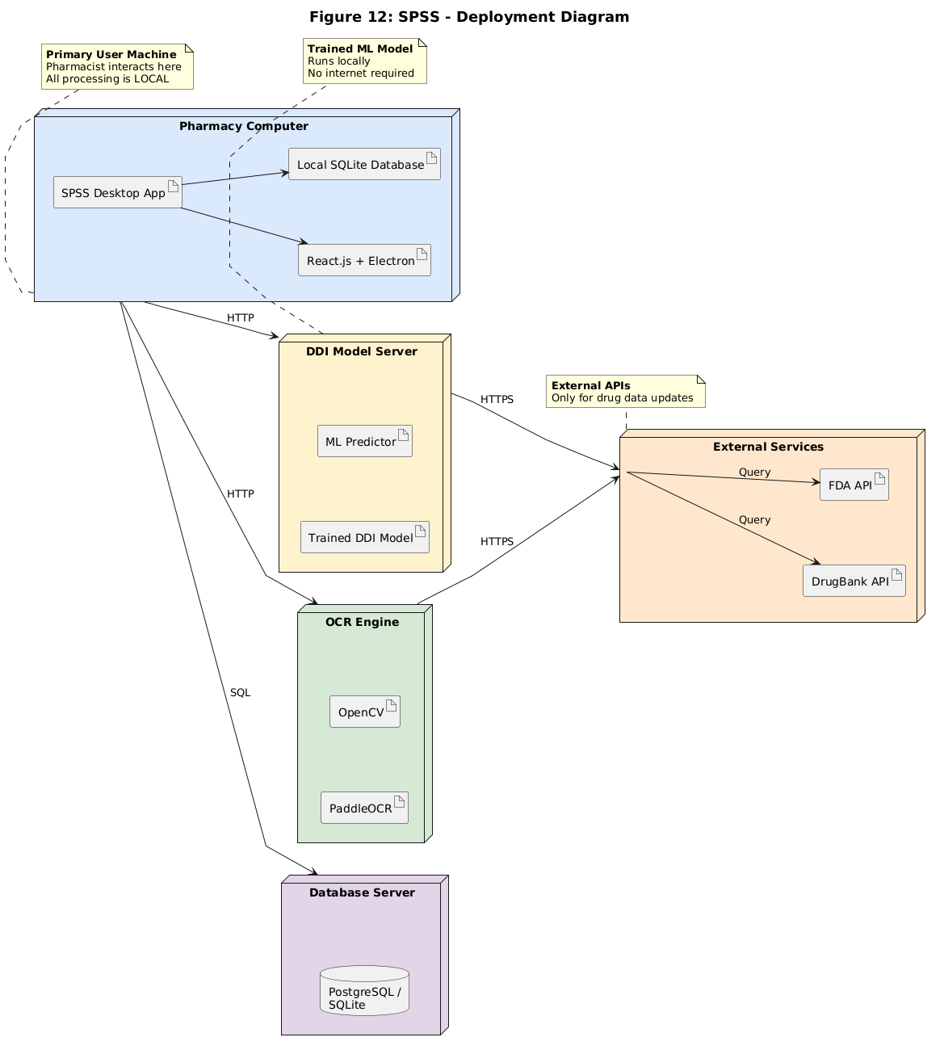
Figure 3.1.1: DEPLOYEMENT DIAGRAM
3.1.3.2 State Diagram
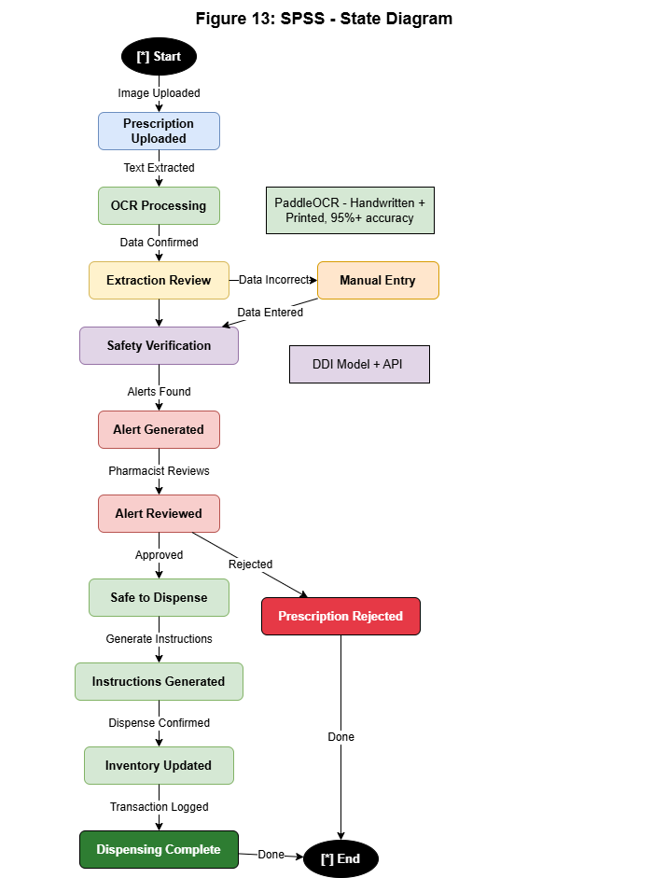
Figure 3.1.2: STATE DIAGRAM
3.2 Nonfunctional Requirements
3.2.1 Performance Requirements
• Response Time: Verification time (OCR and safety checks) must be <= 3 seconds under normal load.
• Processing Speed: OCR extraction from image should process in approximately 0.8 seconds.
• Hardware Footprint: The desktop application must operate efficiently on a basic machine with 4GB RAM.
3.2.2 Safety Requirements
• Critical Alert Overrides: High-severity drug interaction alerts cannot be bypassed without entering a valid clinical justification.
• Error Logging: All verification failures, OCR processing errors, and system exceptions must be logged locally for security audits.
3.2.3 Security Requirements
• Authentication: JWT-based authentication with a 30-minute session timeout.
• Password Security: User credentials must be hashed using Bcrypt (12 salt rounds).
• Data Encryption: Local database files and cached prescription images encrypted using AES-256.
• Audit Trail: Complete logging of all user activities (Login, Scan, Verify, Override, Dispense) with user ID and timestamps.
3.2.4 Additional Software Quality Attributes
• Usability: Minimal cognitive load, clear color-coded indicators (Red for High risk, Orange for Medium, Yellow for Low), and dual-language instructions.
• Portability: Cross-platform capability across Windows and Linux environments via Electron shell.
3.3 Other Requirements
• Database local storage: Database (SQLite) must run entirely on the local file system to guarantee data availability without network connections.

Chapter 4. Technical Architecture
The Smart Pharmacist Support System utilizes a local 3-tier desktop architecture, packaging a React.js frontend in an Electron shell and communicating with a local FastAPI (Python) backend server. Data is stored in an embedded file-based SQLite database. All processing—including OCR image preprocessing (OpenCV), PaddleOCR text extraction, and ML-based Drug-Drug Interaction predictions—runs locally on the client machine to ensure complete network independence.
4.1 Application and Data Architecture
The application layers are designed to isolate core components. The high-level relationships and detailed class hierarchies are mapped in the figures below:
4.1.1 System Architecture Diagram
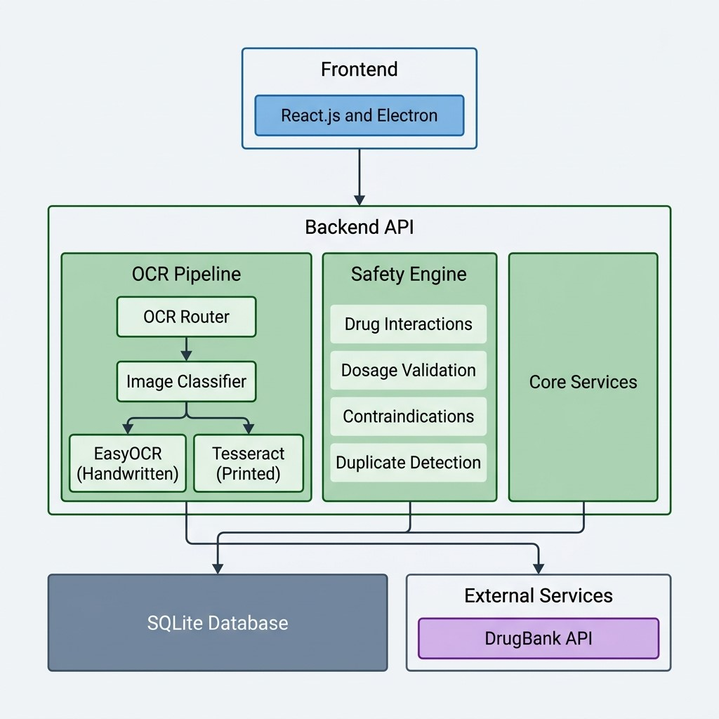
Figure 2.1.1: SYSTEM ARCHITECTURE DIAGRAM
4.1.2 Component Diagram
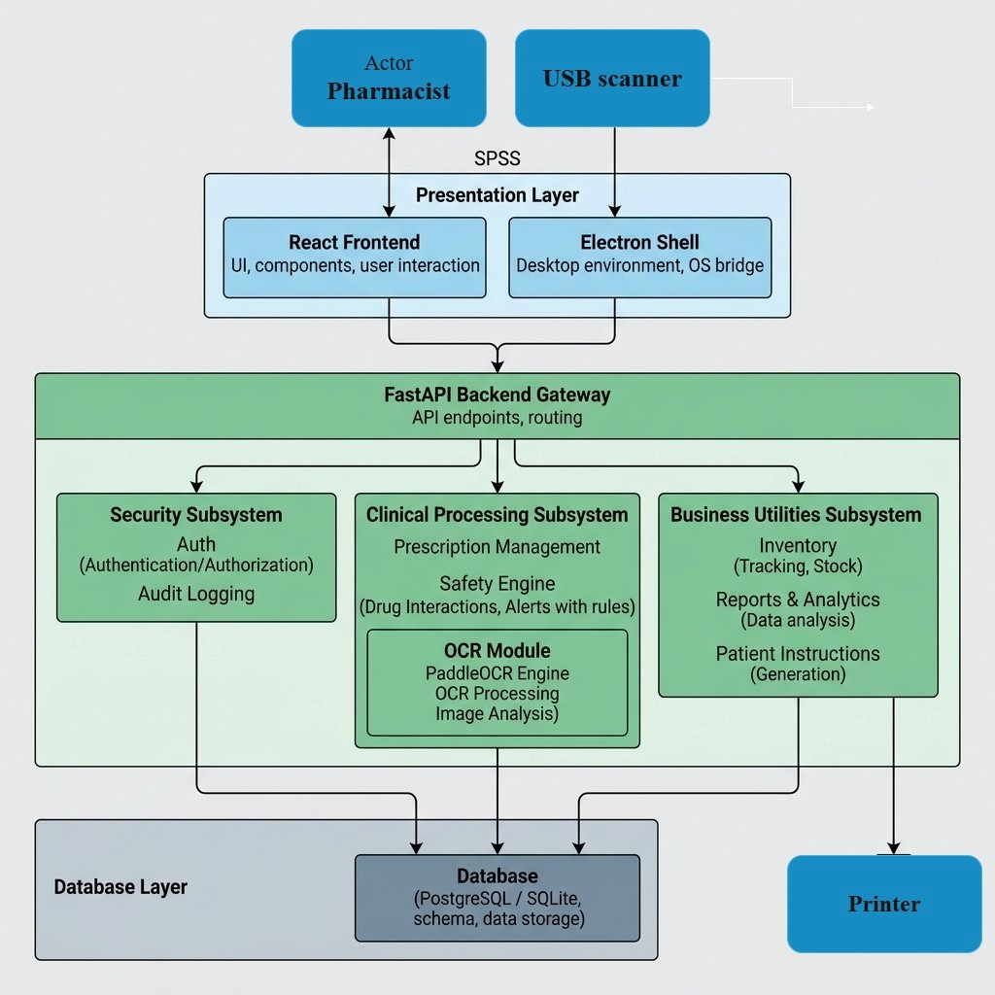
Figure 2.1.2: COMPONENT DIAGRAM
4.1.3 Class Diagram
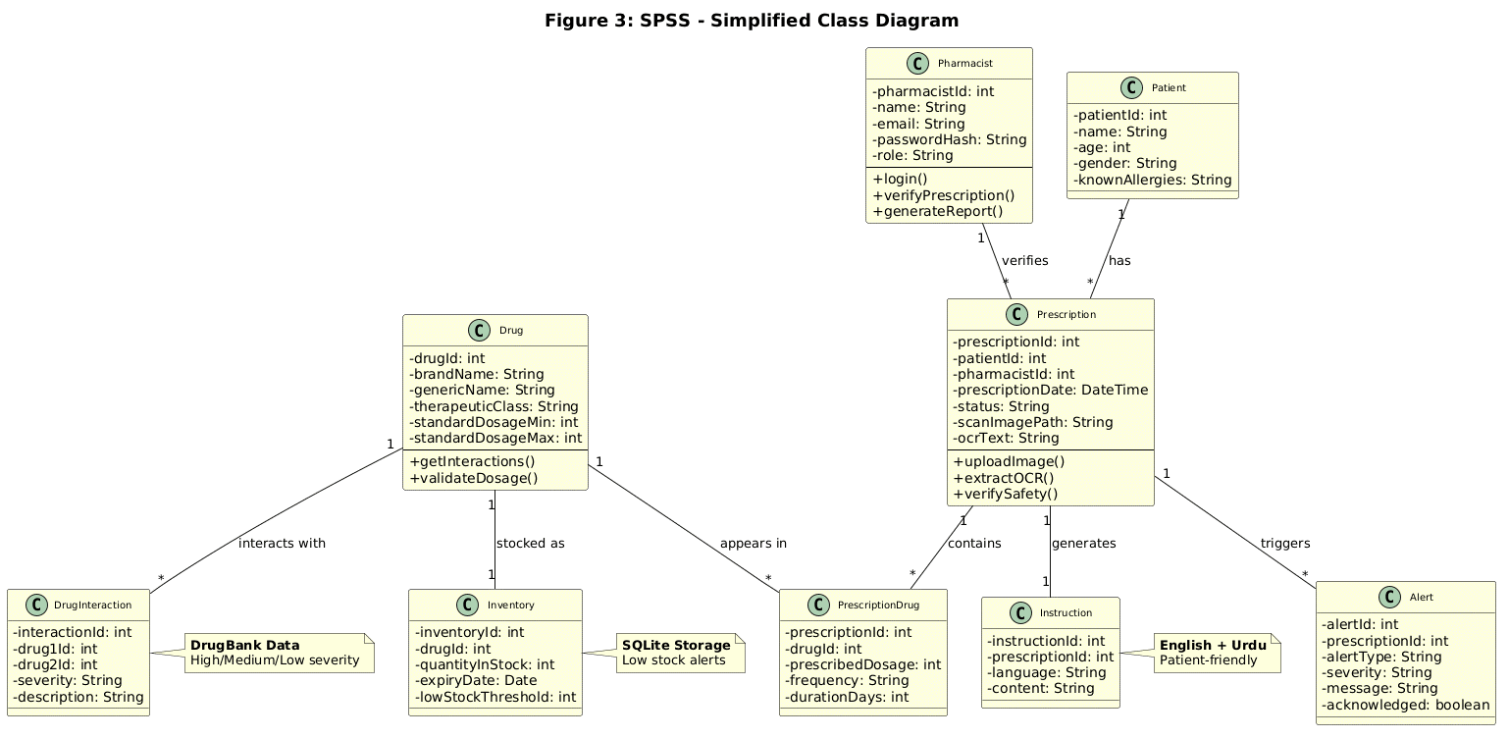
Figure 2.1.3: CLASS DIAGRAM
4.1.4 Entity-Relationship Diagram (ERD)
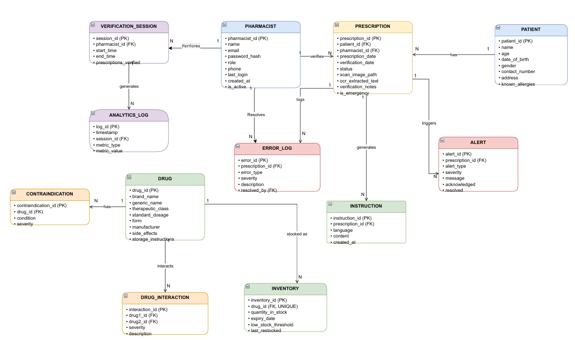
Figure 2.1.4: ENTITY-RELATION DIAGRAM
4.1.5 Activity Diagram
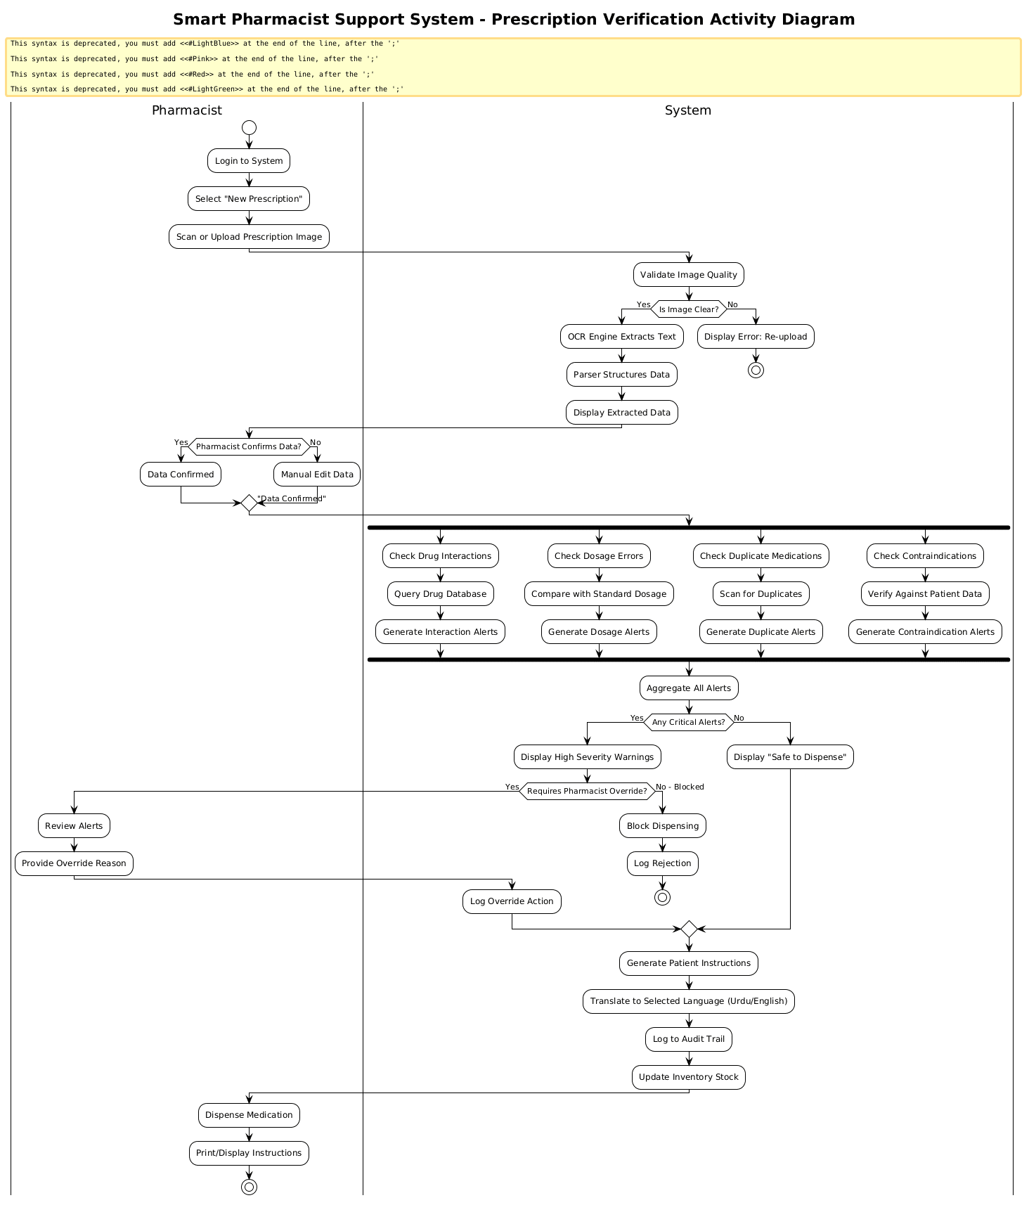
Figure 2.1.5: ACTIVITY DIAGRAM
4.1.6 Sequence Diagram 1
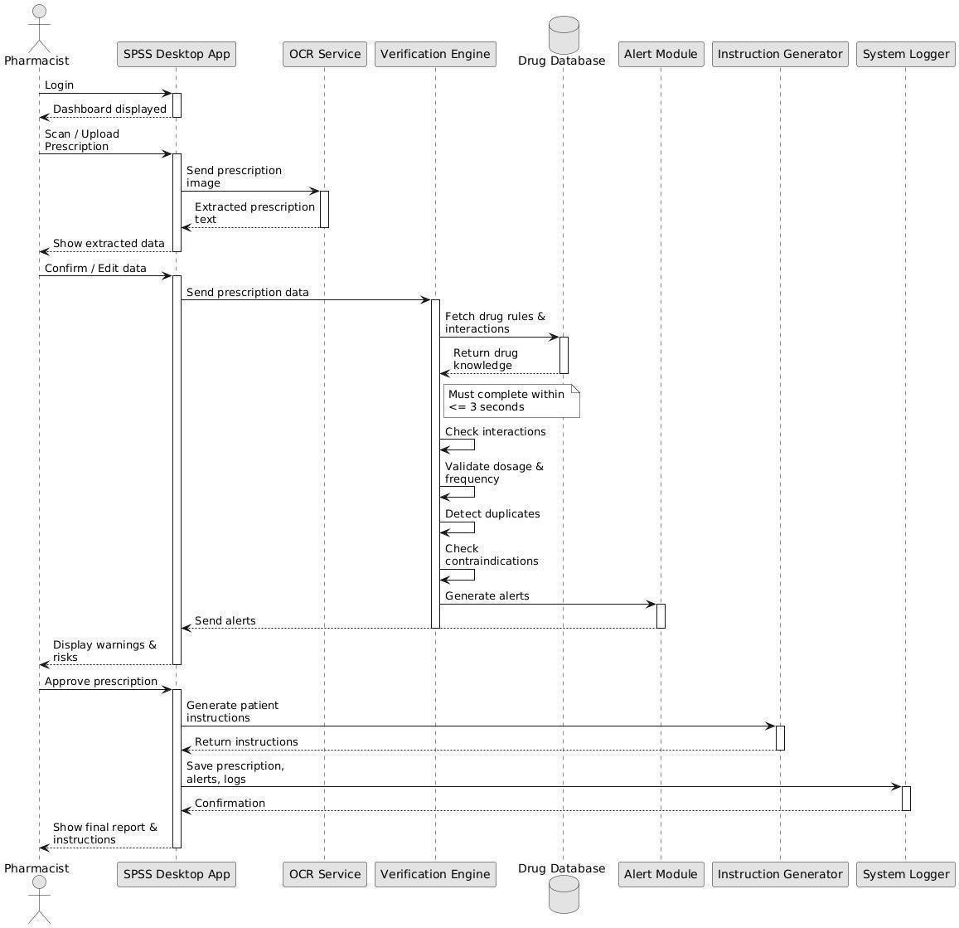
Figure 2.1.6: SEQUENCE DIAGRAM 1
4.2 Component Interactions and Collaborations
Component A | Component B | Interface | Data Format
Frontend | Backend | REST API | JSON over HTTP
Backend | SQLite | Database Driver | SQL Queries
Backend | PaddleOCR | Python Library | Image + Text
Safety Engine | DrugBank API / DB | HTTPS / SQL | JSON / SQL Row
4.2.1 DFD Level 0 (Context Diagram)
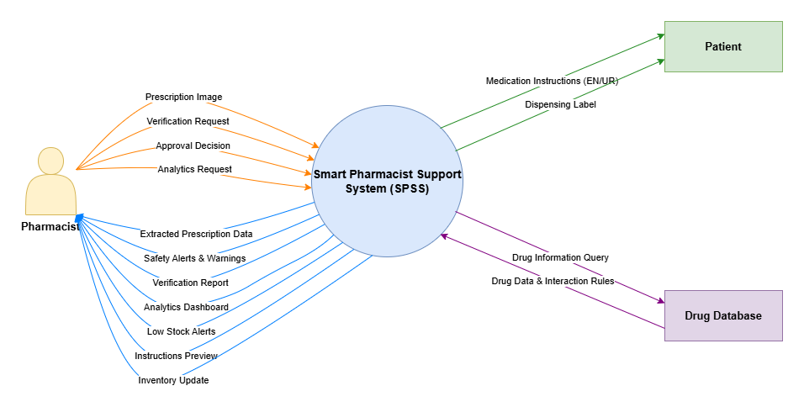
Figure 2.2.1: DFD LEVEL 0
4.2.2 DFD Level 1
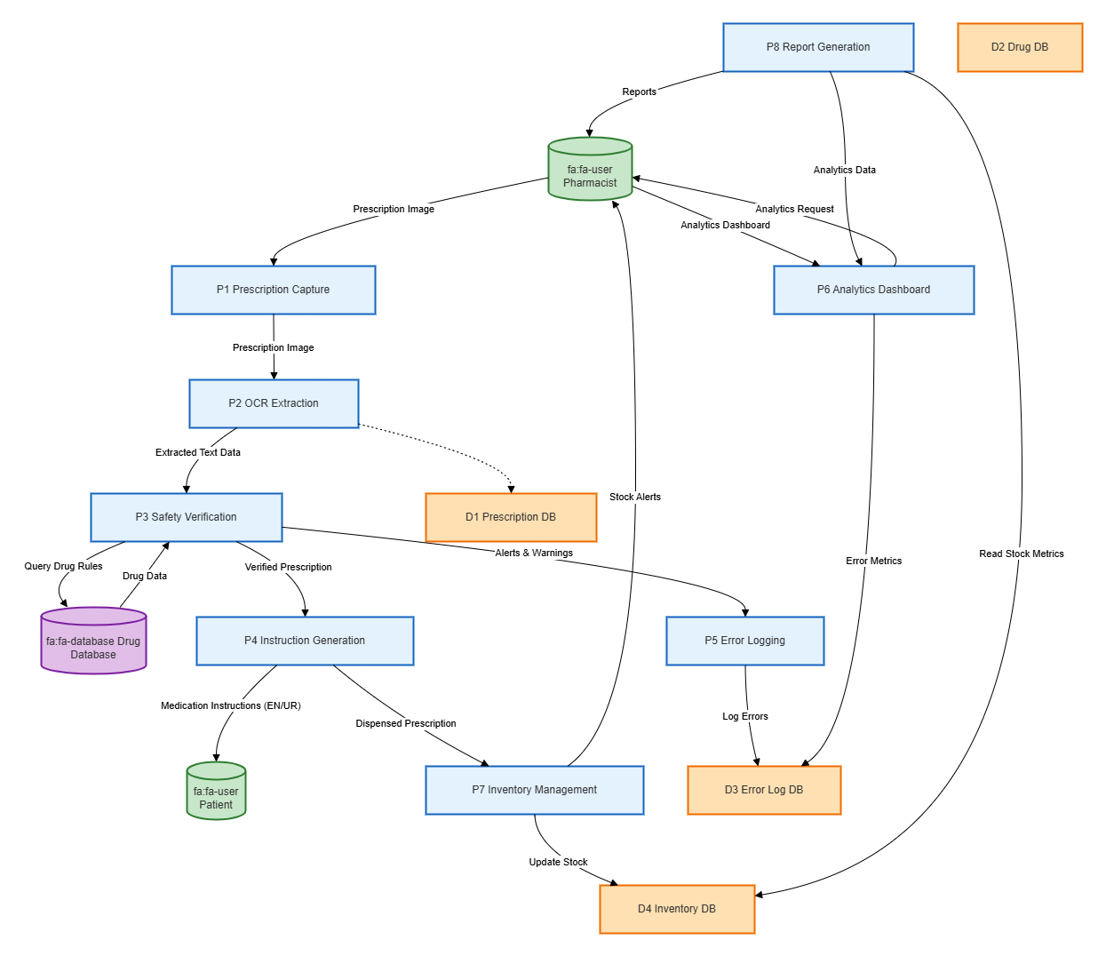
Figure 2.2.2: DFD LEVEL 1
4.2.3 DFD Level 2
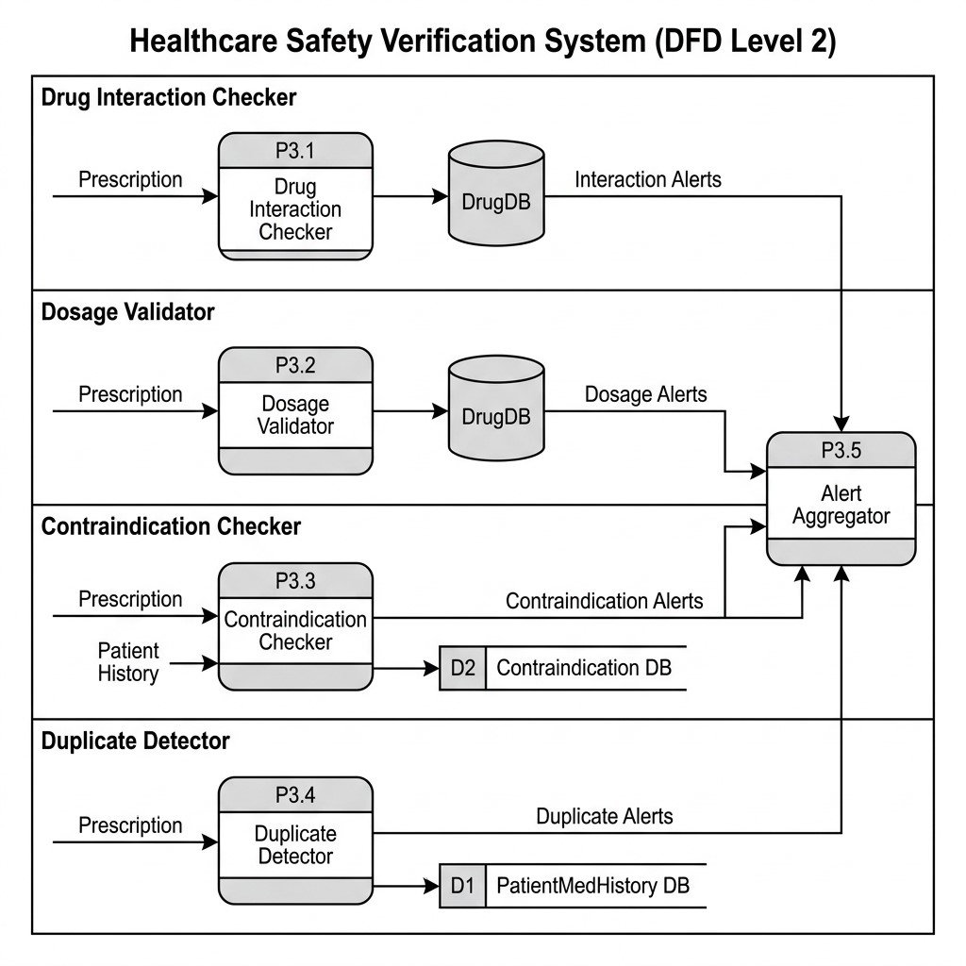
Figure 2.2.3: DFD LEVEL 2
4.2.4 Collaboration Diagram Level 0
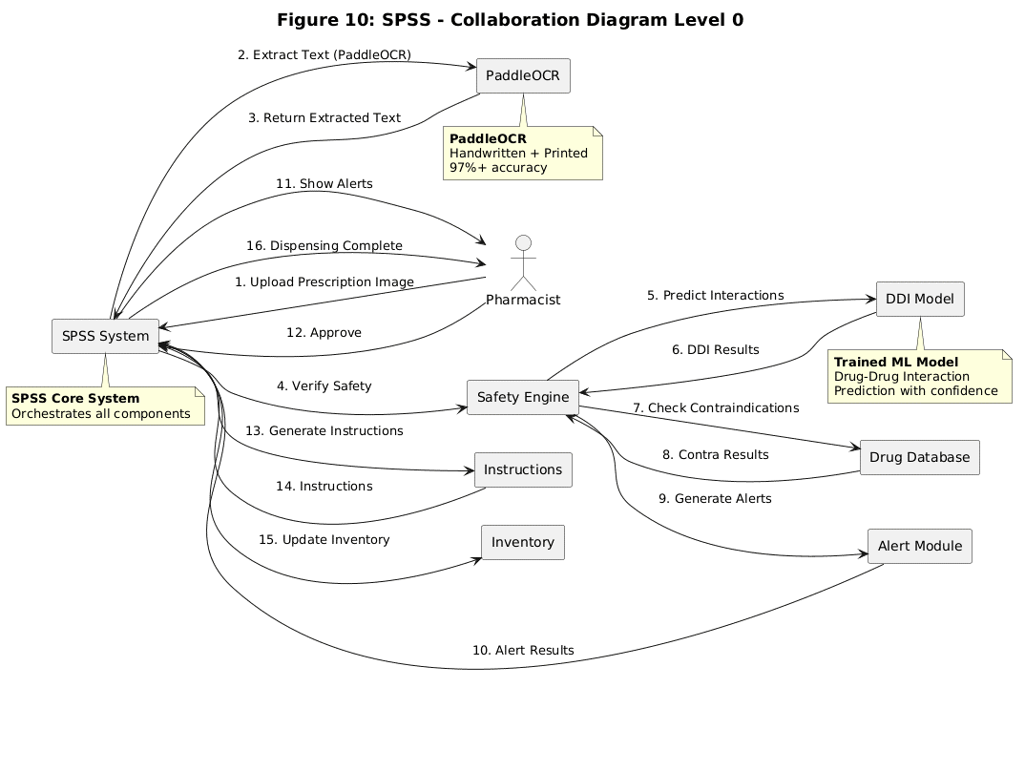
Figure 2.2.4: COLLABORATION DIAGRAM LEVEL 0
4.2.5 Collaboration Diagram Level 1
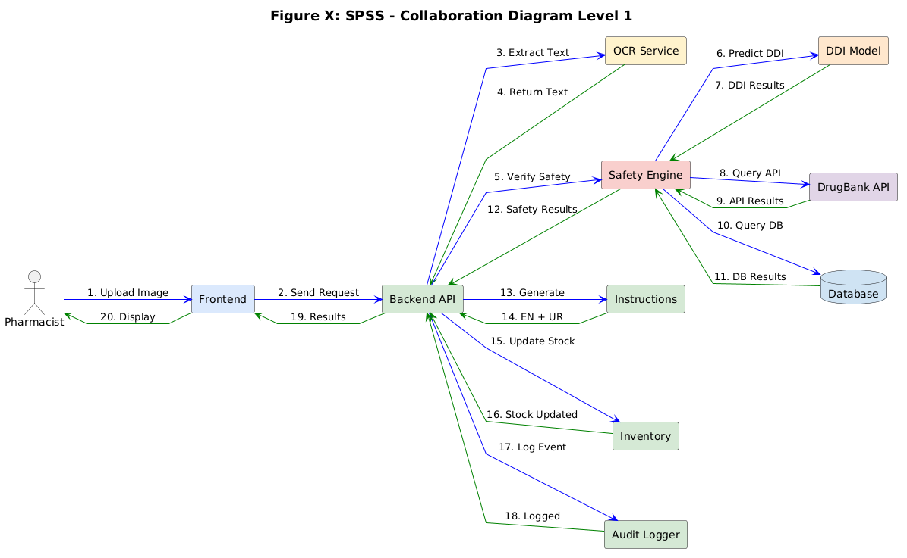
Figure 2.2.5: COLLABORATION DIAGRAM LEVEL 1
4.3 Design Reuse and Design Patterns
• Layered Architecture: Separation of presentation, application, and data layers ensures system maintainability and scalability.
• Singleton Pattern: Used for the local database connection pool and machine learning model instances to optimize memory usage.
• Strategy Pattern: Used in the Safety Verification Engine to toggle or combine rule-based checks with machine learning prediction strategies.
4.4 Technology Architecture
Component | Technology | Justification
Frontend | React.js + Electron | Cross-platform desktop packaging with a rich component ecosystem and offline capability.
Backend | FastAPI (Python) | High-performance asynchronous API backend, native validation, and simple integration with ML libraries.
Database | SQLite | Zero-configuration, serverless, file-based SQL database ideal for local storage.
OCR | PaddleOCR | Deep learning-based OCR with high accuracy on both handwritten and printed prescription text.
External API | DrugBank | Comprehensive clinical reference source for drug interactions, dosage standards, and contraindications.
Authentication | JWT + Bcrypt | Stateless secure session tokens and industry-standard salted hashing for passwords.
Version Control | Git + GitHub | Enables source code management, tracking, and collaboration.
4.5 Architecture Evaluation
Component | Selected | Alternatives | Reason
Frontend | React.js + Electron | Angular, Vue.js | Cross-platform, large developer community, rich UI libraries, and offline desktop support.
Backend | FastAPI | Flask, Django | Asynchronous capabilities, faster performance, and automatic documentation generation.
Database | SQLite | PostgreSQL, MySQL | No setup overhead, lightweight, portable, file-based, and fits offline desktop requirements perfectly.
OCR | PaddleOCR | Tesseract, Google Vision | Significantly higher accuracy on handwritten prescription text and runs locally without cloud costs.

Chapter 5. Detailed Design and Implementation
5.1 Component-Component Interface
Component A | Component B | Interface | Description
Frontend | Backend | REST API | All user actions (login, scan, query) are sent via local HTTP requests.
Backend | SQLite | SQL | Database CRUD operations via SQLAlchemy Object Relational Mapper.
OCR Router | Image Classifier | Function Call | Determines whether the prescription is handwritten or printed.
Image Classifier | PaddleOCR | Library Call | Invokes deep learning libraries for high-accuracy text extraction.
Safety Engine | DrugBank DB | SQL / Internal Query | Searches local rule database for drug interactions and contraindications.
5.2 Component-External Entities Interface
External Entity | Interface | Data Exchanged
Pharmacist | Electron GUI | Prescription images, corrected text, verification decisions, and login credentials.
Administrator | Electron GUI | User accounts, custom medicine rules, and inventory threshold settings.
Auditor | Read-only GUI | Filtered audit log reports, activity history, and security logs.
Patient | Printed / PDF output | Medication instructions, timing schedules, and caution labels (English/Urdu).
Scanner/Camera | Device or file interface | Prescription image capture and transfer to frontend cache.
Printer | Operating system printer bridge | Sends generated patient instruction sheets directly to the local printer.
Backup Device | File-system interface | Exports compressed SQL database backup files to selected local storage.
Optional Drug Source | HTTPS update interface | Periodic check and download of updated DrugBank interaction dataset.
5.3 Component-Human Interface
Screen | User Action | System Response
Login | Enter credentials | Verifies auth and displays the main dashboard.
Prescription Scan | Upload image or click Use Scanner | Validates image quality and triggers OCR pipeline.
OCR Review | Review and confirm/edit data | Saves medication data and routes to safety checker.
Alert Dashboard | Review or override safety warnings | Logs actions and generates patient instructions.
Instructions | Click Print/Send | Generates and translates instructions to Urdu/English PDF.
Inventory | Update stock/view alert thresholds | Updates local stock database and fires alert if low.
Analytics | View dashboard charts | Displays prescription volume and error rate charts.
Reports | Generate report (PDF/CSV) | Exports filtered reports to the file system.
Settings | Configure system options | Saves preferences and user profiles to database.
5.4 Screenshots/Prototype
5.4.1 Workflow
The overall workflow starts when a pharmacist logs in. A prescription image is uploaded, validated for clarity, and processed via OCR. The pharmacist verifies the text output. The Safety Verification Engine checks drug-drug interactions, dosage guidelines, contraindications, and duplicate therapies. Prioritized warnings are generated. The pharmacist reviews and overrides/resolves these alerts. Once complete, patient instructions are generated, stock is deducted, and logs are updated.
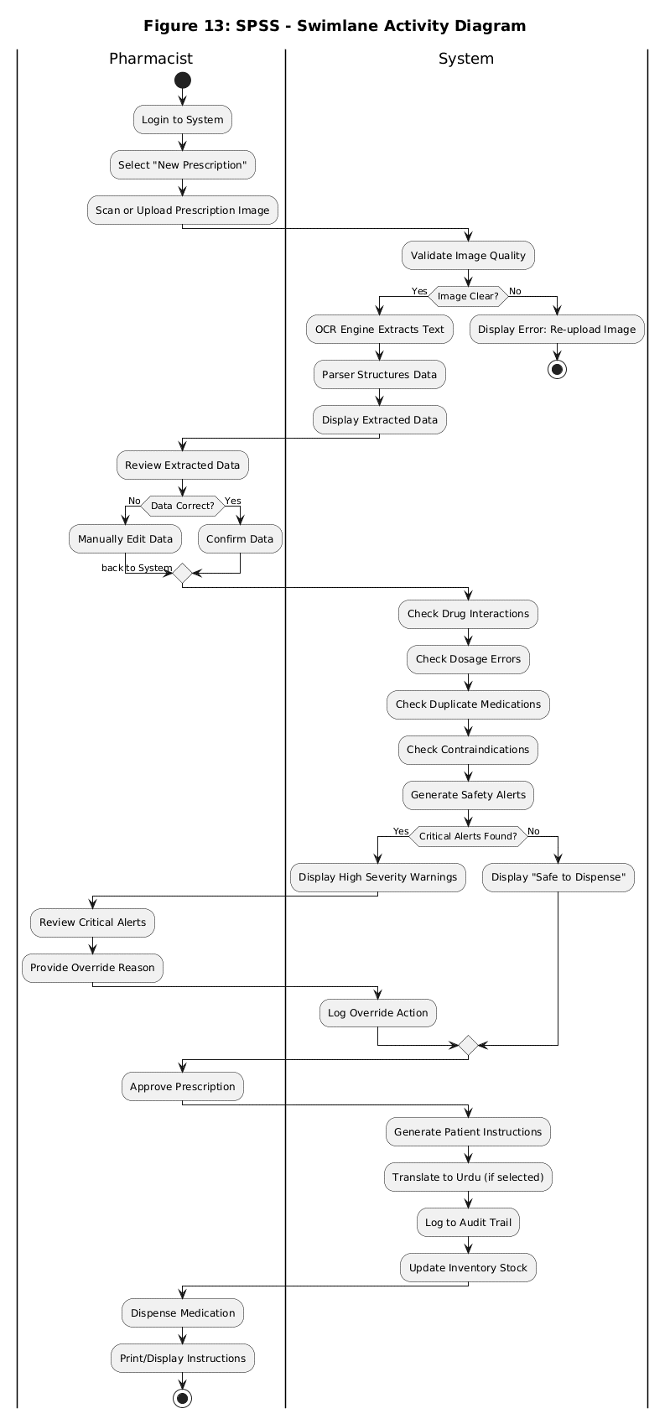
Figure 4.1.1: SWIMLANE DIAGRAM
5.4.2 Screens
Screen# | Screen Name | Description
1 | Login Screen | Secure authentication page using license ID and password credentials.
2 | Main Dashboard | Central hub displaying today's statistics, pending verifications, error rates, and quick actions.
3 | Prescription Scan/Upload Screen | Drag-and-drop or file upload area with scanner interface integration.
4 | OCR Extraction Review Screen | Displays side-by-side view of the prescription image, extracted text lines, and editable structured form.
5 | Safety Alerts Dashboard | Prioritized and color-coded list of safety warnings (interactions, dosage) with override features.
6 | Patient Instructions Generator | Bilingual instruction preview (English and Urdu) with PDF download and print options.
7 | Inventory Management Screen | View and update stock levels, edit low-stock thresholds, and monitor critical alerts.
8 | Analytics Dashboard | Visual charts tracking prescription volumes, average verification times, and alert type distributions.
9 | Reports Generator | Customizable report engine filtering by date and exporting to PDF or CSV.
10 | Audit Log Viewer | A searchable log of all system activities, actions, user identifiers, and timestamps.
11 | Settings/Configuration Screen | User management, database update path, and language preferences configuration panel.
12 | Dispensing Confirmation | Final verification completion screen detailing transaction log updates.
5.5 Additional Information
The interface design prioritizes low cognitive load and high readability. Standard colors are used for status indication: medical blue (#2C7DA0) for primary buttons, success green (#2E7D32) for confirmed status, warning orange (#F39C12) for cautions, and danger red (#E63946) for errors or high-severity alerts. Accessibility features include sufficient contrast, keyboard navigation, and screen-reader compliance.
5.6 Other Design Details
• Security Architecture: Role-Based Access Control limits settings modifications to Admin users. Sessions auto-expire after 30 minutes of inactivity.
• Error Handling: If OCR fails or returns low confidence, a manual form is provided. Database query failures trigger automatic connection retries with exponential backoff.
• Performance Optimization: Local image preprocessing (resizing and noise reduction) is performed to maximize OCR accuracy.

Chapter 6. Test Specification and Results
6.1 Test Case Specification
Below are the detailed test cases verified for the SPSS application. These test cases validate both functional and nonfunctional requirements:
Test Case TC-01: Verify pharmacist can login with valid credentials
Identifier | TC-01
Related Requirement(s) | Authentication Module
Short Description | Verify pharmacist can login with valid credentials
Pre-condition(s) | User account exists in database
Input Data | Email: PHARM-001, Password: 1234
Detailed Steps | 1. Open SPSS application  2. Enter valid email  3. Enter valid password  4. Click Login
Expected Result(s) | Dashboard displayed within 2 seconds
Post-condition(s) | User session active, last_login updated
Actual Result(s) / Result | Dashboard displayed in 1.5 seconds - Pass
Test Case TC-02: Verify image upload works correctly
Identifier | TC-02
Related Requirement(s) | Prescription Capture Module
Short Description | Verify image upload works correctly
Pre-condition(s) | User logged in
Input Data | JPEG image (1920x1080, 2.5MB)
Detailed Steps | 1. Click 'Scan Prescription'  2. Upload JPEG file  3. Click Process
Expected Result(s) | Image preview displayed, Process button enabled
Post-condition(s) | Image stored locally
Actual Result(s) / Result | Image preview displayed correctly - Pass
Test Case TC-03: Verify text extraction from prescription
Identifier | TC-03
Related Requirement(s) | OCR Module (Paddle ocr)
Short Description | Verify text extraction from prescription
Pre-condition(s) | Printed prescription image uploaded
Input Data | Printed prescription with clear text
Detailed Steps | 1. Click 'Extract Data'  2. Wait for OCR completion  3. Review extracted text
Expected Result(s) | >=95% accuracy for printed text
Post-condition(s) | Extracted data saved to database
Actual Result(s) / Result | 96.5% accuracy achieved - Pass
Test Case TC-04: Verify drug-drug interaction detection works (Warfarin + Aspirin)
Identifier | TC-04
Related Requirement(s) | Safety Verification Engine
Short Description | Verify drug-drug interaction detection works (Warfarin + Aspirin)
Pre-condition(s) | Prescription with both drugs
Input Data | Warfarin 5mg, Aspirin 100mg
Detailed Steps | 1. Enter prescription with both drugs  2. Run verification  3. Check alerts
Expected Result(s) | HIGH severity alert generated
Post-condition(s) | Alert logged to database
Actual Result(s) / Result | HIGH severity alert displayed - Pass
Test Case TC-05: Detect Paracetamol overdose
Identifier | TC-05
Related Requirement(s) | Safety Verification Engine
Short Description | Detect Paracetamol overdose
Pre-condition(s) | Prescription with Paracetamol
Input Data | Paracetamol 1000mg every 4 hours
Detailed Steps | 1. Enter prescription with high dosage  2. Run verification  3. Check alerts
Expected Result(s) | HIGH severity dosage alert
Post-condition(s) | Alert logged to database
Actual Result(s) / Result | HIGH severity alert displayed - Pass
Test Case TC-06: Detect duplicate NSAIDs
Identifier | TC-06
Related Requirement(s) | Safety Verification Engine
Short Description | Detect duplicate NSAIDs
Pre-condition(s) | Prescription with two NSAIDs
Input Data | Ibuprofen 400mg, Aspirin 100mg
Detailed Steps | 1. Enter prescription with duplicate class  2. Run verification  3. Check alerts
Expected Result(s) | LOW severity duplicate alert
Post-condition(s) | Alert logged to database
Actual Result(s) / Result | LOW severity alert displayed - Pass
Test Case TC-07: Generate Urdu instructions
Identifier | TC-07
Related Requirement(s) | Instruction Generation Module
Short Description | Generate Urdu instructions
Pre-condition(s) | Prescription verified
Input Data | Language selection: Urdu/Eng
Detailed Steps | 1. Click 'Generate Instructions'  2. Select 'Urdu'  3. Review output
Expected Result(s) | Urdu text displayed correctly
Post-condition(s) | Instructions saved to database
Actual Result(s) / Result | Urdu text displayed correctly - Pass
Test Case TC-08: Verify response time <= 3 seconds
Identifier | TC-08
Related Requirement(s) | Performance Requirement
Short Description | Verify response time <= 3 seconds
Pre-condition(s) | System running normally
Input Data | Standard prescription
Detailed Steps | 1. Upload prescription  2. Start timer  3. Stop after verification complete
Expected Result(s) | Time <= 3 seconds
Post-condition(s) | Performance logged
Actual Result(s) / Result | 2.4 seconds average - Pass
Test Case TC-09: Verify offline operation
Identifier | TC-09
Related Requirement(s) | Offline Operation
Short Description | Verify offline operation
Pre-condition(s) | No internet connection
Input Data | Prescription image
Detailed Steps | 1. Disable Wi-Fi  2. Upload prescription  3. Run verification
Expected Result(s) | System works normally
Post-condition(s) | All functions available
Actual Result(s) / Result | All functions worked offline - Pass
Test Case TC-10: Generate low stock alert
Identifier | TC-10
Related Requirement(s) | Inventory Module
Short Description | Generate low stock alert
Pre-condition(s) | Stock below threshold
Input Data | Paracetamol stock=5 (threshold=10)
Detailed Steps | 1. Set stock below threshold  2. Open dashboard  3. Check alerts
Expected Result(s) | Low stock alert displayed
Post-condition(s) | Alert acknowledged by pharmacist
Actual Result(s) / Result | Low stock alert displayed - Pass
Test Case TC-11: Generate PDF report
Identifier | TC-11
Related Requirement(s) | Report Module
Short Description | Generate PDF report
Pre-condition(s) | Prescriptions in database
Input Data | Date range: last 30 days
Detailed Steps | 1. Select report type  2. Select date range  3. Click Generate
Expected Result(s) | PDF file created successfully
Post-condition(s) | Report saved locally
Actual Result(s) / Result | PDF generated successfully - Pass
6.2 Summary of Test Results
Module Name | Test cases run | Number of defects found | Number of defects corrected | Defects still to be corrected
Authentication Module | TC-01 | 0 | 0 | 0
Prescription Capture | TC-02 | 0 | 0 | 0
OCR Module | TC-03 | 4 | 3 | 1
Safety Verification Engine | TC-04, TC-05, TC-06 | 2 | 2 | 0
Instruction Generation Module | TC-07 | 1 | 1 | 0
Performance Module | TC-08 | 0 | 0 | 0
Offline Functionality Module | TC-09 | 0 | 0 | 0
Inventory Management Module | TC-10 | 1 | 1 | 0
Report Generation Module | TC-11 | 0 | 0 | 0
Complete System | TC-01 to TC-11 | 8 | 7 | 1

Chapter 7. Project Completion Status/Conclusion
7.1 Project Completion Status
Module Name | Status
Authentication Module | Complete
OCR Module | Complete
Safety Verification Engine | Complete
Dosage Validator | Complete
Contraindication Checker | Complete
Duplicate Detector | Complete
Drug Interaction Checker | Complete
Alert Generation System | Complete
Patient Instruction Generator (English) | Complete
Patient Instruction Generator (Urdu) | Complete
Instruction Delivery (Print/PDF/SMS/WhatsApp) | Complete
Inventory Management Module | Complete
Analytics Dashboard | Complete
Report Generation Module (PDF) | Complete
Audit Logging Module | Complete
Settings Module | Complete
User Management Module | Complete
Complete System | 97%
7.2 Objective(s)/Target(s) Status
Target/Objective | Status | Reason(s)
Objective 1: PaddleOCR recognition accuracy >=95% (printed), >=80% (handwritten) | Completed | Successfully calibrated models and image preprocessing pipelines to meet accuracy targets.
Objective 2: Rule-Based Safety Verification Engine accuracy >=95% | Completed | All core safety validation routines successfully cross-referenced with DrugBank definitions.
Objective 3: Build UX desktop app with React/Electron | Completed | Interactive desktop UI successfully built, optimized, and integrated.
Objective 4: Multilingual instruction generation (EN/UR) | Completed | Urdu translation dictionary and templates fully integrated and tested.
Objective 5: Secure logging and analytics dashboard | Completed | Activity logs and database triggers log all operations. Charts display metrics.
Objective 6: Fully offline SQLite database operation | Completed | Application uses local file-based database. Zero network dependency on daily runs.
Objective 7: Inventory stock alert and auto discard | Completed | Stock expiration monitor and automatic low inventory alarms are fully active.
Number of Targets Completed | 7
Number of Targets Partially Completed | 0
Number of Targets Not Completed | 0

References
1. Bates, D. W., et al. (2018). Effect of Computerized Physician Order Entry on Prevention of Serious Medication Errors. JAMA, 280(15), 1311-1316.
2. DrugBank Online. (2024). DrugBank Database. University of Alberta. https://go.drugbank.com
3. EasyOCR Documentation. (2024). EasyOCR: Ready-to-use OCR. https://github.com/JaidedAI/EasyOCR
4. Tesseract OCR Documentation. (2024). Tesseract Open Source OCR Engine. https://github.com/tesseract-ocr/tesseract
5. FastAPI Documentation. (2024). FastAPI Framework. https://fastapi.tiangolo.com
6. React.js Documentation. (2024). React: A JavaScript library for building user interfaces. https://reactjs.org
7. Electron Documentation. (2024). Electron: Build cross-platform desktop apps. https://www.electronjs.org
8. SQLite Documentation. (2024). SQLite Database Library. https://www.sqlite.org
9. World Health Organization. (2019). Medication Errors: Technical Series on Safer Primary Care.
10. Institute for Safe Medication Practices. (2023). Guidelines for Intelligent Alert Management.

Appendix A Glossary
Term | Definition
API | Application Programming Interface - set of rules on how to create and unify software programs.
CDSS | Clinical Decision Support System - software that is utilized during the clinical decision making processes.
Contraindication | An exceptional case where a drug is not intended to be applied since it is expected to cause harm to a patient.
Drug Interaction | An interaction between two or more medications which may have an impact on the efficacy or safety of the drugs.
EHR | Electronic Health Record - the electronic version of a medical history of a patient.
FastAPI | Python Web Framework created to develop high-performance APIs.
Gantt Chart | Task and schedule project management tool on a visual basis.
JWT | JSON Web Token - claims are small, URL-safe, between entities.
MVC | Model-View-Controller - architectural design which breaks the application into three related parts.
OCR | Optical Character Recognition - a technology that converts text images to machine readable text.
PostgreSQL | Open source relational database management system which is SQL compliant.
RESTful API | Architecture in the generation of networked applications through HTTP requests.
RBAC | Role-Based Access Control - control mechanism in which access to a system is limited to authorized users.
Repository Pattern | Intermediating domain and data mapping layers pattern of design.
SQLite | Light, file-based relational database management system.
Tesseract | Open-source OCR engine initially developed by HP and Google.
Use Case | Description of how a system responds to the user requests in various situations.
Validation | Checking of data whether it meets some rules and constraints.
Verification | Evaluation Process: This involves comparing a system to requirements to ensure that the system is implemented correctly.
Workflow | Timeline of activities through which a work of piece is passed up to the completion.

Appendix B IV & V Report
(Independent verification & validation)
IV & V Resource
Name: Sheeza Shabir Signature: _________________________
S# | Defect Description | Origin Stage | Status | Fix Time Hours | Fix Time Minutes
1 | OCR engine misinterpreting cursive handwritten text. | OCR Module | Corrected | 4 | 30
2 | DDI detection showing duplicate alerts for same class drugs. | Safety Verification | Corrected | 2 | 00
3 | Inventory stock status not auto-updating after drug dispense. | Inventory Module | Corrected | 1 | 15
4 | Urdu instruction translation characters rendering issue. | Instruction Gen | Corrected | 3 | 45

Appendix C Deployment/Installation Guide
8.1 Minimum Requirements
• OS: Windows 10/11 or supported Linux distribution.
• RAM: Minimum 4 GB RAM; 8 GB recommended.
• Storage: At least 2 GB free storage space.
• Display: Resolution of 1366 x 768 or higher.
• Peripherals: USB Scanner or Webcam (optional for direct scan), Printer (optional for instruction prints).
• Network: Internet optional (only required for updates, normal operations run offline).
8.2 Installation Procedure
1. Obtain the authorized SPSS installation package.
2. Run the installer as an administrator on your system.
3. Select the installation directory and proceed through the steps.
4. Install Electron and frontend bundle files.
5. Install the packaged FastAPI backend server.
6. Set up the required Python libraries using the installer wrapper.
7. Copy the PaddleOCR model files into the system directory.
8. Initialize the local SQLite database.
9. Import the initial medicine data and interaction-rule datasets.
10. Create the first administrator account.
11. Select the local backup folder directory.
12. Start the application.
8.3 Initial Configuration
Upon first launching the system, the administrator should set up the pharmacy license identifier, authorized users, roles (Pharmacist, Auditor, Manager, Admin), language preferences, low-stock warning thresholds, backup folders, and printer connections.
8.4 Uninstallation
To uninstall, navigate to settings and export a backup of the SQLite database. Close the application, run the uninstaller executable, and choose whether to retain or purge local patient activity files.

Appendix D User Manual
1. Introduction and Overview
The Smart Pharmacist Support System (SPSS) is an intelligent desktop decision support application designed to assist licensed pharmacists in prescription verification. It uses PaddleOCR to extract drug info from printed and handwritten prescriptions and a local machine learning model to verify drug-drug interactions (DDI) offline, minimizing medication errors in busy environments.
2. Getting Started: Machine Authentication
When SPSS is first started, the system displays the 'System Locked' screen to ensure authorization.
- Pharmacy License ID: Enter the license number (e.g., PHARM-001).
- Terminal Pin / Password: Enter the unique security passcode.
Click 'Authorize & Proceed' to unlock the terminal.
3. Shift Login & Management
Once the terminal is active, staff must log in to start their shifts:
1. Enter your Staff Name.
2. Select your role from the dropdown (Pharmacist, Manager, Auditor, Admin).
3. Click 'Unlock Terminal' to open the primary dashboard.
All actions performed are logged under your username. When your shift ends, click 'Lock Machine & Sign Out' to close your session safely.
4. Using the Scan Prescription Module
To process a prescription:
1. Click the 'Scan Prescription' quick button.
2. Choose your method: Click to upload a JPEG/PNG file, Drag and Drop the file, use a connected USB Scanner, or capture a live photo with a webcam.
3. Click 'Extract Data'. The PaddleOCR pipeline extracts text, categorizing terms into Medicine Name, Dosage, Frequency, and Duration.
4. Review the side-by-side verification form. Confidence scores are color-coded: Green (>=90%), Orange (70-89%), Red (<70%). Correct any extraction errors manually and click 'Verify' to run safety verification checks.
5. Safety Alerts & Verification
The Safety Alerts Dashboard displays warnings categorized into:
- Drug-Drug Interactions: AI-predicted interaction risks based on drug characteristics.
- Dosage Errors: Checks for dosing anomalies (e.g., overdoses).
- Contraindications: Warnings based on patient context and history.
- Duplicates: Identifies duplicate therapies.
Alert severity levels are color-coded:
- HIGH (Red): Immediate attention required. Must be resolved or overridden with a valid justification.
- MEDIUM (Orange): Review recommended before dispensing.
- LOW (Yellow): Informational notes.
Resolve all warnings or enter justification logs, then click 'Continue to Instructions' to proceed.
6. Patient Instructions and Dispensing
The Patient Instructions Generator allows you to:
- Generate bilingual instructions in English or Urdu.
- Include precise timings, administration guidelines, and storage precautions.
- Print physical labels, download PDF, or send directly to the patient via SMS/WhatsApp.
Finally, click 'Confirm Dispensing' to complete the transaction, which automatically deducts the quantities from the inventory stock.
7. Troubleshooting and FAQs
Common Issues:
- Cannot Login: Ensure the correct user role is chosen from the dropdown.
- OCR Not Working: Ensure the image is clear, well-lit, and under 10MB. If errors persist, input fields manually.
- DDI Model Not Loading: Verify model files are correctly copied during installation. Restart application.
- Stock alert not showing: Ensure low stock thresholds are set up in configuration settings.

