**­Application of Magnetic Resonance Fingerprinting to Assessment of Acute Stroke**

***Student*:** Jack Allen ***Supervisors*:** Prof. Peter Jezzard & Dr James Kennedy

**Summary**

Quantitative MRI is not commonly used in clinically environments, partly due to long scan times and consistency issues. Magnetic resonance fingerprinting (MRF) is a new approach that shows potential in improving the reliability and speed of quantitative mapping, allowing simultaneous measurements of several properties. This is achieved by matching the signal time course from a pulse sequence run with pseudo-random parameters, to a pre-computed signal dictionary. There is a need for fast and reliable quantitative measurements to be made during MRI scanning protocols for the assessment of acute stroke patients, and for their clinical management beyond the acute phase. Conventional protocols mainly consist of a series of individual sequences, each providing qualitative or partially quantitative estimates of a specific parameter. Here we propose an application and extension of MRF for assessing oedema in metabolically stressed brain tissue. We aim to measure free water content, obtaining maps of T1, T2, and the B1 excitation field in the process. By providing parameters to separate BOLD and CEST frameworks in the same clinical protocol, we aim to reduce the time needed for an acute stroke assessment. Following on from preliminary work, a 2D spin echo EPI sequence will be used to implement MRF, firstly validated with phantom data, then healthy volunteers, before ultimately being implemented *in vivo*, as part of an Acute MRI in Cerebral Ischemia (AMICI) study. Later developments will focus on creating robust algorithms for sequence parameter optimisation and effective post-processing. Once our framework is completed and validated, there is scope for it to be applied to other challenges in emergency imaging. This project falls within the EPSRC medical imaging research area.

1. **Background**
   1. **Quantitative MRI**

Magnetic resonance imaging (MRI) is widely used in clinics to produce qualitative images for the diagnosis and monitoring of disease and pathology. Relative measurements of tissue properties are usually used to provide contrast between particular tissue types. Quantitative measurements would enable a more robust and reliable assessment across different scans, institutions and patients, and would also assist in the research and development of new treatment strategies. One of the factors that hinder the development of quantitative techniques is that many of them currently require large amounts of time for data acquisition, meaning that they are impractical for clinical use. Some new sequences have been developed to attempt to make quantitative measurements of relaxation timesin a clinically reasonable time1–6. For example, the QRAPMASTER sequence3 allows measurements of T1 and T2,only needing approximately 5 minutes to achieve full brain coverage. Another study demonstrated the measurement of T1, T2, T2* and magnetic susceptibility, within 15 minutes, via series of rapid sequences5. However, these approaches are based on gradient echo (GRE) and steady-state free-precession (SSFP) sequences, meaning that they rely on consistent and known flip angles. This means that the ability of these methods to measure these parameters accurately is reduced by factors such as spatial heterogeneity in the static field B0 and the excitation field B1, unless additional time-consuming sequences are run that can calibrate these additional parameters. Also, excitation pulse profiles can also cause unwanted variations in the flip angle across the slice, resulting in signal that is integrated across a range of flip angle conditions across the slice7,8. Any additional acquisitions or post-processing that is performed to correct for these inaccuracies further increases the scan time. The problems associated with achieving quantitative MRI mean that qualitative images are more commonly used in clinics9.

Magnetic resonance fingerprinting (MRF)10 is a recently published method that offers fast, simultaneously quantitative measurements of multiple parameters. It works by matching the signal from a pulse sequence run with pseudo-random timings and flip angles to a pre-computed signal dictionary. The MRF method makes use of the differences between the responses of different tissues, without requiring a steady state of magnetisation to be reached (indeed it relies on disrupting the formation of a steady-state to achieve its sensitivity). The authors of the original MRF method10 stated that their implementation was resilient to movement artefacts and more efficient than two alternatives (DESPOT1 and DESPOT2)2. In order for the MRF approach to perform efficiently, the matching algorithm must be robust and fast. Approaches have been proposed to improve this via different computer-based analysis methods. There have also been attempts to account for the spatial variations in B1 by introduction abrupt changes in the flip angles near the end of a sequence comprising an inversion pulse followed by free induction decay (FID) acquisition. However, the acquisition time for this study was of the order of 1.5 hours, well over the accepted scale for clinical imaging11. The multi-parameter implementations of MRF for brain imaging have used this type of SSFP scheme, with under-sampling of k-space11–14.

* 1. **Acute Stroke Imaging**

Emergency medicine is an area in which fast diagnosis and treatment is crucial for improving the likelihood of a positive patient outcome. Imaging methods in this kind of environment must be fast and reliable. In particular, acute stroke patients benefit from the information that MRI can give to those treating them. Stroke is a major cause of death, but it can also have large negative effects on the quality of life of those who survive15. This negative impact can be reduced if the correct treatment is given in the acute phase. Imaging the brain is essential for understanding how the brain in question is responding to the stroke and for informing decisions about subsequent treatment. MRI has been used to provide information on the severity and extent of the damage, helping clinicians predict the effectiveness of therapy and track the progression of the stroke over time9.

The localised reduction in blood supply that occurs during ischemic episodes can cause a region of cells to die. An area of tissue around this infarcted region can also become hypoperfused and dysfunctional. This region is known as the ischemic penumbra and is potentially salvageable, if treated quickly, making it an important area to characterize. However, there remains controversy over the best way to properly characterize the penumbra. Recent work has identified the penumbra via pH mapping, highlighting the usefulness of using parameters that reflect the cellular level processes16. When presented with a patient suffering from stroke-like symptoms, it is important for clinicians to be able to confirm whether or not an ischemic infarction has occurred within the brain or if other conditions, such as hemorrhages, are the causing the symptoms. If bleeding has occurred, then thrombolysis therapy will not be safe and should not be deployed17. The accepted window within which thrombolysis therapy is likely to be beneficial is approximately 4 hours, but because of the variation across subjects there may be some cases where it will still be beneficial to administer clot-removal therapy some hours beyond this threshold. Another process that can occur after an ischemic attack is the build up of excess extracellular fluid (oedema)18, after a breakdown in the blood-brain barrier. Malfunctioning ionic transport mechanisms create an osmotic force that causes fluid to transfer from within the blood vessels to the extracellular space. Therefore, oedema can be increased by reperfusion of the affected tissue. The influx of fluid to the extracellular areas results in swelling of the affected region, causing displacement of surrounding brain tissue and potentially leading to herniation, a major cause of death in stroke patients. In extreme cases the pressure increase from swollen regions may warrant the removing of a section of the skull, a risky and invasive procedure. Abnormal fluid build-up normally arises between 2-5 days after the initial ischemic attack, it can occur earlier. Also, the preceding pathological processes, that do not themselves cause swelling, can take place much sooner after the infarction. For example, one of these preliminary stages is the uptake of ions and water by neurons, from the extracellular space. In terms of clinical MRI, the current methods for assessing bleeding and water content in acute stroke are mainly based on T1 and T2 contrast, as well as perfusion and diffusion mapping9. Relaxation contrast is used with the view that oedema increases T1 and T2.

* 1. **Research Problem**

There is a need for fast and reliable quantitative measurements to be made during MRI scanning protocols for the assessment of acute stroke patients, and for their clinical management beyond the acute phase. Conventional protocols mainly consist of a series of individual sequences, each providing qualitative or partially quantitative estimates of a specific parameter. MRF has shown its ability to provide quantitative parameter measurements for brain imaging, but there is scope for the approach to be used in emergency settings, where fast diagnosis and treatment is especially important for improving patient outcome. In particular, rapid oedema quantification in stroke would be a useful tool for stratifying patients and monitoring the effectiveness of therapy, by providing a means to quickly and reliably differentiate normal tissue from pathological fluid build-up from the acute stage and beyond. Quantification could allow greater detail in oedema monitoring, providing information about subtle cellular pathology. The property measurements derived from MRF would also be useful to other sequences within a stroke imaging protocol.

1. **Description**

The previously mentioned benefits of MRF give it potential to be useful for quantitative mapping of properties that can be used to infer injury severity and tissue viability during the acute phase of a stroke and beyond. The proposed research aims to establish a framework for obtaining quantitative maps of relevant tissue properties for the assessment of post-stroke brain tissue. This will include the development of a new acquisition sequence and matching algorithm.

In preliminary work, we have used the MRF approach to obtain maps of T1, T2, and variations in the B1 excitation field in a limited number of slices. From the T1 and T2 measurements, we are able to produce maps of the proton density (M0) scaled by the spatially-varying RF receive field. Our current framework produces a dictionary that spans a multi-dimensional parameter space covering T1, T2, excitation and refocusing pulse flip angles. Deviations of ±30% of the intended flip angles were simulated, with consistent deviations within each dictionary entry. This flexibility in terms of flip angle was allowed in order to account for spatial variations in the radio frequency (RF) excitation field B1. The TE, TR and flip angles were stored in a table, with each row representing the parameters used for a specific TR. Thus far a 2D spin echo (SE) sequence has been used for this purpose, with pseudo-randomly varying echo time (TE), repetition time (TR), and excitation flip angles (see Fig. 1). Signal readout was achieved via single-shot EPI. We will build on this work in our future research. Our main goal is to produce a robust and practical MRF framework, which will be used as part of a routine protocol for scanning patients recruited as part of the Acute MRI in Cerebral Ischemia (AMICI) study.

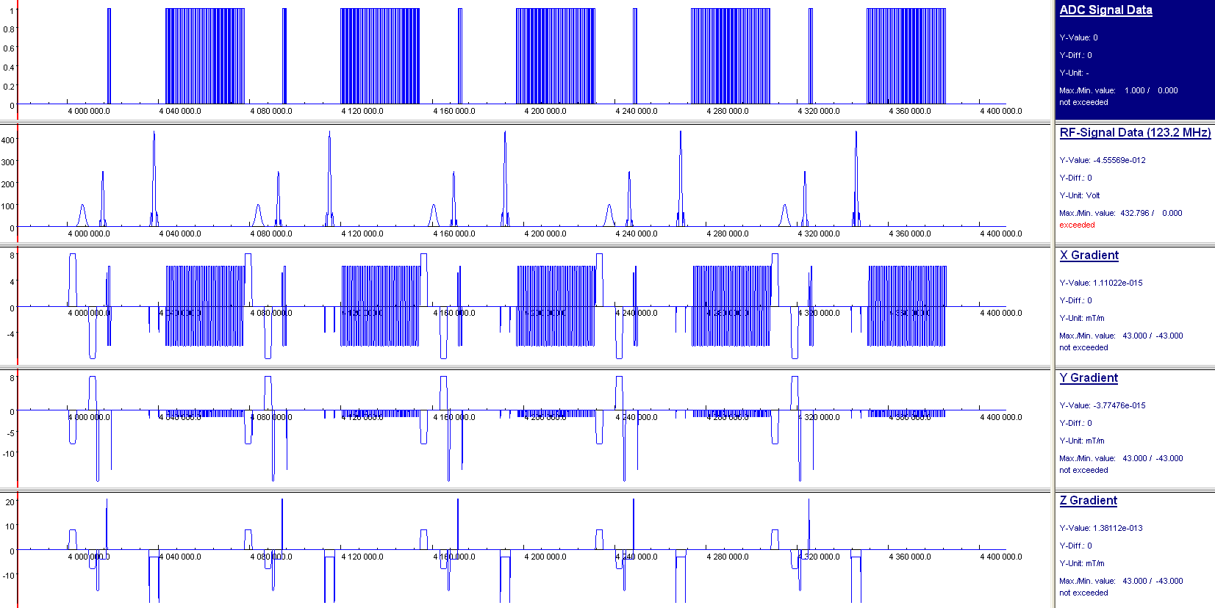

Figure 1 - Spin Echo Pulse Sequence Diagram, Highlighting the Varying MRF Parameters

(TR = Red, TE = Green, “Excitation” Flip Angle Pulse = Brown, “Refocusing” Flip Angle Pulse = Dashed Brown)

* 1. **Completion of** **the Spin Echo EPI** **sequence**

Our first goal is to complete the preliminary work, evaluating the performance of the framework and comparing it with the sequence type that has been used in MRF to date. In our results we observed discrepancies between the simulated and acquired data time courses. There were also subtle signal pattern differences between slices, possibly caused by overlapping pulse profiles for different slices.

We will use the concept of extended phase graph (EPG)19 to account for influences to the signal from preceding pulses. The current sequence applies a spoiling component in the transverse plane, at end of each TR. We will investigate whether completely removing this (and therefore increasing the influence of signal from previous TRs) improves the ability of our framework to correctly distinguish between similar signal time courses. It is also important that we validate our framework with simulated data with the addition of noise. The noise will be based on the standard deviation of the signal from a region in the background of the acquired images. As an additional verification step, integrated data language (IDL) signal simulations will be compared with our MATLAB calculations. We will start by resolving these issues for acquiring single 2D slices, before progressing in complexity and acquiring multiple slices. Once whole volume coverage has been validated with phantom data, we will recruit healthy volunteers and demonstrate the method *in vivo*.

* + 1. **Produce a New Phantom**

We will produce a new phantom with T1 and T2 values that better span the range normally found in the brain4,20. Additionally, we will explore the use of a gel phantom, to avoid vibration and temperature induced convection currents that can occur in liquids.

* + 1. **Incorporate RF Pulse Profiles**

The model we have for simulating the signal for the dictionary entries currently assumes that the applied pulses have an instantaneous effect on the rotation of the net magnetisation moment. We will make the simulations more realistic by simulating the effect of the pulses for discrete points during the duration of each pulse. To do this we will incorporate the RF pulse profiles from the Siemens scanner software.

* + 1. **Estimation of the B1 Excitation Field**

Developing our initial dictionary creation structure, we will produce a refined method for accounting for excitation field inhomogeneity. Flip angle efficiency maps will be produced at the same time as the other parameters, via the same framework. It is important that our framework is able to correctly extract the parameters causing the signal time course patterns, distinguishing between signal effects from T1, T2, and B1 inhomogeneity. There is a particular danger that T1 differences could be incorrectly attributed to B1 inhomogeneity. To validate our MRF assigned excitation field, we will compare it with measurements obtain with a conventional technique: the double-angle method21. This “gold standard” technique was used for comparisons in the previously mentioned B1 mapping study11.

* + 1. **Correct for Receiver Bias**

Large areas of our current phantom M0 maps exhibit an increase, compared to the central pixels. It is likely that the proton density in these regions was exaggerated by spatially varying sensitivity in the combined fields of the receiver coils. This is surprising, as the original MRF approach presented no such variation20. Our first step will be to refine our framework and check for errors in the construction of the software. If the variation persists, we will investigate the inclusion of a method for correcting this bias. Initially we will do this by using ratios of body and head coil images, with information from the T1 measurements22,23 on a subject-wise basis. The current examples of this method show the acquisition of these images can be performed in approximately 30 seconds. Although this would be considered sufficiently fast in most imaging scenarios, this is of a similar length to our current MRF sequence and so we will research a way of reducing it for our implementation. Some studies have used image-processing techniques to smooth the inhomogeneity, but it has been suggested that this does not perform well when applied to images containing pathology24. ­

* + 1. **­Property Measurements**

Once the preceding steps have been completed we will be confident of the values of T1 and T2 assigned to each voxel, and will be able to derive true maps of (free water) proton density (M0), an indicator of water content. We will calibrate our M0 measurements by identifying pixels that are solely represent the cerebrospinal fluid (CSF), a substance that mostly consists of water22. We expect our framework to provide measurements that could normally only be obtained from several different types of sequence, resulting in a significant reduction in scan time when compared with conventional protocols. Our measured properties will be passed to other frameworks within the protocol. For example, a separate chemical exchange saturation transfer (CEST) analysis pipeline will benefit from our quickly acquired T1 and T2 measurements. Also, by varying the time between the refocusing pulse and the sampling of the centre of k-space, we aim to obtain values of T2* which will be used by a quantitative BOLD framework.

* + 1. **Extend Spin Echo EPI Sequence to Whole Brain Coverage**

Our current sequence acquires data from two slices of the sample. In order to make our framework clinically useful, we must extend the current sequence design to include more slices. We will compare two methods for achieving whole volume coverage: multiple slices and phase encoding. The first method will be inspired by a scheme25 originally designed to measure T1: slices will be inter-leaved and acquired in a pseudo-random order. The phase encoding method will be based on the conventional principle of using gradients along three different axes (x, y and z).

* 1. **Optimisation of Sequence Parameters**

As part of the framework, we aim to develop an algorithm capable of producing an optimised set of sequence parameters (TE, TR and flip angles), for given T1 and T2 ranges.To aid the matching process, the chosen set of parameters needs to create the greatest possible dynamic range in measured signal for a given sequence structure.

The T1 and T2 values chosen for this automated sequence design will reflect the expected ranges in the sample and will also be used to create the dictionary.

* 1. **Optimisation of Sequence Design**

Since there is little variation in pulse sequence design across all the current implementations of MRF, it is important that once the spin echo EPI framework is functioning, we investigate whether the performance of the approach can be improved by alterations in the sequence design. Firstly, we will make quantitative comparisons between our SE EPI implementation and the sequence designs that have previously been published (e.g. SSFP), via metrics such as the efficiency calculation used in previous comparisons1,20. SE sequences do not appear to have been used for MRF. For example, we will investigate whether including an inversion pulse will increase T1 sensitivity. The benefits of alternative readout approaches within the spin echo scheme are also worth exploring, such as the spiral trajectories that have been used in previous MRF publications12,14,20.

* 1. **Matching Algorithm Development**

For any MRF approach to be successful, the matching algorithm must rapidly assign accurate parameters. We will produce an algorithm that fulfils these requirements, but also quantifies the estimated error in the parameter assignment. We aim to develop a model-based matching algorithm, which will compare with the dictionary method. Development of this algorithm may require expertise from image analysis researchers, in a cross-department collaboration. Furthermore, in order for the matching to be of practical use we must determine a method for quickly transferring the data from the scanner to our matching software.

* 1. **Extension Beyond Acute Stroke**

We plan to use our optimised approach to provide tissue information at a range of time points after the initial onset, stretching from the acute phase to several days, allowing us to monitor oedema development and recovery. The reduction in scan time provided by MRF improves the feasibility of longitudinal studies with multiple time points. Our optimised approach would be beneficial to other areas of emergency imaging, such as severe inflammation. Our connections with other researchers within AMICI will allow us to explore the application to this area.

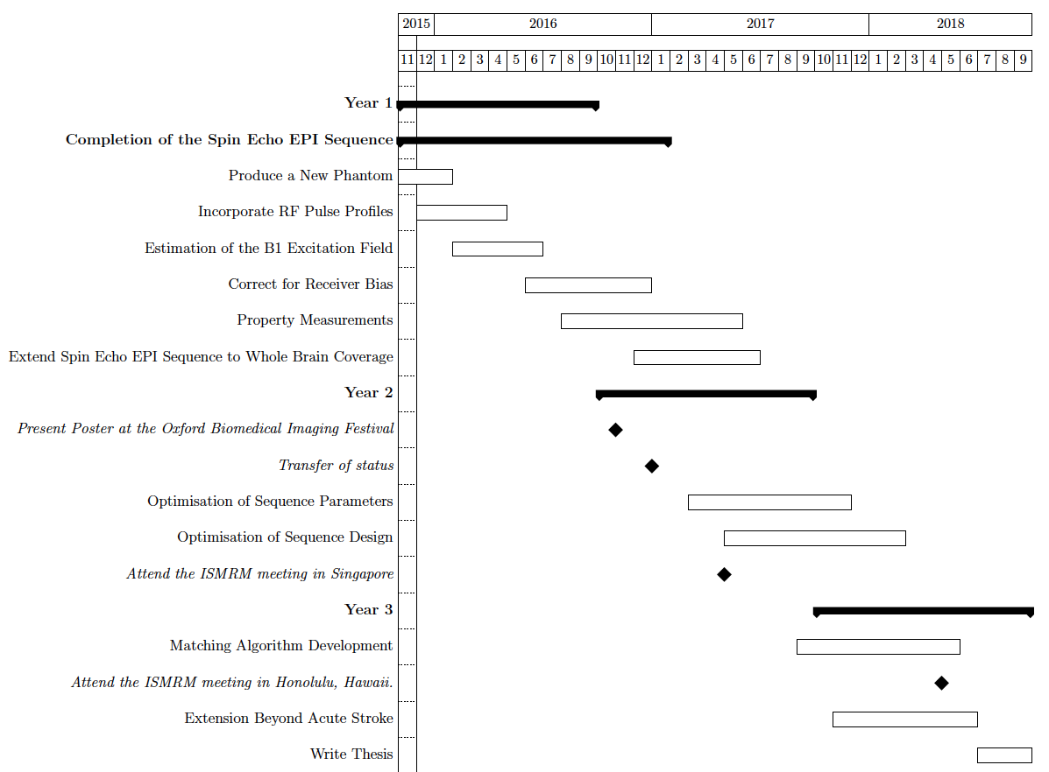

1. **Planned Timeline**
2. **References**

1. Deoni, S. C. L., Rutt, B. K. & Peters, T. M. Rapid combinedT1 andT2 mapping using gradient recalled acquisition in the steady state. *Magn. Reson. Med.* **49,** 515–526 (2003).

2. Deoni, S. C. L., Peters, T. M. & Rutt, B. K. High-resolution T1 and T2 mapping of the brain in a clinically acceptable time with DESPOT1 and DESPOT2. *Magn. Reson. Med.* **53,** 237–241 (2005).

3. Warntjes, J. B. M., Leinhard, O. D., West, J. & Lundberg, P. Rapid magnetic resonance quantification on the brain: Optimization for clinical usage. *Magn. Reson. Med.* **60,** 320–329 (2008).

4. Warntjes, J. B. M., Dahlqvist, O. & Lundberg, P. Novel method for rapid, simultaneousT1,T*2, and proton density quantification. *Magn. Reson. Med.* **57,** 528–537 (2007).

5. Palma, G. *et al.* A Novel Multiparametric Approach to 3D Quantitative MRI of the Brain. 1–20 (2015). doi:10.1371/journal.pone.0134963

6. Neeb, H., Zilles, K. & Shah, N. J. A new method for fast quantitative mapping of absolute water content in vivo. *Neuroimage* **31,** 1156–1168 (2006).

7. Baltes, C., Princz-kranz, F., Rudin, M. & Mueggler, T. Magnetic Resonance Neuroimaging. *Methods Mol. Biol.* **711,** 511–533 (2011).

8. (ESR), E. S. of R. Magnetic Resonance Fingerprinting - a promising new approach to obtain standardized imaging biomarkers from MRI. *Insights Imaging* **6,** 163–165 (2015).

9. González, R. G. Current state of acute stroke imaging. *Stroke.* **44,** 3260–4 (2013).

10. Ma, D. *et al.* Magnetic resonance fingerprinting. *Nature* **495,** 187–192 (2013).

11. Buonincontri, G. & Sawiak, S. Three-dimensional MR fingerprinting with simultaneous B1 estimation. *MRM_submitted* **00,** 1–9 (2015).

12. Ye, H. *et al.* Accelerating magnetic resonance fingerprinting (MRF) using t-blipped simultaneous multislice (SMS) acquisition. *Magn. Reson. Med.* **000,** n/a–n/a (2015).

13. Ma, D. *et al.* Music-based magnetic resonance fingerprinting to improve patient comfort during MRI examinations. *Magn. Reson. Med.* **00,** n/a–n/a (2015).

14. Jiang, Y., Ma, D., Seiberlich, N., Gulani, V. & Griswold, M. a. MR fingerprinting using fast imaging with steady state precession (FISP) with spiral readout. *Magn. Reson. Med.* **00,** n/a–n/a (2014).

15. Heiss, W.-D. & Kidwell, C. S. Imaging for prediction of functional outcome and assessment of recovery in ischemic stroke. *Stroke.* **45,** 1195–201 (2014).

16. Harston, G. W. J. *et al.* Identifying the ischaemic penumbra using pH-weighted magnetic resonance imaging. *Brain* **138,** 36–42 (2015).

17. Lövblad, K.-O. *et al.* Imaging of acute stroke: CT and/or MRI. *J. Neuroradiol.* **42,** 55–64 (2015).

18. Gerriets, T. *et al.* Edema formation in the hyperacute phase of ischemic stroke. Laboratory investigation. *J. Neurosurg.* **111,** 1036–1042 (2009).

19. Weigel, M. Extended phase graphs: Dephasing, RF pulses, and echoes - pure and simple. *J. Magn. Reson. Imaging* **41,** 266–295 (2015).

20. Ma, D. *et al.* Magnetic resonance fingerprinting. *Nature* **495,** 187–192 (2013).

21. Ganter, C. *et al.* B1+-mapping with the transient phase of unbalanced steady-state free precession. *Magn. Reson. Med.* **70,** 1515–23 (2013).

22. Abbas, Z., Gras, V., Möllenhoff, K., Oros-Peusquens, A.-M. & Shah, N. J. Quantitative water content mapping at clinically relevant field strengths: A comparative study at 1.5T and 3T. *Neuroimage* **106,** 404–13 (2015).

23. Abbas, Z. *et al.* Analysis of proton-density bias corrections based on T1 measurement for robust quantification of water content in the brain at 3 Tesla. *Magn. Reson. Med.* **72,** 1735–45 (2014).

24. Vovk, U., Pernuš, F. & Likar, B. A review of methods for correction of intensity inhomogeneity in MRI. *IEEE Trans. Med. Imaging* **26,** 405–421 (2007).

25. Clare, S. & Jezzard, P. Rapid T(1) mapping using multislice echo planar imaging. *Magn. Reson. Med.* **45,** 630–634 (2001).