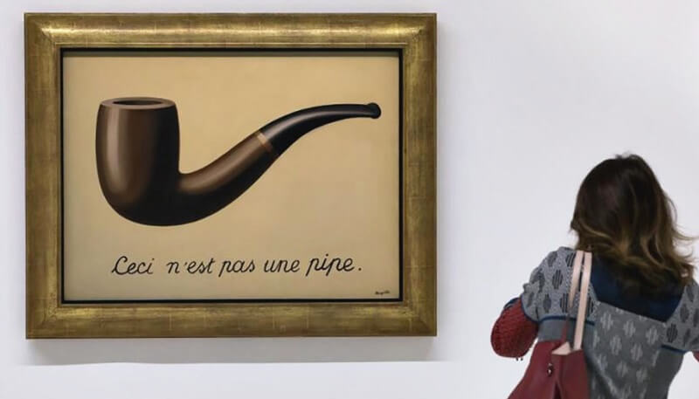
https://www.renemagritte.org/the-treachery-of-images.jsp

This is not a pipe, but this is a digitally signed document.

