**gStore2.0**

Building:

1. Install ANTLR

ANTLR should be installed before you can build gStore2.0 on your 64bit linux system.

You can download it from : <http://www.antlr3.org/download/C/libantlr3c-3.4.tar.gz>

Then:

1.1 Install

tar –xzvf libantlr3c-3.4.tar.gz

./configure -enable-64bit

make

make install

For detailed installation instructions, see INSTALL file in the package *libantlr3c-3.4.tar.gz*

1.2 Link the library

After running “make install”, you will see where the lib has been installed in you linux system from the prompt displayed on the terminal window. For example:

------------------------------------------------------------------------

Libraries have been installed in:

/usr/local/lib

...

------------------------------------------------------------------------

To make sure you can use the lib everywhere, you should add the installation path of the lib into “/etc/ld.so.conf”: insert the library path(“/usr/local/lib”, here) as a new line

Run ‘ldconfig’ on terminal to make you modification on “/etc/ld.so.conf” take effect.

2. Install gStore2.0

gStore2.0 must be built using GNU make and a reasonable c++ complier. Ideally simple

make

is enough, it will build the two executables (see below) in the root dir of gStore2.0

Using gStore2.0：

gStore2.0 currently includes two executables.

1. The first (gStore2.0) is used to build a new database from a 3-triples input:

./gload db_name rdfdata.n3

Each line in the input end up with a dot.

Each line only contains a triple, whose tuples(subject, predicate and object) separated by tab.

For example：



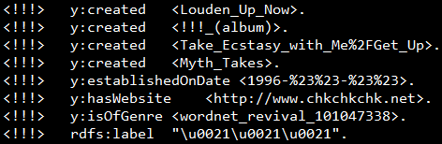

2. After loading the database can be queried with the second executable: gquery

./gquery db_name

The program shows a command prompt: inputting a file name that can be used to interpret a file with single query. When the program finish answering the query, it shows the command prompt again.

gStore2.0 only support simple “select” queries.

