OSINT RECONNAISSANCE REPORT
Target: zendesk.com
Author | Sridharan Thangaraji
Date | 2026-03-31
Scope | zendesk.com
Method | Passive / Open-Source Intelligence

Executive Summary
This report documents passive OSINT reconnaissance conducted against zendesk.com. The objective was to map publicly available information including domain registration data, DNS infrastructure, exposed subdomains, IP geolocation, network path, web surface metadata, and employee/corporate intelligence.

Key findings:
- Domain is protected by MarkMonitor with all EPP lock statuses enabled.
- DNS is hosted on AWS Route 53; web traffic routes through Cloudflare (WAF/CDN).
- Over 200 subdomains were enumerated via passive sources.
- robots.txt reveals internal path structure including marketplace, brand, and partner directories.
- Email infrastructure runs on Google Workspace.
- LinkedIn enumeration identified Zendesk India employees in Bengaluru.
- Indian subsidiary (Zendesk Technologies Pvt. Ltd.) director details are publicly available via MCA records.

1. Domain Registration (WHOIS)
Field | Value
Domain | zendesk.com
Registry Domain ID | 157863981_DOMAIN_COM-VRSN
Registrar | MarkMonitor Inc. (IANA ID: 292)
Created | 2005-05-16
Last Updated | 2024-04-15
Expiry | 2027-05-16
Registrant Org | Zendesk, Inc.
Registrant Country | US
Registrant Email | Redacted (MarkMonitor WHOIS form)
DNSSEC | Unsigned
Abuse Contact | abusecomplaints@markmonitor.com

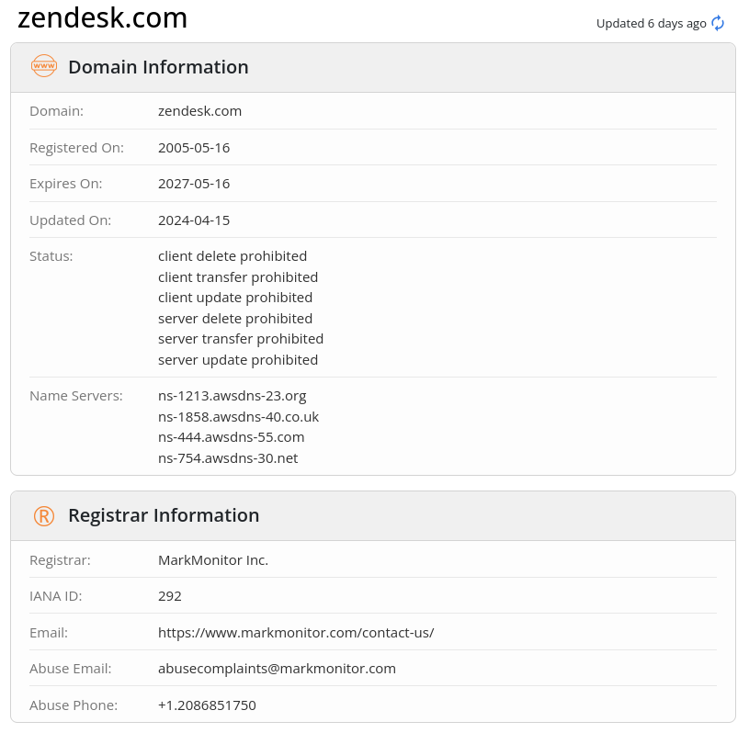
2. DNS Enumeration
2.1 A Records (nslookup)
zendesk.com → 216.198.53.
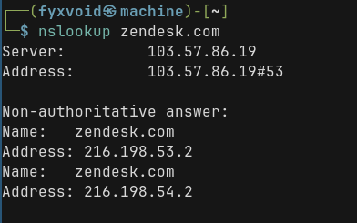
Figure: nslookup zendesk.com — resolves to 216.198.53.2 and 216.198.54.2
2.2 Name Servers (AWS Route 53)
Name Server
ns-1213.awsdns-23.org
ns-1858.awsdns-40.co.uk
ns-444.awsdns-55.com
ns-754.awsdns-30.net

2.3 MX Records (Email Infrastructure)
Priority | Mail Server
Mx0 | aspmx.l.google.com
Mx1 | alt1.aspmx.l.google.com
Mx2 | alt2.aspmx.l.google.com
Mx3 | alt3.aspmx.l.google.com
Mx4 | alt4.aspmx.l.google.com

Zendesk uses Google Workspace for corporate email.
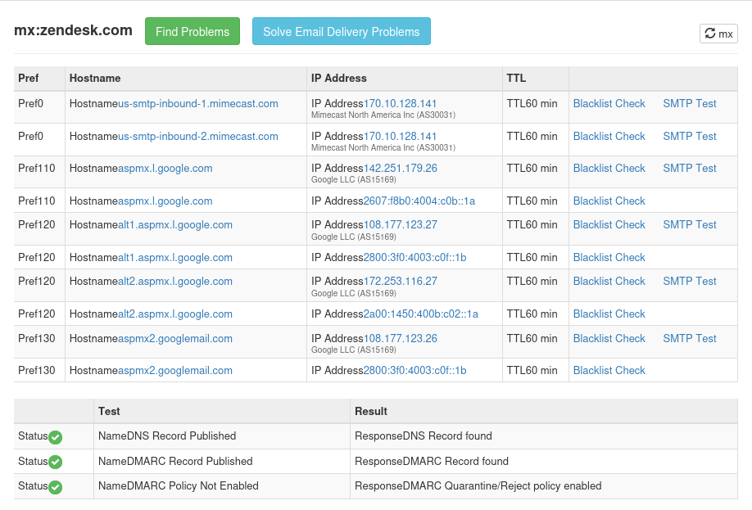
Figure: MX / DNS record check — Google Workspace mail servers confirmed

3. IP Intelligence
3.1 IP Geolocation (216.198.54.2)
Field | Value
IP Address | 216.198.54.2
Country | United States
Region | California
City | San Francisco
Organization | AS209242 — Cloudflare, LLC

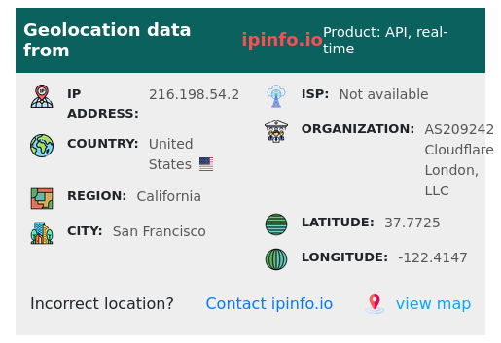
Figure: ipinfo.io — Geolocation data for 216.198.54.2 (Cloudflare / San Francisco)
server IP is hidden behind Cloudflare's reverse proxy.

3.2 Port Scan & Technology Stack (Shodan)
Port scan data reflects Cloudflare's edge, not Zendesk's backend. Web technology fingerprinting confirms CDN: Cloudflare.
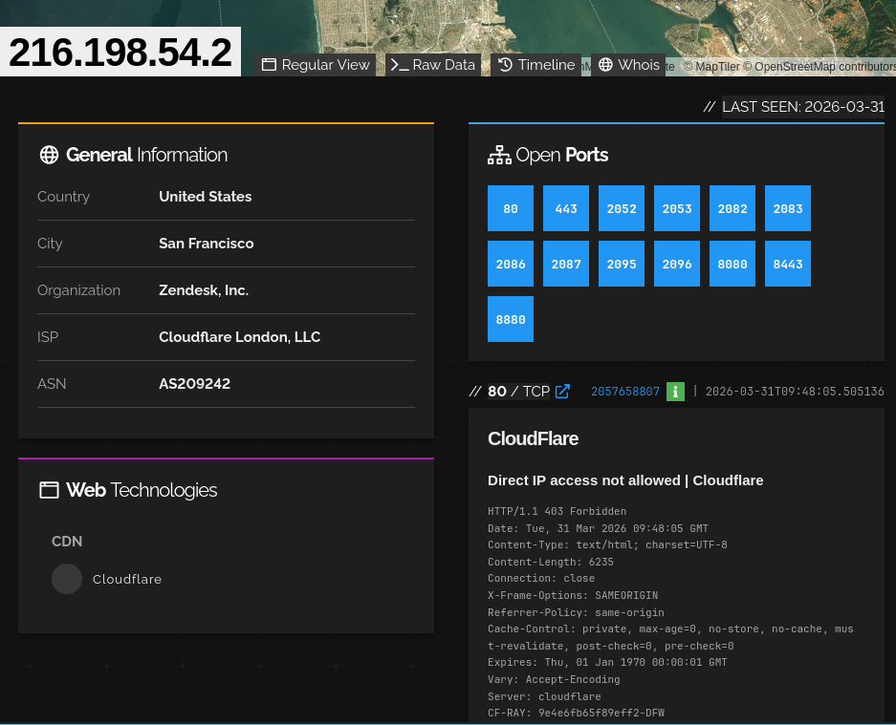

Figure: Shodan — 216.198.54.2 open ports and Cloudflare message

4. Network Path (Traceroute — TCP 443)
Hop | RTT | Address
1 | 3.48 ms | 192.168.1.1
2 | 5.60 ms | blr-tdc-bngs-02 (103.57.86.19)
3 | 8.24 ms | 103.57.86.1
4 | — | * (no response)
5 | 9.02 ms | 216.198.54.2

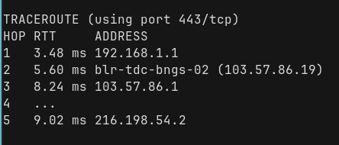
Figure: Traceroute (TCP 443) — 5-hop path from Bengaluru to Cloudflare edge at 216.198.54.2
Origin hops beyond Cloudflare are hidden.

5. Web Surface Intelligence
5.1 robots.txt Analysis
The robots.txt at https://www.zendesk.com/robots.txt reveals internal path structure:
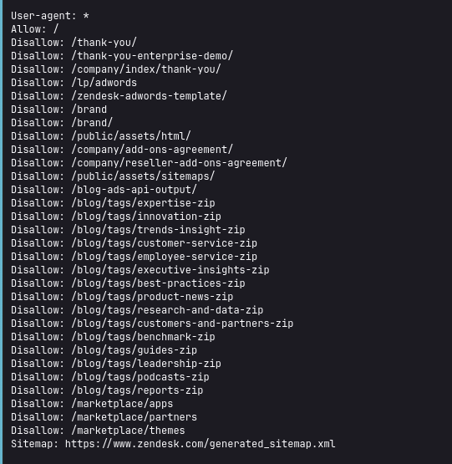Figure:

5.2 Sitemap
Sitemap: https://www.zendesk.com/generated_sitemap.xml
├── generated_sitemap_part1.xml
└── generated_sitemap_part2.xml
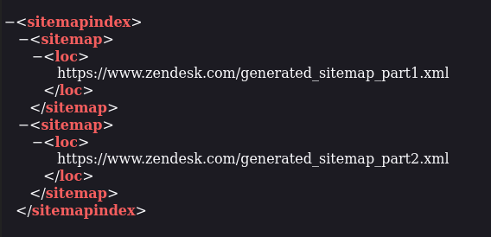
Figure: Sitemap index XML — two-part sitemap structure

6. Subdomain Enumeration
200+ subdomains were passively enumerated. Notable entries by category:
Category | Subdomains
Core | www, support, status, developer, training, event, adm
Partner/Sales | partnersuccess, sellersfundinghelp
Security-adjacent | offensive-security, contrastsecurity, dune-security, gremlin-security, saltsecurity, siteprotect
Crypto/Fintech | bitmart, cryptopia, phantom-wallet, safepalsupport, emurgohelpdesk
Government/Edu | nysed-op, francecompetences, eccouncil
Testing/Dev | testcenter, nm7uqebiup84rmec6eeb (randomised subdomain)
Major Clients | gitlab, nvidia1651665403, zillow, wpengine, fourseasons, tescosupportcentre

7. Employee Intelligence (LinkedIn OSINT)
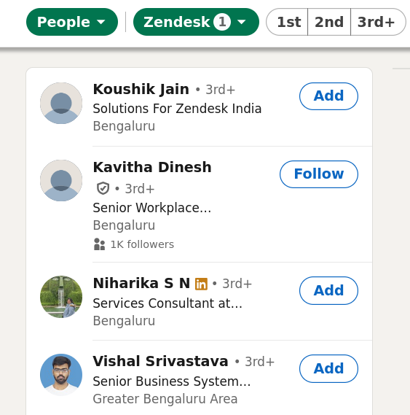
Figure: LinkedIn — Zendesk India employees identified via people search

Name | Role | Location
Koushik Jain | Solutions — Zendesk India | Bengaluru
Kavitha Dinesh | Senior Workplace (1K+ followers) | Bengaluru
Niharika S N | Services Consultant | Bengaluru
Vishal Srivastava | Senior Business Systems | Greater Bengaluru

8. Corporate Intelligence — Indian Subsidiary
Entity: Zendesk Technologies Private Limited
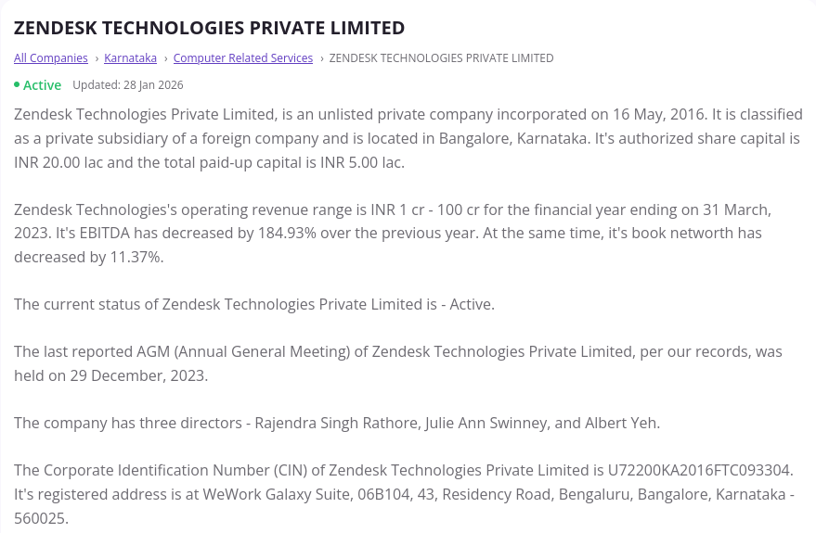
Figure: MCA — Zendesk Technologies Private Limited company overview
Field | Value
Incorporation Date | 19 May 2016
Entity Type | Foreign Company (India subsidiary)
Industry | Computer Related Services; Marketing Management Consulting
Auth Capital | ₹20.0 Lakh
Paid-up Capital | ₹5.0 Lakh
Revenue | ₹50–75 Crore
Registered Address | Salarpuria Sigma, Bengaluru, Karnataka

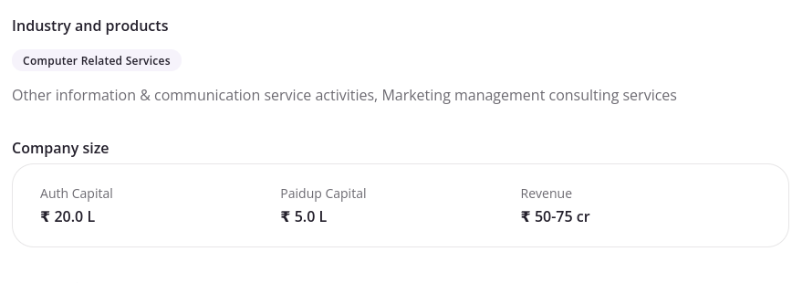
Figure: MCA — Company size and financial details
Directors
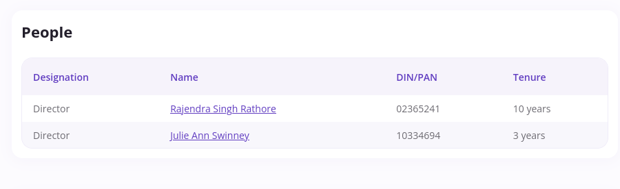
Figure: MCA — Director listing with DIN numbers and tenure
Name | DIN | Tenure
Rajendra Singh Rathore | 02365241 | 10 years
Julie Ann Swinney | 10334694 | 3 years

9. Summary of Findings
Category | Finding
DNSSEC not enabled | Domain vulnerable to DNS spoofing if no edge-level mitigation
Cloudflare WAF/CDN | Origin IP is hidden; direct access blocked
robots.txt disclosure | Internal path structure exposed
200+ subdomains | Large attack surface; some tenants may be misconfigured
Google Workspace email | Target for BEC/phishing if SPF/DMARC not strictly enforced
Employee enumeration | LinkedIn profiles accessible
Director PII (India) | Publicly available DIN and tenure via MCA
AWS Route 53 DNS | DNS infrastructure identified; no immediate risk

10. Tools Used
Tool | Purpose
whois | Domain registration data
nslookup | DNS resolution
traceroute | Network path mapping (TCP 443)
ping | Subdomain liveness check
ipinfo.io | IP geolocation
Shodan | Port scan / web technology detection
robots.txt | Web surface crawl metadata
LinkedIn | Employee / personnel OSINT
MCA Portal | Indian corporate registry lookup
Subfinder | Passive subdomain enumeration

This report is for educational / authorized security assessment purposes only.

