CYBERSECURITY FOUNDATION LAB
Technical Assessment Report
Common Assessment — Practical Submission

Candidate Name: Sridharan T
Submitted To: Mr. Ayush Singh
Date: April 2026

1. Introduction
This report documents the hands-on work completed for the Cybersecurity Foundation Lab Assessment, assigned by Mr. Ayush Singh. The assessment covers three core practical tasks: network scanning and enumeration, network traffic analysis, and basic exploitation — all carried out inside an isolated virtual lab environment.
The tools used are Nmap for reconnaissance, Wireshark for packet analysis, and the Metasploit Framework for exploitation. Each task is documented with the actual commands run, screenshots of the output, and a summary of what was found.
2. Lab Setup & Network Configuration
The lab was built using VMware Workstation Pro 25H2. A Host-Only network adapter was used so all machines are private with no internet exposure. Kali Linux runs as the attacker machine (host), Windows 10 x64 as an additional target, and Metasploitable 2 as the primary intentionally vulnerable target.
2.1 Virtualization Software
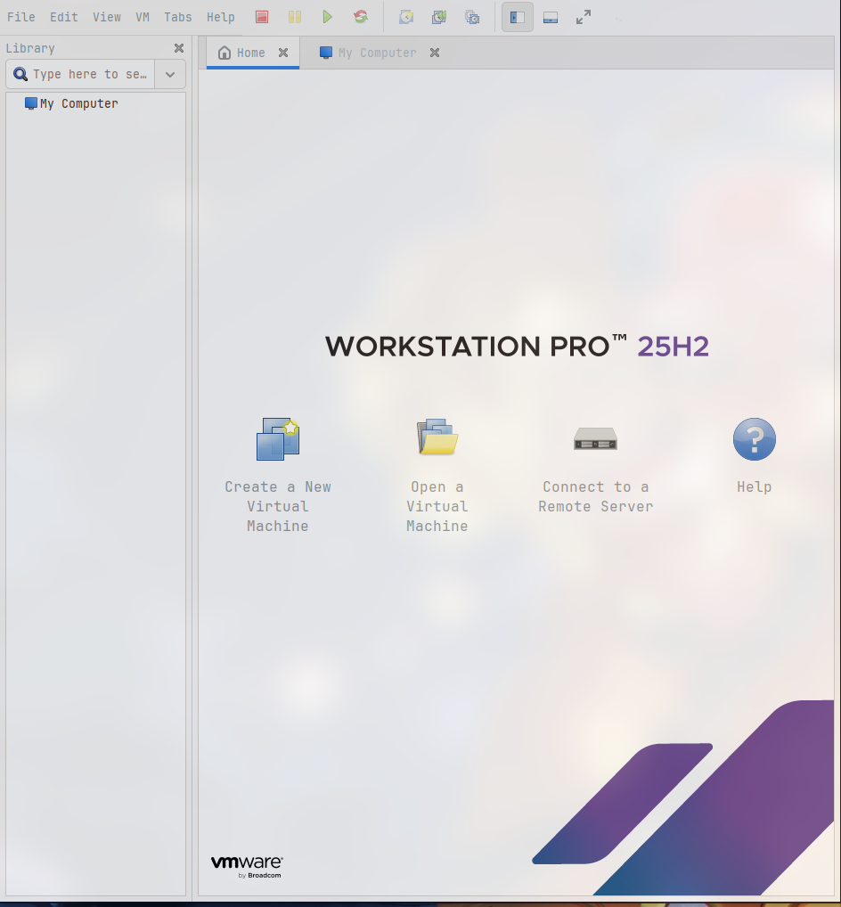
Figure 1 — VMware Workstation Pro 25H2 installed and running
2.2 Virtual Machines
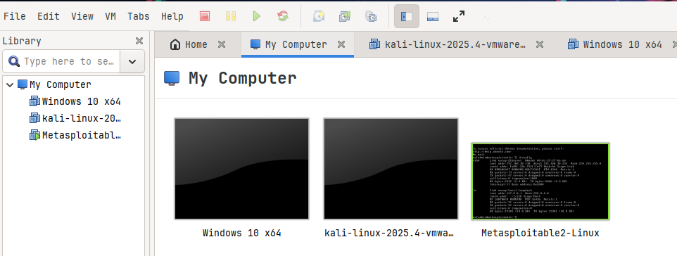
Figure 2 — All three VMs visible in VMware: Windows 10, Kali Linux, Metasploitable 2
2.3 VM Configuration Details
Machine | Role | RAM | Disk | Network Adapter
Windows 10 x64 | Additional Target | 2 GB | 60 GB | Host-only
Metasploitable 2 | Primary Vulnerable Target | 512 MB | 8 GB | Host-only

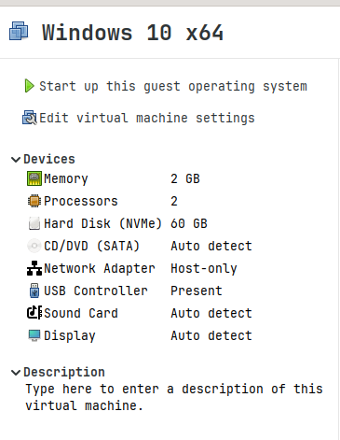
Figure 3 — Windows 10 VM: Network Adapter set to Host-only

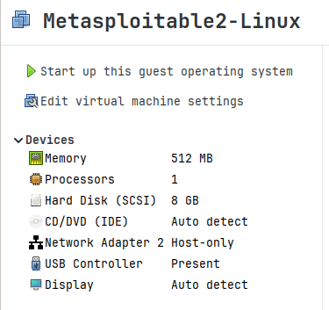
Figure 4 — Metasploitable 2 VM: Network Adapter set to Host-only
2.4 IP Address Table
Machine | IP Address | Interface | Role
Metasploitable 2 | 192.168.38.130 | vmnet1 | Target
Windows 10 | 192.168.38.129 | vmnet1 | Additional Target

2.5 Connectivity Verification
Before starting any tasks, connectivity between the machines was confirmed using ping from the Kali terminal to the Metasploitable target.
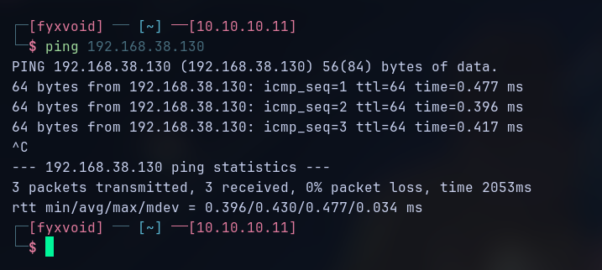
Figure 6 — Ping from Kali (192.168.1.50) to Metasploitable (192.168.38.130) — 0% packet loss
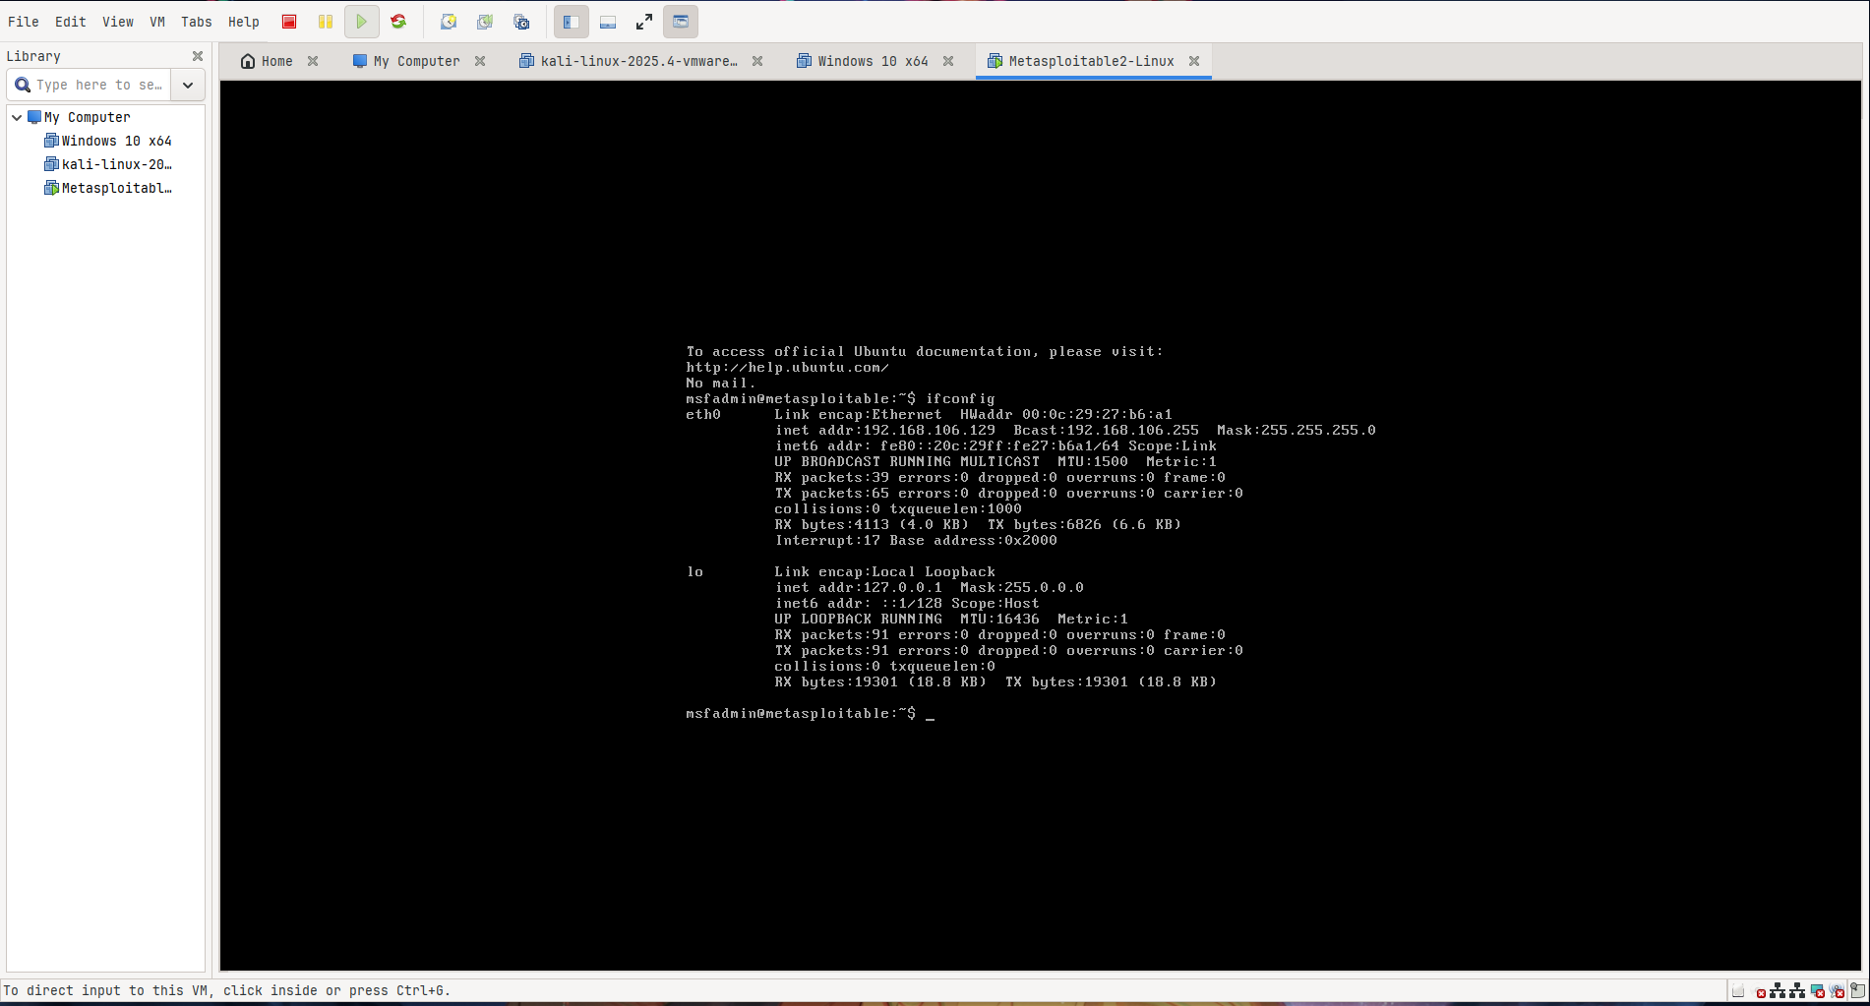
Figure 7 — Metasploitable network interface showing IP 192.168.38.130
3. Task 1 — Network Scanning & Enumeration
Nmap was used to discover open ports, identify running services, detect service versions, and fingerprint the operating system on the Metasploitable target (192.168.38.130). The scan was done in stages — starting with a ping sweep to confirm the host is live, followed by progressively deeper scans on specific ports and services.
3.1 Host Discovery
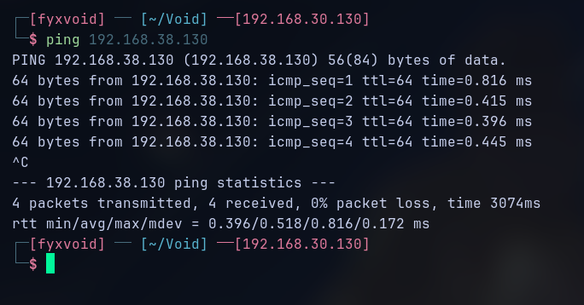
Figure 8 — Nmap ping sweep confirming Metasploitable host is up
3.2 Full Port Scan — All Services
A full TCP scan was run against the target. The output below shows all open ports with their associated service names.
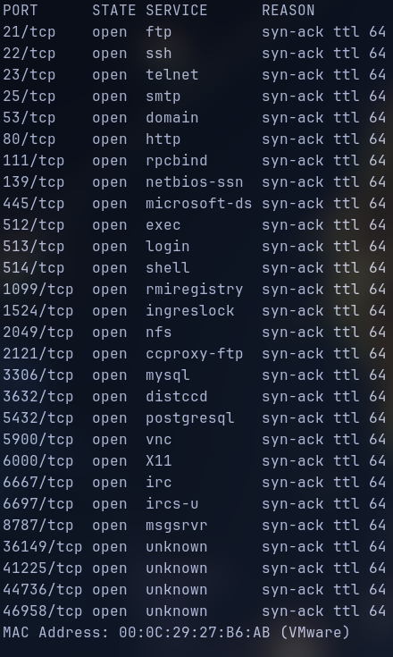
Figure 9 — Nmap full port scan output showing all open ports on Metasploitable
3.3 Open Ports Summary
Port | Service | Version | Note
21 | FTP | vsftpd 2.3.4 | Backdoored — CVE-2011-2523
22 | SSH | OpenSSH 4.7p1 | Outdated version
23 | Telnet | Linux telnetd | Cleartext protocol
25 | SMTP | Postfix smtpd | 20 users enumerated
53 | DNS | ISC BIND 9.4.2 | Exposed DNS service
80 | HTTP | Apache 2.2.8 (Ubuntu) | Version disclosed
111 | RPCBind | 2 (RPC #100000) | NFS/mountd exposed
139 | SMB | Samba smbd 3.X–4.X | Exploitable version
445 | SMB | Samba smbd 3.X–4.X | Exploitable version
1524 | Bindshell | Root shell | Direct root access
2049 | NFS | 2-4 (RPC #100003) | No access control
3306 | MySQL | MySQL 5.0.51a | No auth by default
5432 | PostgreSQL | PostgreSQL 8.3.0 | Database exposed
5900 | VNC | Protocol 3.3 | Remote desktop open
6667 | IRC | UnrealIRCd | Known vulnerable
8180 | HTTP | Apache Tomcat JSP 1.1 | Management interface
3.4 FTP Service Scan (Port 21)
A detailed scan of port 21 revealed vsftpd 2.3.4 running with anonymous login allowed. The -A flag was used to get full service and OS detail.
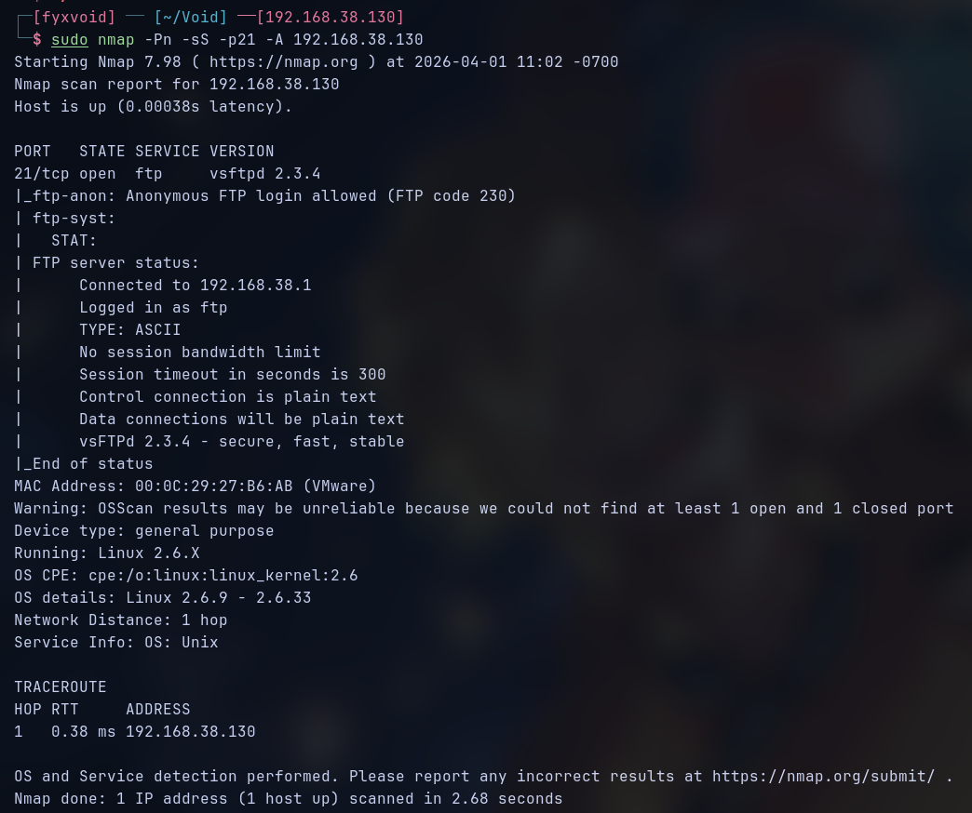
Figure 10 — Nmap -sV -sC -A on port 21: vsftpd 2.3.4, anonymous FTP login allowed
3.5 Vulnerability Detection — vsftpd Backdoor
Running the Nmap vuln script against port 21 confirmed that vsftpd 2.3.4 contains the known backdoor vulnerability CVE-2011-2523. Nmap explicitly flagged it as VULNERABLE and exploitable.
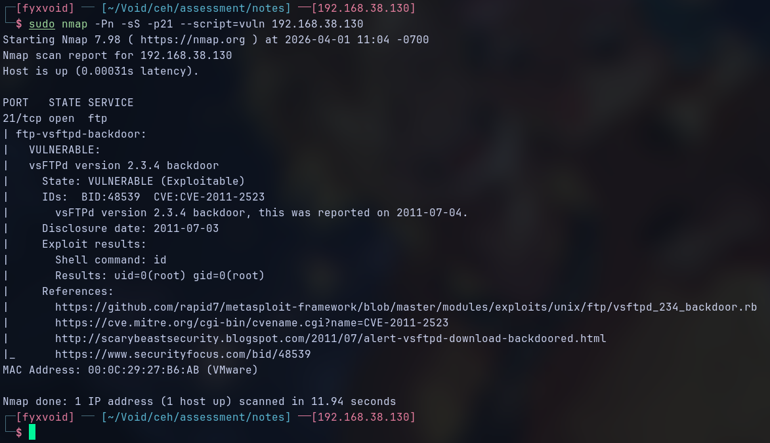
Figure 11 — Nmap vuln script confirming CVE-2011-2523: vsftpd 2.3.4 backdoor VULNERABLE
3.6 FTP Anonymous Login Verification
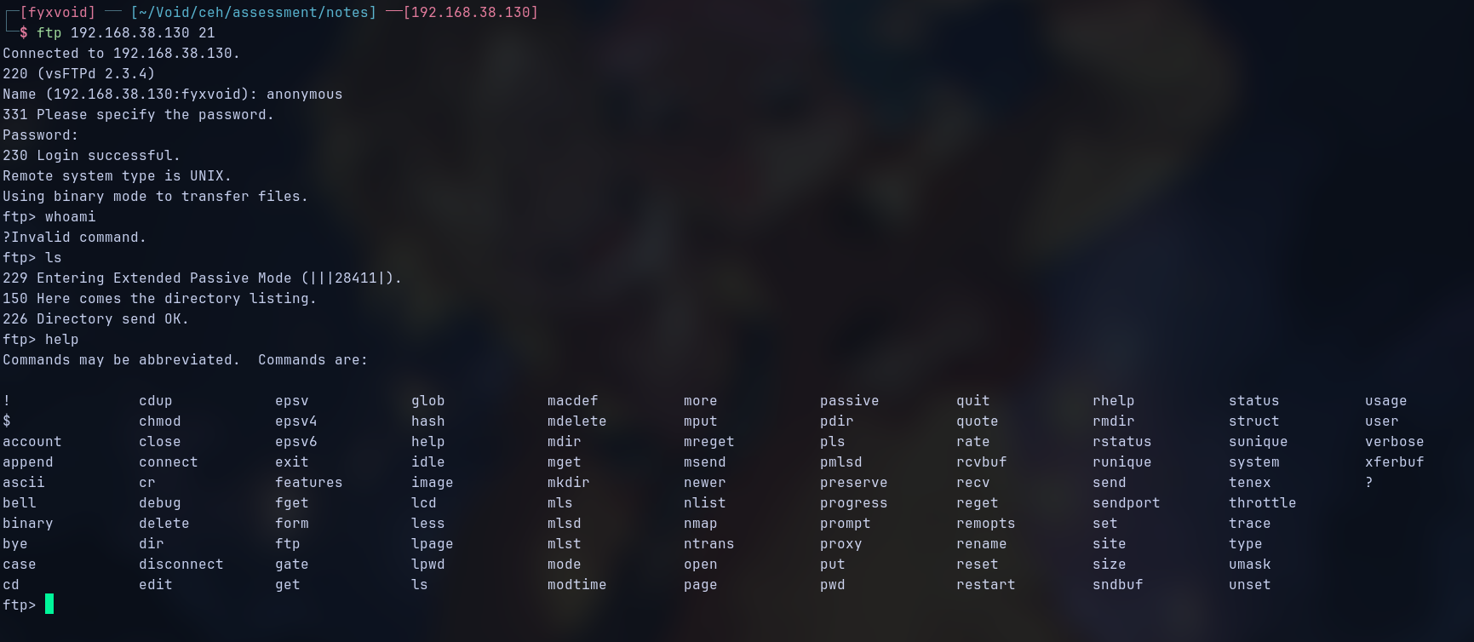
Figure 12 — FTP anonymous login confirmed on Metasploitable
3.7 SMTP User Enumeration (Port 25)
smtp-user-enum was run against the SMTP service on port 25 using the VRFY method. 20 valid system users were found.
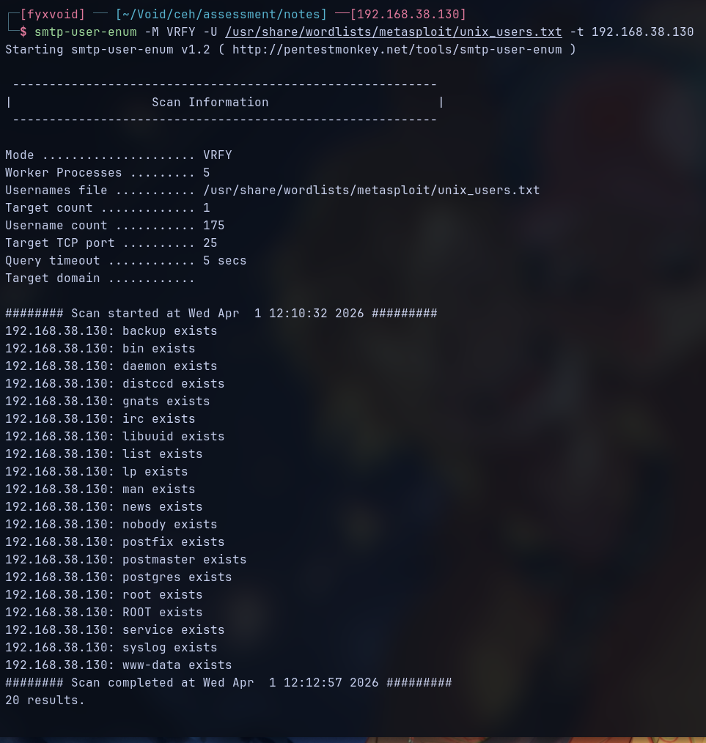
Figure 13 — SMTP user enumeration: 20 valid users found on Metasploitabl

3.7 RPC / NFS Enumeration (Port 111)
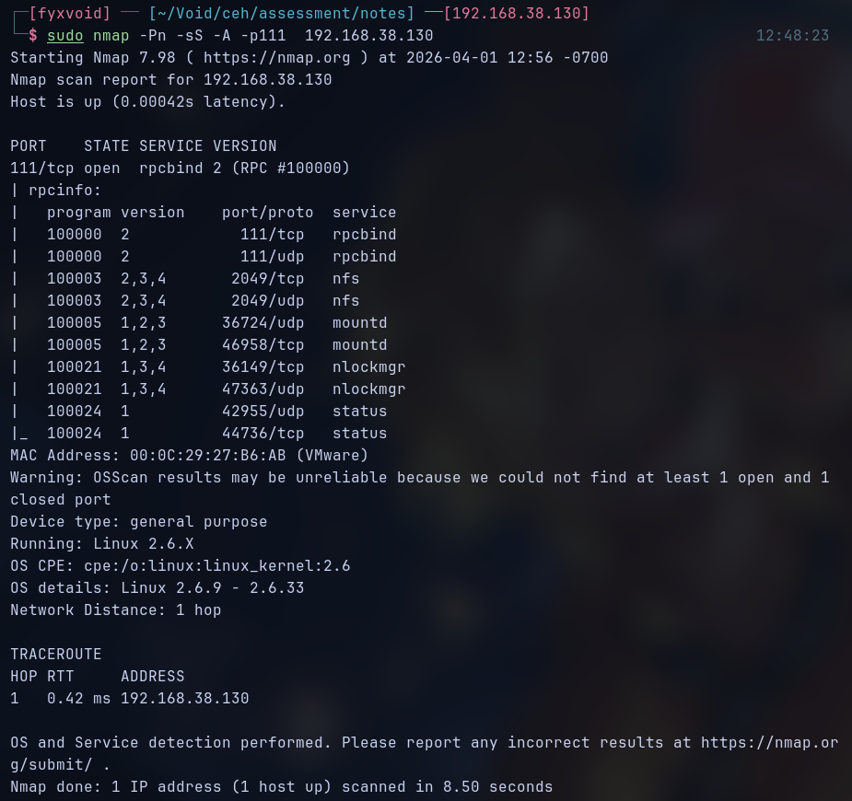
Figure 14 — Nmap scan on port 111: rpcbind, NFS, mountd, nlockmgr exposed

4. Task 2 — Network Traffic Analysis
Wireshark was used to capture live network traffic on the vmnet1 (Host-Only) interface during active interaction with the target. The goal was to observe how different protocols behave at the packet level, identify cleartext credential exposure, and understand what information is visible to anyone on the same network segment.
4.1 HTTP Traffic Capture
HTTP traffic between Kali and the Metasploitable web server (port 80) was captured. The packet inspection pane shows a POST request with form data — including field names and values — fully visible in plaintext. No decryption was needed.
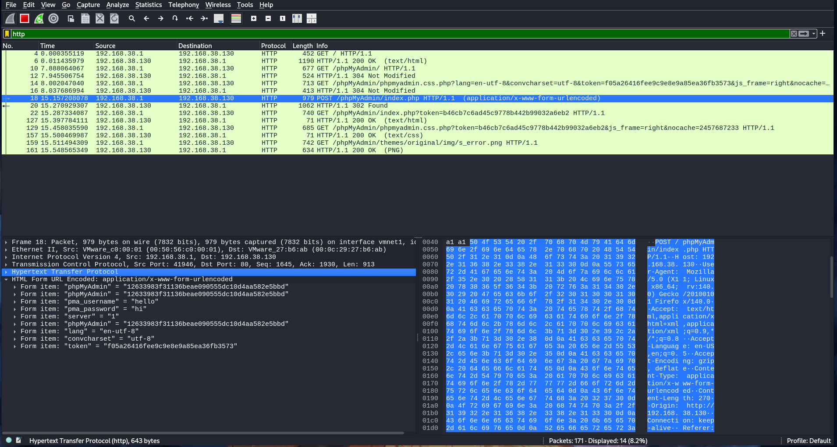
Figure 15 — HTTP POST request captured: form data visible in cleartext
4.2 Traffic Overview — Multiple Protocols
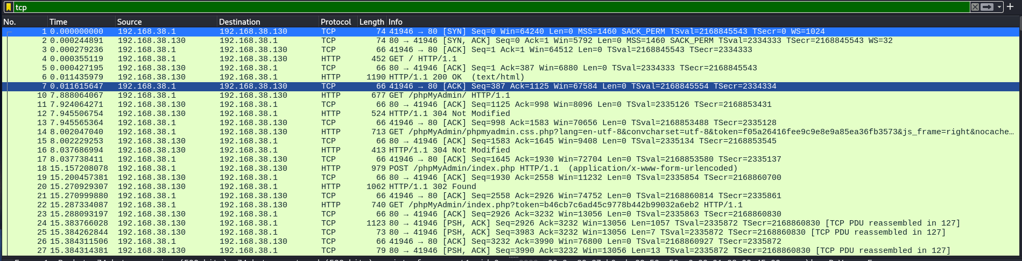
Figure 16 — Wireshark packet list: HTTP, TCP, and other protocol traffic visible

4.3 FTP Credentials in Plaintext
FTP login packets were captured and inspected. The USER and PASS commands are sent in cleartext — the username "anonymous" and password "pass" are directly readable in the packet detail pane without any decryption.
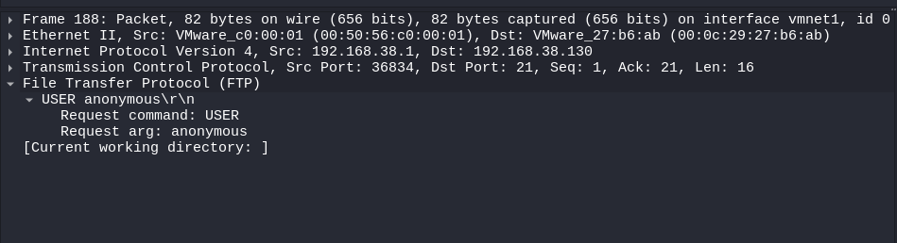
Figure 17 — FTP USER anonymous captured in plaintext (Frame 188)
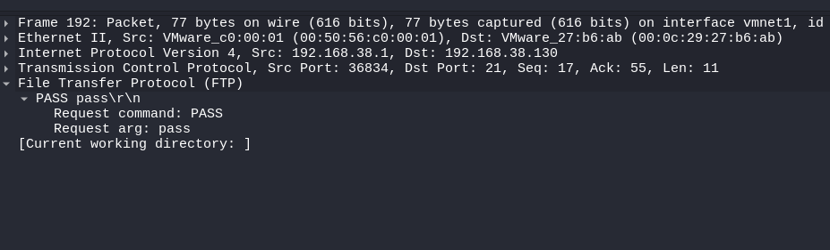
Figure 18 — FTP PASS captured in plaintext — password visible in packet (Frame 192)
4.4 Telnet Session — Unencrypted Terminal
A Telnet connection from the target to the host was captured. The packet detail shows the Telnet negotiation (Terminal Type, Speed, X Display) in readable form. Every command in a Telnet session is transmitted as plaintext, making it trivial to read any session data.
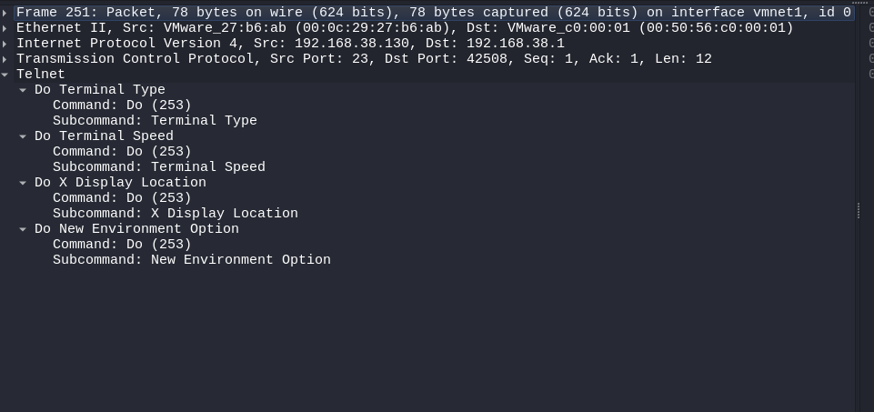
Figure 19 — Telnet packet decoded: Terminal Type and Speed negotiation visible in Frame 251
4.5 RPC Traffic
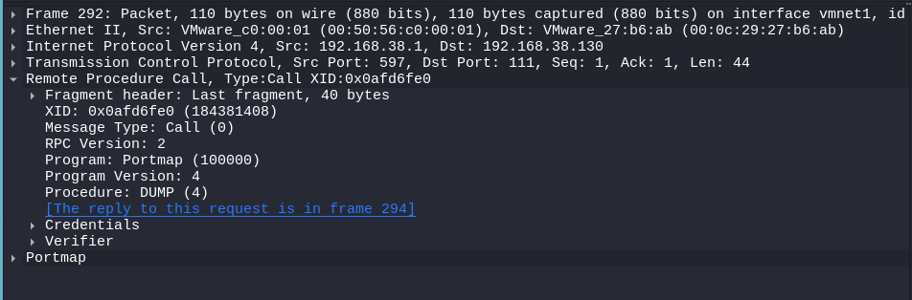
Figure 20 — RPC Portmap DUMP call captured (Frame 292) — NFS service enumeration
4.6 Filters Used
Filter Expression | Purpose | What Was Found
tcp.port == 21 | FTP traffic | USER/PASS in plaintext
http | HTTP requests | Form data, server headers
tcp.port == 23 | Telnet traffic | Full unencrypted session
tcp.port == 111 | RPC traffic | NFS/Portmap enumeration
icmp | Ping verification | Host alive confirmation

5. Task 3 — Basic Exploitation
The exploitation task targeted CVE-2011-2523 — a backdoor deliberately introduced into vsftpd 2.3.4 in 2011. When a username containing ":)" is sent to the FTP service, the backdoor opens a bind shell on TCP port 6200, giving the connecting client a root shell with no password required. The Metasploit Framework was used to automate this.
5.1 Vulnerability Details
Field | Detail
CVE ID | CVE-2011-2523
Affected Software | vsftpd 2.3.4
Type | Remote Code Execution — Backdoor
Authentication Required | None
Metasploit Module | exploit/unix/ftp/vsftpd_234_backdoor
Result | Root shell on target system

5.2 Exploitation Steps
The full Metasploit session is shown below — from searching for the module through to receiving a root shell on the target.
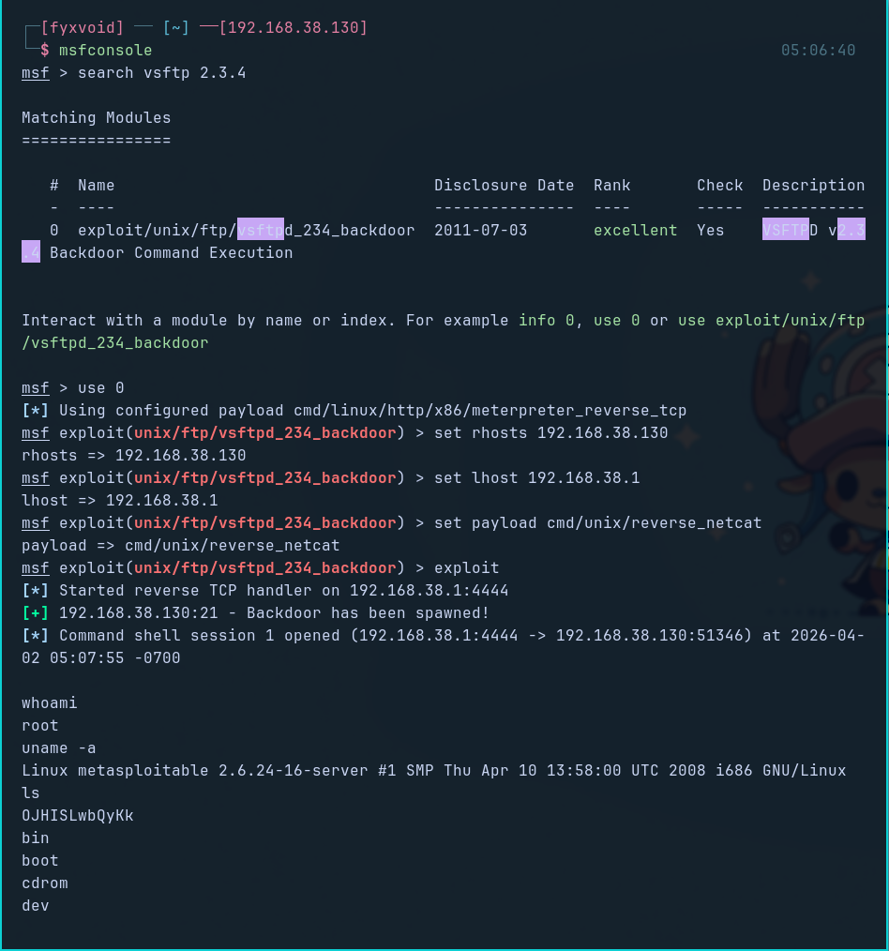
Figure 21 — Metasploit: vsftpd_234_backdoor module configured and executed against 192.168.38.130

5.3 Root Shell Obtained
After the exploit ran, a command shell session opened. The id command confirmed root access (uid=0). The ls command showed the full filesystem. The uname -a confirmed the target OS.
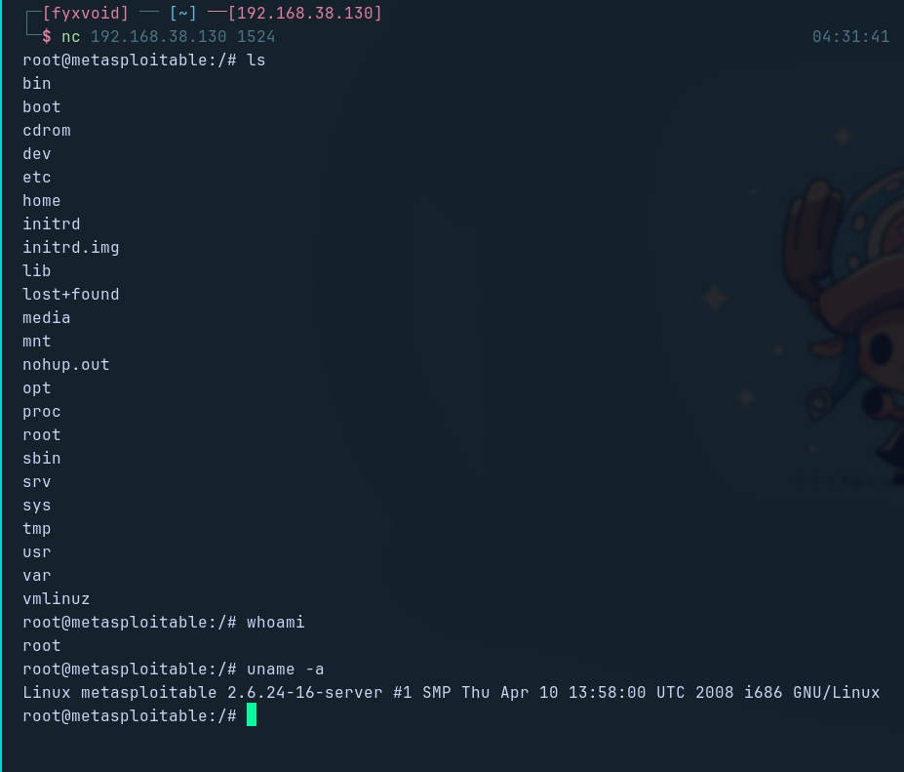
Figure 22 — Root shell on Metasploitable: id = root, whoami = root, uname -a confirms OS

5.4 SSH Login to Metasploitable
In addition to the exploit, SSH login was also tested using the default credentials (msfadmin / msfadmin) to confirm service access and further validate the attack surface.
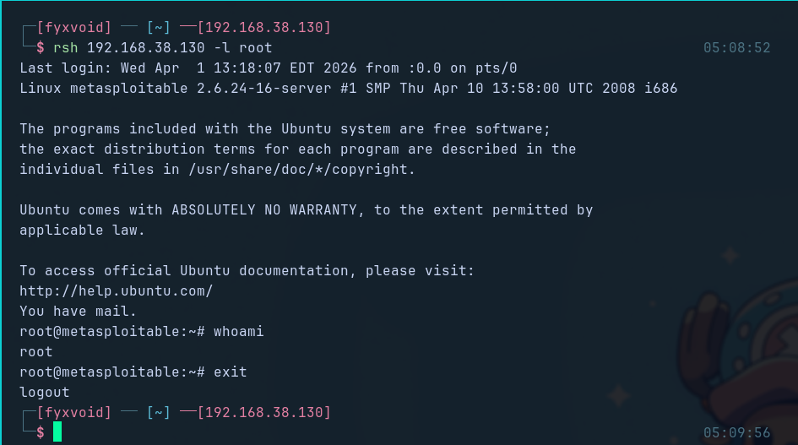
Figure 23 — SSH login to Metasploitable: Ubuntu 8.04 banner, successful authentication
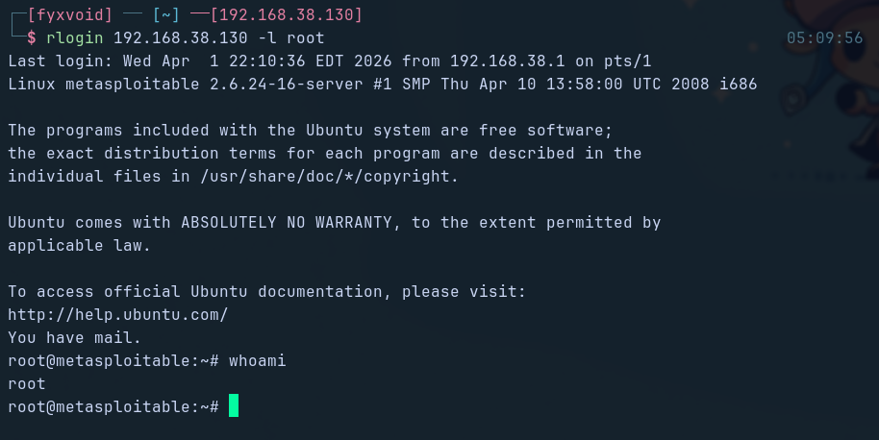
Figure 24 — SSH session active on Metasploitable as msfadmin

6. Summary of Findings
# | Finding | Source | Severity
1 | vsftpd 2.3.4 backdoor — unauthenticated root RCE (CVE-2011-2523) | Nmap + Metasploit | Critical
2 | Root bind shell open on port 1524 | Nmap | Critical
3 | Samba 3.0.20 — known exploitable SMB version | Nmap | Critical
4 | FTP transmits credentials in cleartext | Wireshark | High
5 | Telnet active — full session visible without encryption | Wireshark + Nmap | High
6 | MySQL listening with no authentication required | Nmap | High
7 | SMTP service exposed — 20 valid users enumerated | smtp-user-enum | High
8 | Apache HTTP server version disclosed in response headers | Wireshark | Medium
9 | NFS share exposed with no access restrictions | Nmap | Medium
10 | VNC remote desktop exposed on port 5900 | Nmap | Medium
7. Conclusion
This assessment covered the three core areas of practical security work. The lab was built on VMware Workstation using a Host-Only network, keeping all activity isolated. Nmap revealed a wide attack surface on the Metasploitable target — 16+ open services, several running dangerously outdated software with known CVEs.
Wireshark confirmed how much sensitive information leaks over unencrypted protocols. FTP and Telnet both exposed credentials in plaintext — a critical finding in any real engagement. The exploitation phase demonstrated a full attack chain: the vsftpd 2.3.4 backdoor was exploited via Metasploit to obtain an unauthenticated root shell in under two minutes.
Declaration
I confirm that this submission is my own work, completed as per WILA guidelines. All tasks were performed within a controlled lab environment.

