4.16 Report

I tried counting all the loss and minimize it, but found the problem that as the iteration time becomes larger, the result of model become worse.

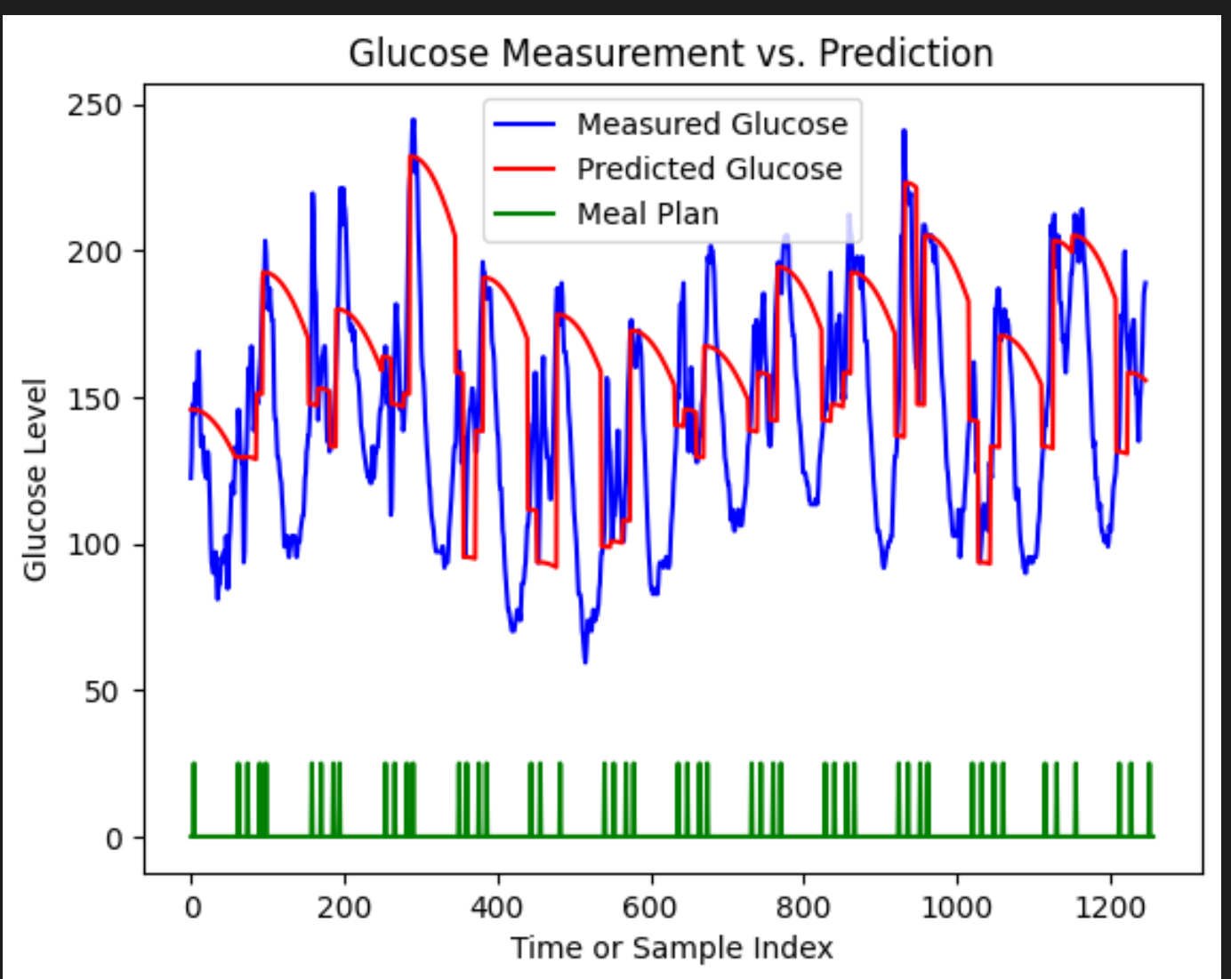

Fig.1 The model prediction effect of first iteration

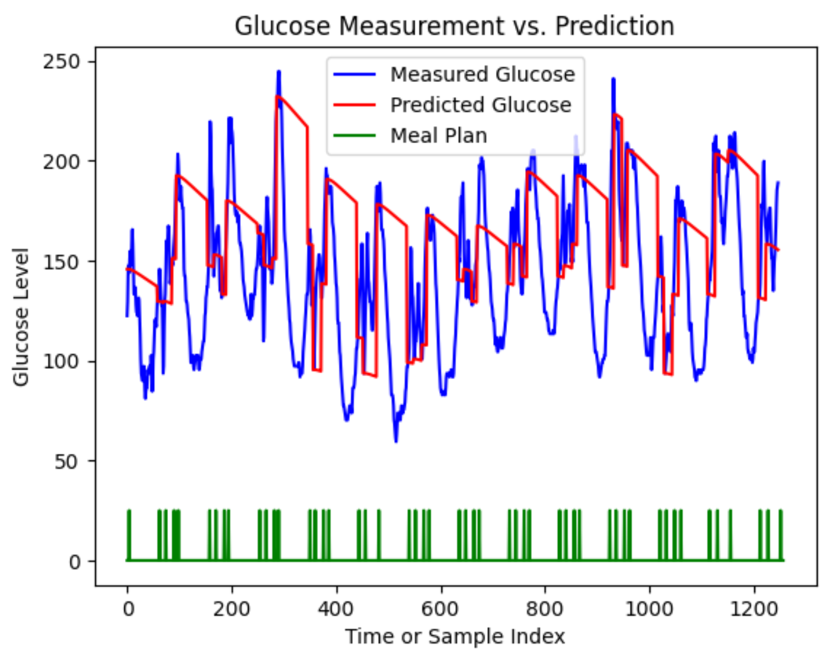

Fig.2 The model prediction effect of last iteration

Also, the model effect is worse than before. The result is weird but I haven’t found out the reason now. Maybe the logic of my code goes wrong, I will check it again after the exam this week. The updated code will be updated in the Feishu document.

Meanwhile, I searched for the dynamic system of non-insulin medicine on glucose control, but haven’t found articles relating to that. Maybe more search is needed or we need to find out the relationship by ourselves.