**2020春《数据库系统》作业3**

主讲教师: 邹兆年(znzou@hit.edu.cn)

姓名: _____陶飞宇____ 学号: ____117030720________ 班号: ____1737301_____

|  |  |  |  |  |  |  |  |  |  |  |  |
| --- | --- | --- | --- | --- | --- | --- | --- | --- | --- | --- | --- |
| 题目 | 1 | 2 | 3 | 4 | 5 | 6 | 7 | 8 | 9 | 10 | 总分 |
| 得分 |  |  |  |  |  |  |  |  |  |  |  |

1. 以课件上的例子为例：

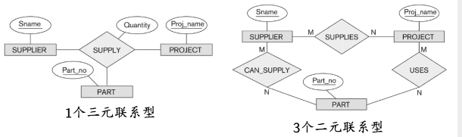

三元联系只能以“SUPPLY”表示提供，并没有SUPPLIER、PROJECT、PART之间的细节联系。

而三个二元联系以明确的CAN_SUPPLY、USES、PART三个联系明确了三个实体之间的关系。

当三个二元联系相同时，使用一个三元联系表示三个二元联系，结果是肯定相同的。

2.

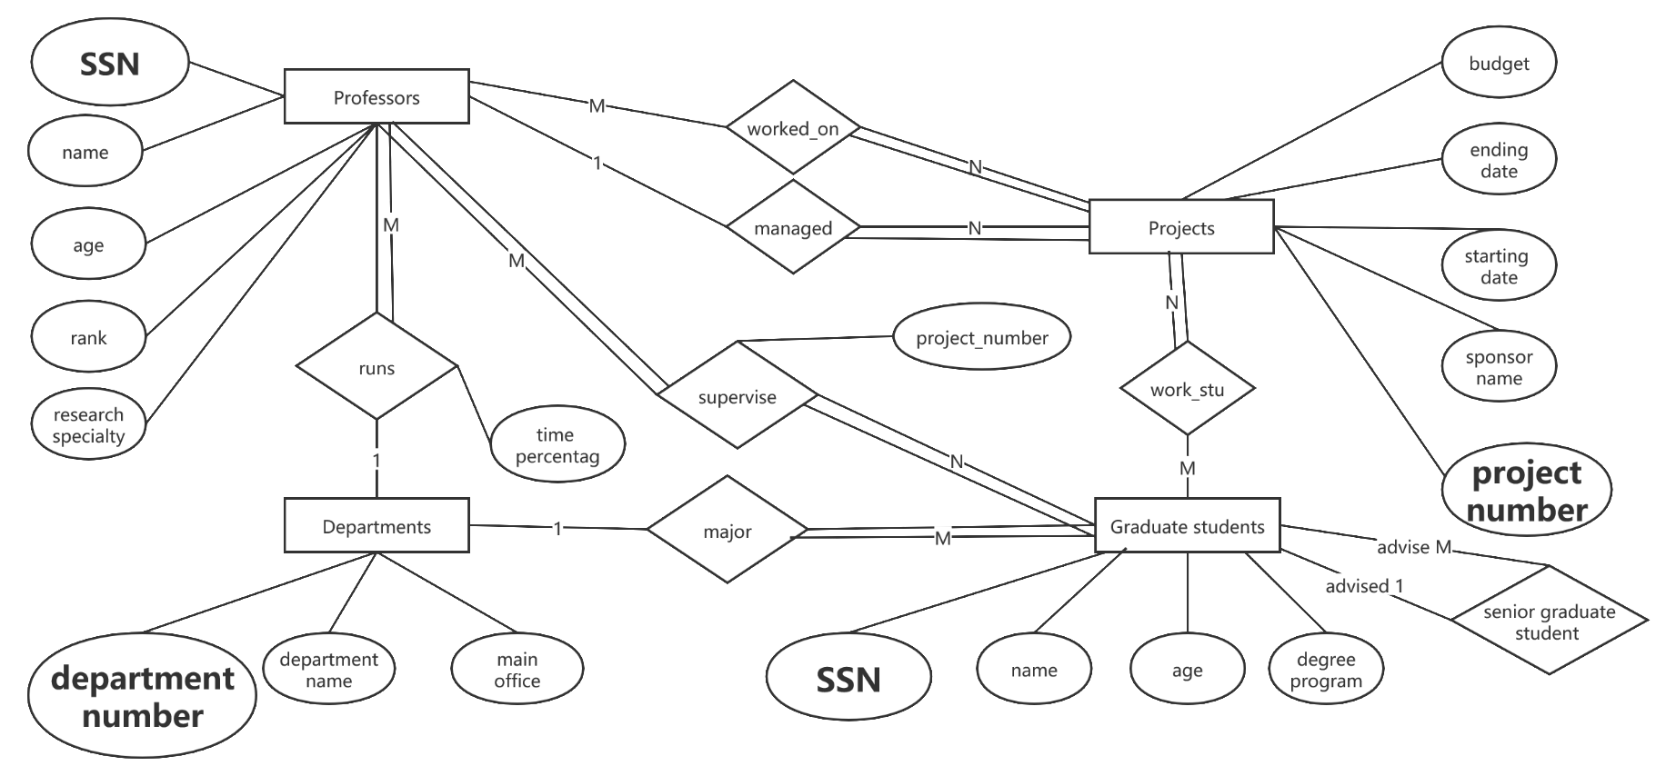

(由于软件本身问题，下划线不清晰，图中加黑加粗为的主键)

3.（下划线为主键，加粗斜体为外键）

Professors（SSN,name,age,rank,research_specialty,***department_number***,time_percentage）

Projects(project_number,sponsor_name,starting_date,ending_date,budget,***SSN_professors***)

Graduate_students(SSN,name,age,degree_program,***department_number***,senior_graduate_student)

Departments(***department_number***,department_name,main_office)

worked_on(***SSN_porfessors,project_number***)

work_stu(***SSN_students,project_number***)

supervise(***SSN_professors,SSN_students***,project_number)

4.

CREATE TABLE Projects

(project_number int PRIMARY KEY,

sponsor_name CHAR(12),

starting_date DATE ,

ending_date DATE,

budget INT,

SSN_professors INT,

KEY(sponsor) SPONSOR,

KEY(starting_date, ending_date) TIME,

FOREIGN KEY (SSN_professors) DUTY Professors(SSN));

利用了二级索引和外键索引