**Types of version control :-**

**LOCAL VERSION CONTROL** **Tools:-** visual source safe

**CENTRALIZED VERSION CONTROL** TOOLS:-CVS&SVN are very good examples of centralized

**DISTRIBUTED VERSION CONTROL** **Tools:-** GIT,MERCURIAL,BAAZAR

**GIT** is a tool is used for tracking and maintaining in **LOCAL SYSTEM**

**GITHUB** is a **SERVER BASED**.

Both are developed by Linux inventor **LINES STRAVATS** in **2005**.

**COMMANDS-**

**Ls-** list of files in a particular folder

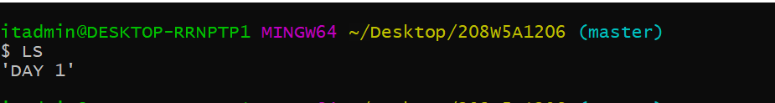

**CD** change directory



**Mkdir** to create a new folder

**Touch** is used to create a empty file



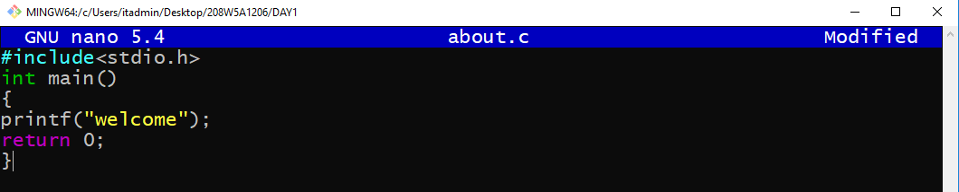**Nano**  used to perform operations on the file

CAT is used to see the contents of file

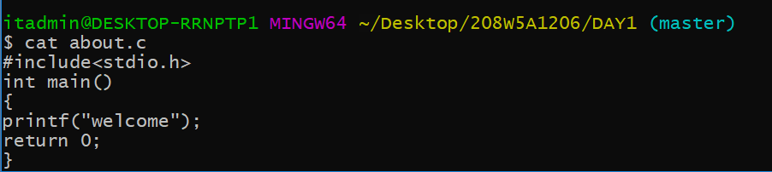

Git init used to initialize the git

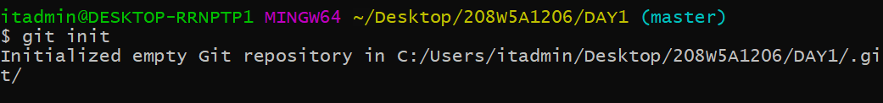

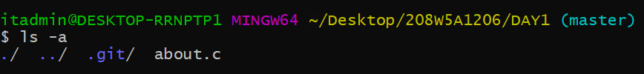

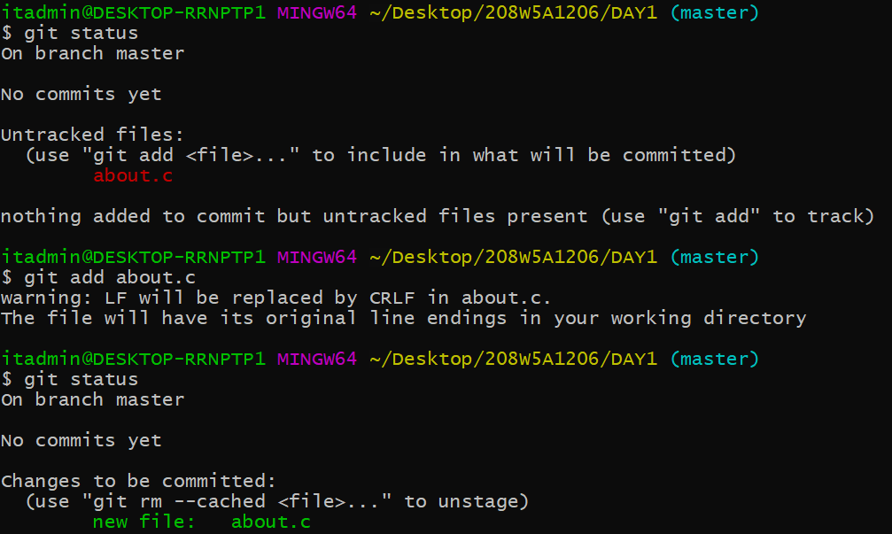Git ststus to check whether it is in tracking or not

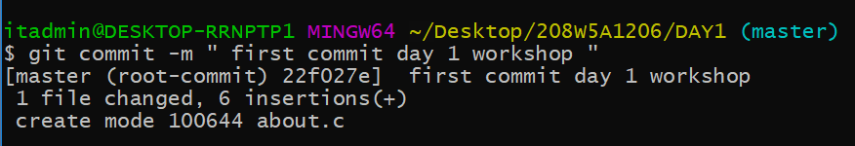

Git log to check the commits if a file

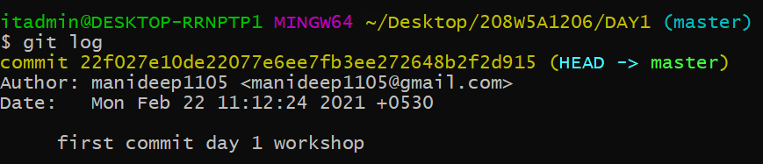

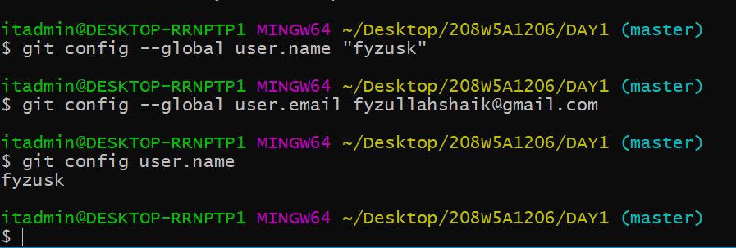CONFIGURATION OF USER IN GIT

