Experiment – 2

Aim : To run the following commands and redirect it to an output file.

1. ifconfig to find the details of the wired/wireless interface of your machine
2. hostname of your machine
3. nslookup for getting ip address of any domain
4. name server listed in /etc/resolv.conf
5. Check the routing table configured
6. ping to a remote destination 10 times
7. Use traceroute for tracing route to a remote destination
8. netstat to list the routing table, check the tcp listening ports and gather statistics
9. telnet to the remote machine 10.10.4.11 in the lab (may be different address)
10. ftp to the remote machine 10.10.4.11 in the lab, upload and download files both
in binary and text modes (may be different address)

1. ifconfig
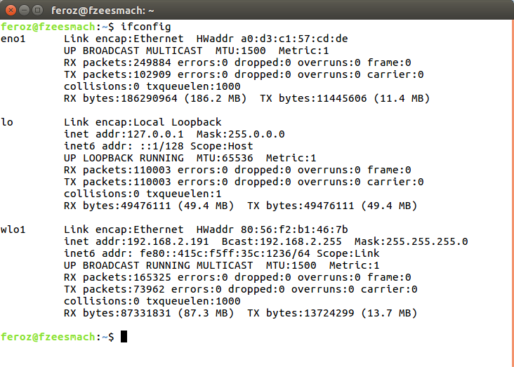
2. hostname

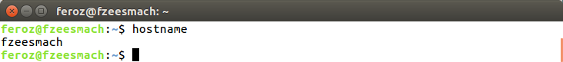
hostname can also be found in file : /etc/hostname

3. nslookup
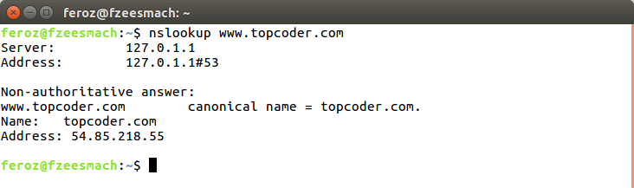
4. name server listed in /etc/resolv.conf
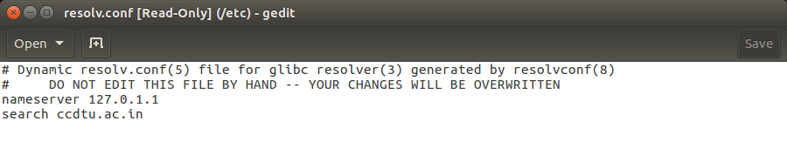
5. check routing table

6. ping to a remote destination 10 times
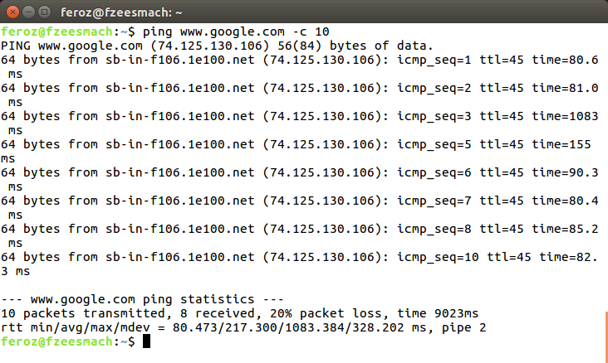

7. Use traceroute for tracing route to a remote destination
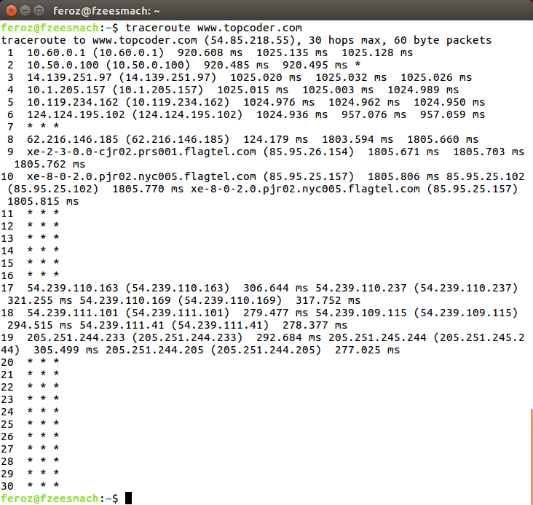

8.netstat to list the routing table, check the tcp listening ports and gather statistics
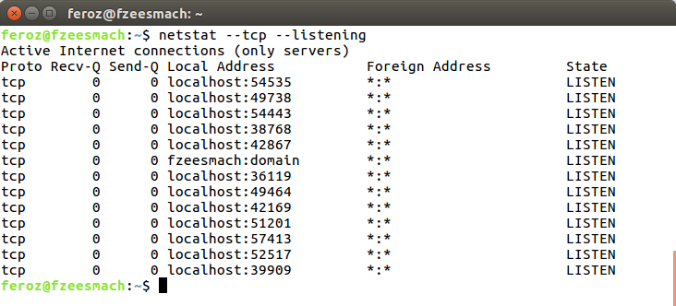

9. telnet to the remote machine in the lab
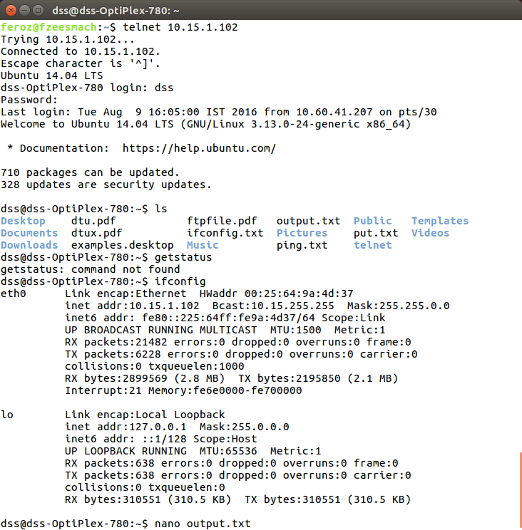

10. ftp to the remote machine in the lab, upload and download files both
in binary and text modes.
